Open Bible Stories

God Calls Moses

## 0 Introduction

### 0.1 Key Idea

The story of God calling Moses teaches us how God raised up a deliverer to rescue his people from slavery/oppression.

### 0.2 Creedal Verse

“And the patriarchs, jealous of Joseph, sold him into Egypt; but God was with him and rescued him out of all his afflictions and gave him favor and wisdom before Pharaoh, king of Egypt, who made him ruler over Egypt and over all his household.” Acts 7:9-11

### 0.3 Metanarrative Summary

The eternal God created all things in six days. He made a good and perfect world. He made humans in his image to fill the earth and rule over creation. But humans rebelled against God and ruined God’s creation. God set to restore his world through his promise. God made a covenant with Abraham. He promised to bless all nations through Abraham. God kept his promises across the generations. God provided Abraham with a promised child, Isaac. God gave Isaac a wife and she bore twins, Jacob and Esau. God blessed Jacob and his sons, and the blessing continued to the next generation. God rescued Joseph, one of Jacob’s sons, and used him to rescue his family. God caused his people, the Israelites, to multiply in the land of Egypt; eventually, they became slaves. But, God raised up a deliverer, Moses, to deliver his people from their slavery.

### 0.4 Open Bible Story: God Calls Moses

09-01

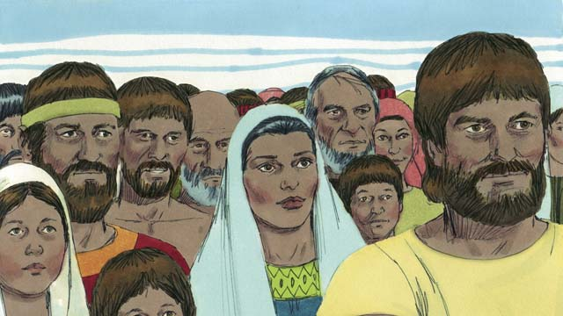

After Joseph died, all of his relatives stayed in Egypt. They and their descendants continued to live there for many years and had many children. They were called the Israelites.

09-02

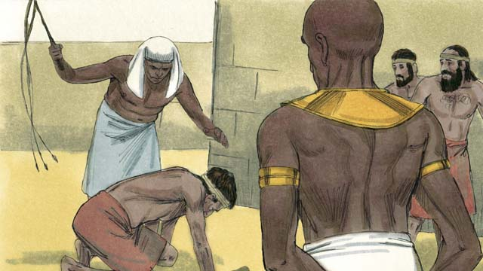

After hundreds of years, the number of Israelites had become very large. The Egyptians were no longer grateful that Joseph had done so much to help them. They became afraid of the Israelites because there were so many of them. So the Pharaoh who was ruling Egypt at that time made the Israelites slaves to the Egyptians.

09-03

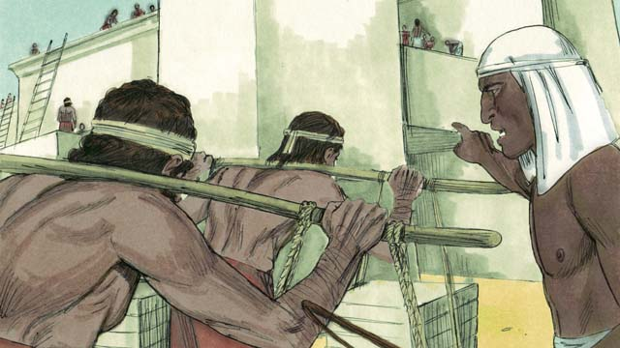

The Egyptians forced the Israelites to build many buildings and even whole cities. The hard work made their lives miserable, but God blessed them, and they had even more children.

09-04

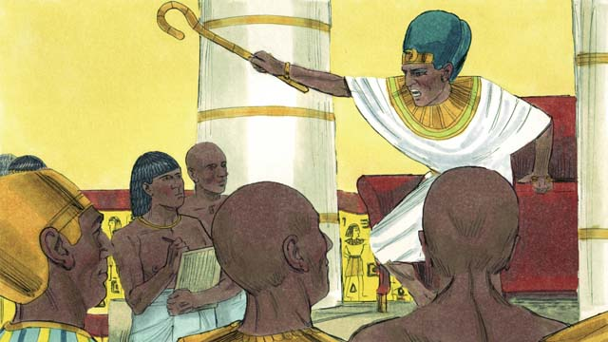

Pharaoh saw that the Israelites were having many babies, so he ordered his people to kill all Israelite baby boys by throwing them into the Nile River.

09-05

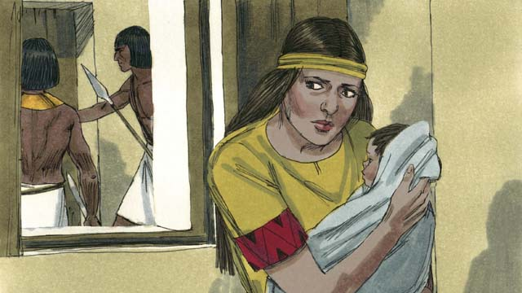

A certain Israelite woman gave birth to a baby boy. She hid the baby for as long as she could.

09-06

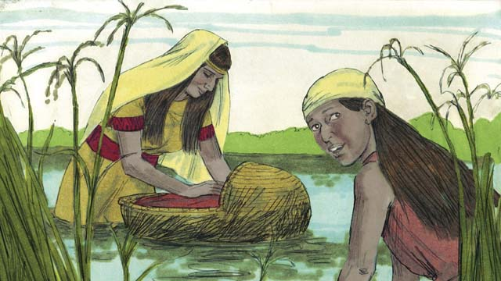

When the boy’s mother could no longer hide him, she put him in a floating basket among the reeds along the edge of the Nile River in order to save him from being killed. His older sister watched to see what would happen to him.

09-07

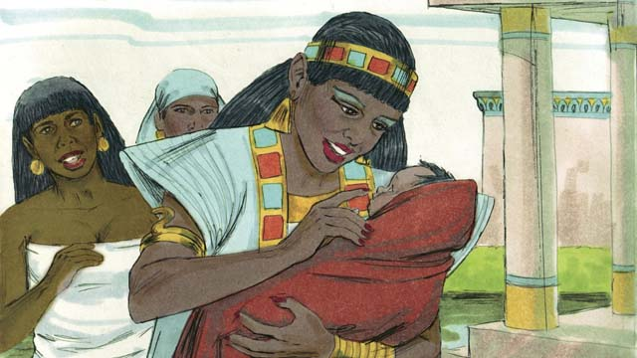

A daughter of Pharaoh saw the basket and looked inside. When she saw the baby, she took him as her own son. She hired an Israelite woman to nurse him without realizing the woman was the baby’s own mother. When the child was old enough that he no longer needed his mother’s milk, his mother returned him to Pharaoh’s daughter, who named him Moses.

09-08

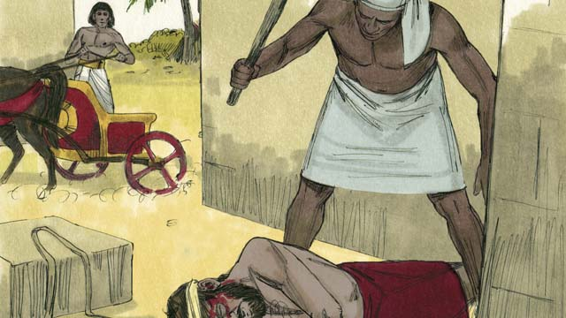

One day, when Moses had grown up, he saw an Egyptian beating an Israelite slave. Moses tried to save his fellow Israelite.

09-09

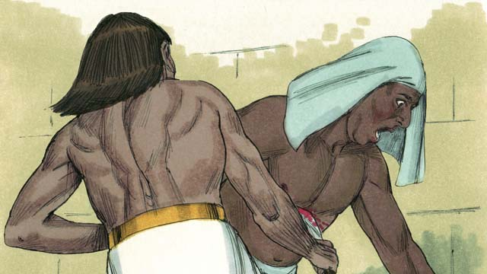

When Moses thought nobody would see, he killed the Egyptian and buried his body. But someone saw what Moses had done.

09-10

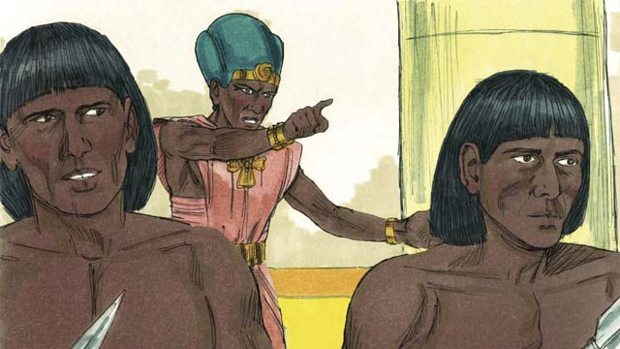

Pharaoh learned what Moses had done. He tried to kill him, but Moses fled from Egypt into the wilderness. Pharaoh’s soldiers could not find him there.

09-11

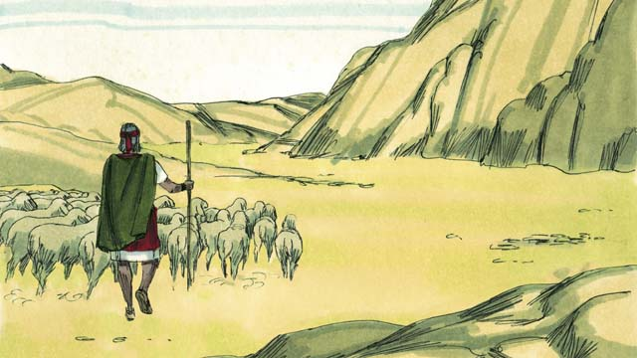

Moses became a shepherd in the wilderness far away from Egypt. He married a woman from that place and had two sons.

09-12

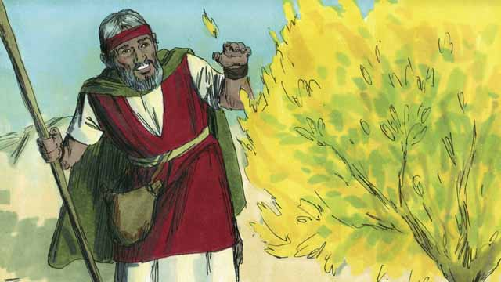

Moses was taking care of his father-in-law’s flock of sheep. One day he saw a bush on fire, burning without being destroyed. He went close to the bush to look at it. When he was very close, God spoke to him and said, “Moses, take off your shoes. You are standing on holy ground.”

09-13

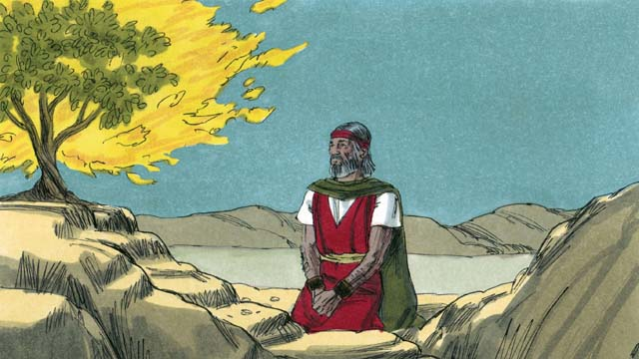

Then God said, “I have seen the suffering of my people. I will send you to Pharaoh so that you can bring the Israelites out of their slavery in Egypt. I will give them the land of Canaan, the land I promised to Abraham, Isaac, and Jacob.”

09-14

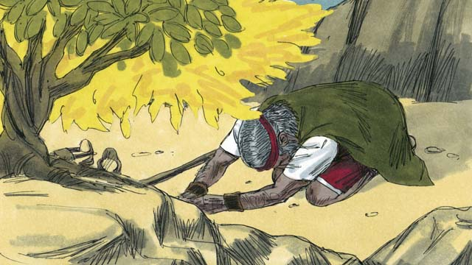

Moses asked, “What if the people want to know who sent me, what should I say?” God said, “I AM WHO I AM. Tell them, ‘I AM has sent me to you.’ Also tell them, ‘I am Yahweh, the God of your ancestors Abraham, Isaac, and Jacob.’ This is my name forever.”

09-15

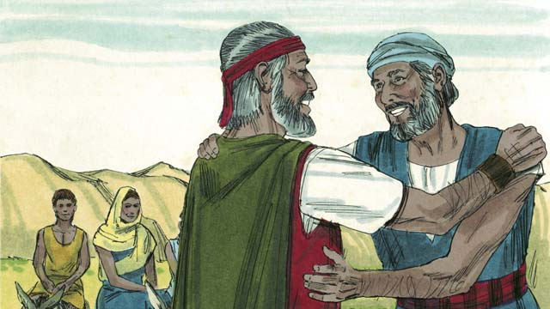

Moses was afraid and did not want to go to Pharaoh because he thought he could not speak well, so God sent Moses’ brother, Aaron, to help him.

*A Bible story from: Exodus 1-4*

## 1 Community Study: Two Ways—Understanding the Difference between the Flesh and the Spirit

* **Key Idea**: distinguishing ungodly vices and godly virtues
* **Key Passage**: Galatians 5:19-26
* **Main Session**: OBS 9 (God Calls Moses)

### 1.1 Recite the Creedal Verse (3–5 minutes)

The verse below summarizes the teaching of the current passage. Read the verse out loud as a community. Read it again several times as a group until the whole community can recite it from memory.

It was by faith that Moses, when he was born, was hidden for three months by his parents because they saw he was a beautiful child. They were not afraid of the king’s command. It was by faith that Moses, after he had grown up, refused to be called the son of Pharaoh’s daughter. Instead, he chose to suffer with the people of God, rather than to enjoy the pleasures of sin for a while. Hebrews 11:23

### 1.2 Name Temptations (5–10 minutes)

It is not easy to be a Christian. God calls us to trust him and obey him in all areas of life. Sometimes, Christians are tempted to do things that disobey God’s commands. Think about what some of these temptations are and how they might disrupt Christian community.

Some of the temptations Christians face are… These temptations disrupt Christian community in these ways…

### 1.3 Read the Passage (5 minutes)

Even though all Christians sometimes disobey God, true Christians no longer live a life characterized by sin. This means that Christians no longer live to please their sinful nature, but they walk by the Holy Spirit. When Christians follow the Holy Spirit, they can enjoy relationships with other believers in joy and peace. In order to understand what it means to walk by the Spirit, read the passage below.

19 Now the works of the sinful nature are evident: sexual immorality, impurity, depravity, 20 idolatry, sorcery, hostilities, strife, jealousy, outbursts of anger, rivalry, dissension, divisions, 21 envy, drunkenness, drunken celebrations, and things like these. I warn you, as I warned you before, that those who practice such things will not inherit the kingdom of God. 22 But the fruit of the Spirit is love, joy, peace, patience, kindness, goodness, faith, 23 gentleness, and self-control; against such things there is no law. 24 Those who belong to Christ Jesus have crucified the sinful nature with its passions and desires. If we live by the Spirit, let us also walk by the Spirit. 26 Let us not become conceited, provoking one another, envying one another. Galatians 5:19-26

### 1.4 Discuss the Idea (10–15 minutes)

People who believe in Jesus belong to Jesus. They no longer live to please sinful desires but to please God. Use the following questions to explore what it means to live the Christian life in the power of the Holy Spirit.

1. What kinds of things do people do when they live to please their sinful nature?
2. How do people live when they follow the Holy Spirit?
3. How do the works of the sinful nature destroy relationships with other people? How does the fruit of the Holy Spirit develop Christian community?
4. How do these two (opposing) lists help you care for the community of believers?

### 1.5 Personal Prayer (5 minutes) (optional)

Think about how this passage teaches us to live. Pick one behavior/attitude from the works of the sinful nature and one behavior/attitude from the fruit of the Spirit. Ask God to keep you from that particular work of the sinful nature and ask him to help you live

God help me not to live by the sinful nature in this way… God help me to live by the Spirit in this way…

### 1.6 Pray to God (5 minutes)

Divide the community into groups of 2–3. Use the above passage to pray over each other. Ask God to guard each member against the works of the sinful nature. Pray that God would help each member to experience the fruit of the Spirit.

### 1.7 Sing to God (3–5 minutes)

Choose a song to sing to praise God and encourage one another.

## 2 Biblical Interpretation: Observing the Details of the Story

After reading the crafted biblical story, answer the following questions to familiarize yourself with the details of the story.

### 2.1 Observation Questions

Answer the following observation questions to gain a basic understanding of the story. Read the story as a community and answer these questions as a group.

#### 09-01

What happened after Joseph died?  
After Joseph died, his relatives continued to live in Egypt. They lived there for many years and had many children and grandchildren.

What were the descendants of Jacob called?  
The defendants of Jacob were called Israelites.

#### 09-02

How many years were the Israelites in Egypt?  
The Israelites were in Egypt for hundreds of years. They had become very large in number.

Why were the Egyptians afraid of the Israelites?  
They were afraid because there were so many Israelites. They were no longer grateful for all that Joseph had done for them.

What did Pharaoh do to the Israelites because he was afraid of them?  
He made them slaves to the Egyptians.

#### 09-03

What kind of work did the Egyptians force the Israelites to do?  
The Egyptians forced the Israelites to build many buildings and cities.

What was life like for the Israelites?  
The work was hard and life was miserable. However, God blessed them and they bore many children.

#### 09-04

How did Pharaoh try to keep the Israelites from increasing in number?  
He ordered all Israelite baby boys to be thrown into the Nile River.

#### 09-05

What did the certain Israelite woman do to her baby boy?  
After she gave birth to her baby boy, she hid him for as long as she could.

#### 09-06

What did the woman do after she could no longer hide her baby?  
The woman put him in a floating basket and place the basket in the Nile River.

Who was watching the basket to see what would happen?  
The older sister of the baby boy watched to see what would happen.

#### 09-07

What happened to the baby boy in the basket in the river?  
A daughter of Pharaoh saw him and took him as her own son.

Who took care of the baby boy?  
Pharaoh’s daughter hired a nurse to care for the baby. The nurse was the child’s own mother.

When did the mother stop taking care of the child?  
When the child was weaned and no longer needed his mother’s milk, the child was returned to Pharaoh’s daughter.

What did Pharaoh’s daughter name the baby boy?  
Pharaoh’s daughter named the baby boy Moses.

#### 09-08

When Moses had grown up, what did he do when he say an Egyptian beating an Israelite slave?  
Moses was an Israelite. When Moses saw the Egyptian beating an Israelite slave, he tried to save his fellow Israelite.

#### 09-09

What did Moses do in order to save a fellow Israelite?  
He killed an Egyptian who was beating him, and buried the Egyptian’s body.

#### 09-10

Why did Moses have to flee from Egypt?  
When Pharaoh found out that he killed the Egyptian, he wanted to kill Moses.

Where did Moses go to escape from Pharaoh?  
He went to the wilderness.

#### 09-11

What did Moses do in the wilderness?  
Moses became a shepherd. He lived far away from Egypt.

When did Moses have a family?  
Moses eventually married a woman from that place and had two sons.

#### 09-12

What unusual thing did Moses see while taking care of his sheep in the wilderness?  
He saw a bush that was on fire, but it did not burn up.

What did God tell Moses as he approached the burning bush?  
God said, “Moses, take off your shoes. You are standing on holy ground.”

#### 09-13

How do we know God cared about the Israelites in Egypt?  
God said to Moses, “I have seen the suffering of my people.”

What did God send Moses to do for the Israelites?  
God told him to go to Pharaoh and bring the Israelites out of their slavery in Egypt.

What land did God say he would give to the Israelites?  
God would give him the land of Canaan, the land God had promised to Abraham, Isaac, and Jacob.

#### 09-14

Who sent Moses to the Israelites?  
God sent Moses to the Israelites. He is I AM Who I AM.

What name did God say would be his forever?  
He said his name would be Yahweh.

#### 09-15

How did Moses feel about going to Pharaoh?  
Moses was afraid and did not want to go because he thought he could not speak well.

Who did God send to help Moses?  
God sent Moses’ brother, Aaron, to help him.

### 2.2 Translation Questions

Use the following translation questions to understand specific details of the passage. Discuss how you might translate these specific elements of the story.

#### 09-01

**After Joseph died** This phrase begins a new event in the story. The events of this story take place after Joseph had died. How would you express **After Joseph died** to mean the events of the story took place following Joseph’s death?

  

**his relatives** This refers to a social relationship—all the people who were related to him by birth or marriage. How would you express **his relatives** to mean all the people who were related to him by birth or marriage?

  

**stayed in Egypt** The relatives of Joseph continued to lived in Egypt after his death. How would you express **stayed in Egypt** to mean the relatives of Joseph continued to live in Egypt?

  

**They were called the Israelites** The people group that descended from Jacob was called ‘Israel,’ which is the name that God gave to Jacob. The people from that group were called Israelites. These are the people of Israel. How would you express **They were called the Israelites** to mean the people who descended from Jacob were named Israelites or the people of Israel?

  

#### 09-02

**After hundreds of years** This phrase begins a new event in the story. The events of this story take place hundred of years following the death of Joseph. How would you express **After hundreds of years** to mean the events of this story take place hundred of years following the death of Joseph?

  

**Egyptians** The people group that lived in the land of Egypt. This refers to the Egyptian people of the people of Egypt. How would you express **Egyptians** to refer to the Egyptian people of the people of Egypt?

  

**because there were so many of them** The word because tells the reason the Egyptians were afraid. The reason the Egyptians were afraid was that there were so many Israelites. How would you express **because there were so many of them** to mean the reason the Egyptians were afraid was that there were so many Israelites?

  

**Pharaoh** **Pharaoh** is an Egyptian word that refers to their king. This **Pharaoh** was probably the son of a former **Pharaoh** who had died, who may have been a descendant of the **Pharaoh** that Joseph knew. How would you express **Pharaoh** as in the Egyptian king who ruled in the land of Egypt?

  

**made the Israelites slaves** The Egyptians forced the Israelites to do hard labor against their will and treated them very harshly. How would you express **made the Israelites slaves** to mean the Egyptians forced the Israelites to do hard labor against their will and treated them very harshly?

  

#### 09-03

**made their lives miserable** The Israelites suffered terribly because of how harshly they were treated and how hard they were forced to work. They also felt very discouraged. How would you express **made their lives miserable** to mean the Egyptians treated the Israelites so harshly that they caused the Israelites to be sorrowful and painful?

  

**but God blessed them** The word but contrasts the misery of the Israelites with God blessing them. One would expect that the Israelites’ affliction/misery meant that God was punishing them. God blessing the Israelites is the opposite of what one would expect toward an enslaved people. How would you express **but God blessed them** to mean that God blessing the Israelites is the opposite/contrast to the hard work that made their lives miserable?

  

#### 09-04

**Pharaoh saw** Pharaoh realized or learned that the Israelites were having many babies. How would you express **Pharaoh saw** to mean Pharaoh realized (or became aware) that the Israelites were having many children?

  

**so he ordered his people to kill all the Israelite baby boys** The word so connects explains that the result of Pharaoh realizing that the Israelites were having many babies was that Pharaoh ordered the people to kill all the Israelite boys. How would you express **so he ordered his people to kill all the Israelite baby boys** to mean the result/outcome of Pharaoh realizing that the Israelites were having many children was that he ordered the people to kill all the Israelite boys?

  

#### 09-05

**A certain Israelite woman** The mother of the baby boy was a woman who was from the people of Israelite. Her name is not given in the story. How would you express **A certain Israelite woman** to mean a specific unnamed woman who was from the people of Israelite?

  

**as long as she could** The mother hid the baby from the Egyptians until it became too difficult to keep him safely hidden in her home. How would you express **as long as she could** to mean the mother hid the baby from the Egyptians until it became too difficult to keep him safely hidden in her home?

  

#### 09-06

**the boy’s mother could no longer hide him** At this point in the story, the mother was not able to keep the baby safely hidden in her home. How would you express **the boy’s mother could no longer hide him** to mean, at this point in the story, the mother was not able to keep the baby safely hidden in her home?

  

**reeds** A reed is a type of tall grass that grew in flat, wet areas. What words in your language mean **reeds** as in a tall grass that grows in flat, wet areas? **in order to save him from being killed** The phrase in order to explains the purpose or objective that something is done. The mother put her child in a floating basket and put the basket in the river with the purpose to keep him safe. How would you express **in order to save him from being killed** to mean the mother put her child in a floating basket and put the basket in the river with the purpose/goal to keep him safe?

  

#### 09-07

**took him as her own son** Pharaoh was the king of Egypt. Pharaoh’s daughter was a princess. When she made the baby her son, the baby became a prince of Egypt. The baby was born from another woman. Pharaoh’s daughter did not give birth to the baby. Pharaoh’s daughter adopted this baby as her own son. How would you express **took him as her own son** to mean Pharaoh’s daughter made this baby boy from another mother her own son?

  

**to nurse** Pharaoh’s daughter hired a woman to breastfeed the baby boy. How would you express **to nurse him** to mean to breastfeed a baby?

  

**no longer needed his mother’s milk** The baby had grown to the point where he no longer needed to nurse/breastfeed. The baby had weaned. How would you express **no longer needed his mother’s milk** to mean the baby had grown to the point where he no longer needed to nurse/breastfeed—the baby was weaned and could eat food other than breast milk?

  

#### 09-08

**had grown up** At this point in the story, Moses had grown into a man. He was an adult. How would you express **had grown up** to mean Moses had become an adult?

  

**his fellow Israelite** Moses was also an Israelite. Although the daughter of the Egyptian Pharaoh raised Moses, Moses remembered that he was really an Israelite. How would you express **his fellow Israelite** to mean Moses was shared a common people with this man—they were both from the people of Israel?

  

#### 09-09

**When Moses thought nobody would see** Moses did not want people to see him kill the Egyptian. Moses killed the Egyptian at a time when he supposed no one would know about it. How would you express **When Moses thought nobody would see** to mean Moses killed the Egyptian at a time when he supposed no one would know about it?

  

**But someone saw what Moses had done** The word but contrasts what Moses thought when he killed the Egyptian and what actually happened when he killed the Egyptian. Moses though nobody saw him kill the Egyptian. The opposite of this was true. Somebody saw Moses kill the Egyptian. How would you express **But someone saw what Moses had done** to mean that somebody saw Moses kill the Egyptian and this is the opposite of what Moses thought when he killed the Egyptian?

  

#### 09-10

**Pharaoh learned what Moses had done** Pharaoh was not there when Moses killed the Egyptian but he had heard about the fact that Moses killed an Egyptian. How would express **Pharaoh learned what Moses had done** to mean Pharaoh heard about the fact that Moses killed an Egyptian? **but Moses fled from Egypt** The word but contrasts Pharaoh trying to kill Moses with Moses escaping into the wilderness. How would you express **but Moses fled from Egypt** to mean Moses fleeing to Egypt is opposite/different from Pharaoh trying to kill Moses?

  

**wilderness** The wilderness was a large area that was rocky and dry. The land there was not good for growing food and few people lived there. What words in your language mean **wilderness** as in a large area that was rocky and dry?

  

#### 09-11

**Moses became a shepherd** Moses was not a shepherd before this time. How would you express **Moses became a shepherd** to mean that Moses began work as a shepherd during his time in the wilderness and this was not something did before?

  

**a woman from that place** The woman Moses married was from the place he lived and worked in the wilderness. How would you express **a woman from that place** to mean a woman who lived in the area Moses was living and working as a shepherd?

  

#### 09-12

**taking care of his father-in-law’s flock of sheep** Moses was doing the work of a shepherd to guide the sheep to grass and water, and to protect them. How would you express **taking care of his father-in-law’s flock of sheep** to mean Moses was tending the sheep that belonged to his father-in-law?

  

**a bush on fire, burning without being destroyed** God made the bush full of fire, but the fire did not damage the bush. How would you express **a bush on fire, burning without being destroyed** to mean the bush was full of flames of fire but the fire did not damage the bush?

  

**God spoke to him** God spoke, but he did not see God. How would you translate **God spoke to him** to mean God talked aloud to Moses even though Moses did not see God?  
**take off your shoes** God commanded Moses to take off his shoes or sandals that he was wearing on his feet. How would express take off your shoes as a command that tells someone to remove the shoes or sandals from their feet?  
**holy ground** God wanted Moses to take off his shoes to show that he greatly respected God. The place was holy in the sense that God set it apart from the ordinary land and made it to be a special place where He would reveal Himself. How would you express **holy ground** as a place set it apart from the ordinary land and made it to be a special place where He would reveal Himself?

  

#### 09-13

**the suffering of my people** This refers to the the very harsh treatment that God’s people were experiencing. This suffering happened because the Egyptians were causing God’s people terrible pain. How would you express **the suffering of my people** to mean the harsh treatment and terrible pain that the Israelites were experiencing because of how Egyptians were treating them?

  

**my people** This refers to the Israelites. God had made a covenant with Abraham and his descendants that he would bless them and make them into a great nation. Through this covenant, the Israelites became God’s own people. How would you express **my people** to mean the Israelites were God’s people whom he had come into relationship with through a covenant?

  

**so that you can bring the Israelites** The words so that explain that the purpose/goal of God sending Moses to Pharaoh was to bring the Israelites out of slavery. How would you express **so that you can bring the Israelites** to mean that the purpose or goal of God sending Moses to Pharaoh was to bring the Israelites out of slavery?

  

#### 09-14

**I AM WHO I AM** This name emphasizes that God is the only one who has always lived and always will live. God has always existed and will always exist. This description shows that God can only be defined by himself, not by anything else that we know of, and he cannot be compared to anyone else. How would you express **I AM WHO I AM** to mean God is the only one who has always lived and always will live?

  

**Yahweh** The name Yahweh means ‘HE IS’ and expresses that God exists by his own power—no one created him. The name that God told Moses and all of Israel to use for him is ‘Yahweh,’ which is related to ‘I AM’ and appears to mean ‘HE IS.’ God exists for all time. He has no beginning or end. How would you express as God’s personal name **Yahweh** which tells us that God eternally exists by his own power and no one created him?

  

#### 09-15

**because he thought he could not speak** One reason Moses was afraid and did not want to go to Pharaoh was he thought he could not speak well. How would you express **because he thought he could not speak** to mean the reason Moses was afraid and did not want to go to Pharaoh was he thought he could not speak well?

  

**so God sent Moses’ brother** The word so tells the result or outcome of Moses being afraid and not wanting to go to Pharaoh because he thought he could not speak well. How would you express **so God sent Moses’ brother** to mean the result or outcome of Moses being afraid and not wanting to go to Pharaoh because he thought he could not speak well was that God sent his brother Aaron to help him?

  

## 3 Theological Dialogue: Discussing the Meaning of the Story

Take time to explore the meaning of this story together as a community. Use the following discussions as a way to grasp what truth the story teaches.

### 3.1 Discourse Questions

Use the following discourse questions to understand the meaning of the story. Pay attention to how the story itself addresses each question or theme.

##### What was life like for Israel in Egypt? (09-01, 09-02, 09-03, 09-04)

Multiplied in Foreign Land: The Israelites lived in Egypt for hundreds of years. They had many children and become a numerous people. The family of Jacob had multiplied to become a large people group called the Israelites. The Israelites became a large people living in a foreign land, not the land of Canaan. (09-01, 09-02)

  

Enslaved: The Egyptians were no longer grateful for what Joseph had done for them. The Egyptians grew afraid of the Israelites because they were so many of them. The Egyptians made the Israelites slaves. (09-02)

  

Hard Labor, Miserable Life: The Egyptians forced the Israelites to to hard work. They made them build buildings and cities. This made their life miserable. (09-03)

  

Kill Baby Boys: Pharaoh ordered all Israelite baby boys to be killed by throwing them into the Nile River. He did this because he saw that the Israelites were growing in number. (09-04)

  

##### How was God’s hand upon the Israelites and Moses? (09-01, 09-02, 09-03, 09-05, 09-06, 09-07, 09-08, 09-09, 09-10, 09-11, 09-13)

God caused the Israelites to grow in number. Even though they were in a foreign land, God fulfilled his promises to Abraham by having his descendants grow in number. (09-01, 09-02)

  

Even though the Israelites were harshly treated as slaves, God blessed them and they had more children. God was blessing his people even though they were be mistreated. (09-03)

  

When Moses was born, his mother hid him safely for some time. God protected Moses from being killed when he was born. (09-05)

  

Moses’ mother put him in a floating basket to keep him from being killed. God protected Moses when he was a young baby. (09-06)

  

God allowed Moses to be found by Pharaoh’s daughter. She adopted him as her son. God allowed Moses to be kept safe by being raised in Pharaoh’s house. (09-07)

  

Pharaoh’s daughter hired Moses’ mother to nurse him. Pharaoh’s daughter did not realize it was Moses’ mother. This was something that God caused to happen. (09-07)

  

Moses killed an Egyptian who was beating a fellow Israelite. Pharaoh learned about this and tried to kill Moses. Moses fled to the wilderness. God protected Moses from being killed (09-08, 09-09, 09-10)

Moses married a wife and had sons. God provided Moses a family. (09-11) God planned to rescue his people from slavery. (09-13)

  

##### How did God reveal himself to Moses? How (09-12, 09-13, 09-14, 09-15)

Holy: Moses saw a bush that was burning but was not destroyed. God spoke to Moses and told him that the place where he was standing was holy ground. He commanded Moses to take off his shoes. God is holy. He is set apart and different from all else. (09-12)

  

Rescuer: God heard the suffering of his people and planned to rescue them. God called Moses to go to Pharaoh to bring the Israelites out of slavery in Egypt. (09-13)

  

Faithful: God planned to fulfill his promises to Abraham, Isaac, and Jacob by causing the Israelites to enter the promise land of Canaan. God was fulfilling his promises hundreds of years after made the promises. (09-13)

  

Eternal: God told Moses that he was I AM WHO I AM. This meant that God has always existed. God also told Moses his name is Yahweh. This name relates to the idea that “God is.” He has no beginning or end. He exists from himself. He also would be present with his people. (09-14)

  

Covenant: God told Moses his name was Yahweh. This was God’s special name for his relationship with his people. God said he was the God of Abraham, Isaac, and Jacob. God’s name is Yahweh: the God would makes and keeps covenant promises with his people for all time. (09-14)

  

Patient/Kind: Moses was afraid to go to Pharaoh. He thought that he could not speak well. God sent Moses’ brother, Aaron to go with him. God was gracious to send Aaron to help Moses in his work. (09-15)

  

##### How did God call Moses? How (09-12, 09-13, 09-14, 09-15)

God showed himself to Moses in a burning bush. (09-12)

  

God told Moses he was sending him to Egypt to bring the Israelites out of slavery. (09-13)

  

Moses was going to represent God. God told Moses his name. (09-14)

  

God reminded Moses of the promises he made to Abraham. (09-14)

  

God sent Aaron with Moses to support him in his work. (09-15)

  

### 3.2 Theological Questions

Answer the following theology questions as a community. Discuss what truths this story teaches.

1. What are some of causes of suffering and hardship? How does the story of Moses teach us about suffering and hardship in the world?
2. What should we believe about God? How does this story help us understand who God is and what it looks like to relate to God?
3. How does God work to bring about the rescue of his people? How did God work in this story to protect and rescue his people?

### 3.3 Translation Draft

Work as a translation team to draft each panel of this story. Pay attention to any specific translation issues that are challenging or significant.

#### Make Translation Draft

Make a draft for each section of this story.

#### Discuss and Revise

After drafting the story, discuss any translation issues that you think need special explanation.

#### Drafting Summary Reflection

Summarize any noteworthy translation decisions and the rationale/reasoning behind these translation decisions. In the final movement of this class, you will use these observations to give an account (i.e., chronicle/narrate) of how your translation improved through the checking process.

## 4 Personal Reflection: Following the Teaching of the Story

Take a moment to allow this story to evaluate your own life and to consider how God would have you respond. After this reflection, use the quality checking questions to check your translation draft among the translation team.

### 4.1 Journal Reflection

Prayerfully think about the following personal reflection questions. Write/Record your answers and/or discuss them as a group.

1. In what ways have you suffered hardship or pain? How can you relate to the hard lives of the Israelites?
2. How can you see God working in the details of your life? How has God protected you or rescued you from misery?
3. What did you learn about God from this story that encouraged you in your faith?
4. What mission might God be sending you on?

### 4.2 Team Check

*The following activity will help you check the clarity, accuracy, and naturalness of your draft. Read the passage aloud and discuss the checking questions with other members of your translation community. You might need to reread portions (or the whole) of the biblical passage multiple times as you answer each of these questions. Record answers to these questions below.*

#### Team Checking Questions

*Use the following questions to check your translation draft for accuracy, clarity, and naturalness.*

1. **Accurate**: Has anything been **added** to your translation of this passage that is not a part of the meaning of the source text? *If additions exist, are they included only added to clarify meaning (such as implied information)?*
2. **Accurate**: Is anything **missing** from your translation of this passage that is a part of the meaning of the source text? *If some part of the meaning is missing from your translation, add it.*
3. **Accurate**: Does any meaning in your translation of this passage appear to be **different** than the meaning of the source text? *If the meaning is different, try changing your translation so that the meaning remains the same.*
4. **Natural**: Does anything sound **unnatural** to how you would say it in your language? *If portions of the passage sound unnatural in your language, try to make them sound the way you would say it in your language while staying true to the meaning of the source text.*
5. **Clear**: Is anything **unclear** or **confusing** in your translation that confuses the meaning of the source text? *If portions of the passage are unclear or confusing, revise them to clearly communicate the meaning of the source text.*
6. **Consistent**: How **consistent** is your translation within the passage and with other passages? *If portions of the passage need to be made consistent or if you need to revise translations of other passages, make these adjustments.*

#### Record Feedback

*After discussing the checking questions above as a translation community, record any feedback on your translation draft. Pay attention for parts of your translation that are translated well and parts of your translation that need correction.*

#### Discuss and Revise

*After gathering feedback on your draft, discuss it together with your translation community and make appropriate revisions in your translation.*

#### Record Translation Decisions

*As a community, discuss some of the most noteworthy translation decisions in your draft. Summarize each decision and explain the reasons your community decided on that translation. You should update these decisions each time you check your draft with various groups of people.*

You should **measure** the quality of your translation draft. You can **record translation decisions** to make it clear why you translated things a certain way. Translation decisions can help your translation team and the surrounding community be a part of the translation process.

How can you know the quality of your translation?

1. **Measure** the translation by marks/standards of quality (i.e., clear, accurate, natural, church-approved)
2. **Test** the translation with others and record feedback and conversations from in the field (i.e., church and community check)
3. **Compare** and **contrast** the translation with the source text (i.e., meaning of text and notes) and alternatives (i.e., other translation choices)
4. **Explain** the reasons why you translated a particular portion of the text.

**Example Sentences That Help Explain Your Translation Decision** Use the following example sentences to help explain your translation decisions:

1. The original text literally **says/means**, so we translated the term in this way…
2. We originally decided to translate **the biblical term** with **this term**, but we changed it because…
3. When our translation team discussed **the biblical term**, this is what we talked about…
4. **The term** is [clear, accurate, natural, consistent] because…
5. The community understands **this term** to mean…
6. We considered these other terms. We did not use **these terms** because…
7. When we checked this in the church, we learned…
8. When we checked this in the community, we learned…

**Example of Translation Decision**

In OBS 01-07 we decided to translate **blessed** like this: [actual translation]. We decided on this translation because of these reasons:

1. The word [actual translation] means to cause good things to happen to someone or something. This term is used when a person desires someone or something to prosper or flourish. This term does not refer to magic or witchcraft.
2. When we checked this word with other believers, they said it describes God showing his kindness and favor on someone or something. These are some of the terms that we did not decide to use…
3. Many of our people will understand this word. When we discussed this phrase with the surrounding community, we discovered it was a natural way to describe God causing good and beneficial things to happen.

## 5 Ministry Practice: Serving the Church with the Story

Now that you have a draft of this story, consider how this story can encourage other believers in their faith. After ministering this story to others, you will also perform a community check of your translation draft.

### 5.1 Church Ministry

Reflect on how this story can edify and mature the Christian community. Design a way to minister this story to your church community.

**Ministry Preparation**: Take time to consider how you could minister this story to others. Record some ministry ideas below.

**Ministry Implementation**: Minister this story to a group of believers as you had planned. Use the information in this study to help develop a teaching/lesson or lead a discussion of this story to other believers. Record your ministry plan below.

**Ministry Reflection**: Think about what you learned from ministering this story to other believers. Reflect on your experience below.

### 5.2 Church Community Check

After teaching or ministering this story to the church, check the translation quality with the church community. Record any feedback from your checking experience.

#### Create Checking Questions

You can use **Translation Questions** to check your draft. Each **Translation Question** explains the meaning of a specific part of the story and asks you to consider how you would translate that part of the story in your own language. Change each **Translation Question** into a **Checking Question** by asking the following questions. The first question asks you to identify how each specific phrase was translated into your language. The second question asks people in the church to determine if your translation of the phrase expresses the meaning clearly, accurately, and naturally. Look at the following examples to see how to change **Translation Questions** into **Checking Questions**:

#### Translation Question Example 1

**to proclaim the good news about Jesus** Paul and Silas traveled to Philippi for the purpose of preaching the gospel. The gospel is the good news that Jesus saves people from their sins if they will believe in Jesus. How would you express **to proclaim the good news about Jesus** to mean to tell other people the message about how Jesus can save people from their sins?

#### Translation Question Example 2

**a merchant** Paul and Silas met a woman named Lydia at the place by the river. She owned a business and sold items to make money. How would you express **a merchant** to mean a business owner who sells items for a profit?

#### Translation Question Example 3

**so Paul and Silas baptized them** The jailer and his whole family followed Paul’s instructions. They believed in Jesus. The result of this was Paul and Silas baptized them. How would you express **so Paul and Silas baptized them** to mean the result of the jailer and his family believing in Jesus that Paul and Silas baptized all of them?

You can change these into **Checking Questions** like this:

#### Checking Question Example 1

**to proclaim the good news about Jesus** How did you translate **to proclaim the good news about Jesus**? Does it mean to tell other people the message about how Jesus can save people from their sins?

#### Checking Question Example 2

**a merchant** How did you translate **a merchant**? Does it mean a business owner who sells items for a profit?

#### Checking Question Example 3

**so Paul and Silas baptized them** How did you translate **so Paul and Silas baptized them**? Does it mean the result of the jailer and his family believing in Jesus that Paul and Silas baptized all of them?

#### Record Feedback

*Discuss the* ***Checking Questions*** *with your church community, and record any feedback on your translation draft. Pay attention to parts of your translation that are translated well and parts of your translation that need correction.*

#### Discuss and Revise

*After gathering feedback on your draft, discuss it together with your translation community and make appropriate revisions to your translation.*

#### Record Translation Decisions

*Update your translation decisions and record any new and noteworthy observations on the quality of your draft.

## 6 Missional Outreach: Sharing the Truth of the Story

*After sharing this story with others, check the translation quality with the wider language community. Record any feedback from your checking experience.*

### 6.1 Mission Engagement

*Consider how you will witness this story to unbelievers. Design a way to share this story and engage them in what it teaches about Christianity and the gospel.*

**Witness Preparation**: Take time to consider how you will witness this narrative to unbelievers. Record some ideas below.

**Witness Implementation**: Share this story with an unbeliever. Use the information in this study to help develop a teaching/lesson or lead a discussion of this story to other believers. Record your ministry plan below.

**Witness Reflection**: Think about what you learned from ministering this story to unbelievers. Reflect on your experience below.

### 6.2 Sociolinguistic Check

After sharing this story with the language community, check your translation draft with the surrounding community. Record your observations.

#### Checking Approach

After witnessing this story to unbelievers, use one of the following methods to check the translation of this story. Consider using the **Observation Questions** to check your translation draft or come up with your own quality checking questions.

**Read-Retell Check:** Read your draft to those the community and ask them to retell the passage. Be attentive to any portions of the passage that are unclear, unnatural, or inaccurate.

**Comprehension Questions Checklist:** Read the draft of the passage and ask a list of comprehension questions to make sure the passage is being rightly understood. You can use the **Observation Questions** in this guide or come up with your own questions. Then, record any insights or issues that arise.

**Discussion Group:** Develop key questions to ask about the passage (both formational and translational). Read the passage and have a group discussion about the passage, paying attention to issues that need to be addressed, edited, and revised.

#### Record Feedback

*After sharing your draft with the language community, discuss the* ***Observations Questions****, and record any feedback on your translation draft. Pay attention to parts of your translation that are translated well and parts of your translation that need correction.*

#### Discuss and Revise

*After gathering feedback on your draft, discuss it together with your translation community and make appropriate revisions to your translation.*

#### Record Translation Decisions

*Update your translation decisions and record and new any noteworthy observations on the quality of your draft.

## 7 Conclusion

As a translation community, take time to reflect on all that was learned in studying, drafting, and checking this story. Celebrate all that God has taught you as a community. Then, submit your revised draft and checking summaries to network leaders for further review.