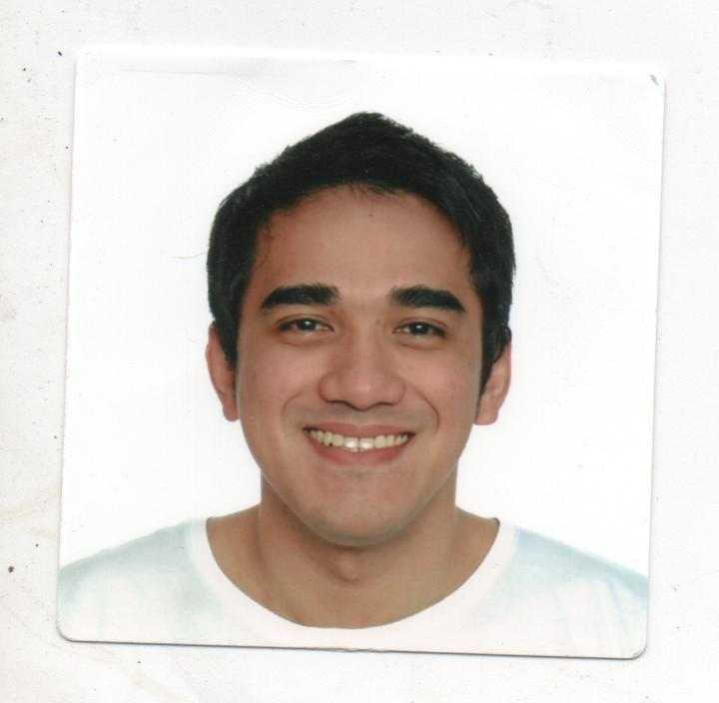**NAME:** Greg Lomeda Osorio

**ADDRESS:** 563-0043 Osaka-fu, Ikeda-shi, Koda 2-5-4

Third Hills Room 403

**MOBILE NO:** +818053376422

**E-MAIL ADDRESS:** greglomeda.osorio@yahoo.com

**PERSONAL BACKGROUND:**

Date of Birth : June 23, 1984

Place of Birth : Manila

Sex : Male

Civil Status : Single

Citizenship : Filipino

Height : 5”11

Weight : 185 lbs.

Religion : Christian

Language : English, Tagalog, Nihonggo

**EDUCATIONAL BACKGROUND:**

2000 – 2005 College

Course: Bachelor of Science in Industrial Engineering

Mapua Institute of Technology

Muralla St., Intramuros, Manila Philippines

1996 – 2000 Secondary School

San Roque Catholic School

Alabang, Muntinlupa City

**CERTIFICATIONS:**

1. Japanese Language Proficiency in Japan **JLPT**- Level 3 Year Attained: January 31, 2009

2. Certificate of Completion (Japanese Language) Year Attained: February 8, 2008

Certificate of Completion – Prepare Computer Year Attained: September 22, 2012

Aided Drawings leading to Technical Drafting NC II

Using **AutoCAD** with Color Rendering ver. 2013

from Autodesk – Authorized Training Center

3. Certification of 9.0 Niner **IELTS** Review Year Attained: September 03, 2012

and Tutorial Center

4. Certificate of Completion on Training and Year Attained: June 11, 2011

Technical Internship Training in **Hitachi Plant**

**Technology and JITCO (Japan)**

5. Certification on Welding Skills **(Japan)**  Year Attained: April 24, 2009

6. Commendation on Hard Work in **(Japan)** Year Attained: December 29, 2009

7. Safety Precautions in Production Area**(Japan)** Year Attained: August 13, 2010

8. Certificate of Competency TESDA Year Attained: February 28, 2008

Shielded Metal Arc Welding

9. Certificate of Attendance Year Attained: May 21, 2008

(Ocean Bridge and Arc Foundation)

10. Job Evaluation and Classification Year Attained: November 6, 2004

11. New trends in Semiconductor Manufacturing Year Attained: November 13, 2004

12. Industrial Engineering as a Career Year Attained: November 20, 2004

13. Total Quality Management Seminar: Year Attained: July 17, 2004.

Best Practices as Applied to Service Organization

**EMPLOYMENT HISTORY**

1) June 2008 – June 2011

**COMPANY NAME:** HITACHI PLANT TECHNOLOGY

Tsuchiura-shi, Ibaraki-ken, Japan

**BUSINESS DESCRIPTION:** Development, design, manufacture, sale, service and construction of social infrastructure systems, industrial systems, air conditioning systems, and energy systems.

NUMBER OF EMPLOYEES: Approximately 6,500 (Consolidated)

POSITION: Production Engineer

**SELF-INTRODUCTION:**

Aside from welding and finishing the products, I also check and examine the overall condition of a product. I also make reports for Safety Precautions and I have know-how in Organizing a Workplace. I also design parts of Industrial Machine such as pumps, compressor, etc..

**JOB DESCRIPTION:**

**Quality Control**

- Examine the appearance of metals

- Assemble the common base of a compressor

- Test the physical appearance of a welding bead

**Autocad Operator**

- Design parts of Industrial Machine such as pumps, compressor, etc..

- Plotting the exact and location points in bending the metal.

**SKILLS:**

Expertise in welding and finishing of products or examine the appearance of the products. AutoCAD and M.S. Office such as MS Word, MS Excel, MS PowerPoint, etc..

**OTHER SKILLS:**

Extensive knowledge in computer hardware and software applications such as AutoCAD drawing, Adobe Photoshop, M.S. Office, etc..

2) February 2006 – July 2007

**COMPANY NAME:** INCA PLASTICS PHILIPPINES, INC.

Km. 23 West Service Road,Cupang Muntinlupa City Philippines

**BUSINESS DESCRIPTION:** A specialized plastic product manufacturer and a pioneer in rotomoulding technology in Asia with existing operations in the Philippines, Thailand and Malaysia.

**POSITION:** Cadet Engineer

**SELF INTRODUCTION:**

INCA Plastics often launches exhibits as one of our sales strategies. I was always sent by the company as a representative and my job was to negotiate with target customers or consumers and explain how our products work. I was successful in getting the interest of the customers and providing important information about our products and it earned us a lot of individual buyers and even bigger clients who made us their distributor.

**JOB DESCRIPTION:**

- Design new products

- Supervise and improve the quality of work of an employee in the production area

- Improve the system in production area

- Perceive a potential customer and negotiate with them (Sales Representative)

- Create product labels using Adobe Photoshop

**SKILLS:**

Extensive knowledge in computer hardware and software applications such as Autocad drawing, Adobe Photoshop, M.S. Office such as MS Word, MS Exel, MS Powerpoint, etc.

3) October 2004-January 2005

**COMPANY NAME**: KAWASAKI MOTORS PHILIPPINES

Km.23, East Service Rd., Cupang Muntinlupa City, Philippines

**BUSINESS DESCRIPTION**: Manufacturing of Motorcycles

**POSITION**: Trainee/Intern (AutoCAD Operator/Quality and Process Control)

**DEPARTMENT**: Engineering and Production

**SELF INTRODUCTION:**

During my Internship, I was trained and tasked to analyze the improvement of the quality of work in the production area. I figured out that one way is to lessen the idle time of the workers by using some apparatus like buzzers within the workplace. I have solved manpower issues and helped in making the production area more efficient. I also design the improvement or revision of the product using AutoCAD.

**JOB DESCRIPTION:**

- Make solutions on how to improve the quality of work of an employee.

- Test the overall quality of a motorcycle.

- Formulate solutions on how to improve or lessen the defects of a product.

**CHARACTER REFERENCES:**

Marvin Norona Industrial Engineering, Instructor

Mapua Institute of Technology

Rex Robielos Industrial Engineering, Dean

Mapua Institute of Technology