Name | ADITI RAO
UID no. | 202220003
Experiment No. | 1

AIM: | Program on Encapsulation: Write a program to demonstrate classes and objects
Program 1
PROBLEM STATEMENT: | Create a class Cow, representing a cow in a dairy herd. The class should include a name, an ID number, a date of birth, and a date of most recent calving. Also write a method that adds the ability to keep a total milk output, enter a value for milking, and compute average milk production. The method should also support the ability to reset the total milk output value to zero. Create appropriate objects and use setter methods to initialize the objects and getter methods to extract the values of these objects.
ALGORITHM: | - START  - Define a class "Cow" with private member variables for Name, ID_Number, DOB (Date of Birth), DORC (Date of Most Recent Calving), and TotalMilk.  - Implement a default constructor for the "Cow" class that initializes all member variables to default values.  - Implement setter methods to set values for each member variable of the "Cow" class.  - Implement getter methods to retrieve values of each member variable of the "Cow" class.  - Implement a method "addMilk" that takes an integer value as input and adds it to the "TotalMilk" member variable of the "Cow" object.  - Implement a method "computeAverageMilk" that computes and returns the average milk production per day for the "Cow" object by dividing the "TotalMilk" by the difference between "DORC" and "DOB".  - Implement a method "resetTotalMilk" that sets the "TotalMilk" member variable of the "Cow" object to 0.  - In the "main" function, create objects of the "Cow" class using the default constructor and parameterized constructor, and set and retrieve values using setter and getter methods.  - Call the "addMilk" method on the "Cow" objects to add milk production.  - Display the values of member variables for each "Cow" object using getter methods.  - END
PROGRAM: | #include <iostream>  #include <string>  using namespace std;  class Cow  {  private:  string Name;  long int ID_Number;  int DOB; // Date of Birth  int DORC; // Date of Most Recent Calving  int TotalMilk;  public:  Cow() //Default Constructor  {  Name = "";  ID_Number = 0;  DOB = 0;  DORC = 0;  TotalMilk = 0;  }  //Parameterized constructor to show Parameterized Constructor Intialization  Cow(string name, long int id, int dob, int dorc, int totalMilk)  {  Name = name;  ID_Number = id;  DOB = dob;  DORC = dorc;  TotalMilk = totalMilk;  }  // Setter methods to show Setter and Getter Methods  void setName(string name)  {  Name = name;  }  void setID(long int id)  {  ID_Number = id;  }  void setDOB(int dob)  {  DOB = dob;  }  void setDORC(int dorc)  {  DORC = dorc;  }  void setTotalMilk(int totalMilk)  {  TotalMilk = totalMilk;  }  // Getter methods  string getName()  {  return Name;  }  long int getID()  {  return ID_Number;  }  int getDOB()  {  return DOB;  }  int getDORC()  {  return DORC;  }  int getTotalMilk()  {  return TotalMilk;  }  // Method to add milk production  void addMilk(int milk)  {  TotalMilk += milk;  }  // Method to find average milk production  double findAverageMilk()  {  if (DORC != 0)  {  (double)(TotalMilk) / (DORC - DOB);  }  else  {  return 0;  }  }  // Method to reset total milk output  void resetTotalMilk()  {  TotalMilk = 0;  }  };  int main()  {  cout << "This program was brought to you by Aditi Rao." << endl;  Cow C1("Arthur", 394029843, 19032022, 28032023, 500); // Example of creating Cow object with initial values  Cow C2; // Example of creating Cow object with default constructor  // Set values using setter methods  C2.setName("Merlin");  C2.setID(29182932);  C2.setDOB(21042021);  C2.setDORC(22032023);  C2.setTotalMilk(300);  // Get values using getter methods  cout << "Cow1 Name: " << C1.getName() << endl;  cout << "Cow1 ID: " << C1.getID() << endl;  cout << "Cow1 DOB: " << C1.getDOB() << endl;  cout << "Cow1 DORC: " << C1.getDORC() << endl;  cout << "Cow1 TotalMilk: " << C1.getTotalMilk() << endl;  cout << "Cow2 Name: " << C2.getName() << endl;  cout << "Cow2 ID: " << C2.getID() << endl;  cout << "Cow2 DOB: " << C2.getDOB() << endl;  cout << "Cow2 DORC: " << C2.getDORC() << endl;  cout << "Cow2 TotalMilk: " << C2.getTotalMilk() << endl;  // Add milk production for Cow1 and Cow2  C1.addMilk(200);  C2.addMilk(100);  }
RESULT: | 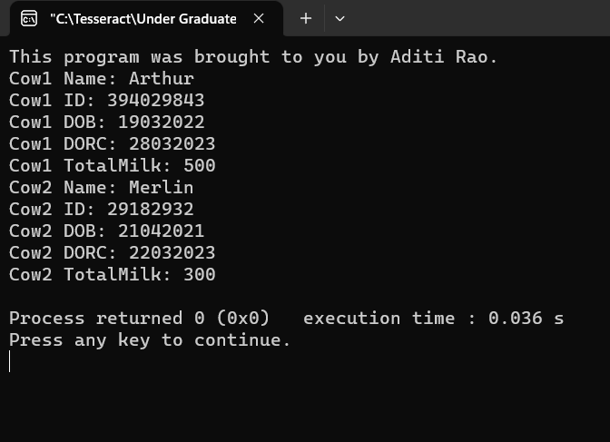
Program 2
PROBLEM STATEMENT: | Define a class to represent a bank account. Include the following members:  Data members  - Name of the depositor  - Account number  - Type of account  - The balance amount in the account  Member function  - To assign initial value  - To deposit an amount  - To withdraw an amount after checking the balance  - To display name and balance  Write a main program to test the program.
ALGORITHM: | 1. Create a class called Account to represent a bank account.  2. Declare private member variables: DepositorName, AccountNumber, AccountType, and Balance to store account details.  3. Define setter methods (setDepositorName(), setAccountNumber(), setAccountType(), setBalance()) to set account details.  4. Define getter methods (getDepositorName(), getAccountNumber(), getAccountType(), getBalance()) to retrieve account details.  5. Define member function Deposit() to allow the user to deposit an amount into the account.  6. Define member function Withdrawal() to allow the user to withdraw an amount from the account after checking the balance.  7. Define member function Display() to display the name and balance of the account.  8. In the main() function:  a. Display a menu with options for creating a new account, depositing money, withdrawing money, displaying balance, and exiting the program.  b. Read input from the user for the selected option using a switch statement.  c. Based on the selected option, perform the corresponding actions using member functions of the Account class.  d. Continue looping until the user selects to exit the program.  9. End the program.
PROGRAM: | #include <iostream>  #include <string>  using namespace std;  class Account  {  private:  string DepositorName, AccountNumber, AccountType;  float Balance;  public:  // Setter methods  void setDepositorName(string name)  {  DepositorName = name;  }  void setAccountNumber(string acc_no)  {  AccountNumber = acc_no;  }  void setAccountType(string acc_type)  {  AccountType = acc_type;  }  void setBalance(float bal)  {  Balance = bal;  }  //getter methods  string getDepositorName()  {  return DepositorName;  }  string getAccountNumber()  {  return AccountNumber;  }  string getAccountType()  {  return AccountType;  }  float getBalance()  {  return Balance;  }  // Member function to deposit an amount  void Deposit()  {  float deposit;  cout << "\nKindly enter the amount to be deposited: " << endl;  cin >> deposit;  Balance += deposit;  }  // Member function to withdraw an amount after checking the balance  void Withdrawal()  {  float withdrawal;  cout << "\nKindly Enter amount to be withdrawn: " << endl;  cin >> withdrawal;  if (Balance > withdrawal)  Balance -= withdrawal;  else  cout << "\nInsufficient Funds. " << endl;  }  // Member function to display name and balance  void Display()  {  cout << "Name of the depositor: " << DepositorName << endl;  cout << "Balance: " << Balance << endl;  }  };  int main()  {  cout << "Good Morning!\nTo create a new account, press 1. \nTo deposit money in your existing bank account, press 2. \nTo withdraw money from your bank account press 3. \nTo display your balance, press 4. \nTo exit the program, press 5." << endl;  cout << endl;  Account account1;  string name, acc_no, acc_type;  float bal;  bool isAccountCreated = false;  int sw_var;  cin >> sw_var;  do  {  switch (sw_var)  {  case 1:  if (isAccountCreated)  cout << "\nBank Account has already been created." << endl;  else  {  cout << "\nEnter Depositor Name: ";  cin.ignore();  getline(cin, name);  cout << "Enter Account Number: ";  cin >> acc_no;  cout << "Enter Account Type: ";  cin.ignore();  getline(cin, acc_type);  cout << "Enter Initial Balance: ";  cin >> bal;  account1.setDepositorName(name);  account1.setAccountNumber(acc_no);  account1.setAccountType(acc_type);  account1.setBalance(bal);  isAccountCreated = true;  }  cout << "Press 0 to exit the loop.\n " << endl;  cin >> sw_var;  break;  case 2:  if (isAccountCreated)  account1.Deposit();  else  cout << "\nThis Bank Account has not been created yet." << endl;  cout << "Press 0 to exit the loop.\n " << endl;  cin >> sw_var;  break;  case 3:  if (isAccountCreated)  account1.Withdrawal();  else  cout << "\nThis Bank Account has not been created yet." << endl;  cout << "Press 0 to exit the loop.\n " << endl;  cin >> sw_var;  break;  case 4:  if (isAccountCreated)  account1.Display();  else  cout << "\nThis Bank Account has not been created yet." << endl;  cout << "Press 0 to exit the loop.\n " << endl;  cin >> sw_var;  break;  default:  cout << "Incorrect Input." << endl;  cout << "Please, try again.\n " << endl;  cin >> sw_var;  }  }  while (sw_var != 0);  return 0;  }
RESULT: | 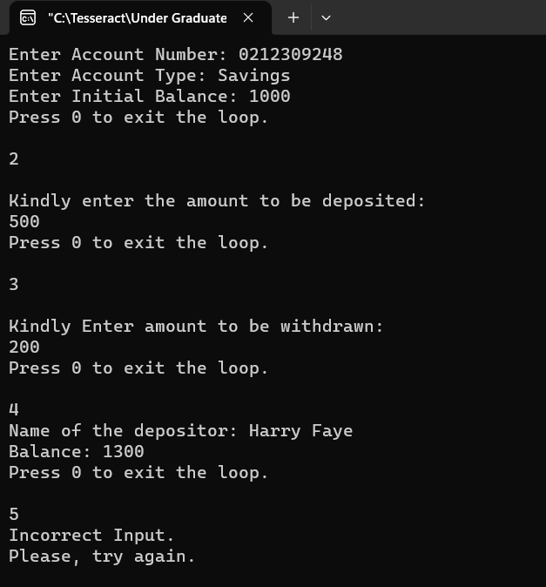
Program 3
PROBLEM STATEMENT: | Create a program using class to process Shopping List for a departmental store.  The list should include details like Code No, Name, and Price for each item. The actions performed on the list should be able to display the name and price for entered code number (Code No ) of the item. There should also be a provision to add a new item as initially, the list is empty and then to delete an existing item. Also, all the items need to be shown with CodeNo, Name, and Price, and then a total of all the prices.
ALGORITHM: | Define classes Item and ShoppingList with appropriate member functions and data members.  Create an instance of ShoppingList class in the main() function.  Display a menu to the user with options to add an item, remove an item, display items, calculate total price, or exit.  Use a loop to repeatedly prompt the user for their choice and process it until the user chooses to exit.  For each option, call the corresponding member function of the ShoppingList class.  In the addItem() member function, check if the item with the given code already exists in the shopping list. If not, add the item to the list.  In the removeItem() member function, find the index of the item with the given code in the shopping list. If found, remove the item from the list by shifting the remaining items.  In the displayItems() member function, iterate through the list and display the code, name, and price of each item.  In the calculateTotalPrice() member function, iterate through the list and sum up the prices of all items.  Return the total price or appropriate messages based on the user's choice.  Handle invalid user inputs and display appropriate error messages.  Exit the program when the user chooses to exit.
PROGRAM: | #include <iostream>  #include <string>  using namespace std;  const int MAX_ITEMS = 100;  class Item  {  private:  int code;  string name;  double price;  public:  Item() : code(0), name(""), price(0.0) {} //Default Constructor  Item(int c, const string& n, double p) : code(c), name(n), price(p) {} //Parameterized Constructor  int getCode() const { return code; }  const string& getName() const { return name; }  double getPrice() const { return price; }  };  class ShoppingList  {  private:  Item items[MAX_ITEMS];  int itemCount;  public:  ShoppingList() : itemCount(0) {}  void addItem(int code, const string& name, double price)  {  for (int i = 0; i < itemCount; i++)  {  if (items[i].getCode() == code)  {  cout << "Item with code " << code << " already exists in the shopping list." << endl;  return;  }  }  if (itemCount < MAX_ITEMS)  {  items[itemCount++] = Item(code, name, price);  cout << "Item added: " << name << " (Code: " << code << ", Price: " << price << ")" << endl;  }  else  {  cout << "Cannot add item. Shopping list is full." << endl;  }  }  void removeItem(int code)  {  int index = -1;  for (int i = 0; i < itemCount; i++)  {  if (items[i].getCode() == code)  {  index = i;  break;  }  }  if (index != -1)  {  cout << "Item removed: " << items[index].getName() << " (Code: " << items[index].getCode() << ", Price: " << items[index].getPrice() << ")" << endl;  if (index < itemCount - 1)  {  for (int i = index; i < itemCount - 1; i++)  {  items[i] = items[i + 1];  }  }  itemCount--;  }  else  {  cout << "Item with code " << code << " not found." << endl;  }  }  void displayItems() const  {  cout << "Items in the shopping list:" << endl;  for (int i = 0; i < itemCount; i++)  {  cout << "Code: " << items[i].getCode() << ", Name: " << items[i].getName() << ", Price: " << items[i].getPrice() << endl;  }  }  double calculateTotalPrice() const  {  double total = 0.0;  for (int i = 0; i < itemCount; i++)  {  total += items[i].getPrice();  }  return total;  }  };  int main()  {  cout << "This code was brought to you by Aditi Rao." << endl;  ShoppingList shop;  int choice, code;  string name;  double price;  while (true)  {  cout << "\n\n1. Add Item\n2. Remove Item\n3. Display Items\n4. Calculate Total Price\n5. Exit\n" << endl;  cout << "Enter your choice: ";  cin >> choice;  switch (choice)  {  case 1:  cout << "Enter item code: ";  cin >> code;  cout << "Enter item name: ";  cin.ignore();  getline(cin, name);  cout << "Enter item price: ";  cin >> price;  shop.addItem(code, name, price);  break;  case 2:  cout << "Enter item code to remove: ";  cin >> code;  shop.removeItem(code);  break;  case 3:  shop.displayItems();  break;  case 4:  cout << "Total price: " << shop.calculateTotalPrice() << endl;  break;  case 5:  cout << "Exiting..." << endl;  return 0;  default:  cout << "Invalid choice. Please enter a valid choice." << endl;  }  }  return 0;  }
RESULT: | 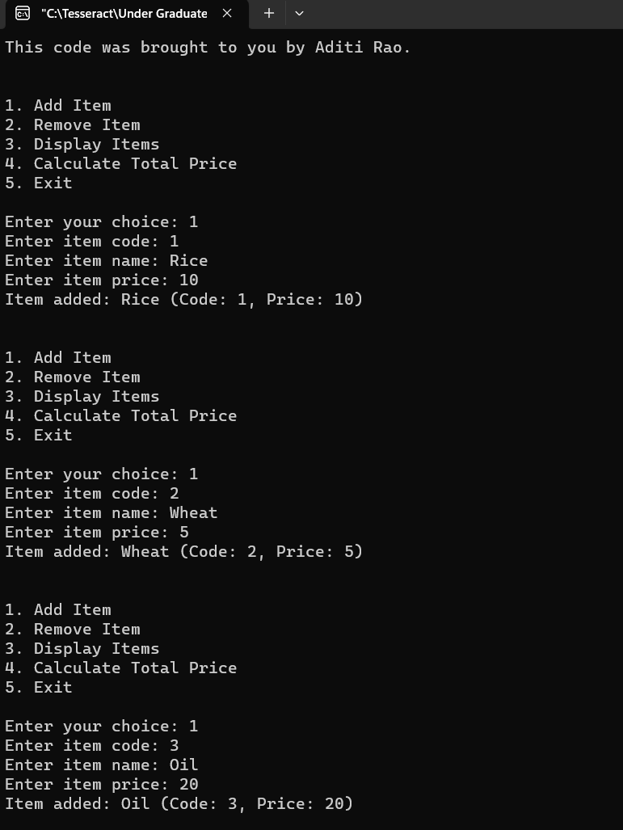  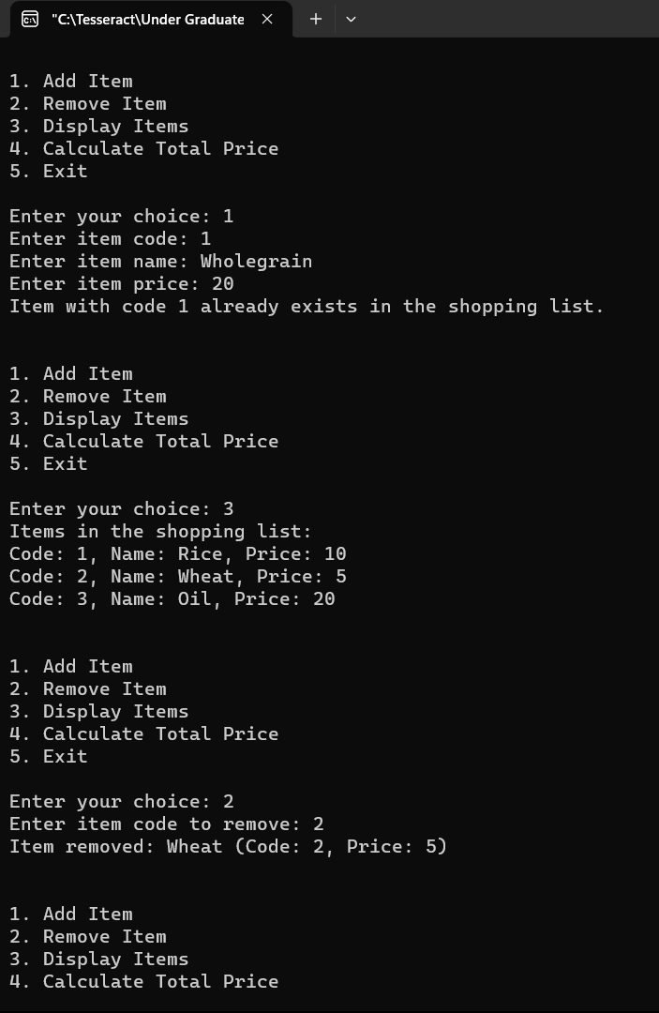
 | 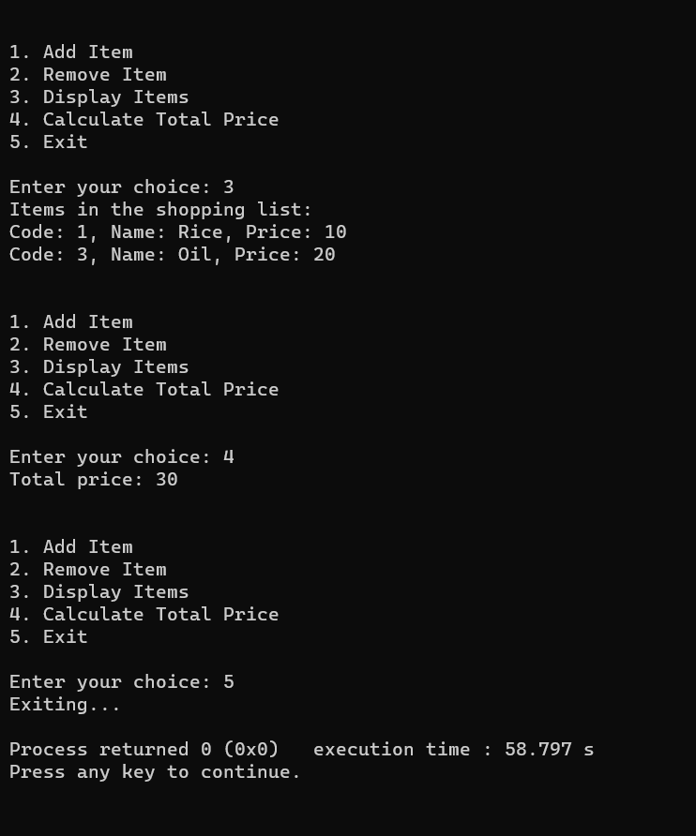
CONCLUSION: | In conclusion, the program effectively demonstrates the fundamental concept of encapsulation in object-oriented programming, utilizing C++ classes and objects. Through the use of constructors, including both default and parameterized options, the programs properly initialize the state of objects during their creation. Additionally, getter and setter methods are employed to ensure controlled access to private data members, thereby achieving encapsulation and data hiding. The programs also showcase practical utilization of arrays of objects and member functions for performing various operations, such as managing a shopping list. Overall, the programs serve as a clear example of how proper class design, encapsulation of data and behavior within objects, and the use of getter and setter methods can successfully achieve encapsulation in an object-oriented programming paradigm.

