Name | ADITI RAO
UID no. | 202220003
Experiment No. | 2

AIM: | Program on Encapsulation: Write a program to demonstrate constructor
Program 1
PROBLEM STATEMENT: | Create a class 'Employee' with three data members which are name, age and Salary. The constructor of the class assigns default values name as "unknown", age as '18' and salary as 20000. Write the setter and getter methods for class Employee. Write another method which prints the name, age and Salary of 10 employees sorted according to their age.
ALGORITHM: | START  // Define the Employee class  CLASS Employee  PRIVATE  name, age, salary  PUBLIC  // Member functions  CONSTRUCTOR default  CONSTRUCTOR parameterized  SETTERS for name, age, and salary  GETTERS for name, age, and salary  FUNCTION printDetails  // Implement the Sort function  FUNCTION Sort(array, size)  For i = 0 to size-1  For j = 0 to size-i-1  If array[j].age > array[j+1].age THEN  Swap array[j] with array[j+1]  END if  END for  END for  RETURN array  // Create the employees array and set the details  CREATE employees array with size 10  employees[0] = Employee(parameterized) // Set the details for the first employee  employees[1] = Employee(parameterized) // Set the details for the second employee  for i = 2 to 9  // Take input from the user and set the details for the remaining employees  employees[i].SETTER for name  employees[i].SETTER for age  employees[i].SETTER for salary  END for  // Sort the employees by age  employees = Sort(employees, 10)  // Print the details of the sorted employees  for i = 0 to 9  employees[i].printDetails()  END for
PROGRAM: | #include <iostream>  #include <string>  #include <algorithm> // for std::sort  using namespace std;  class Employee  {  private:  string name;  int age;  double salary;  public:  //Default Constructor with name ‘unknown’, age 18, default salary 20000  Employee()  {  name = "unknown";  age = 18;  salary = 20000;  }  // Parameterized constructor to pass values to private data members  Employee(string n, int a, double s)  {  name = n;  age = a;  salary = s;  }  // Setter methods  void setName(string n)  {  name = n;  }  void setAge(int a)  {  age = a;  }  void setSalary(double s)  {  salary = s;  }  // Getter methods  string getName()  {  return name;  }  int getAge()  {  return age;  }  double getSalary()  {  return salary;  }  // Method to print Employee details  void printDetails()  {  cout << "Name: " << name << ", Age: " << age << ", Salary: $" << salary << endl;  }  };  void Sort(Employee arr[], int size)  {  for (int i = 0; i < size - 1; i++)  {  for (int j = 0; j < size - i - 1; j++)  {  if (arr[j].getAge() > arr[j + 1].getAge())  {  Employee temp = arr[j];  arr[j] = arr[j + 1];  arr[j + 1] = temp;  }  }  }  }  int main()  {  Employee employees[10];  //Using the Setter Method  employees[0].setName("Adonis");  employees[0].setAge(30);  employees[0].setSalary(50000);  //Using the Parameterized Constructor method  employees[1] = Employee("Venus", 25, 90000);  for (int i = 2; i < 10; i++)  {  cout << "Enter details for Employee " << i + 1 << ":" << endl;  cout << "Name: ";  cin.ignore();  string name;  getline(cin, name);  employees[i].setName(name);  cout << "Age: ";  int age;  cin >> age;  employees[i].setAge(age);  cout << "Salary: ";  double salary;  cin >> salary;  employees[i].setSalary(salary);  }  //Sorting the employees by age by bubble sort technique.  Sort(employees, 10);  // Print details of 10 employees sorted by age  cout << "Employees sorted by age:" << endl;  for (int i = 0; i < 10; i++)  {  employees[i].printDetails();  }  return 0;  }
RESULT: | Input: 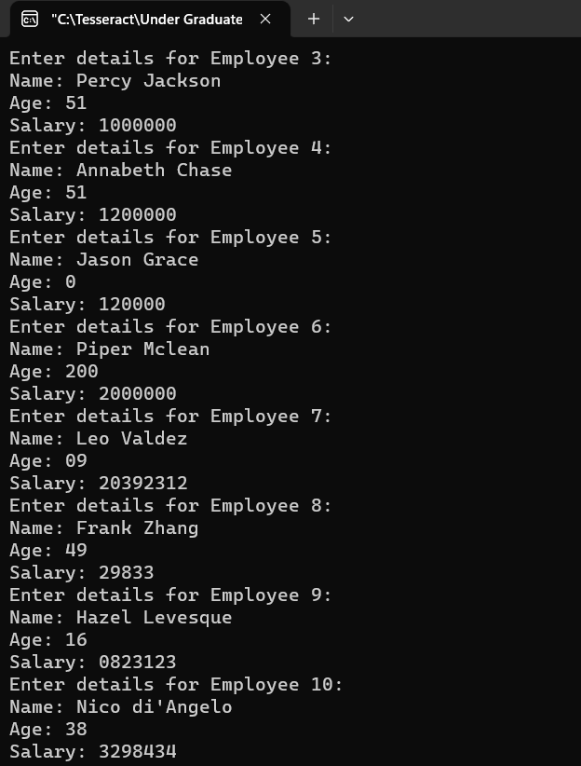  Output:  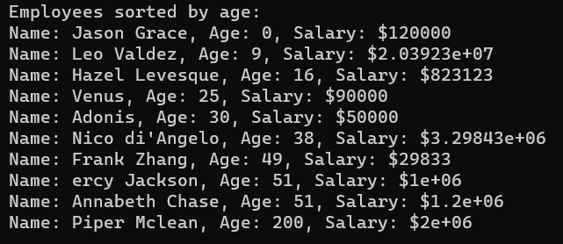
Program 2
PROBLEM STATEMENT: | Define a class to represent a bank account. Include the following members:  Data members  - Name of the depositor  - Account number  - Type of account  - The balance amount in the account  Member functions  - To assign initial value  - To deposit an amount  - To withdraw an amount after checking the balance  - To display name and balance  Write a main program to test the program.
ALGORITHM: | CLASS Account  PRIVATE:  STRING name  STRING acc_no  STRING acc_type  FLOAT bal  PUBLIC:  // parameterized constructor  Account(name, acc_no, acc_type, bal)  this.name = name  this.acc_no = acc_no  this.acc_type = acc_type  this.bal = bal  //deposit method  VOID Deposit()  SET amount  OUTPUT "Enter amount to be deposited: "  INPUT amount  bal += amount  OUTPUT "Amount deposited successfully."  // withdrawal method  VOID Withdrawal()  SET amount  OUTPUT "Enter amount to be withdrawn: "  INPUT amount  IF (amount > bal)  OUTPUT "Insufficient balance in the account."  ELSE  bal -= amount  OUTPUT "Amount withdrawn successfully."  ENDIF  //display method  VOID Display()  OUTPUT "Depositor Name: " + name  OUTPUT "Account Number: " + acc_no  OUTPUT "Account Type: " + acc_type  OUTPUT "Available Balance: " + bal  ENDCLASS  FUNCTION main()  OUTPUT "Good Morning!\nTo create a new account, press 1. \nTo deposit money in your existing bank account, press 2. \nTo withdraw money from your bank account press 3. \nTo display your balance, press 4. \nTo exit the program, press 5."  OUTPUT ""  SET account1 = Account("", "", "", 0.0)  SET isAccountCreated = false  SET sw_var  INPUT sw_var  DO  SWITCH sw_var  CASE 1:  IF (isAccountCreated)  OUTPUT "Bank Account has already been created."  ELSE  SET name, acc_no, acc_type, bal  OUTPUT "Enter Depositor Name: "  INPUT name  OUTPUT "Enter Account Number: "  INPUT acc_no  OUTPUT "Enter Account Type: "  INPUT acc_type  OUTPUT "Enter Initial Balance: "  INPUT bal  SET account1 = Account(name, acc_no, acc_type, bal)  SET isAccountCreated = true  ENDIF  OUTPUT "Press 0 to exit the loop.\n "  INPUT sw_var  BREAK  CASE 2:  IF (isAccountCreated)  CALL account1.Deposit()  ELSE  OUTPUT "This Bank Account has not been created yet."  ENDIF  OUTPUT "Press 0 to exit the loop.\n "  INPUT sw_var  BREAK  CASE 3:  IF (isAccountCreated)  CALL account1.Withdrawal()  ELSE  OUTPUT "This Bank Account has not been created yet."  ENDIF  OUTPUT "Press 0 to exit the loop.\n "  INPUT sw_var  BREAK  CASE 4:  IF (isAccountCreated)  CALL account1.Display()  ELSE  OUTPUT "This Bank Account has not been created yet."  ENDIF  OUTPUT "Press 0 to exit the loop.\n "  INPUT sw_var  BREAK  DEFAULT:  OUTPUT "Incorrect Input."  OUTPUT "Please, try again.\n "  INPUT sw_var  ENDSWITCH  WHILE sw_var != 0  RETURN 0  ENDFUNCTION
PROGRAM: | #include <iostream>  #include <string>  using namespace std;  class Account  {  private:  string DepositorName, AccountNumber, AccountType;  float Balance;  public:  // Parameterized constructor  Account(string name, string acc_no, string acc_type, float bal)  {  DepositorName = name;  AccountNumber = acc_no;  AccountType = acc_type;  Balance = bal;  }  // Function to deposit an amount  void Deposit()  {  float deposit;  cout << "\nKindly enter the amount to be deposited: " << endl;  cin >> deposit;  Balance += deposit;  }  // Function to withdraw an amount after checking the balance  void Withdrawal()  {  float withdrawal;  cout << "\nKindly Enter amount to be withdrawn: " << endl;  cin >> withdrawal;  if (Balance > withdrawal)  Balance -= withdrawal;  else  cout << "\nInsufficient Funds. " << endl;  }  // Function to display name and balance  void Display()  {  cout << "Name of the depositor: " << DepositorName << endl;  cout << "Balance: " << Balance << endl;  }  };  int main()  {  cout << "Good Morning!\nTo create a new account, press 1. \nTo deposit money in your existing bank account, press 2. \nTo withdraw money from your bank account press 3. \nTo display your balance, press 4. \nTo exit the program, press 5." << endl;  cout << endl;  Account account1("", "", "", 0.0);  bool isAccountCreated = false;  int sw_var;  cin >> sw_var;  do  {  switch (sw_var)  {  case 1:  if (isAccountCreated)  cout << "\nBank Account has already been created." << endl;  else  {  {  string name, acc_no, acc_type;  float bal;  cout << "\nEnter Depositor Name: ";  cin.ignore();  getline(cin, name);  cout << "Enter Account Number: ";  cin >> acc_no;  cout << "Enter Account Type: ";  cin.ignore();  getline(cin, acc_type);  cout << "Enter Initial Balance: ";  cin >> bal;  account1 = Account(name, acc_no, acc_type, bal);  isAccountCreated = true;  }  }  cout << "Press 0 to exit the loop.\n "  << endl;  cin >> sw_var;  break;  case 2:  if (isAccountCreated)  account1.Deposit();  else  cout << "\nThis Bank Account has not been created yet." << endl;  cout << "Press 0 to exit the loop.\n "  << endl;  cin >> sw_var;  break;  case 3:  if (isAccountCreated)  account1.Withdrawal();  else  cout << "\nThis Bank Account has not been created yet." << endl;  cout << "Press 0 to exit the loop.\n "  << endl;  cin >> sw_var;  break;  case 4:  if (isAccountCreated)  account1.Display();  else  cout << "\nThis Bank Account has not been created yet." << endl;  cout << "Press 0 to exit the loop.\n "  << endl;  cin >> sw_var;  break;  default:  cout << "Incorrect Input." << endl;  cout << "Please, try again.\n " << endl;  cin >> sw_var;  }  }  while (sw_var != 0);  return 0;  }
RESULT: | 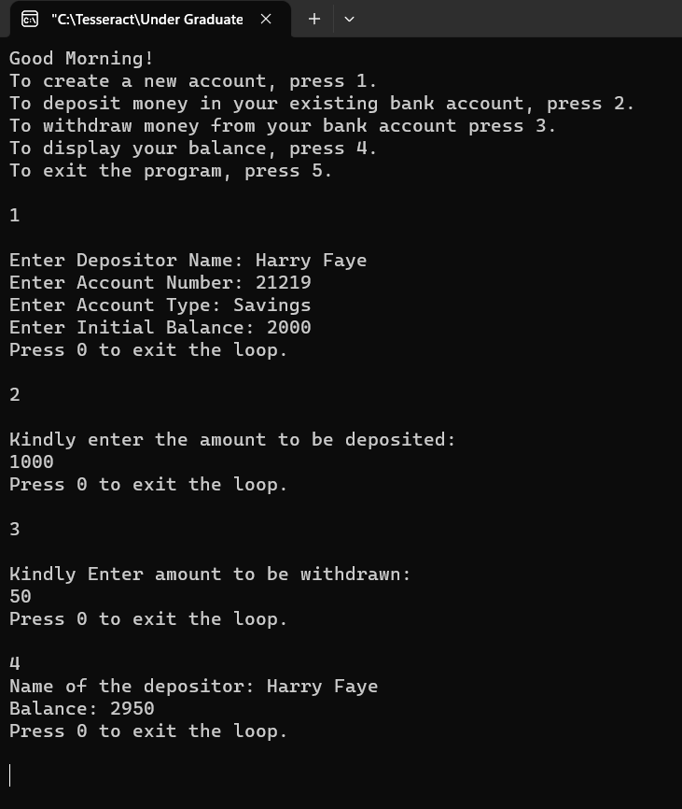
Program 3
PROBLEM STATEMENT: | Write a Program to generate Fibonacci Series by using Constructor to initialize the Data Members.
ALGORITHM: | CLASS FibonacciSeries  PRIVATE:  INT num1, num2, num3, n  public:  CONSTRUCTOR FibonacciSeries(INT count)  num1 = 0;  num2 = 1;  num3 = 0;  n = count;  END CONSTRUCTOR  VOID MakeFibonacci()  FOR i = 0, WHEN i < n,  PRINT num1;  num3 = num1 + num2;  num1 = num2;  num2 = num3;  END FUNCTION  ENDCLASS  VOID main()  INPUT count;  CREATE OBJECT fib of CLASS FibonacciSeries;  PASS count to the object as PARAMETER;  ENDFUNCTION
PROGRAM: | #include <iostream>  using namespace std;  class FibonacciSeries  {  private:  int num1, num2, num3, n;  public:  // Parameterized constructor  FibonacciSeries(int count)  {  num1 = 0;  num2 = 1;  num3 = 0;  n = count;  }  // Function to generate and display Fibonacci series  void MakeFibonacci()  {  cout << "Fibonacci series: ";  for (int i = 0; i < n; i++)  {  cout << num1 << " ";  num3 = num1 + num2;  num1 = num2;  num2 = num3;  }  cout << endl;  }  };  int main()  {  int count;  cout << "Enter the number of terms in Fibonacci series: ";  cin >> count;  FibonacciSeries fib(count);  fib.MakeFibonacci();  return 0;  }
RESULT: | 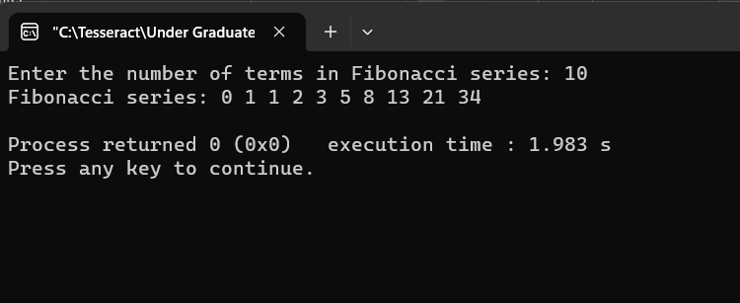
CONCLUSION: | In conclusion, the program effectively demonstrates the fundamental concept of encapsulation in object-oriented programming, utilizing C++ classes and objects. Through the use of constructors, including both default and parameterized options, the programs properly initialize the state of objects during their creation. Additionally, getter and setter methods are employed to ensure controlled access to private data members, thereby achieving encapsulation and data hiding. The programs also showcase practical utilization of arrays of objects and member functions for performing various operations, such as managing a shopping list. Overall, the programs serve as a clear example of how proper class design, encapsulation of data and behavior within objects, and the use of getter and setter methods can successfully achieve encapsulation in an object-oriented programming paradigm.

