Luma Green investor walkthrough
Investor demonstration · 10 October 2026

01 The material journey
Role Visitor
Follow material collection, business planning, trade and evidence in one platform.
1. Open https://lumagreen.vercel.app and confirm the demonstration environment.
2. Open Participants or How it works to see the material chain.
3. Open Prices and read the sample-data or unavailable notice.
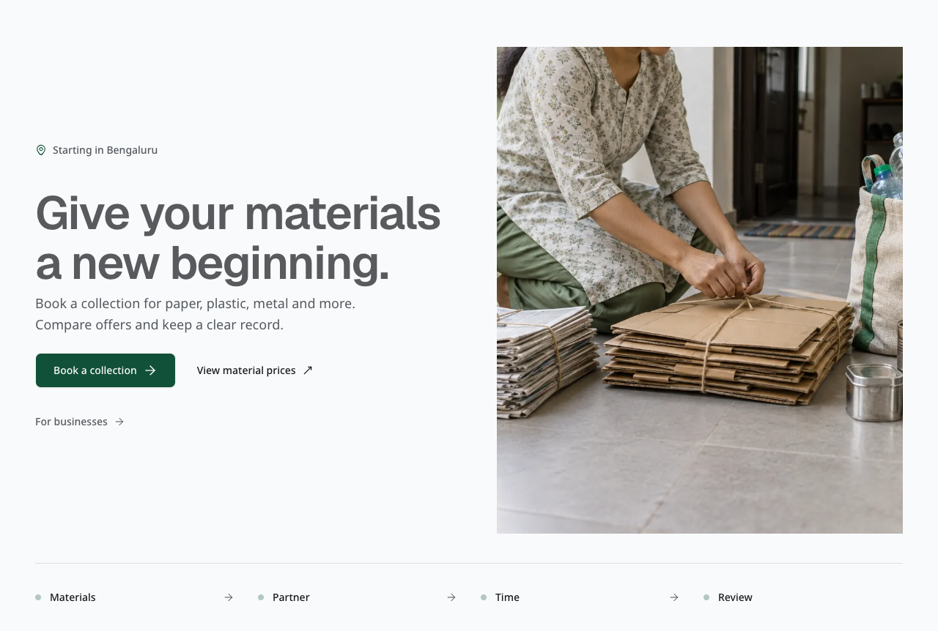
Actual development demo: the material journey. Imported samples; not real payment or certification.
Check Households, shops, preprocessors, recyclers, manufacturers and Saathis have distinct work.
Limit All investor records are imported samples. They do not prove customer activity, revenue or material recovery.

02 Sign in and select a workspace
Role Assigned demonstration user
Use the restricted credentials document for the selected environment.
1. Choose Email on Sign in and use the assigned account. Keep credentials off screen.
2. Open Workspaces and team; confirm the business name and your role.
3. Open Account security and Notifications, then return to the workspace.
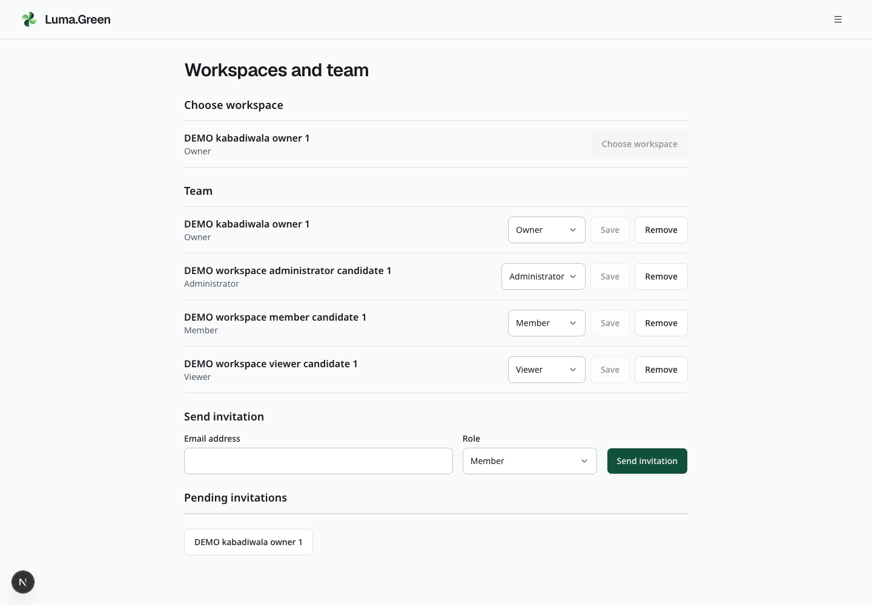
Actual development demo: sign in and select a workspace. Imported samples; not real payment or certification.
Check The correct identity and business are visible before any action. Compare Viewer access in a separate browser profile.
Limit There are 28 persona templates with five users each: 140 accounts per environment. No platform admin is included. Account creation and access must be verified after seeding.

03 Collect household material
Role Household then kabadiwala
Read sample collection requests from the shop workspace.
1. Sign in as the assigned kabadiwala and open Requests.
2. Compare the requested, accepted and completed sample collections.
3. Open a completed record and read its recorded weight and receipt.
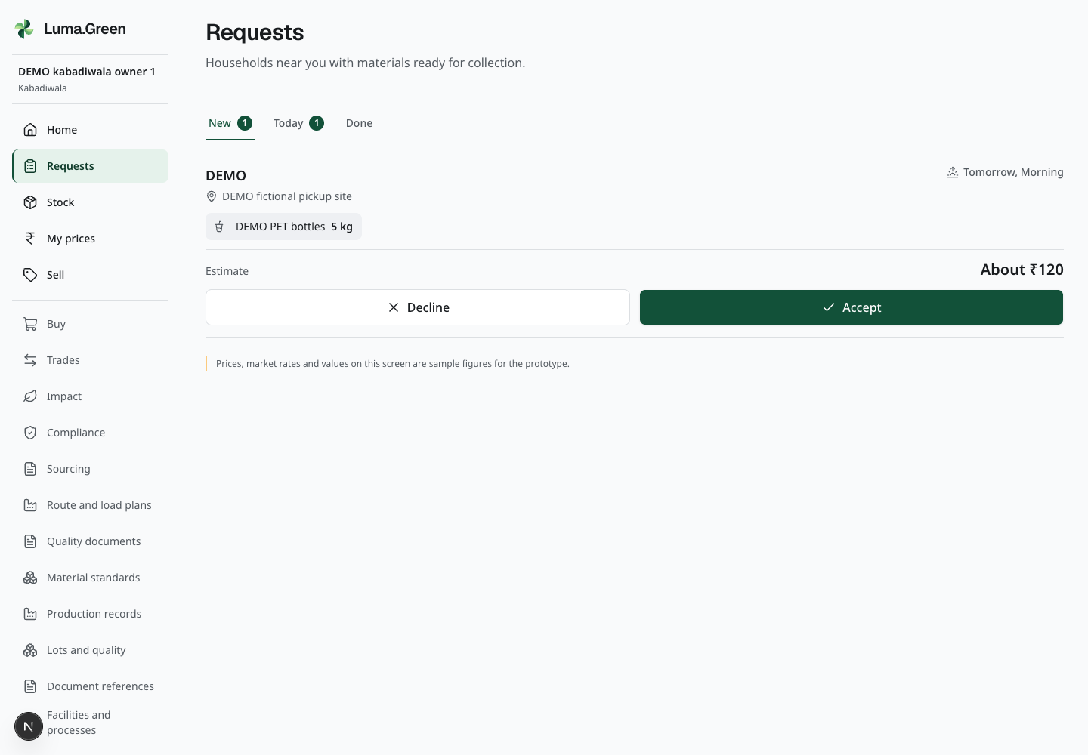
Actual development demo: collect household material. Imported samples; not real payment or certification.
Check The shop can inspect the imported collection stages. Household collection access still requires its phone verification step.
Limit The kabadiwala pays the household directly. These imported examples do not prove a real payment. No SMS-verified phone is supplied by this demo.

04 Record stock and byproducts
Role Manufacturer
A manufacturer can record its own material and offer an eligible byproduct.
1. Open Stock and inspect the sample intake history.
2. Open Record stock intake to see grams, production and weighing references; cancel without saving.
3. Open Sell and read the material, grade and written specification.
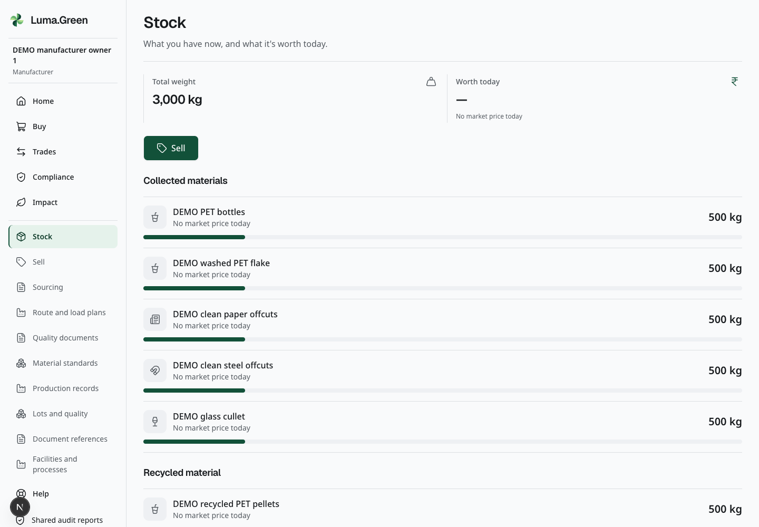
Actual development demo: record stock and byproducts. Imported samples; not real payment or certification.
Check Inventory, an intake declaration and a sale offer have different purposes.
Limit A real intake adds inventory. Do not resubmit an imported sample. Only approved, eligible material can use the ordinary trade route.

05 Match buyers and sellers
Role Approved seller then buyer
Read an offer and the matching trade records from both sides.
1. Open Buy and inspect an offer for material the buyer handles.
2. Open the prepared order in Trades, then switch to its seller.
3. Read the order quantity, price and current payment state.
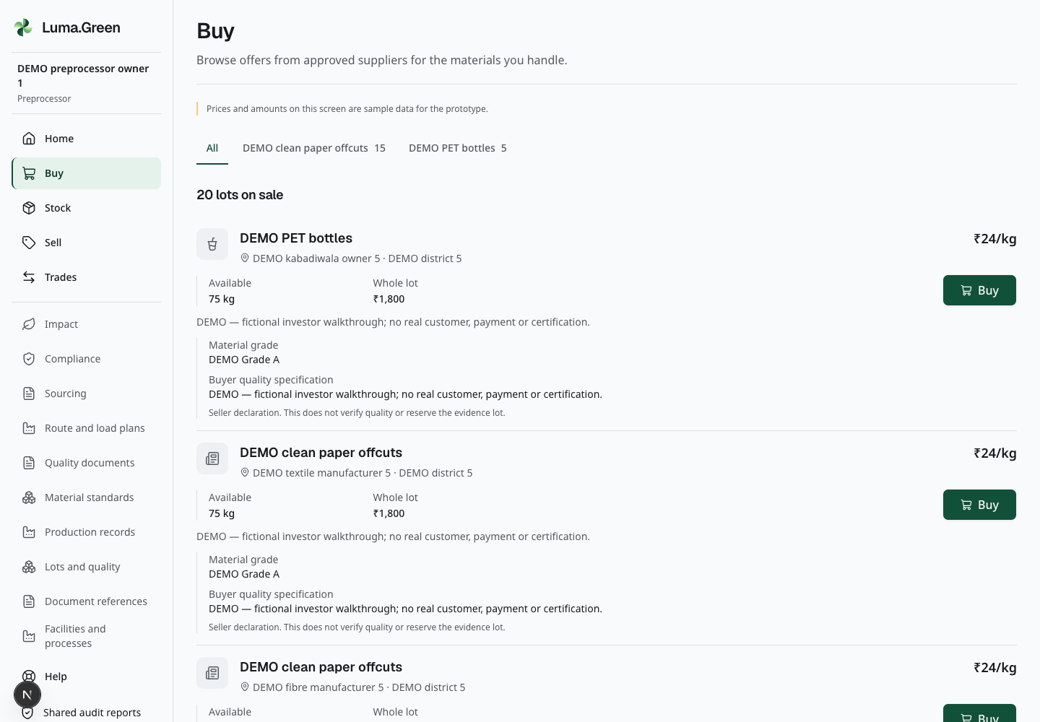
Actual development demo: match buyers and sellers. Imported samples; not real payment or certification.
Check The buyer and seller see consistent grams, paise and order status.
Limit Only the gateway can establish B2B payment. Imported records are not proof of collection, settlement or delivery. Do not mark an order paid outside the gateway.

06 Follow lots and quality
Role Preprocessor then recycler
A lot retains material history and quality evidence.
1. Open Lots and quality, then select the sample washed PET flake lot.
2. Read its transformation: all input grams equal output, contamination and process-loss grams.
3. Read its inspection. The sample has no custody hand-off history; a correction form is available for later controlled testing.
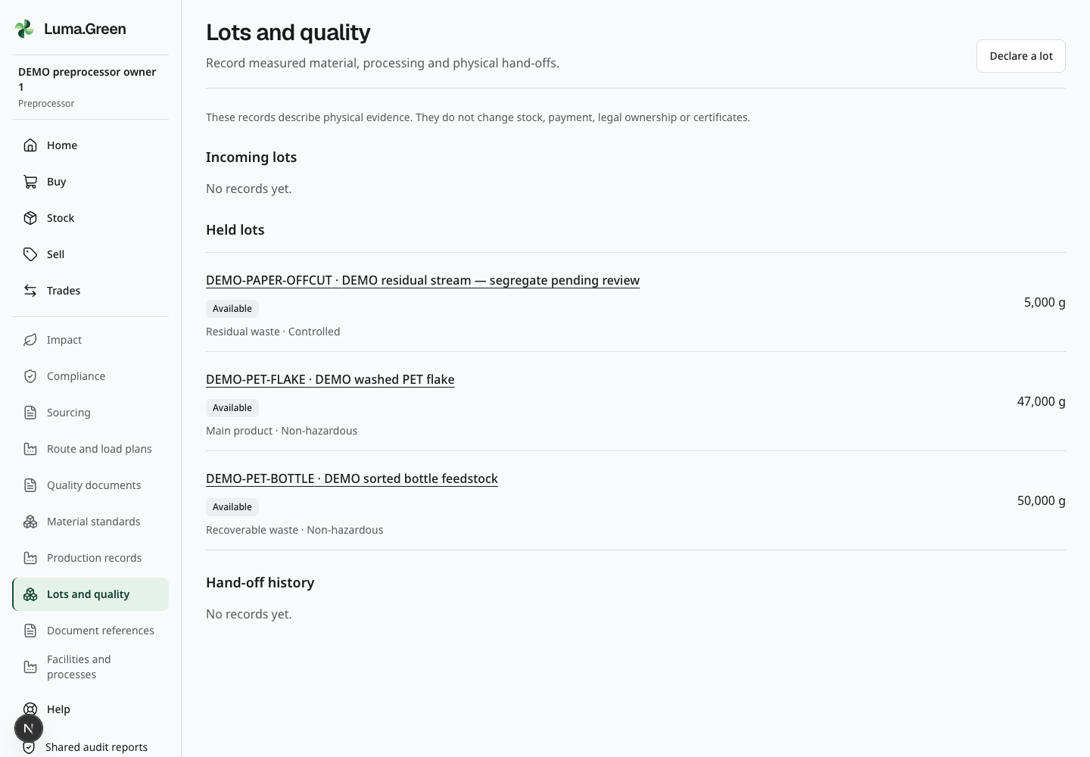
Actual development demo: follow lots and quality. Imported samples; not real payment or certification.
Check The imported input, output and inspection show how a process record links material. A real correction preserves its original.
Limit Evidence lots do not independently credit sale inventory or issue carbon or EPR certificates. Another organisation cannot see private process recipes merely by receiving material.

07 Review facilities and handling
Role Business owner
Read declared processes and workbook-derived industry examples.
1. Open Facilities and processes and inspect a sample site.
2. Read the declared processes and linked sector reference.
3. Open Industry references to compare sector, material and byproduct examples.
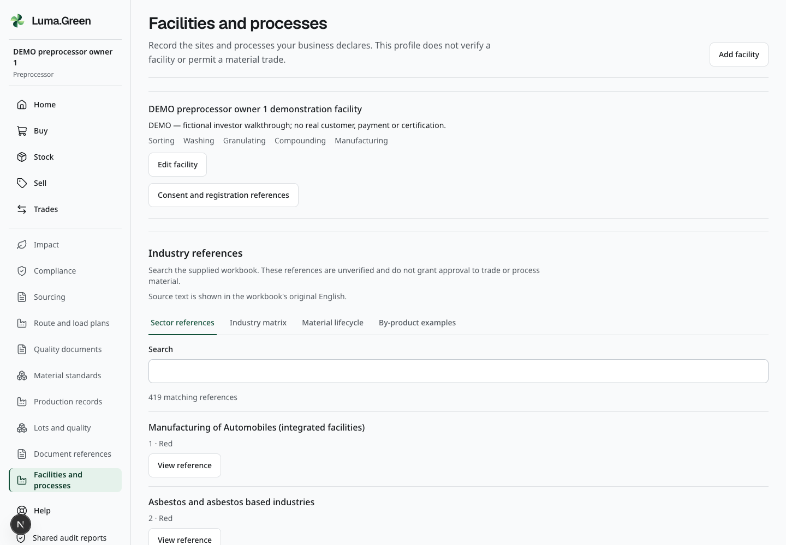
Actual development demo: review facilities and handling. Imported samples; not real payment or certification.
Check The facility record and source examples can be read without treating the workbook as approval.
Limit Consent, registration and residual-disposition evidence are not seeded. Workbook categories do not certify a facility. Real controlled or residual material needs its restricted handling route.

08 Plan supply
Role Business buyer then supplier
Sourcing records prepare a supply relationship before a trade.
1. Open Sourcing and read the Demand board and Recurring demand.
2. Open Supplier decisions to see the buyer’s private qualification record.
3. Open a Standing agreement and its acknowledgement and release history.
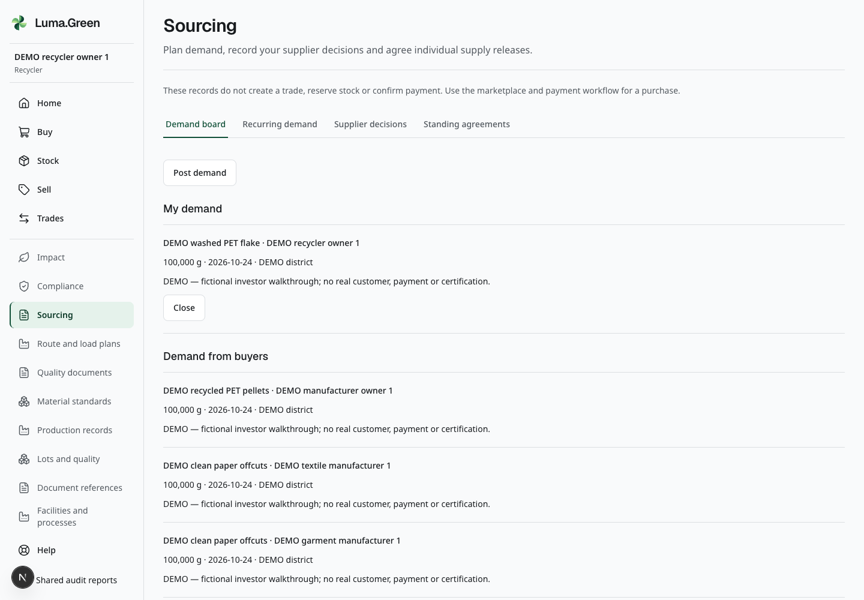
Actual development demo: plan supply. Imported samples; not real payment or certification.
Check The parties can record planned demand and agreed supply steps.
Limit Publishing demand and acknowledging an agreement do not create a trade, reserve stock or confirm payment. Recurring demand still needs an explicit publish action.

09 Read production declarations
Role Recycler or manufacturer
Connect a recipe version to recorded production and inspection.
1. Open the material definition used by the example.
2. Open Production and read the recipe version and proportions.
3. Open a sample batch and follow its transformation and inspection references.
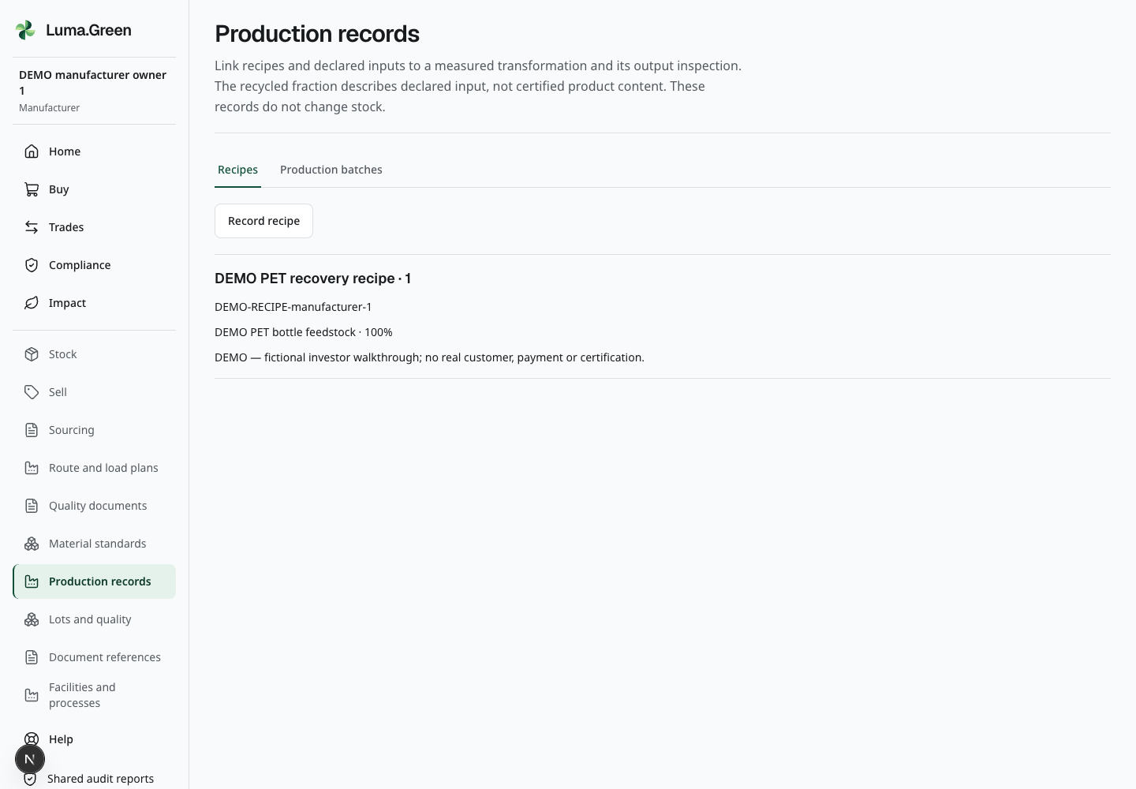
Actual development demo: read production declarations. Imported samples; not real payment or certification.
Check The batch keeps its historical recipe and evidence links.
Limit A declared recycled-input ratio is not a certified recycled-content claim. The sample is not a verified factory production event.

10 Plan loads and local work
Role Business operator then Saathi
Show practical work planning without implying live vehicle tracking.
1. Open Route and load plans, then Revision history for DEMO collection round.
2. Inspect entered stops, materials, grams and vehicle capacity.
3. Switch to Saathi and inspect the prepared local-work record.
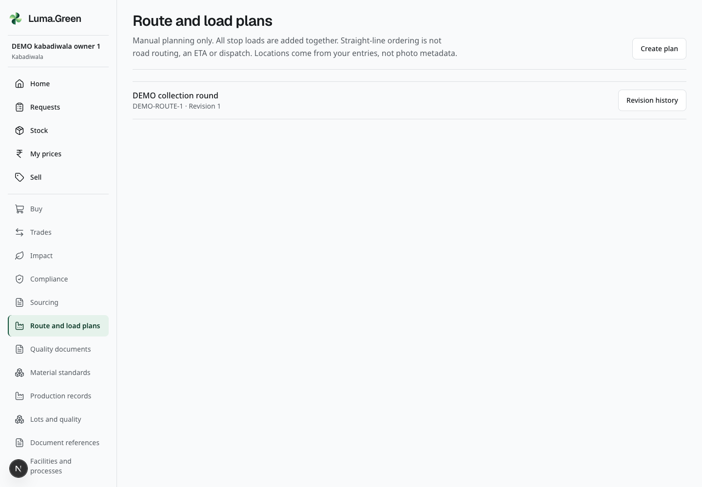
Actual development demo: plan loads and local work. Imported samples; not real payment or certification.
Check A route checks load capacity; the Saathi workspace records a separate work assignment.
Limit Distances are straight-line estimates from entered coordinates. There is no road navigation, GPS-photo tracking or automatic dispatch. Sample earnings do not prove a payout.

11 Share evidence with a recipient
Role Business owner then stakeholder
A report gives an approved recipient a defined view of evidence.
1. Open Quality documents and note the empty upload state; no attachments are included in this dataset.
2. Read the designated buyer’s separate decision.
3. Open Reports as owner, then inspect the assigned recipient’s granted report.
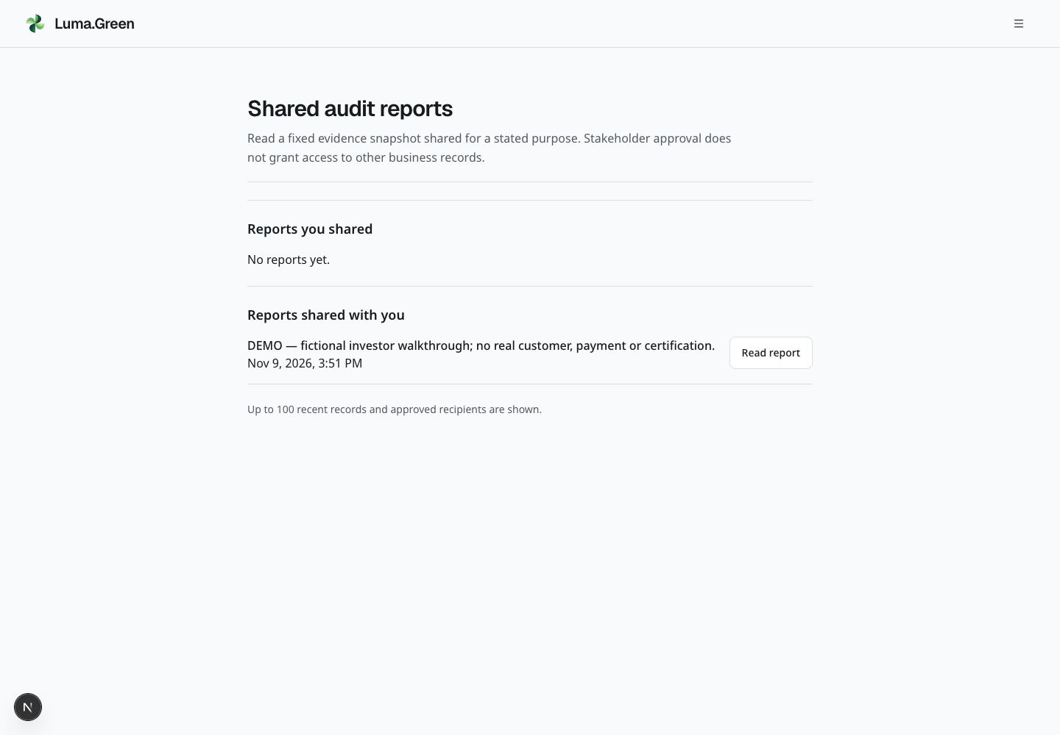
Actual development demo: share evidence with a recipient. Imported samples; not real payment or certification.
Check The recipient sees only the explicitly shared fixed report.
Limit Stakeholder approval grants no blanket business access. Expiry and revocation stop future downloads; downloaded copies cannot be recalled. File storage is not portal verification.

12 Explore team and platform controls
Role Workspace owner or viewer
Use the supporting controls and explain the unavailable administration boundary.
1. Compare owner and viewer controls in separate browser profiles.
2. Open Help, Notifications and Account security; show language and appearance. Notifications start empty, with device delivery off.
3. Open API access with any secret hidden, or show its honest unavailable state.
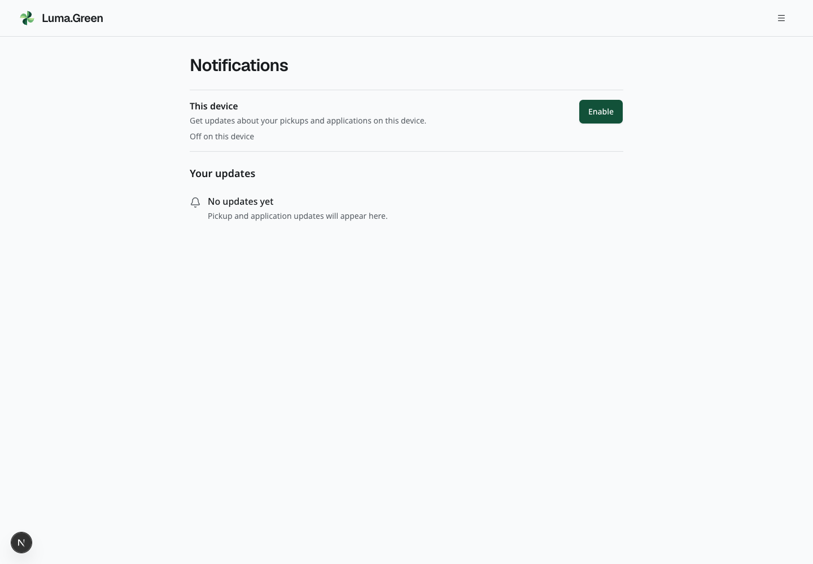
Actual development demo: explore team and platform controls. Imported samples; not real payment or certification.
Check Users can find support, account controls and scoped access tools.
Limit No platform admin account is supplied. Administrative reviews, prices and payment policy are owner setup topics, not an authenticated part of this demo. Native shells do not prove store approval or signed distribution.

13 Read the demonstration limits
Role Presenter
Keep the account roster and provider readiness separate from the product tour.
1. Use one browser profile per active identity; sign out before changing users in a profile.
2. Use the same cohort number, 1 to 5, for a linked story. Begin with kabadiwala, then preprocessor, recycler, manufacturer and auditor.
3. Use the separate production and development credentials documents. Development opens at http://localhost:3102 on this Mac and uses the cloud development database.
4. Record which pages were demonstrated and which were reference only.
Check Each result belongs to an environment and cohort. Other accounts cover households, applicants, Saathis, fibre/textile/garment makers, apartment communities, offices, hotels, resorts, other generators, city officials, CSR sponsors, lenders, unions, apparel/packaging brands, team roles, invitation recipients and an unrelated owner. Household coordinators have personal access only.
Limit No SMS verification or real gateway payment is claimed. Email delivery, provider onboarding, live activation, webhook acceptance and signed native releases need separate verification. Unknown prices or carbon factors remain unavailable.

14 Industry background
Role Presenter
Official industry examples inform the fictional scenarios; they are not Luma customers.
Check PET is the main narrative. Paper, metal and bulk-generator examples show where the same record types can help.
Limit No researched business is a Luma customer, partner, approved facility or demo account. No company identity, logo, contact or regulatory credential is copied into seed users.
Reliance polyesters — Polyester fibre and recycled PET material inform the bottle-to-textile example.
ITC circularity — Packaging, waste reduction and recycling inform the paper and packaging example.
Hindalco Novelis — Aluminium rolling and recycling inform a metal-material scenario.
Tata Steel circular economy — Scrap collection and shredding inform ferrous-material processing.
Saahas Zero Waste — Source segregation and materials recovery inform bulk-generator collection.
IHCL Paathya — Hospitality resource management informs a fictional hotel or resort generator.
Official sources checked 10 October 2026. Scenario mappings are interpretation, not evidence of affiliation.

