Luma Green
Cleaner Tomorrow in Motion.
Product review and team test pack — 2 October 2026
From a household pickup to a recorded material trade, the platform gives each person in the recycling chain a clear next action. The team has built the working software foundation. The next task is to prove it with controlled accounts, approved providers and a measured Bengaluru pilot.
This pack is for the founder, team and early investor conversations. It shows product scope and engineering work. It does not claim customers, revenue, transaction volume, market share, investment returns or regulatory approval. Demo quotes are labelled. The entity is not registered yet.

1 The product in one minute
Luma.Green connects households, kabadiwalas, sorting yards, recyclers, manufacturers and Saathis. An admin verifies applicants and manages prices and support. Each role gets a workspace for its part of the material journey.
The first loop is simple: select scrap, compare available shop offers, book a pickup, record the actual weight, record cash or UPI payment, and keep the receipt. The second loop moves available material from shop to yard, recycler and manufacturer. Stock reservations and audit records connect these actions.
The proposed long-term value is continuity: fewer disconnected records between people who handle the same material. Whether that saves time and improves recovery must be measured in the pilot. Carbon credit issuance and retirement remain future work, not a current certificate or revenue stream.

2 What the team has built
Area | Current scope | Evidence boundary
Recovery | Material basket, offers, pickup/drop-off, tracking, weighing and receipts | Complete live flow needs controlled accounts, configured backend and SMS
Trade | Role-based market, listings, reservations, trades, stock and receipts | Escrow is simulated; no payment provider moves money
People | Five application types, saved drafts, document checks and admin review | Approval, file access and lifecycle cases need staging execution
Work | Saathi jobs, acceptance, completion and earnings views | No automated wage payout or employment-status determination
Operations | Admin verification, prices, support and bounded pilot reports | Reports must separate real and demo records; truncation is reported
Access | Phone OTP implementation; admin password and TOTP | Local OTP preview sends nothing and creates no session
Languages | 33 catalogues, 2,260 values each, 26 material names per locale | Structural/ICU coverage is complete; native-speaker review remains
Devices | Responsive web, Expo mobile shell and Electron desktop shell | Signed releases, stores, physical-device checks and updates remain gates

These numbers describe code and catalogue coverage. They are not adoption or performance figures. The material catalogue is a product reference; sample rates and emission factors are not verified market or certification data.

3 A calmer interface with useful detail
The interface uses open sections, dividers and compact lists. Main public pages have relevant banners. Image corners remain unchanged. On phones and tablets, navigation, language, appearance and account actions sit inside the menu.
Headings and descriptions follow a consistent spacing rhythm. Compact controls stay on one line; longer headings and body text can wrap. Selected sections use subtle text and colour effects. Reduced-motion preferences disable animation.
The following screenshots show actual disconnected local UI, with no live customer data. Light and dark pairs use the same route and viewport. They demonstrate appearance, not authentication or provider delivery.

4 Home in light and dark
The material story leads. Primary actions remain visible; a missing price feed shows a loading placeholder rather than invented chart values.
  Home in light mode, 390 by 844 browser viewport. |   Home in dark mode, same browser viewport.

5 How it works in light and dark
The banner provides context. The following steps explain who handles material and what gets recorded. The image is decorative artwork in the real page, not a fabricated product screenshot.
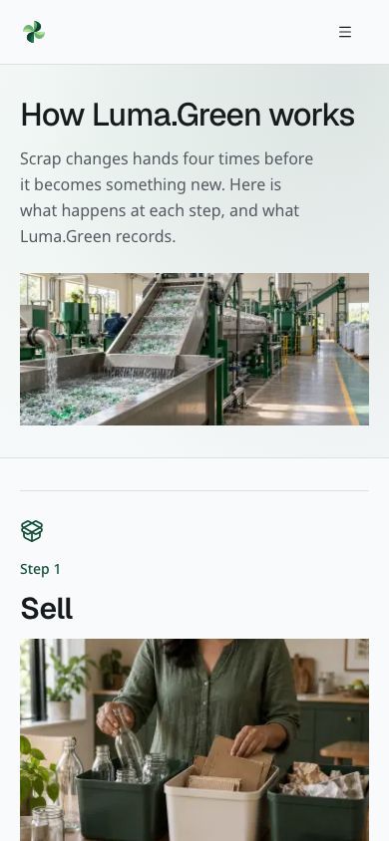  How it works in light mode, phone viewport. | 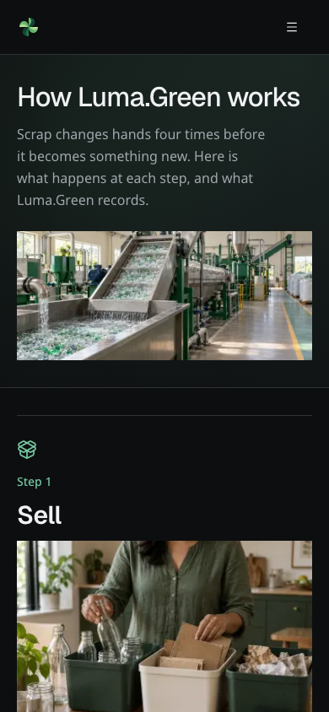  How it works in dark mode, phone viewport.

6 Join and the compact menu
Role requirements stay close to the role description. Language, appearance and account actions follow navigation without an empty full-height gap.
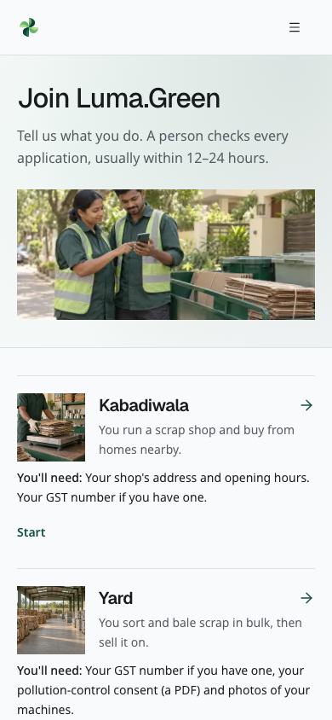  Join in light mode, phone viewport. | 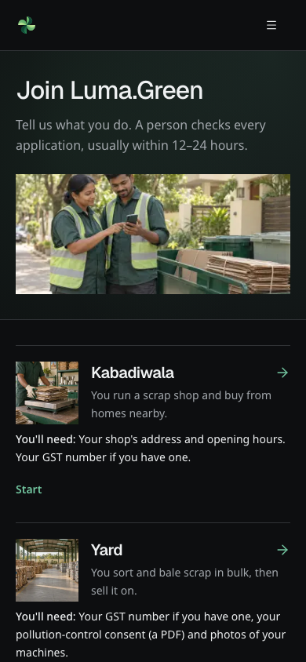  Join in dark mode, phone viewport.

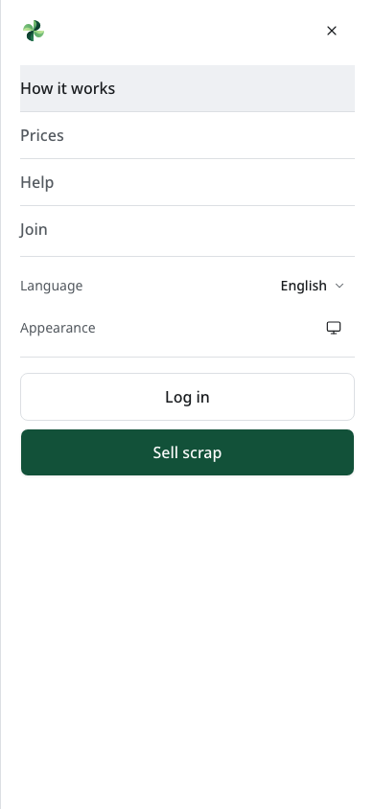  Public menu in light mode, phone viewport. | 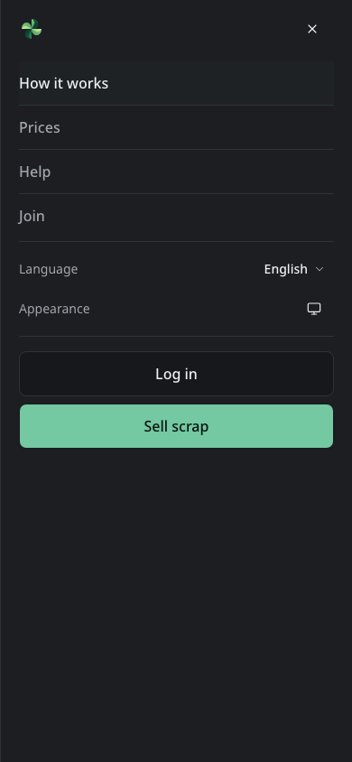  Public menu in dark mode, phone viewport.

7 Translated examples
French and Kannada show the same workflow with different script and text length. Arabic uses right-to-left layout. Japanese loads its configured script font. These are review examples; language fluency still needs a human reviewer.
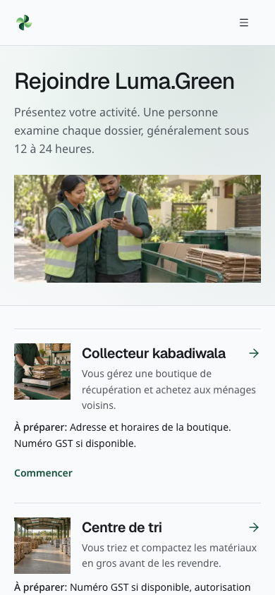  French Join page, current browser UI. | 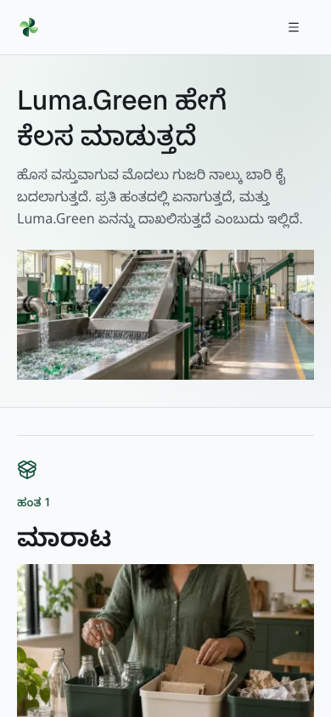  Kannada How it works page, current browser UI.

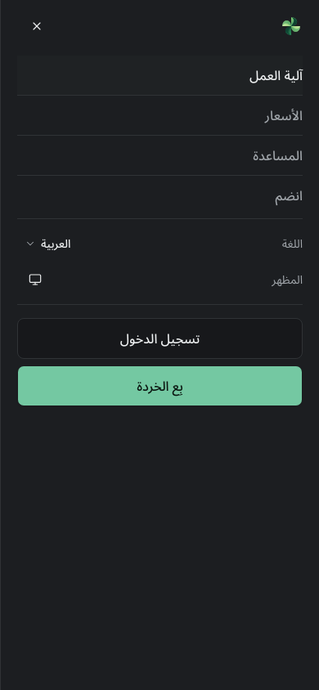  Arabic menu with right-to-left controls. | 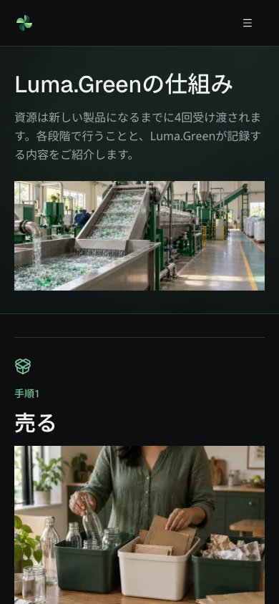  Japanese How it works page with the configured font.

8 How the system is built
Layer | Choice | Why it matters to this product
Web | Next.js 16, React 19, TypeScript | Server components and static public pages reduce browser work; types protect contracts
Interface | Tailwind 4, vendored shadcn/Radix, shared Lucide icons | Shared controls, keyboard behavior, semantic themes and consistent spacing
Data | Convex and guarded server functions | Live operational views, transaction boundaries and audit records
Identity | Better Auth on Convex | Phone access plus a separate admin authentication flow
Forms | React Hook Form and Zod | Shared rules check fields in the browser and on the server
Localisation | next-intl, Geist and Noto script fonts | Locale-aware navigation, numbers, dates and RTL layout
Quality | Vitest, Testing Library, Playwright, strict lint/types | Logic, role guards, browser behavior and responsive layout checks
Delivery | GitHub checks and Vercel; Expo and Electron shells | Reviewed web releases with separate native release gates

Money uses integer paise; mass uses integer grams. Formatting happens at the edge in the selected language. Shared private data must not enter a public cache. Public editorial pages are prerendered; operational views stay live and permission checked. Static rendering already gives public content on the first response, so forcing request-time rendering would add work without a benefit.

9 What the evidence means
The delivery handoff records the exact current commits and test results. The maintained user guide contains detailed screen instructions and clearly marked protected-screen fixtures. This pack adds a team execution manual. A manual case is a task to run, not a result that has already passed.
Evidence | What it can establish | What it cannot establish
Unit and policy tests | Logic, schema rules, permissions and expected failures under test | Real account approval or physical operations
Browser checks and visual review | Layout, navigation, local validation and configured script rendering | SMS receipt, real payment or field usability
Labelled protected-screen fixtures | Current component appearance with synthetic records | Sign-in, backend writes or production permissions
Build and hosted CI | The named revision builds and passes the named suite | All integrations are configured correctly
Provider acceptance record | The named provider accepted a controlled request | Handset delivery or the whole end-to-end journey
Pilot evidence | The observed users and workflows in the recorded period | Market-wide impact, carbon certification or guaranteed growth

10 A seven minute team demonstration
1. Open Home on a phone-sized viewport. Show the material story, loading prices, labelled demo quotes and primary actions.
2. Open How it works. Explain household, shop, yard, recycler and manufacturer hand-offs. State which information is recorded at each step.
3. Open Join. Compare applicant requirements. Show the language menu in Kannada and Arabic, then return to the demo language.
4. Open phone sign-in in the disconnected build. Continue to the labelled OTP preview. Explain that this preview sends no code and grants no access.
5. Use the labelled fixture harness to show a shop request, weighing, trade and admin review. Keep the fixture banner visible. Use staging instead when the test lead has approved controlled accounts and data.
6. Show the maintained guide and choose one role case from the attached manual. Explain setup, expected result and the evidence that the tester must save.
7. Close with the next milestone: a controlled, measurable Bengaluru pilot. Assign an owner to each unresolved account and operational gate.

11 Accounts and APIs to finish
The repository has the integration code. Creating an account, approving its templates and proving a real request are separate jobs. Do not paste secrets into this pack or a ticket. Use the provider dashboard and a team password manager. The full values and locations are in the account/deployment checklist.
Priority and owner | Service or decision | Completion evidence
Pilot — founder + engineering | Register entity, choose domain ownership, verify Vercel production binding and HTTPS | Owner, billing, DNS, canonical origin and deployed revision recorded
Pilot — engineering | Separate Convex development, staging/demo and production; connect each frontend to the right backend | Matching deployment IDs, schema, guards, backup and restore drill
Pilot — founder + operations | MSG91 account; DLT principal entity, sender and approved OTP/Flow templates | Approval IDs stored securely; controlled send accepted and handset receipt observed
Pilot — engineering | Better Auth secret, allowed origins, admin setup and recovery custody | Controlled login, sign-out, TOTP, role denial and recovery tests
Pilot — operations | Verified shops, locations/radii, real price source and support contact | Admin-reviewed records, prices with owner/date and support drill
Optional — engineering | OpenRouter or approved self-hosted vision gateway | Spend cap, labelled photo evaluation, manual fallback and privacy review
Optional — product + engineering | PostHog/GA4 and Sentry | Consent-based safe page view and scrubbed error received in each enabled provider
Optional — founder | Google Search Console and Bing Webmaster Tools | Domain ownership accepted and sitemap fetched
Native — release owner | Apple/Google developer accounts, signing and store submissions; desktop signing/update hosting | Named signed builds, real-device results and tested update/rollback
Later — founder + finance | Payment provider, escrow model and partner/legal terms | Approved money flow and settlement/reconciliation plan before implementation

Razorpay, Resend, Cloudflare R2, Mapbox and WhatsApp Business are not prerequisites for manual-entry pilot operation. Do not buy them only because their names appear in a roadmap. Files currently use Convex storage; location can use the browser. Optional AI does not set prices.
Setup references: account checklist, service inventory, SMS operations, observability, native releases.

12 Demo data and gentle load testing
The offline plan defines 48 business examples, 82 synthetic identities, all 26 materials and connected sample listings, trades, bookings, stock movements and jobs. A fixed seed and timestamp make the logical dataset reproducible. Its validator checks references, integer units and balance rules.
It is not installed in a database. Identity mapping, upload ownership, missing industry outputs and deployment isolation still need decisions. The same reviewed manifest can later drive both approved targets; copying live user records is not part of that plan. Do not use the legacy whole-table reset.
Keep price loading placeholders until a real feed is available, as requested. Do not turn the sample history into an unlabelled public market chart. The gentle stress plan must run on disposable staging, with bounded concurrency, stop limits and scoped cleanup. It does not authorise stress tests against production. See the demo plan.

13 The next six months
The proposed sequence is: prove one pilot loop, improve repeatability, validate the chain trade, prepare integrations, then decide what merits expansion. Each month has an owner and a verifiable exit. The full plan follows the manual in this document. Dates are planning targets, not commercial promises.
The immediate decision is not how many features can be added. It is whether the team can complete a pickup, produce a trustworthy receipt, resolve an exception and reproduce the evidence. Use the test manual below to make that decision visible.

14 Legal and trademark work
India is the first jurisdiction; the entity is not registered. The appended checklist covers entity choice, founder/IP records, a trademark search and filing brief, terms/privacy/partner documents, data protection and regulated recycling roles. No registration, name clearance, contract approval or legal opinion is claimed. A qualified adviser must settle entity and filing choices.
Do not display the registered trademark symbol before registration is granted. Keep identity evidence and signed legal documents in restricted storage, with owners and versions; this repository holds the work checklist only.

15 How to use the appendices
Run the manual in its stated evidence lane. Record Pass, Fail, Blocked or Not run with a reason. Use the six-month plan to assign work, and use the legal checklist to prepare questions and documents for advisers. The product is ready for disciplined evaluation; this pack does not replace that evaluation.

Team end to end test manual
Status: ready for test planning, 2 October 2026. This is an execution manual, not a completed test report. Record the exact build and results for each run. It covers household, kabadiwala, yard, recycler, manufacturer, Saathi and admin, plus public visitors and applicants. Read the user guide for screen instructions and the launch checklist for account gates. This manual does not authorise deployment, import or real sends.

1 Choose the evidence lane
Lane | Environment | What a pass proves
L | Disconnected local production build; optional services off | Public rendering, navigation, validation and inert previews
F | Labelled isolated component fixtures; writes reject | Appearance and displayed states only; no authenticated workflow proof
S | Approved disposable staging deployment with controlled accounts and records | Backend permissions, mutations, audit records and complete workflows
P | Approved staging provider test with controlled recipients and budgets | Named provider acceptance; record handset delivery separately
N | Approved native test build on a named device/OS | That build's navigation, permissions and update behavior

Never use production for these mutation, quota, failure or race tests. Do not send real SMS, place calls, transfer money, publish updates or upload identity files without an approved test environment and controlled destination. Real escrow is not implemented. Do not enable AUTH_DEV_MODE in production, use old demo phone numbers as live recipients, or run the legacy whole-table reset.
The offline manifest is a review plan, not installed test data. Its 48 businesses include explicit onboarding/output gaps. The test lead must approve isolation and account mapping before S/P tests exist. Until then mark those cases Blocked, not passed using F screenshots.

2 Prepare a run
The test lead records the frontend build/commit, backend deployment, schema revision, India date/time, service flags, dataset version/hash, browser/device, locale, theme and tester. A second reviewer owns the final sign-off. Engineering supplies approved accounts through secure channels; never put credentials, phone numbers, tokens or personal documents in this file or an issue.
Use separate browser profiles for each actor. Give controlled records aliases: HH-A, HH-B, SHOP-A, SHOP-B, YARD-A, RECYCLER-A, MAKER-A, WORKER-A, WORKER-B, ADMIN-A and five separate applicant accounts. Include sufficient unreserved stock, a competing listing, today/future/past jobs, safe watermarked uploads, and application states. Record starting balances. Do not invent an admin identity or edit a real user's record to get a test state.
Evidence codes below: UI = current screenshot or short recording; NET = sanitised request/result and status, without cookies, tokens or payload identities; DB = authorised before/after counts, integer values and audit references; FILE = safe exported sample plus contents/hash; DEVICE = build, OS and device result; PROVIDER = redacted provider event and controlled handset observation. Evidence stays in restricted test storage. Save record aliases in the report and keep their real-ID mapping separately.
Run public and access cases first, then onboarding, household/shop, chain trades, Saathi, admin/reporting, and cross-platform checks. Retry a failed case on the same build only after recording the original failure. After an ambiguous network result, inspect the current record before retrying; booking creation does not promise a universal replay/idempotency key.

3 Access and signup

ACC 01
ID: ACC-01
Role / lane: Visitor / L
Setup: SMS and backend off
Steps: Open login; choose language; enter valid-format input; continue; edit number
Expected result: Labelled OTP preview opens; Verify/Resend cannot send or authenticate; private app remains guarded
Evidence: UI, NET

ACC 02
ID: ACC-02
Role / lane: Household/business/Saathi / S+P
Setup: Controlled number and approved OTP template
Steps: Request code; enter correct code; open permitted tracking/workspace; sign out
Expected result: Intended account/session only; correct destination; private reads stop after sign-out
Evidence: UI, NET

ACC 03
ID: ACC-03
Role / lane: Applicant / S+P
Setup: Separate test attempts
Steps: Try malformed phone/code, wrong code five times, expired five-minute code, and used code
Expected result: Clear errors; no session from invalid attempts; new request follows limits
Evidence: UI, NET, PROVIDER

ACC 04
ID: ACC-04
Role / lane: Applicant / S+P
Setup: Reserved quota test window
Steps: Check 30-second resend delay, three sends/15 minutes, ten/day; check address limits with engineering
Expected result: Server enforces limits across sessions; failed/ambiguous sends consume quota; no automatic resend storm
Evidence: NET, PROVIDER

ACC 05
ID: ACC-05
Role / lane: All roles / S
Setup: One session per role
Steps: Open another role's routes, signed-out app URL and admin URL; expire session with approved test controls
Expected result: Server/query guards deny private data; redirect or error is useful; URL editing grants no role
Evidence: UI, NET

ACC 06
ID: ACC-06
Role / lane: HH-B and unrelated org / S
Setup: HH-A booking and another org's trade/file
Steps: Attempt read/action using the other controlled record's alias mapping
Expected result: Mutations and private reads denied. Tracking token may show its designed public view but never authorises cancellation
Evidence: NET, DB

JOIN 01
ID: JOIN-01
Role / lane: Five applicant kinds / S
Setup: Fresh account for each kind
Steps: Choose role; consent; fill valid form; save; reload; resume
Expected result: One owned draft per person; fields persist; correct role sections; no operational access before approval
Evidence: UI, DB

JOIN 02
ID: JOIN-02
Role / lane: All applicants / S
Setup: Editable drafts
Steps: Omit required fields; enter invalid dates/contact/GST/consent values; try another role's section; submit twice
Expected result: Field/server validation agree; no invalid submission or duplicate version; entered valid values remain recoverable
Evidence: UI, NET, DB

JOIN 03
ID: JOIN-03
Role / lane: Business and Saathi / S
Setup: Watermarked test PDF, image, video
Steps: Upload valid files; try spoofed extension/MIME, oversize file, excess machine files and another owner's file
Expected result: Real type/ownership checks reject unsafe files. Limits: 10 MiB documents/images, 20 MiB machine video, ten machine files
Evidence: UI, NET, DB

JOIN 04
ID: JOIN-04
Role / lane: Applicant + admin / S
Setup: Submitted version 1
Steps: Request changes with note; edit; resubmit; approve version 2
Expected result: draft→submitted→changes_requested→submitted→approved; previous snapshot preserved; final role created once
Evidence: UI, DB

JOIN 05
ID: JOIN-05
Role / lane: Applicant + admin / S
Setup: Separate draft and submitted records
Steps: Discard unsent draft; reject submitted application with reason; try editing either decision
Expected result: Only unsubmitted version-zero draft is discardable; rejected record keeps reason; no self-service reopen
Evidence: UI, DB

JOIN 06
ID: JOIN-06
Role / lane: Suspended applicant / F; approved guarded test state / S
Setup: Pre-approved test-state setup
Steps: Inspect status and attempt workspace access
Expected result: Suspension view gives next step; operational access denied. No console suspend/reinstate button exists; do not fabricate one
Evidence: UI, NET

4 Household recovery and shop operations
For calculation cases use synthetic rates of 1,200 paise/kg and 1,000 paise/kg. Weigh 2,125 g and 3,500 g: total 6,050 paise, six points. These are test values, not market quotes. No real household payment is made during this test.

HH 01
ID: HH-01
Role / lane: Household / S
Setup: Empty sell draft
Steps: Add/remove mixed materials; use Back; reload same tab; reject empty, duplicate, zero and >500 kg items
Expected result: Draft steps remain coherent; maximum 20 materials; units clear; invalid basket cannot book
Evidence: UI

HH 02
ID: HH-02
Role / lane: Household / S
Setup: Two active shops with known prices
Steps: Compare offers with precise location; deny location; choose pickup/drop-off; change basket
Expected result: Eligible offers recalculate from rate/fallback tables; nearest with location, best quote without; AI sets no price
Evidence: UI, DB

HH 03
ID: HH-03
Role / lane: Household / S+P
Setup: Valid basket/shop/slot
Steps: Verify phone then confirm; also test signed-in confirmation and rapid double-click
Expected result: One UI submission produces one booking and private tracking link; pending action prevents repeated taps; draft is not labelled confirmed early
Evidence: UI, NET, DB

HH 04
ID: HH-04
Role / lane: Household / S
Setup: Boundary dates and five open bookings
Steps: Try yesterday, beyond seven days, passed India-time slot, missing pickup address and sixth open booking
Expected result: Invalid requests rejected; no extra record. Valid current/future slot works
Evidence: UI, DB

HH 05
ID: HH-05
Role / lane: Household + two shops / S
Setup: Precise location; manual offers
Steps: Decline first offer; separately let 15-minute offer expire; inspect next shop and stale first screen
Expected result: Eligible untried shop receives equal/higher quote; tracking shows reassignment; stale acceptance fails; no match/closed slot ends declined
Evidence: UI, DB

HH 06
ID: HH-06
Role / lane: Shop owner + household / S
Setup: Known radius and location
Steps: Enable auto-accept; book in/out of radius; repeat with approximate location
Expected result: Only eligible precise-location offer auto-accepts; others remain manual/ineligible; settings affect future offers
Evidence: UI, DB

HH 07
ID: HH-07
Role / lane: Household + shop / S
Setup: Requested, accepted, on-way examples
Steps: Cancel own first two; try with HH-B and after Start trip
Expected result: Only owner cancels requested/accepted bookings; denied cases keep records unchanged; status history is consistent
Evidence: UI, NET, DB

HH 08
ID: HH-08
Role / lane: Household + shop / S
Setup: Drop-off booking
Steps: Accept; inspect actions; complete measured receipt
Expected result: Drop-off has no valid Start trip operation; accepted may complete directly; mode/date/address instructions remain correct
Evidence: UI, DB

HH 09
ID: HH-09
Role / lane: Household / L+S
Setup: Invalid token and completed booking
Steps: Open bad token; inspect completed receipt; change shop price; revisit receipt
Expected result: Safe not-found view; completed weights/rates/payment method/points stay frozen; no contact data leaks from invalid link
Evidence: UI, DB

SHOP 01
ID: SHOP-01
Role / lane: Kabadiwala / S
Setup: Assigned pending and accepted work
Steps: Open New/Today/Done; inspect before/after acceptance; try unrelated shop
Expected result: Phone/address withheld until acceptance; only assigned shop acts; counts and tabs update
Evidence: UI, NET

SHOP 02
ID: SHOP-02
Role / lane: Kabadiwala / S
Setup: Accepted pickup; calculation basket
Steps: Start trip; weigh actual amounts; select cash/UPI record; complete; retry completion
Expected result: One receipt, exact total/points and stock increase once; retry cannot duplicate effects; payment label is a record, not bank confirmation
Evidence: UI, DB

SHOP 03
ID: SHOP-03
Role / lane: Kabadiwala / S
Setup: Editable weigh form
Steps: Try empty/negative/fractional-gram, excessive, inactive/recycled and no-price lines; test duplicate material input via engineer test
Expected result: Invalid lines fail without stock change; valid duplicate lines aggregate once; cap is 30 inputs and 5,000,000 g per material
Evidence: NET, DB

SHOP 04
ID: SHOP-04
Role / lane: Kabadiwala + admin / S
Setup: Existing rate and receipt
Steps: Save below-floor rate; save valid rate; raise floor above it; reread receipt
Expected result: Below-floor fails; current rate lifts to floor when required; historical receipt unchanged; audit records change
Evidence: UI, DB

SHOP 05
ID: SHOP-05
Role / lane: Kabadiwala / S
Setup: Stock with open reservations
Steps: Compare stock, sellable amount and value; lose network during action; reconnect
Expected result: Only free stock can be listed; loading is not false zero; inspect committed state before retry; no offline write queue is claimed
Evidence: UI, DB

5 Chain trades and Saathi work
Run TRADE-01–03 using permitted active stock. Recycled outputs exist only for PET flakes, HDPE granules, kraft and aluminium ingots. Textile onboarding and normal glass/e-waste shop approval remain planning gaps. There is no processing batch/conversion screen. Do not create fictional output to complete a test.

TRADE 01
ID: TRADE-01
Role / lane: Shop seller + yard buyer / S
Setup: Free scrap and same-city businesses
Steps: List; request partial quantity; accept; demo-pay; dispatch; confirm delivery
Expected result: requested→accepted→paid_to_escrow→dispatched→completed; available listing falls on accept; seller stock falls on dispatch; buyer stock rises on confirmation
Evidence: UI, DB

TRADE 02
ID: TRADE-02
Role / lane: Yard seller + recycler buyer / S
Setup: Scrap stock
Steps: Repeat full sequence; compare both trade lists and stock
Expected result: Correct next-chain supplier visibility; exact grams/paise; both parties agree; sorting outside app adds no invented production record
Evidence: UI, DB

TRADE 03
ID: TRADE-03
Role / lane: Recycler seller + manufacturer buyer / S
Setup: Approved recycled-output stock
Steps: Repeat sequence; filter scrap/output; inspect manufacturer navigation
Expected result: Manufacturer buys recycled output from recycler; wrong stage/role rejected; manufacturer has no onward seller role
Evidence: UI, DB

TRADE 04
ID: TRADE-04
Role / lane: Seller + two buyers / S
Setup: Same listing in two profiles
Steps: Compete for more than remaining quantity; seller accepts; repeat a stale action
Expected result: No over-allocation or negative stock; sold listing closes; pending competing requests decline when fully sold; stale step fails
Evidence: NET, DB

TRADE 05
ID: TRADE-05
Role / lane: Seller/buyer/outsider / S
Setup: New listing and requested trade
Steps: Withdraw listing; decline request; try own-listing purchase, wrong-city/role access and skipped steps
Expected result: Correct terminal state; reservations released as applicable; participant/role checks deny invalid action; no fake escrow transfer
Evidence: UI, DB

TRADE 06
ID: TRADE-06
Role / lane: Both parties / S
Setup: Paid trade
Steps: Open invoice route; print; compare line, parties, number and total; repeat pay
Expected result: Stable numbered printable trade receipt; one number; not a GST tax invoice; outsider cannot read it
Evidence: UI, FILE, DB

TRADE 07
ID: TRADE-07
Role / lane: Buyer/seller / S
Setup: Synthetic totals at/above ₹50,000
Steps: Inspect transport note and simulate connection loss after dispatch
Expected result: App threshold hint appears above threshold; it is not legal clearance. Reconnect shows one dispatch; no second stock decrement
Evidence: UI, DB

WORK 01
ID: WORK-01
Role / lane: Saathi / S
Setup: Four job types, date/city variants
Steps: Browse open/today/upcoming; vary date, city, area and poster status
Expected result: Current/future open jobs from active same-city businesses, or team jobs, appear; own area first. No work-type/availability matching is claimed
Evidence: UI, NET

WORK 02
ID: WORK-02
Role / lane: Two Saathis / S
Setup: One open job
Steps: Take simultaneously; attempt second job in same assigned time window
Expected result: One assignee; loser sees taken state; conflicting slot rejected; no duplicate assignment
Evidence: UI, DB

WORK 03
ID: WORK-03
Role / lane: Saathi / S
Setup: Own today/future job and other's job
Steps: Finish today's job; repeat; try future/other job
Expected result: Own job completes on/after its date once; future and other's work rejected; no payment transfer implied
Evidence: UI, DB

WORK 04
ID: WORK-04
Role / lane: Saathi / F+S
Setup: Known completed jobs, empty worker
Steps: Compare weekly/total/by-kind earnings and recent list; check empty state
Expected result: Totals derive from completed jobs; pending work excluded; period boundaries use India time; no invented wages or withdrawal control
Evidence: UI, DB for S

6 Admin reporting and exports
Reads are bounded: support shows 200 records; verification lists 200; job reads use 500 and show 20 recent completions; impact reads use 2,000 and compliance shows 50 receipts. Reconcile the same scope, not an assumed unlimited history.

ADM 01
ID: ADM-01
Role / lane: Authorised admin / S
Setup: Disposable backend with setup permission
Steps: Complete setup; interrupt/resume; enable TOTP; store backup codes securely; retry setup
Expected result: Single authorised admin; setup resumes safely; console requires completed 2FA; no secrets in screenshots
Evidence: UI without secrets, NET

ADM 02
ID: ADM-02
Role / lane: Admin / S
Setup: TOTP and controlled recovery code
Steps: Test password/TOTP failure, three/10-second limit, one recovery code twice, logout and 12-hour expiry
Expected result: Correct challenge/limits; recovery code single-use; expired/logged-out console cannot read or mutate
Evidence: NET

ADM 03
ID: ADM-03
Role / lane: Admin / S
Setup: Submitted applications aged 17/18/24 hours
Steps: Review queue; tick role checklist; approve, request changes, reject; test short/long notes and competing review
Expected result: Due-soon at 18h, overdue at 24h; only submitted applications decide; required trimmed note 5–1,000 characters; role creation/audit once
Evidence: UI, DB

ADM 04
ID: ADM-04
Role / lane: Applicant/admin/outsider / S
Setup: Safe owned files
Steps: Preview image/PDF; load video explicitly; open/download; sign out; repeat as outsider; induce network error
Expected result: Authorised requests succeed; unauthenticated 401, unauthorised 403, missing 404; private, no-store; retry useful; no raw public storage link
Evidence: UI, NET, FILE

ADM 05
ID: ADM-05
Role / lane: Admin / S
Setup: Approved sample price rows
Steps: Save positive minimum/fallback; try minimum above fallback, >₹10,000 and >2 decimals; Undo; add missing names
Expected result: Row validation works; Undo discards unsaved edit only; name repair preserves existing names/prices; no bulk destructive change
Evidence: UI, DB

ADM 06
ID: ADM-06
Role / lane: Visitor + admin / S
Setup: Controlled help/solar enquiry
Steps: Submit valid/invalid forms; inspect Open/All; cancel telephone handler; mark answered
Expected result: Valid enquiry saved once per submission; invalid fields rejected; Answered updates status only, sends nothing; no reply/reopen/delete tool promised
Evidence: UI, DB

REP 01
ID: REP-01
Role / lane: Admin / F+S
Setup: Known period records; bounded large fixture
Steps: Compare Today/7/30/pilot ranges, empty data and >1,000 rows
Expected result: India-time range shown; max 31 days; current outcomes selected by booking/latest-submission date; partial warning; charts agree with tables
Evidence: UI, DB for S

REP 02
ID: REP-02
Role / lane: Each business / S
Setup: Completed and incomplete trades; consent boundaries
Steps: Check impact, financial-year EPR and consent at expired/89/90 days
Expected result: Totals use intended completed records; 90-day warning behavior matches code; no issued credits/certificates implied; renewal date copy is consistent
Evidence: UI, DB

REP 03
ID: REP-03
Role / lane: Visitor / S
Setup: Current catalogue
Steps: Download Standards CSV; open it; compare codes/names and quoting
Expected result: 26 current codes, correct fields/escaping and safe filename; no private records in public export
Evidence: FILE

REP 04
ID: REP-04
Role / lane: Admin/business / F+S
Setup: Reports and receipt views
Steps: Inspect export affordances and zero/partial states
Expected result: Receipt printing and public codes CSV exist; admin pilot CSV/PDF export does not. Demo rows in reports are identified as non-production evidence
Evidence: UI

7 Presentation privacy providers and native apps
Apply UX cases to every changed route template, including all role-help pages and articles. Follow the UI contract. Use actual loaded fonts; a CSS family string or passing scroll-width assertion is insufficient visual evidence.

UX 01
ID: UX-01
Role / lane: All roles / L+F
Setup: 33 registry locales
Steps: Visit public route templates and each role fixture; switch language; inspect headings/materials/settings
Expected result: Complete localised copy/endonyms, preserved route, correct glyphs; admin remains English; native-language review recorded separately
Evidence: UI, locale checklist

UX 02
ID: UX-02
Role / lane: Visitor/all roles / L+F
Setup: 320/390/640/768/1024/1280/1440px; short height
Steps: Inspect header, menus, forms, tables, sticky controls and page bottom
Expected result: Header one row; below1280 controls in menu; phone mark only; settings reachable; single-line actions fit; no overlap/clipping/page overflow
Evidence: UI, bounds report

UX 03
ID: UX-03
Role / lane: All roles / L+F
Setup: Light/dark/system, Arabic/Urdu
Steps: Toggle theme; reload; inspect focus, chart labels, files and RTL drawers/arrows
Expected result: Stable first paint, readable contrast, logical alignment and direction; chosen theme persists; no green-wash/card regression
Evidence: UI

UX 04
ID: UX-04
Role / lane: Household/operators / L+S
Setup: Native digits; comma/dot locales
Steps: Enter 2.125 kg and 12.50 rupees using supported digit/separator forms; try grouping and excess precision
Expected result: Operator fields: exact 2,125 g/1,250 paise; household estimate: 2.1 kg after 0.1-kg rounding. Invalid formats fail; exact operator fields reject excess precision
Evidence: UI, DB for S

UX 05
ID: UX-05
Role / lane: Keyboard/screen-reader user / L+F
Setup: Zoom/large text, keyboard only
Steps: Complete menus/forms/dialogs; Escape; return focus; inspect labels/errors and table/chart equivalents
Expected result: Named controls, visible focus, reachable content, sensible order, no traps; meaningful error announcements and usable targets
Evidence: UI, reader notes

UX 06
ID: UX-06
Role / lane: Motion-sensitive user / L+F
Setup: Fine pointer, touch, reduced motion
Steps: Hover/focus logo; pause marquee; change motion preference mid-animation; inspect banner crops
Expected result: Mark turns once; wordmark still; decorative motion stops; static reduced-motion content; images loaded and text readable
Evidence: UI

SVC 01
ID: SVC-01
Role / lane: Household / L+S
Setup: Offline/slow network/provider unavailable
Steps: Disconnect during browsing and a controlled write; reconnect; inspect saved state before retry
Expected result: Useful retry/error; no false completion or offline queue; manual entry remains available; no sample live-price fallback
Evidence: UI, NET, DB

SVC 02
ID: SVC-02
Role / lane: Household / S+P
Setup: Approved AI endpoint and cost limit
Steps: Test clear/dark/distant/non-scrap image; edit suggestions; hit device/deployment quota; simulate malformed response/timeout
Expected result: Safe result or retake/error; no invented material/price; manual flow works; no stored photo/output; quota applies
Evidence: NET, PROVIDER

SVC 03
ID: SVC-03
Role / lane: Household/applicant/shop / S+P
Setup: Approved templates; controlled recipients
Steps: Trigger each of eight supported events once; repeat same event; test missing locale/config, stale event, failure/timeout
Expected result: Deduped outbox; disabled events not replayed; rate cap20/day; no automatic retry; accepted vs handset-delivered recorded separately
Evidence: DB, PROVIDER

SVC 04
ID: SVC-04
Role / lane: Visitor / L; provider receipt P
Setup: Analytics test configuration
Steps: Decline/allow/withdraw; visit public then private routes; test blocked storage and another tab
Expected result: Consent governs analytics; only allowlisted public paths; no query/token/form leakage; one page view; flag-off disables transport
Evidence: NET, PROVIDER when approved

SVC 05
ID: SVC-05
Role / lane: Admin/test engineer / S+P
Setup: Controlled error and private-file sample
Steps: Trigger safe browser/server error; inspect redacted payload; compare public HTML/cache to private responses
Expected result: Sentry independent of analytics consent; no identifying details; private data never shared-cached; static public shell works without JS
Evidence: NET, PROVIDER

SVC 06
ID: SVC-06
Role / lane: Engineer + test lead / S
Setup: Disposable workload and backup
Steps: Run one, three, then five read sessions at one request/s/session, maximum two minutes/step; restore backup to separate target
Expected result: Record latency/errors, stop on limits/errors or >2× baseline; restore reconciles counts; no production write load or reset
Evidence: NET, DB

NAT 01
ID: NAT-01
Role / lane: All mobile roles / N+S
Setup: Android/iOS test builds
Steps: Login/logout; camera/upload/location deny/allow; Android Back; external links; offline recovery
Expected result: Correct trusted origin/role; no unsafe navigation; permission denial recoverable; private-file browser handoff honest
Evidence: DEVICE, UI

NAT 02
ID: NAT-02
Role / lane: Mobile tester / N
Setup: Signed preview channel, prior install
Steps: Check none/available/failed update; download; choose Later; then Restart; test invalid signature/runtime
Expected result: Current/ready/failed accurate; Later preserves form; restart requires choice; invalid update not applied; rollback path tested
Evidence: DEVICE

NAT 03
ID: NAT-03
Role / lane: Desktop tester / N+S
Setup: Signed macOS/Windows prior install/feed
Steps: Repeat check/later/restart; invalid feed/signature; private file; native menu locale/RTL
Expected result: Shell remains usable; trusted update only; session survives supported upgrade; unconfigured/unsigned state not called current production
Evidence: DEVICE, NET

8 Run sheet defects and sign off
Copy one row per case and per distinct locale/device variant. Status values are Not run / Pass / Fail / Blocked / Not applicable. “Not applicable” needs a reason and reviewer. A blocked API is not a failed UI, but it prevents live-flow acceptance. F passes never fill S/P result cells.

Fill before run
Run/build: Fill before run
Case + variant: e.g. HH-05 / kn / Android
Lane/role/data alias: S / SHOP-A
Tester/time: Name + IST/UTC
Result/actual behavior: Not run
Evidence/defect: Restricted link
Retest/reviewer: Pending
Use P0 for data exposure, auth bypass, destructive loss or real unintended sends; stop the run and contain the environment. P1 blocks a core task or breaks ledger correctness. P2 has a safe workaround or material usability failure. P3 is minor polish. Record expected/actual, minimal reproduction, first affected build, evidence, owner, severity and a retest result. Never put secrets in the bug title or attachment. Severity is separate from scheduling.
Sign-off requires: named test lead; all applicable core S cases passed; no open P0/P1; reconciled stock/receipt/audit evidence; required P/N gates completed or explicitly excluded from launch scope; native-language review for launch locales; and current guide screenshots/DOCX visual review. Product, engineering and operations each record a decision, date, exceptions and rollback owner. Hosted CI, deployment, live provider acceptance and store approval remain separate proof fields. Do not replace them with a local test count.
Until configured, block live OTP, status SMS, optional AI, provider telemetry receipt, private backend workflows and signed-update delivery as applicable. Real escrow, credit issuance, textile completion, processing batches, admin suspension/staff tools and report exports are unimplemented scope, not tests to “pass” by adding keys. See the launch and native release checklists before unblocking. Do not borrow production secrets for convenience.
Source checks: convex/lib/{chain,lifecycle,households,review}.ts, convex/{households,shop,dispatch,market,saathi,review,applicationFiles,files,adminPrices,support,pilot,insights}.ts, src/lib/number-input.ts, the locale registry, provider runbooks and native update modules. If code changes a status or limit, update the affected case and user guide together; do not silently follow older prototype reset/login instructions.

Six month execution plan October 2026 March 2027
Status: proposed plan, 2 October 2026. These are decision gates and suggested team goals, not committed delivery dates, traction claims or approved spending. The founder selects scope and assigns people to the owner roles below. If a release gate is not met, move the affected milestone; do not bypass it to keep a calendar promise.
The current product connects households, shops, yards, recyclers, manufacturers and Saathis, with one admin. The implemented pilot has phone authentication, onboarding, pickup dispatch, weighed receipts, stock, simulated business trade, job records and bounded reports. Public UI and 33 translated catalogues do not prove live operations, provider approval, native release acceptance or native language review. Use the feature inventory, launch checklist and current delivery handoff for verified status.

Working ownership and order
- Founder/product: pilot scope, partners, budget, release decisions and legal adviser coordination. A proposal does not authorise a production change.
- Engineering lead: auth/data integrity, releases, instrumentation, recovery and technical acceptance evidence.
- Operations lead/admin: business verification, dispatch exceptions, price approval, support and field training.
- Design/QA lead: the UI contract, role testing, accessibility, translation review and maintained guide.
- Release/security owner: environment isolation, backup/restore, secrets, provider budgets and signed native distribution. One person may hold several roles; each milestone still needs one accountable owner and a reviewer.
Critical path: isolated environment and controlled identities → verified provider/auth flow → auditable end-to-end recovery → repeatable field operations → measured chain trade → justified expansion. Design polish, legal research, training preparation and offline test data can proceed in parallel. A provider key alone does not complete any operational gate.

October 2026 make the Bengaluru pilot safe to operate
Accountable: engineering lead; operations and QA review. Dependencies: founder chooses demo/staging isolation; approved controlled identities; matching frontend/backend origins; admin setup and 2FA; MSG91 approval and budgets.
Finish core role acceptance using the team manual. Run a controlled household→shop pickup from booking through measured receipt, then a permitted shop→yard trade with the simulation boundary visible. Verify reassignment, cancellation, invalid transitions, private-file ownership and exact stock/points once-only effects. Complete the price review and Kannada, Hindi and English field-copy review. Rehearse backup restoration in a disposable environment. Keep demo rows separate from pilot reporting.
Exit evidence: no open P0/P1 in the agreed pilot scope; approved real-device OTP and handset delivery record; functioning 2FA; reviewed restore result; current guide and role training; support/rollback owners named. The previously proposed 13–20 October pilot window is conditional on these gates, not a launch promise. Legal/privacy and brand checks must have a named adviser and decision owner before the public pilot; use the separate legal workstream for current requirements.
Measure: eligible offers, accepted/completed/cancelled/reassigned bookings, acceptance time, estimate-versus-weighed differences, receipt corrections, support incidents and actual provider cost. Establish a baseline first; no customer-volume or revenue claim is implied.

November 2026 stabilise pickup work and support
Accountable: operations lead; engineering and QA review. Dependencies: October core gates and a real, consented pilot cohort.
Observe household and shop tasks in the field. Fix the largest measured causes of abandonment, stale offers, missed work and receipt disputes. Define the accepted-work exception process with operators; if cancellation/release or correction tools are needed, design and review their state/audit rules before implementation. Improve support triage and training from actual incidents. Keep OTP, SMS spend and request limits under review. Do not add dashboards just to fill space.
Exit evidence: a written and rehearsed pickup exception procedure; every critical bug has a reproduced regression test and retest; consecutive weekly operations reviews reconcile completed receipts with stock. Any new workflow has a guide update and staging acceptance before pilot rollout.
Measure: completion rate within a defined booking cohort, reassignment rate, median/upper-percentile acceptance time, support response time, duplicate records and cost per completed pickup. Set improvement targets only after checking the October denominator and data quality.

December 2026 validate the business chain
Accountable: founder/product; engineering and operations review. Dependencies: reliable recovery records, willing verified businesses and agreed physical handoff/quality practices.
Run supervised shop→yard, yard→recycler and recycler→manufacturer scenarios. Check quantities, grades, packaging, transport evidence and receipt expectations with each party. Confirm listing reservations, partial quantities, competing orders and delivery acknowledgement against stock. Record the actual reasons a business would repeat a trade. Document disputes, returns and settlement needs before adding those features.
Exit evidence: all three permitted handoffs pass the staging manual; each handoff has a field-reviewed operating checklist and a reconciled record sample. Keep escrow labelled simulation. Real payments require a separate approved commercial, legal, provider and reconciliation design; December does not promise fund custody or settlement.
Measure: order acceptance/completion, time between each trade state, quantity/quality disputes, repeat activity by a defined business cohort and reconciled grams. Collect confidential business feedback without inventing marketplace liquidity or contracted demand.

January 2027 decide the next traceability and reporting scope
Accountable: engineering lead; product and operations review. Dependencies: December evidence and a documented reason for each new record.
Review whether operators need processing batches, input/output mass balance, quality grades or a controlled report export. Define integer units, correction rules, ownership, audit events and migration/rollback before schema work. Resolve textile onboarding, normal shop-family restrictions and missing recycled output codes with domain reviewers; do not invent a complete chain from the current catalogue. Assess separate reviewer/support roles only if the single-admin workload justifies them.
Exit evidence: reviewed ADRs and acceptance cases for selected changes; one bounded staging implementation at a time; mass-balance/permission/concurrency checks and restore evidence. Unselected proposals stay out of production. EPR records and impact estimates remain distinct from regulatory certificates and issued carbon credits.
Measure: traceability completeness for sampled transactions, unexplained stock differences, report reconciliation time and admin review age. State report bounds and demo inclusion. A partial report cannot support an unqualified total.

February 2027 prove device and language readiness
Accountable: design/QA lead; release/security owner review. Dependencies: stable hosted workflows, owned app identifiers, signing access and approved test channels.
Run field-device acceptance on Android/iOS and macOS/Windows with actual fonts, large text, RTL, camera, location denial, private documents and poor networks. Test a previous signed install updating to the candidate, Later/Restart behavior, bad signatures, unavailable feeds and recovery. Complete human review for each language the team intends to support operationally; keep automated checks across all 33 catalogues and document remaining native-review gaps.
Exit evidence: named devices/build IDs with passing core cases, reviewed signatures and rollback, current store/privacy submission materials and guide. Publish only after the relevant platform acceptance; a JavaScript export or unsigned package is not an approved app release.
Measure: task completion and support friction by device/launch language, missing-glyph/overflow defects, crash reports from the supported instrumentation, update failures and download size. Do not infer Convex/native crash coverage from browser Sentry alone.

March 2027 choose a measured expansion or a focused repair cycle
Accountable: founder/product; operations, engineering and finance/adviser review. Dependencies: prior gates, reliable cost and cohort data, operational capacity and documented business demand.
Review six months of evidence. Decide whether to deepen Bengaluru coverage, expand one supported chain, add a carefully chosen area, or spend another cycle on reliability. Compare service cost, operator workload, support load, real completed activity and repeat use. Conduct bounded load/readiness and recovery checks before increasing traffic. Reassess pricing/business model and required legal arrangements with the appropriate advisers.
Exit evidence: an explicit go/no-go decision with scope, budget, owners, capacity assumptions and rollback; a prioritised next-quarter plan linked to observed needs. Carbon-credit feasibility may be researched, but issuance, verification, trading and retirement remain a separate programme with external requirements—not an automatic March deliverable.
Measure: contribution assumptions using actual recorded costs, support and verification capacity, cohort retention/repeat activity, correctness incidents, performance and restore time. Label forecasts as forecasts and exclude demo data.

Review cadence and scorecard
Hold a weekly engineering/operations review and a monthly founder gate review. Each metric entry records definition, date range, timezone, source, completeness, demo exclusions, owner and collection method. Use operational records for private workflow measures; do not widen public analytics to collect identities or private routes. Current pilot reports are bounded, use current outcomes and do not measure abandoned forms or original AI accuracy. Add reviewed measurement only when it answers a specific decision.
Gate | Evidence required | Decision if missing
Correctness | Reconciled integer receipts/stock; audit and concurrency tests | Stop affected mutations and repair before expansion
Access/privacy | Role/file denials; controlled identities; retention/settings review | Keep environment closed; investigate exposure immediately
Provider | Configuration plus controlled acceptance/delivery and cost evidence | Leave optional feature disabled; keep manual alternative
Usability | Core role tasks, native review, responsive/a11y/motion evidence | Restrict launch scope or fix the failing path
Release/recovery | Current CI/build, guide, backup/restore, signed-device proof where needed | Hold release and keep last accepted build
Commercial | Real cohort and cost evidence with adviser-reviewed assumptions | Continue discovery; make no traction/return guarantee

No month authorises broad production seeding, whole-table resets, purchased accounts, unsolicited messages or spend. Keep API/account setup, legal/trademark research and the team/investor pack as linked workstreams owned by the founder; their conclusions must be current and separately verified.

India entity trademark and legal preparation
Prepared 2 October 2026 for the Luma.Green founder. The founder confirmed that an Indian entity has not yet been registered. This is a preparation checklist for the founder, a company secretary or chartered accountant, and legal counsel. It is not a filing, a trademark clearance opinion or an approved customer contract. No registry search, entity incorporation or trademark application was completed by this software task. Keep identity papers and signed documents outside Git.

Decisions before accounts and contracts
Choose the legal owner before opening business accounts or signing customer and provider agreements. Record the proposed entity type, proposed legal names, registered office, founders, ownership, directors or partners, authorised signer, and the owner of the domain, code and brand. Consider funding plans, governance, liability, tax and ongoing compliance with the professional who will file.
For a company, MCA provides SPICe+ and linked incorporation forms. Check current requirements in the official portal; a company-name reservation is separate from trademark clearance. An LLP requires its own route and documents. Do not publish an invented legal name, CIN, GSTIN or registered-office address while formation is pending. MCA incorporation guidance and MCA portal.
Preparation file | Owner | Completion evidence
Entity choice and incorporation checklist | Founder + CA/CS | Written decision, current filing list and cost estimate
Founder and ownership agreement | Founders + counsel | Signed roles, equity, vesting, decisions and exit terms
Registered office and signer records | Founder + CA/CS | Accepted office evidence and signer authority
IP ownership schedule | Founder + counsel | Domain, code, logo, artwork and contributor ownership listed
Business bank and tax setup | Finance + CA | Account in the correct owner's name; applicable registrations verified
Compliance calendar | CA/CS | Named owner and due dates for applicable returns and filings

Do not assume that a software marketplace has the same obligations as a recycling plant, transporter, waste processor or payment operator. Write down which activities Luma.Green itself will perform and which are partner services. Ask counsel and the CA to assess the actual model, including marketplace tax, invoicing, consumer obligations and labour arrangements. No applicability or exemption is established by this document.

Trademark work packet
Use separate work items for the Luma.Green word mark and the pinwheel logo. The domain name and a free social handle do not establish trademark rights.
1. Decide the proposed proprietor. If a founder files before incorporation, have counsel plan ownership and any later assignment to the entity.
2. Search exact, spaced and phonetic variants, including Luma Green, Luma.Green and Luma. Review similar names, devices and relevant goods or services. Keep a dated search report and the examiner's or counsel's risk assessment.
3. Describe actual services and intended use. Ask counsel to choose the class scope. Candidate areas for review are an online marketplace, hosted software and downloadable applications; separately assess logistics or material processing only if the business will provide those services itself.
4. Supply the mark artwork, proprietor details, use basis, first-use evidence if applicable, and any agent authority or eligibility proof requested.
5. File the approved specification through the official TM-A workflow. Record the application number, acknowledgement, class, proprietor and filing date.
6. Assign one owner to monitor examination, objections, publication, opposition and renewal. Record deadlines from actual registry notices. Do not use the registration symbol before the relevant registration is granted.
IP India lists e-filing fees of ₹4,500 per mark per class for an eligible individual, startup or small enterprise, and ₹9,000 in other cases. Professional work and later proceedings are separate. Confirm eligibility and fees at filing; this is not a fee quote. Official forms and fees. The official filing workflow and public search services are the starting points. Counsel should verify the current WIPO goods and services classification.

Customer and partner documents to draft
These are drafting briefs, not text ready to accept in the application.
Document | Required subjects | Gate before use
Platform terms | Legal operator, service scope, user eligibility, roles, acceptable materials, prices, disputes, suspension, liability, notices, governing terms | Counsel review; correct entity and support details; versioned acceptance where required
Household booking terms | Estimate versus final weight, pickup/drop-off, cancellation, access and safety, direct cash/UPI payment, receipt and complaint route | Operations can perform every promised step
Business partner agreement | Verification, accepted materials, weighing, invoice responsibility, transport, inspection, rejection, disputes, records and termination | Signed party identity and actual operational responsibilities
Saathi engagement terms | Work scope, eligibility, safety, pay calculation and timing, cancellation, insurance and relationship classification | Labour/tax review and an executable payment process
Privacy notices by role | Data fields, purposes, legal grounds, sharing, provider processing, rights contact, retention and transfer position | Data map matches code and vendors; local-language review
Provider and processing terms | Confidentiality, location, retention, sub-processors, security, incident support, deletion, export and termination | Executed vendor terms and verified configuration
Founder and contributor IP assignment | Code, artwork, documentation, inventions, confidentiality and third-party exceptions | Signed assignments and asset/license register
Support and incident procedures | Complaint intake, ownership, escalation, recordkeeping, security response and regulator assessment | Named people, contact channels and a tested response exercise

The current product records household cash/UPI payments; it does not transfer funds. Business escrow is a simulation. Impact totals and EPR records are not issued carbon credits or government certificates. Contracts and the pitch must retain those boundaries until separately implemented and verified.

Data protection work before the pilot
MeitY publishes the DPDP Rules 2025 and a separate enforcement timeline. Have counsel map the duties and their applicable dates to this business before launch; do not treat the presence of a consent switch as compliance. Official rules and timeline.
Prepare a data inventory for phone numbers, household addresses, location pins, business certificates, identity uploads, receipts, audit records and request counters. Distinguish the intended retention policy from implemented deletion. The existing data protection draft requires legal and implementation review; its retention and response targets are not proof that automated erasure exists.
Check the optional AI photo route against the selected provider's actual retention and processing terms. The application does not save scrap photos; provider transmission still requires clear notice and controlled configuration. Use masked or alternative identity documents for Saathi review. Test rejection and removal handling for excessive data without keeping copies in test reports. Document account access, correction and erasure requests, incident triage, backup expiry, vendor exports and the limits imposed by required recordkeeping.

SMS and environmental records
Before operational SMS, complete the principal-entity, header and template registration and mapping required for the selected route. Include the intended languages and booking links. Confirm handset delivery and provider failures; an API key alone is not approval. TRAI sender guidance and MSG91 registration guide.
The CPCB plastic portal states that its operations moved to the Common EPR Portal on 28 June 2026. Use the current portal and the relevant authority to verify each partner's applicable registration, consent and permitted materials. Luma.Green's uploaded document check does not grant a licence or replace that verification. CPCB migration notice and Common EPR Portal.

Release record
For each document, record version, owner, reviewer, approval date, effective date, where the user sees it and the evidence of acceptance when required. Keep approved customer text separate from internal drafts. Recheck documents when the entity, data provider, retention behavior, payment model, material scope, geography or worker arrangement changes. The founder signs off the business model; qualified advisers review legal and tax applicability.

