一、界面及对应的linux命令

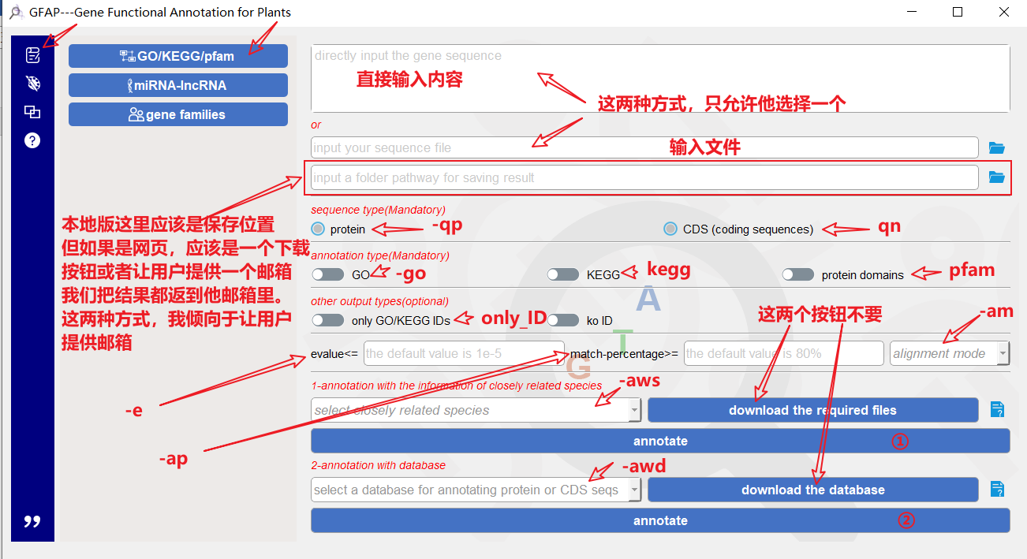

1. 调用的命令：

**python GFAP-linux.py -qp/qn** 用户的输入文件或内容 **-aws** 用户选择的内容 **-go/kegg/pfam** (这里是一个多选，根据用户选择，这里也会是-go -kegg -pfam) **-am** (fast 或者sensitive或者不设置该选项) **-e** 用户设置的值(可设可不设) **-ap** 用户设置的值(可设可不设) -**only_ID** (可设可不设) **-o** 保存的文件夹（如果前面的是一个多选，这里会同时产生多个结果文件，所以应该是一个文件夹的路径，然后将这个文件夹中的所有结果都发送给用户，发送完成后删除文件）

1. 调用的命令：

**python GFAP-linux.py -qp/qn** 用户的输入文件或内容 **-awd** 用户选择的内容 **-go/kegg/pfam** (这里是一个多选，根据用户选择，这里也会是-go -kegg -pfam) **-am** (fast 或者sensitive或者不设置该选项) **-e** 用户设置的值(可设可不设) **-ap** 用户设置的值(可设可不设) -**only_ID** (可设可不设) **-o** 保存的文件夹（如果前面的是一个多选，这里会同时产生多个结果文件，所以应该是一个文件夹的路径，然后将这个文件夹中的所有结果都发送给用户，发送完成后删除文件）

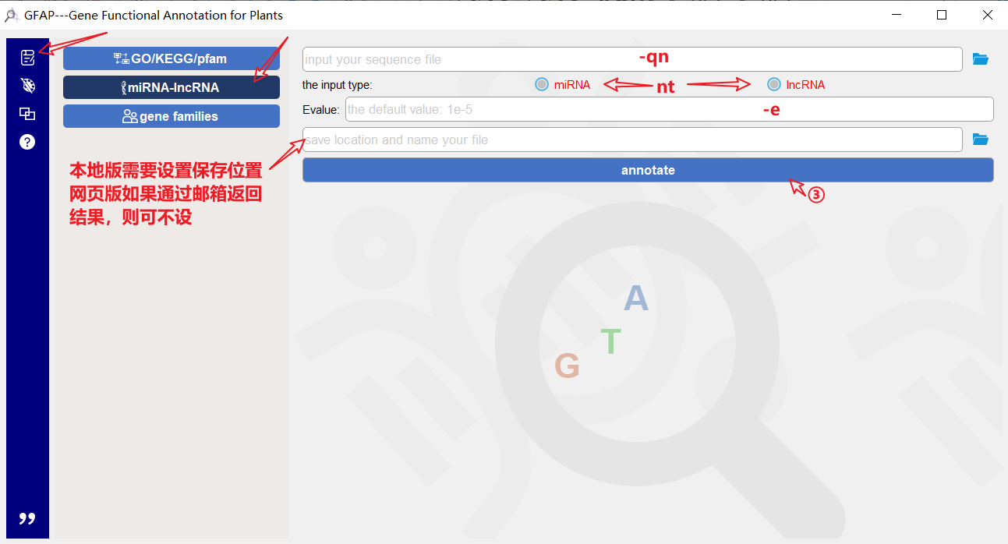

1. 调用的命令：

python GFAP-linux.py -na -nt (根据用户选择分miRNA或者lncRNA) -qn 用户输入文件 -o 结果文件的保存路径，完成后发送给用户（可考虑发送完成后删除，以下不赘述）。

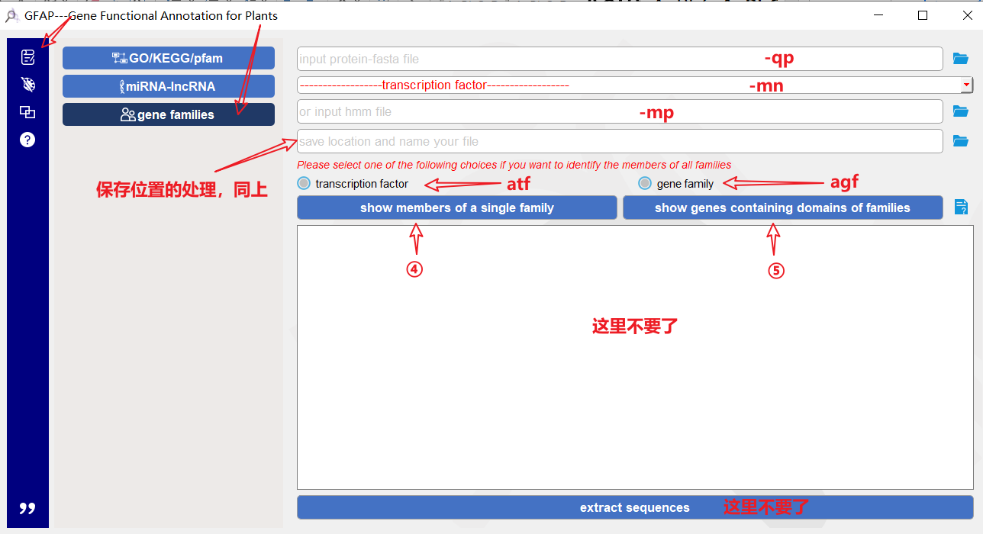

1. 调用的命令：

**python GFAP-linux.py -sf -qp** (输入文件) **-mn/mp** (这里需要检测mp处是否有文件放入，如果有文件放入则该处的参数是mp并加输入文件，如果没有，则是mn并加用户选择的内容) **-o** (结果文件的保存路径，处理方法同前)

1. 调用的命令：

**python GFAP-linux.py -mf -atf/agf** (筛选转录因子/非转录因子家族) **-qp** (输入文件) **-o** (结果文件的保存路径)

1. 调用的命令：

**python GFAP-linux.py -ds -ar** (输入文件) **-cut_value** (有默认值，用户可设可不设,以下相同) **-gn** (有默认值，用户可设可不设) **-drawtypes** (接值) **-colormodel** (接值) **-sts** (接值) **-singlecolor** **-go/-kegg/pfam** **-o** (会将结果保存到：./draw/)

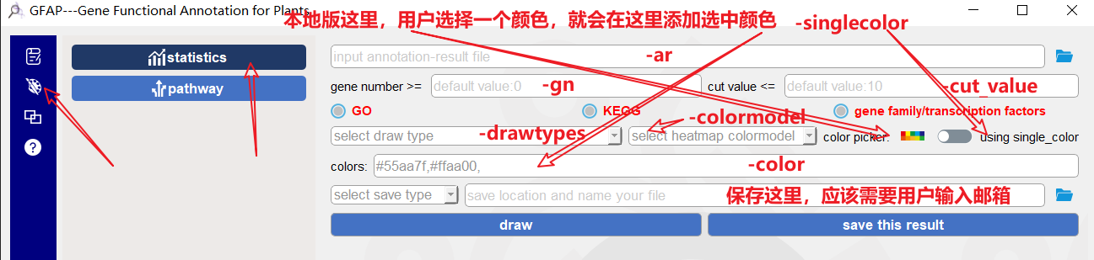

**pfam**

**-kegg**

**-go**

**7**

**-st**

**6**

这个功能执行完成后，会保存在结果会保存在服务器上（地址和名字是./draw/ draw_detail.svg），需要在这个界面的下方提供一个框，用于展示这个结果（如何将图片传给页面需要陶老师来解决）。**网页版这里，按钮6和7做一个合并**。展示结果，同时也向邮箱发送一份结果。**注意，-pfam对应的那个按钮显示的不对，应该显示为pfam**

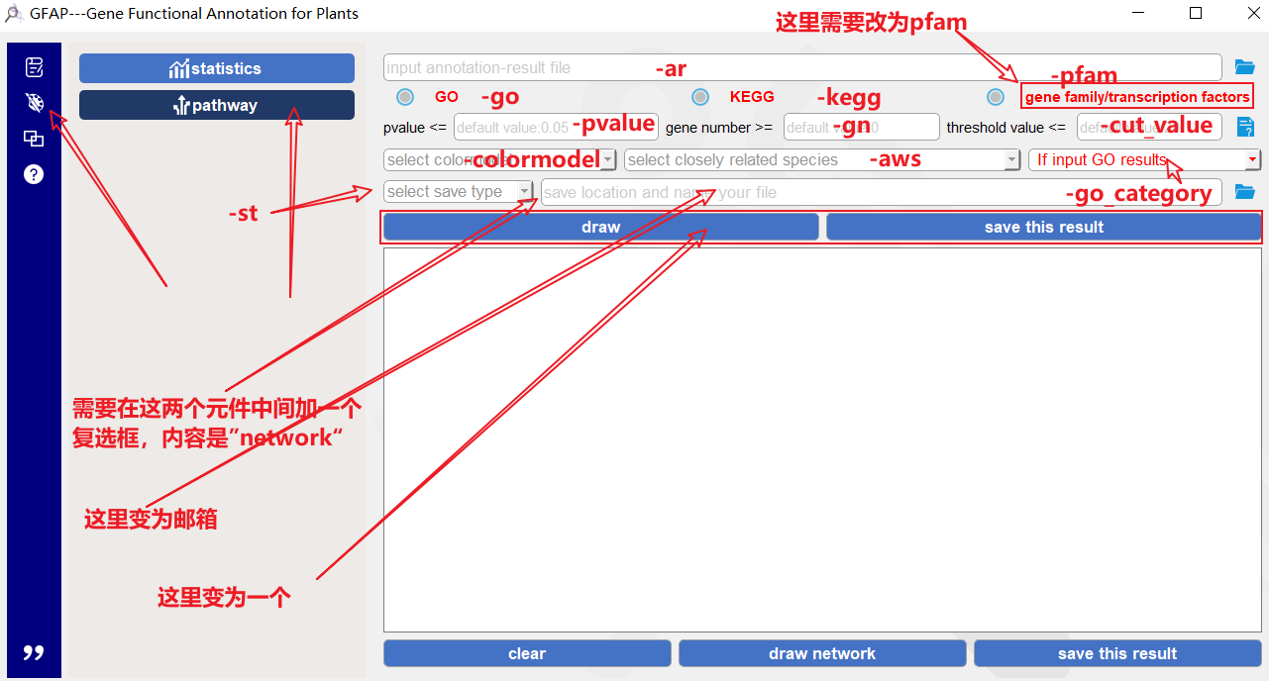

**7**

**这个元件删除以及删除下面三个元件**

1. 调用的命令：

**python GFAP-linux.py -dn -ar** (输入文件) **-cut_value** (有默认值，用户可设可不设,以下相同) **-gn** (有默认值，用户可设可不设) **-pvalue** (有默认值，用户可设可不设) **-colormodel** (接值) **-aws** (接值) **-st** (接值) **-gca** (接值) **-go/kegg/pfam** **-o** (会将结果保存到：./draw/)

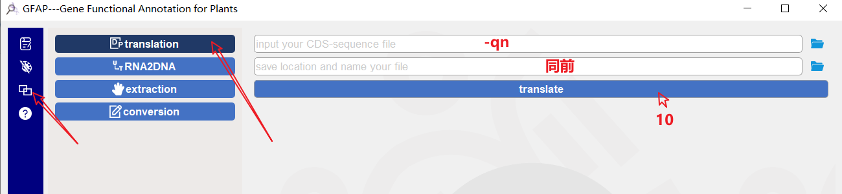

10、调用命令：

**python GFAP-linux.py -t -qn** (输入文件) **-o** (结果文件的保存路径，同前)

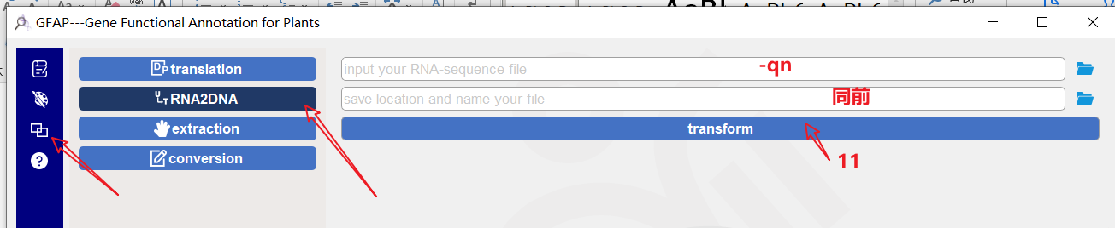

11、调用命令：

**python GFAP-linux.py -rd -qn** (输入文件) **-o** (结果文件的保存路径，同前)

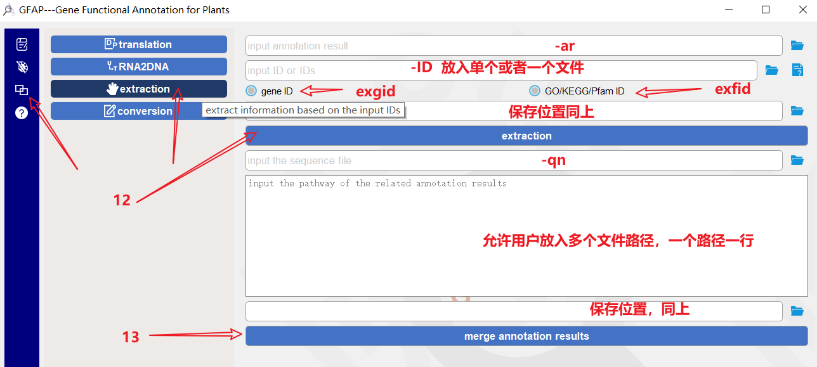

网页版，这里放小一些，就放个文本框吧，需要用户输入的是一个文件夹

12、调用命令：

**python GFAP-linux.py -ex -ar** (输入文件) **-ID** (ID或者ID文件) **-exfid/exgid** (选其一) **-o** (结果文件的保存路径，同上)

13、调用命令：

**python GFAP-linux.py -mr - qn** (输入文件) -rp (需要将之前的结果放入一个空文件夹并在此输入该文件夹的位置，注意移动文件的过程中不要更改文件名字) **-o** (结果文件的保存路径，同上)

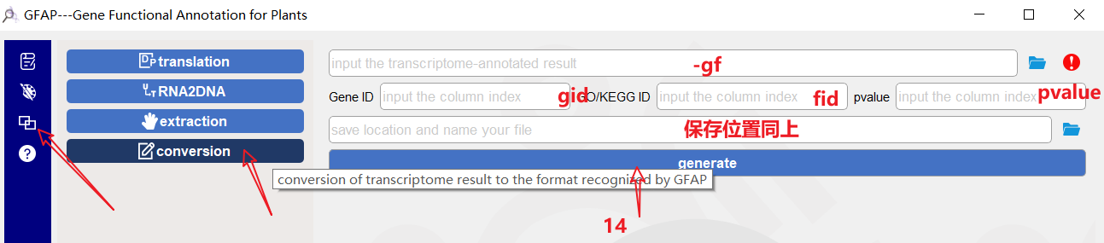

14、调用命令：

**python GFAP-linux.py -cf -gf** (输入文件) **-gid** (基因ID在结果文件中的index，接收的是一个整数) **-fid** (go/pfam/kegg在结果文件中的index，接收的是一个整数) **-pvalue** (pvalue在结果文件中的index，接收的是一个整数) **-o** (结果文件的保存路径，对结果的处理同上)

二、各下拉列表中的选项：

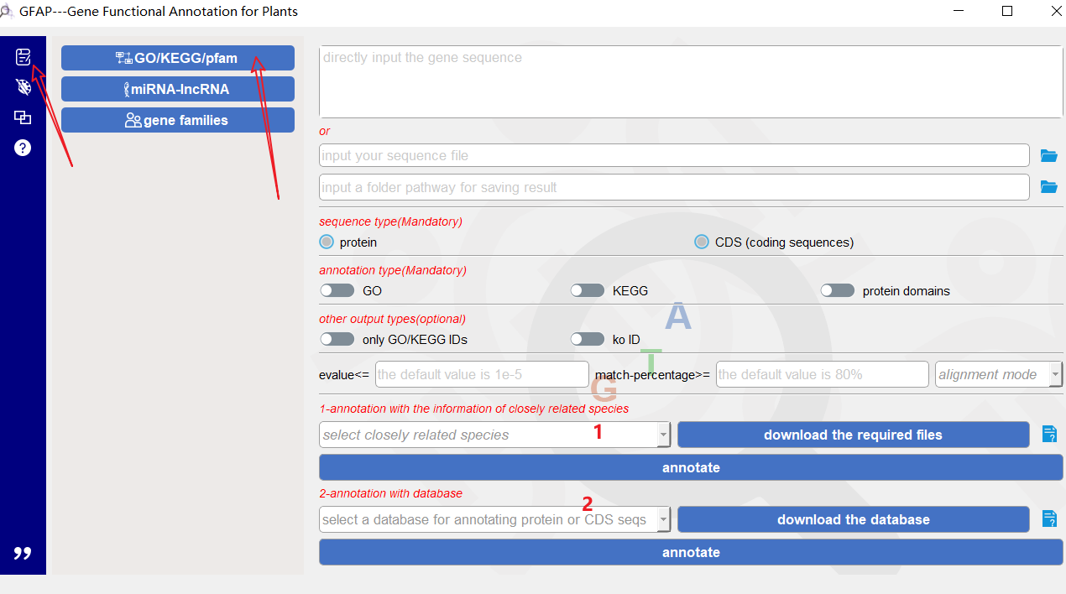

1、

['selectcloselyrelatedspecies','Abies_alba(Pinaceae)','Abrus_precatorius(Fabaceae)','Acer_yangbiense(Aceraceae)','Actinidia_chinensis(Actinidiaceae)','Aegilops_tauschii(Poaceae)','Alyssum_linifolium(Brassicaceae)','Amaranthus_hypochondriacus(Amaranthaceae)','Amborella_trichopoda(Amborellaceae)','Ananas_comosus(Bromeliaceae)','Aquilegia_coerulea(Ranunculaceae)','Arabidopsis_halleri(Brassicaceae)','Arabidopsis_lyrata(Brassicaceae)','Arabidopsis_thaliana(Brassicaceae)','Arabis_alpina(Brassicaceae)','Arachis_hypogaea(Brassicaceae)','Arachis_ipaensis(Brassicaceae)','Asparagus_officinalis(Liliaceae)','Asparagus_setaceus(Liliaceae)','Auxenochlorella_protothecoides(Chlorellaceae)','Azolla_filiculoides(Salviniaceae)','Bathycoccus_prasinos(Bathycoccaceae)','Benincasa_hispida(Cucurbitaceae)','Beta_vulgaris(Chenopodiaceae)',

'Betula_platyphylla(Betulaceae)','Boechera_stricta(Brassicaceae)','Brachypodium_distachyon(Poaceae)','Brachypodium_hybridum(Poaceae)','Brachypodium_stacei(Poaceae)','Brassica_carinata(Brassicaceae)','Brassica_chinensis(Brassicaceae)','Brassica_juncea(Brassicaceae)','Brassica_napus(Brassicaceae)','Brassica_nigra(Brassicaceae)','Brassica_oleracea(Brassicaceae)','Brassica_rapa(Brassicaceae)','Cajanus_cajan(Fabaceae)','Camelina_sativa(Brassicaceae)','Camellia_sinensis(Theaceae)','Cannabis_sativa(Cannabaceae)','Capsella_grandiflora(Bignoniaceae)','Capsella_rubella(Brassicaceae)','Capsicum_annuum(Solanaceae)','Capsicum_baccatum(Solanaceae)','Capsicum_chinense(Solanaceae)','Carica_papaya(Caricaceae)','Carya_illinoinensis(Juglandaceae)','Ceratodon_purpureus(Ditrichaceae)','Chara_braunii(Characeae)','Chenopodium_quinoa(Chenopodiaceae)','Chimonanthus_praecox(Calycanthaceae)','Chlamydomonas_reinhardtii(Chlamydomonadaceae)','Chlorella_variabilis(Chlorellaceae)','Chondrus_crispus(Gigartinaceae)','Cicer_arietinum(Fabaceae)','Citrullus_lanatus(Cucurbitaceae)','Citrus_clementina(Rutaceae)','Citrus_sinensis(Rutaceae)','Citrus_unshiu(Rutaceae)','Coccomyxa_subellipsoidea(Trebouxiophyceae)','Coffea_canephora(Rubiaceae)','Coffea_eugenioides(Rubiaceae)','Corchirus_olitorius(Malvaceae)','Corchorus_capsularis(Malvaceae)','Corymbia_citriodora(Myrtaceae)','Cucumis_melo(Cucurbitaceae)','Cucumis_sativus(Cucurbitaceae)','Cucurbita_argyrosperma(Cucurbitaceae)','Cucurbita_moschata(Cucurbitaceae)','Cucurbita_pepo(Cucurbitaceae)','Cyanidioschyzon_merolae(Galdieriaceae)','Cynara_cardunculus(Compositae)','Daucus_carota(Apiaceae)','Dendrobium_catenatum(Orchidaceae)','Dendrobium_officinale(Orchidaceae)','Dioscorea_alata(Dioscoreaceae)','Dioscorea_cayenensis(Dioscoreaceae)','Durio_zibethinus(Malvaceae)','Elaeis_guineensis(Arecaceae)','Ensete_ventricosum(Musaceae)','Eragrostis_curvula(Poaceae)','Eragrostis_tef(Poaceae)','Eremochloa_ophiuroides(Poaceae)','Erigeron_canadensis(Compositae)',

'Erythranthe_guttata(Phrymaceae)','Eucalyptus_grandis(Myrtaceae)','Eutrema_salsugineum(Brassicaceae)','Fragaria_ananassa(Rosaceae)','Fragaria_vesca(Rosaceae)','Galdieria_sulphuraria(Cyanidiaceae)','Ginkgo_biloba(Ginkgoaceae)','Glycine_max(Fabaceae)','Glycine_soja(Fabaceae)','Gnetum_montanum(Gnetaceae)','Gossypium_hirsutum(Malvaceae)','Gossypium_raimondii(Malvaceae)','Handroanthus_impetiginosus(Bignoniaceae)','Helianthus_annuus(Compositae)','Herrania_umbratica(Fabaceae)','Hevea_brasiliensis(Euphorbiaceae)','Hibiscus_syriacus(Malvaceae)','Hordeum_vulgare(Poaceae)','Hylocereus_undatus(Cactaceae)','Ipomoea_nil(Convolvulaceae)','Ipomoea_triloba(Convolvulaceae)','Jatropha_curcas(Euphorbiaceae)','Juglans_regia(Juglandaceae)','Kalanchoe_fedtschenkoi(Crassulaceae)','Kalanchoe_laxiflora(Crassulaceae)',

'Kandelia_obovata(Rhizophoraceae)','Lactuca_sativa(Compositae)','Leersia_perrieri(Poaceae)','Lindenbergia_philippensis(Orobanchaceae)','Linum_usitatissimum(Linaceae)','Liriodendron_chinense(Magnoliaceae)','Lobularia_maritima(Brassicaceae)','Lotus_japonicus(Fabaceae)','Lupinus_albus(Fabaceae)','Lupinus_angustifolius(Fabaceae)','Macadamia_integrifolia(Proteaceae)','Manihot_esculenta(Euphorbiaceae)','Marchantia_polymorpha(Marchantiaceae)','Medicago_truncatula(Fabaceae)','Micromonas_commoda(Mamiellaceae)','Micromonas_pusilla(Mamiellaceae)','Mimulus_guttatus(Phrymaceae)','Miscanthus_sinensis(Fabaceae)','Momordica_charantia(Cucurbitaceae)','Monoraphidium_neglectum(Sphaeropleales)','Morus_notabilis(Moraceae)','Musa_acuminata(Musaceae)','Nelumbo_nucifera(Nymphaeaceae)','Nicotiana_attenuata(Solanaceae)','Nicotiana_tabacum(Solanaceae)','Nymphaea_colorata(Nymphaeaceae)','Olea_europaea(Oleaceae)','Oropetium_thomaeum(Poaceae)','Oryza_sativa(Poaceae)','Ostreococcus_lucimarinus(Bathycoccaceae)','Ostreococcus_tauri(Bathycoccaceae)','Panicum_hallii(Poaceae)','Panicum_virgatum(Poaceae)','Papaver_somniferum(Papaveraceae)','Petunia_axillaris(Solanaceae)','Phalaenopsis_equestris(Orchidaceae)','Pharus_latifolius(Poaceae)','Phaseolus_acutifolius(Fabaceae)','Phaseolus_vulgaris(Papilionaceae)','Phoenix_dactylifera(Arecaceae)','Phyllostachys_heterocycla(Fabaceae)','Physcomitrella_patens(Funariaceae)','Picea_abies(Pinaceae)','Pinus_lambertiana(Pinaceae)','Pinus_taeda(Pinaceae)','Piper_nigrum(Piperaceae)','Pistacia_vera(Anacardiaceae)','Poncirus_trifoliata(Rutaceae)','Populus_bolleana(Salicaceae)','Populus_deltoides(Salicaceae)','Populus_euphratica(Salicaceae)','Populus_trichocarpa(Salicaceae)','Portulaca_amilis(Portulacaceae)','Prosopis_alba(Poaceae)','Prunus_avium(Rosaceae)','Prunus_dulcis(Rosaceae)','Prunus_persica(Rosaceae)','Punica_granatum(Punicaceae)','Pyrus_x_bretschneideri(Rosaceae)','Quercus_lobata(Fagaceae)','Quercus_rubra(Fagaceae)','Quercus_suber(Fagaceae)','Raphanus_sativus(Brassicaceae)','Rhodamnia_argentea(Myrtaceae)','Ricinus_communis(Euphorbiaceae)','Rosa_chinensis(Rosaceae)','Rosa_rugosa(Rosaceae)','Saccharum_spontaneum(Poaceae)','Salix_purpurea(Salicaceae)','Salvia_splendens(Lamiaceae)','Schrenkiella_parvula(Brassicaceae)','Selaginella_moellendorffii(Selaginellaceae)','Sequoia_sempervirens(Taxodiaceae)','Sesamum_indicum(Pedaliaceae)','Setaria_italica(Poaceae)','Setaria_viridis(Poaceae)','Solanum_lycopersicum(Solanaceae)','Solanum_pennellii(Solanaceae)','Solanum_tuberosum(Solanaceae)','Sorghum_bicolor(Poaceae)','Spinacia_oleracea(Chenopodiaceae)','Spirodela_polyrhiza(Lemnaceae)','Synechocystis_sp.pcc(Chroococcaceae)','Tarenaya_hassleriana(Capparaceae)',

'Theobroma_cacao(Malvaceae)','Trifolium_pratense(Fabaceae)','Triticum_aestivum(Poaceae)','Urochloa_fusca(Poaceae)','Utricularia_gibba(Lentibulariaceae)','Vaccinium_macrocarpon(Ericaceae)','Vigna_angularis(Fabaceae)','Vigna_radiata(Fabaceae)','Vigna_unguiculata(Fabaceae)','Vitis_vinifera(Vitaceae)','Volvox_carteri(Pseudoviridae)','Xanthoceras_sorbifolium(Sapindaceae)','Zea_mays(Poaceae)','Zingiber_officinale(Zingiberaceae)','Ziziphus_jujuba(Rhamnaceae)','Zostera_marina(Zosteraceae)']

2、

["select a database for annotating protein or CDS seqs","plant-special database","total database","nr","swissprot"]

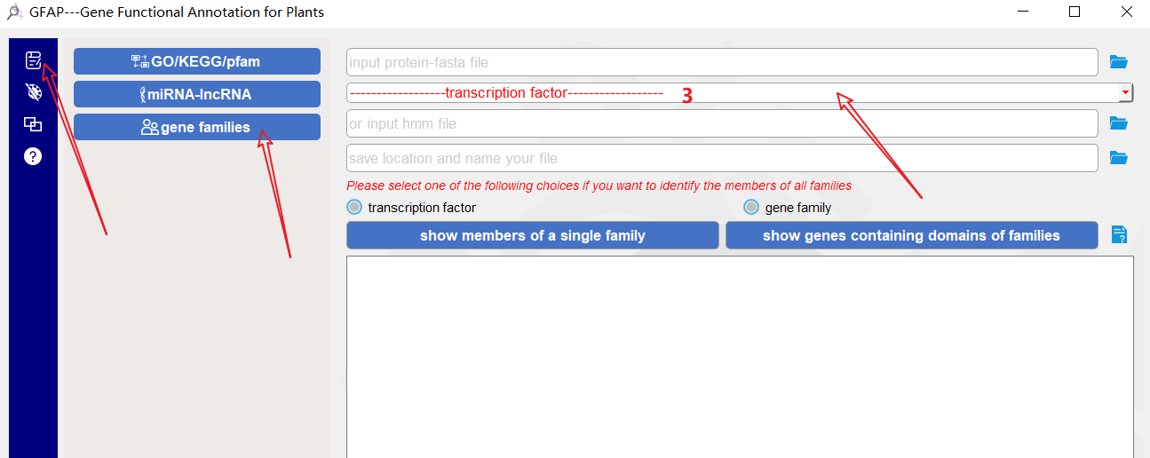

3、

['------------------transcription factor------------------','AP2 (APETALA2)', 'AP2ERF', 'ARR (Arabidopsis response regulators)','ARF (Auxin response factors)', 'B3','BBR-BPC (barley B-recombinant/basic pentacysteine)','BES1 (BRI1-EMS-SUPPRESSOR 1)','bHLH (basic Helix-Loop-Helix)', 'bZIP (basic leucine zipper)','CAMTA (calmodulin binding transcription activator)', 'CO (CONSTANS)', 'CPP (cystein-rich polycomb)','DBB (double B-box zinc finger)', 'E2FDP (Early 2 factor )', 'EIL (EIN3-like)','FAR1 (FAR‐RED‐IMPAIRED RESPONSE1)', 'G2-like (GARP superfamily)', 'GATA','GRAS (gibberellic acid insensitive)', 'GRF (Growth regulating-factors)','HB-PHD (homeobox and protein domain, the homeodomain)', 'HB (homeobox)',

'HSF (heat shock transcription factor)', 'LBD (lateral organ boundaries domain)', 'LFY (LEAFY)',

'MADS', 'MYB', 'NAC (NAM, ATAF1/2, and CUC2)', 'NFYA', 'NFYB','NOZZLE', 'RAV (ABI3/VP1)',

'S1FA', 'SBP (SQUAMOSA promoter-binding protein)', 'SRS (Shi-related sequence)', 'STAT',

'TALE (three-amino-acid-loop-extension)', 'TCP (Teosinte branched 1/Cycloidea/Proliferating cell factor)','tify (TIF[F/Y]XG)', 'Trihelix (helix-loop-helix-loop-helix)', 'WHY (Whirly)','WOX (WUSCHEL-related homeobox)', 'WRKY', 'YABBY', 'zf-C2H2 (C2H2-type zinc finger)','zf-CCCH (CCCH-type zinc finger protein)', 'zf-Dof (DNA binding with one finger)', 'ZF-HD (Zinc finger homeodomain)','','------------------gene family------------------','AAO (Ascorbic acid oxidase)', 'ABC (ATP-binding cassette)','AIG (avrRpt2-induced gene)', 'Alba (acetylation lowers binding affinity)', 'Amts (Ammonium transporter)','Ank (ankyrin)', 'ASR (ABA,stress,and ripening-induced)', 'AUX_IAA', 'BSP (basic secretory protein)','bZIP (basic leucine zipper)', 'Chs (chitin synthase)','CIPKs (Calcineurin B-like protein-interacting protein kinases)', 'CK (Choline kinase)','CNGC (cyclic nucleotide-gated ion channel)', 'COL1 (CONSTANS-LIKE)', 'Csl (cellulose synthase-like)','DREB (dehydration responsive element-binding)', 'DUF (Domain of unknown function)', 'Expansin','F-box (F-box motifs)', 'FAD2 (FA_desaturase)', 'FBA (Fructose-1,6-bisphosphate Aldolase)','GAox (gibberellin-dioxygenases)', 'GASA (Gibberellic Acid Stimulated in Arabidopsis)','GELP (GDSL-type esterases_lipases)', 'HAC (Histone acetylation protein)','HAF (TATA box-binding protein binding)', 'HAG (Gcn5-related N- acetyltransferase)','HAK (K+ potassium transporter)', 'HDA (Histone deacetylase)', 'HDMA (SWIRM domain)','HMA (heavy metal-associated)', 'HSP (Heat shock proteins)', 'HXK (Hexokinase)', 'H_PPase (H+-PPase)','JHDM (JmjC domain-containing histone demethylase)', 'JMJs (JmjC domain_hydroxylase)','LEA (Late embryogenesis abundant)', 'LecRLKs (Lectin receptor-like kinases)', 'LOX (lipoxygenase)','LPP (phosphatase superfamily)', 'LRR (Leucine Rich Repeat)', 'LTP (lipid transfer proteins)','LysM (lysin motif)','MAPKs (Mitogen-activated protein kinase)','MATE (Multidrug and Toxic Compound Extrusion)', 'MOZ_SAS', 'MRP (multidrug resistance proteins)','MST (Monosaccharide transporter)', 'NBS (nucleotide-binding site)','NRAMP (natural resistance associated macrophage protein)', 'P-ATPase (P-type H+-ATPase)','p450 (Cytochromes P450)', 'PAL (Phenylalanine ammonia-lyase)','PEBP (phosphatidy ethanolamine-binding protein)', 'PLD (Phospholipase D)', 'PP2C (phosphatase 2C)','PRMTs (PRMT5 arginine-N-methyltransferase)', 'PRO (Probable reticuline oxidase)', 'Prxs (Peroxidases)','PSY (Phytoene synthase)', 'PT (phosphate transporter)', 'PYRPYL (pyrabactin resistance)','rboh (respiratory burst oxidase homolog)', 'RGP (eversible glycosylation polypeptide)','SET (SET domain)', 'SOD (Superoxide Dismutase)', 'sox (high mobility group)','SPL (squamosa promoter-binding protein-like)', 'SRTs (Sir2 family)', 'TGF (transforming growth factor)','TPS (trehalose-6-phosphate synthase)', 'TSs (Terpene synthases)']

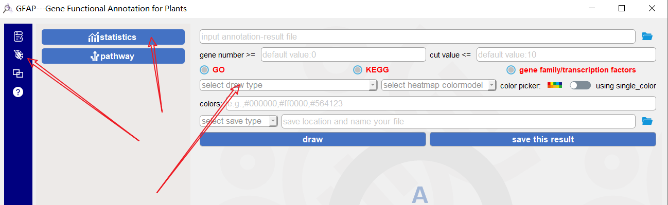

4、

['select draw type ','bar chart','heatmap']

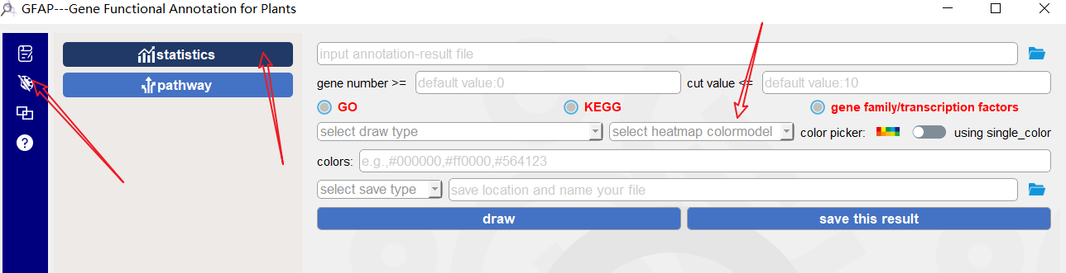

5、

['select heatmap colormodel',"cy2bl","lp2dp","cy2p","rcy2cy","cy2bb","lcy2dcy","lg2cy","lg2db","r2cy","lb2db","r2g","y2b","r2b","yrp","y2cy","y2p","lr2dr","lpk2dpk","y2pur","pur2b","y2r","dp2b","o2cy","y2db","y2o","y2lp","o2r","y2g"]

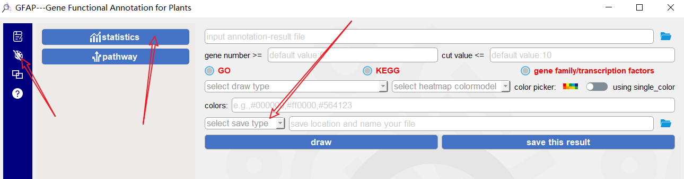

6、

["select save type","svg","pdf"]

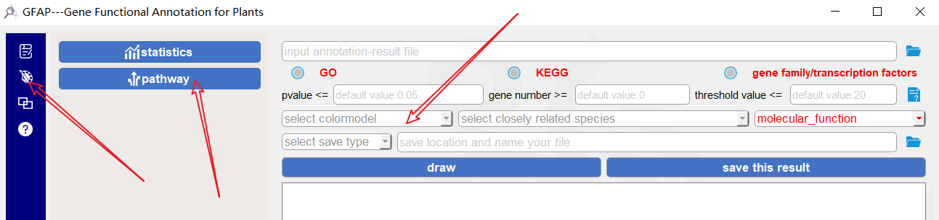

7、['select heatmap colormodel',"cy2bl","lp2dp","cy2p","rcy2cy","cy2bb","lcy2dcy","lg2cy","lg2db","r2cy","lb2db","r2g","y2b","r2b","yrp","y2cy","y2p","lr2dr","lpk2dpk","y2pur","pur2b","y2r","dp2b","o2cy","y2db","y2o","y2lp","o2r","y2g"]

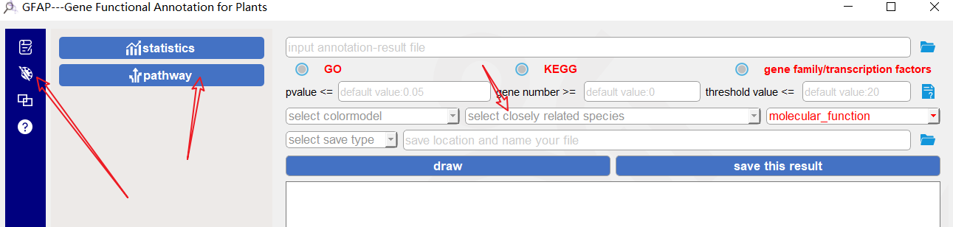

8、同第一个

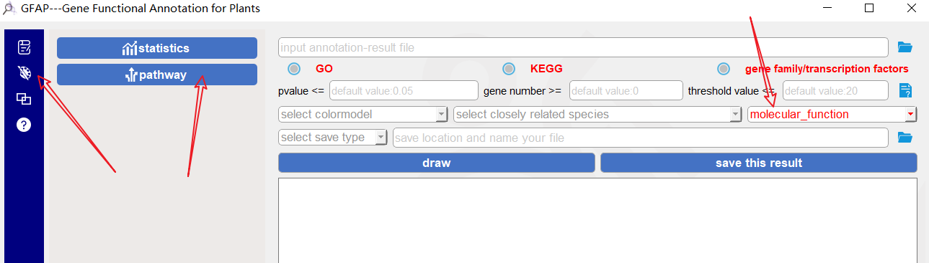

9、

[' If input GO results','biological_process','cellular_component','molecular_function']

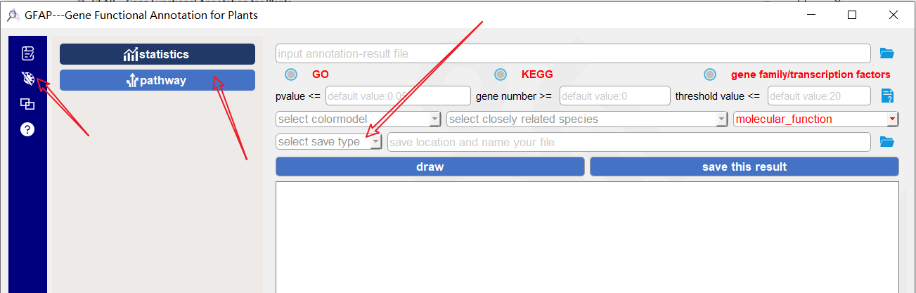

10、同第六个