**Báo Cáo Nhóm**

Danh Sách:

Nguyễn Phan Quốc Thắng 14047941

Nguyễn Minh Vĩ 14054491

Nguyễn VĂn Cương 14027141

Class Employee:

**package** sample;

**public** **class** Employee **implements** java.io.Serializable{

**private** String Ten;

**private** **int** tuoi;

**private** String dc;

**public** Employee() {

**this**("",0,"");

}

**public** Employee(String ten, **int** tuoi, String dc) {

**super**();

**this**.Ten = ten;

**this**.tuoi = tuoi;

**this**.dc = dc;

}

**public** String getTen() {

**return** Ten;

}

**public** **void** setTen(String ten) {

Ten = ten;

}

**public** **int** getTuoi() {

**return** tuoi;

}

**public** **void** setTuoi(**int** tuoi) {

**this**.tuoi = tuoi;

}

**public** String getDc() {

**return** dc;

}

**public** **void** setDc(String dc) {

**this**.dc = dc;

}

**public** Employee getEmployee(String ten , **int** tuoi, String dc) {

Employee e = **new** Employee(ten, tuoi, dc);

**return** e;

}

}

Class Test:

/**

*

*/

**package** sample;

/**

* **@author** Minh Vi

*

*/

**public** **class** TEst {

**public** Employee getEmployee(String ten , **int** tuoi, String dc) {

Employee e = **new** Employee(ten, tuoi, dc);

**return** e;

}

}

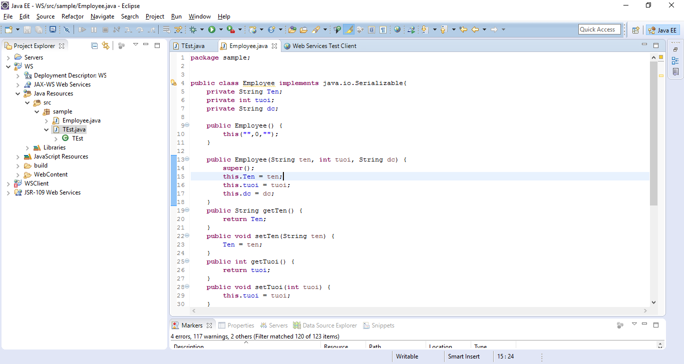

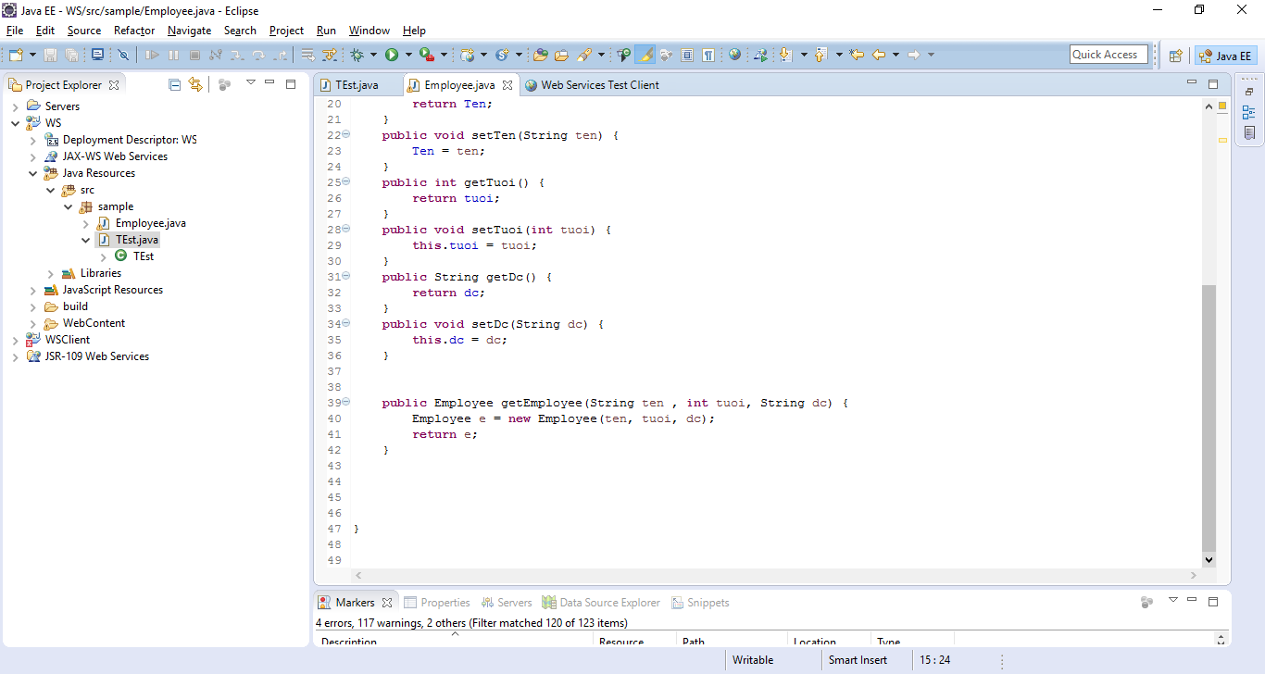

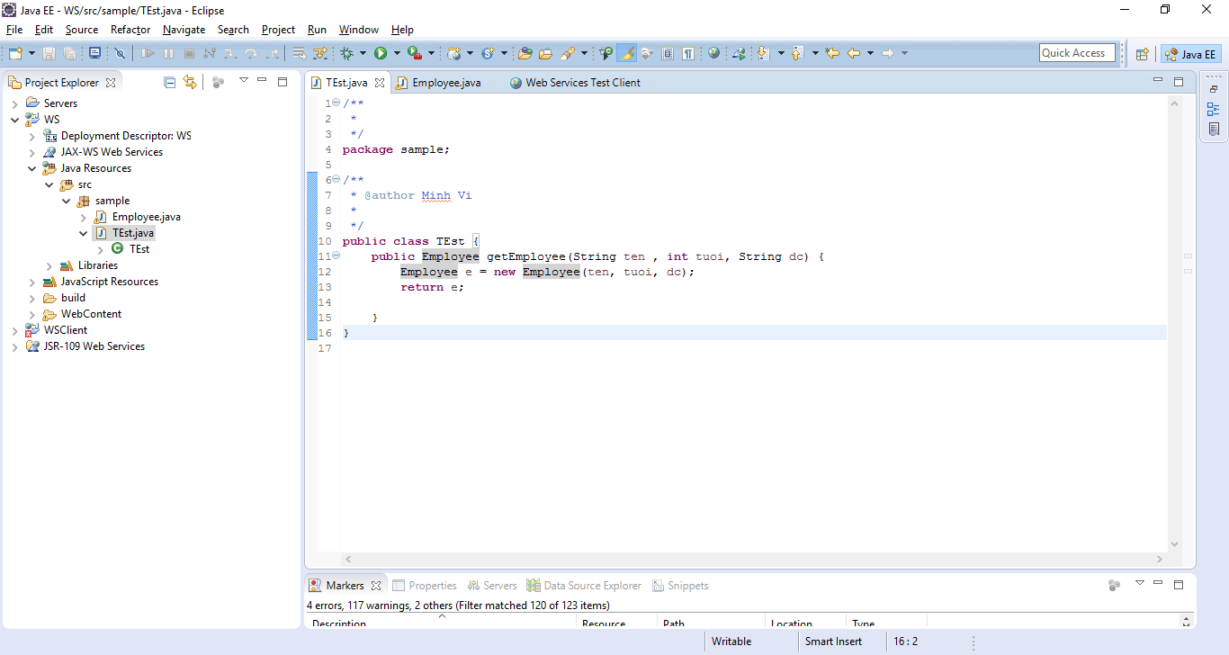

Kết quả test:

