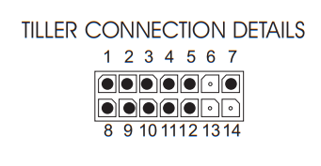

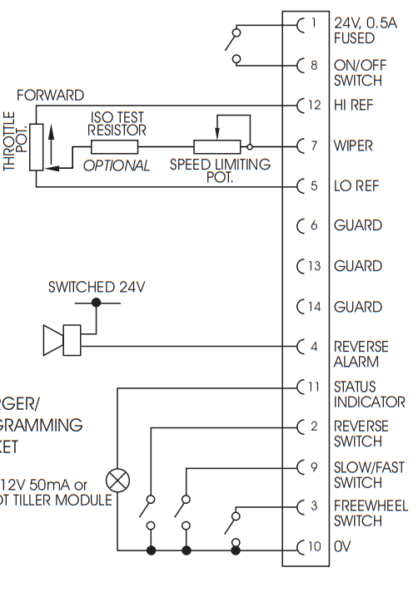
1-8 = on off. Rele.. Easy
7-12 = pot Back
7-5 = pot Forward

