Module 2 Challenge

**Background**

You are well on your way to becoming a programmer and Excel expert! In this homework assignment, you will use VBA scripting to analyze generated stock market data.

**Before You Begin**

1. Create a new repository for this project called VBA-challenge. **Do not add this assignment to an existing repository**.
2. Inside the new repository that you just created, add any VBA files that you use for this assignment. These will be the main scripts to run for each analysis.

**Instructions**

Create a script that loops through all the stocks for one year and outputs the following information:

* The ticker symbol
* Yearly change from the opening price at the beginning of a given year to the closing price at the end of that year.
* The percentage change from the opening price at the beginning of a given year to the closing price at the end of that year.
* The total stock volume of the stock. The result should match the following image:

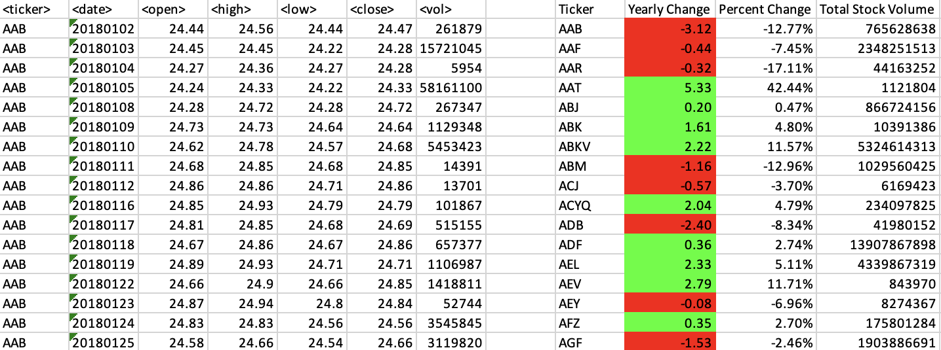

* Add functionality to your script to return the stock with the "Greatest % increase", "Greatest % decrease", and "Greatest total volume". The solution should match the following image:

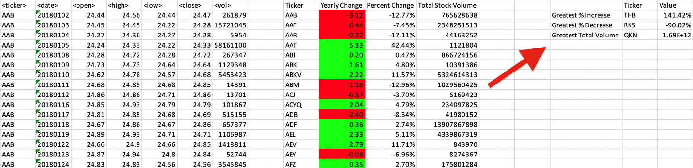

* Make the appropriate adjustments to your VBA script to enable it to run on every worksheet (that is, every year) at once.

**NOTE**

Make sure to use conditional formatting that will highlight positive change in green and negative change in red.

**Other Considerations**

* Use the sheet alphabetical_testing.xlsx while developing your code. This dataset is smaller and will allow you to test faster. Your code should run on this file in under 3 to 5 minutes.
* Make sure that the script acts the same on every sheet. The joy of VBA is that it takes the tediousness out of repetitive tasks with the click of a button.

**Requirements**

**Retrieval of Data (20 points)**

* The script loops through one year of stock data and reads/ stores all of the following values from each row:
  + ticker symbol (5 points)
  + volume of stock (5 points)
  + open price (5 points)
  + close price (5 points)

**Column Creation (10 points)**

* On the same worksheet as the raw data, or on a new worksheet all columns were correctly created for:
  + ticker symbol (2.5 points)
  + total stock volume (2.5 points)
  + yearly change ($) (2.5 points)
  + percent change (2.5 points)

**Conditional Formatting (20 points)**

* Conditional formatting is applied correctly and appropriately to the yearly change column (10 points)
* Conditional formatting is applied correctly and appropriately to the percent change column (10 points)

**Calculated Values (15 points)**

* All three of the following values are calculated correctly and displayed in the output:
  + Greatest % Increase (5 points)
  + Greatest % Decrease (5 points)
  + Greatest Total Volume (5 points)

**Looping Across Worksheet (20 points)**

* The VBA script can run on all sheets successfully.

**GitHub/GitLab Submission (15 points)**

* All three of the following are uploaded to GitHub/GitLab:
  + Screenshots of the results (5 points)
  + Separate VBA script files (5 points)
  + README file (5 points)