In this assignment we had to analyze stock data by looping through and make aggregations and leaderboards. The dataset was very large and diverse. Takeaway message- invest at own risk.

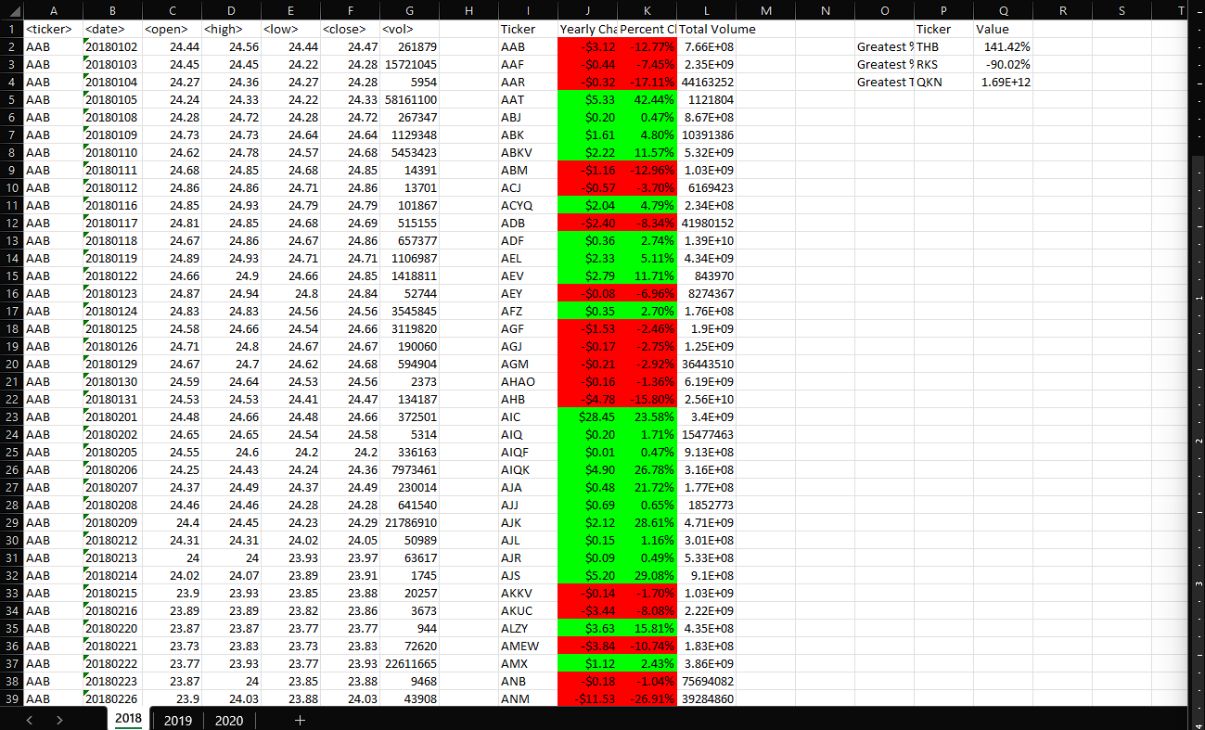

In 2018, Ticker RKS had an incredibly bad return (-90%) - perhaps due to a mismanaged product launch and/or scandal with the leadership structure resulting in the dismissal of several top executives and the loss of momentum and vision for the year. THB on the other hand exhibited steady growth for the 2018 year (141.42%) and it seems that their employees can look forward to a bonus payment at the end of the year.

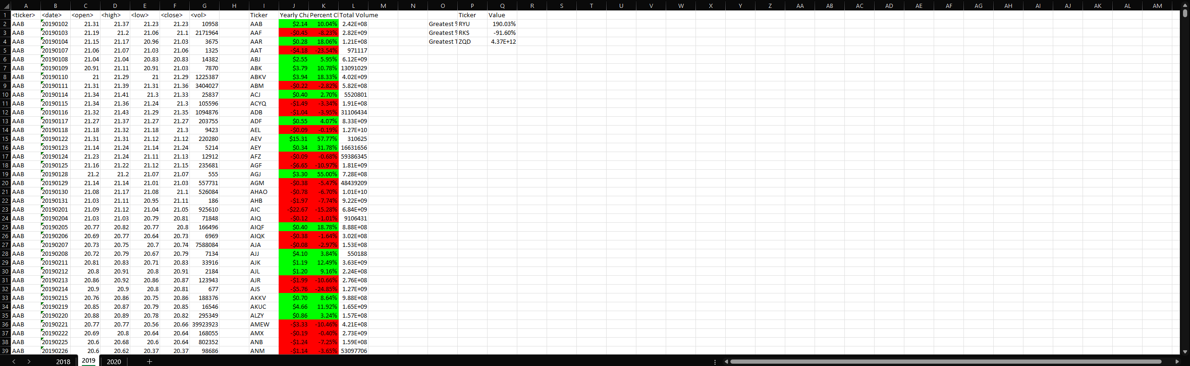

2019 shows RKS continually digging themselves into a hole (-91.6%) and you have to wonder if at this point if it is intentional. RYU is doing exceptional (190.03%) and I would recommend investing in them as this strong growth demonstrates a deep understanding of current market conditions.

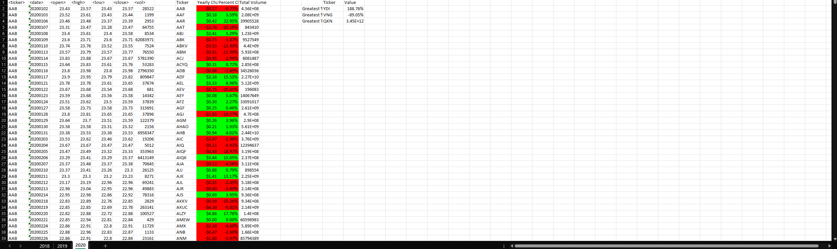

For 2020, VNG is showing some disappointing results (-89.05%) and you have to wonder if they acquired RKS after significant devaluation for two straight years and just couldn’t turn it around quickly. Best performer for the year was YDI (188.76%), and I would strongly recommend investigating what has made them a leader this year.

\*All code was provided by Instructor Alexander Booth.