Module 15 Challenge

**Background**

The United States Geological Survey, or USGS for short, is responsible for providing scientific data about natural hazards, the health of our ecosystems and environment, and the impacts of climate and land-use change. Their scientists develop new methods and tools to supply timely, relevant, and useful information about the Earth and its processes.

The USGS is interested in building a new set of tools that will allow them to visualize their earthquake data. They collect a massive amount of data from all over the world each day, but they lack a meaningful way of displaying it. In this challenge, you have been tasked with developing a way to visualize USGS data that will allow them to better educate the public and other government organizations (and hopefully secure more funding) on issues facing our planet.

**Before You Begin**

1. Create a new repository for this project called leaflet-challenge. **Do not add this Challenge to an existing repository**.
2. Clone the new repository to your computer.
3. Inside your local git repository, create a directory for the Leaflet challenge. Use the folder names to correspond to the challenges: **Leaflet-Part-1** and **Leaflet-Part-2**.
4. This Challenge uses both **HTML** and **JavaScript**, so be sure to add all the necessary files. These will be the main files to run for analysis.
5. Push the above changes to GitHub.

**Files**

Download the following files to help you get started:

[Module 15 Challenge filesLinks to an external site.](https://static.bc-edx.com/data/dl-1-2/m15/lms/starter/Starter_Code.zip)

**Instructions**

The instructions for this activity are broken into two parts:

* Part 1: Create the Earthquake Visualization
* Part 2: Gather and Plot More Data (Optional with no extra points earning)

**Part 1: Create the Earthquake Visualization**

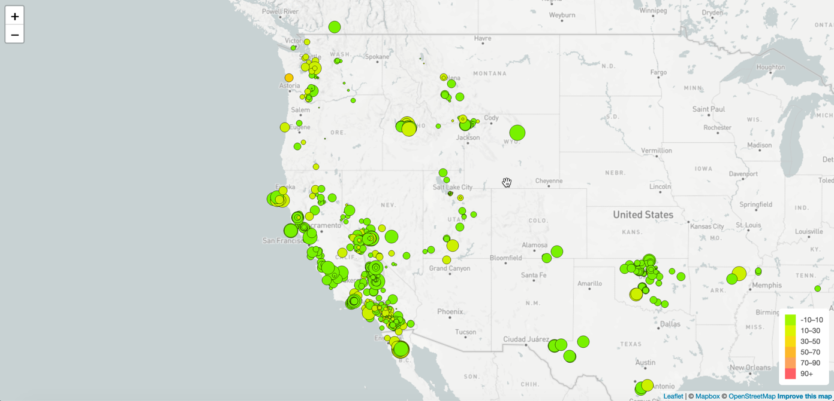

Your first task is to visualize an earthquake dataset. Complete the following steps:

1. Get your dataset. To do so, follow these steps:
   * The USGS provides earthquake data in a number of different formats, updated every 5 minutes. Visit the [USGS GeoJSON FeedLinks to an external site.](http://earthquake.usgs.gov/earthquakes/feed/v1.0/geojson.php) page and choose a dataset to visualize. The following image is an example screenshot of what appears when you visit this link:

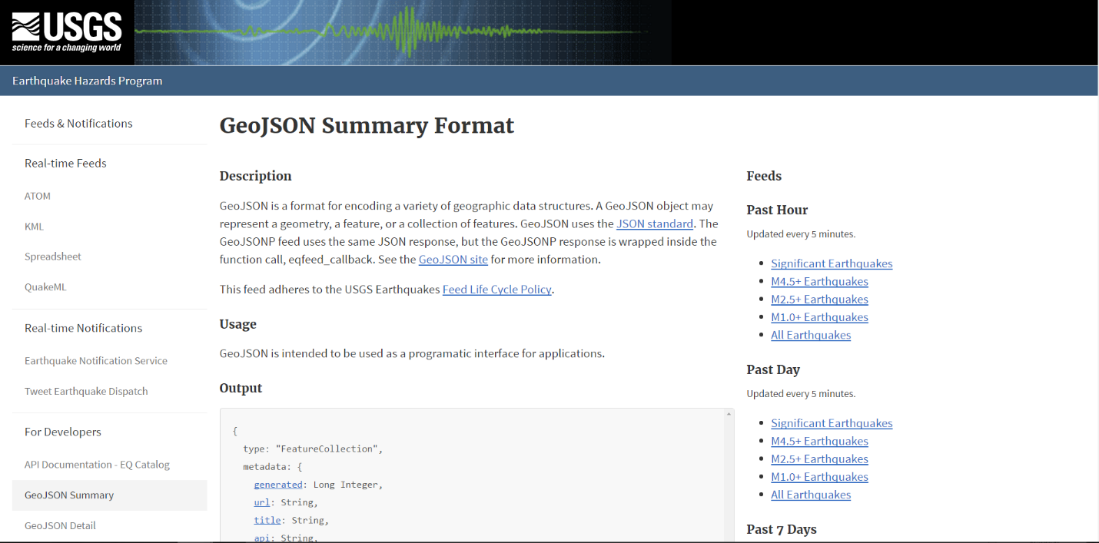

* + When you click a dataset (such as "All Earthquakes from the Past 7 Days"), you will be given a JSON representation of that data. Use the URL of this JSON to pull in the data for the visualization. The following image is a sampling of earthquake data in JSON format:

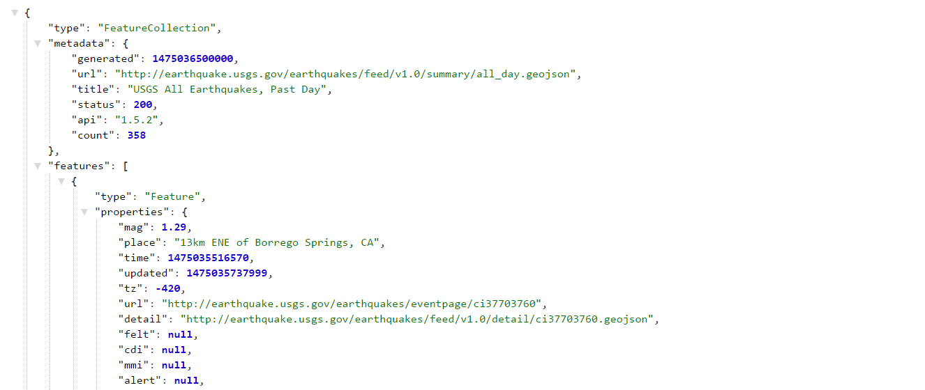

1. Import and visualize the data by doing the following:
   * Using Leaflet, create a map that plots all the earthquakes from your dataset based on their longitude and latitude.
     + Your data markers should reflect the magnitude of the earthquake by their size and the depth of the earthquake by color. Earthquakes with higher magnitudes should appear larger, and earthquakes with greater depth should appear darker in color.
     + **Hint:** The depth of the earth can be found as the third coordinate for each earthquake.
   * Include popups that provide additional information about the earthquake when its associated marker is clicked.
   * Create a legend that will provide context for your map data.
   * Your visualization should look something like the preceding map.

**Part 2: Gather and Plot More Data (Optional with no extra points earning)**

Plot a second dataset on your map to illustrate the relationship between tectonic plates and seismic activity. You will need to pull in this dataset and visualize it alongside your original data. Data on tectonic plates can be found at [https://github.com/fraxen/tectonicplatesLinks to an external site.](https://github.com/fraxen/tectonicplates).

This part is completely optional; you can complete this part as a way to challenge yourself and boost your new skills.

The following image is an example screenshot of what you should produce:

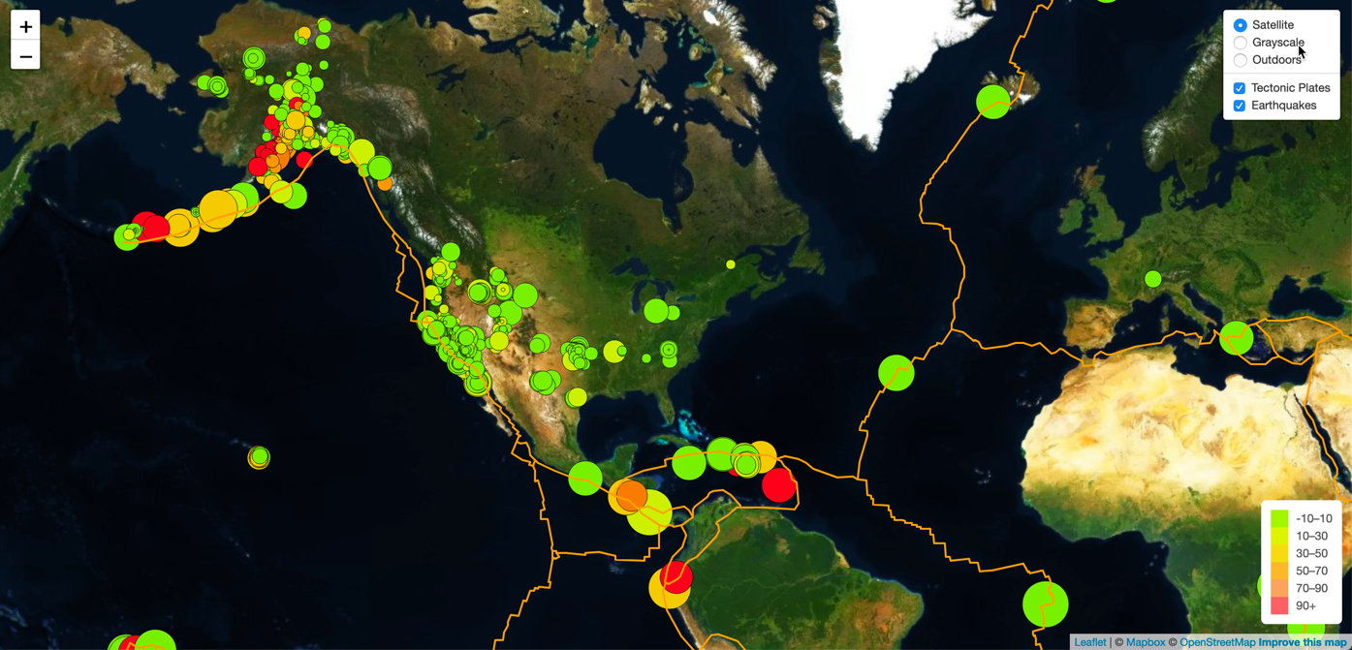

Perform the following tasks:

* Plot the tectonic plates dataset on the map in addition to the earthquakes.
* Add other base maps to choose from.
* Put each dataset into separate overlays that can be turned on and off independently.
* Add layer controls to your map.

**Requirements**

These requirements apply only to "Part 1: Create the Earthquake Visualization" as "Part 2" is optional with no extra points earning.

**Map (60 points)**

* TileLayer loads without error (20 points)
* Connects to geojson API using D3 without error (20 points)
* Markers with size corresponding to earthquake magnitude (10 points)
* A legend showing the depth and their corresponding color (10 points)

**Data Points (40 points)**

* Data points scale with magnitude level (10 points)
* Data points colors change with depth level (10 points)
* Each point has a tooltip with the Magnitude, the location and depth (10 points)
* All data points load in the correct locations (10 points)

**Grading**

This assignment will be evaluated against the requirements and assigned a grade according to the following table:

| **Grade** | **Points** |
| --- | --- |
| A (+/-) | 90+ |
| B (+/-) | 80–89 |
| C (+/-) | 70–79 |
| D (+/-) | 60–69 |
| F (+/-) | < 60 |

**Submission**

To submit your Challenge assignment, click Submit, and then provide the URL of your GitHub repository for grading.

**NOTE**

You are allowed to miss up to two Challenge assignments and still earn your certificate. If you complete all Challenge assignments, your lowest two grades will be dropped. If you wish to skip this assignment, click Next, and move on to the next module.

Comments are disabled for graded submissions in Bootcamp Spot. If you have questions about your feedback, please notify your instructional staff or your Student Success Advisor. If you would like to resubmit your work for an additional review, you can use the Resubmit Assignment button to upload new links. You may resubmit up to three times for a total of four submissions.

**IMPORTANT**

**It is your responsibility to include a note in the README section of your repo specifying code source and its location within your repo**. This applies if you have worked with a peer on an assignment, used code in which you did not author or create sourced from a forum such as Stack Overflow, or you received code outside curriculum content from support staff such as an Instructor, TA, Tutor, or Learning Assistant. This will provide visibility to grading staff of your circumstance in order to avoid flagging your work as plagiarized.

If you are struggling with a challenge assignment or any aspect of the academic curriculum, please remember that there are student support services available for you:

1. Ask the class Slack channel/peer support.
2. AskBCS Learning Assistants exists in your class Slack application.
3. Office hours facilitated by your instructional staff before and after each class session.
4. [Tutoring GuidelinesLinks to an external site.](https://docs.google.com/document/d/1hTldEfWhX21B_Vz9ZentkPeziu4pPfnwiZbwQB27E90/edit?usp=sharing) - schedule a tutor session in the Tutor Sessions section of Bootcampspot - Canvas
5. If the above resources are not applicable and you have a need, please reach out to a member of your instructional team, your Student Success Advisor, or submit a support ticket in the Student Support section of your BCS application.

**References**

Dataset created by [the United States Geological SurveyLinks to an external site.](http://earthquake.usgs.gov/earthquakes/feed/v1.0/geojson.php).