We began the b) questions by importing our libraries and reading in the csv file to display our dataset. We determined that we could get a percentage of the payment source data to determine what if any was the favored method of payment.

**Hypothesis:** Our hypothesis is that Credit Card was going to be the favored category, with cash being in the last place. This is because shoppers typically do not carry cash with them, and online orders require credit card or bank information, not physical currency. Limitations of this dataset include: not listing specific credit card companies, Venmo being owned by Paypal, Venmo not typically being an accepted form of payment at retailers, Paypal and Venmo being transaction agents and not final payment sources, and what if any was the difference between a Bank Transfer, a Debit Card purchase and Cash? The following is our results for payment method analysis.

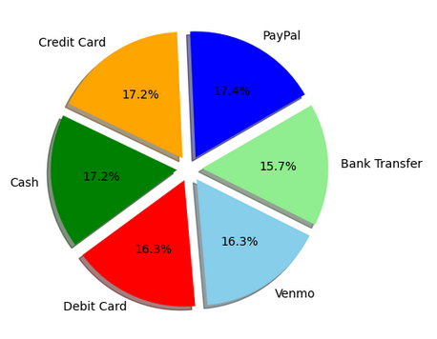

Our next question regarded whether certain states had a higher usage of discounts or promo codes. Once we dug into the Discount and Promo Code columns, we discovered that they were likely the exact same dataset repeated. Further analysis should operate on this assumption for other locations in this dataset.

**Hypothesis:** That there is not a significant difference in the number of transactions using discounts and promo codes amongst the states. After our analysis we found that roughly 60-65% of all transactions did not utilize any sort of discount or promo code across all locations provided. Below is a sample of one location’s data- we did not feel the need to provide the graphs obtained from every location, however the code to do so is included in this project.

