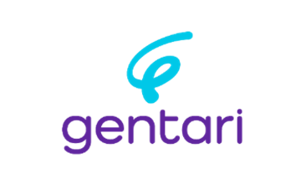
LARGE SCALE INDUSTRIAL AMMONIA CRACKING TECHNOLOGY DATABASE

Rev | Date | Prepared | Reviewed | Approved
0 | 13th October 2025 | Ungku M Zulhilmi Ungku Zakaria, Project Dev. Engineer, Front End & Hydrogen Technology Solutions | Wan M Ikhwan Wan Yussoff,  Head, Front End & Hydrogen Technology Solutions | Danial Khairi Ahmad,  Global Head, Projects

REVISION HISTORY

Rev No | Date | Revision Description | Reason For Revision
0 | 13th October 2025 | Document Issuance | Issuance
 | 12th November 2025 | Correction and information update | Update
 | 30th June 2026 | KBR, Duiker & Casale data refreshed from December 2025 technical packages | Update

Table Of Contents

1.0 Introduction to Ammonia and Ammonia Cracker 5
1.1. Ammonia 5
1.2 Ammonia Cracker 8
1.3 Technology Traction 9

2.0 Abstract 11

3.0 Process Overview 12
3.1 Mass Balance 12
3.2 Energy Balance 13
3.3 Ammonia Cracker Component (ISBL) 14
3.4 Process Flow Diagram 19

4.0 Technology players and geographical presence – as of October 2025 20
4.1 Topsoe 20
4.2 Technip Energies 20
4.3 Kellogg Brown & Root (KBR) 21
4.4 Casale 21
4.5 AFC Energy (Hyamtec) 22
4.6 Air Liquide 22
4.7 Hoegh EVI 22
4.8 ThyssenKrupp 23
4.9 Nippon Gases 23
4.10 Duiker 24

5.0 Technical parameters definition 25
5.1 Design capacity 25
5.2 Efficiency 25

6.0 Licensors & Tolling Specifications 27
6.1 Licensor Specifications 27
6.2 Tolling Model Specifications as of October 2025 28
6.3 Technical OPEX Component 29

7.0 Regulatory Compliance 30
7.1 Carbon Intensity Components 31
7.1.1 Fuel 31
7.1.2 Catalyst 31
7.1.3 Electricity 32
7.1.4 Balance of Plant 32

8.0 Ammonia Cracker Challenges in Industrial Landscape 33
8.1 Key Learnings 34
8.1.1 Ammonia Cracking – Technical 34
8.1.1.1 Licensors Ranking based on Energy Efficiency 34
8.1.2 Tolling Mode – Due Diligence 35
8.1.3 Enabling Solutions 35
8.1.3.1 Techno-Commercial Drivers for FASCU 36
8.1.3.2 Permitting Drivers for FASCU 36

Introduction to Ammonia and Ammonia Cracker

Ammonia
A key component of the deep decarbonization of the worldwide energy system is to build up the large-scale utilization of hydrogen to substitute for fossil fuels in all sectors including industry, the electricity sector, transportation, and heating. Hence, apart from reducing hydrogen production costs, establishing an efficient and suitable infrastructure for the storage, transportation and distribution of hydrogen becomes essential.
Hydrogen, despite its high energy content per unit mass, presents significant challenges in storage and transportation due to its low volumetric energy density and the need for high-pressure or cryogenic conditions. To overcome these issues, hydrogen carriers - substances that can chemically or physically store, and release hydrogen have emerged as a critical enabler for the hydrogen economy. These carriers facilitate safer, more cost-effective, and scalable hydrogen logistics across various applications and geographies.
Among various hydrogen carriers, such as compressed hydrogen, liquid hydrogen (LH₂), liquid organic hydrogen carriers (LOHCs), and metal hydrides, ammonia (NH₃) has gained significant attention. More recently, it has gained attention as an energy carrier and a potential enabler of the hydrogen economy due to its high hydrogen density (17.8 wt% H₂), liquefies at moderate pressures (around 10 bar at 25°C), and well-established global transport infrastructure since more than 120 ports handle ammonia and regional pipelines already exist in Europe and United States, enabling brownfield projects instead of greenfield that costs more. Furthermore, ammonia does not emit carbon dioxide when decomposed, making it an ideal carbon-free hydrogen carrier.
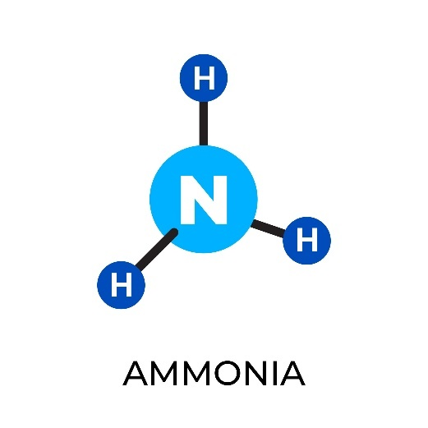
Figure 1: Molecular structure of ammonia

The use of ammonia as a hydrogen carrier aligns closely with large-scale hydrogen production via electrolysis or other low-carbon pathways. It allows hydrogen to be synthesized into ammonia at centralized facilities (ammonia synthesis), transported using conventional shipping or pipeline methods, and then decomposed (ammonia cracking) at the point of use to recover hydrogen. This approach decouples hydrogen production from consumption and opens pathways for international hydrogen trade and grid-independent hydrogen supply.
In the context of global decarbonization, hydrogen carriers like ammonia are pivotal in enabling hydrogen deployment in hard-to-abate sectors such as shipping, power generation, and heavy industry. Ammonia's dual role as both an energy carrier and a chemical feedstock further enhances its appeal within integrated hydrogen and nitrogen value chains.
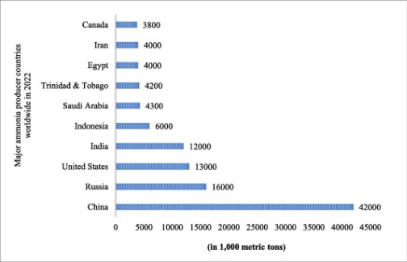
Figure 2: Major ammonia producer countries at global level
With growing focus on decarbonization and hydrogen economy, ammonia increasingly being recognise as a hydrogen carrier. Its ability to transport substantial amounts of hydrogen efficiently over long distance become one of the challenges of hydrogen infrastructure. But hydrogen stored in ammonia cannot be directly utilized in most end-use applications such as fuel cells or high purity hydrogen processes. Challenges that related to combustion efficiency and NO_{x} emission limits its direct use.

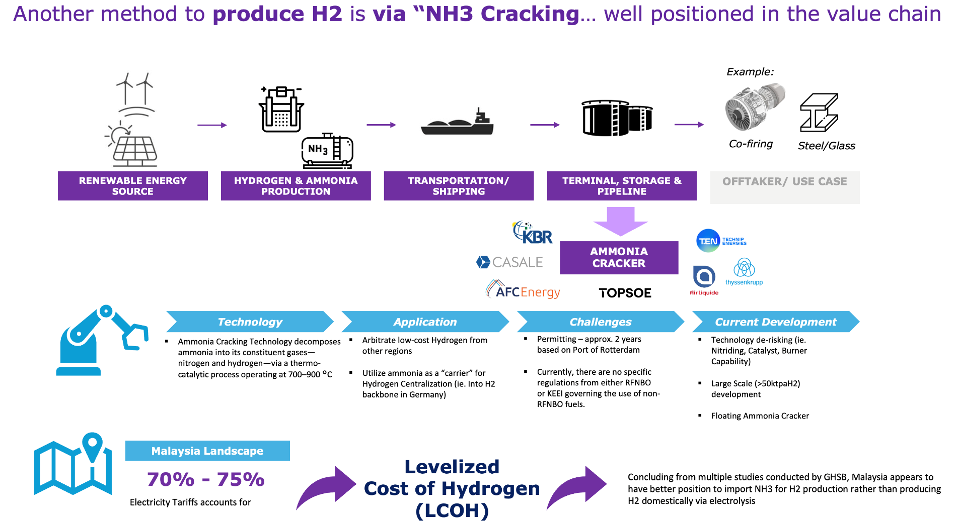

Figure 3: Ammonia value chain

Ammonia Cracker
To unlock its full potential, ammonia must undergo catalytic decomposition process known as ammonia cracking. Ammonia cracking is the process of decomposing ammonia into its constituent hydrogen and nitrogen gases through catalytic thermal decomposition:
2NH₃ → 3H₂ + N₂, ΔH = +92.4 kJ/mol
This reaction is endothermic, requiring high temperatures (typically 600-900°C) and presence of catalyst. Most used catalysts for this reaction are nickel, ruthenium, or some transition metals to achieve high conversion efficiency. Nickel-based catalysts are widely used due to cost-effectiveness, while ruthenium and other transition-metal catalyst provide higher activity and resistance to deactivation that results hydrogen requiring further purification especially application such as PEM fuel cells, which demand >99.97% purity.
PETRONAS subsidiary, Petronas Research Sdn Bhd (PRSB) is committed to develop PETRONAS’ own nickel-based catalyst as part of a component of ammonia cracker technology.
Despite its promise, several challenges remain. Ammonia is toxic and corrosive, requiring strict safety protocols in handling and storage. The cracking process itself is energy-intensive, demanding integration with efficient heat management and renewable energy sources. Furthermore, the economics of ammonia cracking depend on achieving low-cost renewable ammonia production, reliable catalysts, and supportive policy frameworks.

Technology Traction
Ammonia cracking technologies are advancing from lab development to pilot and early commercial deployment, indicate increasing technological readiness (TRL). Several recent pilot and demo projects bring focus to the worldwide momentum as below.
- Air Liquide (Antwerp, Belgium):
Operating a pilot ammonia cracker to demonstrate feasibility of large-scale hydrogen supply in Europe. (TRL~6-7, Estimated, Pilot/Demo)
COD status: No public commissioning date available.

- KBR H₂ACT® (Ulsan, South Korea):
Development of the world’s first commercial-scale ammonia cracker with Hanwha Impact, producing >200 MTPD hydrogen. (TRL~8–9, Estimated, Early Commercial)
COD status: No confirmed COD in press releases but, industry reports suggest mid-2026 target.

- Thyssenkrupp & Uniper (Wilhelmshaven, Germany):
Planned pilot-scale cracker integrated with import terminal to support Europe’s hydrogen imports strategy. (TRL ~6–7, Pilot Planning)
COD status: Confirmed, End 2026

- PETRONAS Research Sdn Bhd (PRSB) (Heidelberg University, Germany):
Catalyst development program (ammonia cracking using non-noble catalyst). Approved on 13th August 2025 as part of Energy Superstore initiative. (Advanced from TRL 4 to TRL 6)

Historically, ammonia cracking was applied in heavy water D₂O production for nuclear power plant, where small-to-medium scale crackers generated hydrogen isotopes for isotopic exchange. These early units used side fired tubular designs, iron-cobalt catalyst and fossil-fired heating, achieving around 90% efficiency but with limited scale-up potential. down-fired configurations, nickel-based catalysts, and integrated heat recovery, achieving >96 % efficiency and enabling clean hydrogen production.

- Heavy Water Crackers: 244 ktpa H₂ equivalent
These units were considered small- to medium-scale because they were purpose-built for isotope separation, not for mass hydrogen supply.
- Modern Clean H₂ Crackers (e.g., KBR H₂ACT®): 3150 ktpa H₂ equivalent, representing industrial or commercial scale.

Today, the technology evolved into larger-scale and high efficiency systems such as KBR H₂ACT® which evolved from nuclear derived heavy water crackers to modern hydrogen systems demonstrates a strong technological lineage and readiness for wider commercial deployment.
With several players achieving pilot validation and the first phase of commercial facilities in development, these initiatives show that ammonia cracking has advanced past the conceptual stage. According to this pattern, the technical base is maturing and ready for wider use in hydrogen supply chains.

Abstract
Gentari Hydrogen is pivoting towards ammonia cracking as part of its strategy to deliver competitive Levelized Cost of Hydrogen (LCOH). Electrolyser-based hydrogen production, while under active assessment, remains highly exposed to electricity prices, which contribute 70–75% of LCOH. In Southeast Asia, where renewable energy penetration is limited, and round-the-clock supply is costly, local hydrogen production risks reaching unsustainable double-digit costs per kilogram. On top of this, the European Union’s Renewable Fuels of Non-Biological Origin (RFNBO) framework requires renewable-only inputs, creating compliance hurdles that many producers struggle to meet.
To overcome these constraints, Gentari Hydrogen is pursuing a geographic arbitrage strategy for certain demographic. The company plans to produce hydrogen in regions with abundant, lower-cost renewable resources, such as India, where electricity prices can support more affordable production. This hydrogen would then be converted into ammonia, enabling safe, large-scale transport to high-demand hubs like Malaysia and Singapore. Once imported, the ammonia can be cracked back into hydrogen at the point of use, allowing supply at cost levels aligned with off taker expectations.
This arbitrage model mirrors approaches underway in Europe, where ports such as Rotterdam, Antwerp, and Hamburg are gearing up to import low-cost, low-carbon ammonia from overseas, crack it domestically, and distribute hydrogen to local and cross-border markets. By applying similar strategies, Gentari Hydrogen can bypass local cost barriers, diversify supply chains, and provide flexibility in meeting both commercial and regulatory requirements.
Ultimately, Gentari Hydrogen’s pivot towards ammonia cracking, underpinned by geographic arbitrage, represents more than just a tactical cost-reduction measure. It is a forward-looking pathway to stabilise hydrogen pricing, unlock regional market opportunities, and strengthen Malaysia and Singapore’s positions as hydrogen hubs in Asia. By leveraging arbitrage across geographies, Gentari Hydrogen is positioning itself to deliver scalable, low-carbon hydrogen that aligns with global decarbonisation targets while remaining economically viable for end users. As of September 2025, only a few ammonia cracking projects are operational globally, including Gentari Hydrogen’s initiatives, the Port of Rotterdam’s hydrogen-from-ammonia facilities, and pilot projects in Antwerp and Hamburg, highlighting the early-stage but rapidly growing potential of this technology.

Process Overview

Mass Balance
An ammonia cracker utilizes ammonia (NH₃) as both a feedstock and fuel to produce hydrogen through thermal decomposition. The primary reaction can be represented as:
2NH₃ → 3H₂ + N₂, ΔH= +92.4 kJ/mol, ${LHV}_{NH3}$= 18.6MJ/kg
In practice, however, the reaction is not perfective selective. Under high-temperature operating conditions, side reactions can occur, leading to the formation of nitrogen oxides (NO_{x}). These by-products, created by the combustion processes that rely on atmospheric air, can contribute indirectly to CO₂e emissions, since the elevated temperatures promote the oxidation of atmospheric nitrogen and may necessitate nitriding risk to the mechanical integrity. As such, while ammonia cracking provides a promising pathway for hydrogen re-gas/generation and utilization, its environmental performance is influenced by both reaction conditions and system design.
In principle, the stoichiometric ratio of ammonia to hydrogen is 5.66:1. However, in practical applications of ammonia cracker, the process typically requires more ammonia input since ammonia is used not only as the feedstock but also as the fuel to sustain high-temperature operations. Under the cleaner operating mode, the effective ammonia-to-hydrogen ratio increase to approximately 7.0 – 7.2, accounting for both the combustion of ammonia as a heat source and an additional energy penalty from thermal losses (<5%).

Energy Balance
Ammonia Cracking is an inherently endothermic reaction, requiring a continuous supply of external heat to reach and maintain equilibrium. The reaction is approximately +92.5 kJ/mol, representing the energy input necessary to dissociate ammonia into its constituent Hydrogen and Nitrogen molecules.
In a practical case, producing 1 kg of hydrogen (with an energy content, LHV of 120 MJ) requires about 5.66 kg of ammonia, which corresponds to an energy value, LHV of 105.28 MJ. The delta of 14.724 MJ per kg of H₂, equivalent to 4.09 kWh per kg of H₂, quantifies the external energy that must be supplied to sustain the cracking reaction.
In practice, however, ammonia crackers typically operate at 600–900 °C with conversion efficiencies ranging from 40% to 50% currently. This lowers the practical performance to about 8–10 kWh of energy input per kilogram of hydrogen produced, more than double the theoretical minimum. The discrepancy underscores the challenges of heat management, reactor design, and system integration in real-world operations. Enhancing thermal efficiency and optimizing process design are therefore critical to improving the viability of ammonia cracking as a hydrogen supply pathway.

Ammonia Cracker Component (ISBL)

Cracker Unit

Burner
In ammonia cracking systems, the burner is a critical component that supplies the heat required for the strongly endothermic decomposition of ammonia into hydrogen and nitrogen. Typically installed in the fired heater or furnace section surrounding the catalyst-filled reactor tubes, the burner generates heat by combusting fuels such as natural gas, hydrogen, syngas, or even part of the cracked hydrogen product itself.
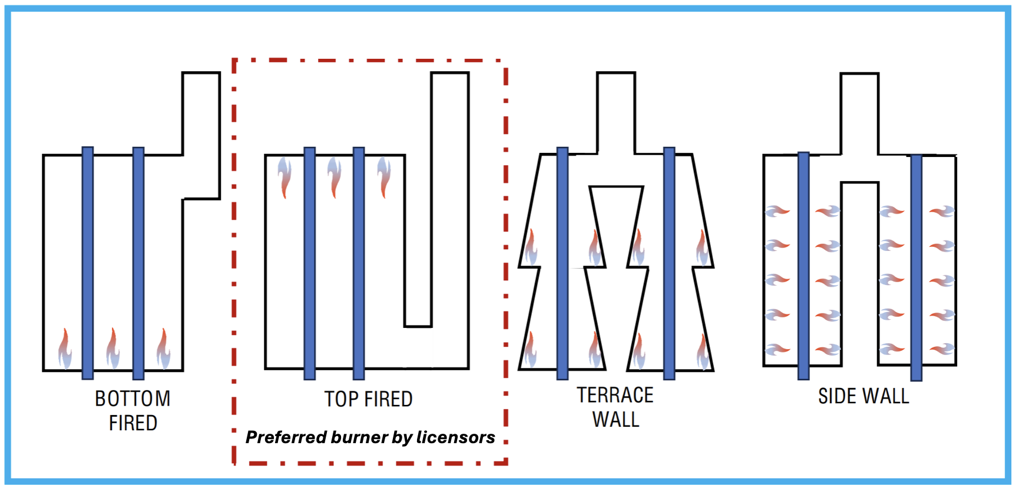
Figure 4: Type of burner use in Ammonia Cracking Process

Alternative heating technologies such as electric heaters or plasma systems are being explored, especially in green hydrogen projects aiming to eliminate fossil fuels, conventional gas-fired burners remain the most widely used at industrial scale.

Catalyst
In ammonia cracking, the catalyst is central to enabling efficient decomposition of ammonia into hydrogen and nitrogen at industrially feasible temperatures. Without a catalyst, the reaction would require extremely high heat, making the process uneconomical and energy intensive. Instead, catalyst-filled reactor tubes allow the reaction to proceed effectively at around 600–900 °C, with the catalyst providing active sites that lower the activation energy of ammonia dissociation. The choice of catalyst affects not only conversion efficiency but also durability, cost, and resistance to poisoning by impurities. While nickel-based catalysts are most employed due to their balance of activity and affordability, other advanced formulations are being developed to improve performance, lower operating temperatures, or reduce by-products. Depending on application needs and operating conditions, the main types of catalysts used in ammonia cracking include:
  - Nickel based catalyst – the industry standard, offering high activity and relatively low cost.
  - Ruthenium based catalyst – highly active even at low temperature, though more expensive, making them suitable for compact or energy efficient system.
  - Cobalt based catalyst – an alternative solution to nickel with moderate activity and low sensitivities to some impurities.
  - Iron based catalyst – less common but can be used when cost is the primary driver.
  - Advanced supported catalyst – such as (Ru on alumina, carbon, or perovskite supports) design to increase the surface area, stability and activity in lower temperature.

Demineralized Water System
Primarily use in the system for two (2) processes
  - Ammonia Wash/Scrubber to separate unreacted ammonia in product gas (syngas) by wash the gas mixed with Demin water since ammonia dissolves readily, forming an aqueous ammonia solution (NH₃.H₂O).
  - Steam Generation for Ammonia Reboiler to recover unreacted ammonia from aqueous ammonia solution back to the cracking unit as a feedstock. Separated H₂O solution will be sent to Condensate Tank to be treated. When steam generated is substantial for energy generation, steam turbine could be installed in the system to power the auxiliaries.

Heat Exchanger

Vaporizer
Use to vaporized liquid ammonia into gas form for Selective Catalytic Reduction (SCR) usage.

Pre-heater
To elevate the temperature of liquid ammonia from –33°C to 400°C prior to entering the cracker unit, a preheating stage is required to ensure an energy-efficient process. Conventionally, licensors channel flue gas from the cracking unit to an external preheater as a means of utilizing waste heat before discharging it to the flare. Haldor Topsoe’s technology enhances this approach by incorporating a “bayonet tube” design directly within the cracker. This innovation serves as a compact, integrated preheater inside the unit itself, eliminating the need for a separate heat exchanger within the battery limits.

Gas Cooler
A series of gas coolers are employed to reduce the temperature of the product gas (syngas) from approximately 700°C down to the target level, typically around 20°C. During this process, the gas coolers transfer heat to the cooling system, which in turn generates multiple grades of pressurized steam at different levels.

Purification (PSA)
The product gas from cracking unit is a mixture of (75% Hydrogen and 25% Nitrogen) by volume. For many industrial application, high-purity hydrogen is required. This is where Pressure Swing Adsorption (PSA) is integrated and able to achieve 99.999% of Hydrogen purity.
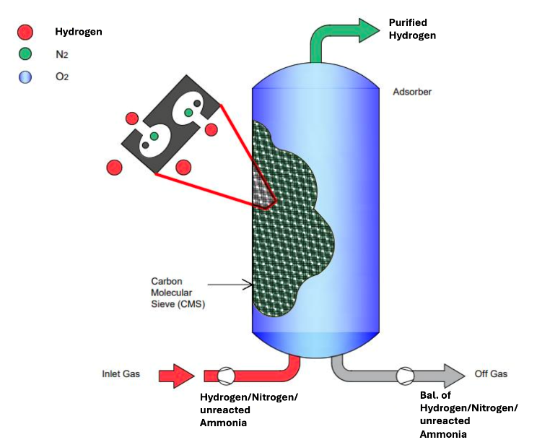
Figure 5: Pressure Swing Adsorption for Hydrogen
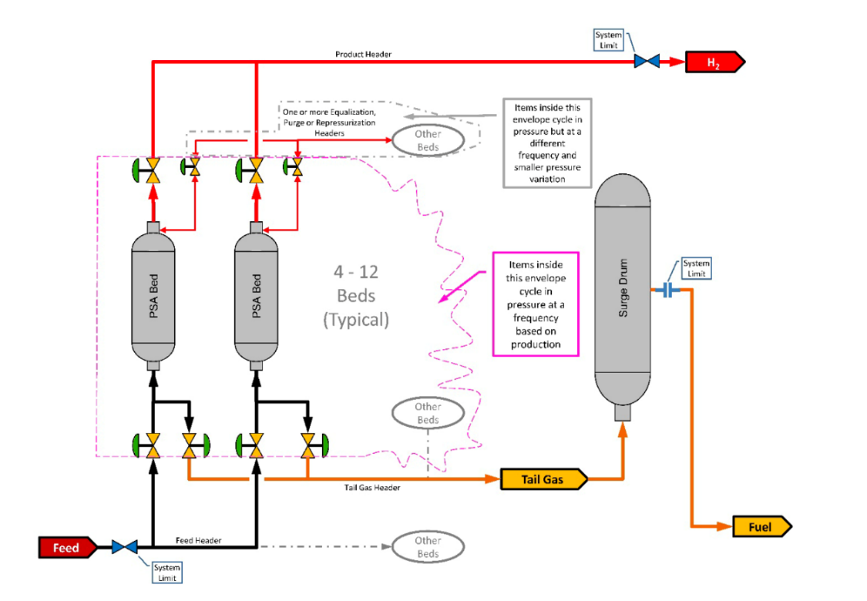
Figure 6: PSA System schematics

Selective Catalytic Reduction (SCR)
Selective Catalytic Reduction (SCR) is a catalytic process that mitigates NOₓ emissions by converting them into harmless nitrogen (N₂) and water (H₂O) using a reducing agent, typically ammonia or urea. NOₓ is a regulated emission due to its significant contribution to greenhouse gas effects in terms of CO₂ equivalence.
$4NO+ {4NH}_{3}+ O_{2}→ {4N}_{2}+ {6H}_{2}O$
$${6NO}_{2}+ {8NH}_{3}+ O_{2}→ {7N}_{2}+ {12H}_{2}O$$
In the context of an ammonia cracker, SCR is integrated after the combustion in the cracker unit as a flue gas to minimize NO_{x} emission. Additionally, nitrogen decomposed from ammonia may also be vented to the air.

Process Flow Diagram
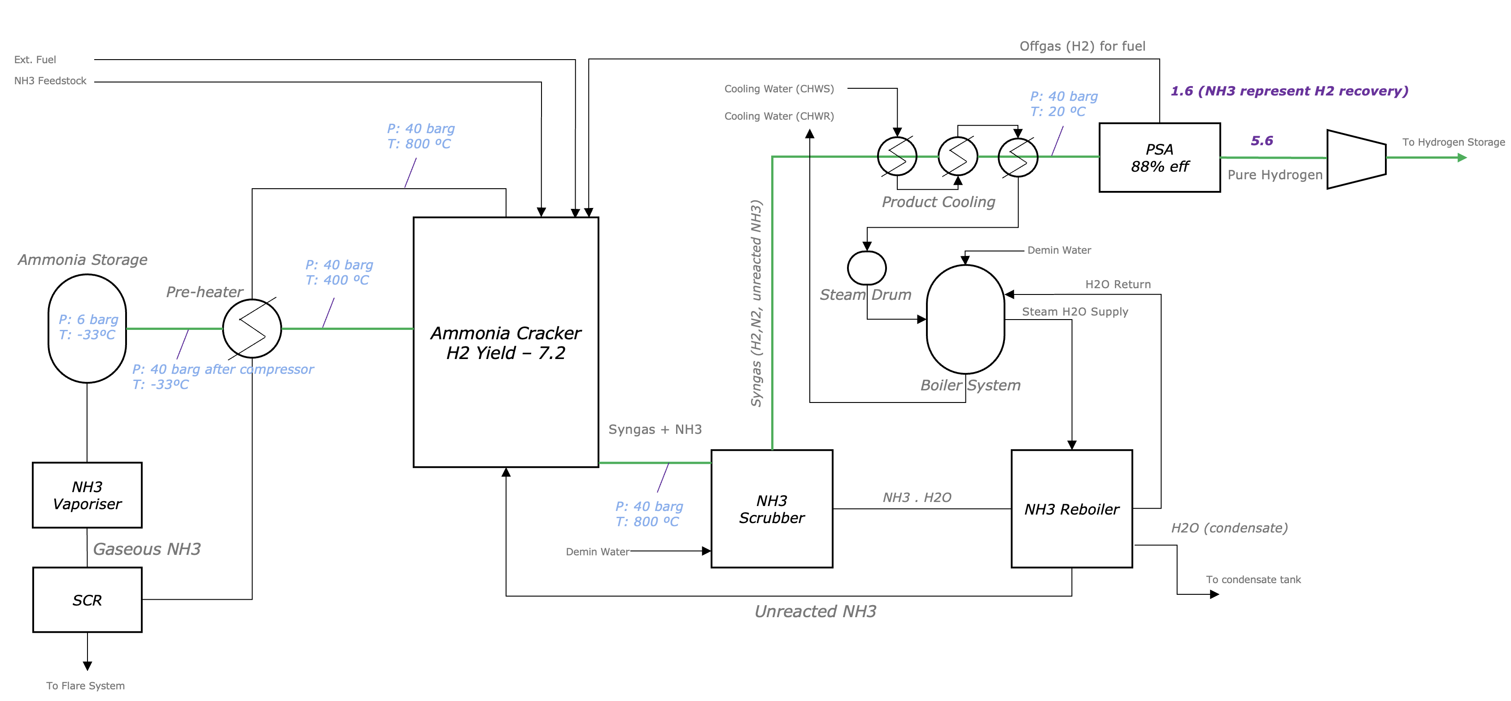

Technology players and geographical presence – as of October 2025
The development of ammonia cracking technologies is led by a small number of global technology providers with established expertise in ammonia, hydrogen, and process engineering. This section highlights nine (9) key players such as Haldor Topsoe, Technip Energies, KBR, Casale, AFC Energy, Air Liquide, Hoegh EVI, Thyssenkrupp, Nippon Gases and Duiker by outlining their technological offerings, major projects, and geographical presence, which refers to the regions where they are headquartered, actively deliver projects, and influence the ammonia-to-hydrogen value chain.


Topsoe
- Headquarters: Denmark
- Specialization: Catalysts and process technologies for ammonia, methanol, and hydrogen.
- Technology: H₂Retake™ ammonia cracking
- Key Projects:
  - South Korea (with Approtium): Large-scale ammonia cracker for 75,000 t/y hydrogen by 2027
  - Arroyito, Argentina: 4,800 MTPD ammonia cracked in two trains for heavy-water production
- Geographical Presence: Europe, Asia, Latin America, Middle East


Technip Energies
- Headquarters: France
- Specialization: Engineering and technology for sustainable energy and chemical infrastructure
- Technology: Hynext by T.EN™ ammonia cracking
- Key Projects:
  - FRESH floating platform: Offshore ammonia storage + Hynext cracker, producing ~50,000 t/y H₂ for maritime use (Pilot/Pre-commercial).
- Geographical Presence: North America, Europe, India, Asia-Pacific


Kellogg Brown & Root (KBR)
- Headquarters: United States
- Specialization: Engineering, procurement, and technology for ammonia and hydrogen
- Technology: H₂ACT® ammonia cracking
- Key Projects: [Rev 30-Jun-2026 — refreshed from KBR H2ACT® Technical Information Package, Rev 0, 23 Dec 2025]
  - Hanwha Impact, South Korea — World's first large-scale commercial H₂ACT® cracker, 219 MTPD H₂; Licensor Proprietary Engineering Design (LPED) + FEED completed (Operational).
  - Hanwha Impact, South Korea — Large-scale commercial H₂ACT® cracker for power generation, 173 MTPD H₂; LPED + FEED completed.
  - ISU Chemical, Ulsan, South Korea — 10 MTPD H₂ commercial small-scale unit; LPED + FEED completed; operated as H₂ACT® demonstration unit from 2026 to 2031, commercial operation thereafter (Pilot/Demo).
  - 24+ feasibility and de-risking studies executed worldwide.
  - Daesan, South Korea: Commercial-scale H₂ACT cracker, ~200 MTPD hydrogen, under development. [Remark: retained from earlier source — not listed in the Dec-2025 KBR package; confirm or remove.]
- Technology Readiness: novel technology elements on KBR's roadmap to TRL-9 by 2028; offered single-train scale 10–1200 MTPD H₂. [Rev 30-Jun-2026 — added from Dec-2025 KBR package.]
- Geographical Presence: South Korea (current focus), North America, Middle East, Asia


Casale
- Headquarters: Switzerland
- Specialization: Ammonia, methanol, syngas processes, plant revamping
- Technology: MACH²™ ammonia cracking (FLEXIGREEN® family; launched 2021; catalyst-agnostic; proprietary axial-radial adiabatic cracker + top-fired cracking furnace). [Rev 30-Jun-2026 — refreshed from Casale Technical Proposal A23070S, MACH²™, 05 Dec 2025]
- Scale & maturity: single-train capacity up to 1300+ MTPD H₂ (>9900 MTPD NH₃); overall TRL 7–8 (limited by commercial catalyst availability, not unit size); furnace catalytic tubes designed for 100,000 h; H₂-rich (≈85 %v H₂) burner tested and in continuous operation since 2019. [Rev 30-Jun-2026 — added from Dec-2025 Casale package.]
- Key Projects:
  - MACH² Demonstrations (Europe): Partnership with Elcogen to integrate SOEC with MACH² cracking, targeting higher efficiency (Pilot/Demo). [Remark: retained from earlier source — not referenced in the Dec-2025 Casale package; confirm or remove.]
- Geographical Presence: India, Australia, Europe


AFC Energy (Hyamtec)
- Headquarters: United Kingdom
- Specialization: Hydrogen generation via alkaline fuel cells and ammonia-to-hydrogen conversion
- Technology: Ammonia-to-Hydrogen cracker integrated with alkaline fuel cells
- Key Projects:
  - UK Demonstrator (2023): Portable ammonia cracker delivering hydrogen for fuel cell applications.
- Geographical Presence: United Kingdom, Europe (R&D focus)


Air Liquide
- Headquarters: France
- Specialization: Industrial gases, hydrogen solutions, and ammonia-based hydrogen technologies
- Technology: Proprietary ammonia cracking pilot systems
- Key Projects:
  - Antwerp, Belgium – Pilot ammonia cracker at industrial scale to support European hydrogen imports (Pilot/Demo).
  - Antwerp, Belgium – 2nd Ammonia Cracker will be developed within Antwerp Port vicinity by converting their renowned SMR-X to Ammonia Cracker to support European Hydrogen Backbone.
- Geographical Presence: Belgium (pilot), Europe-wide hydrogen R&D initiatives

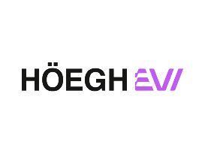
Hoegh EVI
- Headquarters: Norway
- Specialization: Floating storage and regasification, ammonia import infrastructure
- Technology: Floating ammonia imports and cracking infrastructure
- Key Projects:
  - Lubmin, Germany – development of floating ammonia cracker on a barge equipped with ammonia storage.
- Geographical Presence: Europe (project focus), global maritime operations



ThyssenKrupp
- Headquarters: Germany
- Specialization: Industrial engineering and technology solutions focusing on hydrogen, ammonia, and chemical process plants
- Technology: Ammonia cracking integrated with hydrogen import terminals
- Key Projects:
  - Wilhelmshaven, Germany (with Uniper) – Pilot ammonia cracker at import terminal to validate large-scale hydrogen production from ammonia (Pilot Planning).
- Geographical Presence: Germany, Europe, Asia, and the United States

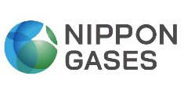

Nippon Gases
- Headquarters: Japan
- Specialization: Industrial gases, hydrogen technologies, and ammonia-based hydrogen solutions
- Technology: Tubular ammonia cracking furnace
- Key Projects:
  - R&D Project for Low-Carbon Hydrogen Production – Development of large-scale (110,000 tons hydrogen per year) ammonia cracking technology using tubular ammonia cracking furnace (Pilot/Demo / R&D).
- Geographical Presence: Japan, with R&D collaborations in global hydrogen supply chain projects.


Duiker
- Headquarters: Netherlands
- Specialization: thermal process equipment, industrial furnaces, ammonia cracking technology and hydrogen production systems
- Technology: Ammonia to Hydrogen Converter (AHC) — three core units: Stoichiometry Controlled Oxidation (SCO) combustor + ammonia cracking reactor + PSA; operates at 50 bar(g); convective (non-radiant) reactor with tube life up to 200,000 h. [Rev 30-Jun-2026 — refreshed from Duiker AHC Concept Study / Budgetary Proposal 122380, 05 Dec 2025]
- Key Projects:
  - Ammonex pilot plant — SCO plus a cracking reactor with full-scale reactor tubes, to demonstrate operational efficiency and catalyst performance over a 6-month pilot (Pilot/Demo).
  - Development and supply of ammonia cracking furnaces for hydrogen production in industrial applications (including large-scale hydrogen supply and energy transition projects).
- Technology Readiness: TRL 8 (system complete and qualified), ready for commercial-scale deployment; ultra-low NOx (5 ppm @ 3% O₂ with small-size SCR). [Rev 30-Jun-2026 — added from Dec-2025 Duiker package.]
- Geographical presence: Europe, Asia and Middle East, supporting international hydrogen and industrial gas projects.

*Additional information is available at the hyperlink above.
*For clarification or information not available in this document, please contact the Gentari Hydrogen Technical Center of Excellence.

Technical parameters definition
To evaluate and compare ammonia cracking technologies effectively, several technical parameters are to be considered. These parameters are grouped into design capacity, efficiency, utilities requirements and financial considerations where each of the aspect will provide insights into the performance and economic viability of the process.

Design capacity

Hydrogen Capacity
Refers to the volume of hydrogen produced/converted per unit of time, usually expressed in kg/hour, ton/day, or kiloton/year (ktpa).

Ammonia Feed
Refers to the volume of ammonia feedstock inclusive of associated fuel requirement per unit of time, usually expressed in kg/hour, ton/day, or kiloton/year (ktpa).

Efficiency

Hydrogen yield
The amount of ammonia required to produce 1 unit of hydrogen inclusive of fuel and losses.

Hydrogen Purity (%)
Measures the concentration of hydrogen as a product gas.

Energy Efficiency (%)
The hydrogen output in term of its energy content over the energy input to the system inclusive of feedstock, fuel, and losses.

Hydrogen Efficiency (%)
The amount of the hydrogen content of the ammonia feed over the actual hydrogen obtained at the output, considering conversion losses and energy use.

Specific Energy Consumption (kWh/kg H₂)
Quantifies the energy required (e.g., fuel input, electricity consumption, system losses) to produced 1KG of hydrogen.

Fuel Quantity Required
Represents the thermal energy inputs (e.g., ammonia fuel, natural gas fuel) per unit of hydrogen including process efficiencies and energy losses.

Losses
Losses include energy that are unavoidably lost during production such as through flue gas, heat, or electricity consumption.

Carbon Intensity
- Indicates the CO₂ equivalent (CO₂e) emitted per unit of hydrogen produced production/conversion.

Licensors & Tolling Specifications
Ranking depends on specific business value driver (e.g. CAPEX, OPEX, schedule, Carbon Intensity, ease of operation)

Licensor Specifications
Licensors (Clean Fuel Mode)$^{1}$
 | Units | Haldor Topsoe | Technip Energies | KBR  (68 ktpa) | Casale | Duiker  (12 ktpa)
Hydrogen capacity (as 100% H₂) | Mtpd (ktpa) | 150.00 (50) | 142.86 (50) | 194.3 | 142.86 (50) | 36
Ammonia feed (as 100% NH₃) | mtpd | 1080.00 | 1013.21 | 1233.7 | 1028.57 | 251
Hydrogen Output Pressure | bar(g) |  |  | 28 | 20 | 50
Carbon Intensity | kgCO₂e/kgH₂ | 0.136 | 0.136 | 0.80 | 0 | 0.0
Hydrogen efficiency | wt% | 78.20 | 80 | 88.8 | 78 | 80.5
Energy Efficiency | % | 96$^{2}$ | 88 | 89.8 | 89 | 90.9
Hydrogen purity | % | 99.9 | 99.95 | 99.97 | 99.999 | 99.97
Specific Energy Consumption | kWh/kgH₂ | 7.93 | 8.71 | 0.290 | 8.18 | 0.25
Electrical power consumption | kWh/kg H₂ | 0.365 | 0.11 | 0.290 | 0.04 | 0.25
Ton Ammonia per  ton Hydrogen Product (as 100% H₂) | ton/ton | 7.20 | 7.09 | 6.35 | 7.20 | 7.03
CAPEX (ISBL)  Class V Estimates | USD (mil) | 100.00 | Not available at current maturity | 191 | Not available at current maturity | 51 (lumpsum)
Footprint (ISBL) | m × m | 80 × 80 | 80 × 80 | 95 × 75 | 80 × 80 | 30 × 30

$^{1}$For natural gas fuel mode; a detailed assessment will be conducted by the Gentari Hydrogen Technical Center of Excellence.
$^{2}$The efficiency values may not align with those of other licensors; a detailed assessment will be conducted by the Gentari Hydrogen Technical Center of Excellence.
$^{2}$[Rev 30-Jun-2026 — KBR / Duiker / Casale data-review remarks (in red for review)]
$^{2}$• Casale Carbon Intensity corrected from 0.136 → 0. Casale's self-sustaining (clean fuel) scheme is 0 kgCO₂/kg H₂ (Low-Carbon up to 0.3; Maximum-fuel >1.2). Source: Casale Technical Proposal A23070S, Table 1, 05 Dec 2025. The prior 0.136 appears to have been copied from the Topsoe/Technip columns.
$^{2}$• Casale column reflects the self-sustaining scheme (NH₃ 7.2 t/t, ~78% yield, ~89% energy efficiency). Casale data is given as a range across three schemes — Self-sustaining / Low-carbon / Maximum-fuel: NH₃ 7.2 / 6.4 / <6.4 t/t; H₂ yield up to 78 / 87 / 96%; energy efficiency up to 89 / 90 / 90+%.
$^{2}$• Casale Specific Energy Consumption (8.18) and Electrical power consumption (0.04) are not stated in the Dec-2025 Casale package — values unverified, retained pending vendor confirmation.
$^{2}$• Casale Footprint (ISBL) 80 × 80 is not stated in the Dec-2025 package (“Licensor will define the required plot area”) — placeholder, to be confirmed. Casale CAPEX correctly remains “Not available at current maturity” (Dec-2025 proposal is technical only, no cost figures).
$^{2}$• Column fuel-mode basis differs and is retained as-is: KBR = 100% NG fuel mode (CI 0.80); Casale & Duiker = clean fuel mode (CI 0). Note the table title “Clean Fuel Mode” vs footnote 1 “natural gas fuel mode” remains internally inconsistent — to reconcile.
$^{2}$• KBR column = 68 ktpa, 100% NG fuel mode, verified against KBR Technical Information Package, Rev 0, 23 Dec 2025 (H₂ 194.3 TPD, NH₃ 1233.7 TPD, 6.35 t/t, energy eff 89.8%, yield 88.8%, elec 0.290 kWh/kg, 28 bar(g), footprint 95×75, CAPEX 191 MMUSD). No change required.
$^{2}$• Duiker column = 12 ktpa, NH₃-fired, verified against Duiker Budgetary Proposal 122380, 05 Dec 2025. No numeric change required, except notes below.
$^{2}$• Duiker Hydrogen Output Pressure 50 bar(g) is the PSA delivery pressure; the project battery-limit spec is 20 bar(g), achieved by letdown after the PSA.
$^{2}$• Duiker CAPEX (ISBL) 51 (lumpsum) USD is an unstated EUR→USD conversion; the source figure is €47 M lump-sum turnkey (±40%). Related: OPEX €2.9 M/yr; licence fees €2.7 M (construction) + €8.50/t H₂ (operation).

Tolling Model Specifications as of October 2025
Tolling Model (Clean Fuel Mode)$^{1}$
 | Units | Hoegh EVI (Floating Solution) | VTTI | Vopak & Linde
Hydrogen capacity (as 100% H₂) | mtpd | 110 | 400 | 342.86
Ammonia feed (as 100% NH₃) | mtpd | 792 | 2880 | 2400
Direct CO₂ emission | kgCO2e/MJ |  | 7.7 - Nat Gas  1.13 - Clean | 0.136
Hydrogen efficiency | wt% | 79 | 78 | 80
Hydrogen purity | % | 99.999 | 99.999 | 99.999
Ton Ammonia per  ton Hydrogen Product (as 100% H₂) | ton/ton | 7.13 | 6.3 - 6.5 Nat Gas  7.1 - 7.3 Clean | 7
Tolling Fee w/o cost pass-through. With Storage  Class IV Estimates$^{2}$ | USD/kgH₂ | 1.50 | 1.67 | 1.10

$^{1}$For natural gas fuel mode; a detailed assessment will be conducted by the Gentari Hydrogen Technical Center of Excellence.
$^{2}$The tolling fees are at Class V estimates; a detailed assessment will be conducted by the Gentari Hydrogen Technical Center of Excellence.
**Further information covering both the Licensor and Tolling models can be accessed here. The file is maintained as a live document and updated from time to time.

Technical OPEX Component
No. | Elements | Purpose
1. | Ammonia Feedstock | Main driver for ammonia cracking cost as well as carbon intensity of the operation.
2. | Fuel | Most licensors can operate ammonia cracker in dual-fuel mode (natural gas and/or cracked ammonia)
3. | Catalyst | Contribute to 30% of total OPEX per year.
4. | Nitrogen | To purge the flare header creating positive pressure to avoid ingression of air.
5. | Instrument Air | To operate instrumentation valves
6. | Cooling Water | To cool product gas to ambient temperature
7. | Demineralize Water | To wash unreacted ammonia in syngas/product gas exiting cracking unit. It is also use for steam generation for ammonia reboiler.
8. | Wastewater | To treat schedule waste heavily on the condensate water from ammonia reboiler
9. | Power | To power auxiliary equipment such as pump, tail gas compressor, electrical vaporiser for SCR
10. | Plant Maintenance | Typically, between 3 – 5% of total CAPEX

Regulatory Compliance
Regulatory compliance is a critical driver for Gentari Hydrogen’s ammonia cracking strategy, as it directly shapes market access and price competitiveness. The carbon intensity (CI) of hydrogen determines whether the product qualifies as “renewable” or “low carbon” under international frameworks.
One of the most influential frameworks is the EU Renewable Fuels of Non-Biological Origin (RFNBO) standard, established under the Renewable Energy Directive (RED II/RED III). To qualify, hydrogen and its derivatives must:
- Be produced using renewable electricity with:
  - Additionality
  - Temporal correlation
  - Geographic correlation
- Demonstrate at least a 70% reduction in greenhouse gas emissions compared to fossil-based hydrogen, equating to an approximate CI ceiling of 28.2gCO₂e/MJ.
- Compliance is verified through certification schemes such as ISCC EU or CertifHy, which are essential for entering the EU hydrogen market.
In Asia, South Korea has emerged as another major hydrogen import hub. The Korea Energy Economics Institute (KEEI) guides the country’s Clean Hydrogen Certification Scheme, which sets CI thresholds for hydrogen and ammonia imports. Current proposals require a CI below 4.0 kg CO₂/kg H₂ to qualify as clean hydrogen with expectations of tighter standards in the coming years. For Gentari Hydrogen, alignment with KEEI’s framework is vital, as Korea is a strategic offtake destination.

Carbon Intensity Components

Fuel
Fuel accounts for the largest share of carbon intensity in ammonia cracking, as the process is inherently endothermic. Most licensor technologies are designed to operate in dual-fuel mode, powered by:
- Hydrogen recovery from PSA as an off gas.
- Natural Gas as an external fuel.
Strategic fuel blending can provide a significant competitive advantage from a commercial perspective. Indicatively, common carbon intensity for both fuel modes is.
- Natural Gas Fuel - 0.924 kgCO₂e/kgH₂ @ 6.5 Hydrogen Yield
- Ammonia Fuel - 0.136 kgCO₂e/kgH₂ @ 7.2 Hydrogen Yield

Catalyst
The most used catalyst in large-scale industrial ammonia cracking is nickel-based. However, nickel catalysts operate with lower efficiency compared to ruthenium-based alternatives, which indirectly results in higher energy consumption. When natural gas is used as the primary fuel, this reduced efficiency translates into greater fuel demand relative to ruthenium catalysts. Additionally, nickel catalysts carry a higher environmental footprint, as they typically require replacement every 3–4 years depending on the operating regime, thereby contributing to increased material consumption and global warming potential (GWP).

Electricity
In furnace-based ammonia crackers, electricity consumption is primarily associated with auxiliary equipment such as pumps and tail gas compressors. While renewable electricity is the preferred configuration, cost considerations in certain regions often necessitate reliance on carbon-intensive grid power when minimizing expenses is the primary driver. Some licensors also offer alternative configurations that integrate steam generation and steam turbines, enabling on-site electricity production by harnessing excess heat from the system.

Balance of Plant
One of the major contributors to carbon intensity in the process is the purification system, particularly the Pressure Swing Adsorption (PSA) unit. PSA typically relies on adsorbent materials such as zeolites, activated carbon, and molecular sieves, the production of which is highly energy intensive. From an efficiency standpoint, poor PSA performance—whether due to design limitations or suboptimal operating regimes—can significantly reduce hydrogen recovery. This not only lowers the net hydrogen output but also increases overall energy consumption, thereby amplifying the system’s carbon footprint & levelized cost of hydrogen (LCOH) as the feedstock and fuel contribute significantly to the cost.

Ammonia Cracker Challenges in Industrial Landscape
While decarbonization through molecular carriers such as hydrogen and ammonia is rapidly gaining global traction, the end-to-end production cost remains significantly higher than that of the conventional grey pathways. Given the current price levels for low-carbon hydrogen and ammonia, the economics of ammonia cracking are heavily influenced by the cost of procuring ammonia—both for clean-fuel and natural-fuel operations. The Class V cost estimates are summarized below.

Figure 7: Levelized Cost of Hydrogen breakdown for Ammonia Cracking Project at 770 USD/tNH₃ (DES), 140 ktpa H₂, 40 kt NH₃ Storage
Beyond the ammonia price point, another major challenge for ammonia cracking technology lies in the permitting process, as no industrial-scale operating plants currently exist worldwide. According to the TCOE’s database, only VTTI’s Project Amplify in Rotterdam, the Netherlands, has successfully obtained permits for an integrated ammonia storage and cracking facility. The project’s permitting process, from application to approval was completed within a two-year period. Notably, the most complex aspect of the permitting was related to the storage battery limits rather than the cracker unit itself. This is primarily because liquid ammonia poses significantly greater hazards compared to its gaseous form used in cracking operations. Furthermore, the recent issuance of the PGS-12 regulation, introducing social risk assessments for ammonia facilities within designated zones (Dutch), has added another layer of complexity to the approval process.
A further limitation for ammonia cracker deployment is the issue of scale. As of October 2025, most licensors indicate that the optimal plant capacity stands at around 50 ktpa of hydrogen output. At this scale, centralized cracking facilities are more economically viable than dedicated units, as few off takers currently require such large volumes of hydrogen. To support this model, a robust downstream hydrogen pipeline network becomes essential for efficient distribution. This rationale underpins the ongoing investment by several European ports in developing interconnected hydrogen pipeline infrastructures, commonly referred to as the Hydrogen Backbone, linking major ports and industrial clusters across countries such as Belgium, the Netherlands, and Germany.

Key Learnings

Ammonia Cracking – Technical
Across the industry, licensors generally demonstrate comparable technical parameters in terms of efficiency, land requirements, fuel modes, and carbon intensity. Given that ammonia price remains the dominant driver of cracking economics, energy efficiency becomes the most critical factor from a technical standpoint when selecting a suitable technology. The list below ranks licensors according to their reported efficiencies as of October 2025.

Licensors Ranking based on Energy Efficiency
- Haldor Topsoe
- KBR
- Casale
- Technip Energies
Based on their technical documentation, Haldor Topsoe claims superior energy efficiency of approximately 96%, compared to other licensors averaging around 88–90%. However, according to TCOE’s technical due diligence based on projects engagement with licensors, these figures may not be directly comparable due to variations in calculation methodologies among licensors. As of October 2025, Gentari Hydrogen is focusing more closely on KBR and Casale, with whom discussions are progressing toward greater technical maturity.
It is also worth noting that, except for AFC Energy, all licensors recommend an optimal cracker capacity of around 50 ktpa H₂. AFC Energy, through its subsidiary Hyamtec, instead targets smaller-scale systems at approximately 4 ktpa H₂, catering to niche and modular applications. This variation in scale broadens Gentari Hydrogen’s evaluation framework, allowing licensor selection not only based on efficiency but also on scalability and alignment with specific project requirements.

Tolling Mode – Due Diligence
As of October 2025, three commercial packages have been received, from Höegh EVI (Floating Solution), VTTI, and the Vopak & Linde consortium. The proposed price points are currently at Class V estimate levels with non-mature exclusivity list and will require further refinement and validation before determining the most suitable tolling model for selection.

Enabling Solutions
As discussed above regarding the key challenges of ammonia cracking, such as permitting constraints, land availability, and site-specific geographical limitations, one of the major insights derived from Project Taurus is the potential for marinizing ammonia cracking technology through the development of a Floating Ammonia Storage and Cracking Unit (FASCU).
The FASCU concept involves integrating the ammonia cracking system into a vessel’s topside design, constructed at a dedicated shipyard, and subsequently positioned in a nearshore configuration at ports facing the aforementioned challenges. This approach enables the deployment of cracking capacity without the need for extensive onshore infrastructure.

Techno-Commercial Drivers for FASCU
The integration of ammonia storage and cracking within a single vessel enables a fully consolidated facility, eliminating the need for long ammonia transfer pipelines between storage and cracking unit and significantly reducing associated land and infrastructure costs. The facility can be relocatable and also repurposed as commercial ammonia vessel.

Permitting Drivers for FASCU
Based on insights from VTTI’s experience, the onshore development of an ammonia storage and cracking facility typically requires a minimum of two years for permitting and approval. The recent introduction of the PGS-12 regulation for Dutch projects, which mandates “triple-insulated walls” for ammonia storage has further intensified permitting challenges. In contrast, the FASCU concept, designed in alignment with maritime standards and subject to approval by recognized marine classification bodies, is expected to undergo a considerably swifter approval process.

END OF DOCUMENT

Appendix 1 – User Requirement

