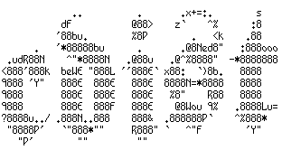

cdist configuration management

- allows you to save time
- allows you to have consistent systems
- improves performance of your staff
- is highly scalable (add more ressources and you can configure more hosts in parallel)
- is being used world wide
- is a industry proven product
- is 100% free and open source software (GPLv3)

cdist is not the only configuration management available, but it has some unique features:

- zero dependency configuration management (no need to install software on target hosts)
- easy to scale out
- uses well known easy to implement Posix Shell for configuration
- is coded in future proven Python 3
- is being developed in Switzerland

cdist is developed and maintained mostly by Nico Schottelius and Steven Armstrong.
cdist is commercially supported by ungleich GmbH.

