HỌC VIỆN CÔNG NGHỆ BƯU CHÍNH VIỄN THÔNG
KHOA CÔNG NGHỆ THÔNG TIN



DATABASE DESIGN TERM PROJECT

Database system for a construction company with multiple projects

Course: Database [E24-Class 5].
Team: 5.
Members:
Lê Anh Minh - B24DCCE180.
Ứng Trọng Trình - B24DCCE271.
Nguyễn Đinh Anh Quân - B24DCCE222.

Instructor: Nguyễn Đình Hoá.
REQUIREMENT ANALYSIS

1. Company background and scenario

1.1 Overview
A34Build is a general contractor handling civil infrastructure, commercial buildings, and industrial facilities. The company runs multiple active projects at the same time across different sites. Each project has fixed deadlines, strict budgets, and safety requirements. Daily work involves field engineers, site managers, equipment operators, heavy machinery, specialized subcontractors, and tons of building materials.
The company currently relies on spreadsheets and paper logs. This causes scheduling delays, budget overruns, inventory loss at job sites, and slow cost tracking. The goal is to build a centralized relational database to manage projects, staff, equipment, materials, subcontracts, and site safety.

1.2 Main business operations
The database covers seven main operational areas:
- Projects: Client contracts, job sites, phases, and task schedules.
- Workforce: Job roles, reporting hierarchy, certifications, and task assignments.
- Equipment: Owned and rented machinery, site deployments, run hours, and maintenance logs.
- Materials: Suppliers, purchase orders, site deliveries, and stock levels.
- Subcontractors: Trade specialties, contract agreements, and safety ratings.
- Project costs: Budget tracking against spending on labor, equipment, materials, and subcontracts.
- Safety: Safety audits, inspection scores, and incident reports.

2. Data requirements

2.1 Entity sets

Strong entity sets
- DEPARTMENT: Company departments (Civil Engineering, Heavy Fleet, Procurement, Safety, Finance).
- EMPLOYEE: Full-time and field staff (engineers, managers, operators, inspectors).
- CLIENT: Public agencies and private developers that hire the company.
- PROJECT: Construction contracts with defined budgets and delivery schedules.
- PROJECT_SITE: Physical work locations for a project.
- TASK: Work packages within a project phase assigned to workers.
- EQUIPMENT: Heavy machinery and vehicles.
- SUPPLIER: Vendors supplying raw materials and parts.
- MATERIAL: Standard catalog items (cement, rebar, gravel, pipes).
- PURCHASE_ORDER: Purchase orders sent to suppliers.
- SUBCONTRACTOR: Outside contractors hired for specialized trades.
- SAFETY_INSPECTION: Periodic site safety audits.
- INCIDENT_REPORT: Logs of workplace accidents, equipment damage, or near-misses.

Weak entity sets
- DEPENDENT: Family members of an employee for benefits and emergency contact.
  - Identifying entity: EMPLOYEE
  - Identifying relationship: HAS_DEPENDENT
  - Partial key: DependentName
- PROJECT_PHASE: Stages within a project (Foundation, Structure, Finishing).
  - Identifying entity: PROJECT
  - Identifying relationship: CONSISTS_OF_PHASES
  - Partial key: PhaseNumber
- PO_ITEM: Individual line items on a purchase order.
  - Identifying entity: PURCHASE_ORDER
  - Identifying relationship: CONTAINS_ITEM
  - Partial key: LineNumber
- MAINTENANCE_RECORD: Service and repair logs for a machine.
  - Identifying entity: EQUIPMENT
  - Identifying relationship: HAS_MAINTENANCE
  - Partial key: RecordNumber

2.2 Attributes

Strong entity sets

1. DEPARTMENT
Attribute | Type | Description
DeptID | Primary Key | Unique department code (e.g., D01)
DeptName | Simple | Department name
OfficeLocation | Simple | Office room or floor
Budget | Simple | Annual operating budget

2. EMPLOYEE
Attribute | Type | Description
EmpID | Primary Key | Unique employee identifier
Name | Composite | Composed of FirstName, MiddleName, LastName
Address | Composite | Composed of Street, Ward, District, City
DOB | Simple | Date of birth
Age | Derived | Current date minus date of birth
HireDate | Simple | Employment start date
Salary | Simple | Monthly base salary
JobTitle | Simple | Job title (Site Engineer, Crane Operator)
Email | Candidate Key | Unique company email
PhoneNumber | Multi-valued | Contact phone numbers
Certifications | Multi-valued | Licenses and certificates (OSHA, Crane Class A)

3. CLIENT
Attribute | Type | Description
ClientID | Primary Key | Unique client identifier
ClientName | Simple | Organization or company name
ClientType | Simple | Sector (Government, Commercial, Residential, Industrial)
ContactPerson | Simple | Primary contact person
ContactEmail | Simple | Email address
ContactPhone | Multi-valued | Contact phone numbers
TaxCode | Candidate Key | Business tax code

4. PROJECT
Attribute | Type | Description
ProjectID | Primary Key | Project code (e.g., PRJ-2026-001)
ProjectName | Simple | Project name
StartDate | Simple | Planned start date
PlannedEndDate | Simple | Contractual deadline
ActualEndDate | Simple | Real completion date (null if ongoing)
ProjectDuration | Derived | Elapsed days from StartDate to ActualEndDate or today
EstimatedBudget | Simple | Contract budget limit
ActualCost | Derived | Total cost of labor, equipment, materials, and subcontracts
Status | Simple | Planned, In-Progress, Suspended, Completed

5. PROJECT_SITE
Attribute | Type | Description
SiteID | Primary Key | Unique site identifier
SiteName | Simple | Site name or sector
LocationCoordinates | Composite | Composed of Latitude, Longitude
Address | Composite | Composed of StreetAddress, District, City_Province
EnvironmentalPermit | Simple | Environmental permit number
SiteStatus | Simple | Operating state (Preparation, Active, Handed_Over)

6. TASK
Attribute | Type | Description
TaskID | Primary Key | Unique task identifier
TaskName | Simple | Task name (Pour pile B12)
EstimatedHours | Simple | Estimated work hours
ActualHours | Derived | Sum of worker hours logged on this task
ScheduledStartDate | Simple | Scheduled start date
ScheduledEndDate | Simple | Scheduled end date
ActualEndDate | Simple | Actual completion date (null if ongoing)
PriorityLevel | Simple | Low, Medium, High, Urgent
TaskStatus | Simple | Execution state (Pending, In_Progress, Completed, Blocked)

7. EQUIPMENT
Attribute | Type | Description
EquipmentID | Primary Key | Unique asset code
Model | Simple | Make and model (CAT 320D)
SerialNumber | Candidate Key | Manufacturer serial number
Category | Simple | Excavator, Crane, Truck, Paver, Mixer
Ownership | Simple | Owned or Rented
HourlyRate | Simple | Cost per operating hour
CurrentStatus | Simple | Available, Deployed, Under-Maintenance, Retired
TotalRunHours | Derived | Total operating hours across all jobs

8. SUPPLIER
Attribute | Type | Description
SupplierID | Primary Key | Unique vendor identifier
CompanyName | Simple | Registered company name
TaxCode | Candidate Key | Official business tax ID
ContactEmail | Simple | Sales email
ContactPhone | Multi-valued | Contact phone numbers
SupplyCategories | Multi-valued | Product lines (Steel, Cement, Lumber)
CreditRating | Simple | Rating grade (A, B, C)

9. MATERIAL
Attribute | Type | Description
MaterialID | Primary Key | Unique material SKU
MaterialName | Simple | Material name (Portland Cement PCB40)
Category | Simple | Material classification (Steel, Cement, Aggregate, Piping, Electrical)
StandardUnit | Simple | Unit of measurement (Ton, m3, Bag, Piece)
UnitPrice | Simple | Reference price per unit
MinStock | Simple | Minimum safety stock count

10. PURCHASE_ORDER
Attribute | Type | Description
PO_ID | Primary Key | Unique PO number
OrderDate | Simple | Date order was placed
ExpectedDeliveryDate | Simple | Promised arrival date
DeliveryStatus | Simple | Issued, Partial_Delivery, Fulfilled, Cancelled
TotalPOAmount | Derived | Sum of line subtotals

11. SUBCONTRACTOR
Attribute | Type | Description
SubcontractorID | Primary Key | Unique subcontractor identifier
CompanyName | Simple | Registered company name
TaxCode | Candidate Key | Official business tax ID
ContactEmail | Simple | Official contact email
ContactPhone | Simple | Primary dispatch phone number
TradeSpecialty | Simple | Specialized trade (Piling, Electrical, HVAC, Facade)
LicenseNumber | Candidate Key | Trade license number
SafetyRatingScore | Simple | Safety score (0.0 to 10.0)

12. SAFETY_INSPECTION
Attribute | Type | Description
InspectionID | Primary Key | Unique inspection log ID
InspectionDate | Simple | Date of inspection
InspectionType | Simple | Audit type (Routine, Unannounced, Pre-Operation)
InspectionScope | Simple | Inspected area or structure (e.g., Tower crane, Scaffold level 4)
OverallScore | Simple | Evaluation score (0 to 100)
InspectionResult | Simple | Audit conclusion (Passed, Conditional_Pass, Failed)
ViolationNoted | Simple | Safety issues found
FixDeadline | Simple | Deadline to fix issues (null if passed)

13. INCIDENT_REPORT
Attribute | Type | Description
IncidentID | Primary Key | Unique incident case ID
IncidentTimestamp | Simple | Date and time of incident
IncidentType | Simple | Event category (Fall, Electrical, Equipment_Collision, Falling_Object)
IncidentLevel | Simple | Impact classification (Warning, Minor, Serious, Fatal)
DamageDescription | Simple | Injury or equipment damage details
LostDays | Simple | Work days lost due to injury
Solution | Simple | Immediate remedial or preventive action taken

Weak entity sets

1. DEPENDENT
Attribute | Type | Description
DependentName | Partial Key | Full name of dependent
Gender | Simple | Gender (M, F, Other)
BirthDate | Simple | Date of birth
Relationship | Simple | Relationship to employee (Spouse, Child, Parent)
ContactPhone | Simple | Emergency contact phone number
IsEmergencyContact | Simple | Primary emergency contact flag (true or false)

2. PROJECT_PHASE
Attribute | Type | Description
PhaseNumber | Partial Key | Phase sequence number (1, 2, 3...)
PhaseTitle | Simple | Phase title (Excavation, Structure)
StartDate | Simple | Scheduled start date for this phase
TargetCompletionDate | Simple | Target completion date for phase
PhaseBudget | Simple | Budget allocated to this phase
PhaseStatus | Simple | Pending, Active, Under-Inspection, Accepted

3. PO_ITEM
Attribute | Type | Description
LineNumber | Partial Key | Line item number (1, 2, 3...)
QuantityOrdered | Simple | Quantity purchased
AgreedUnitPrice | Simple | Negotiated unit price
ItemSubtotal | Derived | QuantityOrdered multiplied by AgreedUnitPrice

4. MAINTENANCE_RECORD
Attribute | Type | Description
RecordNumber | Partial Key | Service record counter
ServiceDate | Simple | Date of service
MaintenanceType | Simple | Service type (Oil Change, Inspection, Hydraulic Repair, Overhaul)
Cost | Simple | Repair and parts cost
ServiceVendor | Simple | Workshop name or external vendor

3. Relationships and constraints

3.1 Relationships

1. DEPARTMENT_HEAD (EMPLOYEE to DEPARTMENT)
- Binary 1:1
- Participation: DEPARTMENT is total (every department has one manager); EMPLOYEE is partial (only some employees are managers).
- Rule: An employee manages at most one department.

2. WORKS_IN_DEPARTMENT (DEPARTMENT to EMPLOYEE)
- Binary 1:N
- Participation: EMPLOYEE is total (every employee must belong to one department); DEPARTMENT is total (every department has at least one employee).
- Rule: An employee belongs to exactly one department.

3. SUPERVISES (EMPLOYEE to EMPLOYEE)
- Unary (recursive) 1:N
- Participation: Both roles are partial (not all employees supervise, and the top director has no supervisor).
- Rule: An employee has at most one direct supervisor.

4. HAS_DEPENDENT (EMPLOYEE to DEPENDENT)
- Identifying 1:N
- Participation: EMPLOYEE is partial; DEPENDENT is total (a dependent must belong to an employee).

5. COMMISSIONS (CLIENT to PROJECT)
- Binary 1:N
- Participation: CLIENT is partial; PROJECT is total (each project must have a client).

6. DEPARTMENT_SPONSORS_PROJECT (DEPARTMENT to PROJECT)
- Binary 1:N
- Participation: DEPARTMENT is partial; PROJECT is total (each project is assigned to a managing department).

7. DIRECTS_PROJECT (EMPLOYEE to PROJECT)
- Binary 1:1
- Participation: PROJECT is total (every project has one site director); EMPLOYEE is partial.
- Rule: An employee directs at most one active project at a time.

8. HAS_SITES (PROJECT to PROJECT_SITE)
- Binary 1:N
- Participation: PROJECT is total (every project has at least one site); PROJECT_SITE is total.

9. CONSISTS_OF_PHASES (PROJECT to PROJECT_PHASE)
- Identifying 1:N
- Participation: PROJECT is total; PROJECT_PHASE is total.

10. CONTAINS_TASKS (PROJECT_PHASE to TASK)
- Binary 1:N
- Participation: PROJECT_PHASE is total; TASK is total.

11. PRECEDES (TASK to TASK)
- Unary (recursive) M:N
- Participation: Both roles are partial.
- Rule: Defines task order on the project schedule (for example, Foundation must finish before Framing starts).

12. WORKS_ON_TASK (EMPLOYEE to TASK)
- Binary M:N
- Attributes: AssignedDate, RoleOnTask, HoursLogged
- Participation: EMPLOYEE is partial; TASK is total (a task needs at least one assigned worker).

13. EQUIPMENT_DEPLOYMENT (EQUIPMENT to PROJECT_SITE)
- Binary M:N
- Attributes: DeploymentStartDate, DeploymentEndDate, HoursOperated, OperatorID (references EMPLOYEE)
- Participation: Both EQUIPMENT and PROJECT_SITE are partial.

14. HAS_MAINTENANCE (EQUIPMENT to MAINTENANCE_RECORD)
- Identifying 1:N
- Participation: EQUIPMENT is partial; MAINTENANCE_RECORD is total.

15. ISSUES_PO (PROJECT to PURCHASE_ORDER)
- Binary 1:N
- Participation: PROJECT is partial; PURCHASE_ORDER is total.

16. SUPPLIES_PO (SUPPLIER to PURCHASE_ORDER)
- Binary 1:N
- Participation: SUPPLIER is partial; PURCHASE_ORDER is total.

17. CONTAINS_ITEM (PURCHASE_ORDER to PO_ITEM)
- Identifying 1:N
- Participation: PURCHASE_ORDER is total; PO_ITEM is total.

18. ITEM_REFERENCES_MATERIAL (PO_ITEM to MATERIAL)
- Binary N:1
- Participation: PO_ITEM is total; MATERIAL is partial.

19. SITE_INVENTORY (PROJECT_SITE to MATERIAL)
- Binary M:N
- Attributes: CurrentStockQuantity, SafetyReorderQuantity, LastStocktakeDate
- Participation: Both are partial.

20. DELIVERY_DISPATCH (SUPPLIER x MATERIAL x PROJECT_SITE)
- Ternary relationship (M:N:P)
- Attributes: DeliveryCode, DeliveryDate, DeliveredQuantity, ReceiverEmployeeID (references EMPLOYEE), PO_ID (references PURCHASE_ORDER)
- Meaning: A supplier delivers a specific material to a project site against an approved purchase order on a given date.

21. ENGAGES_SUBCONTRACTOR (PROJECT to SUBCONTRACTOR)
- Binary M:N
- Attributes: ContractAgreementNo, ScopeDescription, ContractValue, WarrantyHoldRate, StartDate, CompletionDate
- Participation: Both are partial.

22. CONDUCTS_INSPECTION (PROJECT_SITE to SAFETY_INSPECTION to EMPLOYEE)
- PROJECT_SITE has 1:N with SAFETY_INSPECTION; EMPLOYEE has 1:N with SAFETY_INSPECTION.
- Participation: SAFETY_INSPECTION is total on both (each inspection records the site and the inspector).

23. LOGS_INCIDENT (PROJECT_SITE to INCIDENT_REPORT)
- Binary 1:N
- Participation: PROJECT_SITE is partial; INCIDENT_REPORT is total (each incident happens at a site).

24. INVOLVES_EMPLOYEE (EMPLOYEE to INCIDENT_REPORT)
- Binary 1:N
- Participation: EMPLOYEE is partial; INCIDENT_REPORT is partial (an incident may involve an injured worker, or may solely involve property/equipment damage).
- Rule: An incident report references at most one primary affected employee.

4. Business rules

4.1 Domain constraints
- Amounts must be positive (> 0): Salary, Budget, PhaseBudget, ContractValue, UnitPrice, AgreedUnitPrice, Cost, HourlyRate.
- Quantities and hours must be non-negative (>= 0): QuantityOrdered, DeliveredQuantity, CurrentStockQuantity, MinStock, EstimatedHours, ActualHours, HoursLogged, HoursOperated, LostDays.
- Status and classification fields use fixed values:
  - PROJECT.Status: Planned, In-Progress, Suspended, Completed
  - PROJECT_SITE.SiteStatus: Preparation, Active, Handed_Over
  - PROJECT_PHASE.PhaseStatus: Pending, Active, Under-Inspection, Accepted
  - TASK.PriorityLevel: Low, Medium, High, Urgent
  - TASK.TaskStatus: Pending, In_Progress, Completed, Blocked
  - EQUIPMENT.Ownership: Owned, Rented
  - EQUIPMENT.CurrentStatus: Available, Deployed, Under-Maintenance, Retired
  - PURCHASE_ORDER.DeliveryStatus: Issued, Partial_Delivery, Fulfilled, Cancelled
  - SAFETY_INSPECTION.InspectionResult: Passed, Conditional_Pass, Failed
  - INCIDENT_REPORT.IncidentLevel: Warning, Minor, Serious, Fatal
  - INCIDENT_REPORT.IncidentType: Fall, Electrical, Equipment_Collision, Falling_Object

4.2 Date and time rules
- End dates cannot be earlier than start dates (StartDate <= PlannedEndDate, StartDate <= ActualEndDate).
- Workers must be at least 18 years old (CurrentDate - DOB >= 18 and HireDate >= DOB + 18).
- Task start and end dates must fall within the dates of the parent project phase.

4.3 Rules not modeled in ERD
These rules cannot be shown with ER notation and will be enforced through triggers, check constraints, or application logic:
- Phase budget limit: The sum of all phase budgets in a project cannot exceed the project's estimated budget.
- No overlapping machine bookings: A piece of equipment cannot be scheduled at two different sites during overlapping dates.
- Operator licensing: An employee assigned to run heavy equipment must have the required license listed in their certifications.
- Daily work limit: A worker cannot log more than 12 hours total across all tasks in a single day.
- No circular task dependencies: The PRECEDES relationship between tasks must not create cycles.
- Stock limit on consumption: Tasks cannot consume more material than the current stock recorded at that site.
- Single project limit for directors: An employee can be the director of only one active project at a time.
- Accident emergency notification: When an incident involves an employee, the system must trigger a notification looking up their emergency contact in DEPENDENT where IsEmergencyContact = true.

5. Database applications

5.1 Data loading
- Import the standard material catalog with units and benchmark prices.
- Add new employees, job titles, and verified licenses.
- Set up new project contracts, site locations, and milestone schedules.
- Register newly purchased or rented machinery with serial numbers.

5.2 Updates
- Log daily worker hours on specific tasks.
- Record material deliveries arriving at a site and update on-site inventory counts.
- Deduct materials used during daily work from site inventory.
- Update equipment operating hours and switch status to maintenance when service intervals arrive.
- Mark project phases as completed after inspection sign-off.
- Log site safety audit scores and incident reports.

5.3 Queries
- Find heavy equipment by category that is available and not booked for the next two weeks.
- Check which materials at a specific site have dropped below their minimum safety stock (MinStock).
- List urgent tasks that are past their scheduled end date.
- Look up the reporting chain of an employee up to the general director.
- View active subcontractors on a project with their contracted amounts and remaining warranty hold balances (WarrantyHoldRate).

5.4 Reports
- Cost vs. budget variance: Compares the initial project budget against total spending on labor, equipment, materials, and subcontracts.
- Earned value analysis: Computes Planned Value (PV), Earned Value (EV), Actual Cost (AC), Cost Performance Index (CPI), and Schedule Performance Index (SPI).
- Site safety report: Summarizes audit scores, open safety issues, lost work days (LostDays), and total injury-free hours per site.
- Subcontractor scorecard: Ranks subcontractors by delivery speed, work quality, and safety compliance.
- Fleet utilization report: Shows machine run hours (TotalRunHours) against idle hours and hourly rate costs (HourlyRate).

Entity-Relationship Diagram
This section presents the ERD of the A34Build database. Figure 1 shows the whole model, and Figures 2 to 7 zoom into the six domains (Organization, Projects, Equipment, Materials and procurement, Subcontractors, and Safety) with every attribute. An entity set that appears in a domain other than its own is drawn as a plain box labelled "(see Organization)", "(see Projects)", or "(see Equipment)" and shows only its key. The diagrams cover the entity sets in Section 2.1, the attributes in Section 2.2, and the relationships in Section 3.1.
Notation: rectangles are strong entity sets and double rectangles are weak entity sets. Diamonds are relationships, and double diamonds are identifying relationships. Ellipses are attributes: underlined for keys, double-lined for multi-valued attributes, and dashed for derived attributes. A double line means total participation. Cardinalities are marked 1, N, M, and P. A dashed box marks an aggregation.
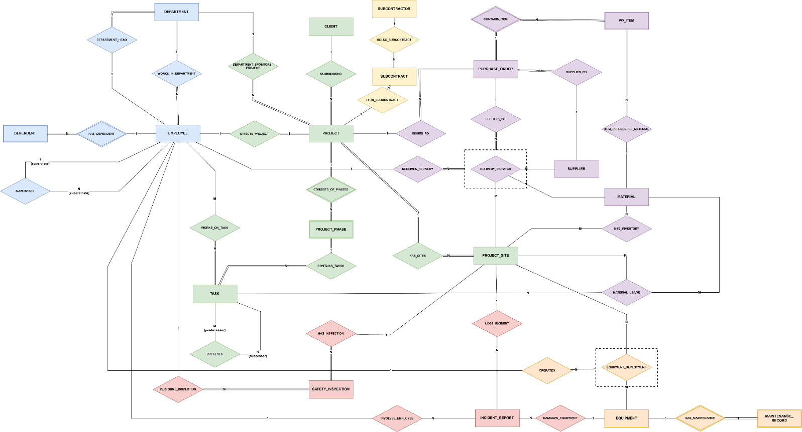
Figure 1. Overall ERD. Complete model on a single page. Entity sets and relationships are colour-coded by domain: blue for Organization, green for Projects, purple for Materials, orange for Equipment, yellow for Subcontractors, and red for Safety. Dashed boxes mark the two aggregations, DELIVERY_DISPATCH and EQUIPMENT_DEPLOYMENT, which are treated as entities so they can take part in further relationships. Attributes are left out here and shown in Figures 2 to 7.
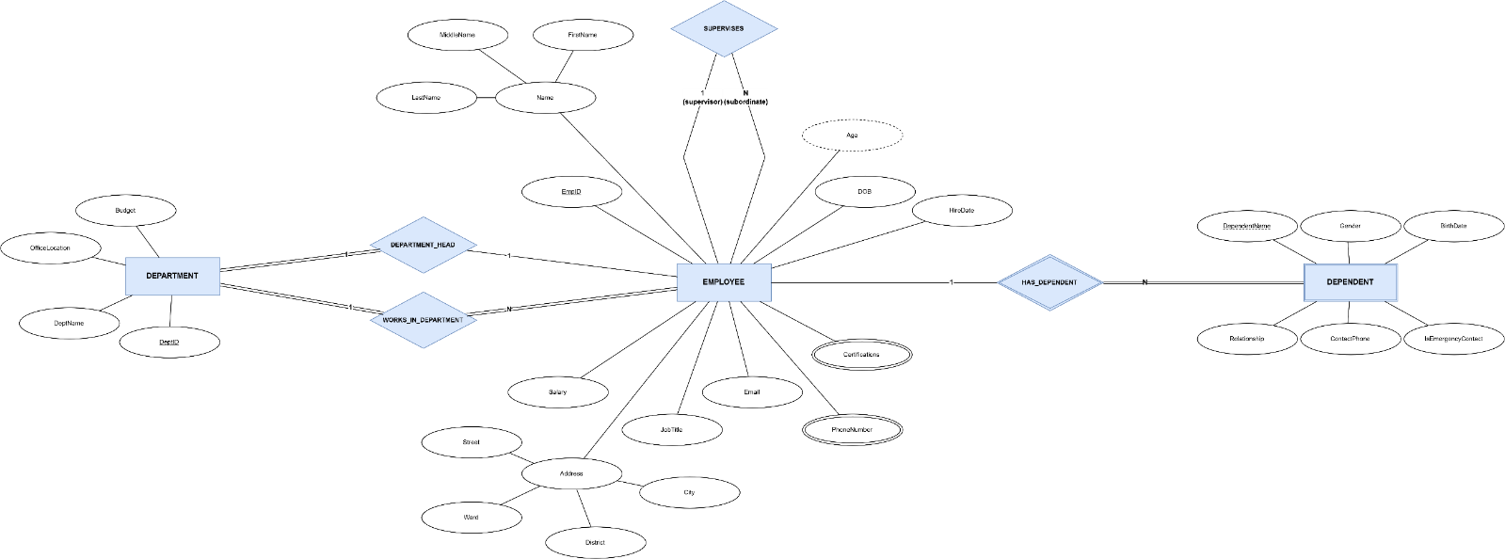
Figure 2. Organization. DEPARTMENT, EMPLOYEE, and DEPENDENT with their attributes. DEPARTMENT_HEAD (1:1) and WORKS_IN_DEPARTMENT (1:N) link employees to departments, SUPERVISES is the recursive reporting line, and HAS_DEPENDENT is the identifying relationship for the weak entity set DEPENDENT. Name and Address are composite, Age is derived, and PhoneNumber and Certifications are multi-valued.
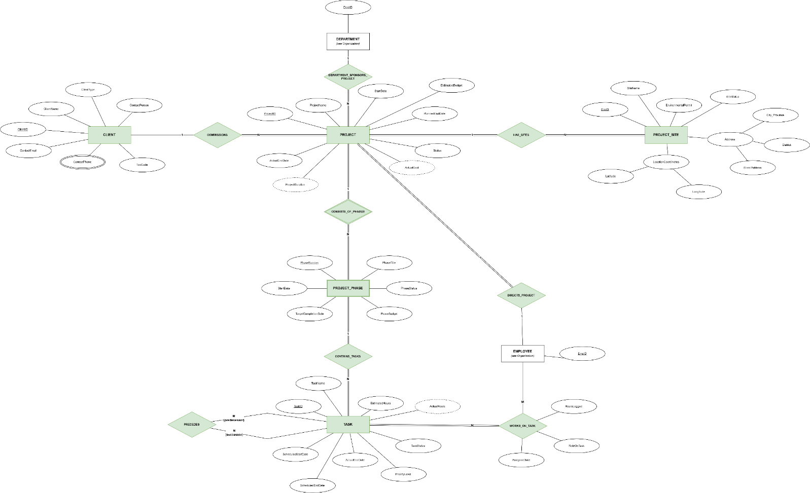
Figure 3. Projects. CLIENT, PROJECT, PROJECT_SITE, PROJECT_PHASE, and TASK. A client commissions many projects, and each project has sites, phases, a managing department, and one site director. Phases contain tasks, PRECEDES orders tasks within the schedule, and WORKS_ON_TASK (M:N) records AssignedDate, RoleOnTask, and HoursLogged for each employee. ProjectDuration, ActualCost, and ActualHours are derived attributes.
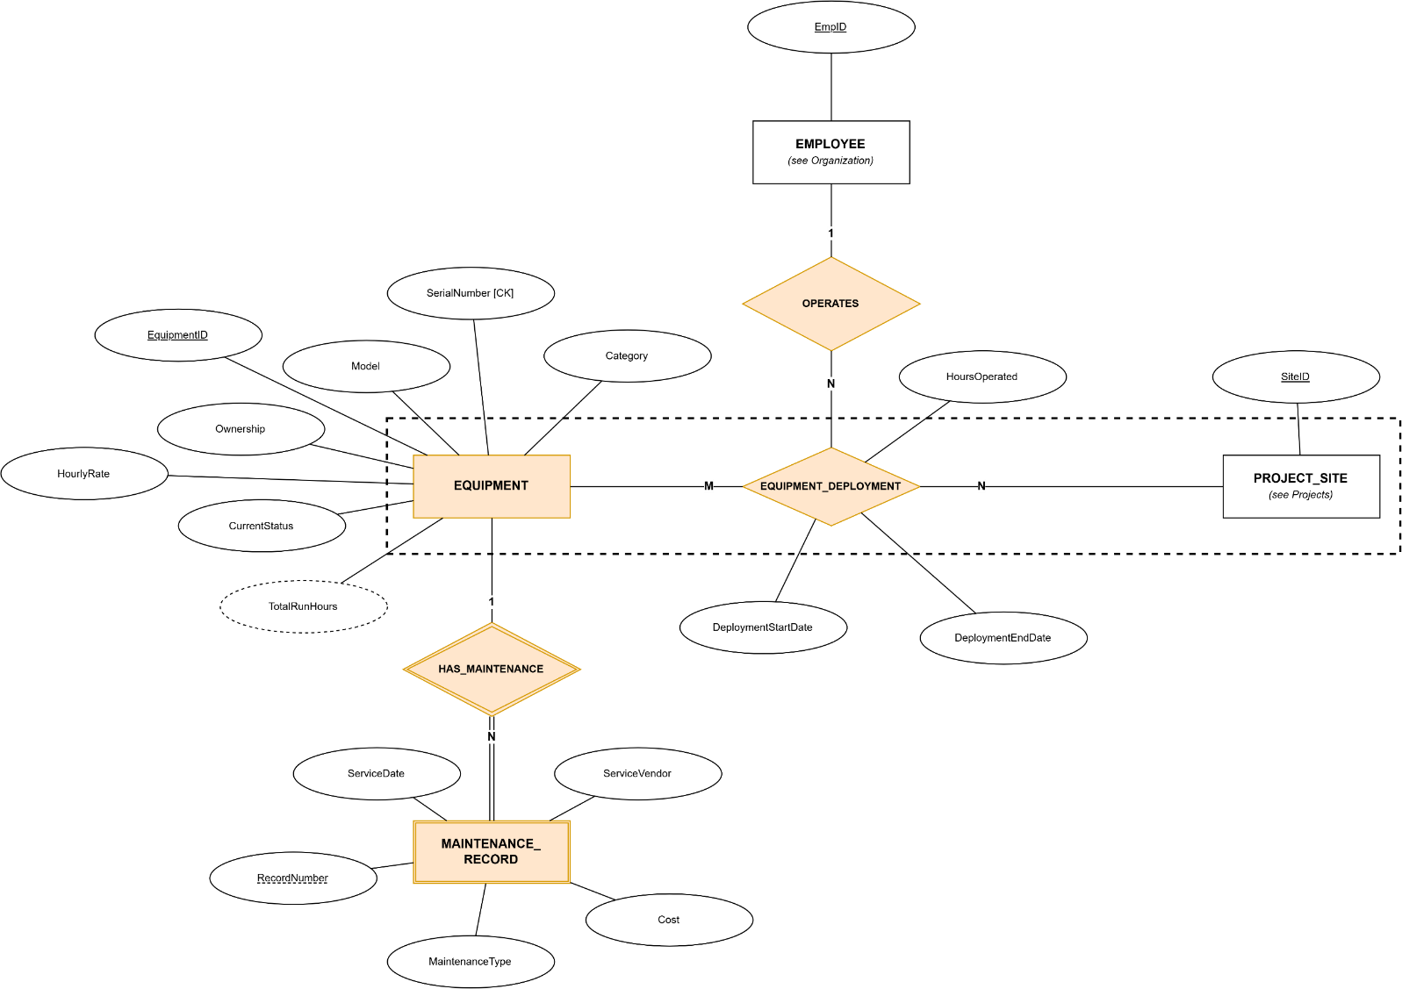
Figure 4. Equipment. EQUIPMENT and its weak entity set MAINTENANCE_RECORD, linked by HAS_MAINTENANCE. EQUIPMENT_DEPLOYMENT is an M:N relationship between EQUIPMENT and PROJECT_SITE with DeploymentStartDate, DeploymentEndDate, and HoursOperated. It is aggregated (dashed box) so that OPERATES can tie each deployment to the employee who runs the machine. TotalRunHours is derived, and SerialNumber is a candidate key.
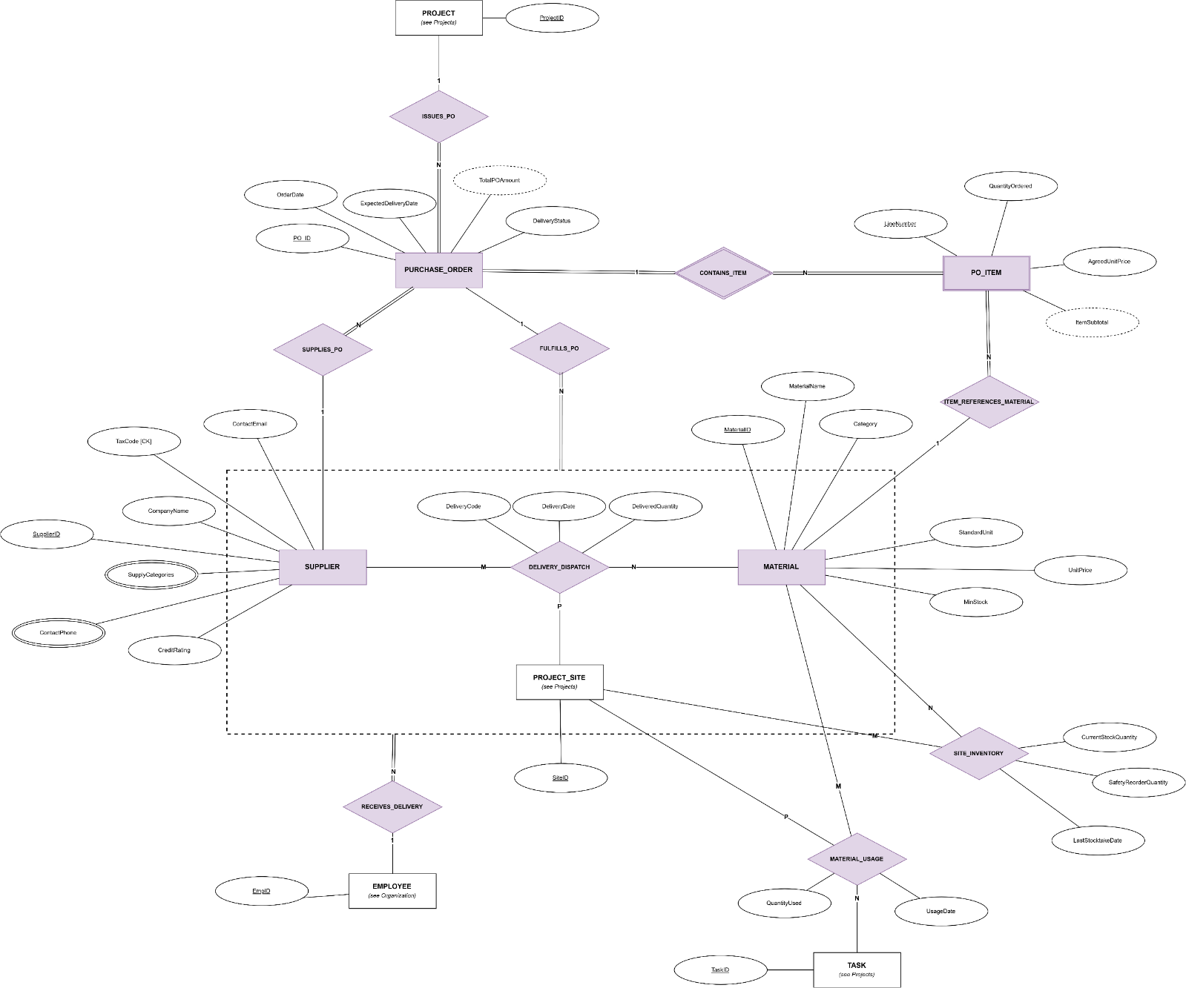
Figure 5. Materials and procurement. SUPPLIER, PURCHASE_ORDER, PO_ITEM, and MATERIAL. A project issues purchase orders, a supplier fulfils them, and each order contains line items that reference a material. SITE_INVENTORY holds stock levels per site and material. DELIVERY_DISPATCH is the ternary relationship among SUPPLIER, MATERIAL, and PROJECT_SITE; FULFILLS_PO ties each delivery to its purchase order, and RECEIVES_DELIVERY records the employee who accepts it. MATERIAL_USAGE records the quantity of a material used by a task at a site.
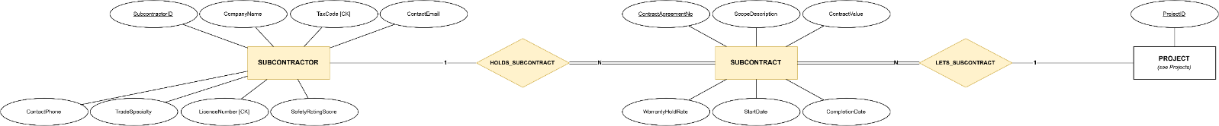
Figure 6. Subcontractors. SUBCONTRACTOR, SUBCONTRACT, and PROJECT. A subcontractor can hold many subcontracts (HOLDS_SUBCONTRACT), and a project can let many subcontracts (LETS_SUBCONTRACT). SUBCONTRACT carries ContractAgreementNo, ScopeDescription, ContractValue, WarrantyHoldRate, StartDate, and CompletionDate, which Section 3.1 lists as attributes of ENGAGES_SUBCONTRACTOR.
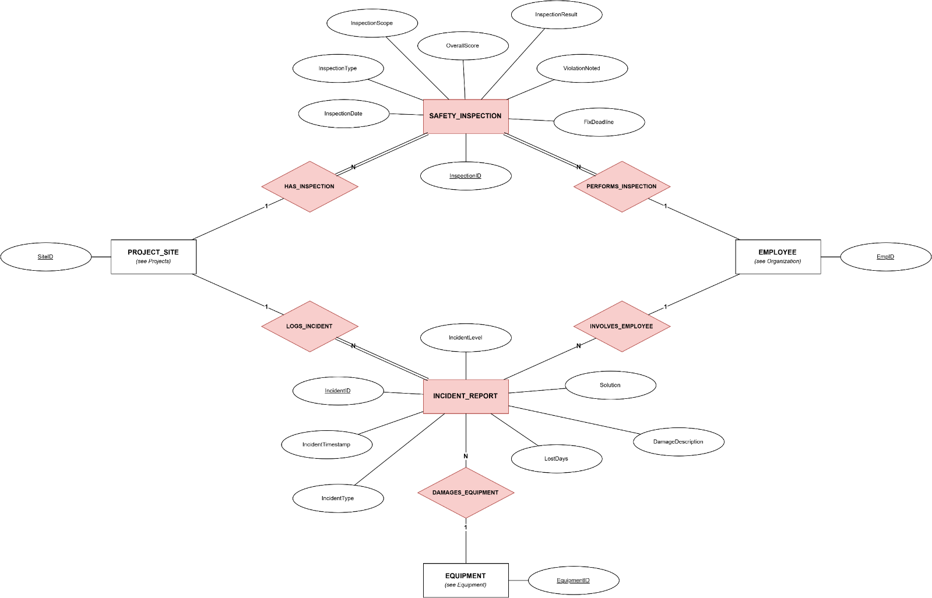
Figure 7. Safety. SAFETY_INSPECTION and INCIDENT_REPORT. Each inspection belongs to one project site (HAS_INSPECTION) and one inspecting employee (PERFORMS_INSPECTION). Each incident is logged at a site (LOGS_INCIDENT) and can involve an employee (INVOLVES_EMPLOYEE) or damage a piece of equipment (DAMAGES_EQUIPMENT).

Relational Schemas
This section presents the relational schemas derived from the ERD. Figure 8 shows the whole schema, and Figures 9 to 14 zoom into the six domains (Organization, Projects, Equipment, Materials and procurement, Subcontractors, and Safety) with every column. A table that belongs to another domain is drawn as a dashed box labelled with its name and shows only its primary key. The schemas follow the entity sets in Section 2.1, the attributes in Section 2.2, and the relationships in Section 3.1.
Notation: each box is a table, with the table name in the header and one cell per column. Underlined columns form the primary key, and a dashed underline marks the partial key of a weak entity set. Arrows run from a foreign key to the primary key it references. Colours match the ERD: blue for Organization, green for Projects, purple for Materials, orange for Equipment, yellow for Subcontractors, and red for Safety. Composite attributes are split into their components, multi-valued attributes become separate tables, and derived attributes are not stored.
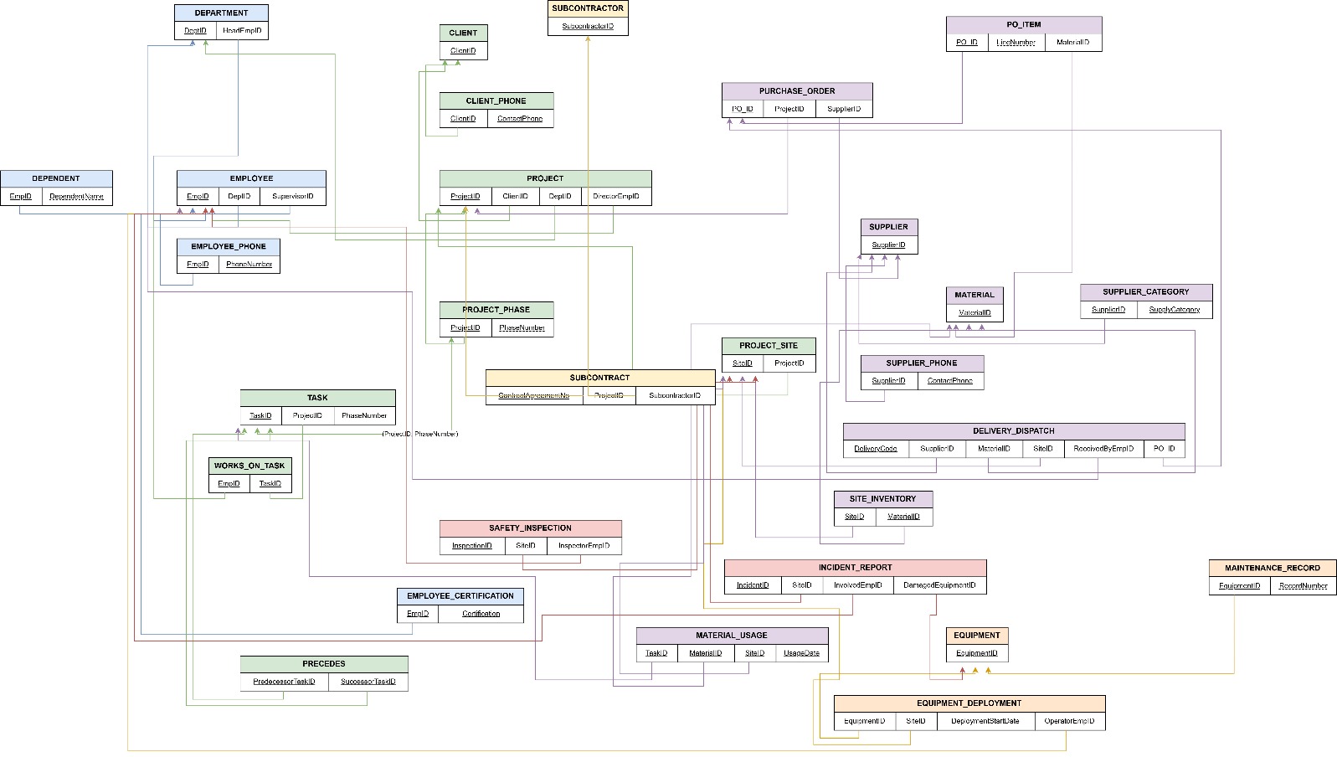
Figure 8. Overall relational schema. All tables on a single page, showing only primary key and foreign key columns. The full column lists are in Figures 9 to 14.
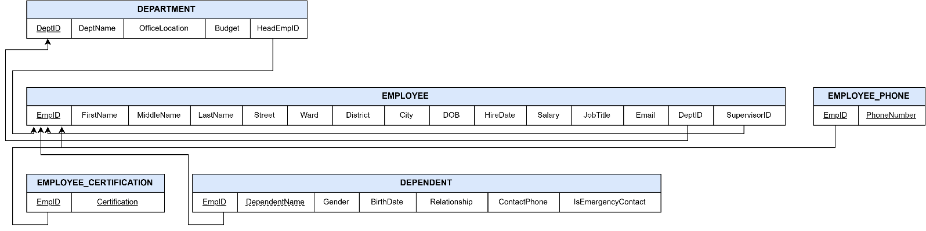
Figure 9. Organization. DEPARTMENT, EMPLOYEE, EMPLOYEE_PHONE, EMPLOYEE_CERTIFICATION, and DEPENDENT. Name and Address are split into FirstName, MiddleName, LastName and Street, Ward, District, City. The multi-valued attributes PhoneNumber and Certifications become their own tables, keyed by EmpID plus the value. DEPENDENT takes its key (EmpID, DependentName) from its owner EMPLOYEE. HeadEmpID in DEPARTMENT, and DeptID and SupervisorID in EMPLOYEE, are foreign keys.
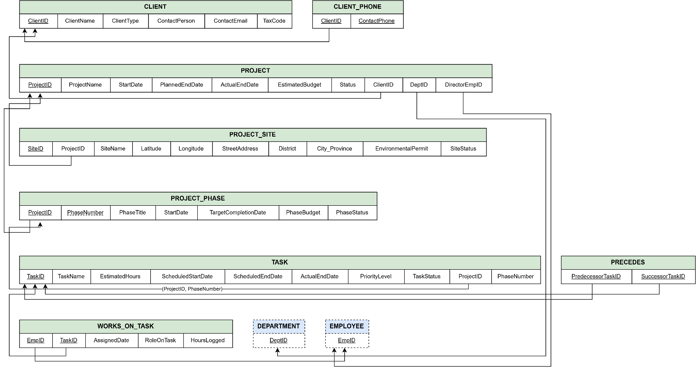
Figure 10. Projects. CLIENT, CLIENT_PHONE, PROJECT, PROJECT_SITE, PROJECT_PHASE, TASK, PRECEDES, and WORKS_ON_TASK. PROJECT references CLIENT, DEPARTMENT, and EMPLOYEE (DirectorEmpID). PROJECT_PHASE is keyed by (ProjectID, PhaseNumber), and TASK references it through the composite foreign key (ProjectID, PhaseNumber). PRECEDES and WORKS_ON_TASK hold the recursive and M:N relationships among tasks and employees. DEPARTMENT and EMPLOYEE appear as dashed reference boxes.
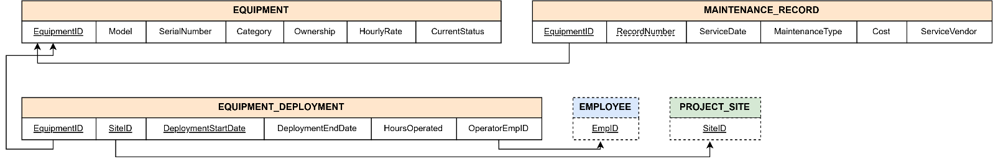
Figure 11. Equipment. EQUIPMENT, MAINTENANCE_RECORD, and EQUIPMENT_DEPLOYMENT. MAINTENANCE_RECORD is keyed by (EquipmentID, RecordNumber). EQUIPMENT_DEPLOYMENT is keyed by (EquipmentID, SiteID, DeploymentStartDate), and OperatorEmpID references EMPLOYEE. EMPLOYEE and PROJECT_SITE appear as dashed reference boxes.
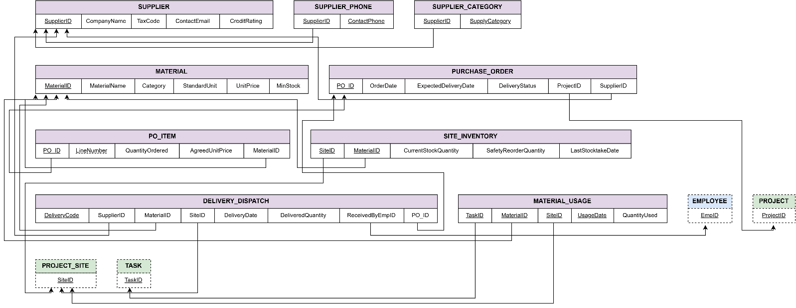
Figure 12. Materials and procurement. SUPPLIER, SUPPLIER_PHONE, SUPPLIER_CATEGORY, MATERIAL, PURCHASE_ORDER, PO_ITEM, SITE_INVENTORY, DELIVERY_DISPATCH, and MATERIAL_USAGE. The multi-valued ContactPhone and SupplyCategories of SUPPLIER become separate tables. PO_ITEM is keyed by (PO_ID, LineNumber), and SITE_INVENTORY by (SiteID, MaterialID). DELIVERY_DISPATCH has its own key DeliveryCode and references SUPPLIER, MATERIAL, PROJECT_SITE, EMPLOYEE (ReceivedByEmpID), and PURCHASE_ORDER (PO_ID). MATERIAL_USAGE is keyed by (TaskID, MaterialID, SiteID, UsageDate). EMPLOYEE, PROJECT, PROJECT_SITE, and TASK appear as dashed reference boxes.
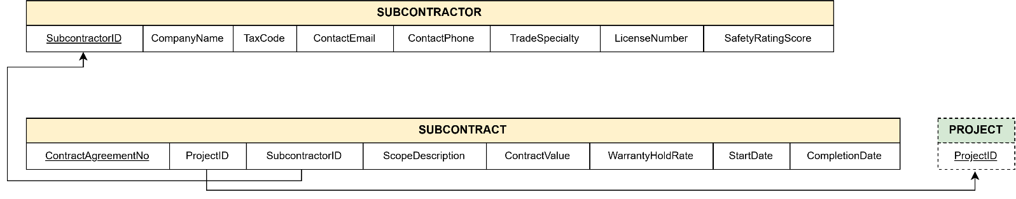
Figure 13. Subcontractors. SUBCONTRACTOR and SUBCONTRACT. The M:N relationship between PROJECT and SUBCONTRACTOR becomes the table SUBCONTRACT, keyed by ContractAgreementNo, with ProjectID and SubcontractorID as foreign keys. ScopeDescription, ContractValue, WarrantyHoldRate, StartDate, and CompletionDate are the relationship attributes listed in Section 3.1. PROJECT appears as a dashed reference box.
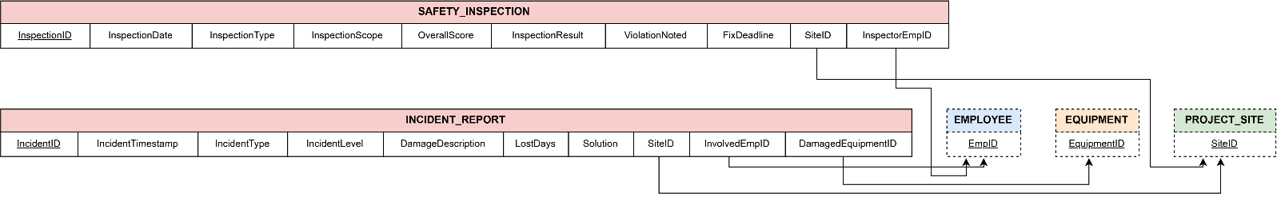
Figure 14. Safety. SAFETY_INSPECTION and INCIDENT_REPORT. Both tables carry SiteID as a foreign key to PROJECT_SITE. SAFETY_INSPECTION also holds InspectorEmpID (EMPLOYEE), while INCIDENT_REPORT holds InvolvedEmpID (EMPLOYEE) and DamagedEquipmentID (EQUIPMENT). EMPLOYEE, EQUIPMENT, and PROJECT_SITE appear as dashed reference boxes.

