HỌC VIỆN CÔNG NGHỆ BƯU CHÍNH VIỄN THÔNG
KHOA CÔNG NGHỆ THÔNG TIN



DATABASE DESIGN TERM PROJECT

Database system for a construction company with multiple projects
(Phase 3: Normalization & Physical database design)

Course: Database [E24-Class 5].
Team: 5.
Members:
Lê Anh Minh - B24DCCE180.
Ứng Trọng Trình - B24DCCE271.
Nguyễn Đinh Anh Quân - B24DCCE222.

Instructor: Nguyễn Đình Hoá.
Table of Contents

1. Introduction & Final Relational Schema 3
2. Functional Dependencies & Normalization 4
2.1 Overview 4
2.2 Detailed Normalization Analysis 4
2.2.1 Subsystem 1: Organization & Human Resources 4
2.2.2 Subsystem 2: Project Management & Work Breakdown Structure (WBS) 6
2.2.3 Subsystem 3: Heavy Machinery & Fleet Maintenance 9
2.2.4 Subsystem 4: Procurement, Materials & Site Inventory 10
2.2.5 Subsystem 5: Trade Subcontractors 13
2.2.6 Subsystem 6: Health, Safety & Environment (HSE) 14
2.3 Master Summary of 3NF Normalized Relational Schema 15
3. Physical Database Design & Implementation Details 19
3.1 DBMS Selection & Configuration 19
3.2 Database Scripts Organization & Proofs. 19
3.2.1 01_schema_ddl.sql (DDL — 29 Core Tables & Indexes): 19
3.2.2 02_triggers_procedures.sql (8 Business Rule Triggers): 19
3.2.3 03_sample_data_dml.sql (Realistic Sample Data): 24
3.2.4 04_business_queries.sql (Operational & Analytical Queries): 26
3.2.5 05_user_queries.sql (User Queries — Multi-Table Joins, Grouping & Filtering) 32
4. Conclusion 34

- Introduction & Final Relational Schema
This Phase 3 report completes the logical normalization and physical implementation of the A34Build enterprise database system on MySQL, building upon the Conceptual Design (ERD) and Relational Schema Mapping established in Phase 2.
The system covers 6 core operational subsystems across 29 normalized tables (plus 1 automated audit log table, EMERGENCY_DISPATCH_LOG, for safety alerting):
- Organization & Human Resources (HR): DEPARTMENT, EMPLOYEE, EMPLOYEE_PHONE, EMPLOYEE_CERTIFICATION, DEPENDENT.
- Project Management & WBS:
CLIENT, CLIENT_PHONE, PROJECT, PROJECT_SITE, PROJECT_PHASE, TASK, PRECEDES, WORKS_ON_TASK
- Heavy Machinery & Fleet Maintenance:
EQUIPMENT, MAINTENANCE_RECORD, EQUIPMENT_DEPLOYMENT
- Procurement, Materials & Site Inventory:
SUPPLIER, SUPPLIER_PHONE, MATERIAL, PURCHASE_ORDER, PO_ITEM, SITE_INVENTORY, DELIVERY_DISPATCH, MATERIAL_USAGE
- Trade Subcontractors: SUBCONTRACTOR, SUBCONTRACT
- Health, Safety & Environment (HSE):
SAFETY_INSPECTION, INCIDENT_REPORT, EMERGENCY_DISPATCH_LOG (trigger audit table)

- Functional Dependencies & Normalization
  - Overview
All 29 relational schemas mapped from the Phase 2 ERD were audited against 1NF, 2NF, and 3NF criteria (Elmasri & Navathe, Fundamentals of Database Systems, 6th ed., Chapter 14):
- 27 schemas satisfy 3NF directly without structural modification.
- 2 schemas exhibited normal form violations from initial ERD mapping and were decomposed/corrected:
Table | Initial Defect (Phase 2) | Violation | 3NF Correction (Phase 3)
16. EQUIPMENT_  DEPLOYMENT | $\text{SiteID}$ was in the PK: $(\underline{\text{EquipmentID}},\underline{\text{SiteID}},\underline{\text{DeploymentStartDate}})$, but $\{\text{EquipmentID},\text{DeploymentStartDate}\}→\text{SiteID}$. | 2NF(Partial Key Dependency) | Moved $\text{SiteID}$ out of PK into a non-prime FK. Minimal PK: $(\underline{\text{EquipmentID}},\underline{\text{DeploymentStartDate}})$.
24. DELIVERY_  DISPATCH | Contained both $\text{PO_ID}$ and $\text{SupplierID}$, where $\text{PO_ID}→\text{SupplierID}$ via PURCHASE_ORDER. | 3NF  (Transitive Dependency:$\text{DeliveryCode}→\text{PO_ID}→\text{SupplierID}$) | Removed $\text{SupplierID}$. Vendor is resolved via FK $\text{PO_ID}→\text{PURCHASE_ORDER}$.

  - Detailed Normalization Analysis
Each table is evaluated using a uniform template: Relational Schema, Functional Dependencies ($F$), Candidate Keys, Attribute Classification, and Normal Form Verification (1NF $→$ 2NF $→$ 3NF).
    - Subsystem 1: Organization & Human Resources

1. Table: DEPARTMENT
- Relational Schema: $\text{DEPARTMENT}(\underline{\text{DeptID}},\text{DeptName},\text{OfficeLocation},\text{Budget},\text{HeadEmpID})$
- Functional Dependencies ($F_{1}$):
  - $FD_{1.1}:\text{DeptID}→\{\text{DeptName, OfficeLocation, Budget, HeadEmpID}\}$ (Department ID uniquely identifies the department).
  - $FD_{1.2}:\text{DeptName}→\{\text{DeptID, OfficeLocation, Budget, HeadEmpID}\}$ (Department name is unique enterprise-wide).
  - $FD_{1.3}:\text{HeadEmpID}→\{\text{DeptID, DeptName, OfficeLocation, Budget}\}$ (An employee heads at most one department).
- Candidate Keys & Attributes:
  - Candidate Keys: $CK_{1}=\{\text{DeptID}\}$ (PK), $CK_{2}=\{\text{DeptName}\}$ (AK), $CK_{3}=\{\text{HeadEmpID}\}$ (AK).
  - Prime Attributes: DeptID, DeptName, HeadEmpID.
  - Non-Prime Attributes: OfficeLocation, Budget.
- Normal Form Evaluation:
  - 1NF: Satisfied (atomic domains).
  - 2NF: Satisfied (all candidate keys are single attributes; no partial dependencies possible).
  - 3NF: Satisfied (all determinants are superkeys; no transitive dependencies of non-prime attributes).
- Conclusion: Achieves 3NF.

2. Table: EMPLOYEE
- Relational Schema: $\text{EMPLOYEE}(\underline{\text{EmpID}},\text{FirstName},\text{MiddleName},\text{LastName},\text{Street},\text{Ward},\text{District},\text{City},\text{DOB},\text{HireDate},\text{Salary},$$$\text{JobTitle},\text{Email},\text{DeptID},\text{SupervisorID})$$
- Functional Dependencies ($F_{2}$):
  - $FD_{2.1}:\text{EmpID}→\{\text{FirstName, MiddleName, LastName, Street, Ward, District, City, DOB, HireDate, Salary, JobTitle,}$
$\text{ Email, DeptID, SupervisorID}\}$
  - (Employee ID uniquely identifies the employee).
  - $FD_{2.2}:\text{Email}→\{\text{EmpID, FirstName, MiddleName, LastName, Street, Ward, District, City, DOB, HireDate, }$
$\text{Salary, JobTitle, DeptID, SupervisorID}\}$ (Corporate email is unique).
- Candidate Keys & Attributes:
  - Candidate Keys: $CK_{1}=\{\text{EmpID}\}$ (PK), $CK_{2}=\{\text{Email}\}$ (AK).
  - Prime Attributes: EmpID, Email.
  - Non-Prime Attributes: FirstName, MiddleName, LastName, Street, Ward, District, City, DOB, HireDate, Salary, JobTitle, DeptID, SupervisorID.
- Normal Form Evaluation:
  - 1NF: Satisfied (composite name and address attributes decomposed into atomic columns; multivalued attributes separated).
  - 2NF: Satisfied (candidate keys are single attributes; no partial dependencies).
  - 3NF: Satisfied (all determinants are superkeys; no transitive dependencies).
- Conclusion: Achieves 3NF.

3. Table: EMPLOYEE_PHONE
- Relational Schema: $\text{EMPLOYEE_PHONE}(\underline{\text{EmpID}},\underline{\text{PhoneNumber}})$
- Functional Dependencies ($F_{3}$): Trivial dependencies only
($\{\text{EmpID, PhoneNumber}\}→\{\text{EmpID, PhoneNumber}\}$).
- Candidate Keys & Attributes:
  - Candidate Key: $CK=\{\text{EmpID, PhoneNumber}\}$ (PK).
  - Prime Attributes: EmpID, PhoneNumber.
  - Non-Prime Attributes: $∅$ (None).
- Normal Form Evaluation:
  - 1NF: Satisfied (single atomic phone number per tuple).
  - 2NF / 3NF: Trivially satisfied (all attributes are prime).
- Conclusion: Achieves 3NF.

4. Table: EMPLOYEE_CERTIFICATION
- Relational Schema: $\text{EMPLOYEE_CERTIFICATION}(\underline{\text{EmpID}},\underline{\text{Certification}})$
- Functional Dependencies ($F_{4}$): Trivial dependencies only.
- Candidate Keys & Attributes:
  - Candidate Key: $CK=\{\text{EmpID, Certification}\}$ (PK).
  - Prime Attributes: EmpID, Certification.
  - Non-Prime Attributes: $∅$ (None).
- Normal Form Evaluation:
  - 1NF / 2NF / 3NF: Trivially satisfied (all attributes are prime).
- Conclusion: Achieves 3NF.

5. Table: DEPENDENT
- Relational Schema: $\text{DEPENDENT}(\underline{\text{EmpID}},\underline{\text{DependentName}},\text{Gender},\text{BirthDate},\text{Relationship},\text{ContactPhone},\text{IsEmergencyContact})$
- Functional Dependencies ($F_{5}$):
  - $FD_{5.1}:\{\text{EmpID, DependentName}\}→\{\text{Gender, BirthDate, Relationship, ContactPhone, IsEmergencyContact}\}$ (Weak entity identified by employee and partial key).
- Candidate Keys & Attributes:
  - Candidate Key: $CK=\{\text{EmpID, DependentName}\}$ (PK).
  - Prime Attributes: EmpID, DependentName.
  - Non-Prime Attributes: Gender, BirthDate, Relationship, ContactPhone, IsEmergencyContact.
- Normal Form Evaluation:
  - 1NF: Satisfied (atomic domains).
  - 2NF: Satisfied (neither EmpID alone nor DependentName alone determines dependent attributes; no partial dependency).
  - 3NF: Satisfied (determinant is the candidate key; no transitive dependencies).
- Conclusion: Achieves 3NF.

    - Subsystem 2: Project Management & Work Breakdown Structure (WBS)

6. Table: CLIENT
- Relational Schema: $\text{CLIENT}(\underline{\text{ClientID}},\text{ClientName},\text{ClientType},\text{ContactPerson},\text{ContactEmail},\text{TaxCode})$
- Functional Dependencies ($F_{6}$):
  - $FD_{6.1}:\text{ClientID}→\{\text{ClientName, ClientType, ContactPerson, ContactEmail, TaxCode}\}$
  - $FD_{6.2}:\text{TaxCode}→\{\text{ClientID, ClientName, ClientType, ContactPerson, ContactEmail}\}$ (Corporate tax code is unique).
- Candidate Keys & Attributes:
  - Candidate Keys: $CK_{1}=\{\text{ClientID}\}$ (PK), $CK_{2}=\{\text{TaxCode}\}$ (AK).
  - Prime Attributes: ClientID, TaxCode.
  - Non-Prime Attributes: ClientName, ClientType, ContactPerson, ContactEmail.
- Normal Form Evaluation:
  - 1NF / 2NF: Satisfied (single-attribute keys; no partial dependencies).
  - 3NF: Satisfied (all determinants are superkeys).
- Conclusion: Achieves 3NF.

7. Table: CLIENT_PHONE
- Relational Schema: $\text{CLIENT_PHONE}(\underline{\text{ClientID}},\underline{\text{ContactPhone}})$
- Functional Dependencies ($F_{7}$): Trivial dependencies only.
- Candidate Keys & Attributes:
  - Candidate Key: $CK=\{\text{ClientID, ContactPhone}\}$ (PK).
  - Prime Attributes: ClientID, ContactPhone.
  - Non-Prime Attributes: $∅$ (None).
- Normal Form Evaluation:
  - 1NF / 2NF / 3NF: Trivially satisfied (all attributes are prime).
- Conclusion: Achieves 3NF.

8. Table: PROJECT
- Relational Schema: $\text{PROJECT}(\underline{\text{ProjectID}},\text{ProjectName},\text{StartDate},\text{PlannedEndDate},\text{ActualEndDate},\text{EstimatedBudget},\text{Status},$
$$\text{ClientID},\text{DeptID},\text{DirectorEmpID})$$
- Functional Dependencies ($F_{8}$):
  - $FD_{8.1}:\text{ProjectID}→\{\text{ProjectName, StartDate, PlannedEndDate, ActualEndDate, EstimatedBudget, Status, ClientID, }$
$$\text{DeptID, DirectorEmpID}\}$$
  - $FD_{8.2}:\text{ProjectName}→\{\text{ProjectID, StartDate, PlannedEndDate, ActualEndDate, EstimatedBudget, Status, ClientID, }\text{DeptID, DirectorEmpID}\}$
(Contract title is unique).
- Candidate Keys & Attributes:
  - Candidate Keys: $CK_{1}=\{\text{ProjectID}\}$ (PK), $CK_{2}=\{\text{ProjectName}\}$ (AK).
  - Prime Attributes: ProjectID, ProjectName.
  - Non-Prime Attributes: StartDate, PlannedEndDate, ActualEndDate, EstimatedBudget, Status, ClientID, DeptID, DirectorEmpID.
- Normal Form Evaluation:
  - 1NF / 2NF: Satisfied (single-attribute keys; no partial dependencies).
  - 3NF: Satisfied (all determinants are superkeys; foreign keys reference external entities without creating intra-table transitive dependencies).
- Conclusion: Achieves 3NF.

9. Table: PROJECT_SITE
- Relational Schema: $\text{PROJECT_SITE}(\underline{\text{SiteID}},\text{ProjectID},\text{SiteName},\text{Latitude},\text{Longitude},\text{StreetAddress},\text{District},\text{City_Province},$
- $\text{EnvironmentalPermit},\text{SiteStatus})$
- Functional Dependencies ($F_{9}$):
  - $FD_{9.1}:\text{SiteID}→\{\text{ProjectID, SiteName, Latitude, Longitude, StreetAddress, District, City_Province, }$
$$\text{EnvironmentalPermit, SiteStatus}\}$$
  - $FD_{9.2}:\{\text{ProjectID, SiteName}\}→\{\text{SiteID, Latitude, Longitude, StreetAddress, District, City_Province, EnvironmentalPermit, SiteStatus}\}$ (Site name is unique per project).
  - $FD_{9.3}:\{\text{Latitude, Longitude}\}→\{\text{SiteID, ProjectID, SiteName, StreetAddress, District, City_Province, EnvironmentalPermit, SiteStatus}\}$ (Geographic coordinates identify a site).
- Candidate Keys & Attributes:
  - Candidate Keys: $CK_{1}=\{\text{SiteID}\}$ (PK), $CK_{2}=\{\text{ProjectID, SiteName}\}$ (AK), $CK_{3}=\{\text{Latitude, Longitude}\}$ (AK).
  - Prime Attributes: SiteID, ProjectID, SiteName, Latitude, Longitude.
  - Non-Prime Attributes: StreetAddress, District, City_Province, EnvironmentalPermit, SiteStatus.
- Normal Form Evaluation:
  - 1NF: Satisfied (atomic fields).
  - 2NF: Satisfied (for composite keys $CK_{2}$ and $CK_{3}$, no proper subset determines any non-prime attribute).
  - 3NF: Satisfied (all determinants are superkeys).
- Conclusion: Achieves 3NF.

10. Table: PROJECT_PHASE
- Relational Schema: $\text{PROJECT_PHASE}(\underline{\text{ProjectID}},\underline{\text{PhaseNumber}},\text{PhaseTitle},\text{StartDate},\text{TargetCompletionDate},\text{PhaseBudget},\text{PhaseStatus})$
- Functional Dependencies ($F_{10}$):
  - $FD_{10.1}:\{\text{ProjectID, PhaseNumber}\}→\{\text{PhaseTitle, StartDate, TargetCompletionDate, PhaseBudget, PhaseStatus}\}$
- Candidate Keys & Attributes:
  - Candidate Key: $CK=\{\text{ProjectID, PhaseNumber}\}$ (PK).
  - Prime Attributes: ProjectID, PhaseNumber.
  - Non-Prime Attributes: PhaseTitle, StartDate, TargetCompletionDate, PhaseBudget, PhaseStatus.
- Normal Form Evaluation:
  - 1NF: Satisfied.
  - 2NF: Satisfied (full functional dependency on composite key; neither ProjectID nor PhaseNumber alone determines phase attributes).
  - 3NF: Satisfied (determinant is the candidate key).
- Conclusion: Achieves 3NF.

11. Table: TASK
- Relational Schema: $\text{TASK}(\underline{\text{TaskID}},\text{TaskName},\text{EstimatedHours},\text{ScheduledStartDate},\text{ScheduledEndDate},\text{ActualEndDate},$
$$\text{PriorityLevel},\text{TaskStatus},\text{ProjectID},\text{PhaseNumber})$$
- Functional Dependencies ($F_{11}$):
  - $FD_{11.1}:\text{TaskID}→\{\text{TaskName, EstimatedHours, ScheduledStartDate, ScheduledEndDate, ActualEndDate, PriorityLevel, }$
$$\text{TaskStatus, ProjectID, PhaseNumber}\}$$
  - $FD_{11.2}:\{\text{ProjectID, PhaseNumber, TaskName}\}→\{\text{TaskID, EstimatedHours, ScheduledStartDate, ScheduledEndDate, ActualEndDate, PriorityLevel, }$
$$\text{TaskStatus}\}$$
- Candidate Keys & Attributes:
  - Candidate Keys: $CK_{1}=\{\text{TaskID}\}$ (PK), $CK_{2}=\{\text{ProjectID, PhaseNumber, TaskName}\}$ (AK).
  - Prime Attributes: TaskID, ProjectID, PhaseNumber, TaskName.
  - Non-Prime Attributes: EstimatedHours, ScheduledStartDate, ScheduledEndDate, ActualEndDate, PriorityLevel, TaskStatus.
- Normal Form Evaluation:
  - 1NF / 2NF: Satisfied (no partial dependencies on either candidate key).
  - 3NF: Satisfied (all determinants are superkeys; composite foreign key (ProjectID, PhaseNumber) does not determine other non-prime attributes).
- Conclusion: Achieves 3NF.

12. Table: PRECEDES
- Relational Schema: $\text{PRECEDES}(\underline{\text{PredecessorTaskID}},\underline{\text{SuccessorTaskID}})$
- Functional Dependencies ($F_{12}$): Trivial dependencies only.
- Candidate Keys & Attributes:
  - Candidate Key: $CK=\{\text{PredecessorTaskID, SuccessorTaskID}\}$ (PK).
  - Prime Attributes: PredecessorTaskID, SuccessorTaskID.
  - Non-Prime Attributes: $∅$ (None).
- Normal Form Evaluation:
  - 1NF / 2NF / 3NF: Trivially satisfied (all attributes are prime).
- Conclusion: Achieves 3NF.

13. Table: WORKS_ON_TASK
- Relational Schema: $\text{WORKS_ON_TASK}(\underline{\text{EmpID}},\underline{\text{TaskID}},\text{AssignedDate},\text{RoleOnTask},\text{HoursLogged})$
- Functional Dependencies ($F_{13}$):
  - $FD_{13.1}:\{\text{EmpID, TaskID}\}→\{\text{AssignedDate, RoleOnTask, HoursLogged}\}$
- Candidate Keys & Attributes:
  - Candidate Key: $CK=\{\text{EmpID, TaskID}\}$ (PK).
  - Prime Attributes: EmpID, TaskID.
  - Non-Prime Attributes: AssignedDate, RoleOnTask, HoursLogged.
- Normal Form Evaluation:
  - 1NF: Satisfied.
  - 2NF: Satisfied (full functional dependency; neither EmpID nor TaskID alone determines logged hours).
  - 3NF: Satisfied (determinant is the candidate key).
Conclusion: Achieves 3NF.

    - Subsystem 3: Heavy Machinery & Fleet Maintenance

14. Table: EQUIPMENT
- Relational Schema: $\text{EQUIPMENT}(\underline{\text{EquipmentID}},\text{Model},\text{SerialNumber},\text{Category},\text{Ownership},\text{HourlyRate},\text{CurrentStatus})$
- Functional Dependencies ($F_{14}$):
  - $FD_{14.1}:\text{EquipmentID}→\{\text{Model, SerialNumber, Category, Ownership, HourlyRate, CurrentStatus}\}$
  - $FD_{14.2}:\text{SerialNumber}→\{\text{EquipmentID, Model, Category, Ownership, HourlyRate, CurrentStatus}\}$ (Manufacturer chassis/VIN is unique).
- Candidate Keys & Attributes:
  - Candidate Keys: $CK_{1}=\{\text{EquipmentID}\}$ (PK), $CK_{2}=\{\text{SerialNumber}\}$ (AK).
  - Prime Attributes: EquipmentID, SerialNumber.
  - Non-Prime Attributes: Model, Category, Ownership, HourlyRate, CurrentStatus.
- Normal Form Evaluation:
  - 1NF / 2NF: Satisfied (single-attribute keys; no partial dependencies).
  - 3NF: Satisfied (all determinants are superkeys).
- Conclusion: Achieves 3NF.

15. Table: MAINTENANCE_RECORD
- Relational Schema: $\text{MAINTENANCE_RECORD}(\underline{\text{EquipmentID}},\underline{\text{RecordNumber}},\text{ServiceDate},\text{MaintenanceType},\text{Cost},\text{ServiceVendor})$
- Functional Dependencies ($F_{15}$):
  - $FD_{15.1}:\{\text{EquipmentID, RecordNumber}\}→\{\text{ServiceDate, MaintenanceType, Cost, ServiceVendor}\}$
- Candidate Keys & Attributes:
  - Candidate Key: $CK=\{\text{EquipmentID, RecordNumber}\}$ (PK).
  - Prime Attributes: EquipmentID, RecordNumber.
  - Non-Prime Attributes: ServiceDate, MaintenanceType, Cost, ServiceVendor.
- Normal Form Evaluation:
  - 1NF / 2NF: Satisfied (full functional dependency on composite key).
  - 3NF: Satisfied (determinant is the candidate key).
- Conclusion: Achieves 3NF.

16. Table: EQUIPMENT_DEPLOYMENT (2NF Partial Key Resolution)
1. Phase 2 Initial Design & Conflict Analysis:
- Initial Relational Schema: $\text{EQUIPMENT_DEPLOYMENT}(\underline{\text{EquipmentID}},\underline{\text{SiteID}},\underline{\text{DeploymentStartDate}},\text{DeploymentEndDate},$$$\text{HoursOperated},\text{OperatorEmpID})$$
- Initial Key & Functional Dependencies:
  - Initial Composite Key: $\{\text{EquipmentID, SiteID, DeploymentStartDate}\}$
  - Logistics Dependency ($FD_{16.1}$): $\{\text{EquipmentID, DeploymentStartDate}\}→\{\text{SiteID, DeploymentEndDate, HoursOperated, OperatorEmpID}\}$ (A machine operates at exactly one site per start date).
- Conflict & 2NF Violation:
  - Violation Analysis: In $FD_{16.1}$, the attribute $\text{SiteID}$ is functionally determined by $\{\text{EquipmentID, DeploymentStartDate}\}$, which is a proper subset of the initial 3-part key.
  - Conflict: This constitutes a Partial Key Dependency, directly violating 2NF. The initial key is non-minimal and redundant.
2. Conflict Resolution & Normalized Design (3NF Certified):
- Resolution Strategy: Remove $\text{SiteID}$ from the composite primary key and retain it as a non-prime foreign key referencing PROJECT_SITE. The primary key is minimized to strictly $\{\text{EquipmentID},\text{DeploymentStartDate}\}$, eliminating the partial key dependency and restoring 2NF/3NF compliance without losing the job site relationship.
- Normalized Relational Schema: $\text{EQUIPMENT_DEPLOYMENT}(\underline{\text{EquipmentID}},\underline{\text{DeploymentStartDate}},\text{SiteID},\text{DeploymentEndDate},$$$\text{HoursOperated},\text{OperatorEmpID})$$
- Normalized Candidate Keys & Attributes:
  - Candidate Key: $CK=\{\text{EquipmentID, DeploymentStartDate}\}$ (Minimal PK).
  - Prime Attributes: EquipmentID, DeploymentStartDate.
  - Non-Prime Attributes: SiteID, DeploymentEndDate, HoursOperated, OperatorEmpID.
- Normal Form Evaluation:
  - 1NF / 2NF: Satisfied (all non-prime attributes depend fully on the complete 2-attribute minimal key; partial dependency eliminated).
  - 3NF: Satisfied (the sole determinant is a superkey; no transitive dependencies).
- Conclusion: Achieves 3NF.

    - Subsystem 4: Procurement, Materials & Site Inventory

17. Table: SUPPLIER
- Relational Schema: $\text{SUPPLIER}(\underline{\text{SupplierID}},\text{CompanyName},\text{TaxCode},\text{ContactEmail},\text{CreditRating})$
- Functional Dependencies ($F_{17}$):
  - $FD_{17.1}:\text{SupplierID}→\{\text{CompanyName, TaxCode, ContactEmail, CreditRating}\}$
  - $FD_{17.2}:\text{TaxCode}→\{\text{SupplierID, CompanyName, ContactEmail, CreditRating}\}$ (Tax code is unique).
- Candidate Keys & Attributes:
  - Candidate Keys: $CK_{1}=\{\text{SupplierID}\}$ (PK), $CK_{2}=\{\text{TaxCode}\}$ (AK).
  - Prime Attributes: SupplierID, TaxCode.
  - Non-Prime Attributes: CompanyName, ContactEmail, CreditRating.
- Normal Form Evaluation:
  - 1NF / 2NF / 3NF: Satisfied (single-attribute keys; determinants are superkeys).
- Conclusion: Achieves 3NF.

18. Table: SUPPLIER_PHONE
- Relational Schema: $\text{SUPPLIER_PHONE}(\underline{\text{SupplierID}},\underline{\text{ContactPhone}})$
- Functional Dependencies ($F_{18}$): Trivial dependencies only.
- Candidate Keys & Attributes:
  - Candidate Key: $CK=\{\text{SupplierID, ContactPhone}\}$ (PK).
  - Prime Attributes: SupplierID, ContactPhone.
  - Non-Prime Attributes: $∅$ (None).
- Normal Form Evaluation:
  - 1NF / 2NF / 3NF: Trivially satisfied (all attributes are prime).
- Conclusion: Achieves 3NF.

19. Table: SUPPLIER_CATEGORY
- Relational Schema: $\text{SUPPLIER_CATEGORY}(\underline{\text{SupplierID}},\underline{\text{SupplyCategory}})$
- Functional Dependencies ($F_{19}$): Trivial dependencies only.
- Candidate Keys & Attributes:
  - Candidate Key: $CK=\{\text{SupplierID, SupplyCategory}\}$ (PK).
  - Prime Attributes: SupplierID, SupplyCategory.
  - Non-Prime Attributes: $∅$ (None).
- Normal Form Evaluation:
  - 1NF / 2NF / 3NF: Trivially satisfied (all attributes are prime).
- Conclusion: Achieves 3NF.

20. Table: MATERIAL
- Relational Schema: $\text{MATERIAL}(\underline{\text{MaterialID}},\text{MaterialName},\text{Category},\text{StandardUnit},\text{UnitPrice},\text{MinStock})$
- Functional Dependencies ($F_{20}$):
  - $FD_{20.1}:\text{MaterialID}→\{\text{MaterialName, Category, StandardUnit, UnitPrice, MinStock}\}$
  - $FD_{20.2}:\text{MaterialName}→\{\text{MaterialID, Category, StandardUnit, UnitPrice, MinStock}\}$ (Standard catalog name is unique).
- Candidate Keys & Attributes:
  - Candidate Keys: $CK_{1}=\{\text{MaterialID}\}$ (PK), $CK_{2}=\{\text{MaterialName}\}$ (AK).
  - Prime Attributes: MaterialID, MaterialName.
  - Non-Prime Attributes: Category, StandardUnit, UnitPrice, MinStock.
- Normal Form Evaluation:
  - 1NF / 2NF / 3NF: Satisfied (single-attribute keys; determinants are superkeys).
- Conclusion: Achieves 3NF.

21. Table: PURCHASE_ORDER
- Relational Schema: $\text{PURCHASE_ORDER}(\underline{\text{PO_ID}},\text{OrderDate},\text{ExpectedDeliveryDate},\text{DeliveryStatus},\text{ProjectID},\text{SupplierID})$
- Functional Dependencies ($F_{21}$):
  - $FD_{21.1}:\text{PO_ID}→\{\text{OrderDate, ExpectedDeliveryDate, DeliveryStatus, ProjectID, SupplierID}\}$
- Candidate Keys & Attributes:
  - Candidate Key: $CK=\{\text{PO_ID}\}$ (PK).
  - Prime Attributes: PO_ID.
  - Non-Prime Attributes: OrderDate, ExpectedDeliveryDate, DeliveryStatus, ProjectID, SupplierID.
- Normal Form Evaluation:
  - 1NF / 2NF / 3NF: Satisfied (single-attribute key; determinant is a superkey).
- Conclusion: Achieves 3NF.

22. Table: PO_ITEM
- Relational Schema: $\text{PO_ITEM}(\underline{\text{PO_ID}},\underline{\text{LineNumber}},\text{QuantityOrdered},\text{AgreedUnitPrice},\text{MaterialID})$
- Functional Dependencies ($F_{22}$):
  - $FD_{22.1}:\{\text{PO_ID, LineNumber}\}→\{\text{QuantityOrdered, AgreedUnitPrice, MaterialID}\}$
  - $FD_{22.2}:\{\text{PO_ID, MaterialID}\}→\{\text{LineNumber, QuantityOrdered, AgreedUnitPrice}\}$ (A material appears once per purchase order).
- Candidate Keys & Attributes:
  - Candidate Keys: $CK_{1}=\{\text{PO_ID, LineNumber}\}$ (PK), $CK_{2}=\{\text{PO_ID, MaterialID}\}$ (AK).
  - Prime Attributes: PO_ID, LineNumber, MaterialID.
  - Non-Prime Attributes: QuantityOrdered, AgreedUnitPrice.
- Normal Form Evaluation:
  - 1NF: Satisfied.
  - 2NF: Satisfied (full functional dependency; neither PO_ID nor LineNumber alone determines quantity or price).
  - 3NF: Satisfied (determinants are candidate keys. AgreedUnitPrice is contract-locked and does not depend on MaterialID, precluding transitive dependency).
- Conclusion: Achieves 3NF.

23. Table: SITE_INVENTORY
- Relational Schema: $\text{SITE_INVENTORY}(\underline{\text{SiteID}},\underline{\text{MaterialID}},\text{CurrentStockQuantity},\text{SafetyReorderQuantity},\text{LastStocktakeDate})$
- Functional Dependencies ($F_{23}$):
  - $FD_{23.1}:\{\text{SiteID, MaterialID}\}→\{\text{CurrentStockQuantity, SafetyReorderQuantity, LastStocktakeDate}\}$
- Candidate Keys & Attributes:
  - Candidate Key: $CK=\{\text{SiteID, MaterialID}\}$ (PK).
  - Prime Attributes: SiteID, MaterialID.
  - Non-Prime Attributes: CurrentStockQuantity, SafetyReorderQuantity, LastStocktakeDate.
- Normal Form Evaluation:
  - 1NF / 2NF / 3NF: Satisfied (full functional dependency; determinant is candidate key).
- Conclusion: Achieves 3NF.

24. Table: DELIVERY_DISPATCH (3NF Transitive Dependency Resolution)
1. Phase 2 Initial Design & Conflict Analysis:
- Initial Relational Schema: $\text{DELIVERY_DISPATCH}(\underline{\text{DeliveryCode}},\text{SupplierID},\text{MaterialID},\text{SiteID},\text{DeliveryDate},\text{DeliveredQuantity},$
$$\text{ReceivedByEmpID},\text{PO_ID})$$
- Initial Key & Functional Dependencies:
  - Initial Candidate Key: $\{\text{DeliveryCode}\}$
  - $FD_{24.1}:\text{DeliveryCode}→\{\text{SupplierID, MaterialID, SiteID, DeliveryDate, DeliveredQuantity, ReceivedByEmpID, PO_ID}\}$
  - $FD_{24.2}:\text{PO_ID}→\text{SupplierID}$ (Each purchase order is issued to exactly one supplier in PURCHASE_ORDER).
- Conflict & 3NF Violation:
  - Violation Analysis: In $FD_{24.2}$, $\text{PO_ID}$ is NOT a superkey of DELIVERY_DISPATCH (a purchase order may be fulfilled across multiple delivery batches), and $\text{SupplierID}$ is a non-prime attribute.
  - Conflict: This induces a Transitive Dependency:
$$\text{DeliveryCode}→\text{PO_ID}→\text{SupplierID}$$
  - violating 3NF.
  - Business Anomalies: Data redundancy (vendor ID duplicated across PO and delivery records); update anomaly (reassigning a PO vendor creates inconsistency in dispatch history).
2. Conflict Resolution & Normalized Design (3NF Certified):
- Resolution Strategy: Eliminate $\text{SupplierID}$ from DELIVERY_DISPATCH. Because $\text{PO_ID}→\text{SupplierID}$ is fully maintained in PURCHASE_ORDER, vendor information is retrieved losslessly by joining on the foreign key $\text{PO_ID}$, completely resolving the transitive dependency and eliminating update anomalies.
- Normalized Relational Schema: $\text{DELIVERY_DISPATCH}(\underline{\text{DeliveryCode}},\text{MaterialID},\text{SiteID},\text{DeliveryDate},\text{DeliveredQuantity},$
$$\text{ReceivedByEmpID},\text{PO_ID})$$
- Normalized Candidate Keys & Attributes:
  - Candidate Key: $CK=\{\text{DeliveryCode}\}$ (PK).
  - Prime Attributes: DeliveryCode.
  - Non-Prime Attributes: MaterialID, SiteID, DeliveryDate, DeliveredQuantity, ReceivedByEmpID, PO_ID.
- Normal Form Evaluation:
  - 1NF / 2NF: Satisfied (single-attribute candidate key).
  - 3NF: Satisfied (projecting out $\text{SupplierID}$ eliminates the transitive dependency; supplier identity is preserved without loss via foreign key $\text{PO_ID}→\text{PURCHASE_ORDER}$).
- Conclusion: Achieves 3NF.

25. Table: MATERIAL_USAGE
- Relational Schema: $\text{MATERIAL_USAGE}(\underline{\text{TaskID}},\underline{\text{MaterialID}},\underline{\text{SiteID}},\underline{\text{UsageDate}},\text{QuantityUsed})$
- Functional Dependencies ($F_{25}$):
  - $FD_{25.1}:\{\text{TaskID, MaterialID, SiteID, UsageDate}\}→\{\text{QuantityUsed}\}$
- Candidate Keys & Attributes:
  - Candidate Key: $CK=\{\text{TaskID, MaterialID, SiteID, UsageDate}\}$ (PK).
  - Prime Attributes: TaskID, MaterialID, SiteID, UsageDate.
  - Non-Prime Attributes: QuantityUsed.
- Normal Form Evaluation:
  - 1NF / 2NF / 3NF: Satisfied (full functional dependency on 4-part key; determinant is candidate key).
- Conclusion: Achieves 3NF.

    - Subsystem 5: Trade Subcontractors

26. Table: SUBCONTRACTOR
- Relational Schema: $\text{SUBCONTRACTOR}(\underline{\text{SubcontractorID}},\text{CompanyName},\text{TaxCode},\text{ContactEmail},\text{ContactPhone},$
$$\text{TradeSpecialty},\text{LicenseNumber},\text{SafetyRatingScore})$$
- Functional Dependencies ($F_{26}$):
  - $FD_{26.1}:\text{SubcontractorID}→\{\text{CompanyName, TaxCode, ContactEmail, ContactPhone, TradeSpecialty, LicenseNumber,}$
$$\text{ SafetyRatingScore}\}$$
  - $FD_{26.2}:\text{TaxCode}→\{\text{SubcontractorID, CompanyName, ContactEmail, ContactPhone, TradeSpecialty,}$
$$\text{ LicenseNumber, SafetyRatingScore}\}$$
  - $FD_{26.3}:\text{LicenseNumber}→\{\text{SubcontractorID, CompanyName, TaxCode, ContactEmail, ContactPhone, TradeSpecialty, }$
$\text{SafetyRatingScore}\}$ (Trade license is unique).
- Candidate Keys & Attributes:
  - Candidate Keys: $CK_{1}=\{\text{SubcontractorID}\}$ (PK), $CK_{2}=\{\text{TaxCode}\}$ (AK), $CK_{3}=\{\text{LicenseNumber}\}$ (AK).
  - Prime Attributes: SubcontractorID, TaxCode, LicenseNumber.
  - Non-Prime Attributes: CompanyName, ContactEmail, ContactPhone, TradeSpecialty, SafetyRatingScore.
- Normal Form Evaluation:
  - 1NF / 2NF / 3NF: Satisfied (all determinants are superkeys).
- Conclusion: Achieves 3NF.

27. Table: SUBCONTRACT
- Relational Schema: $\text{SUBCONTRACT}(\underline{\text{ContractAgreementNo}},\text{ProjectID},\text{SubcontractorID},\text{ScopeDescription},\text{ContractValue},$
$$\text{WarrantyHoldRate},\text{StartDate},\text{CompletionDate})$$
- Functional Dependencies ($F_{27}$):
  - $FD_{27.1}:\text{ContractAgreementNo}→\{\text{ProjectID, SubcontractorID, ScopeDescription, ContractValue, WarrantyHoldRate, StartDate, }$
$$\text{CompletionDate}\}$$
- Candidate Keys & Attributes:
  - Candidate Key: $CK=\{\text{ContractAgreementNo}\}$ (PK).
  - Prime Attributes: ContractAgreementNo.
  - Non-Prime Attributes: ProjectID, SubcontractorID, ScopeDescription, ContractValue, WarrantyHoldRate, StartDate, CompletionDate.
- Normal Form Evaluation:
  - 1NF / 2NF / 3NF: Satisfied (single-attribute key; determinant is superkey).
- Conclusion: Achieves 3NF.

    - Subsystem 6: Health, Safety & Environment (HSE)

28. Table: SAFETY_INSPECTION
- Relational Schema: $\text{SAFETY_INSPECTION}(\underline{\text{InspectionID}},\text{InspectionDate},\text{InspectionType},\text{InspectionScope},$
$$\text{OverallScore},\text{InspectionResult},\text{ViolationNoted},\text{FixDeadline},\text{SiteID},\text{InspectorEmpID})$$
- Functional Dependencies ($F_{28}$):
  - $FD_{28.1}:\text{InspectionID}→\{\text{InspectionDate, InspectionType, InspectionScope, OverallScore, InspectionResult, }$
$$\text{ViolationNoted, FixDeadline, SiteID, InspectorEmpID}\}$$
- Candidate Keys & Attributes:
  - Candidate Key: $CK=\{\text{InspectionID}\}$ (PK).
  - Prime Attributes: InspectionID.
  - Non-Prime Attributes: InspectionDate, InspectionType, InspectionScope, OverallScore, InspectionResult, ViolationNoted, FixDeadline, SiteID, InspectorEmpID.
- Normal Form Evaluation:
  - 1NF / 2NF / 3NF: Satisfied (single-attribute key; determinant is superkey).
- Conclusion: Achieves 3NF.

29. Table: INCIDENT_REPORT
- Relational Schema: $\text{INCIDENT_REPORT}(\underline{\text{IncidentID}},\text{IncidentTimestamp},\text{IncidentType},\text{IncidentLevel},$
$$\text{DamageDescription},\text{LostDays},\text{Solution},\text{SiteID},\text{InvolvedEmpID},\text{DamagedEquipmentID})$$
- Functional Dependencies ($F_{29}$):
  - $FD_{29.1}:\text{IncidentID}→\{\text{IncidentTimestamp, IncidentType, IncidentLevel, DamageDescription, LostDays, }$
$$\text{Solution, SiteID, InvolvedEmpID, DamagedEquipmentID}\}$$
- Candidate Keys & Attributes:
  - Candidate Key: $CK=\{\text{IncidentID}\}$ (PK).
  - Prime Attributes: IncidentID.
  - Non-Prime Attributes: IncidentTimestamp, IncidentType, IncidentLevel, DamageDescription, LostDays, Solution, SiteID, InvolvedEmpID, DamagedEquipmentID.
- Normal Form Evaluation:
  - 1NF / 2NF / 3NF: Satisfied (single-attribute key; determinant is superkey).
- Conclusion: Achieves 3NF.

  - Master Summary of 3NF Normalized Relational Schema
The following master reference table summarizes the normalization results, candidate keys, and foreign keys across all 29 normalized relations:

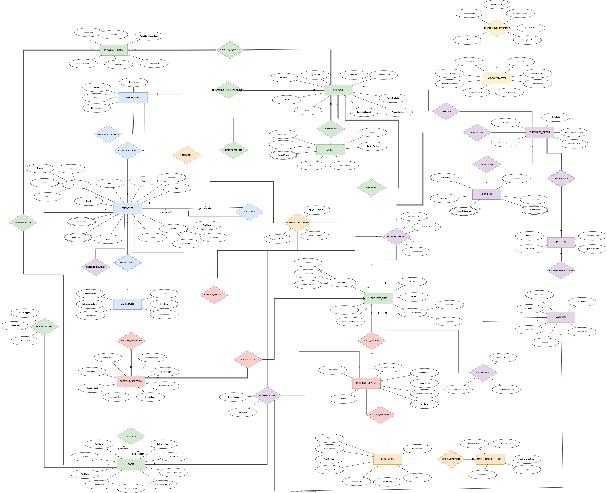
No. | Relational Schema Name | Primary Key (PK) | Alternate Candidate Keys (AK) | Foreign Keys (FK) & Referencing Targets | Normal Form
1 | DEPARTMENT | DeptID | DeptName, HeadEmpID | HeadEmpID $→$ EMPLOYEE(EmpID) | 3NF
2 | EMPLOYEE | EmpID | Email | DeptID $→$ DEPARTMENT, SupervisorID $→$ EMPLOYEE | 3NF
3 | EMPLOYEE_PHONE | (EmpID, PhoneNumber) | None | EmpID $→$ EMPLOYEE | 3NF
4 | EMPLOYEE_CERTIFICATION | (EmpID, Certification) | None | EmpID $→$ EMPLOYEE | 3NF
5 | DEPENDENT | (EmpID, DependentName) | None | EmpID $→$ EMPLOYEE | 3NF
6 | CLIENT | ClientID | TaxCode | None | 3NF
7 | CLIENT_PHONE | (ClientID, ContactPhone) | None | ClientID $→$ CLIENT | 3NF
8 | PROJECT | ProjectID | ProjectName | ClientID $→$ CLIENT, DeptID $→$ DEPARTMENT, DirectorEmpID $→$ EMPLOYEE | 3NF
9 | PROJECT_SITE | SiteID | (ProjectID, SiteName), (Latitude, Longitude) | ProjectID $→$ PROJECT | 3NF
10 | PROJECT_PHASE | (ProjectID, PhaseNumber) | None | ProjectID $→$ PROJECT | 3NF
11 | TASK | TaskID | (ProjectID, PhaseNumber, TaskName) | (ProjectID, PhaseNumber) $→$ PROJECT_PHASE | 3NF
12 | PRECEDES | (PredecessorTaskID, SuccessorTaskID) | None | PredecessorTaskID $→$ TASK, SuccessorTaskID $→$ TASK | 3NF
13 | WORKS_ON_TASK | (EmpID, TaskID) | None | EmpID $→$ EMPLOYEE, TaskID $→$ TASK | 3NF
14 | EQUIPMENT | EquipmentID | SerialNumber | None | 3NF
15 | MAINTENANCE_RECORD | (EquipmentID, RecordNumber) | None | EquipmentID $→$ EQUIPMENT | 3NF
16 | EQUIPMENT_DEPLOYMENT | (EquipmentID, DeploymentStartDate) | None | EquipmentID $→$ EQUIPMENT, SiteID $→$ PROJECT_SITE, OperatorEmpID $→$ EMPLOYEE | 3NF
17 | SUPPLIER | SupplierID | TaxCode | None | 3NF
18 | SUPPLIER_PHONE | (SupplierID, ContactPhone) | None | SupplierID $→$ SUPPLIER | 3NF
19 | SUPPLIER_CATEGORY | (SupplierID, SupplyCategory) | None | SupplierID $→$ SUPPLIER | 3NF
20 | MATERIAL | MaterialID | MaterialName | None | 3NF
21 | PURCHASE_ORDER | PO_ID | None | ProjectID $→$ PROJECT, SupplierID $→$ SUPPLIER | 3NF
22 | PO_ITEM | (PO_ID, LineNumber) | (PO_ID, MaterialID) | PO_ID $→$ PURCHASE_ORDER, MaterialID $→$ MATERIAL | 3NF
23 | SITE_INVENTORY | (SiteID, MaterialID) | None | SiteID $→$ PROJECT_SITE, MaterialID $→$ MATERIAL | 3NF
24 | DELIVERY_DISPATCH | DeliveryCode | None | MaterialID $→$ MATERIAL, SiteID $→$ PROJECT_SITE, ReceivedByEmpID $→$ EMPLOYEE, PO_ID $→$ PURCHASE_ORDER | 3NF
25 | MATERIAL_USAGE | (TaskID, MaterialID, SiteID, UsageDate) | None | TaskID $→$ TASK, (SiteID, MaterialID) $→$ SITE_INVENTORY | 3NF
26 | SUBCONTRACTOR | SubcontractorID | TaxCode, LicenseNumber | None | 3NF
27 | SUBCONTRACT | ContractAgreementNo | None | ProjectID $→$ PROJECT, SubcontractorID $→$ SUBCONTRACTOR | 3NF
28 | SAFETY_INSPECTION | InspectionID | None | SiteID $→$ PROJECT_SITE, InspectorEmpID $→$ EMPLOYEE | 3NF
29 | INCIDENT_REPORT | IncidentID | None | SiteID $→$ PROJECT_SITE, InvolvedEmpID $→$ EMPLOYEE, DamagedEquipmentID $→$ EQUIPMENT | 3NF

- Physical Database Design & Implementation Details
  - DBMS Selection & Configuration
We implemented the physical database on MySQL Community Server 8.0.46 with MySQL Workbench 8.0:
- InnoDB Engine: Supports ACID transactions and foreign-key referential integrity.
- CHECK Constraints: Validates domain rules such as positive salaries, working hours, and date ranges.
- Recursive CTEs (WITH RECURSIVE): Handles employee reporting hierarchies and DAG cycle detection on PRECEDES.
- Triggers: Enforces cross-table business rules and automated emergency alerts.
- UTF-8 Support (utf8mb4): Stores Vietnamese and multilingual text.
  - Database Scripts Organization & Proofs.
    - 01_schema_ddl.sql (DDL — 29 Core Tables & Indexes):
  - Creates A34Build_DB and all 29 normalized 3NF tables.
  - Resolves the circular foreign key between DEPARTMENT.HeadEmpID and EMPLOYEE.DeptID using a deferred ALTER TABLE DEPARTMENT ADD CONSTRAINT FK_DEPARTMENT_HeadEmpID ... statement.
  - Adds performance indexes on frequently joined/filtered foreign keys (IDX_EMPLOYEE_DeptID, IDX_PROJECT_ClientID, IDX_INCIDENT_REPORT_Site, etc.).
  - Example code:
CREATE TABLE DEPARTMENT (
DeptID VARCHAR(10) NOT NULL,
DeptName VARCHAR(100) NOT NULL,
OfficeLocation VARCHAR(255) NOT NULL,
Budget DECIMAL(15,2) NOT NULL DEFAULT 0.00,
HeadEmpID VARCHAR(10) NULL,
CONSTRAINT PK_DEPARTMENT PRIMARY KEY (DeptID),
CONSTRAINT UQ_DEPARTMENT_DeptName UNIQUE (DeptName),
CONSTRAINT UQ_DEPARTMENT_HeadEmpID UNIQUE (HeadEmpID),
CONSTRAINT CK_DEPARTMENT_Budget CHECK (Budget >= 0)
) ENGINE=InnoDB DEFAULT CHARSET=utf8mb4 COLLATE=utf8mb4_unicode_ci;
…
-- Resolve circular FK from DEPARTMENT to EMPLOYEE

ALTER TABLE DEPARTMENT
ADD CONSTRAINT FK_DEPARTMENT_HeadEmpID FOREIGN KEY (HeadEmpID)
REFERENCES EMPLOYEE (EmpID)
ON UPDATE CASCADE ON DELETE SET NULL;

The complete SQL scripts (01_schema_ddl.sql – 04_business_queries.sql) are attached in deliverables/sql/

    - 02_triggers_procedures.sql (8 Business Rule Triggers):
  - Creates EMERGENCY_DISPATCH_LOG and registers triggers enforcing all 8 complex business rules identified in Phase 2:
    - Rule 1: Total PhaseBudget cannot exceed PROJECT.EstimatedBudget.
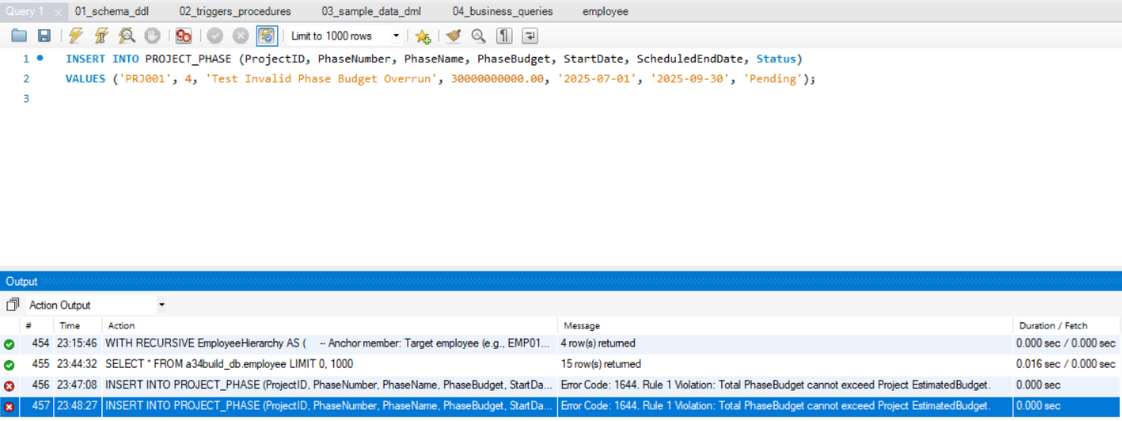

    - Rule 2: No overlapping EQUIPMENT_DEPLOYMENT date intervals for the same machine.

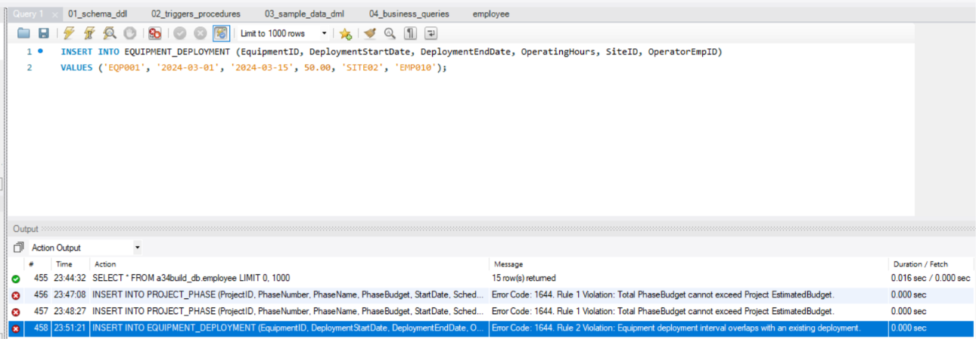

    - Rule 3: Equipment operator must hold a valid certification matching the equipment category.
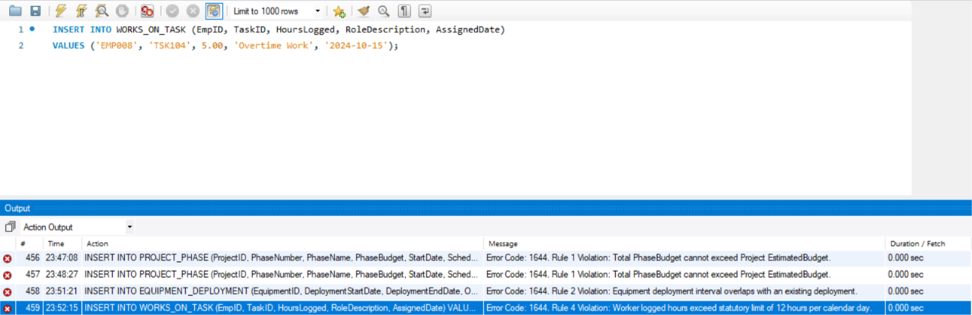

    - Rule 4: Worker logged hours cannot exceed 12.00 hours per calendar day.
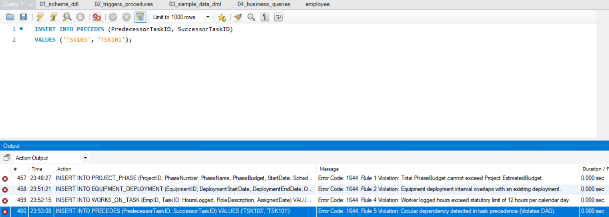

    - Rule 5: PRECEDES task dependencies must form a DAG (no self-loops or cycles, checked via WITH RECURSIVE).

    - Rule 6: Material usage cannot exceed SITE_INVENTORY.CurrentStockQuantity (automatically deducts stock).
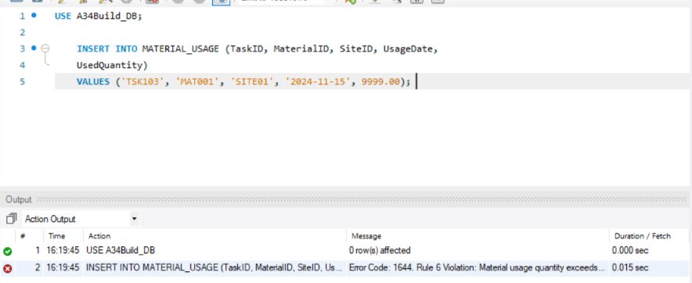

    - Rule 7: An employee can direct at most one project with Status = 'Active'.

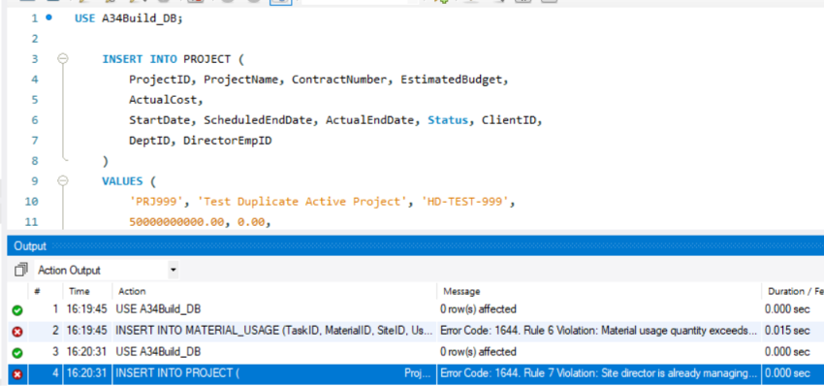

    - Rule 8: Level-2 to Level-4 incidents automatically look up the injured employee’s DEPENDENT and log an emergency dispatch notification in EMERGENCY_DISPATCH_LOG.
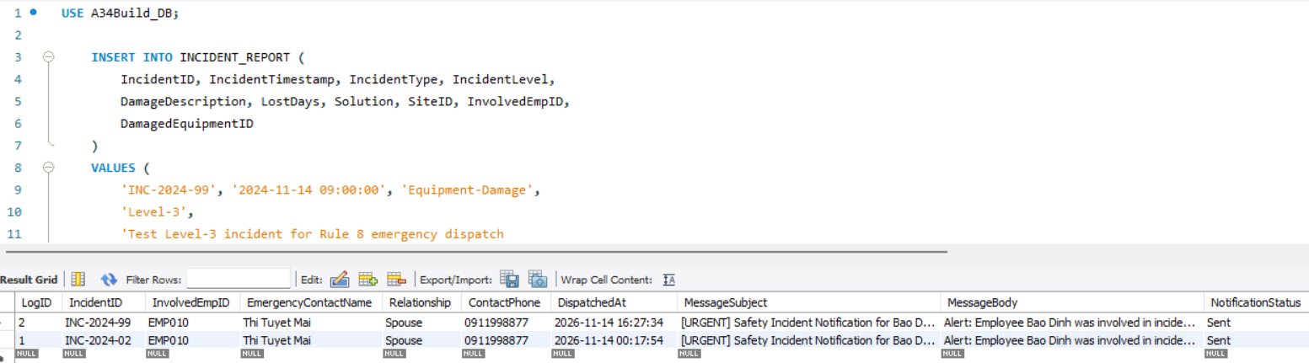
    - Sample code:

-- BUSINESS RULE 5: Acyclic Dependency Constraint (DAG on PRECEDES)
-- Prevents circular dependency loops (e.g., T1 -> T2 -> T3 -> T1).
====================================================================
DROP TRIGGER IF EXISTS TRG_CHECK_PRECEDES_DAG //
CREATE TRIGGER TRG_CHECK_PRECEDES_DAG
BEFORE INSERT ON PRECEDES
FOR EACH ROW
BEGIN
DECLARE v_cycle_detected INT DEFAULT 0;

-- Self-loop check is already partially enforced, but verify
IF NEW.PredecessorTaskID = NEW.SuccessorTaskID THEN
SIGNAL SQLSTATE '45000'
SET MESSAGE_TEXT = 'Rule 5 Violation: Self-loop precedence is strictly prohibited.';
END IF;

-- Check if a path already exists from SuccessorTaskID to PredecessorTaskID
-- Using CTE recursion in MySQL 8.0+
WITH RECURSIVE PrecedenceChain AS (
SELECT SuccessorTaskID AS CurrentTask
FROM PRECEDES
WHERE PredecessorTaskID = NEW.SuccessorTaskID

UNION ALL

SELECT p.SuccessorTaskID
FROM PRECEDES p
INNER JOIN PrecedenceChain pc ON p.PredecessorTaskID = pc.CurrentTask
)
SELECT COUNT(*) INTO v_cycle_detected
FROM PrecedenceChain
WHERE CurrentTask = NEW.PredecessorTaskID;

IF v_cycle_detected > 0 THEN
SIGNAL SQLSTATE '45000'
SET MESSAGE_TEXT = 'Rule 5 Violation: Circular dependency detected in task precedence (Violates DAG).';
END IF;
END //
-- =============================================================================
-- BUSINESS RULE 8: Automated Emergency Contact Notification on Incident
-- Finds dependent where IsEmergencyContact = TRUE and dispatches an alert.
-- =============================================================================
DROP TRIGGER IF EXISTS TRG_DISPATCH_EMERGENCY_ALERT //
CREATE TRIGGER TRG_DISPATCH_EMERGENCY_ALERT
AFTER INSERT ON INCIDENT_REPORT
FOR EACH ROW
BEGIN
DECLARE v_contact_name VARCHAR(100);
DECLARE v_relationship VARCHAR(50);
DECLARE v_contact_phone VARCHAR(20);
DECLARE v_emp_name VARCHAR(150);

IF NEW.InvolvedEmpID IS NOT NULL AND NEW.IncidentLevel IN ('Level-2', 'Level-3', 'Level-4') THEN
-- Get Employee Name
SELECT CONCAT(FirstName, ' ', LastName) INTO v_emp_name
FROM EMPLOYEE
WHERE EmpID = NEW.InvolvedEmpID;

-- Find Emergency Dependent
SELECT d.DependentName, d.Relationship, COALESCE(ep.PhoneNumber, 'No Phone on Record')
INTO v_contact_name, v_relationship, v_contact_phone
FROM DEPENDENT d
LEFT JOIN EMPLOYEE_PHONE ep ON ep.EmpID = d.EmpID
WHERE d.EmpID = NEW.InvolvedEmpID
AND d.IsEmergencyContact = TRUE
LIMIT 1;

-- If found, record into emergency dispatch log
IF v_contact_name IS NOT NULL THEN
INSERT INTO EMERGENCY_DISPATCH_LOG (
IncidentID,
InvolvedEmpID,
EmergencyContactName,
Relationship,
ContactPhone,
DispatchedAt,
MessageSubject,
MessageBody,
NotificationStatus
)
VALUES (
NEW.IncidentID,
NEW.InvolvedEmpID,
v_contact_name,
v_relationship,
v_contact_phone,
NOW(),
CONCAT('[URGENT] Safety Incident Notification for ', v_emp_name),
CONCAT('Alert: Employee ', v_emp_name, ' was involved in incident ', NEW.IncidentID,
' (Level: ', NEW.IncidentLevel, ', Type: ', NEW.IncidentType, ') at Site ', NEW.SiteID,
'. Description: ', NEW.DamageDescription),
'Sent'
);
END IF;
END IF;
END //

The complete SQL scripts (01_schema_ddl.sql – 04_business_queries.sql) are attached in deliverables/sql/

    - 03_sample_data_dml.sql (Realistic Sample Data):
  - Populates all 29 tables with realistic Vietnamese construction project data (projects in Hanoi, Da Nang, and Ho Chi Minh City; 12+ employees, equipment fleet, POs, site inventory, subcontractors, safety inspections, and incident reports).

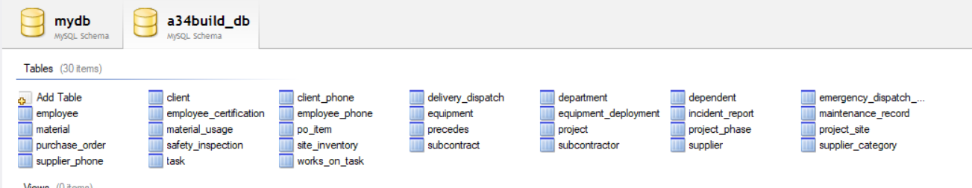
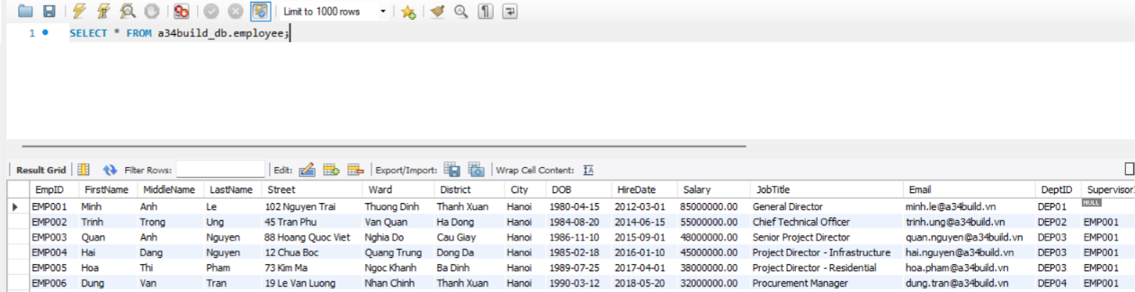
The complete SQL scripts (01_schema_ddl.sql – 04_business_queries.sql) are attached in deliverables/sql/

  - EER diagram of database:

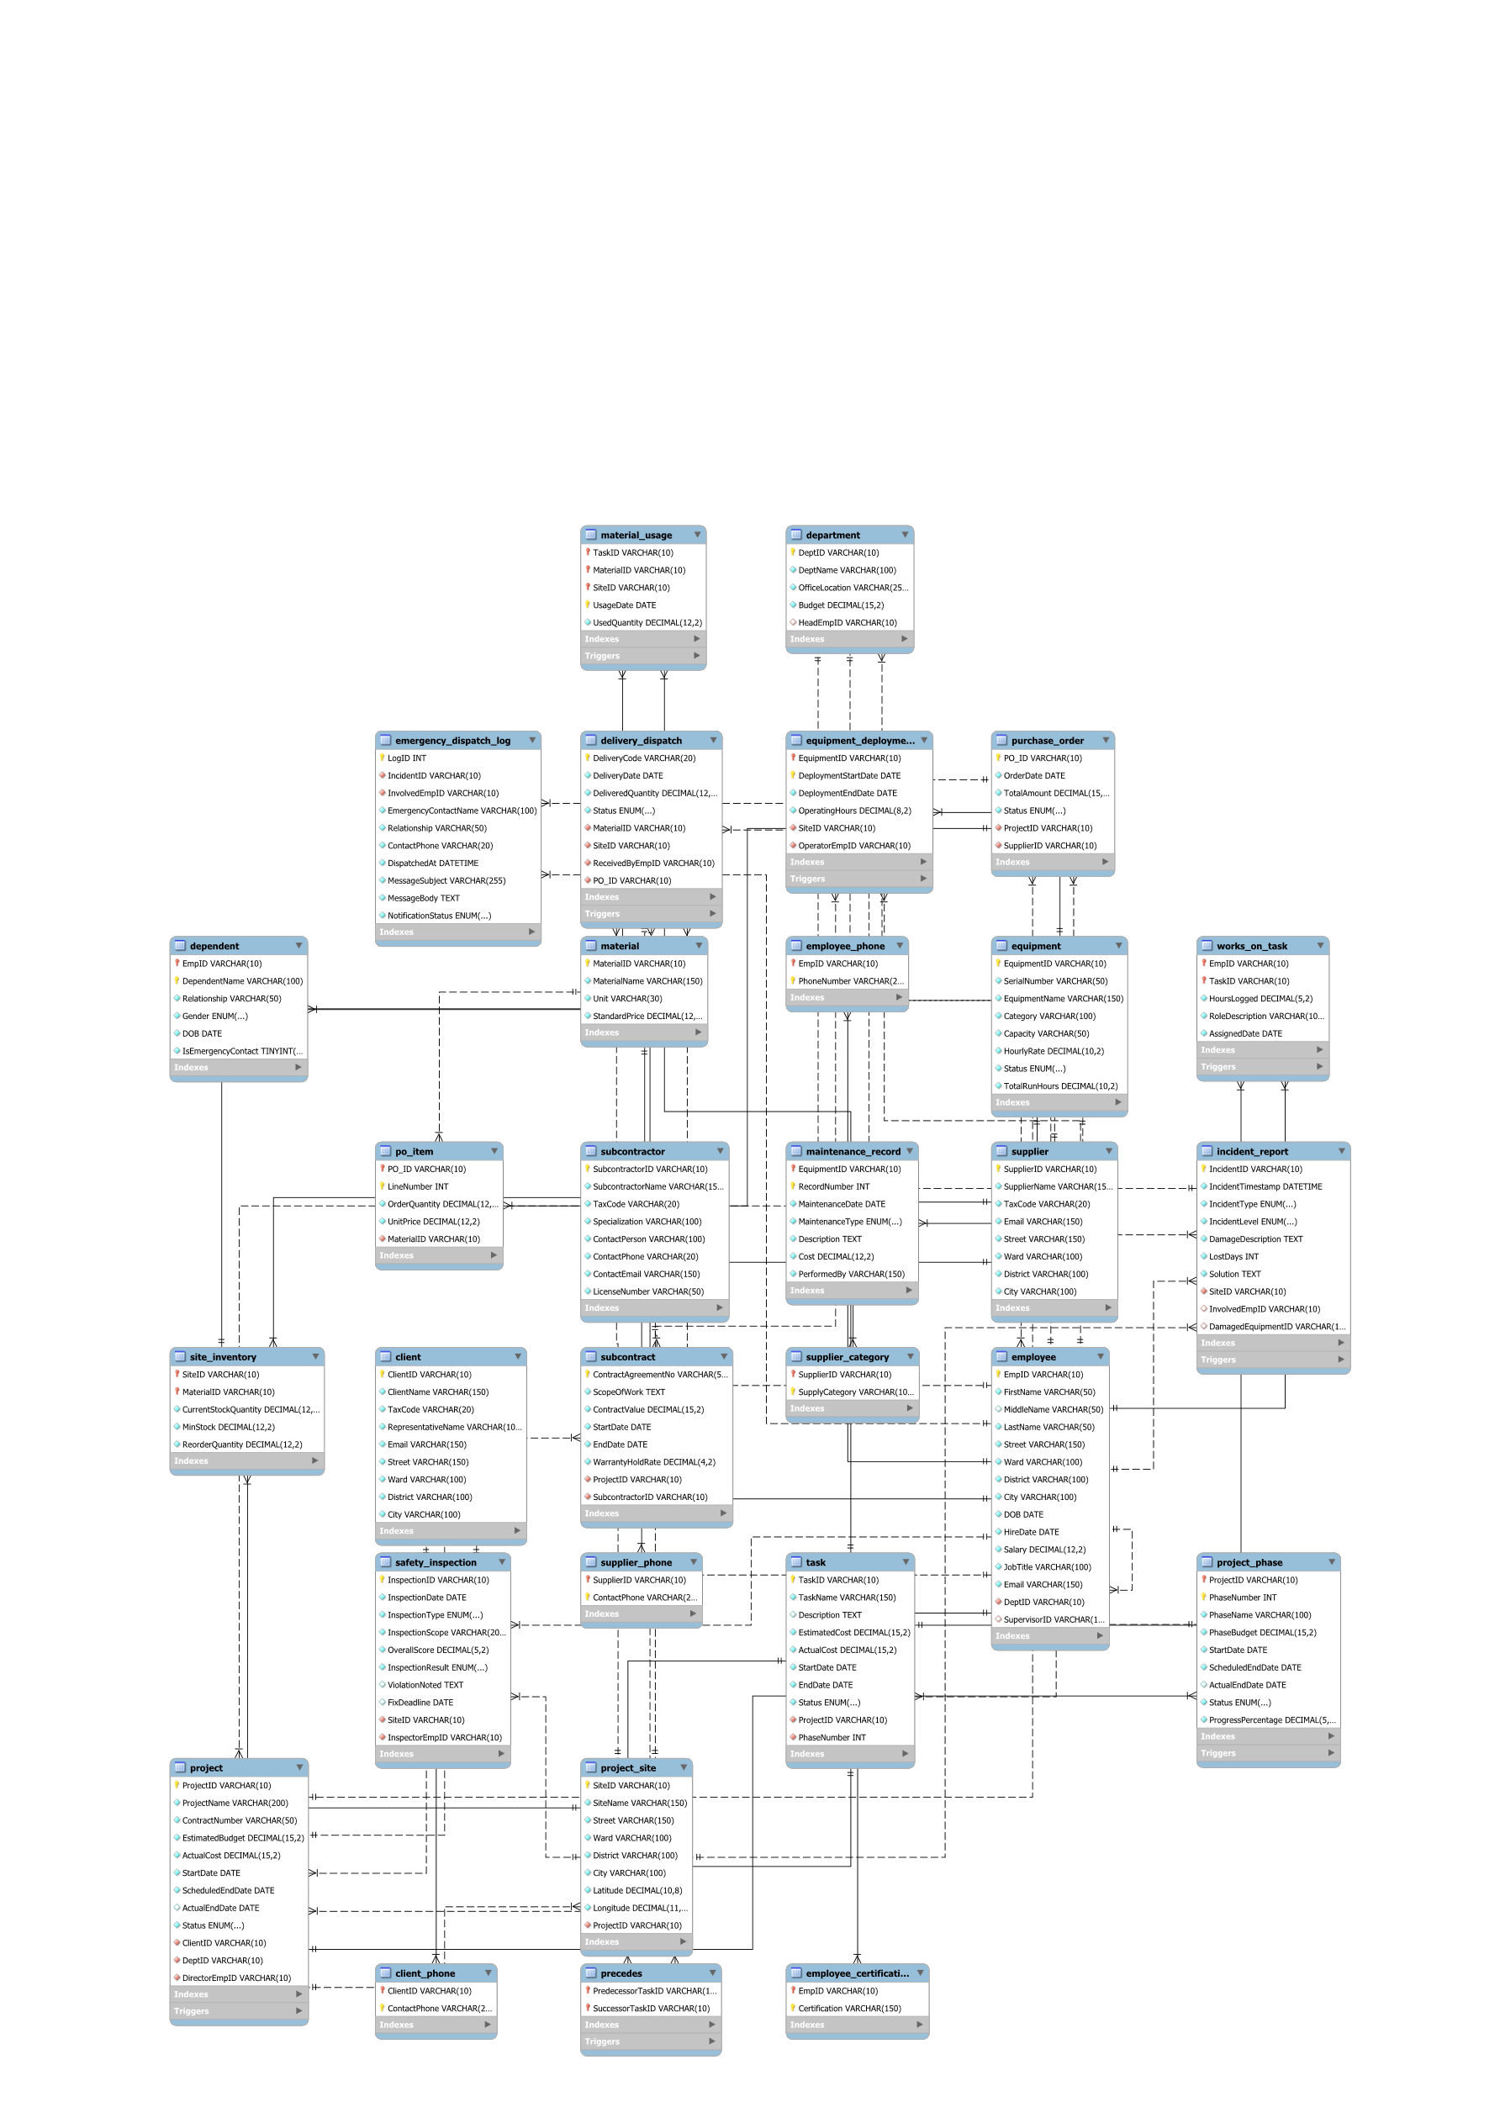

    - 04_business_queries.sql (Operational & Analytical Queries):
Implements 9 queries/reports covering operational checks, recursive hierarchy, cost/budget variance, Earned Value Management (EVM), safety & incident audit, fleet utilization, and trigger verification. And

  - Query 1.1: Find machinery by category that is currently 'Available' or not deployed in the next 14 days.
SELECT
e.EquipmentID,
e.EquipmentName,
e.Category,
e.Capacity,
e.HourlyRate,
e.Status AS CurrentStatus,
COALESCE(MAX(ed.DeploymentEndDate), 'Never Deployed') AS LastDeploymentEndDate
FROM EQUIPMENT e
LEFT JOIN EQUIPMENT_DEPLOYMENT ed ON e.EquipmentID = ed.EquipmentID
WHERE e.Status NOT IN ('Decommissioned', 'Under-Maintenance')
AND e.EquipmentID NOT IN (
SELECT EquipmentID
FROM EQUIPMENT_DEPLOYMENT
WHERE DeploymentEndDate >= CURDATE()
AND DeploymentStartDate <= DATE_ADD(CURDATE(), INTERVAL 14 DAY)
)
GROUP BY e.EquipmentID, e.EquipmentName, e.Category, e.Capacity, e.HourlyRate, e.Status
ORDER BY e.HourlyRate DESC;
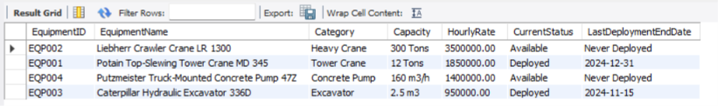

  - Query 1.2: Check materials whose current stock on site is below or near the minimum safety stock.
SELECT
ps.SiteID,
ps.SiteName,
p.ProjectName,
m.MaterialID,
m.MaterialName,
m.Unit,
si.CurrentStockQuantity,
si.MinStock,
si.ReorderQuantity,
(si.MinStock - si.CurrentStockQuantity) AS DeficitQuantity,
ROUND((si.CurrentStockQuantity / NULLIF(si.MinStock, 0)) * 100, 2) AS StockSufficiencyRatioPct,
CASE
WHEN si.CurrentStockQuantity <= (si.MinStock * 0.5) THEN 'CRITICAL: Stockout Imminent'
WHEN si.CurrentStockQuantity <= si.MinStock THEN 'WARNING: Below Min Safety Stock'
ELSE 'NORMAL: Adequate'
END AS ReplenishmentStatus
FROM SITE_INVENTORY si
JOIN PROJECT_SITE ps ON si.SiteID = ps.SiteID
JOIN PROJECT p ON ps.ProjectID = p.ProjectID
JOIN MATERIAL m ON si.MaterialID = m.MaterialID
WHERE si.CurrentStockQuantity <= (si.MinStock * 1.5)
ORDER BY StockSufficiencyRatioPct ASC;

  - Query 1.3: Look up the complete management reporting chain of an employee up to the General Director.
WITH RECURSIVE EmployeeHierarchy AS (
-- Anchor member: Target employee (e.g., EMP010 - Crane Operator)
SELECT
EmpID,
FirstName,
LastName,
JobTitle,
SupervisorID,
1 AS HierarchyLevel,
CAST(CONCAT(FirstName, ' ', LastName) AS CHAR(500)) AS ManagementPath
FROM EMPLOYEE
WHERE EmpID = 'EMP010'

UNION ALL

-- Recursive member: Traverse up to the supervisor
SELECT
m.EmpID,
m.FirstName,
m.LastName,
m.JobTitle,
m.SupervisorID,
eh.HierarchyLevel + 1,
CONCAT(eh.ManagementPath, ' -> ', m.FirstName, ' ', m.LastName)
FROM EMPLOYEE m
INNER JOIN EmployeeHierarchy eh ON eh.SupervisorID = m.EmpID
)
SELECT
HierarchyLevel,
EmpID,
CONCAT(FirstName, ' ', LastName) AS EmployeeName,
JobTitle,
SupervisorID,
ManagementPath
FROM EmployeeHierarchy
ORDER BY HierarchyLevel ASC;
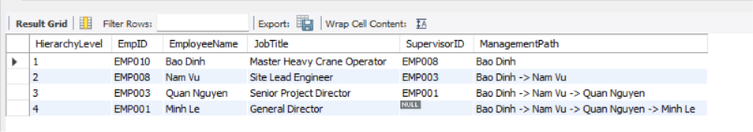

  - Query 1.4: Calculate financial commitments and warranty retention hold amounts per subcontractor.
SELECT
s.SubcontractorID,
s.SubcontractorName,
s.Specialization,
sc.ContractAgreementNo,
p.ProjectName,
sc.ContractValue,
sc.WarrantyHoldRate,
ROUND((sc.ContractValue * sc.WarrantyHoldRate / 100.0), 2) AS WarrantyRetainedAmount,
ROUND(sc.ContractValue - (sc.ContractValue * sc.WarrantyHoldRate / 100.0), 2) AS NetPayableAmount,
sc.StartDate,
sc.EndDate,
DATEDIFF(sc.EndDate, CURDATE()) AS DaysRemaining
FROM SUBCONTRACT sc
JOIN SUBCONTRACTOR s ON sc.SubcontractorID = s.SubcontractorID
JOIN PROJECT p ON sc.ProjectID = p.ProjectID
WHERE sc.EndDate >= CURDATE()
ORDER BY sc.ContractValue DESC;
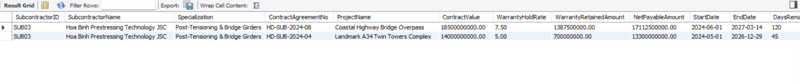

  - Report 2.1: Aggregates budget breakdown and compares with actual costs (Labor, Machinery, Materials, Subcontracts).
WITH LaborCost AS (
SELECT
t.ProjectID,
COALESCE(SUM(w.HoursLogged * (e.Salary / 160.0)), 0) AS TotalLaborCost
FROM TASK t
JOIN WORKS_ON_TASK w ON t.TaskID = w.TaskID
JOIN EMPLOYEE e ON w.EmpID = e.EmpID
GROUP BY t.ProjectID
),
EquipmentCost AS (
SELECT
ps.ProjectID,
COALESCE(SUM(ed.OperatingHours * eq.HourlyRate), 0) AS TotalEquipmentCost
FROM PROJECT_SITE ps
JOIN EQUIPMENT_DEPLOYMENT ed ON ps.SiteID = ed.SiteID
JOIN EQUIPMENT eq ON ed.EquipmentID = eq.EquipmentID
GROUP BY ps.ProjectID
),
MaterialCost AS (
SELECT
t.ProjectID,
COALESCE(SUM(mu.UsedQuantity * m.StandardPrice), 0) AS TotalMaterialCost
FROM TASK t
JOIN MATERIAL_USAGE mu ON t.TaskID = mu.TaskID
JOIN MATERIAL m ON mu.MaterialID = m.MaterialID
GROUP BY t.ProjectID
),
SubcontractCost AS (
SELECT
ProjectID,
COALESCE(SUM(ContractValue), 0) AS TotalSubcontractCost
FROM SUBCONTRACT
GROUP BY ProjectID
)
SELECT
p.ProjectID,
p.ProjectName,
p.Status,
p.EstimatedBudget,
p.ActualCost AS GeneralLedgerActualCost,
ROUND(COALESCE(lc.TotalLaborCost, 0), 2) AS CalculatedLaborCost,
ROUND(COALESCE(ec.TotalEquipmentCost, 0), 2) AS CalculatedEquipmentCost,
ROUND(COALESCE(mc.TotalMaterialCost, 0), 2) AS CalculatedMaterialCost,
ROUND(COALESCE(sc.TotalSubcontractCost, 0), 2) AS CommittedSubcontractCost,
ROUND(
COALESCE(lc.TotalLaborCost, 0) +
COALESCE(ec.TotalEquipmentCost, 0) +
COALESCE(mc.TotalMaterialCost, 0) +
COALESCE(sc.TotalSubcontractCost, 0), 2
) AS TotalProjectCommittedCost,
ROUND(
p.EstimatedBudget - (
COALESCE(lc.TotalLaborCost, 0) +
COALESCE(ec.TotalEquipmentCost, 0) +
COALESCE(mc.TotalMaterialCost, 0) +
COALESCE(sc.TotalSubcontractCost, 0)
), 2
) AS RemainingBudgetVariance,
ROUND(
((COALESCE(lc.TotalLaborCost, 0) + COALESCE(ec.TotalEquipmentCost, 0) +
COALESCE(mc.TotalMaterialCost, 0) + COALESCE(sc.TotalSubcontractCost, 0)) / NULLIF(p.EstimatedBudget, 0)) * 100, 2
) AS BudgetBurnRatePct
FROM PROJECT p
LEFT JOIN LaborCost lc ON p.ProjectID = lc.ProjectID
LEFT JOIN EquipmentCost ec ON p.ProjectID = ec.ProjectID
LEFT JOIN MaterialCost mc ON p.ProjectID = mc.ProjectID
LEFT JOIN SubcontractCost sc ON p.ProjectID = sc.ProjectID
ORDER BY p.EstimatedBudget DESC;
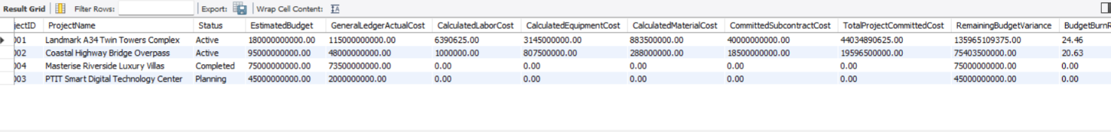

  - Report 2.2:Computes Planned Value (PV), Earned Value (EV), Actual Cost (AC), CPI, and SPI.
SELECT
p.ProjectID,
p.ProjectName,
SUM(pp.PhaseBudget) AS PlannedValue_PV,
ROUND(SUM(pp.PhaseBudget * (pp.ProgressPercentage / 100.0)), 2) AS EarnedValue_EV,
p.ActualCost AS ActualCost_AC,
-- Cost Variance (CV = EV - AC)
ROUND(SUM(pp.PhaseBudget * (pp.ProgressPercentage / 100.0)) - p.ActualCost, 2) AS CostVariance_CV,
-- Schedule Variance (SV = EV - PV)
ROUND(SUM(pp.PhaseBudget * (pp.ProgressPercentage / 100.0)) - SUM(pp.PhaseBudget), 2) AS ScheduleVariance_SV,
-- Cost Performance Index (CPI = EV / AC)
ROUND(SUM(pp.PhaseBudget * (pp.ProgressPercentage / 100.0)) / NULLIF(p.ActualCost, 0), 3) AS CostPerformanceIndex_CPI,
-- Schedule Performance Index (SPI = EV / PV)
ROUND(SUM(pp.PhaseBudget * (pp.ProgressPercentage / 100.0)) / NULLIF(SUM(pp.PhaseBudget), 0), 3) AS SchedulePerformanceIndex_SPI,
-- Project Health Status
CASE
WHEN (SUM(pp.PhaseBudget * (pp.ProgressPercentage / 100.0)) / NULLIF(p.ActualCost, 0)) >= 1.0
AND (SUM(pp.PhaseBudget * (pp.ProgressPercentage / 100.0)) / NULLIF(SUM(pp.PhaseBudget), 0)) >= 1.0
THEN 'EXCELLENT: Ahead of Schedule & Under Budget'
WHEN (SUM(pp.PhaseBudget * (pp.ProgressPercentage / 100.0)) / NULLIF(p.ActualCost, 0)) >= 0.90
THEN 'FAIR: Minor Variance Within Tolerance'
ELSE 'ALERT: Cost Overrun or Significant Delay'
END AS ProjectHealthStatus
FROM PROJECT p
JOIN PROJECT_PHASE pp ON p.ProjectID = pp.ProjectID
WHERE p.Status = 'Active'
GROUP BY p.ProjectID, p.ProjectName, p.ActualCost;

  - Report 2.3: Summarizes safety audit scores, open corrective actions, and lost-time injuries.
SELECT
ps.SiteID,
ps.SiteName,
p.ProjectName,
COUNT(DISTINCT si.InspectionID) AS TotalInspectionsConducted,
ROUND(AVG(si.OverallScore), 2) AS AverageSafetyAuditScore,
COUNT(DISTINCT CASE WHEN si.InspectionResult = 'Pass' THEN si.InspectionID END) AS PassedAudits,
COUNT(DISTINCT CASE WHEN si.InspectionResult IN ('Conditional-Pass', 'Fail') THEN si.InspectionID END) AS AuditsWithDeficiencies,
COUNT(DISTINCT ir.IncidentID) AS TotalIncidentsRecorded,
COALESCE(SUM(ir.LostDays), 0) AS TotalLostDaysFromInjuries,
CASE
WHEN COALESCE(SUM(ir.LostDays), 0) = 0 AND AVG(si.OverallScore) >= 90.0 THEN 'EXEMPLARY: Gold Standard Site'
WHEN AVG(si.OverallScore) >= 75.0 THEN 'ACCEPTABLE: Standard Site Monitoring'
ELSE 'HIGH RISK: Immediate Safety Intervention Required'
END AS SiteRiskProfile
FROM PROJECT_SITE ps
JOIN PROJECT p ON ps.ProjectID = p.ProjectID
LEFT JOIN SAFETY_INSPECTION si ON ps.SiteID = si.SiteID
LEFT JOIN INCIDENT_REPORT ir ON ps.SiteID = ir.SiteID
GROUP BY ps.SiteID, ps.SiteName, p.ProjectName;

  - Report 2.4: Evaluates machine productivity (run hours vs maintenance expense).
SELECT
e.EquipmentID,
e.EquipmentName,
e.Category,
e.HourlyRate,
e.TotalRunHours,
ROUND(e.TotalRunHours * e.HourlyRate, 2) AS LifetimeGrossRevenueGenerated,
COUNT(mr.RecordNumber) AS TotalMaintenanceSessions,
COALESCE(SUM(mr.Cost), 0.00) AS TotalMaintenanceCostSpent,
ROUND(
(COALESCE(SUM(mr.Cost), 0.00) / NULLIF(e.TotalRunHours * e.HourlyRate, 0)) * 100, 2
) AS MaintenanceCostToRevenueRatioPct
FROM EQUIPMENT e
LEFT JOIN MAINTENANCE_RECORD mr ON e.EquipmentID = mr.EquipmentID
GROUP BY e.EquipmentID, e.EquipmentName, e.Category, e.HourlyRate, e.TotalRunHours
ORDER BY LifetimeGrossRevenueGenerated DESC;
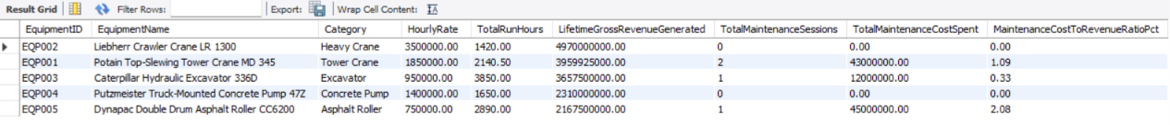

  - Verification Query 3.1: Verify Rule 8 Emergency Dispatch Trigger Execution
  - Confirms that when INC-2024-02 was created, the trigger automatically identified the employee's dependent and logged an emergency alert.
SELECT
l.LogID,
l.IncidentID,
l.InvolvedEmpID,
CONCAT(e.FirstName, ' ', e.LastName) AS InjuredEmployee,
l.EmergencyContactName,
l.Relationship,
l.ContactPhone,
l.DispatchedAt,
l.MessageSubject,
l.MessageBody,
l.NotificationStatus
FROM EMERGENCY_DISPATCH_LOG l
JOIN EMPLOYEE e ON l.InvolvedEmpID = e.EmpID;

    - 05_user_queries.sql (User Queries — Multi-Table Joins, Grouping & Filtering)
Implements 2 user-defined analytical queries demonstrating multi-table INNER JOIN, WHERE filtering, GROUP BY, HAVING, and ORDER BY, together with their corresponding Relational Algebra expressions and MySQL Workbench execution results.

Query 5.1: High-Salary Employee Workload by Department
Retrieves employees earning at least 15,000,000 VND who are assigned to project tasks, summarizing their assigned task count and total logged hours.
- Problem Statement: List employees with Salary >= 15,000,000 VND who are assigned to tasks, displaying their department, salary, total assigned tasks, and total logged hours. Keep only employees with total logged hours greater than 0, sorted by total logged hours descending.
- Relational Algebra Expression:
  - Filter high-salary employees (WHERE):
$$E_{\text{high}}←σ_{\text{Salary}≥15000000}(\text{EMPLOYEE})$$
  - Join with department and task assignment tables (INNER JOIN):
$$J_{1}←(E_{\text{high}}⋈_{\text{DeptID}}\text{DEPARTMENT})⋈_{\text{EmpID}}\text{WORKS_ON_TASK}$$
  - Group by employee and aggregate task count & logged hours (GROUP BY):
$$G_{1}←​_{\text{EmpID, FirstName, LastName, DeptName, Salary}}F_{\text{COUNT(TaskID)}→\text{TotalTasks}, \text{SUM(HoursLogged)}→\text{TotalHoursLogged}}(J_{1})$$
  - Keep only employees with positive logged hours (HAVING):
$$H_{1}←σ_{\text{TotalHoursLogged}>0}(G_{1})$$
  - Project output columns and sort descending (SELECT, ORDER BY):
$${\text{Result}}_{5.1}←τ_{\text{TotalHoursLogged}↓}\left(π_{\text{EmpID, FullName, DeptName, Salary, TotalTasks, TotalHoursLogged}}(H_{1})\right)$$
- SQL Code:
SELECT
e.EmpID,
CONCAT(e.FirstName, ' ', e.LastName) AS FullName,
d.DeptName,
e.Salary,
COUNT(w.TaskID) AS TotalTasks,
SUM(w.HoursLogged) AS TotalHoursLogged
FROM EMPLOYEE e
INNER JOIN DEPARTMENT d ON e.DeptID = d.DeptID
INNER JOIN WORKS_ON_TASK w ON e.EmpID = w.EmpID
WHERE e.Salary >= 15000000
GROUP BY e.EmpID, e.FirstName, e.LastName, d.DeptName, e.Salary
HAVING TotalHoursLogged > 0
ORDER BY TotalHoursLogged DESC;

- Execution Result:
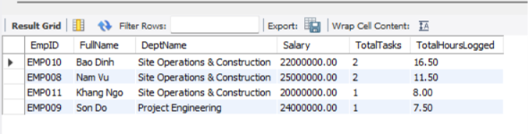

Query 5.2: Project & Job Site Count by Client
Aggregates non-cancelled high-budget projects by client and counts their active job sites.
- Problem Statement: Retrieve all non-cancelled projects with EstimatedBudget > 30,000,000,000 VND, together with the client name and total number of job sites. Keep only projects that have at least 1 job site, sorted by EstimatedBudget descending.
- Relational Algebra Expression:
  - Filter non-cancelled projects with budget over 30 billion (WHERE):
$$P_{\text{high}}←σ_{\text{Status}≠\text{’Cancelled’}∧\text{EstimatedBudget}>30000000000}(\text{PROJECT})$$
  - Join with client and project site tables (INNER JOIN):
$$J_{2}←(P_{\text{high}}⋈_{\text{ClientID}}\text{CLIENT})⋈_{\text{ProjectID}}\text{PROJECT_SITE}$$
  - Group by project and count job sites (GROUP BY):
$$G_{2}←​_{\text{ProjectID, ProjectName, Status, ClientName, EstimatedBudget}}F_{\text{COUNT(SiteID)}→\text{TotalSites}}(J_{2})$$
  - Keep only projects with at least 1 site (HAVING):
$$H_{2}←σ_{\text{TotalSites}≥1}(G_{2})$$
  - Project output columns and sort by budget descending (SELECT, ORDER BY):
$${\text{Result}}_{5.2}←τ_{\text{EstimatedBudget}↓}\left(π_{\text{ProjectID, ProjectName, Status, ClientName, EstimatedBudget, TotalSites}}(H_{2})\right)$$

- SQL Code:
SELECT
p.ProjectID,
p.ProjectName,
p.Status,
c.ClientName,
p.EstimatedBudget,
COUNT(ps.SiteID) AS TotalSites
FROM PROJECT p
INNER JOIN CLIENT c ON p.ClientID = c.ClientID
INNER JOIN PROJECT_SITE ps ON p.ProjectID = ps.ProjectID
WHERE p.Status <> 'Cancelled'
AND p.EstimatedBudget > 30000000000
GROUP BY p.ProjectID, p.ProjectName, p.Status, c.ClientName, p.EstimatedBudget
HAVING TotalSites >= 1
ORDER BY p.EstimatedBudget DESC;

- Execution Result:
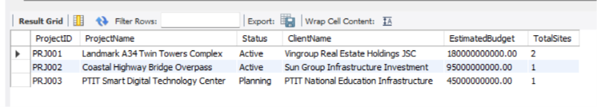

- Conclusion
In Phase 3, we checked the A34Build schema against 1NF, 2NF, and 3NF, removing the partial dependency in EQUIPMENT_DEPLOYMENT and the transitive dependency in DELIVERY_DISPATCH, and implemented the database in MySQL. The 29 core tables, 8 business-rule triggers,sample data, and analytical queries all ran as expected.

