User's manual for
Writer4LaTeX
development version 1.1.1
© 2002-2009 Henrik Just
Table of Contents
1 Introduction 3
2 Installation 4
3 Using Writer2LaTeX and Writer2BibTeX 6
4 Using Writer2xhtml and Calc2xhtml 18
5 Using Writer2LaTeX from another application 25
6 Troubleshooting 27

Introduction

What is Writer4LaTeX?
Writer4LaTeX is an extension for the OpenOffice.org Writer application. The purpose of Writer4LaTeX is to turn Writer into a frontend for LaTeX. By installing Writer4LaTeX you will thus be available to author well-structured LaTeX documents using (almost) the full power of OpenOffice.org Writer.
The functionality of OpenOffice.org Writer with Writer4LaTeX can be compared to the application LyX (http://www.lyx.org).
You can use Writer4LaTeX in two different ways
- You can prepare your documents with Writer as you usually do, keeping a few guidelines (see below) in mind. You can then invoke Writer4LaTeX to convert your document into LaTeX, process the LaTeX document and display the final result. You are free to create either a LaTeX document that preserves as much of your formatting as possible – or create a clean LaTeX document that will resemble a LaTeX document created by hand.
- You can use some special Writer templates provided with Writer4LaTeX to create your documents. Using the styles supported by these templates, you can easily create standard LaTeX documents using the opportunities of standard LaTeX document classes.
For this initial version, templates for the standard LaTeX classes article are provided. More templates will be added later (report, book, beamer...), and you can also add your own templates.
In addition
- You can import existing LaTeX documents into Writer. This feature uses Eitan M. Gurari's excellent TeX4ht system. Note however, that this doesn't mean that roundtrip editing OOo Writer ↔ LaTeX is possible. The intended use of the import feature is to be able to work on documents that were orginally authored in LaTeX.
Writer4LaTeX is a Java application, and thus should work on any platform that supports Java. You need Sun's Java 2 Virtual Machine (Runtime Environment), version 5 or later. You can download this from http://java.sun.com/getjava/download.html. Writer4LaTeX may run under other Java interpreters, but this has not been tested.
Furthermore, you need an OpenOffice.org installation (version 2.2 or later) which is configured to use Java, and the extension Writer2LaTeX must be installed.
Finally you need a working TeX installation such as MikTeX for Windows or TeX Live for unix/linux.
Note: In this manual OOo is used as an abbreviation of OpenOffice.org/StarOffice/NeoOffice.

Installation
To use Writer4LaTeX you must first install it into OOo Writer. This requires OpenOffice.org 2.2 or later, or an equivalent version of StarOffice or NeoOffice.
The following instructions covers all operating systems.
- Before you install Writer4LaTeX, you need to set up OOo to use Java. You can configure this in OOo under Tools – Options. Of course this requires that you have installed Java on your system.
- You also have to install the LaTeX export filter Writer2LaTeX (writer2latex.oxt), version 1.0 or later; you cannot use Writer4LaTeX without it.
- The extension package writer4latex.oxt is installed using the Extension Manager in OOo, see http://extensions.services.openoffice.org for instructions.
After installation, restart OOo. If you can see a new menu named LaTeX, the installation was succesful.

Configuring Writer4LaTeX
Before you can use Writer4LaTeX you must configure it to use your LaTeX distribution as well as viewers for the different output formats.
You can do this directly from the Extension Manager: Select Writer4LaTeX and click Configure. Alternatively, you can configure Writer4LaTeX using Tools – Options; select OpenOffice.org Writer – Writer4LaTeX.
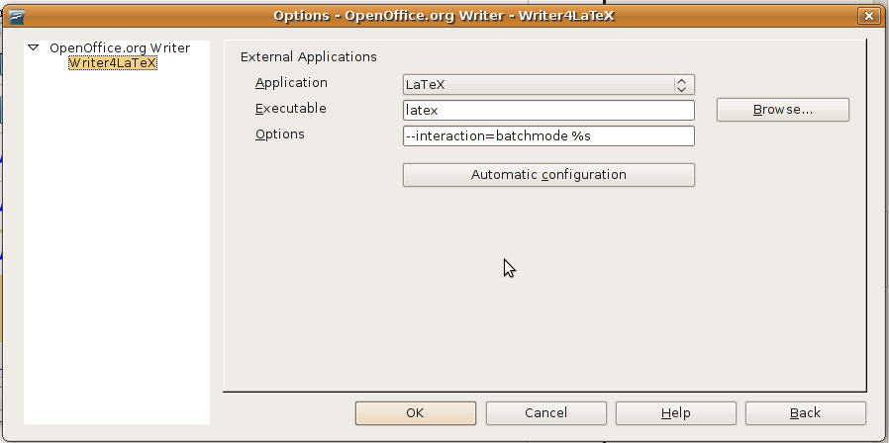
If you click Automatic configuration, Writer4LaTeX will try to locate the external programs and configure them. If this does not work, you have to configure each application manually. To do this, select the application in the list, and fill out the executable and the options. In the options, %s denotes the file name.

Using Writer4LaTeX

Overview
Writer4LaTeX integrates seamless into the Writer. It provides
- A set of Writer templates (File – New – Templates and Documents) to be used as a basis for new LaTeX document, see section ...
- A new top level menu providing four new commands, see section ...
- An new page in the configuration, see above.

The menu
Writer4LaTeX offers the new top level menu LaTeX in Writer with the following commands:
- Run LaTeX
- Run LaTeX directly
- View Log files
- Import LaTeX

Some guidelines for Writer documents

Using the templates

The article template
Here is a short description:
Create a new document based on the template LaTeX-article.stw.
This template contains a number of styles that corresponds to LaTeX code:
OOo Writer style | LaTeX code
Title | \title{...}
author | \author{...}
date | \date{...}
abstract title | renews \abstractname
abstract | abstract environment
part | \part{...}
Heading 2 | \section{...}
Heading 3 | \subsection{...}
Heading 4 | \subsubsection{...}
Heading 5 | \paragraph{...}
Heading 6 | \subparagraph{...}
flushleft | flushleft environment
flushright | flushright environment
center | center environment
verse | verse environment
quote | quote environment
quotation | quotation environment
Preformatted text | verbatim environment
theorem | theorem environment
itemize | itemize list
enumerate | enurerate list
List Heading | description list (item label)
List Contents | description list (item text)

OOo Writer style | LaTeX code
verb | \verb|...|
Emphasis | \emph{...}
Strong Emphasis | \textbf{...}
textrm | \textrm{...}
textsf | \textsf{...}
texttt | \texttt{...}
textup | \textup{...}
textsl | \textsl{...}
textit | \textit{...}
textsc | \textsc{...}
textmd | \textmd{...}
textbf | \textbf{...}
tiny | {\tiny ...}
scriptsize | {\sciptsize ...}
footnotesize | {\footnotesize ...}
small | {\small ...}
normalsize | {\normalsize ...}
large | {\large ...}
Large | {\Large ...}
LARGE | {\LARGE ...}
huge | {\huge ...}
Huge | {\Huge ...}
If you use these styles and uses the configuration file article.xml when you convert your document with Writer2LaTeX, you will get a result that resembles a handwritten LaTeX file. Note that hard formatting and any other styles will be ignored.

The book and report templates
...

The beamer template
...

Adding your own templates
....(see doc for w2l)

The use of italics in this table indicates styles that are predefined in OOo. The names of these styles will be localized if you use a non-english version of OOo.
Also \maketitle is added at the end of a sequence of Title, author and date.
Only characters available in the inputenc are accepted. Other characters are converted to question marks and other content is discarded, eg. footnotes.

