Result Based Management - Indicator Quality Assurance

Regional Bureau Americas | 2022

01 April 2024

# Introduction: Quality Assurance Framework

Core indicator data must be quality assured by the Regional Bureau in relation to completeness, accuracy and consistency. In each section below you will see the criteria that should be used for this validation – defined by the Global Data Service.

## Completeness:

**Comp1.** All mandatory core impact indicators and core outcome indicators from relevant outcome areas have been selected for all relevant population groups

**Comp2.** Values for baselines, targets and actuals have been entered for all selected indicators and all relevant population groups

**Comp3.** Appropriate means of verification have been selected - aka data source is not empty

**Comp4.** Data limitations have been recorded for each indicator, as applicable - when no data is provided, while that indicator was selected for that population group

## Accuracy:

**Acc1.** Percentage indicators are correctly calculated, when both numerator and baseline

**Acc2.** Appropriate scales are used for text indicators. If a text unit, should be between 1 & 3

**Acc3.** Units of measurements are consistently used for baselines, actuals and targets. , if pecent between 0 & 100, if a number no denominator

**Acc4.** The approach to missing values is correct, i.e., the use of “0” vs NA

**Acc5.** The relationship between baseline and target data is logical, e.g., targets are equal to or higher than the baselines

**Acc6.** The sum of disaggregated data, when available adds up to the totals for numeric indicators

**Acc7.** Possible erroneous values are identified based on the known situation in the country (e.g., the data entered seems plausible and outliers can be explained)

## Consistency:

**Cons1.** The data and the narrative in the multi-year country strategy and/or the country annual results reports align, i.e., they tell the same story

**Cons2.** Multi-year budgets across years are consistent with planned indicator targets

**Cons3.** The results data (baseline, target, actual) is consistent with data that has been reported elsewhere in internal and external reports

**Cons4.** The results data (baseline, target, actual) is consistent with historical data from recent years

**Cons5.** Inconsistencies and contradictions are explained or can be explained

## Summary of automatic check

The full list of implemented automatic check output is below

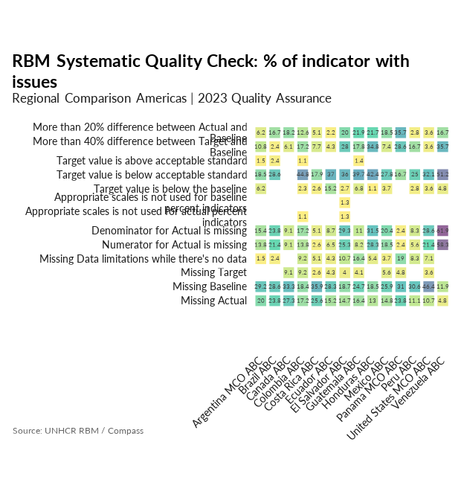

The table below summarizes the main issues

| Plan | % of baselines available | % of targets available | % of 2022 actuals available |
| --- | --- | --- | --- |
| Argentina MCO ABC | 70.8 | 100.0 | 80.0 |
| Brazil ABC | 71.4 | 100.0 | 76.2 |
| Canada ABC | 66.7 | 90.9 | 72.7 |
| Colombia ABC | 81.6 | 90.8 | 82.8 |
| Costa Rica ABC | 64.1 | 97.4 | 74.4 |
| Ecuador ABC | 71.7 | 95.7 | 84.8 |
| El Salvador ABC | 81.3 | 96.0 | 85.3 |
| Guatemala ABC | 75.3 | 95.9 | 83.6 |
| Honduras ABC | 81.5 | 100.0 | 87.0 |
| Mexico ABC | 74.1 | 94.4 | 85.2 |
| Panama MCO ABC | 69.0 | 95.2 | 76.2 |
| Peru ABC | 69.4 | 100.0 | 88.9 |
| United States MCO ABC | 53.6 | 96.4 | 89.3 |
| Venezuela ABC | 88.1 | 100.0 | 95.2 |
| Regional Average | 72.8 | 96.6 | 83.0 |

## A visual Tool for Regional Review

In order to facilitate a quick regional review, the review includes, for each indicator, a summary chart together with a table outlining:

* Actual value with generated logical validation warning and feedback when required (concatenating: **Comp1, Comp2, Comp3, Acc1, Acc2, Acc3, Acc5**)
* Existing Data Limitation ( **Acc4, Cons5**)
* Missing data ( **Comp4**) for indicator that were selected and not data limitation was provided.

The table only includes indicators that have been included in the Monitoring & Evaluation Plan.

The charts are called “**bullet graph**”; they are a variation of a regular bar graph inspired by the traditional “thermometer charts” (*are we good?*) and progress bars (*are we progressing?*). This type of visualization allows to represent as multiple nested bars the different values of the indicators (baseline 2022 and current 2022) for all the different countries and population group to be compared. The dark center line represents the actual value, the dark vertical line represents the baseline value an the the colored bands represent standard ranges extracted from the [indicator metadata](https://intranet.unhcr.org/content/dam/unhcr/intranet/protection-operations/compass/en/guidance/3/coreindicatorsmetadata/2.0%20Core%20Indicator%20Metadata%2004%2010%202021.pdf), i.e. acceptable /green, unacceptable/ orange & critical/red. The labels for the countries includes, for outcome what percentage of the total budget for the operation was spent on the outcome and some background in relation with the data source.

Indicators are grouped together in relation with technical area of expertise within the bureau:

* Protection / Legal ( Access to Territory, Non-refoulement; Complementary Pathways; Freedom of Movement; Statelessness; Law & Policy)
* Protection / thematic ( Gender-Based Violence; Child Protection; Education; Community-Based Protection; Accountability to Affected Populations)
* Protection / case management (Registration; Refugee Status Determination; Resettlement; Documentation; Voluntary Repatriation)
* Assistance & Inclusion (Basic Needs; Health; Shelter; Water, Sanitation & Hygiene; Energy; Security; Livelihoods & Economic Inclusion; Social Protection)

A visual inspection of the charts provides technical experts a quick check the remaining dimensions ( **Cons1, Cons2, Cons3, Cons4, Acc4, Acc7**).

Experts are then providing in a dedicated text box for each indicator with This document can be edited online and through the browser in order to have different people working on it at the same time.

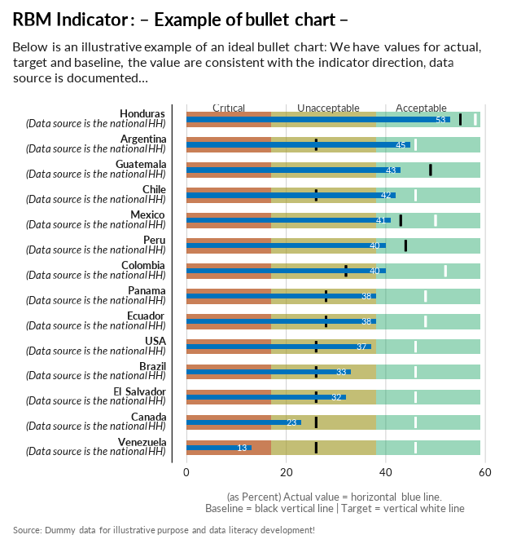

# Protection / Legal

## Access to Territory, Non-refoulement

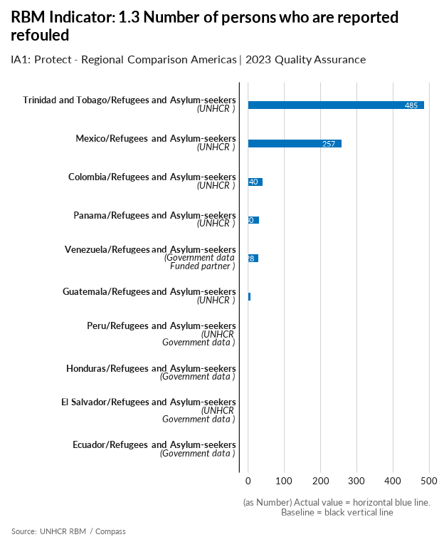

| group | baseline | actual | QA_logical | data_limitation |
| --- | --- | --- | --- | --- |
| Argentina/Refugees and Asylum-seekers | - | - | Missing Actual - Missing Baseline | MCO Arg was unable to document refoulement cases due to lack of access to border areas (i.e. airports) and the fact that in certain countries there are migratory legal entry options for those who are denied access to asylum procedures at the borders. MCO Arg is currently taking mesure to improve capacity of partnerts to monitor refoulment across contries in line with the lastes refoulment policy |
| Bolivia/Refugees and Asylum-seekers | - | - | Missing Actual - Missing Baseline | MCO Arg was unable to document refoulement cases due to lack of access to border areas (i.e. airports) and the fact that in certain countries there are migratory legal entry options for those who are denied access to asylum procedures at the borders. MCO Arg is currently taking mesure to improve capacity of partnerts to monitor refoulement across contries in line with the lastes refoulment policy |
| Brazil/Refugees and Asylum-seekers | - | - | Missing Actual - Missing Baseline | The Brazilian government currently does not have this information systematized nor does UNHCR have access to it, despite many attempts in the past. UNHCR will continue to engage with the government to have access to such information during 2024. |
| Canada/Refugees and Asylum-seekers | - | - | Missing Actual - Missing Baseline | While UNHCR is unaware of any instance of refoulement, given UNHCR's limited monitoring and the volume of asylum seekers, it cannot be certain there were no instances of refoulement. |
| Chile/Refugees and Asylum-seekers | - | - | Missing Actual - Missing Baseline | No information on documented cases. In 2024, the operation will explore methods, including through working with operations in neighboring countries, to obtain data for the indicator on reports of cases with International Protection needs that have been returned from Chile |
| Colombia/Refugees and Asylum-seekers | - | 40 | Missing Baseline | Han sido documentados |
| Costa Rica/Refugees and Asylum-seekers | - | - | Missing Actual - Missing Baseline | We know of some cases, but we don't have the full information or documentation |
| Ecuador/Refugees and Asylum-seekers | - | 0 | Missing Baseline | We have no recorded incidents, there is 0 cases of refoulement. |
| El Salvador/Refugees and Asylum-seekers | - | 0 | Missing Baseline | - |
| Guatemala/Refugees and Asylum-seekers | - | 7 | Missing Baseline | AS an operation we had a better coordination with the PDH so they could intervene, so we have less refouled reported |
| Honduras/Refugees and Asylum-seekers | - | 0 | Missing Baseline | Honduras does not expel non-nationals from its territory and has an amnesty for irregular entries to be able to transit freely throughout the country for 5 days. In 2023, no refoulement cases have been registered by UNHCR or its partners. Nevertheless, it's possible that unknown cases have occurred through incidents with the police, but none have reached UNHCR. |
| Mexico/Refugees and Asylum-seekers | - | 257 | Missing Baseline | In 2023, UNHCR expanded monitoring of cases of refoulment in the population benefetting from the local integration programme PIL through targeted questions during interviews with prospective beneficiaries and during follow up monitoring (SEPIL). 199 PIL beneficiaries reported having been refouled in the past as asylum-seekers or refugees. The remaining 58 cases have been reported via UNHCR funded projects (helpdesk, legal aid projects, field offices) |
| Panama/Refugees and Asylum-seekers | - | 30 | Missing Baseline | Only cases brought to UNHCR. Most likely it is a significant under-reporting |
| Paraguay/Refugees and Asylum-seekers | - | - | Missing Actual - Missing Baseline | MCO Arg was unable to document refoulement cases due to lack of access to border areas (i.e. airports) and the fact that in certain countries there are migratory legal entry options for those who are denied access to asylum procedures at the borders. MCO Arg is currently taking mesure to improve capacity of partnerts to monitor refoulment across contries in line with the lastes refoulement policy |
| Peru/Refugees and Asylum-seekers | - | 0 | Missing Baseline | UNHCR Peru has so far not received any information, either from the government or from forcibly displaced persons, about refoulement cases. |
| Trinidad and Tobago/Refugees and Asylum-seekers | - | 485 | Missing Baseline | - |
| Uruguay/Refugees and Asylum-seekers | - | - | Missing Actual - Missing Baseline | MCO Arg was unable to document refoulement cases due to lack of access to border areas (i.e. airports) and the fact that in certain countries there are migratory legal entry options for those who are denied access to asylum procedures at the borders. MCO Arg is currently taking mesure to improve capacity of partnerts to monitor refoulmentacross contries in line with the lastes refoukment policy |
| Venezuela/Refugees and Asylum-seekers | - | 28 | Missing Baseline | - |

[Link to indicator metadata](https://intranet.unhcr.org/content/dam/unhcr/intranet/protection-operations/compass/en/guidance/3/coreindicatorsmetadata/2.0%20Core%20Indicator%20Metadata%2004%2010%202021.pdf#page=19)

## Freedom of Movement

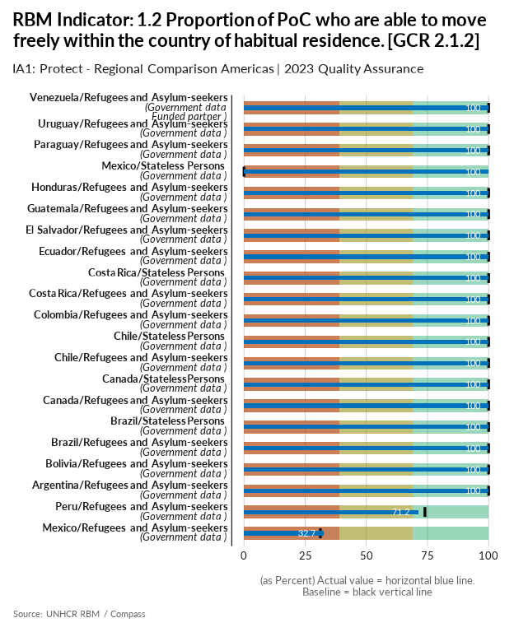

| group | baseline | actual | QA_logical | data_limitation |
| --- | --- | --- | --- | --- |
| Argentina/Refugees and Asylum-seekers | 100 | 100 |  | - |
| Bolivia/Refugees and Asylum-seekers | 100 | 100 |  | - |
| Brazil/Refugees and Asylum-seekers | 100 | 100 |  | - |
| Brazil/Stateless Persons | 100 | 100 |  | - |
| Canada/Refugees and Asylum-seekers | 100 | 100 |  | Both actual numerator and denominator are from the 2023 MYSR. Both numerator and denominator are the total number of refugees and asylum seekers combined. |
| Canada/Stateless Persons | 100 | 100 |  | Both actual numerator and denominator are from the 2023 MYSR. Both numerator and denominator are the total number of stateless persons. |
| Chile/Refugees and Asylum-seekers | 100 | 100 |  | OIP included. In any case, indicator is 100% |
| Chile/Stateless Persons | 100 | 100 |  | - |
| Colombia/Refugees and Asylum-seekers | 100 | 100 |  | Refugiados + Migrantes Venezolanos con Permiso de Protección Temporal+ Migrantes en proceso de regularización. |
| Costa Rica/Refugees and Asylum-seekers | 100 | 100 |  | - |
| Costa Rica/Stateless Persons | 100 | 100 |  | - |
| Ecuador/Refugees and Asylum-seekers | 100 | 100 |  | Venezuelans in Ecuador figure as of june 2024. This figure was validated by the Ministry of Human Mobility and Foreign Affairs and so was its methodology. |
| El Salvador/Refugees and Asylum-seekers | 100 | 100 |  | - |
| Guatemala/Refugees and Asylum-seekers | 100 | 100 |  | - |
| Honduras/Refugees and Asylum-seekers | 100 | 100 |  | 184 recognised refugees for the year and 104 active asylum seekers by end of 2023 according to ASR. Per the Honduran Republic's Constitution, Art. 81, all persons have the right to move freely in national territory and we are unaware of any breaches to this. |
| Mexico/Stateless Persons | 0 | 100 | Numerator for baseline is missing - Denominator for baseline is missing - More than 20% difference between Actual and Baseline | Data on stateless population is not available |
| Mexico/Refugees and Asylum-seekers | 31.2 | 32.7 |  | A refugee has 100% freedom of movement in the country, while an asylum-seeker in Mexico once their claim is lodged cannot move freely within the country; Asylum-seekers are restricted to move freely within the state where they applied for asylum. As such, asylum-seekers are not considered as moving freely within the country of asylum and have been excluded from the calculation. Operation completed the standard calculation tool. |
| Paraguay/Refugees and Asylum-seekers | 100 | 100 |  | - |
| Peru/Refugees and Asylum-seekers | 74 | 71.2 |  | Estimate of Venezuelans in irregular situation based on population totals provided by the National Superintendence for Migrations and ENPOVE 2022 data. |
| Uruguay/Refugees and Asylum-seekers | 100 | 100 |  | - |
| Venezuela/Refugees and Asylum-seekers | 100 | 100 |  | ASR Data 2023 |

[Link to indicator metadata](https://intranet.unhcr.org/content/dam/unhcr/intranet/protection-operations/compass/en/guidance/3/coreindicatorsmetadata/2.0%20Core%20Indicator%20Metadata%2004%2010%202021.pdf#page=8)

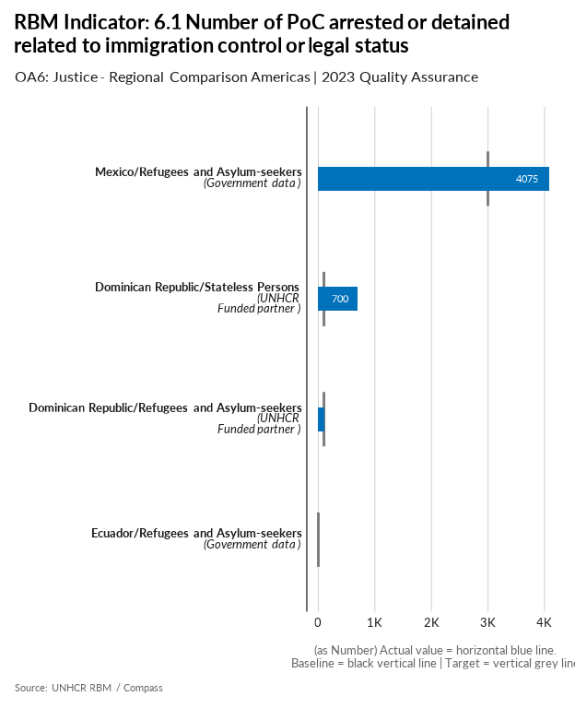

| group | baseline | actual | target | QA_logical | data_limitation |
| --- | --- | --- | --- | --- | --- |
| Colombia/Refugees and Asylum-seekers | - | - | 0 | Missing Actual - Missing Baseline | No se tiene conocimiento de las persons retenidas. La figura no esta prevista en Colombia. Las personas quedan en Zona de Transito Internacional. La cifra reportada correponde a capturas entre colombianos y extranjeros |
| Costa Rica/Refugees and Asylum-seekers | - | - | 0 | Missing Actual - Missing Baseline | We don't have access to the full information. |
| Dominican Republic/Stateless Persons | - | 700 | 100 | Missing Baseline | There is only the data collected by the UNHCR, the State does not disaggregate the profiles it detains and deports, and protection and advocacy interviews can only be done for cases that have documents, Group B2 cases without documents. Your advocacy is not possible. |
| Dominican Republic/Refugees and Asylum-seekers | - | 110 | 100 | Missing Baseline | - |
| Ecuador/Refugees and Asylum-seekers | - | 0 | 0 | Missing Baseline | In Ecuador, the law does not establish any kind of arrest for any migratory situation |
| Mexico/Refugees and Asylum-seekers | - | 4075 | 3000 | Missing Baseline | According to the National Immigration Institute 4,075 asylum seekers were detained. The data does not reflect if they were realesed after detention. |
| Panama/Refugees and Asylum-seekers | - | - | 0 | Missing Actual - Missing Baseline | The operation does not have access to this information. |

[Link to indicator metadata](https://intranet.unhcr.org/content/dam/unhcr/intranet/protection-operations/compass/en/guidance/3/coreindicatorsmetadata/2.0%20Core%20Indicator%20Metadata%2004%2010%202021.pdf#page=100)

## Statelessness

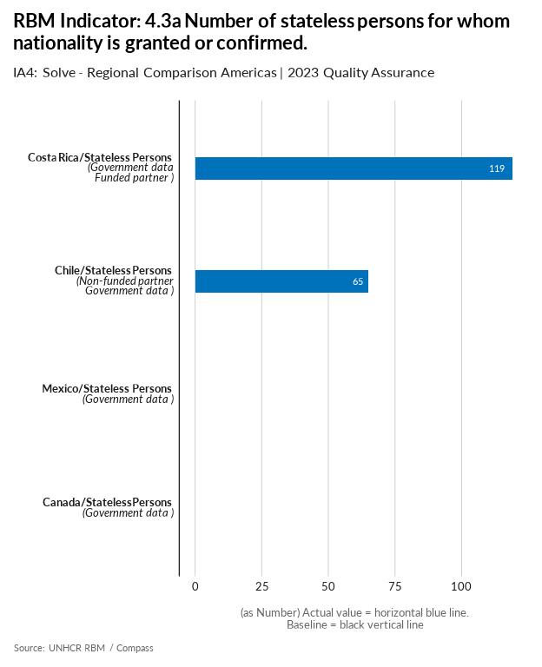

| group | baseline | actual | QA_logical | data_limitation |
| --- | --- | --- | --- | --- |
| Brazil/Stateless Persons | - | - | Missing Actual - Missing Baseline | The Brazilian government does not share this information publicly. |
| Canada/Stateless Persons | - | 0 | Missing Baseline | Figures from the 2022 ASR. |
| Chile/Stateless Persons | - | 65 | Missing Baseline | - |
| Costa Rica/Stateless Persons | - | 119 | Missing Baseline | Data provided by Civil Registry for 2023 and consisten with the ASR. |
| Dominican Republic/Stateless Persons | - | - | Missing Actual - Missing Baseline | The Government (Junta Central Electoral) does not report the statistics on confirmation of nationality. |
| Mexico/Stateless Persons | - | 0 | Missing Baseline | - |

[Link to indicator metadata](https://intranet.unhcr.org/content/dam/unhcr/intranet/protection-operations/compass/en/guidance/3/coreindicatorsmetadata/2.0%20Core%20Indicator%20Metadata%2004%2010%202021.pdf#page=57)

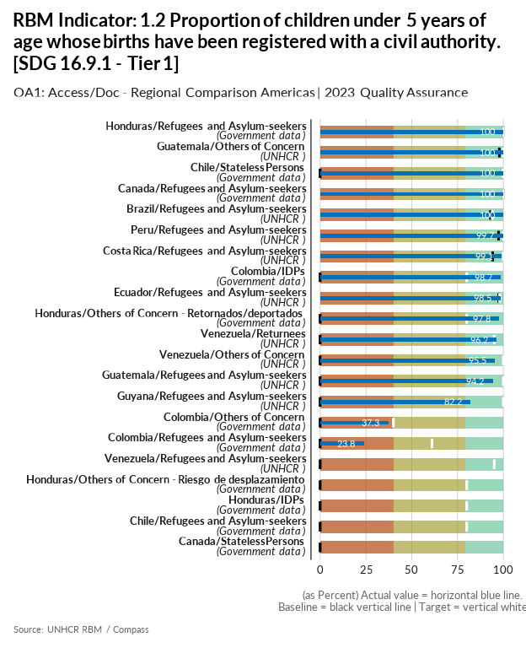

| group | baseline | actual | target | QA_logical | data_limitation |
| --- | --- | --- | --- | --- | --- |
| Brazil/Refugees and Asylum-seekers | 93 | 100 | 94 | Target value is below acceptable standard | - |
| Canada/Refugees and Asylum-seekers | 100 | 100 | 100 |  | Both actual numerator and denominator are from the 2022 ASR. |
| Canada/Stateless Persons | 0 | 0 | - | Missing Target - Numerator for Actual is missing - Denominator for Actual is missing - Numerator for baseline is missing - Denominator for baseline is missing | There are no STA people under 5 years from the 2022 ASR. |
| Chile/Stateless Persons | 0 | 100 | 100 | Numerator for baseline is missing - Denominator for baseline is missing - More than 40% difference between Target and Baseline - More than 20% difference between Actual and Baseline | At the moment we do not have information disaggregated by nationality of the parents; however, it is known that the majority are Bolivian and Peruvian. |
| Chile/Refugees and Asylum-seekers | 0 | 0 | 80 | Numerator for Actual is missing - Denominator for Actual is missing - Numerator for baseline is missing - Denominator for baseline is missing - Target value is below acceptable standard - More than 40% difference between Target and Baseline | No data available. During 2024 we will move forward by contacting the civil registry to find out if they make estimates of unregistered children by the nationality of the parents. Generally this level of detail does not exist, so we are also considering including the corresponding question in our JNA. |
| Colombia/IDPs | 0 | 98.7 | 80 | Numerator for baseline is missing - Denominator for baseline is missing - Target value is below acceptable standard - More than 40% difference between Target and Baseline - More than 20% difference between Actual and Baseline | Numerador: Número de deslazados de 0-5 años con registro civil / Denominador: Total de desplazados de 0-5 años |
| Colombia/Others of Concern | 0 | 37.3 | 40 | Numerator for baseline is missing - Denominator for baseline is missing - Target value is below acceptable standard | En la Encuesta de Calidad de Vida incluye variables sobre ciudadanía, lugar de nacimiento y lugar d residencia cinco años antes y se realizan las estimaciones de retornados basándose en los ciudadanos colombianos, incluidos los de doble nacionalidad. Numerador: Personas con registro de nacimiento / Denominador: Total de personas menores de 5 años |
| Colombia/Refugees and Asylum-seekers | 0 | 23.8 | 61 | Numerator for baseline is missing - Denominator for baseline is missing - Target value is below acceptable standard - More than 40% difference between Target and Baseline | En la Encuesta de Calidad de Vida se incluye variables sobre lugar de nacimiento y país de origen. Se realizan las estimaciones de venezolanos reportados en la encuesta con estas variables. Numerador: Número de Venezolanos con registro de nacimiento / Denominador: Total de venezolanos menores de 5 años. El reporte 2022 y la línea base de 2023 corresponde a la High Frequency Survey, mientras que el Actual 2023 es de la Encuesta de Calidad de Vida, por lo tanto no son comparables. |
| Costa Rica/Refugees and Asylum-seekers | 94.2 | 99.1 | 100 |  | Calculation methodology changed in 2023 using RMS module questions incorporated to CBI socio economic evaluation (targetting tool). 2211 households have been interviewed between september 22st and december 31st. |
| Ecuador/Refugees and Asylum-seekers | 97.5 | 98.5 | 98 | Target value is below acceptable standard | Num: # of children under 5 years old who are registered with civil authorities (in the household survey*) Den: Total # of children under 5 years old (in the household survey*) |
| Guatemala/Others of Concern | 97.8 | 100 | 100 |  | - |
| Guatemala/Refugees and Asylum-seekers | 0 | 94.2 | 100 | Numerator for baseline is missing - Denominator for baseline is missing - More than 40% difference between Target and Baseline - More than 20% difference between Actual and Baseline | In this indicator we present the whole number of people surveyed in the RMS who reported having children of that age. We used the real number and not a generalization to portray the reality of children as it was reported. |
| Guyana/Refugees and Asylum-seekers | 0 | 82.2 | 100 | Numerator for baseline is missing - Denominator for baseline is missing - More than 40% difference between Target and Baseline - More than 20% difference between Actual and Baseline | - |
| Honduras/Refugees and Asylum-seekers | 100 | 100 | 100 |  | Small sample of refugees and asylum-seekers surveyed through the RMS in collaboration with the National Migration Institute. |
| Honduras/Others of Concern - Retornados/deportados | 0 | 97.8 | 80 | Numerator for baseline is missing - Denominator for baseline is missing - Target value is below acceptable standard - More than 40% difference between Target and Baseline - More than 20% difference between Actual and Baseline | Calculated through SEDESOL's government portal SIRBHO which provides registration rates on the vulnerable Honduran population aged between 0-4 years. This was projected and crossed with returnees that originally abandoned their homes due to violence. |
| Honduras/IDPs | 0 | 0 | 80 | Numerator for Actual is missing - Denominator for Actual is missing - Numerator for baseline is missing - Denominator for baseline is missing - Target value is below acceptable standard - More than 40% difference between Target and Baseline | This data is from National Statistics Institute's (INE) EPHPM Q1-Q3 survey data. We are still pending the consolidated data for the whole year (including Q4) but did not receive it yet. The data produced very low registration figures so we left in blank, this will be revised once Q4 data is available from INE. |
| Honduras/Others of Concern - Riesgo de desplazamiento | 0 | 0 | 80 | Numerator for Actual is missing - Denominator for Actual is missing - Numerator for baseline is missing - Denominator for baseline is missing - Target value is below acceptable standard - More than 40% difference between Target and Baseline | Challenges were faced in collecting this data. In 2024 criteria will be reviewed with bureau to identify how to collect this information. |
| Peru/Refugees and Asylum-seekers | 97.3 | 99.7 | 100 |  | RMS uses a random sample of 1,000 persons registered by UNHCR during the 12 months preceding data collection. Actuals have been calculated using scripts provided by the RB |
| Venezuela/Returnees | 0 | 96.2 | 95 | Numerator for baseline is missing - Denominator for baseline is missing - Target value is below acceptable standard - More than 40% difference between Target and Baseline - More than 20% difference between Actual and Baseline | Calculation based on the Mobility Survey applied to returnees at the points of care of UNHCR and its partners, applied to 26563 people entering the country. |
| Venezuela/Others of Concern | 0 | 95.5 | 100 | Numerator for baseline is missing - Denominator for baseline is missing - More than 40% difference between Target and Baseline - More than 20% difference between Actual and Baseline | The calculation is based on the population under 5 years of age who have a birth certificate. |
| Venezuela/Refugees and Asylum-seekers | 0 | 0 | 95 | Numerator for Actual is missing - Denominator for Actual is missing - Numerator for baseline is missing - Denominator for baseline is missing - Target value is below acceptable standard - More than 40% difference between Target and Baseline | There is no data available for refugees and asylum seekers. ENCOVI is a national household survey that is representative to the entire host population. There could be different profiles and needs of the displaced population within Venezuela, which the survey is not capturing. To respond to this indicator in 2024, the operation is preparing an instrument that will be carried out by the UCAB; This instrument is the HAUS survey, which is being modified to include questions from the RMS, and to respond to the indicators following the methodology proposed in the metadata. |

[Link to indicator metadata](https://intranet.unhcr.org/content/dam/unhcr/intranet/protection-operations/compass/en/guidance/3/coreindicatorsmetadata/2.0%20Core%20Indicator%20Metadata%2004%2010%202021.pdf#page=63)

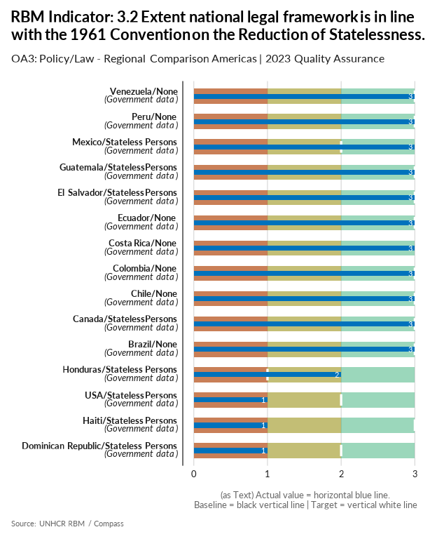

| group | baseline | actual | target | QA_logical | data_limitation |
| --- | --- | --- | --- | --- | --- |
| Brazil/None | - | 3 | 3 | Missing Baseline | - |
| Canada/Stateless Persons | - | 3 | 3 | Missing Baseline | - |
| Chile/None | - | 3 | 3 | Missing Baseline | - |
| Colombia/None | - | 3 | 3 | Missing Baseline | - |
| Costa Rica/None | - | 3 | - | Missing Baseline - Missing Target | - |
| Dominican Republic/Stateless Persons | - | 1 | 2 | Missing Baseline - Target value is below acceptable standard | - |
| Ecuador/None | - | 3 | 3 | Missing Baseline | - |
| El Salvador/Stateless Persons | - | 3 | 3 | Missing Baseline | - |
| Guatemala/Stateless Persons | - | 3 | 3 | Missing Baseline | - |
| Haiti/Stateless Persons | - | 1 | 3 | Missing Baseline | - |
| Honduras/Stateless Persons | - | 2 | 1 | Missing Baseline - Target value is below acceptable standard | Filled in Excel. Despite that Honduras ratified the 1954 Convention relating to the Status of Stateless Persons and the 1961 Convention on the Reduction of Statelessness, there are no specific procedures established in the domestic law. |
| Mexico/Stateless Persons | - | 3 | 2 | Missing Baseline - Target value is below acceptable standard | There is no condition of Statelessness for Mexicans by birth. Just persons who acquired nationality by naturalization. |
| Peru/None | - | 3 | 3 | Missing Baseline | - |
| USA/Stateless Persons | - | 1 | 2 | Missing Baseline - Target value is below acceptable standard | - |
| Venezuela/None | - | 3 | 3 | Missing Baseline | - |

[Link to indicator metadata](https://intranet.unhcr.org/content/dam/unhcr/intranet/protection-operations/compass/en/guidance/3/coreindicatorsmetadata/2.0%20Core%20Indicator%20Metadata%2004%2010%202021.pdf#page=81)

## Law & Policy

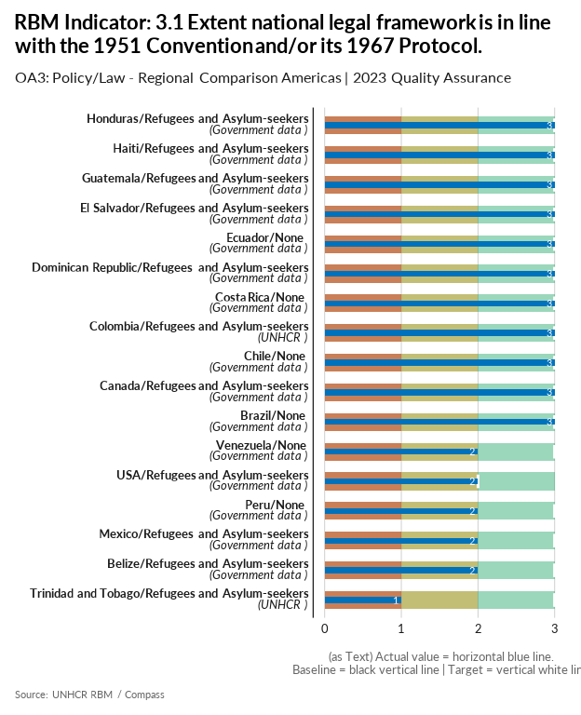

| group | baseline | actual | target | QA_logical | data_limitation |
| --- | --- | --- | --- | --- | --- |
| Belize/Refugees and Asylum-seekers | - | 2 | 3 | Missing Baseline | - |
| Brazil/None | - | 3 | 3 | Missing Baseline | - |
| Canada/Refugees and Asylum-seekers | - | 3 | 3 | Missing Baseline | - |
| Chile/None | - | 3 | 3 | Missing Baseline | - |
| Colombia/Refugees and Asylum-seekers | - | 3 | 3 | Missing Baseline | - |
| Costa Rica/None | - | 3 | 3 | Missing Baseline | - |
| Dominican Republic/Refugees and Asylum-seekers | - | 3 | 3 | Missing Baseline | - |
| Ecuador/None | - | 3 | 3 | Missing Baseline | - |
| El Salvador/Refugees and Asylum-seekers | - | 3 | 3 | Missing Baseline | - |
| Guatemala/Refugees and Asylum-seekers | - | 3 | 3 | Missing Baseline | - |
| Haiti/Refugees and Asylum-seekers | - | 3 | 3 | Missing Baseline | - |
| Honduras/Refugees and Asylum-seekers | - | 3 | 3 | Missing Baseline | Since there have been no changes to the legal framework in comparison to 2022, the same analysis was applied by UNHCR to the Excel provided in the guidance. |
| Mexico/Refugees and Asylum-seekers | - | 2 | 3 | Missing Baseline | Same data, no changes |
| Peru/None | - | 2 | 3 | Missing Baseline | - |
| Trinidad and Tobago/Refugees and Asylum-seekers | - | 1 | 3 | Missing Baseline | - |
| USA/Refugees and Asylum-seekers | - | 2 | 2 | Missing Baseline - Target value is below acceptable standard | - |
| Venezuela/None | - | 2 | 3 | Missing Baseline | - |

[Link to indicator metadata](https://intranet.unhcr.org/content/dam/unhcr/intranet/protection-operations/compass/en/guidance/3/coreindicatorsmetadata/2.0%20Core%20Indicator%20Metadata%2004%2010%202021.pdf#page=77)

## Documentation

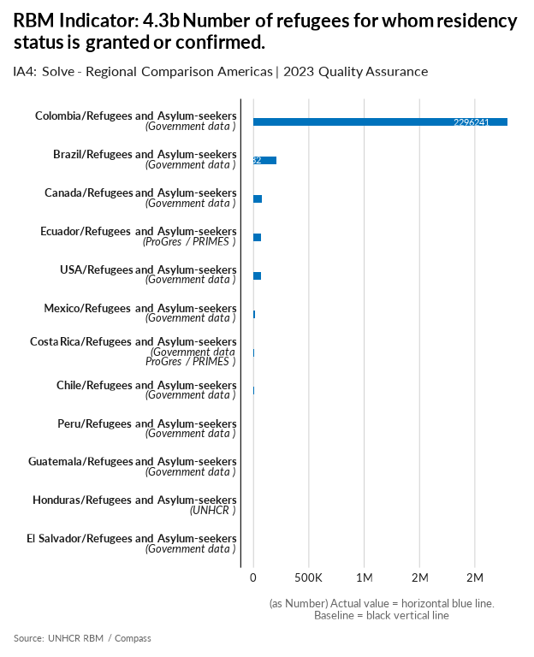

| group | baseline | actual | QA_logical | data_limitation |
| --- | --- | --- | --- | --- |
| Brazil/Refugees and Asylum-seekers | - | 208132 | Missing Baseline | Baseline updated following the same methodology as the actuals in 2023. |
| Canada/Refugees and Asylum-seekers | - | 75414 | Missing Baseline | Figures from the 2023 MYSR. |
| Chile/Refugees and Asylum-seekers | - | 2343 | Missing Baseline | - |
| Colombia/Refugees and Asylum-seekers | - | 2296241 | Missing Baseline | Observatorio Colombiano de Migración desde Venezuela - DNP - Módulo Permisos y Visa. Población que solicitó Visa de residencia + VDA regularizados |
| Costa Rica/Refugees and Asylum-seekers | - | 2690 | Missing Baseline | # of individual recognitions in line with ASR 2023 |
| Ecuador/Refugees and Asylum-seekers | - | 70649 | Missing Baseline | The value corresponds to the historical records. This indicator only covers RAS and not OIP. The calculation is the same for baseline and actual |
| El Salvador/Refugees and Asylum-seekers | - | 0 | Missing Baseline | The National Commission for Refugee Status Determination (CODER) reported zero people recognized during 2023. |
| Guatemala/Refugees and Asylum-seekers | - | 293 | Missing Baseline | This is the number of residencies granted this year. Residencies given in Guatemala are temporary for 5 years. |
| Honduras/Refugees and Asylum-seekers | - | 184 | Missing Baseline | As far as UNHCR's knowledge, all recognized refugees are granted residency provided they renew their refugee status every 3 months. |
| Mexico/Refugees and Asylum-seekers | - | 15743 | Missing Baseline | This figure refers to Permanent Residency Cards issued to recognized refugees by the Government during 2023. Revision of methodology compared to baseline setting: cases of naturalization are not considered as they were reported as residents in previous years. |
| Peru/Refugees and Asylum-seekers | - | 1437 | Missing Baseline | The figure reflects the total number of recognized refugees with a valid Carnet de Extranjería as of the time of reporting. Figures provided by the National Superintendence for Migrations. |
| USA/Refugees and Asylum-seekers | - | 67591 | Missing Baseline | Asylees and refugees are eligible to adjust one year after arrival/grant. Therefore this # was derived by counting refugee arrivals and asylee grants for the previous year, taking the % rate of adjustment to LPR status reported by the USG. |
| Venezuela/Refugees and Asylum-seekers | - | - | Missing Actual - Missing Baseline | The operation has no official information about the number of refugees for whom residency status is granted or confirmed. To respond to this indicator in 2024, the operation is trying to sign a Work Plan with CONARE and the Office of the Ombudsperson, to try to get more information about the situation of refugees in Venezuela. |

[Link to indicator metadata](https://intranet.unhcr.org/content/dam/unhcr/intranet/protection-operations/compass/en/guidance/3/coreindicatorsmetadata/2.0%20Core%20Indicator%20Metadata%2004%2010%202021.pdf#page=60)

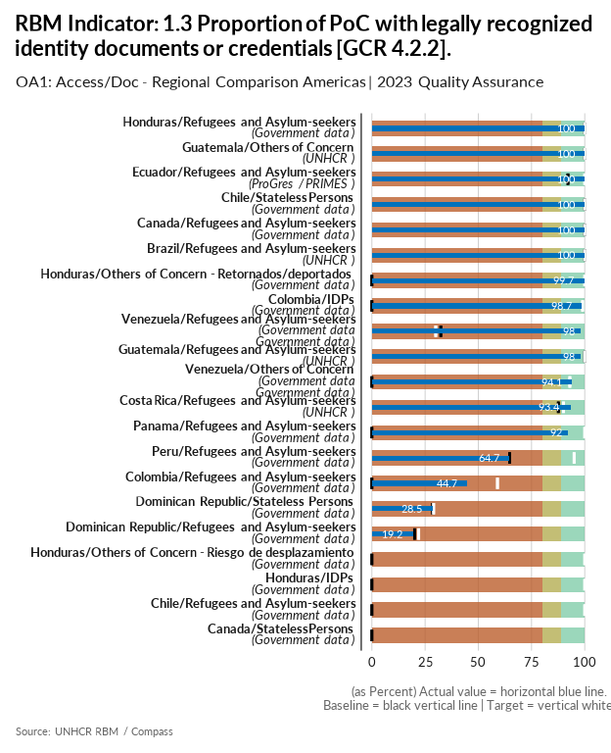

| group | baseline | actual | target | QA_logical | data_limitation |
| --- | --- | --- | --- | --- | --- |
| Brazil/Refugees and Asylum-seekers | 100 | 100 | 100 |  | - |
| Canada/Refugees and Asylum-seekers | 100 | 100 | 100 |  | Both actual numerator and denominator are from the 2023 MYSR. Both numerator and denominator are the total number of refugees, refugee-like and asylum seekers combined. |
| Canada/Stateless Persons | 0 | 0 | - | Missing Target - Numerator for Actual is missing - Denominator for Actual is missing - Numerator for baseline is missing - Denominator for baseline is missing | It is possible some provinces may issue documents but there is no reliable. Data is not available as there is no Stateless determination process in Canada. |
| Chile/Stateless Persons | 100 | 100 | 100 |  | - |
| Chile/Refugees and Asylum-seekers | 0 | 0 | 100 | Numerator for Actual is missing - Denominator for Actual is missing - Numerator for baseline is missing - Denominator for baseline is missing - More than 40% difference between Target and Baseline | As of December 2023, the Chilean government published an estimate of foreigners that includes a percentage of people in an irregular situation. In the case of Venezuela this corresponds to 13%. If not through a survey, we cannot estimate how many of these people have valid identity documents and how many do not. Following the estimate, we can affirm that at least 87% meet the requirement of the indicator. The operation will explore methods to obtain data for the indicator in 2024 |
| Colombia/IDPs | 0 | 98.7 | 99 | Numerator for baseline is missing - Denominator for baseline is missing - Target value is below acceptable standard - More than 40% difference between Target and Baseline - More than 20% difference between Actual and Baseline | Numerador: Número de desplazados con documento de identidad / Denominador: Total de desplazados |
| Colombia/Refugees and Asylum-seekers | 0 | 44.7 | 59 | Numerator for baseline is missing - Denominator for baseline is missing - Target value is below acceptable standard - More than 40% difference between Target and Baseline - More than 20% difference between Actual and Baseline | En la Encuesta de Calidad de Vida se incluye variables sobre lugar de nacimiento y país de origen. Se realizan las estimaciones de venezolanos reportados en la encuesta con estas variables. Numerador: Número de venezolanos con documento de identidad / Denominador: Total de venezolanos reportados en esta variable. El reporte 2022 y la línea base de 2023 corresponde a PPT entregados, mientras que el Actual 2023 es de la Encuesta de Calidad de Vida, por lo tanto no son comparables. |
| Costa Rica/Refugees and Asylum-seekers | 87.6 | 93.4 | 90 | Target value is below acceptable standard | - |
| Dominican Republic/Stateless Persons | 28.5 | 28.5 | 29 | Target value is below acceptable standard | The Government (Junta Central Electoral) does not report the statistics on confirmation of nationality. And also we just have the official data from the first generarion the descendets that we have identified are the cases accompanied by partners. |
| Dominican Republic/Refugees and Asylum-seekers | 20.1 | 19.2 | 22 | Target value is below acceptable standard | For the numerator we have added the all Venezuelans with documents by the normalization programme and for the denominator added total number of refugees + asylum-seekers + OIP |
| Ecuador/Refugees and Asylum-seekers | 92.1 | 100 | 100 |  | Numerator: # of POC with valid identity documents or credentials Denominator: Total # of POC |
| Guatemala/Others of Concern | 100 | 100 | 100 |  | - |
| Guatemala/Refugees and Asylum-seekers | 100 | 98 | 100 |  | - |
| Honduras/Refugees and Asylum-seekers | 100 | 100 | 100 |  | Small sample of refugees and asylum-seekers surveyed through the RMS in collaboration with the National Migration Institute. Data is extrapolated to RAS population. |
| Honduras/Others of Concern - Retornados/deportados | 0 | 99.7 | 100 | Numerator for baseline is missing - Denominator for baseline is missing - More than 40% difference between Target and Baseline - More than 20% difference between Actual and Baseline | Calculated through SEDESOL's government portal SIRBHO which provides documentation rates on the vulnerable Honduran population. This was projected and crossed with returnees that originally abandoned their homes due to violence. |
| Honduras/IDPs | 0 | 0 | 100 | Numerator for Actual is missing - Denominator for Actual is missing - Numerator for baseline is missing - Denominator for baseline is missing - More than 40% difference between Target and Baseline | The data from the National Statistics Institute's (INE) EPHPM Q1-Q3 produced very low documentation figures so we left in blank, this will be revised once Q4 data is available from INE, as we have not received it yet. |
| Honduras/Others of Concern - Riesgo de desplazamiento | 0 | 0 | 100 | Numerator for Actual is missing - Denominator for Actual is missing - Numerator for baseline is missing - Denominator for baseline is missing - More than 40% difference between Target and Baseline | Challenges were faced in collecting this data. In 2024 criteria will be reviewed with bureau to identify how to collect this information. |
| Panama/Refugees and Asylum-seekers | 0 | 92 | 100 | More than 40% difference between Target and Baseline - More than 20% difference between Actual and Baseline | - |
| Peru/Refugees and Asylum-seekers | 64.7 | 64.7 | 95 | Target value is below acceptable standard | Data from ENPOVE (2022) |
| Venezuela/Refugees and Asylum-seekers | 32.4 | 98 | 30 | Target value is below the baseline - Target value is below acceptable standard - More than 20% difference between Actual and Baseline | Given the absence of data on the refugee population (last update of CONARE 2022) existing in the country, absence of progress/prime and implementation of the RMS in the operation. The latest number of refugees and applicants given by CONARE that is reflected in the ASR is used as the denominator. For the numerator, the protection unit estimates that 98% of refugees and asylum seekers have valid identity documents from the country of origin (given the low number of cases at risk of statelessness of this population group in the operation) which allows their identity to be certified in the absence of identity documents from the country of asylum (SAIME Venezuela) |
| Venezuela/Others of Concern | 0 | 94.1 | 93 | Numerator for baseline is missing - Denominator for baseline is missing - Target value is below acceptable standard - More than 40% difference between Target and Baseline - More than 20% difference between Actual and Baseline | The calculation is based on the population aged 8 and over who have an identity card. |

[Link to indicator metadata](https://intranet.unhcr.org/content/dam/unhcr/intranet/protection-operations/compass/en/guidance/3/coreindicatorsmetadata/2.0%20Core%20Indicator%20Metadata%2004%2010%202021.pdf#page=65)

# Protection / Thematic

## Gender-Based Violence

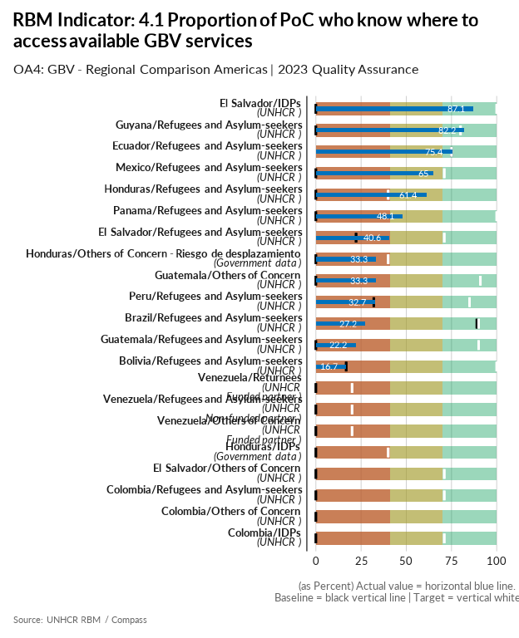

| group | baseline | actual | target | QA_logical | data_limitation |
| --- | --- | --- | --- | --- | --- |
| Bolivia/Refugees and Asylum-seekers | 16.7 | 16.7 | 100 | More than 40% difference between Target and Baseline | Non-probabilistic sample. 209 people interviewed by phone in December 2023. |
| Brazil/Refugees and Asylum-seekers | 89 | 27.2 | 90 | Target value is below acceptable standard - More than 20% difference between Actual and Baseline | The results considered methodology changes that regards only life saving services selection in the numerator field. |
| Colombia/Refugees and Asylum-seekers | 0 | 0 | 71 | Numerator for Actual is missing - Denominator for Actual is missing - Numerator for baseline is missing - Denominator for baseline is missing - Target value is below acceptable standard - More than 40% difference between Target and Baseline | No hay información disponible para este indicador |
| Colombia/IDPs | 0 | 0 | 71 | Numerator for Actual is missing - Denominator for Actual is missing - Numerator for baseline is missing - Denominator for baseline is missing - Target value is below acceptable standard - More than 40% difference between Target and Baseline | No hay información disponible para este indicador |
| Colombia/Others of Concern | 0 | 0 | - | Missing Target - Numerator for Actual is missing - Denominator for Actual is missing - Numerator for baseline is missing - Denominator for baseline is missing | No hay información disponible para este indicador |
| Ecuador/Refugees and Asylum-seekers | 75 | 75.4 | 75 | Target value is below acceptable standard | Ecuador maintains same methodology as 2023 (considering all 4 GBV services as we consider them essential). HQ suggestions only considers 2 GBV services (health services and psycho-social services). |
| El Salvador/IDPs | 0 | 87.1 | 100 | Numerator for baseline is missing - Denominator for baseline is missing - More than 40% difference between Target and Baseline - More than 20% difference between Actual and Baseline | - |
| El Salvador/Refugees and Asylum-seekers | 22.2 | 40.6 | 71 | Target value is below acceptable standard - More than 40% difference between Target and Baseline | - |
| El Salvador/Others of Concern | 0 | 0 | 71 | Numerator for Actual is missing - Denominator for Actual is missing - Numerator for baseline is missing - Denominator for baseline is missing - Target value is below acceptable standard - More than 40% difference between Target and Baseline | Data not available for this population in 2023, depending on the availability of resources, an RMS survey exercise is planned for 2024. |
| Guatemala/Others of Concern | 0 | 33.3 | 91 | Numerator for baseline is missing - Denominator for baseline is missing - Target value is below acceptable standard - More than 40% difference between Target and Baseline | The phrasing of this question changed in the new RMS, specifically stating that the surveyer could not hint what a GBV service could be. This change in the phrasing resulted in the low number reported. |
| Guatemala/Refugees and Asylum-seekers | 0 | 22.2 | 90 | Numerator for baseline is missing - Denominator for baseline is missing - Target value is below acceptable standard - More than 40% difference between Target and Baseline | The phrasing of this question changed in the new RMS, specifically stating that the surveyer could not hint what a GBV service could be. This change in the phrasing resulted in the low number reported. |
| Guyana/Refugees and Asylum-seekers | 0 | 82.2 | 80 | Numerator for baseline is missing - Denominator for baseline is missing - Target value is below acceptable standard - More than 40% difference between Target and Baseline - More than 20% difference between Actual and Baseline | - |
| Honduras/Refugees and Asylum-seekers | 0 | 61.4 | 40 | Numerator for baseline is missing - Denominator for baseline is missing - Target value is below acceptable standard - More than 20% difference between Actual and Baseline | Small sample of refugees and asylum-seekers surveyed through the RMS in collaboration with the National Migration Institute. Data is extrapolated to RAS population. |
| Honduras/Others of Concern - Riesgo de desplazamiento | 0 | 33.3 | 40 | Numerator for baseline is missing - Denominator for baseline is missing - Target value is below acceptable standard | This only includes a small sample surveyed by UNHCR and partners. This indicator could be included in an RMS exercise next year if population identification is possible. |
| Honduras/IDPs | 0 | 0 | 40 | Numerator for Actual is missing - Denominator for Actual is missing - Numerator for baseline is missing - Denominator for baseline is missing - Target value is below acceptable standard | We were not able to collect data on this indicator, but discussions will be held with the GBV team to identify ways to collect this info. |
| Mexico/Refugees and Asylum-seekers | 0 | 65 | 71 | Numerator for baseline is missing - Denominator for baseline is missing - Target value is below acceptable standard - More than 40% difference between Target and Baseline - More than 20% difference between Actual and Baseline | Preliminary RMS data relates only to Refugee population (this includes complementary protection beneficiaries). Dissagregation per sex: female 27,315/40,046=68%; male 29,592/47,518=62% |
| Panama/Refugees and Asylum-seekers | 0 | 48.1 | 100 | Numerator for baseline is missing - Denominator for baseline is missing - More than 40% difference between Target and Baseline - More than 20% difference between Actual and Baseline | - |
| Peru/Refugees and Asylum-seekers | 32 | 32.7 | 85 | Target value is below acceptable standard - More than 40% difference between Target and Baseline | - |
| Venezuela/Others of Concern | 0 | 0 | 20 | Numerator for Actual is missing - Denominator for Actual is missing - Numerator for baseline is missing - Denominator for baseline is missing - Target value is below acceptable standard | There is no data availible to determine the proportion of PoC who know where to access GBV services. |
| Venezuela/Refugees and Asylum-seekers | 0 | 0 | 20 | Numerator for Actual is missing - Denominator for Actual is missing - Numerator for baseline is missing - Denominator for baseline is missing - Target value is below acceptable standard | There is no data available to determine the proportion of PoC who know where to access GBV services. |
| Venezuela/Returnees | 0 | 0 | 20 | Numerator for Actual is missing - Denominator for Actual is missing - Numerator for baseline is missing - Denominator for baseline is missing - Target value is below acceptable standard | There is no data available to determine the proportion of PoC who know where to access GBV services. |

[Link to indicator metadata](https://intranet.unhcr.org/content/dam/unhcr/intranet/protection-operations/compass/en/guidance/3/coreindicatorsmetadata/2.0%20Core%20Indicator%20Metadata%2004%2010%202021.pdf#page=85)

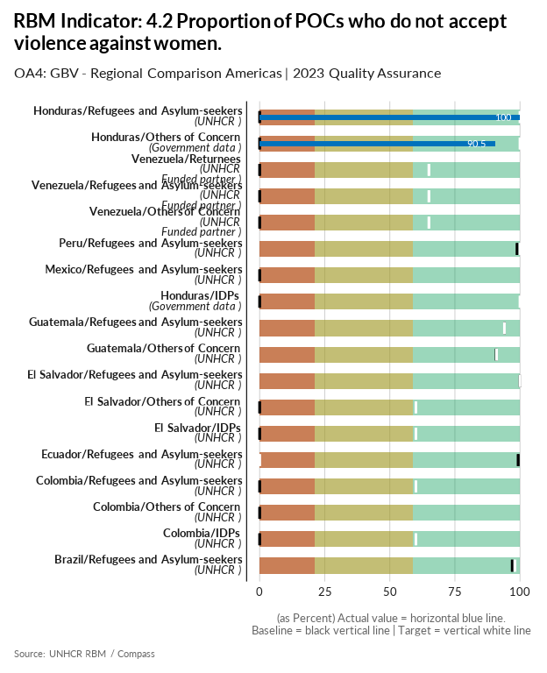

| group | baseline | actual | target | QA_logical | data_limitation |
| --- | --- | --- | --- | --- | --- |
| Brazil/Refugees and Asylum-seekers | 97 | 0 | 98 | Numerator for Actual is missing - Denominator for Actual is missing - Target value is below acceptable standard - More than 20% difference between Actual and Baseline | RMS conducted via telephone-based interviews. However, HQ has released guidance discouraging collecting such information in this modality. Therefore, UNHCR Brazil is unable to update this indicator. |
| Colombia/Refugees and Asylum-seekers | 0 | 0 | 60 | Numerator for Actual is missing - Denominator for Actual is missing - Numerator for baseline is missing - Denominator for baseline is missing - Target value is below acceptable standard - More than 40% difference between Target and Baseline | No se cuenta con fuentes de información para este indicador. Adicionalmente, el indicador puede enfrentar varios sesgos de respuesta social, que son distorsiones sistemáticas en las respuestas de las personas debido a factores sociales o culturales. Esto genera que la información sobre este indicador no evidencie la realidad del fenómeno |
| Colombia/IDPs | 0 | 0 | 60 | Numerator for Actual is missing - Denominator for Actual is missing - Numerator for baseline is missing - Denominator for baseline is missing - Target value is below acceptable standard - More than 40% difference between Target and Baseline | No se cuenta con fuentes de información para este indicador. Adicionalmente, el indicador puede enfrentar varios sesgos de respuesta social, que son distorsiones sistemáticas en las respuestas de las personas debido a factores sociales o culturales. Esto genera que la información sobre este indicador no evidencie la realidad del fenómeno. |
| Colombia/Others of Concern | 0 | 0 | - | Missing Target - Numerator for Actual is missing - Denominator for Actual is missing - Numerator for baseline is missing - Denominator for baseline is missing | No se cuenta con fuentes de información para este indicador. Adicionalmente, el indicador puede enfrentar varios sesgos de respuesta social, que son distorsiones sistemáticas en las respuestas de las personas debido a factores sociales o culturales. Esto genera que la información sobre este indicador no evidencie la realidad del fenómeno. |
| Ecuador/Refugees and Asylum-seekers | 99.3 | 0 | 0 | Numerator for Actual is missing - Denominator for Actual is missing - Target value is below the baseline - Target value is below acceptable standard - More than 40% difference between Target and Baseline - More than 20% difference between Actual and Baseline | The question that feeds this indicator is not appropriate to be applied in surveys since it induces and suggests an answer in advance. In addition, this question could provoke protection risks associated with gender-based violence. There is no available information for this indicator |
| El Salvador/Refugees and Asylum-seekers | 100 | 0 | 100 | Numerator for Actual is missing - Denominator for Actual is missing - More than 20% difference between Actual and Baseline | Data not available. In RMS exercise, questions related with this indicator were not included. |
| El Salvador/IDPs | 0 | 0 | 60 | Numerator for Actual is missing - Denominator for Actual is missing - Numerator for baseline is missing - Denominator for baseline is missing - Target value is below acceptable standard - More than 40% difference between Target and Baseline | Data not available. In RMS exercise conducted in 2023, questions related with this indicator were not included on the script provided for phone-based surveys (CATI) . |
| El Salvador/Others of Concern | 0 | 0 | 60 | Numerator for Actual is missing - Denominator for Actual is missing - Numerator for baseline is missing - Denominator for baseline is missing - Target value is below acceptable standard - More than 40% difference between Target and Baseline | Data not available for this population in 2023, depending on the availability of resources, an RMS survey exercise is planned for 2024. |
| Guatemala/Refugees and Asylum-seekers | 94.1 | 0 | 94 | Numerator for Actual is missing - Denominator for Actual is missing - Target value is below the baseline - Target value is below acceptable standard - More than 20% difference between Actual and Baseline | We don't have data on this indicator because the RMS was made by telephone calls, and this version of the survey did not include the GBV qustions. |
| Guatemala/Others of Concern | 90.9 | 0 | 91 | Numerator for Actual is missing - Denominator for Actual is missing - Target value is below acceptable standard - More than 20% difference between Actual and Baseline | We don't have data on this indicator because the RMS was made by telephone calls, and this version of the survey did not include the GBV qustions. |
| Honduras/Refugees and Asylum-seekers | 0 | 100 | 100 | Numerator for baseline is missing - Denominator for baseline is missing - More than 40% difference between Target and Baseline - More than 20% difference between Actual and Baseline | Small sample of refugees and asylum-seekers surveyed through the RMS in collaboration with the National Migration Institute. Data is extrapolated to RAS population. |
| Honduras/Others of Concern | 0 | 90.5 | 100 | Numerator for baseline is missing - Denominator for baseline is missing - More than 40% difference between Target and Baseline - More than 20% difference between Actual and Baseline | Challenges were faced in collecting this data. A rather small sample was interviewed for this indicator and we will try to amplify this exercise in 2024. |
| Honduras/IDPs | 0 | 0 | 100 | Numerator for Actual is missing - Denominator for Actual is missing - Numerator for baseline is missing - Denominator for baseline is missing - More than 40% difference between Target and Baseline | We were not able to collect data on this indicator, but discussions will be held with the GBV team to identify ways to collect this info. |
| Mexico/Refugees and Asylum-seekers | 0 | 0 | - | Missing Target - Numerator for Actual is missing - Denominator for Actual is missing - Numerator for baseline is missing - Denominator for baseline is missing | This indicator was piloted pre RMS and serious issues were found in attempting to gather it: respondents did not understand the question, it generated unsafe situations and high risks of disclosure in inadequate/unsafe contexts. It was not possible to include it in the RMS using the suggested methodology (survey question on "husbands beating their wives") |
| Peru/Refugees and Asylum-seekers | 98.9 | 0 | 100 | Numerator for Actual is missing - Denominator for Actual is missing - More than 20% difference between Actual and Baseline | Peru applies RMS via phone interviews. The newer version of the RMS Computer Assisted Telephone Interview (CATI) form no longer includes this question. |
| Venezuela/Others of Concern | 0 | 0 | 65 | Numerator for Actual is missing - Denominator for Actual is missing - Numerator for baseline is missing - Denominator for baseline is missing - Target value is below acceptable standard - More than 40% difference between Target and Baseline | Data Limitation. The operation does not have data available to determine the proportion of PoC who do not accept violence against women. |
| Venezuela/Refugees and Asylum-seekers | 0 | 0 | 65 | Numerator for Actual is missing - Denominator for Actual is missing - Numerator for baseline is missing - Denominator for baseline is missing - Target value is below acceptable standard - More than 40% difference between Target and Baseline | Data limitation. The operation does not have data to determine the proportion of Refugees who do not accept violence against women. |
| Venezuela/Returnees | 0 | 0 | 65 | Numerator for Actual is missing - Denominator for Actual is missing - Numerator for baseline is missing - Denominator for baseline is missing - Target value is below acceptable standard - More than 40% difference between Target and Baseline | Data limitation. The operation does not have data available to determine the proportion of returnees who do not accept violence against women. |

[Link to indicator metadata](https://intranet.unhcr.org/content/dam/unhcr/intranet/protection-operations/compass/en/guidance/3/coreindicatorsmetadata/2.0%20Core%20Indicator%20Metadata%2004%2010%202021.pdf#page=88)

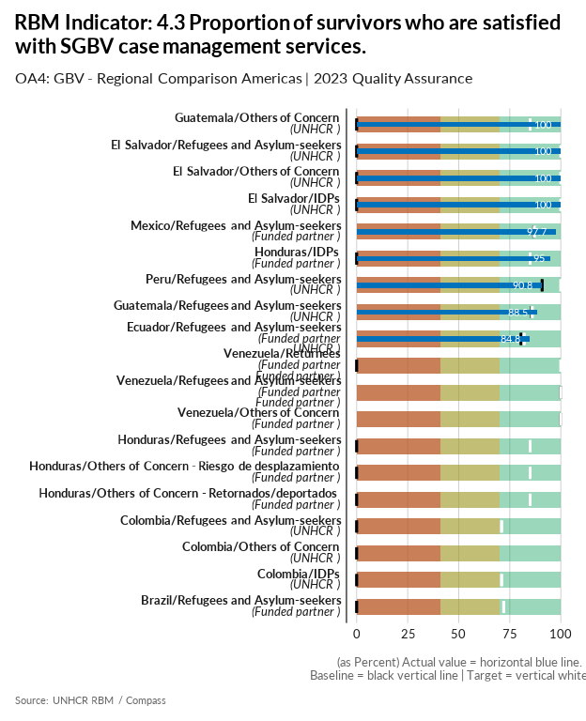

| group | baseline | actual | target | QA_logical | data_limitation |
| --- | --- | --- | --- | --- | --- |
| Brazil/Refugees and Asylum-seekers | 0 | 0 | 72 | Numerator for Actual is missing - Denominator for Actual is missing - Numerator for baseline is missing - Denominator for baseline is missing - Target value is below acceptable standard - More than 40% difference between Target and Baseline | The instruments for the measurement of the indicator are ready, but due to programme recommendation and ease of accession the tool will be implemented from 2024 onwards. |
| Colombia/Refugees and Asylum-seekers | 0 | 0 | 71 | Numerator for Actual is missing - Denominator for Actual is missing - Numerator for baseline is missing - Denominator for baseline is missing - Target value is below acceptable standard - More than 40% difference between Target and Baseline | No hay información disponible para este indicador. Posiblemente se incluirá este indicador en la HFS. |
| Colombia/IDPs | 0 | 0 | 71 | Numerator for Actual is missing - Denominator for Actual is missing - Numerator for baseline is missing - Denominator for baseline is missing - Target value is below acceptable standard - More than 40% difference between Target and Baseline | No hay información disponible para este indicador. Posiblemente se incluirá este indicador en la HFS. |
| Colombia/Others of Concern | 0 | 0 | - | Missing Target - Numerator for Actual is missing - Denominator for Actual is missing - Numerator for baseline is missing - Denominator for baseline is missing | No hay información disponible para este indicador. Posiblemente se incluirá este indicador en la HFS. |
| Ecuador/Refugees and Asylum-seekers | 80.5 | 84.8 | 82 | Target value is below acceptable standard | Since the data comes from a survey applied by the partner to its own beneficiaries, the information may not reflect the reality of survivors' satisfaction with all GBV services provided by UNHCR. The satisfaction rate is calculated through a survey conducted by HIAS from January to August in 2023. n=297, of which 84.51% of the surveyed individuals indicated that they are satisfied or very satisfied with the case management received |
| El Salvador/Refugees and Asylum-seekers | 0 | 100 | 100 | Numerator for baseline is missing - Denominator for baseline is missing - More than 40% difference between Target and Baseline - More than 20% difference between Actual and Baseline | The feedback survey was conducted between November and December 2023, It only covered people assisted with GVB specialized services in those months. |
| El Salvador/IDPs | 0 | 100 | 100 | Numerator for baseline is missing - Denominator for baseline is missing - More than 40% difference between Target and Baseline - More than 20% difference between Actual and Baseline | The feedback survey was conducted between November and December 2023, It only covered people assisted with GVB specialized services in those months. |
| El Salvador/Others of Concern | 0 | 100 | 100 | Numerator for baseline is missing - Denominator for baseline is missing - More than 40% difference between Target and Baseline - More than 20% difference between Actual and Baseline | The feedback survey was conducted between November and December 2023, It only covered people assisted with GVB specialized services in those months. |
| Guatemala/Others of Concern | 0 | 100 | 85 | Numerator for baseline is missing - Denominator for baseline is missing - Target value is below acceptable standard - More than 40% difference between Target and Baseline - More than 20% difference between Actual and Baseline | - |
| Guatemala/Refugees and Asylum-seekers | 85.7 | 88.5 | 86 | Target value is below acceptable standard | - |
| Honduras/IDPs | 0 | 95 | 85 | Numerator for baseline is missing - Denominator for baseline is missing - Target value is below acceptable standard - More than 40% difference between Target and Baseline - More than 20% difference between Actual and Baseline | Partners conducted satisfactory surveys to a number of persons receiving case management. This exercise will be further integrated into our activities. |
| Honduras/Others of Concern - Retornados/deportados | 0 | 0 | 85 | Numerator for Actual is missing - Denominator for Actual is missing - Numerator for baseline is missing - Denominator for baseline is missing - Target value is below acceptable standard - More than 40% difference between Target and Baseline | Challenges were faced in collecting this data and we were not able to identify a mechanism for integrating this into partner monitoring activities. |
| Honduras/Others of Concern - Riesgo de desplazamiento | 0 | 0 | 85 | Numerator for Actual is missing - Denominator for Actual is missing - Numerator for baseline is missing - Denominator for baseline is missing - Target value is below acceptable standard - More than 40% difference between Target and Baseline | Challenges were faced in collecting this data and we were not able to identify a mechanism for integrating this into partner monitoring activities. |
| Honduras/Refugees and Asylum-seekers | 0 | 0 | 85 | Numerator for Actual is missing - Denominator for Actual is missing - Numerator for baseline is missing - Denominator for baseline is missing - Target value is below acceptable standard - More than 40% difference between Target and Baseline | Neither UNHCR nor partners attended GBV cases for refugees and asylum seekers this year. |
| Mexico/Refugees and Asylum-seekers | 86.7 | 97.7 | 87 | Target value is below acceptable standard | to report on 2023 actual, the survey methodology was followed in accordance to GBV AoR standards, in contrast to last year when the results and targets were estimated by averaging the partners' self reported results. |
| Peru/Refugees and Asylum-seekers | 90.8 | 90.8 | 100 |  | - |
| Venezuela/Others of Concern | 100 | 0 | 100 | Numerator for Actual is missing - Denominator for Actual is missing - More than 20% difference between Actual and Baseline | During 2022, UNHCR maintained Case Management with partners. For 2023, the GBV Case Management in PPAs was not agreed. |
| Venezuela/Refugees and Asylum-seekers | 100 | 0 | 100 | Numerator for Actual is missing - Denominator for Actual is missing - More than 20% difference between Actual and Baseline | During 2022, UNHCR maintained Case Management with partners. For 2023, the GBV Case Management in PPAs was not agreed. |
| Venezuela/Returnees | 0 | 0 | 100 | Numerator for Actual is missing - Denominator for Actual is missing - Numerator for baseline is missing - Denominator for baseline is missing - More than 40% difference between Target and Baseline | During 2022, UNHCR maintained Case Management with partners. For 2023, the GBV Case Management in PPAs was not agreed. |

[Link to indicator metadata](https://intranet.unhcr.org/content/dam/unhcr/intranet/protection-operations/compass/en/guidance/3/coreindicatorsmetadata/2.0%20Core%20Indicator%20Metadata%2004%2010%202021.pdf#page=91)

## Child Protection

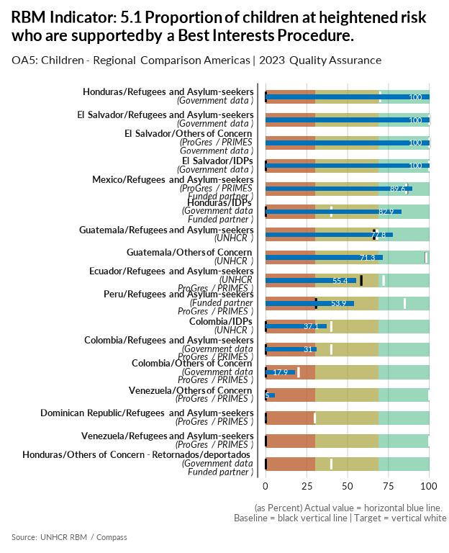

| group | baseline | actual | target | QA_logical | data_limitation |
| --- | --- | --- | --- | --- | --- |
| Colombia/IDPs | 0 | 37.1 | 40 | Numerator for baseline is missing - Denominator for baseline is missing - Target value is below acceptable standard | Numerador: Estadísticas ICBF Ingresos 2023. Numerador: NNA Ingreso a PARD (Desplazados) Denominador: Identificación de NNA (Desplazados) en riesgo con verificación de derechos sin apertura de PAR |
| Colombia/Refugees and Asylum-seekers | 0 | 31 | 40 | Numerator for baseline is missing - Denominator for baseline is missing - Target value is below acceptable standard | Numerador: Estadísticas Migrantes ICBF Ingresos 2023. Numerador: NNA Ingreso a PARD (Venezolanos y otras nacionalidad) Denominador: Identificación de NNA (Venezolanos y otras nacionalidad) en riesgo con verificación de derechos sin apertura de PAR |
| Colombia/Others of Concern | 0 | 17.9 | 20 | Numerator for baseline is missing - Denominator for baseline is missing - Target value is below acceptable standard | Estimacion de los Colombianos Retornados reportados en el RMRP: Numerador: NNA que recibieron servicios especializados de protección de la niñez. Denominador: NNA que fueron asistidos en el Sector de Protección de la Niñez |
| Dominican Republic/Refugees and Asylum-seekers | 0 | 0.1 | 30 | Numerator for baseline is missing - Denominator for baseline is missing - Target value is below acceptable standard | We dont have the child protection module available and the information is in internal folders within sharepoint. Besides the information avaliable in progres jus includ NNA specific needs wich means we can not calculate the exact number of child in risk atomaticaly in ProGres. |
| Ecuador/Refugees and Asylum-seekers | 58.4 | 55.4 | 72 | Target value is below acceptable standard | We take the cases registered by HIAS in progress and which of those were supported with BIAS |
| El Salvador/Refugees and Asylum-seekers | 100 | 100 | 100 |  | - |
| El Salvador/IDPs | 0 | 100 | 100 | Numerator for baseline is missing - Denominator for baseline is missing - More than 40% difference between Target and Baseline - More than 20% difference between Actual and Baseline | - |
| El Salvador/Others of Concern | 100 | 100 | 100 |  | - |
| Guatemala/Refugees and Asylum-seekers | 66.2 | 77.8 | 68 | Target value is below acceptable standard | - |
| Guatemala/Others of Concern | 97.8 | 71.3 | 98 | Target value is below acceptable standard | - |
| Honduras/Refugees and Asylum-seekers | 0 | 100 | 70 | Numerator for baseline is missing - Denominator for baseline is missing - Target value is below acceptable standard - More than 40% difference between Target and Baseline - More than 20% difference between Actual and Baseline | UNHCR only knows of one case (asylum seekers) that we worked with in collaboration with the INM (National Migration Institute) and the SENAF (Secretary for Children, Adolescents and Families) |
| Honduras/IDPs | 0 | 82.9 | 40 | Numerator for baseline is missing - Denominator for baseline is missing - Target value is below acceptable standard - More than 20% difference between Actual and Baseline | Data from the SENAF (Secretary for Children, Adolescents and Families) and our humanitarian partner Casa Alianza. The denominator is extracted from new EPHPM data from children in school (17,885) and applied 5% (894) to determine those at heightened risk per recommendation from bureau. The numerator 741, is the sum of 677 children that had a case management procedure including a BIP managed directly with the relevant government institution SENAF and 64 children were cases managed by our partner that provides humanitarian assistance and especially shelter to children at heightened risk. These children went through an evaluation to determine whether they fit the programme, where many cases included a legal officer to determine protection measures for the minors. If they were included in the programme, it meant that they were at heightened risk, received a BIP and were later referred to the SENAF. |
| Honduras/Others of Concern - Retornados/deportados | 0 | 0 | 40 | Numerator for Actual is missing - Denominator for Actual is missing - Numerator for baseline is missing - Denominator for baseline is missing - Target value is below acceptable standard | Inconsistent data reported by the SENAF, therefore it was not possible to reach a conclusive figure. We are still fortifying capacities at SEDESOL (who work directly with returnees) to improve data with SENAF and we will be working in 2024 to improve this. |
| Mexico/Refugees and Asylum-seekers | 86.4 | 89.6 | 86 | Target value is below the baseline - Target value is below acceptable standard | Since there is no government/official data available, the reported indicator is not representative of all children at heightened risk in the country, but only those in contact with UNHCR and partner STC (registered in proGres). UNHCR will continue to advocate before relevant government counterparts to have access to official information. |
| Peru/Refugees and Asylum-seekers | 30.7 | 53.9 | 85 | Target value is below acceptable standard - More than 40% difference between Target and Baseline | Monitoring system management + proGres |
| Venezuela/Others of Concern | 0 | 5.5 | 100 | Numerator for baseline is missing - Denominator for baseline is missing - More than 40% difference between Target and Baseline | Data Provided by ASONACOP. Method of calculation: Number of children at higher risk who are supported by a child protection case management or best interests procedure (Numerator) divided by the total number of children at high risk (Denominator) Data: Numerator: Children and adolescents (NNA), who were identified as having a violation of rights who were referred to the multidisciplinary team, and who needed specialized attention: 5,378 Denominator Children attended by the Protection Council and violations of rights were identified and were not referred: 91,703 + Numerator 91,703 + 5,378 = 97,081 children Total number of children at risk: 97,081 Denominator: 97.081 – 5% (4.854) established in the Core Metadata to determine children at higher risk: 92.227 Result: Numerator: 5,378 Denominator: 92,227. The denominator was updated to 97,801 as suggested by the bureau. |
| Venezuela/Refugees and Asylum-seekers | 0 | 0 | 100 | Numerator for Actual is missing - Denominator for Actual is missing - Numerator for baseline is missing - Denominator for baseline is missing - More than 40% difference between Target and Baseline | Data limitation. The operation does not have data available to determine the proportion of refugee children at heightened risk who are supported by a Best Interests Procedure. |

[Link to indicator metadata](https://intranet.unhcr.org/content/dam/unhcr/intranet/protection-operations/compass/en/guidance/3/coreindicatorsmetadata/2.0%20Core%20Indicator%20Metadata%2004%2010%202021.pdf#page=93)

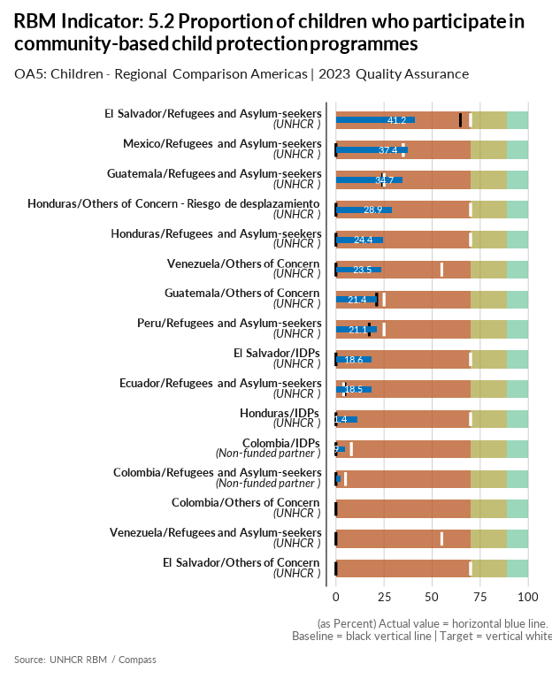

| group | baseline | actual | target | QA_logical | data_limitation |
| --- | --- | --- | --- | --- | --- |
| Colombia/IDPs | 0 | 4.9 | 8 | Numerator for baseline is missing - Denominator for baseline is missing - Target value is below acceptable standard | Estimación de IDP reportados en el 345W: Numerador NNA con actividades de proteccion basado en comunidad. El denominador coresponde al total de NNA reportadas en el 2023. |
| Colombia/Refugees and Asylum-seekers | 0 | 2.2 | 5 | Numerator for baseline is missing - Denominator for baseline is missing - Target value is below acceptable standard | Estimación de los Refugges and Asylun-seekers reportados en el RMRP: Número de NNA que participaron en actividades de protección basado en comunidad. Denominador: Número total de NNA que fueron asistidos en el Sector de Protección General |
| Colombia/Others of Concern | 0 | 0.1 | - | Missing Target - Numerator for baseline is missing - Denominator for baseline is missing | Estimación de los Colombianos Retornados reportados en el RMRP: Numerador: NNA que participaron en actividades de protección basado en comunidad. Denominador: Número total de NNA que fueron asistidos en el Sector de Protección General. |
| Ecuador/Refugees and Asylum-seekers | 4.6 | 18.5 | 4 | Target value is below the baseline - Target value is below acceptable standard | Methodology changed slightly. Last year this indicator considered children who attended at least 2 times to cb child protection programmes. This year methodology suggested to change that to at least 1 time participation on said programmes. We will be replicating the latter methodology for the 2023 baseline. |
| El Salvador/Refugees and Asylum-seekers | 64.7 | 41.2 | 70 | Target value is below acceptable standard | - |
| El Salvador/IDPs | 0 | 18.6 | 70 | Numerator for baseline is missing - Denominator for baseline is missing - Target value is below acceptable standard - More than 40% difference between Target and Baseline | - |
| El Salvador/Others of Concern | 0 | 0 | 70 | Numerator for Actual is missing - Denominator for Actual is missing - Numerator for baseline is missing - Denominator for baseline is missing - Target value is below acceptable standard - More than 40% difference between Target and Baseline | There are not data available for 2023. Resources are required to implement an RMS exercise in 2024. |
| Guatemala/Refugees and Asylum-seekers | 24.3 | 34.7 | 25 | Target value is below acceptable standard | The number reported is based on the whole number of people surveyed for the RMS that have childres, it is not a generalization of the whole refugee community in Guatemala as in the other RMS questions because we wanted to portray childrens reality as it was reported in the RMS |
| Guatemala/Others of Concern | 21.2 | 21.4 | 25 | Target value is below acceptable standard | - |
| Honduras/Others of Concern - Riesgo de desplazamiento | 0 | 28.9 | 70 | Numerator for baseline is missing - Denominator for baseline is missing - Target value is below acceptable standard - More than 40% difference between Target and Baseline | This only includes a small sample surveyed by UNHCR and partners. This indicator could be included in an RMS exercise next year if population identification is possible. |
| Honduras/Refugees and Asylum-seekers | 0 | 24.4 | 70 | Numerator for baseline is missing - Denominator for baseline is missing - Target value is below acceptable standard - More than 40% difference between Target and Baseline | Small sample of refugees and asylum-seekers surveyed through the RMS in collaboration with the National Migration Institute. Data is extrapolated to RAS population. |
| Honduras/IDPs | 0 | 11.4 | 70 | Numerator for baseline is missing - Denominator for baseline is missing - Target value is below acceptable standard - More than 40% difference between Target and Baseline | This only includes UNHCR data. This indicator could be included in an RMS exercise next year, however IDP identification has proven tricky this year. Denominator extracted from new EPHPM data. |
| Mexico/Refugees and Asylum-seekers | 0 | 37.4 | 35 | Numerator for baseline is missing - Denominator for baseline is missing - Target value is below acceptable standard | Preliminary RMS data relates only to Refugee population (this includes complementary protection beneficiaries) |
| Peru/Refugees and Asylum-seekers | 17.3 | 21.1 | 25 | Target value is below acceptable standard | - |
| Venezuela/Others of Concern | 0 | 23.5 | 55 | Numerator for baseline is missing - Denominator for baseline is missing - Target value is below acceptable standard - More than 40% difference between Target and Baseline | Based on the consultation of the accumulated sheet of the 5W report corresponding to the Area of ​​Responsibility for Children and Adolescents (AdR NNA), the number of children served during 2023 between 6 and 17 was quantified to establish the denominator. The numerator was obtained from filtering 5W activities related to community-based child protection. Unfortunately, the age division of the 5W does not allow the group to be disaggregated from 0 to 5. |
| Venezuela/Refugees and Asylum-seekers | 0 | 0 | 55 | Numerator for Actual is missing - Denominator for Actual is missing - Numerator for baseline is missing - Denominator for baseline is missing - Target value is below acceptable standard - More than 40% difference between Target and Baseline | Data limitation. The operation doesn't have information about refugees to determine the proportion of children who participate in community-based child protection programmes. |

[Link to indicator metadata](https://intranet.unhcr.org/content/dam/unhcr/intranet/protection-operations/compass/en/guidance/3/coreindicatorsmetadata/2.0%20Core%20Indicator%20Metadata%2004%2010%202021.pdf#page=96)

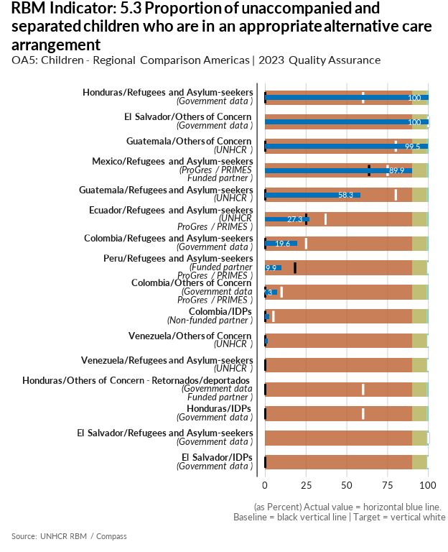

| group | baseline | actual | target | QA_logical | data_limitation |
| --- | --- | --- | --- | --- | --- |
| Colombia/Refugees and Asylum-seekers | 0 | 19.6 | 25 | Numerator for baseline is missing - Denominator for baseline is missing - Target value is below acceptable standard | - |
| Colombia/Others of Concern | 0 | 7.3 | 10 | Numerator for baseline is missing - Denominator for baseline is missing - Target value is below acceptable standard | Estimacion de los Colombianos Retornados reportados en el RMRP: Numerador: NNA que recibieron servicios especializados de protección de la niñez. Denominador: NNA que recibieron servicios especializados de protección de la Niñez |
| Colombia/IDPs | 0 | 2.4 | 5 | Numerator for baseline is missing - Denominator for baseline is missing - Target value is below acceptable standard | - |
| Ecuador/Refugees and Asylum-seekers | 25.1 | 27.3 | 37 | Target value is below acceptable standard | Numerator: # of UASC in appropriate interim or long-term alternative care (indicator 10G02) Denominator: Total # of UASC children registered in progress BSS Unir UNHCR |
| El Salvador/Others of Concern | 100 | 100 | 100 |  | - |
| El Salvador/Refugees and Asylum-seekers | 100 | 0 | 100 | More than 20% difference between Actual and Baseline | - |
| El Salvador/IDPs | 0 | 0 | 100 | Numerator for baseline is missing - Denominator for baseline is missing - More than 40% difference between Target and Baseline | CONAPINA reports zero cases of unaccompanied children for IDPs |
| Guatemala/Others of Concern | 0 | 99.5 | 80 | Numerator for baseline is missing - Denominator for baseline is missing - Target value is below acceptable standard - More than 40% difference between Target and Baseline - More than 20% difference between Actual and Baseline | This number comes from both UNHCR and government data. We would like to explain that we are referring 100% of the people we or our institutional partners have identifies. We have worked on strengthening the capacities of PGN in this specific matter. The data is divided as follows: ProGres: 76; PGN: 4159 (returnees); PGN 100 (in transit) |
| Guatemala/Refugees and Asylum-seekers | 0 | 58.3 | 80 | Numerator for baseline is missing - Denominator for baseline is missing - Target value is below acceptable standard - More than 40% difference between Target and Baseline - More than 20% difference between Actual and Baseline | PGN has identified a total of 5 unaccompanied children seeking refuge, of which only 1 case has been placed with a family resource in Guatemala. The other 4 have been placed in shelters/institutionalized, but this is due to impediments in the country's regulations, there are no temporary foster families for these cases and practically if there is no other family resource the only option continues to be institutionalization. The five children institutionalized is because Guatemalan legislation does not include families giving temporal care for RAS children, and the state does not have any other alternative. |
| Honduras/Refugees and Asylum-seekers | 0 | 100 | 60 | Numerator for baseline is missing - Denominator for baseline is missing - Target value is below acceptable standard - More than 40% difference between Target and Baseline - More than 20% difference between Actual and Baseline | UNHCR only knows of one case (asylum seekers) that we worked with in collaboration with the INM (National Migration Institute) and the SENAF (Secretary for Children, Adolescents and Families) |
| Honduras/IDPs | 0 | 0 | 60 | Numerator for Actual is missing - Denominator for Actual is missing - Numerator for baseline is missing - Denominator for baseline is missing - Target value is below acceptable standard - More than 40% difference between Target and Baseline | Insufficient data from the SENAF and we decided to leave in blank. |
| Honduras/Others of Concern - Retornados/deportados | 0 | 0 | 60 | Numerator for Actual is missing - Denominator for Actual is missing - Numerator for baseline is missing - Denominator for baseline is missing - Target value is below acceptable standard - More than 40% difference between Target and Baseline | Insufficient data from the SENAF, therefore it was not possible to reach a conclusive figure. We are still fortifying capacities at SEDESOL (who work directly with returnees) to improve data with SENAF and we will be working in 2024 to improve this. |
| Mexico/Refugees and Asylum-seekers | 63.6 | 89.9 | 75 | Target value is below acceptable standard | Since there is no government/official data available, the reported indicator is not representative of all unaccompanied and separated children, but only those registered in proGres. UNHCR will continue to advocate before relevant government counterparts to have access to official information. |
| Peru/Refugees and Asylum-seekers | 18.3 | 9.9 | 100 | More than 40% difference between Target and Baseline | Monitoring system management + proGres |
| Venezuela/Others of Concern | 0 | 1.7 | 100 | Numerator for baseline is missing - Denominator for baseline is missing - More than 40% difference between Target and Baseline | Method of calculation: Number of unaccompanied and separated children in alternative care or reunified divided by Total number of unaccompanied and separated children identified. Data: Numerator: Children reunified with the ASONACOP program: Number of unaccompanied and separated children in alternative care or reunified: 160 children. Denominator: Children identified as unaccompanied and separated by Child Protection Councils: Total number of unaccompanied and separated minors identified: 9,572 Result Numerator: 160 Denominator: 9,572 |
| Venezuela/Refugees and Asylum-seekers | 0 | 0 | 100 | Numerator for Actual is missing - Denominator for Actual is missing - Numerator for baseline is missing - Denominator for baseline is missing - More than 40% difference between Target and Baseline | Data Limitation. The operation does not have data available to determine the Proportion of unaccompanied and separated refugee children who are in an appropriate alternative care arrangement. |

[Link to indicator metadata](https://intranet.unhcr.org/content/dam/unhcr/intranet/protection-operations/compass/en/guidance/3/coreindicatorsmetadata/2.0%20Core%20Indicator%20Metadata%2004%2010%202021.pdf#page=98)

## Education

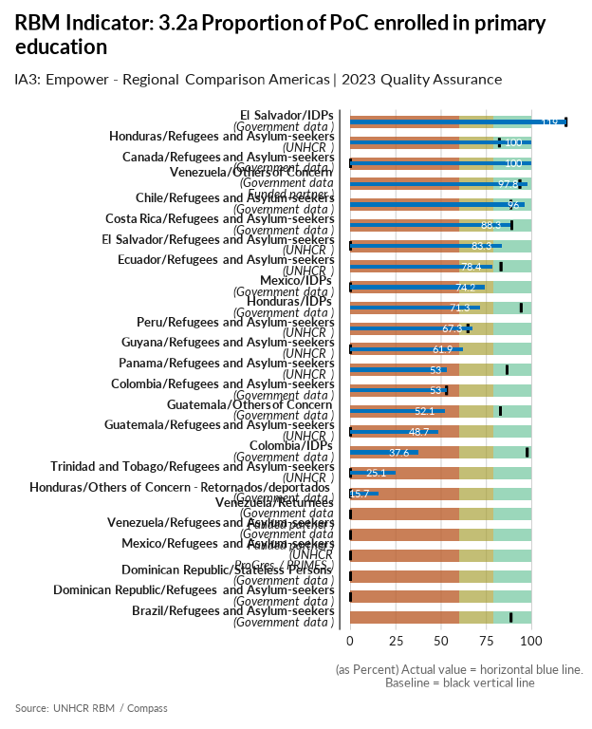

| group | baseline | actual | QA_logical | data_limitation |
| --- | --- | --- | --- | --- |
| Brazil/Refugees and Asylum-seekers | 88.6 | 0 | Numerator for Actual is missing - Denominator for Actual is missing - More than 20% difference between Actual and Baseline | The launch of 2023 Educational Census has been delayed and, in that sense, we have not been able to report 2023 data. We will keep advocating to speed up the sharing of the data in preparation to SHOW 2024. |
| Canada/Refugees and Asylum-seekers | 0 | 100 | Numerator for baseline is missing - Denominator for baseline is missing - More than 20% difference between Actual and Baseline | Denominator and numerator figures from ASR 2022. Based on the practice of primary and secondary public education being available to all refugees and asylum-seeker children. |
| Chile/Refugees and Asylum-seekers | 88.6 | 96 |  | Was calculated with data from CASEN 2022 |
| Colombia/Refugees and Asylum-seekers | 53 | 53 |  | No information available for 2023; the data is from the DNP 2021 |
| Colombia/IDPs | 97.5 | 37.6 | More than 20% difference between Actual and Baseline | Numerador: Nümero de deslazados 5 y 27 años que asistente a un establecimiento educativo en primaria / Denominador: Total de desplazados |
| Costa Rica/Refugees and Asylum-seekers | 89 | 88.3 |  | ENAHO2023 - 2,148 nicaraguans surveyed.Weighted result.Ver https://github.com/UNHCR-CostaRica/ENAHOrbm Numerator= 5-11 ASR population 2023 * % enrrollment & Denominator=5-11 ASR population 2023 |
| Dominican Republic/Refugees and Asylum-seekers | 0 | 0 | Numerator for Actual is missing - Denominator for Actual is missing - Numerator for baseline is missing - Denominator for baseline is missing | It is estimated that the results report of ENI III-Third National Survey of Immigrants will be published by the ONE in 2026. |
| Dominican Republic/Stateless Persons | 0 | 0 | Numerator for Actual is missing - Denominator for Actual is missing - Numerator for baseline is missing - Denominator for baseline is missing | It is estimated that the results report of ENI III-Third National Survey of Immigrants will be published by the ONE in 2026. |
| Ecuador/Refugees and Asylum-seekers | 83.1 | 78.4 |  | Mantained primary school age >=5 and <=11, as age ranges suggested by HQ are not relevant for Ecuador. |
| El Salvador/IDPs | 119 | 119 | Appropriate scales is not used for actual percent indicators - Appropriate scales is not used for baseline percent indicators | Available data from the last IDP profiling exercise from 2016; Data will be updated when EHPM be officially published in July/August 2024 Denominator is 230, the value for this indicator is 119% |
| El Salvador/Refugees and Asylum-seekers | 0 | 83.3 | Numerator for baseline is missing - Denominator for baseline is missing - More than 20% difference between Actual and Baseline | - |
| Guatemala/Others of Concern | 82.7 | 52.1 |  | - |
| Guatemala/Refugees and Asylum-seekers | 0 | 48.7 | Numerator for baseline is missing - Denominator for baseline is missing - More than 20% difference between Actual and Baseline | This indicator was measured with data of the RMS, however, instead of generalizing our statistically relevant data to the whole population of REFAS in Guatemala, for this indicator specifically (with children) we decided to use the whole numbers of the people surveyed in the RMS who reported having children. |
| Guyana/Refugees and Asylum-seekers | 0 | 61.9 | Numerator for baseline is missing - Denominator for baseline is missing - More than 20% difference between Actual and Baseline | - |
| Honduras/Refugees and Asylum-seekers | 82.1 | 100 |  | Small sample of refugees and asylum-seekers surveyed through the RMS in collaboration with the National Migration Institute. Data is extrapolated to RAS population. |
| Honduras/IDPs | 94.2 | 71.3 |  | This data is from National Statistics Institute's (INE) EPHPM Q1-Q3 survey data. We are still pending the consolidated data for the whole year (including Q4) but did not receive it yet. Last year's baseline was from the 2018 Characterization Study which cannot be compared to this year's data, which is from EPHPM survey that was implemented in 2023. |
| Honduras/Others of Concern - Retornados/deportados | 0 | 15.7 | Numerator for baseline is missing - Denominator for baseline is missing | Calculated through SEDESOL's government portal SIRBHO which provides enrollment rates on the vulnerable Honduran population aged between 6-15 years. This was projected and crossed with returnees that originally abandoned their homes due to violence. |
| Mexico/IDPs | 0 | 74.2 | Numerator for baseline is missing - Denominator for baseline is missing - More than 20% difference between Actual and Baseline | The IDP total population figure is different from that of the ASR as it is an estimate based on the expanded 2020 Census questionnaire that is applied to a representative sample and not to all persons. To calculate the required indicator an analysis of the 2020 Census extended questionnaire microdata was conducted. Particularly, Q22-Enrollment was considered. Only people with ages between 6 and 12 years old were considered for the denominator. |
| Mexico/Refugees and Asylum-seekers | 0 | 0 | Numerator for Actual is missing - Denominator for Actual is missing - Numerator for baseline is missing - Denominator for baseline is missing | This indicator is left blank as requested by Result Manager. There is an available preliminary RMS result that relates only to Refugee population (this includes complementary protection beneficiaries). |
| Panama/Refugees and Asylum-seekers | 86.4 | 53 |  | - |
| Peru/Refugees and Asylum-seekers | 64.8 | 67.3 |  | - |
| Trinidad and Tobago/Refugees and Asylum-seekers | 0 | 25.1 | Numerator for baseline is missing - Denominator for baseline is missing | - |
| Venezuela/Others of Concern | 93.5 | 97.8 |  | The calculation is based on the population aged 7 to 12 years attending an educational institution as a percentage of the total in that age group. |
| Venezuela/Refugees and Asylum-seekers | 0 | 0 | Numerator for Actual is missing - Denominator for Actual is missing - Numerator for baseline is missing - Denominator for baseline is missing | Any children born to refugee parents in Venezuela are automatically regarded as Venezuelan nationals. There is no data about the refugee children. |
| Venezuela/Returnees | 0 | 0 | Numerator for Actual is missing - Denominator for Actual is missing - Numerator for baseline is missing - Denominator for baseline is missing | There is no data for returnees. ENCOVI is a national household survey that is representative to the entire host population. There could be different profiles and needs of the displaced population within Venezuela, which the survey is not capturing. |

[Link to indicator metadata](https://intranet.unhcr.org/content/dam/unhcr/intranet/protection-operations/compass/en/guidance/3/coreindicatorsmetadata/2.0%20Core%20Indicator%20Metadata%2004%2010%202021.pdf#page=43)

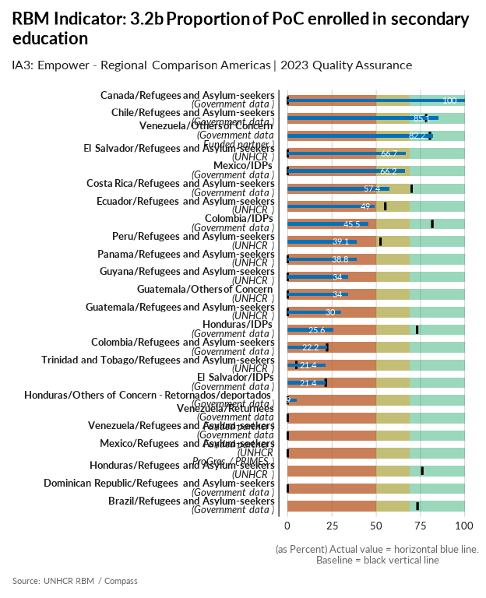

| group | baseline | actual | QA_logical | data_limitation |
| --- | --- | --- | --- | --- |
| Brazil/Refugees and Asylum-seekers | 73.3 | 0 | Numerator for Actual is missing - Denominator for Actual is missing - More than 20% difference between Actual and Baseline | The launch of 2023 Educational Census has been delayed and, in that sense, we have not been able to report 2023 data. We will keep advocating to speed up the sharing of the data in preparation to SHOW 2024. |
| Canada/Refugees and Asylum-seekers | 0 | 100 | Numerator for baseline is missing - Denominator for baseline is missing - More than 20% difference between Actual and Baseline | Denominator and numerator figures from ASR 2022. Based on the practice of primary and secondary public education being available to all refugees and asylum-seeker children. |
| Chile/Refugees and Asylum-seekers | 78.2 | 85.1 |  | Was calculated with data from CASEN 2022 |
| Colombia/IDPs | 81.7 | 45.5 |  | Numerador: Nümero de deslazados 5 y 27 años que asistente a un establecimiento educativo básica secundaria y educación media / Denominador: Total de desplazados |
| Colombia/Refugees and Asylum-seekers | 22.2 | 22.2 |  | No information available for 2023; the data is from the DNP 2021 |
| Costa Rica/Refugees and Asylum-seekers | 70 | 57.4 |  | ENAHO2023 - 2,148 nicaraguans surveyed.Weighted result.Ver https://github.com/UNHCR-CostaRica/ENAHOrbm Numerator= 12-17 ASR population 2023 * % enrrollment & Denominator=12-17 ASR population 2023 |
| Dominican Republic/Refugees and Asylum-seekers | 0 | 0 | Numerator for Actual is missing - Denominator for Actual is missing - Numerator for baseline is missing - Denominator for baseline is missing | It is estimated that the results report of ENI III-Third National Survey of Immigrants will be published by the ONE in 2026. |
| Ecuador/Refugees and Asylum-seekers | 55.1 | 49 |  | Mantained primary school age >=12 and <=18, as age ranges suggested by HQ are not relevant for Ecuador. |
| El Salvador/Refugees and Asylum-seekers | 0 | 66.7 | Numerator for baseline is missing - Denominator for baseline is missing - More than 20% difference between Actual and Baseline | - |
| El Salvador/IDPs | 21.4 | 21.4 |  | Available data from the last IDP profiling exercise from 2016; Data will be updated when EHPM be officially published in July/August 2024 |
| Guatemala/Others of Concern | 0 | 34 | Numerator for baseline is missing - Denominator for baseline is missing | - |
| Guatemala/Refugees and Asylum-seekers | 0 | 30 | Numerator for baseline is missing - Denominator for baseline is missing | - |
| Guyana/Refugees and Asylum-seekers | 0 | 34 | Numerator for baseline is missing - Denominator for baseline is missing | - |
| Honduras/IDPs | 73.1 | 25.6 | More than 20% difference between Actual and Baseline | This data is from National Statistics Institute's (INE) EPHPM Q1-Q3 survey data. We are still pending the consolidated data for the whole year (including Q4) but did not receive it yet. Last year's baseline was from the 2018 Characterization Study which cannot be compared to this year's data, which is from EPHPM survey that was implemented in 2023. |
| Honduras/Others of Concern - Retornados/deportados | 0 | 4.9 | Numerator for baseline is missing - Denominator for baseline is missing | Calculated through SEDESOL's government portal SIRBHO which provides enrollment rates on the vulnerable Honduran population aged between 15-18 years. This was projected and crossed with returnees that originally abandoned their homes due to violence. |
| Honduras/Refugees and Asylum-seekers | 76 | 0 | Numerator for Actual is missing - Denominator for Actual is missing - More than 20% difference between Actual and Baseline | Small sample of refugees and asylum-seekers surveyed through the RMS in collaboration with the National Migration Institute. Since it was a small sample, there were no children with secondary school age. |
| Mexico/IDPs | 0 | 66.2 | Numerator for baseline is missing - Denominator for baseline is missing - More than 20% difference between Actual and Baseline | The IDP total population figure is different from that of the Annual Statistical Report as it is an estimate based on the expanded 2020 Census questionnaire that is applied to a representative sample and not to all persons. To calculate the required indicator an analysis of the 2020 Census extended questionnaire microdata was conducted. Particularly, Q22-Enrollment was considered. Only people with ages between 13 and 15 years old were considered for the denominator. |
| Mexico/Refugees and Asylum-seekers | 0 | 0 | Numerator for Actual is missing - Denominator for Actual is missing - Numerator for baseline is missing - Denominator for baseline is missing | This indicator is left blank as requested by Result Manager. There is an available preliminary RMS result that relates only to Refugee population (this includes complementary protection beneficiaries). |
| Panama/Refugees and Asylum-seekers | 0 | 38.8 | Numerator for baseline is missing - Denominator for baseline is missing | - |
| Peru/Refugees and Asylum-seekers | 52.4 | 39.1 |  | UNHCR Peru does not conduct any activities relating to enrollment for secondary education. A possible reason for this variation is the change in the RMS questionnaire used by the operation: While previously every NNA in the household was asked about school enrollment, this is now done only on a random NNA per household. This, together with a relatively small sample for the Actual value (256), might explain the variation over time. |
| Trinidad and Tobago/Refugees and Asylum-seekers | 4.9 | 21.4 |  | - |
| Venezuela/Others of Concern | 80.3 | 82.2 |  | The calculation is based on the population aged 13 to 17 attending an educational institution out of the total in that age group. |
| Venezuela/Returnees | 0 | 0 | Numerator for Actual is missing - Denominator for Actual is missing - Numerator for baseline is missing - Denominator for baseline is missing | There is no data for returnees. ENCOVI is a national household survey that is representative to the entire host population. There could be different profiles and needs of the displaced population within Venezuela, which the survey is not capturing. |
| Venezuela/Refugees and Asylum-seekers | 0 | 0 | Numerator for Actual is missing - Denominator for Actual is missing - Numerator for baseline is missing - Denominator for baseline is missing | There is no data for refugees and asylum seekers. ENCOVI is a national household survey that is representative to the entire host population. There could be different profiles and needs of the displaced population within Venezuela, which the survey is not capturing. |

[Link to indicator metadata](https://intranet.unhcr.org/content/dam/unhcr/intranet/protection-operations/compass/en/guidance/3/coreindicatorsmetadata/2.0%20Core%20Indicator%20Metadata%2004%2010%202021.pdf#page=45)

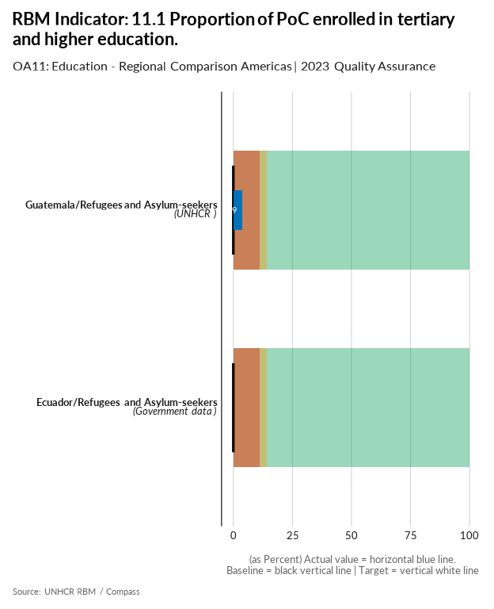

| group | baseline | actual | target | QA_logical | data_limitation |
| --- | --- | --- | --- | --- | --- |
| Ecuador/Refugees and Asylum-seekers | 0 | 0 | - | Missing Target - Numerator for Actual is missing - Denominator for Actual is missing - Numerator for baseline is missing - Denominator for baseline is missing | There is not available information for this indicator. Last year they try to calculate it from ENEMDU but the data wasnt realiable. This year we send an information request to Senecyt to obtain the data but they have not repplied, even after multiple follow up meetings. We leave it without data as there is not available information |
| Guatemala/Refugees and Asylum-seekers | 0 | 3.9 | - | Missing Target - Numerator for baseline is missing - Denominator for baseline is missing | ProGres reports 9 RAS in tertiary education, the denominator comes from the number of RAS in university age according to the RMS |

[Link to indicator metadata](https://intranet.unhcr.org/content/dam/unhcr/intranet/protection-operations/compass/en/guidance/3/coreindicatorsmetadata/2.0%20Core%20Indicator%20Metadata%2004%2010%202021.pdf#page=124)

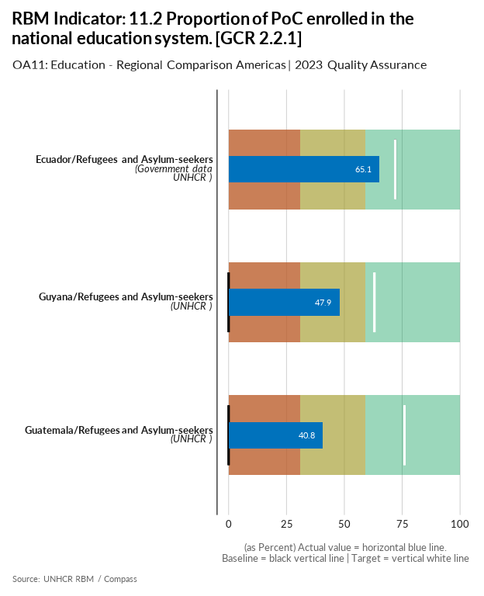

| group | baseline | actual | target | QA_logical | data_limitation |
| --- | --- | --- | --- | --- | --- |
| Ecuador/Refugees and Asylum-seekers | 72 | 65.1 | 72 | Target value is below the baseline - Target value is below acceptable standard | Outcome indicator 11.2 last year took data from the Ministry of Education for the numerator and GTRM´s population estimation data for the denominator. The ministry´s administrative data are hard data, but dividing this number for a population estimate is not advisable. Furthermore, there is no coherence between outcome indicator 11.2 and impact indicators 3.2a and 3.2b, which were calculated with RMS. Therefore, a decision was made to calculate all 3 indicators (impact 3.2a, impact 3.2b, and outcome 11.2) with RMS data for greater coherence. |
| Guatemala/Refugees and Asylum-seekers | 0 | 40.8 | 76 | Numerator for baseline is missing - Denominator for baseline is missing - Target value is below acceptable standard - More than 40% difference between Target and Baseline - More than 20% difference between Actual and Baseline | Values represents the sum of children enrolled in primary and secondary school according to the RMS results. |
| Guyana/Refugees and Asylum-seekers | 0 | 47.9 | 63 | Numerator for baseline is missing - Denominator for baseline is missing - Target value is below acceptable standard - More than 40% difference between Target and Baseline - More than 20% difference between Actual and Baseline | - |

[Link to indicator metadata](https://intranet.unhcr.org/content/dam/unhcr/intranet/protection-operations/compass/en/guidance/3/coreindicatorsmetadata/2.0%20Core%20Indicator%20Metadata%2004%2010%202021.pdf#page=126)

## Community-Based Protection & Accountability to Affected Populations

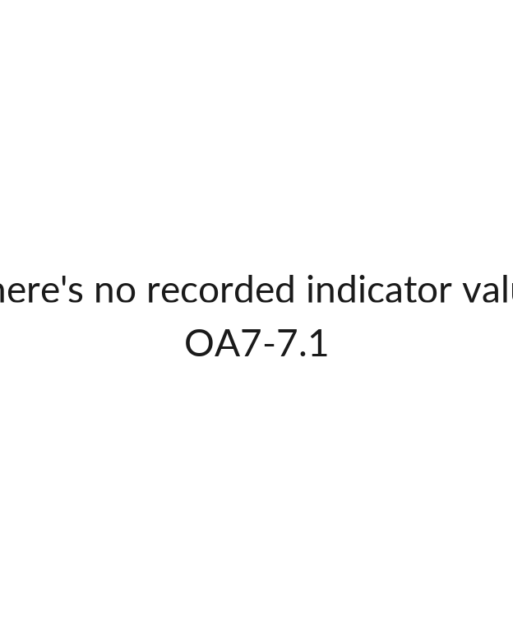

## [1] ""

[Link to indicator metadata](https://intranet.unhcr.org/content/dam/unhcr/intranet/protection-operations/compass/en/guidance/3/coreindicatorsmetadata/2.0%20Core%20Indicator%20Metadata%2004%2010%202021.pdf#page=102)

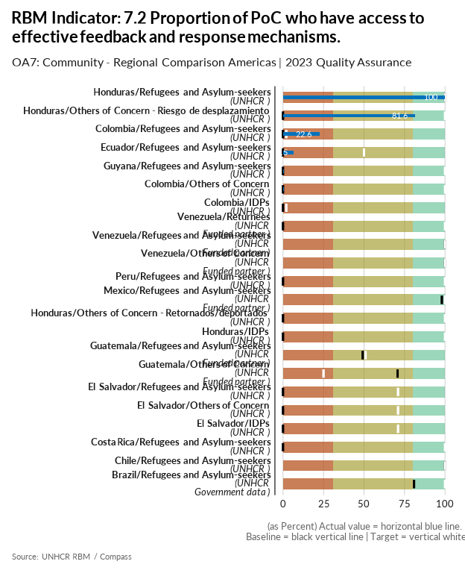

| group | baseline | actual | target | QA_logical | data_limitation |
| --- | --- | --- | --- | --- | --- |
| Brazil/Refugees and Asylum-seekers | 80.9 | 0 | 100 | Numerator for Actual is missing - Denominator for Actual is missing - More than 20% difference between Actual and Baseline | Since the metadata for this indicator changed very late in 2023, the operation was unable to include its questions in its primary research surveys and questionnaires. Protection unit will discuss how to incorporate such questions in its future surveys or the RMS. |
| Chile/Refugees and Asylum-seekers | 100 | 0 | 100 | Numerator for Actual is missing - Denominator for Actual is missing - More than 20% difference between Actual and Baseline | The mechanisms exist and have been prioritized, however, people's perceptions of them have not been measured (a key component in responding to the indicator). For 2024 we are working on the implementation of instruments, through partners, to measure people's knowledge and perception of these mechanisms. |
| Colombia/Refugees and Asylum-seekers | 0 | 22.6 | 2 | Numerator for baseline is missing - Denominator for baseline is missing - Target value is below acceptable standard | RMRP 5W: Numerador: Personas que acceden a mecansmos de comunicación bidireccional /Denominador Total de población intervenida en el sector de Integración del 5W. El reporte 2022 y la línea base de 2023 corresponde al indicator calcultation sheet, mientras que el Actual 2023 es del RMRP Colombia |
| Colombia/Others of Concern | 0 | 0.5 | 100 | Numerator for baseline is missing - Denominator for baseline is missing - More than 40% difference between Target and Baseline | RMRP 5W: Numerador: Personas que acceden a mecansmos de comunicación bidireccional /Denominador Total de población reportada en el 5W |
| Colombia/IDPs | 0 | 0 | 2 | Numerator for baseline is missing - Denominator for baseline is missing - Target value is below acceptable standard | HRP 345W: Numerador: Personas que haceden a mecanismos de retroalimentación y quejas/Denominador Total de población reportada en el 345W |
| Costa Rica/Refugees and Asylum-seekers | 0 | 0 | 100 | Numerator for Actual is missing - Denominator for Actual is missing - Numerator for baseline is missing - Denominator for baseline is missing - More than 40% difference between Target and Baseline | Data was not collected through survey. |
| Ecuador/Refugees and Asylum-seekers | 0 | 6.5 | 50 | Target value is below acceptable standard - More than 40% difference between Target and Baseline | The RMS incorporated this year the question to calculate this indicator, since it is the first time that this question is asked, it is a proxy result that could underestimate the reality of access to feedback mechanisms, we have no way to compare data. Different calculation methodologies, the current 2023 does not reflect a reduction but a more precise calculation of the indicator. |
| El Salvador/Refugees and Asylum-seekers | 0 | 0 | 71 | Numerator for Actual is missing - Denominator for Actual is missing - Numerator for baseline is missing - Denominator for baseline is missing - Target value is below acceptable standard - More than 40% difference between Target and Baseline | Data is not available. In RMS exercise, questionnaire form delivered by HQ did not include questions related with this indicator. |
| El Salvador/IDPs | 0 | 0 | 71 | Numerator for Actual is missing - Denominator for Actual is missing - Numerator for baseline is missing - Denominator for baseline is missing - Target value is below acceptable standard - More than 40% difference between Target and Baseline | Data is not available. In RMS exercise, questionnaire form delivered by HQ did not include questions related with this indicator. |
| El Salvador/Others of Concern | 0 | 0 | 71 | Numerator for Actual is missing - Denominator for Actual is missing - Numerator for baseline is missing - Denominator for baseline is missing - Target value is below acceptable standard - More than 40% difference between Target and Baseline | There are not data available for 2023. Resources are required to implement an RMS exercise in 2024. |
| Guatemala/Refugees and Asylum-seekers | 49.2 | 0 | 51 | Numerator for Actual is missing - Denominator for Actual is missing - Target value is below acceptable standard - More than 20% difference between Actual and Baseline | We can't report this indicator. The new method of calculation demands surveys to FDP |
| Guatemala/Others of Concern | 70.8 | 0 | 25 | Numerator for Actual is missing - Denominator for Actual is missing - Target value is below the baseline - Target value is below acceptable standard - More than 40% difference between Target and Baseline - More than 20% difference between Actual and Baseline | We can't report this indicator. The new method of calculation demands surveys to FDP |
| Guyana/Refugees and Asylum-seekers | 0 | 0.6 | 100 | Numerator for baseline is missing - Denominator for baseline is missing - More than 40% difference between Target and Baseline | Actual was calculated only based on UNHCR program monitoring records, and it reflects a proportion of level of access to feedback mechanisms for UNHCR funded activities. The actual does not reflect the total level of access of all people we protect to humantarian feedback mechanisms |
| Honduras/Refugees and Asylum-seekers | 100 | 100 | 100 |  | Small sample of refugees and asylum-seekers surveyed through the RMS in collaboration with the National Migration Institute. Data is extrapolated to RAS population. We included a qualitative exercise as part of this activity to explore further matters with the RAS population that was not included in the RMS. |
| Honduras/Others of Concern - Riesgo de desplazamiento | 0 | 81.6 | 100 | Numerator for baseline is missing - Denominator for baseline is missing - More than 40% difference between Target and Baseline - More than 20% difference between Actual and Baseline | This only includes a small sample surveyed by UNHCR and partners. This indicator could be included in an RMS exercise next year if population identification is possible. |
| Honduras/IDPs | 0 | 0 | 100 | Numerator for Actual is missing - Denominator for Actual is missing - Numerator for baseline is missing - Denominator for baseline is missing - More than 40% difference between Target and Baseline | Due to the update in tools released later in the year (Oct 2023), challenges were faced in collecting this data and we were not able to identify a mechanism for integrating this into partner and direct implementation monitoring activities on time. We will be committed to integrating this into our activities for this year. |
| Honduras/Others of Concern - Retornados/deportados | 0 | 0 | 100 | Numerator for Actual is missing - Denominator for Actual is missing - Numerator for baseline is missing - Denominator for baseline is missing - More than 40% difference between Target and Baseline | We are still fortifying capacities at SEDESOL and were unable to collect this data, but will be working in 2024 to improve this. |
| Mexico/Refugees and Asylum-seekers | 98 | 0 | 100 | Numerator for Actual is missing - Denominator for Actual is missing - More than 20% difference between Actual and Baseline | No survey conducted in 2023 containing all questions required in the revised guidance. Actual left blank according to regional guidelines. Questionnaire will be implemented as of 2024. |
| Peru/Refugees and Asylum-seekers | 0 | 0 | 100 | Numerator for Actual is missing - Denominator for Actual is missing - Numerator for baseline is missing - Denominator for baseline is missing - More than 40% difference between Target and Baseline | - |
| Venezuela/Others of Concern | 100 | 0 | 100 | Numerator for Actual is missing - Denominator for Actual is missing - More than 20% difference between Actual and Baseline | UNHCR has through the Inter-Agency Hotline (LDCI), FO/FU and partners implemented comment and complaint mechanisms (3,889). However, the instrument recommended in the Core Metadata was not raised in 2023; and the two required questions: a) people know about feedback mechanism, and b) people feel safe using those mechanisms? are not included for 2023. For this reason and following the suggestion the indicator will be leaved in blank. For2024 this will be take into consideration. |
| Venezuela/Refugees and Asylum-seekers | 100 | 0 | 100 | Numerator for Actual is missing - Denominator for Actual is missing - More than 20% difference between Actual and Baseline | UNHCR has through the Inter-Agency Hotline (LDCI), FO/FU and partners implemented comment and complaint mechanisms. However, the instrument recommended in the Core Metadata was not raised in 2023. Such a survey is planned for 2024. |
| Venezuela/Returnees | 0 | 0 | 100 | Numerator for Actual is missing - Denominator for Actual is missing - Numerator for baseline is missing - Denominator for baseline is missing - More than 40% difference between Target and Baseline | The instrument recommended in the Core Metadata was not raised in 2023; and the two required questions: a) people know about feedback mechanism, and b) people feel safe using those mechanisms? are not included for 2023. For this reason and following the suggestion the indicator will be leaved in blank. For 2024 this will be take into consideration. |

[Link to indicator metadata](https://intranet.unhcr.org/content/dam/unhcr/intranet/protection-operations/compass/en/guidance/3/coreindicatorsmetadata/2.0%20Core%20Indicator%20Metadata%2004%2010%202021.pdf#page=105)

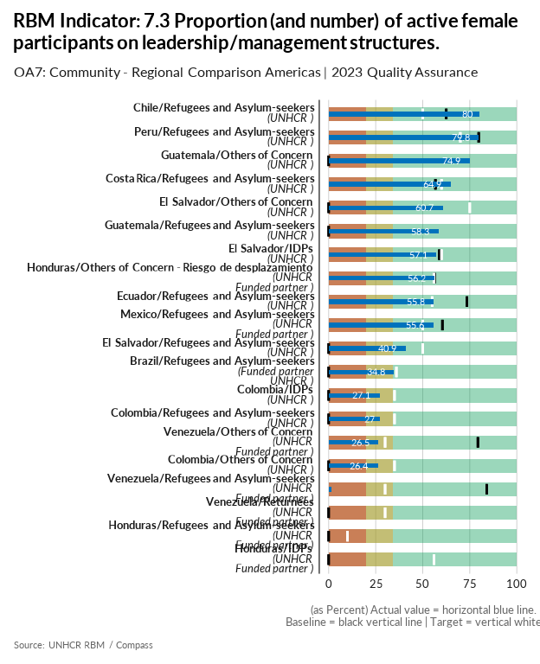

| group | baseline | actual | target | QA_logical | data_limitation |
| --- | --- | --- | --- | --- | --- |
| Brazil/Refugees and Asylum-seekers | 0 | 34.8 | 36 | Numerator for baseline is missing - Denominator for baseline is missing - Target value is below acceptable standard | The numerator represents 56 female participants on leadership or management structures over 161 total number of participants on leadership or management structures identified by UNHCR Brazil's implementing partners in their CBP and community self-management interventions. |
| Chile/Refugees and Asylum-seekers | 62.5 | 80 | 50 | Target value is below the baseline - Target value is below acceptable standard | Calculation made based in number of organizations with female leaderships. Num: # of organizations led by women / Den: total of organizations. The total number of organisations mentioned represents those in UNHCR's register that are active to date. Among the 15 registered in different regions of Chile, 12 of them are led by women. Regarding the full integration of the organisations, there is no complete record. |
| Colombia/IDPs | 0 | 27.1 | 35 | Numerator for baseline is missing - Denominator for baseline is missing - Target value is below acceptable standard | Numerador: Mujeres que participan/influyen en procesos de fortalecimiento comunitario/ Denominador Total de participantes |
| Colombia/Refugees and Asylum-seekers | 0 | 27 | 35 | Numerator for baseline is missing - Denominator for baseline is missing - Target value is below acceptable standard | Numerador: Mujeres que participan/influyen en procesos de fortalecimiento comunitario/ Denominador Total de participantes |
| Colombia/Others of Concern | 0 | 26.4 | 35 | Numerator for baseline is missing - Denominator for baseline is missing - Target value is below acceptable standard | Numerador: Mujeres que participan/influyen en procesos de fortalecimiento comunitario/ Denominador Total de participantes |
| Costa Rica/Refugees and Asylum-seekers | 56.8 | 64.9 | 60 | Target value is below acceptable standard | Red de Adolescentes DNI in GAM / Comunity leaders in Upala |
| Ecuador/Refugees and Asylum-seekers | 73.5 | 55.8 | 55 | Target value is below the baseline - Target value is below acceptable standard | We change the indicator from the information is taken from 11A01 to 11902. Numerator: adult women registered under indicator 11902 - No. people for whom UNHCR works who participate in the decision-making structures of the supported community organizations/ Denominator: Total number of people registered under indicator 11902 |
| El Salvador/Others of Concern | 0 | 60.7 | 75 | Numerator for baseline is missing - Denominator for baseline is missing - Target value is below acceptable standard - More than 40% difference between Target and Baseline - More than 20% difference between Actual and Baseline | Numerator refers to the Number of women who are participating in community groups, community leaders, and outreach volunteers. Denominator refers to the total of people who are participating in community groups, community leaders, and outreach volunteers. |
| El Salvador/IDPs | 58.8 | 57.1 | 60 | Target value is below acceptable standard | Numerator refers to the Number of women who are participating in community groups, community leaders, and outreach volunteers. Denominator refers to the total of people who are participating in community groups, community leaders, and outreach volunteers. |
| El Salvador/Refugees and Asylum-seekers | 0 | 40.9 | 50 | Numerator for baseline is missing - Denominator for baseline is missing - Target value is below acceptable standard - More than 40% difference between Target and Baseline - More than 20% difference between Actual and Baseline | Numerator refers to the Number of women who are participating in community groups, community leaders, and outreach volunteers. Denominator refers to the total of people who are participating in community groups, community leaders, and outreach volunteers. |
| Guatemala/Others of Concern | 0 | 74.9 | - | Missing Target - Numerator for baseline is missing - Denominator for baseline is missing - More than 20% difference between Actual and Baseline | Numerator: Number of women participating in leadership / management structures  Denominator: Total number of individuals participating in leadership / management structures |
| Guatemala/Refugees and Asylum-seekers | 0 | 58.3 | - | Missing Target - Numerator for baseline is missing - Denominator for baseline is missing - More than 20% difference between Actual and Baseline | Numerator: Number of women participating in leadership / management structures  Denominator: Total number of individuals participating in leadership / management structures |
| Honduras/Others of Concern - Riesgo de desplazamiento | 56.2 | 56.2 | 56 | Target value is below the baseline - Target value is below acceptable standard | This data was collected in 2022 and reported under IDPs as this population was included there. As with the rest of indicators, we will better integrate this into our activities for future reports. |
| Honduras/IDPs | 0 | 0 | 56 | Numerator for baseline is missing - Denominator for baseline is missing - Target value is below acceptable standard - More than 40% difference between Target and Baseline | No IDP organizations work under community structures as they fear further persecution once they self-identify. The report in 2022 included community structures led by persons at-risk of displacement. This year they are required to be under the OOC category, and therefore we cannot report any this year. |
| Honduras/Refugees and Asylum-seekers | 0 | 0 | 10 | Numerator for Actual is missing - Denominator for Actual is missing - Numerator for baseline is missing - Denominator for baseline is missing - Target value is below acceptable standard | Very small number of refugees and asylum-seekers in the country and there are no known structures lead by them in Honduras. |
| Mexico/Refugees and Asylum-seekers | 60.5 | 55.6 | 50 | Target value is below the baseline - Target value is below acceptable standard | Rational: 8 iniciativas de movilización comunitaria lideradas por personas refugiadas o solicitantes de asilo, donde participan 18 personas y 10 son mujeres. |
| Peru/Refugees and Asylum-seekers | 79.7 | 79.8 | 70 | Target value is below the baseline - Target value is below acceptable standard | It includes community leaders, CBOs and community networks in Arequipa, Lima, La Libertad, Tacna and Tumbes. Numerator and denominator are based on a review of leadership in CBOs working with UNHCR only, hence it has more of an output focus . |
| Venezuela/Others of Concern | 79.3 | 26.5 | 30 | Target value is below the baseline - Target value is below acceptable standard - More than 40% difference between Target and Baseline - More than 20% difference between Actual and Baseline | It refers to economically active women whose main work corresponds to managerial or managerial occupations with respect to the total of both sexes in that category. |
| Venezuela/Refugees and Asylum-seekers | 84 | 1.7 | 30 | Target value is below the baseline - Target value is below acceptable standard - More than 40% difference between Target and Baseline - More than 20% difference between Actual and Baseline | It was calculated using the number of refugee women participating in community structures, networks, etc., and the total number of participants in these for 2023. |
| Venezuela/Returnees | 0 | 0 | 30 | Numerator for Actual is missing - Denominator for Actual is missing - Numerator for baseline is missing - Denominator for baseline is missing - Target value is below acceptable standard | The operation has no information on the proportion (and number) of female participants active in leadership and management structures. To respond to this indicator in 2024, the operation is preparing an instrument that will be carried out by the UCAB; This instrument is the HAUS survey, which is being modified to include questions from the RMS, and to respond to the indicators following the methodology proposed in the metadata. |

[Link to indicator metadata](https://intranet.unhcr.org/content/dam/unhcr/intranet/protection-operations/compass/en/guidance/3/coreindicatorsmetadata/2.0%20Core%20Indicator%20Metadata%2004%2010%202021.pdf#page=108)

## Security

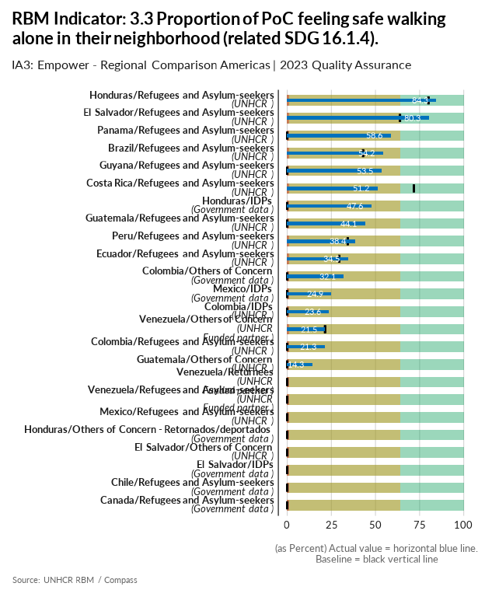

| group | baseline | actual | QA_logical | data_limitation |
| --- | --- | --- | --- | --- |
| Brazil/Refugees and Asylum-seekers | 43 | 54.2 |  | The perception is that the improvement result can be reflecting the RMS biased and not representative sample. |
| Canada/Refugees and Asylum-seekers | 0 | 0 | Numerator for Actual is missing - Denominator for Actual is missing - Numerator for baseline is missing - Denominator for baseline is missing | Data not available. |
| Chile/Refugees and Asylum-seekers | 0 | 0 | Numerator for Actual is missing - Denominator for Actual is missing - Numerator for baseline is missing - Denominator for baseline is missing | No updated data available. EBS 2023 won't be published until october 2024 |
| Colombia/Others of Concern | 0 | 32.1 | Numerator for baseline is missing - Denominator for baseline is missing | En la Encuesta de Calidad de Vida incluye variables sobre ciudadanía, lugar de nacimiento y lugar d residencia cinco años antes y se realizan las estimaciones de retornados basándose en los ciudadanos colombianos, incluidos los de doble nacionalidad. Numerador: Personas que se sienten seguros donde viven / Denominador: Total de personas país reportadas en esta variable. |
| Colombia/IDPs | 0 | 23.6 | Numerator for baseline is missing - Denominator for baseline is missing | Numerador: Nümero de deslazados con percepción de seguridad al caminar solo durante la noche / Denominador: Total de desplazados |
| Colombia/Refugees and Asylum-seekers | 0 | 21.3 | Numerator for baseline is missing - Denominator for baseline is missing | En la Encuesta de Calidad de Vida se incluye variables sobre lugar de nacimiento y país de origen. Se realizan las estimaciones de venezolanos reportados en la encuesta con estas variables. Numerador: Número de Venezolanos que se sienten seguros donde viven / Denominador: Total de Venezolanos reportados en esta variable. La información de líneaa base 2023 fue tomada del Scorecard, mientras el Actual 2023 es de la Encuesta de Calidad Vida, por lo tanto no son comparables. |
| Costa Rica/Refugees and Asylum-seekers | 71.7 | 51.2 |  | Calculation methodology changed in 2023 using RMS module questions incorporated to CBI socio economic evaluation (targetting tool). 2211 households have been interviewed between september 22st and december 31st. |
| Ecuador/Refugees and Asylum-seekers | 29.5 | 34.5 |  | Likert scale changed and, consequently, results may not reflect real impact in this indicator. |
| El Salvador/Refugees and Asylum-seekers | 63.9 | 80.3 |  | - |
| El Salvador/IDPs | 0 | 0 | Numerator for Actual is missing - Denominator for Actual is missing - Numerator for baseline is missing - Denominator for baseline is missing | Data will be available when EHPM be officially published in July/August 2024 |
| El Salvador/Others of Concern | 0 | 0 | Numerator for Actual is missing - Denominator for Actual is missing - Numerator for baseline is missing - Denominator for baseline is missing | There are not data available for 2023. Resources are required to implement an RMS exercise in 2024. |
| Guatemala/Refugees and Asylum-seekers | 0 | 44.1 | Numerator for baseline is missing - Denominator for baseline is missing - More than 20% difference between Actual and Baseline | - |
| Guatemala/Others of Concern | 0 | 14.3 | Numerator for baseline is missing - Denominator for baseline is missing | - |
| Guyana/Refugees and Asylum-seekers | 0 | 53.5 | Numerator for baseline is missing - Denominator for baseline is missing - More than 20% difference between Actual and Baseline | - |
| Honduras/Refugees and Asylum-seekers | 80 | 84.3 |  | Small sample of refugees and asylum-seekers surveyed through the RMS in collaboration with the National Migration Institute. Data is extrapolated to RAS population. |
| Honduras/IDPs | 0 | 47.6 | Numerator for baseline is missing - Denominator for baseline is missing - More than 20% difference between Actual and Baseline | This data is from National Statistics Institute's (INE) EPHPM Q1-Q3 survey data. We are still pending the consolidated data for the whole year (including Q4) but did not receive it yet. |
| Honduras/Others of Concern - Retornados/deportados | 0 | 0 | Numerator for Actual is missing - Denominator for Actual is missing - Numerator for baseline is missing - Denominator for baseline is missing | We are still fortifying capacities at SEDESOL and were unable to collect this data, but will be working in 2024 to improve this. |
| Mexico/IDPs | 0 | 24.9 | Numerator for baseline is missing - Denominator for baseline is missing | No official data on IDPs in Mexico. In addition, the 2020 Population and Housing Census includes a question regarding people who change their place of residency due to insecurity and violence that serves as a proxy to estimate this population, The National Survey of Victimization and Perception of Public Security (ENVIPE) also includes a question a question regarding people who changed their place of residency to protect themselves from crime during the year before the data is collected. Q4.11-Measures for protection from crime-change in residency was used to estimate the population.The IDP total population figure is different from that of the Annual Statistical Report as it is an estimate based on the expanded 2023 ENVIPE questionnaire that is applied to a representative sample and not to all persons. To calculate the required indicator an analysis of the 2023 ENVIPE main questionnaire microdata was conducted. In particular, Q4.4a-Feeling safe when walking alone at night near home was considered. |
| Mexico/Refugees and Asylum-seekers | 0 | 0 | Numerator for Actual is missing - Denominator for Actual is missing - Numerator for baseline is missing - Denominator for baseline is missing | This indicator is left blank as requested by Result Manager. There is an available preliminary RMS result that relates only to Refugee population (this includes complementary protection beneficiaries). |
| Panama/Refugees and Asylum-seekers | 0 | 58.6 | Numerator for baseline is missing - Denominator for baseline is missing - More than 20% difference between Actual and Baseline | Actual was calcualted with RMS while baseline values used secondary data. |
| Peru/Refugees and Asylum-seekers | 34.3 | 38.4 |  | - |
| Venezuela/Others of Concern | 21.5 | 21.5 |  | The calculation is based on the population that by 2017 did not feel insecure on the streets. |
| Venezuela/Returnees | 0 | 0 | Numerator for Actual is missing - Denominator for Actual is missing - Numerator for baseline is missing - Denominator for baseline is missing | There is no data for returnees. ENCOVI is a national household survey that is representative to the entire host population. There could be different profiles and needs of the displaced population within Venezuela, which the survey is not capturing. |
| Venezuela/Refugees and Asylum-seekers | 0 | 0 | Numerator for Actual is missing - Denominator for Actual is missing - Numerator for baseline is missing - Denominator for baseline is missing | There is no data for refugees and asylum seekers. ENCOVI is a national household survey that is representative to the entire host population. There could be different profiles and needs of the displaced population within Venezuela, which the survey is not capturing. |

[Link to indicator metadata](https://intranet.unhcr.org/content/dam/unhcr/intranet/protection-operations/compass/en/guidance/3/coreindicatorsmetadata/2.0%20Core%20Indicator%20Metadata%2004%2010%202021.pdf#page=47)

# Protection / Case Management

## Registration

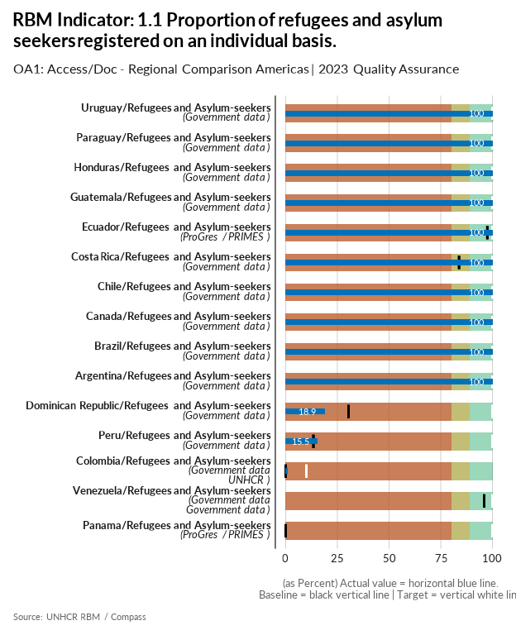

| group | baseline | actual | target | QA_logical | data_limitation |
| --- | --- | --- | --- | --- | --- |
| Argentina/Refugees and Asylum-seekers | 100 | 100 | 100 |  | - |
| Brazil/Refugees and Asylum-seekers | 100 | 100 | 100 |  | Numerator: Total number of asylum-seekers/refugees registered at individual level in CONARE/SISCONARE at end of Dec 2023 (active) / Denominator: number of asylum-seekers/refugees registered at individual level in CONARE/SISCONARE at end of Dec 2023 (active) + Gov backlog (which is 0 considering asylum-seekers are registered on the day of approach to the Gov at individual level) |
| Canada/Refugees and Asylum-seekers | 100 | 100 | 100 |  | Both actual numerator and denominator are from the 2023 MYSR. Both numerator and denominator are the total number of refugees, refugee-like and asylum seekers combined. |
| Chile/Refugees and Asylum-seekers | 100 | 100 | 100 |  | - |
| Colombia/Refugees and Asylum-seekers | 0 | 1.2 | 10 | Numerator for baseline is missing - Denominator for baseline is missing - Target value is below acceptable standard | Numerador: Solicitudes admitidas (5808) + Refugiados reconocidos ( 61) Denominador: númerador + migrantes venezolanos en situación irregular a diciembre de 2023. |
| Costa Rica/Refugees and Asylum-seekers | 83.8 | 100 | 100 |  | In the previous year's calculations, the backlog of appointments was taken into account. However, in 2023, we lack sufficient data to demonstrate an invisible backlog of prospective asylum seekers who are unable to access appointments due to the implementation of daily appointments quotas. |
| Dominican Republic/Refugees and Asylum-seekers | 30.4 | 18.9 | 100 | More than 40% difference between Target and Baseline | For the numerator we have used the DR Government data shared by CONARE as of December 2022. For the denominator, the data source is proGres |
| Ecuador/Refugees and Asylum-seekers | 97.5 | 100 | 100 |  | It includes all individuals registered by the government in proGres, with status Active or On Hold by the end of December 2023. The Government in Ecuador is consistently working on data cleaning. Therefore, this number shall vary throughout time (regardless of new applications). |
| Guatemala/Refugees and Asylum-seekers | 100 | 100 | 100 |  | Actual values reported in the ASR for this reporting period |
| Honduras/Refugees and Asylum-seekers | 100 | 100 | 100 |  | All refugees and asylum-seekers are registered by the INM as soon as they bring forth their paperwork to apply for asylum or to receive the refugee status. |
| Panama/Refugees and Asylum-seekers | 0 | 0 | 100 | Numerator for Actual is missing - Denominator for Actual is missing - Numerator for baseline is missing - Denominator for baseline is missing - More than 40% difference between Target and Baseline | After consultations with DIMA, it has been decided to don't report this indicator due the lack of data on the number of people registered by the government, specially since there are several challenges in which UNHCR is currently working with ONPAR to address on refugee statistics. The operation hopes that for the next round of indicators reporting, it will have the data to be report this indicator accurately. The operation has hired a consultant to work specifically on this topic with ONPAR and to try to "clean up" the statistics reporting of the number of refugees, asylum seekers in the country, including those who are registered with a minimum required dataset. |
| Paraguay/Refugees and Asylum-seekers | 100 | 100 | 100 |  | - |
| Peru/Refugees and Asylum-seekers | 13.4 | 15.5 | 100 | More than 40% difference between Target and Baseline | The numerator reflects the number of asylum seekers who have gone through a registration interview (73,146) with the Special Commission for Refugees (CEPR) plus the number of recognized refugees as reported in the ASR 2023. The denominator is the total of asylum seekers and refugees as reported in the ASR 2023. |
| Uruguay/Refugees and Asylum-seekers | 100 | 100 | 100 |  | - |
| Venezuela/Refugees and Asylum-seekers | 96 | 0 | 100 | Numerator for Actual is missing - Denominator for Actual is missing - More than 20% difference between Actual and Baseline | UNHCR Venezuela send two notes to CONARE requesting the information, but CONARE did not respond to nether of them. |

[Link to indicator metadata](https://intranet.unhcr.org/content/dam/unhcr/intranet/protection-operations/compass/en/guidance/3/coreindicatorsmetadata/2.0%20Core%20Indicator%20Metadata%2004%2010%202021.pdf#page=61)

## Refugee Status Determination

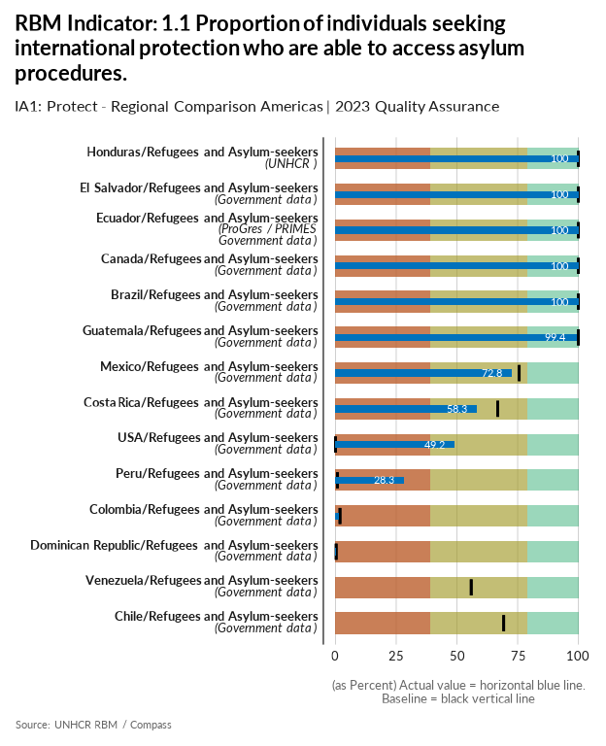

| group | baseline | actual | QA_logical | data_limitation |
| --- | --- | --- | --- | --- |
| Brazil/Refugees and Asylum-seekers | 100 | 100 |  | - |
| Canada/Refugees and Asylum-seekers | 100 | 100 |  | Both actual numerator and denominator are from the 2023 MYSR. Both numerator and denominator are the total number of refugees, refugee-like and asylum seekers combined. |
| Chile/Refugees and Asylum-seekers | 69.3 | 0 | Numerator for Actual is missing - Denominator for Actual is missing - More than 20% difference between Actual and Baseline | There are practical barriers to access the asylum procedure. Not all persons who try to access the asylum procedure succeed in formalizing their application; however, we were unable to obtain a figure for such cases. From 2024, with the entry into force of the new law, we should be able to request this information. |
| Colombia/Refugees and Asylum-seekers | 1.8 | 1.5 |  | Numerador: Solicitudes admitidas por Cancillería. El dato de de admitidas no ha sido entregado oficalmente por cancilerria. El dato de 1 de enero al 30 Junio es 5,808. Denominador Carta MRD 18 de agosto de 2023 con las informe de mitad de año de estádistica relacionado las solicitudes recibidas (5902)+ venezolanos en proceso de regularización (392,615) |
| Costa Rica/Refugees and Asylum-seekers | 66.8 | 58.3 |  | Manifestly unfounded and inadmissible applications (largely related to the criteria outlined in Decree 43810/22) are not considered for access to asylum procedures. To calculate the numerator, we count the number of persons registered by the national government system in the calendar year minus the claims declared inadmissible (often on the same day). To calculate the denominator, we count the number of persons registered by the national government system in the calendar day. The backlog of pending appointments for registration/formalization disappeared in 2023, but limited daily appointments (quotas) create an invisible backlog of prospective asylum seekers (which is difficult to estimate). We do not include undocumented OIP in the denominator due to the lack of evidence to estimate this population share. |
| Dominican Republic/Refugees and Asylum-seekers | 0.3 | 0.3 |  | For the numerator we used the data of the DR Government shared by CONARE of asylum seekers as December 2022 because the government has not shared with UNHCR updated figures. Denominator includes Venezuelans who have NOT applied to the normalization programme. |
| Ecuador/Refugees and Asylum-seekers | 100 | 100 |  | In Ecuador, before becoming officially an asylum seeker, all individuals seeking international protection must undergo an admissibility process. Therefore, the reported 10,740 refers to the total of individuals registered by the government in 2023. Even though they are not all officially asylum seekers, they are so de facto , as per UNHCR’s broader interpretation of the term. |
| El Salvador/Refugees and Asylum-seekers | 100 | 100 |  | Data shared by government with no possibility of verifying if there were additional persons intending to seek asylum. |
| Guatemala/Refugees and Asylum-seekers | 100 | 99.4 |  | We added 7 people refouled to the denominator. However, we did not add any other people from mixed movements as we can't know for sure how many of all the people who crossed the country are in fact in need of international protection and would want to access the asylum system. |
| Honduras/Refugees and Asylum-seekers | 100 | 100 |  | There is no information available from the National Institute of Migration (INM) that identifies those that are unable to access asylum procedures. UNHCR does not have a way to estimate the total denominator outside of using the total number of asylum-seekers in the year, and we don't have identified any specific structural barriers to access the procedure. |
| Mexico/Refugees and Asylum-seekers | 75.6 | 72.8 |  | To calculate this we are using the no-show rate in appointments as a proxy to estimate the % of ppl who cannot access or abandon the process due to late interview dates given. The proportion is obtained by calculating the proportion of a total of 126,039 appointments scheduled by COMAR in 2023 (Tapachula) and the total of new asylum applications registered there (126,039). |
| Peru/Refugees and Asylum-seekers | 0.8 | 28.3 |  | Calculated as (# of new asylum applications during the year) / (# of new asylum applications during the year + stock increase in Venezuelans during the year), as agreed with RBA. This refers only to REF, ASY and OIP reported under the ASR 2023. |
| USA/Refugees and Asylum-seekers | 0 | 49.2 | Numerator for baseline is missing - Denominator for baseline is missing - More than 20% difference between Actual and Baseline | Only data for January-June 2023, Q3-Q4 reported by USG next month. The result is highly imprecise because of two factors. (1) Not all undocumented persons encountered at a US land border intend to seek asylum, however, given obstacles to seeking asylum and lack of US data availability, there is no realistic way to identify the sub-set of arrivals who should be considered to be asylum-seekers. Therefore we treat all arrivals as potential asylum seekers. (2) Not all asylum-seekers are border arrivals. Many of those accessing asylum status determination procedures are in the country in a regular status (parolees, student visa holders, other non-immigrant visa holders). Yet because the US government does not share disaggregated data with UNHCR on the number of asylum receipts filed by persons in a regular status, we are unable to account for this in our calculation. |
| Venezuela/Refugees and Asylum-seekers | 55.9 | 0 | Numerator for Actual is missing - Denominator for Actual is missing - More than 20% difference between Actual and Baseline | Data limitation. UNHCR Venezuela send two notes to CONARE requesting the information, but CONARE did not respond to nether of them. |

[Link to indicator metadata](https://intranet.unhcr.org/content/dam/unhcr/intranet/protection-operations/compass/en/guidance/3/coreindicatorsmetadata/2.0%20Core%20Indicator%20Metadata%2004%2010%202021.pdf#page=5)

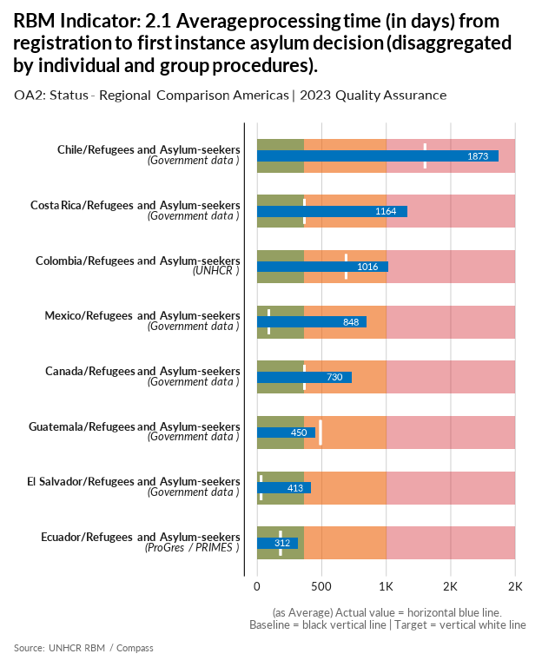

| group | baseline | actual | target | QA_logical | data_limitation |
| --- | --- | --- | --- | --- | --- |
| Brazil/Refugees and Asylum-seekers | - | - | 1577 | Missing Actual - Missing Baseline - Target value is above acceptable standard | The official data source is the CONARE dashboard. However, in 2023, the dashboard has not been updated with this information. It is unclear whether Conare will continue to process and share this information in such a format. However, UNHCR Protection unit will continue to advocate to collect the information. The methodology used by the Regional Bureau was not accepted by our operation considering that the calculation provides an unrealistic result considering recent CONARE process changes and what is estimated to be indeed the average processing time in 2023. Protection and DIMA units will continue to follow up with the Regional Bureau to improve the monitoring and calculation of this result. |
| Canada/Refugees and Asylum-seekers | - | 730 | 365 | Missing Baseline | 24 months based on public reporting. |
| Chile/Refugees and Asylum-seekers | - | 1873 | 1300 | Missing Baseline - Target value is above acceptable standard | - |
| Colombia/Refugees and Asylum-seekers | - | 1016 | 688 | Missing Baseline - Target value is above acceptable standard | Se estima que el tiempo del tramite de registro hasta la decisión de asilo en primera instancia es de 3 años |
| Costa Rica/Refugees and Asylum-seekers | - | 1164 | 365 | Missing Baseline | - |
| Ecuador/Refugees and Asylum-seekers | - | 312 | 180 | Missing Baseline | The government does not systematically open and update the Admissibility Local Process module before creating a RSD Case for admitited individuals. Therefore, Ecuador reports the average processing time only for admited cases based on the creation of the individual in proGres and the Review date in the RSD case (1st instance decision). Legal Status is not a reliable source of reporting, since it can change regardlessly of the RSD process. Ecuador changed the processing criteria for this indicator, based on the government's usage of proGres, and data reliability. New indicator is based on RSD cases in proGres, with Procedure set for Status determination and a 1st instance decision (RSD Review) during the reporting period. Said calculation method was applied both to baseline and actual indicators. |
| El Salvador/Refugees and Asylum-seekers | - | 413 | 30 | Missing Baseline | - |
| Guatemala/Refugees and Asylum-seekers | - | 450 | 490 | Missing Baseline - Target value is above acceptable standard | The indicator refers to average processing from registration to the asylum decision. If the number of days is lower, is better. We are reporting a lower number of days than the target. |
| Mexico/Refugees and Asylum-seekers | - | 848 | 90 | Missing Baseline | - |

[Link to indicator metadata](https://intranet.unhcr.org/content/dam/unhcr/intranet/protection-operations/compass/en/guidance/3/coreindicatorsmetadata/2.0%20Core%20Indicator%20Metadata%2004%2010%202021.pdf#page=71)

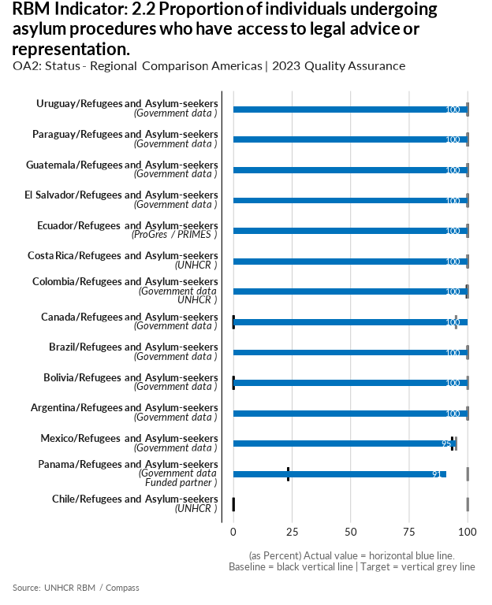

| group | baseline | actual | target | QA_logical | data_limitation |
| --- | --- | --- | --- | --- | --- |
| Argentina/Refugees and Asylum-seekers | 100 | 100 | 100 |  | - |
| Bolivia/Refugees and Asylum-seekers | 0 | 100 | 100 | More than 40% difference between Target and Baseline - More than 20% difference between Actual and Baseline | - |
| Brazil/Refugees and Asylum-seekers | 100 | 100 | 100 |  | - |
| Canada/Refugees and Asylum-seekers | 0 | 100 | 95 | Numerator for baseline is missing - Denominator for baseline is missing - More than 40% difference between Target and Baseline - More than 20% difference between Actual and Baseline | Both actual numerator and denominator are from the 2023 MYSR. |
| Chile/Refugees and Asylum-seekers | 0 | 0 | 100 | More than 40% difference between Target and Baseline | - |
| Colombia/Refugees and Asylum-seekers | 99.7 | 100 | 100 |  | El dato oficial es a 30 de junio de la Cancillería |
| Costa Rica/Refugees and Asylum-seekers | 100 | 100 | 100 |  | All asylum seekers have access to legal services provided by partners. |
| Ecuador/Refugees and Asylum-seekers | 100 | 100 | 100 |  | In Ecuador, before becoming officially an asylum seeker, all individuals seeking international protection must undergo an admissibility process. Therefore, the reported 10,740 refers to the total of individuals registered by the government in 2023. Even though they are not all officially asylum seekers, they are so de facto, as per UNHCR’s broader interpretation of the term. In this context, any person can access legal assistance and representation through dedicate civil-society organizations (such as NRC) in whatever stage of the asylum procedure. |
| El Salvador/Refugees and Asylum-seekers | 100 | 100 | 100 |  | - |
| Guatemala/Refugees and Asylum-seekers | 100 | 100 | 100 |  | - |
| Mexico/Refugees and Asylum-seekers | 93.3 | 95 | 95 |  | No-show actual data not available in Chiapas and Tabasco at the time of reporting. No show rate is estimated at 5% on the total amount of asylum seekers. |
| Panama/Refugees and Asylum-seekers | 23.4 | 91 | 100 | More than 40% difference between Target and Baseline - More than 20% difference between Actual and Baseline | Several cases among these ones reported were people who sought legal assistance at the border. Legally they are not allowed to move out from the migratory stations, and ONPAR does not have presence at this stations. So, yes, we can assume it would be quite difficult for the reported cases to access legal assistance without the assistance provided by UNHCR through NRC. In Panama, NRC is the only organization processing asylum seekers cases to the ONPAR. |
| Paraguay/Refugees and Asylum-seekers | 100 | 100 | 100 |  | - |
| Uruguay/Refugees and Asylum-seekers | 100 | 100 | 100 |  | - |

[Link to indicator metadata](https://intranet.unhcr.org/content/dam/unhcr/intranet/protection-operations/compass/en/guidance/3/coreindicatorsmetadata/2.0%20Core%20Indicator%20Metadata%2004%2010%202021.pdf#page=71)

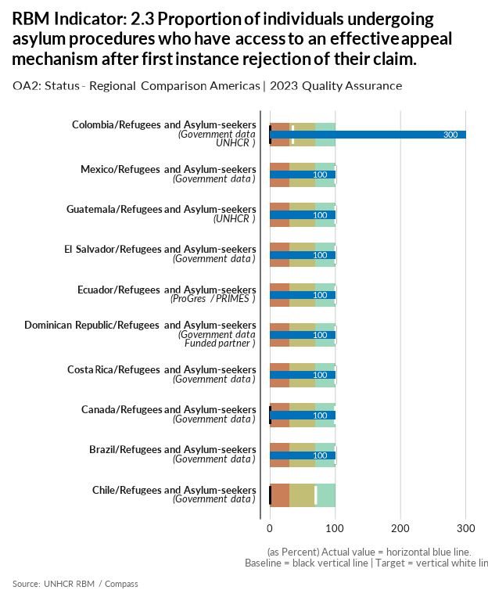

| group | baseline | actual | target | QA_logical | data_limitation |
| --- | --- | --- | --- | --- | --- |
| Brazil/Refugees and Asylum-seekers | 100 | 100 | 100 |  | - |
| Canada/Refugees and Asylum-seekers | 0 | 100 | 100 | Numerator for baseline is missing - Denominator for baseline is missing - More than 40% difference between Target and Baseline - More than 20% difference between Actual and Baseline | Both numerator and denominator are from the 2023 MYSR. Both numerator and denominator are the total number of asylum seekers who receive a rejection on the first instance. |
| Chile/Refugees and Asylum-seekers | 0 | 0 | 70 | Target value is below acceptable standard - More than 40% difference between Target and Baseline | in Chile there are instances of appeal, however they are not in line with the definition of effective appeal, as the authority deciding on the appeal is in principle the same as the one that issues the decision appealed against. In addition, there is no instance where the person is heard in as mentioned in the guidelines (hearing or interview). |
| Colombia/Refugees and Asylum-seekers | 0 | 300 | 35 | Appropriate scales is not used for actual percent indicators - Target value is below acceptable standard - More than 20% difference between Actual and Baseline | NO hay apelación sino reconsideración por parte del Ministro. El numerador es estimado ya que el prodecimiento tiene varios filtro para hacer analisados y decididos. |
| Costa Rica/Refugees and Asylum-seekers | 100 | 100 | 100 |  | Numerator = Denominator: All asylum seekers notified of a first instance rejection (including Manifiestly unfounded in 2023 (17667)) have access to appeal mechanism. |
| Dominican Republic/Refugees and Asylum-seekers | 100 | 100 | 100 |  | CONARE has not provided data for 2023. In December 2022, the government reported a total of 206 asylum seekers. All of them have access to the appeal mechanism established in national legislation. We do not have information on how many actually accessed the mechanism, however, through a collaborating organization (IDDI), 38 asylum seekers received support to appeal the rejection of CONARE, in 2023. UNHCR does not participate directly in legal representation, but provides funds to the partner, through an agreement, in order to cover the expenses of the judicial process. |
| Ecuador/Refugees and Asylum-seekers | 100 | 100 | 100 |  | DPIN has a backlog of processing appeals, i.e., those that are not formally received and therefore registered in proGres, so the number may be underestimated. |
| El Salvador/Refugees and Asylum-seekers | 100 | 100 | 100 |  | While in 2023 there were no decisions over any case of asylum claim, ergo no refusals, there were 3 inadmissibilities. |
| Guatemala/Refugees and Asylum-seekers | 100 | 100 | 100 |  | - |
| Mexico/Refugees and Asylum-seekers | 100 | 100 | 100 |  | Calculation is based on legal analysis. All asylum-seekers in Mexico have access to appeal mechanisms. |

[Link to indicator metadata](https://intranet.unhcr.org/content/dam/unhcr/intranet/protection-operations/compass/en/guidance/3/coreindicatorsmetadata/2.0%20Core%20Indicator%20Metadata%2004%2010%202021.pdf#page=74)

## Resettlement

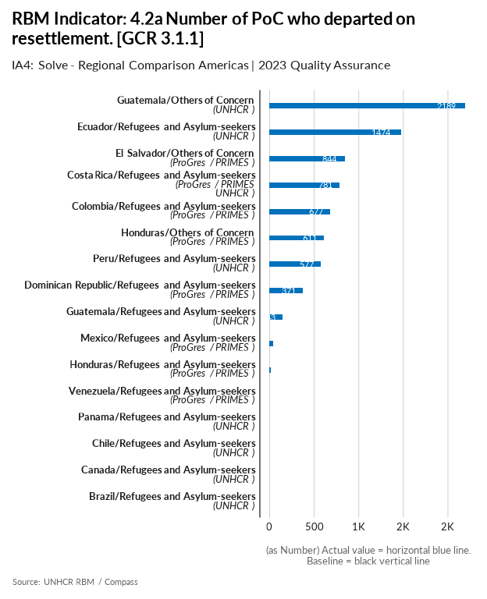

| group | baseline | actual | QA_logical | data_limitation |
| --- | --- | --- | --- | --- |
| Brazil/Refugees and Asylum-seekers | - | 0 | Missing Baseline | UNHCR Brazil does not support resettlement from Brazil. |
| Canada/Refugees and Asylum-seekers | - | 0 | Missing Baseline | Canada is a resettlement receiving country. |
| Chile/Refugees and Asylum-seekers | - | 0 | Missing Baseline | Not applicable for Chile |
| Colombia/Refugees and Asylum-seekers | - | 677 | Missing Baseline | - |
| Costa Rica/Refugees and Asylum-seekers | - | 781 | Missing Baseline | - |
| Dominican Republic/Refugees and Asylum-seekers | - | 371 | Missing Baseline | - |
| Ecuador/Refugees and Asylum-seekers | - | 1474 | Missing Baseline | - |
| El Salvador/Others of Concern | - | 844 | Missing Baseline | - |
| Guatemala/Others of Concern | - | 2189 | Missing Baseline | - |
| Guatemala/Refugees and Asylum-seekers | - | 143 | Missing Baseline | - |
| Honduras/Others of Concern | - | 611 | Missing Baseline | - |
| Honduras/Refugees and Asylum-seekers | - | 17 | Missing Baseline | - |
| Mexico/Refugees and Asylum-seekers | - | 41 | Missing Baseline | - |
| Panama/Refugees and Asylum-seekers | - | 0 | Missing Baseline | - |
| Peru/Refugees and Asylum-seekers | - | 577 | Missing Baseline | - |
| Venezuela/Refugees and Asylum-seekers | - | 0 | Missing Baseline | No refugees were reported to have departed with resettlement opportunities. |

[Link to indicator metadata](https://intranet.unhcr.org/content/dam/unhcr/intranet/protection-operations/compass/en/guidance/3/coreindicatorsmetadata/2.0%20Core%20Indicator%20Metadata%2004%2010%202021.pdf#page=52)

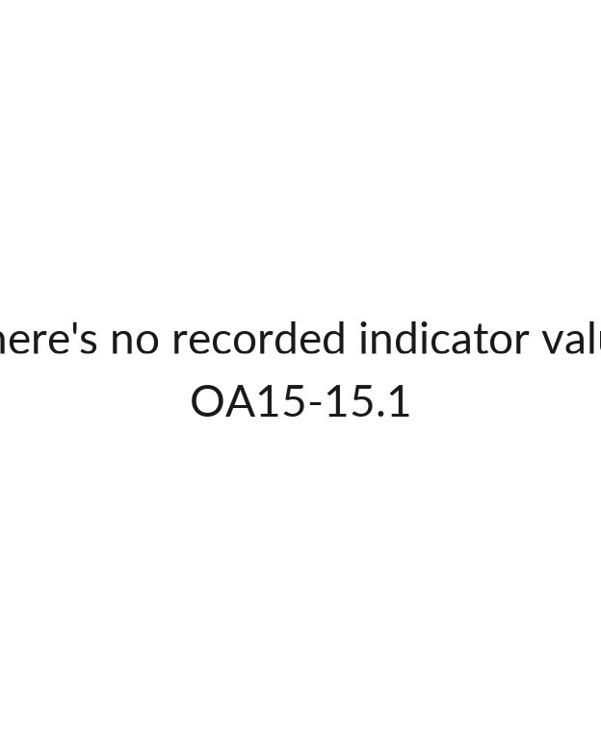

## [1] ""

[Link to indicator metadata](https://intranet.unhcr.org/content/dam/unhcr/intranet/protection-operations/compass/en/guidance/3/coreindicatorsmetadata/2.0%20Core%20Indicator%20Metadata%2004%2010%202021.pdf#page=145)

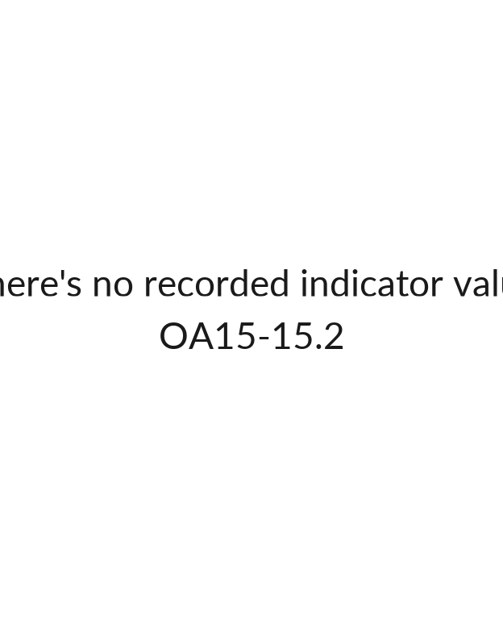

## [1] ""

[Link to indicator metadata](https://intranet.unhcr.org/content/dam/unhcr/intranet/protection-operations/compass/en/guidance/3/coreindicatorsmetadata/2.0%20Core%20Indicator%20Metadata%2004%2010%202021.pdf#page=147)

## Complementary Pathways

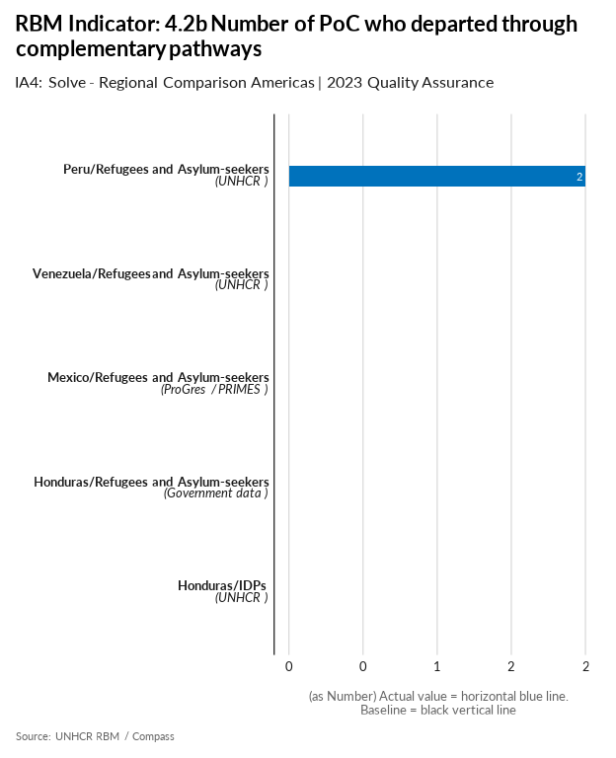

| group | baseline | actual | QA_logical | data_limitation |
| --- | --- | --- | --- | --- |
| Brazil/Refugees and Asylum-seekers | - | - | Missing Actual - Missing Baseline | UNHCR Brazil currently does not have data on departures through complementary pathways on any nationality. |
| Canada/Refugees and Asylum-seekers | - | - | Missing Actual - Missing Baseline | Canada is a third country solutions destination. Canada does not keep records of people leaving the country including for family reunification. |
| Chile/Refugees and Asylum-seekers | - | - | Missing Actual - Missing Baseline | In order to leave Chile, persons are not required to inform whether they will be admitted to a third country as a holder of a type of residence that falls under a complementary pathway. |
| Colombia/Refugees and Asylum-seekers | - | - | Missing Actual - Missing Baseline - Missing Data limitations while there's no data | - |
| Costa Rica/Refugees and Asylum-seekers | - | - | Missing Actual - Missing Baseline | Operation does not have access to relevant data and is not sure that 0 departed through complementary pathways occurred in the reporting period. |
| Ecuador/Refugees and Asylum-seekers | - | - | Missing Actual - Missing Baseline | There may have been refugees and asylum seekers that departed for family reunification that were not assisted by UNHCR and that UNHCR is not aware of. There may have also been persons departing through humanitarian pathways, such as parole to the USA, who UNHCR is not aware of. |
| El Salvador/Others of Concern | - | - | Missing Actual - Missing Baseline | Due the operation does not have data related with complementary pathways, we are leaving the value in blank. |
| Guatemala/Refugees and Asylum-seekers | - | - | Missing Actual - Missing Baseline - Missing Data limitations while there's no data | - |
| Guatemala/Others of Concern | - | - | Missing Actual - Missing Baseline - Missing Data limitations while there's no data | - |
| Honduras/Refugees and Asylum-seekers | - | 0 | Missing Baseline | There are no known-of complementary pathways in Honduras, especially since UNHCR generally does not work with refugees. |
| Honduras/IDPs | - | 0 | Missing Baseline | There are no known-of complementary pathways in Honduras. |
| Mexico/Refugees and Asylum-seekers | - | 0 | Missing Baseline | 0 persons departed through complementary pathways during the year |
| Peru/Refugees and Asylum-seekers | - | 2 | Missing Baseline | Both beneficiaries of complementary pathways were under labour mobility. UNHCR´s efforts have been centered around a small-scale international labor mobility initiative with the support of HIAS. |
| Trinidad and Tobago/Refugees and Asylum-seekers | - | - | Missing Actual - Missing Baseline - Missing Data limitations while there's no data | - |
| Venezuela/Refugees and Asylum-seekers | - | 0 | Missing Baseline | No cases of refugees that departed through complementary pathways received. |

[Link to indicator metadata](https://intranet.unhcr.org/content/dam/unhcr/intranet/protection-operations/compass/en/guidance/3/coreindicatorsmetadata/2.0%20Core%20Indicator%20Metadata%2004%2010%202021.pdf#page=54)

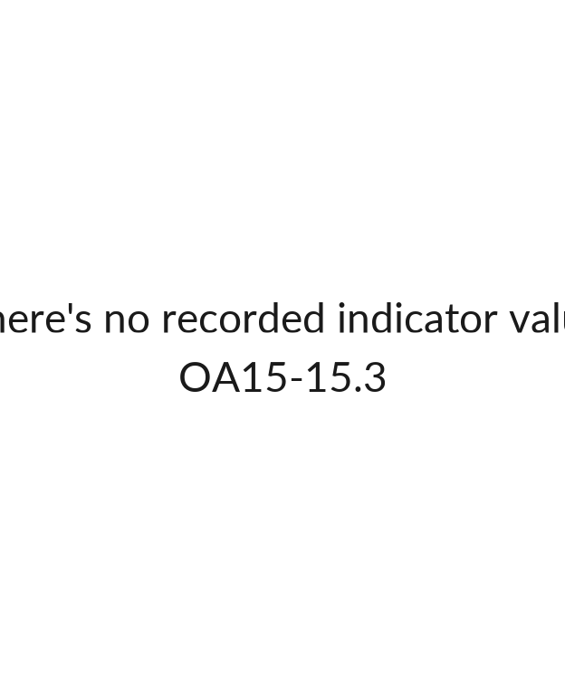

## [1] ""

[Link to indicator metadata](https://intranet.unhcr.org/content/dam/unhcr/intranet/protection-operations/compass/en/guidance/3/coreindicatorsmetadata/2.0%20Core%20Indicator%20Metadata%2004%2010%202021.pdf#page=150)

## Voluntary Repatriation

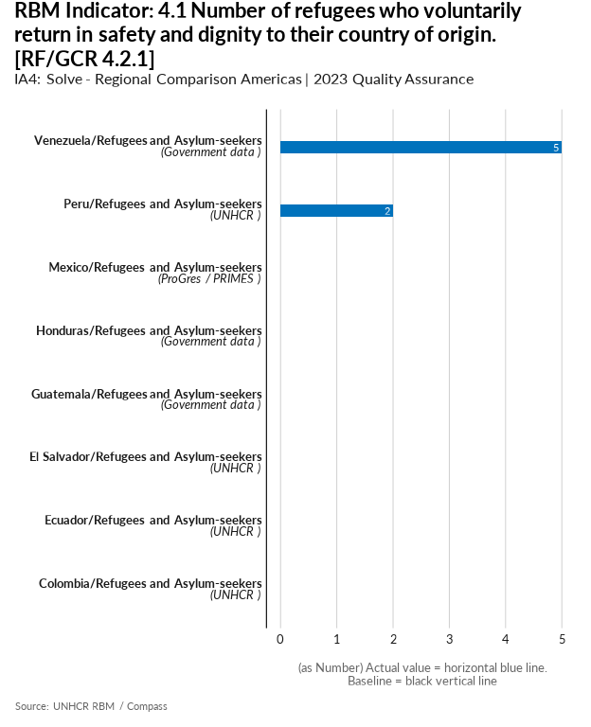

| group | baseline | actual | QA_logical | data_limitation |
| --- | --- | --- | --- | --- |
| Brazil/Refugees and Asylum-seekers | - | - | Missing Actual - Missing Baseline | UNHCR has not been engaging with Venezuelans on returns and does not have the data at this time. |
| Canada/Refugees and Asylum-seekers | - | - | Missing Actual - Missing Baseline | Canada does not keep records of persons leaving the country including PoCs. |
| Chile/Refugees and Asylum-seekers | - | - | Missing Actual - Missing Baseline | No data available |
| Colombia/Refugees and Asylum-seekers | - | 0 | Missing Baseline | No se han registrado casos en el país. |
| Costa Rica/Refugees and Asylum-seekers | - | - | Missing Actual - Missing Baseline | Operation do not have the relevant data and as we are not sure that there were 0 returns in safety and dignity, we leave the actual value in blank. |
| Ecuador/Refugees and Asylum-seekers | - | 0 | Missing Baseline | Currently EC operation is not working with voluntarily return refugees so the sources of information are limited |
| El Salvador/Refugees and Asylum-seekers | - | 0 | Missing Baseline | - |
| Guatemala/Refugees and Asylum-seekers | - | 0 | Missing Baseline | UNHCR has not received information from local authorities about voluntary return of guatemalans in a country of asylum |
| Honduras/Refugees and Asylum-seekers | - | 0 | Missing Baseline | - |
| Mexico/Refugees and Asylum-seekers | - | 0 | Missing Baseline | - |
| Peru/Refugees and Asylum-seekers | - | 2 | Missing Baseline | - |
| Venezuela/Refugees and Asylum-seekers | - | 5 | Missing Baseline | Sum of the number of refugees returned in a calendar year. |

[Link to indicator metadata](https://intranet.unhcr.org/content/dam/unhcr/intranet/protection-operations/compass/en/guidance/3/coreindicatorsmetadata/2.0%20Core%20Indicator%20Metadata%2004%2010%202021.pdf#page=49)

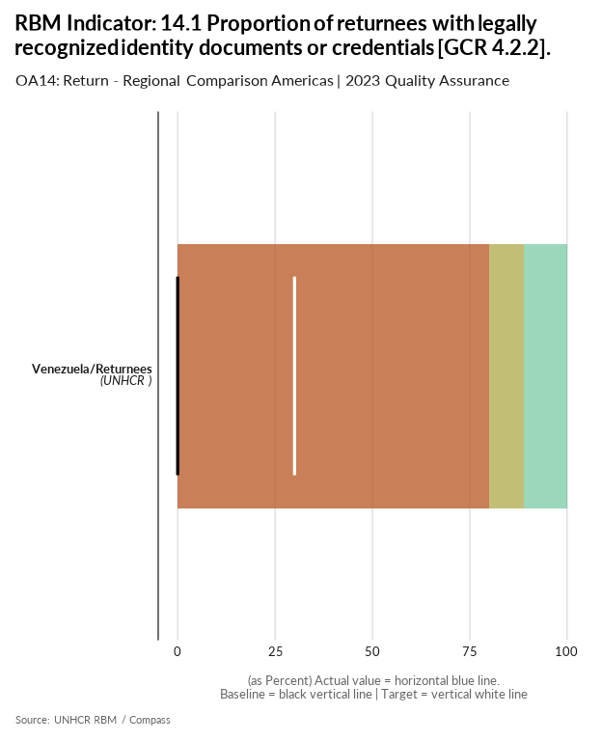

| group | baseline | actual | target | QA_logical | data_limitation |
| --- | --- | --- | --- | --- | --- |
| Venezuela/Returnees | 0 | 0 | 30 | Numerator for Actual is missing - Denominator for Actual is missing - Numerator for baseline is missing - Denominator for baseline is missing - Target value is below acceptable standard | The operation does not have information on Venezuelan refugees who have been returned to the country. |

[Link to indicator metadata](https://intranet.unhcr.org/content/dam/unhcr/intranet/protection-operations/compass/en/guidance/3/coreindicatorsmetadata/2.0%20Core%20Indicator%20Metadata%2004%2010%202021.pdf#page=141)

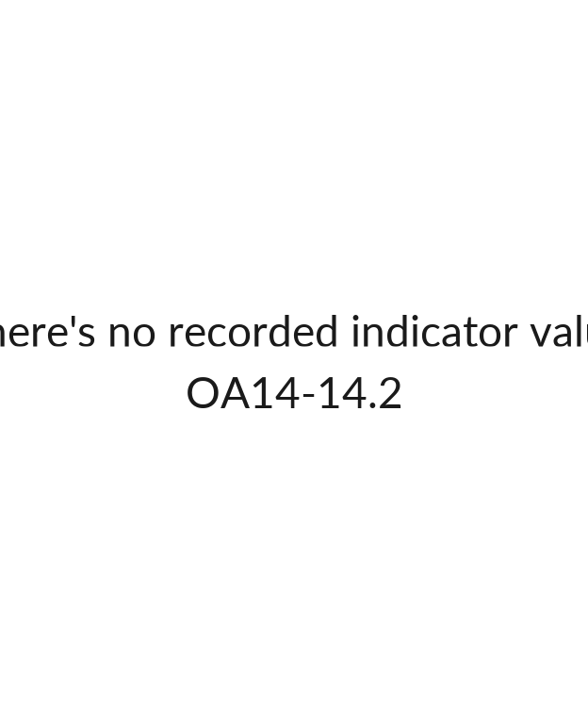

## [1] ""

[Link to indicator metadata](https://intranet.unhcr.org/content/dam/unhcr/intranet/protection-operations/compass/en/guidance/3/coreindicatorsmetadata/2.0%20Core%20Indicator%20Metadata%2004%2010%202021.pdf#page=143)

# Assistance & Inclusion

## Basic Needs

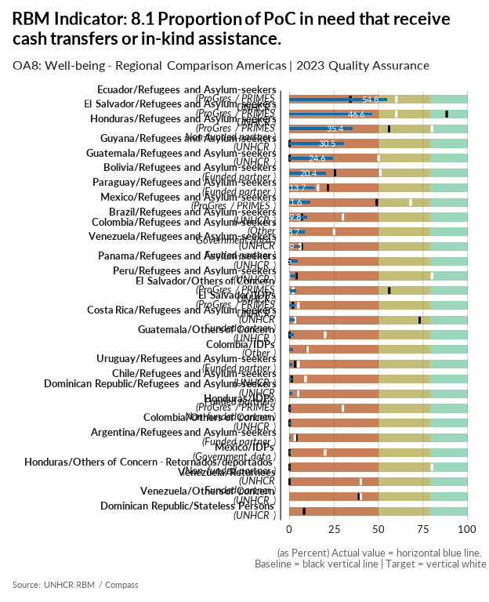

| group | baseline | actual | target | QA_logical | data_limitation |
| --- | --- | --- | --- | --- | --- |
| Argentina/Refugees and Asylum-seekers | 3.7 | 0.8 | 3 | Target value is below the baseline - Target value is below acceptable standard | - |
| Bolivia/Refugees and Asylum-seekers | 25.5 | 20.4 | 51 | Target value is below acceptable standard | It is an estimation as proGres was rolled-out in Bolivia in November 2023. |
| Brazil/Refugees and Asylum-seekers | 7 | 9.8 | 30 | Target value is below acceptable standard | - |
| Chile/Refugees and Asylum-seekers | 1.2 | 1.6 | 9 | Target value is below acceptable standard | 7089 CBI for basic needs and 286 CBI livelihoods |
| Colombia/Refugees and Asylum-seekers | 25 | 8.7 | 25 | Target value is below the baseline - Target value is below acceptable standard | RMRP 2023: Numerador: número de personas que reciben trasnferencias económicas + artículos domesticos + suministros. Denominador: Total de veneolanos en el país (Migración Colombia) Se asume que toda la población requiere trasnferencias económicas. |
| Colombia/IDPs | 9.7 | 2.1 | 10 | Target value is below acceptable standard | 345W: El denominador corresponde a las personas asistidas - IDPs en el 2023 con transferencias monetarias (asistencia alimentaria 141,496 - multipropósito 4,000). Denominador: Total de personas asistidas IDPs |
| Colombia/Others of Concern | 0 | 0.9 | - | Missing Target - Numerator for baseline is missing - Denominator for baseline is missing | RMRP 2023: Numerador Colombianos retornados que recibieron transferencias económicas (2836) + artículos domesticos + suministros (2058). Denominador: Total de Colombianos retornados asistidos. |
| Costa Rica/Refugees and Asylum-seekers | 73.1 | 2.8 | 3 | Target value is below the baseline - Target value is below acceptable standard - More than 40% difference between Target and Baseline - More than 20% difference between Actual and Baseline | Calculation methodology changed in 2023 including all the population of concern in the denominator and not only the targeted population (through CBI targetting tool). Denominator should only be REF+ASY as ROC and OIP do not have access to the programme. |
| Dominican Republic/Refugees and Asylum-seekers | 5.1 | 1.4 | 5 | Target value is below the baseline - Target value is below acceptable standard | - |
| Dominican Republic/Stateless Persons | 8.2 | 0 | - | Missing Target - Denominator for Actual is missing | Distribution of basic relief items for humanitarian assistance to vulnerable people in emergency situations due to natural disasters such as Hurricane Fiona |
| Ecuador/Refugees and Asylum-seekers | 34.2 | 54.8 | 60 | Target value is below acceptable standard | The calculation related to the denominator is maintained over the years for sake of coherence. The denominator is calculated taking into account new individuals register during the covering year that have a least one specific protection need registered in proGres |
| El Salvador/Refugees and Asylum-seekers | 88.3 | 46.6 | 60 | Target value is below the baseline - Target value is below acceptable standard - More than 20% difference between Actual and Baseline | - |
| El Salvador/Others of Concern | 56 | 3.6 | 2 | Target value is below the baseline - Target value is below acceptable standard - More than 40% difference between Target and Baseline - More than 20% difference between Actual and Baseline | - |
| El Salvador/IDPs | 1.9 | 3.4 | 5 | Target value is below acceptable standard | - |
| Guatemala/Refugees and Asylum-seekers | 0 | 24.6 | 50 | Numerator for baseline is missing - Denominator for baseline is missing - Target value is below acceptable standard - More than 40% difference between Target and Baseline | - |
| Guatemala/Others of Concern | 0 | 2.3 | 20 | Numerator for baseline is missing - Denominator for baseline is missing - Target value is below acceptable standard | - |
| Guyana/Refugees and Asylum-seekers | 0 | 30.5 | - | Missing Target - Numerator for baseline is missing - Denominator for baseline is missing | - |
| Honduras/Refugees and Asylum-seekers | 55.9 | 35.4 | 80 | Target value is below acceptable standard | Only UNHCR and partner data for cash-transfers and in-kind assistance. |
| Honduras/IDPs | 0 | 1.2 | 30 | Numerator for baseline is missing - Denominator for baseline is missing - Target value is below acceptable standard | Only UNHCR and partner data for cash-transfers and in-kind assistance. |
| Honduras/Others of Concern - Retornados/deportados | 0 | 0 | 80 | Numerator for baseline is missing - Denominator for baseline is missing - Target value is below acceptable standard - More than 40% difference between Target and Baseline | Only UNHCR and partner data for cash-transfers and in-kind assistance. |
| Mexico/Refugees and Asylum-seekers | 49 | 11.6 | 68 | Target value is below acceptable standard | Initially, only offices providing humanitarian assistance programme were to be considered in the baseline setting. As per indicator instructions, all CBIs are reported as actual (Protection, Education, Humanitarian Assistance, Solutions). There may be a limited number of cases for which both types of assistance has been provided (e.g. cases who received cash assistance and were accommodated and supported in shelters). In-kind support is provided to shelters for distrubution to beneficiaries who may stay up to a certain period of time, as such double-reporting is considered to be limited). |
| Mexico/IDPs | 0 | 0.6 | 20 | Numerator for baseline is missing - Denominator for baseline is missing - Target value is below acceptable standard | The Operation does not have a CBI program for IDPs, but has supported the authorities in their response to mass displacements events to provide in-kind assistance. Also, it is currently assessing local integration strategies for durable solutions response. In 2023, we assisted 1,526 IDPs (Michoacan: 750 IDPs). |
| Panama/Refugees and Asylum-seekers | 0 | 4.5 | - | Missing Target - Numerator for baseline is missing - Denominator for baseline is missing | - |
| Paraguay/Refugees and Asylum-seekers | 21.6 | 13.7 | 16 | Target value is below the baseline - Target value is below acceptable standard | - |
| Peru/Refugees and Asylum-seekers | 3.9 | 3.8 | 80 | Target value is below acceptable standard - More than 40% difference between Target and Baseline | The numerator includes both cash and in-kind assistance provided UNHCR. The denominator refers to REF, ASY and OIP reported under the ASR 2023. |
| Uruguay/Refugees and Asylum-seekers | 3.2 | 1.7 | 5 | Target value is below acceptable standard | - |
| Venezuela/Refugees and Asylum-seekers | 6.8 | 5.9 | 6 | Target value is below the baseline - Target value is below acceptable standard | Data obtained from output # of PoCs receiving material (in-kind) assistance |
| Venezuela/Others of Concern | 39 | 0 | 40 | Numerator for Actual is missing - Denominator for Actual is missing - Target value is below acceptable standard | Data limitation, since is not possible to use an estimation of the recipients of cash transfers by the government, the operation does not have data to report this indicator. To respond to this indicator in 2024, the operation is preparing an instrument that will be carried out by the UCAB; This instrument is the HAUS survey, which is being modified to include questions from the RMS, and to respond to the indicators following the methodology proposed in the metadata. |
| Venezuela/Returnees | 0 | 0 | 40 | Numerator for Actual is missing - Denominator for Actual is missing - Numerator for baseline is missing - Denominator for baseline is missing - Target value is below acceptable standard | Data limitation, the numerator obtained From output # of PoCs receiving material (in-kind) assistance (3,231). The total number of returnees is unknown for the operation. |

[Link to indicator metadata](https://intranet.unhcr.org/content/dam/unhcr/intranet/protection-operations/compass/en/guidance/3/coreindicatorsmetadata/2.0%20Core%20Indicator%20Metadata%2004%2010%202021.pdf#page=111)

## Health

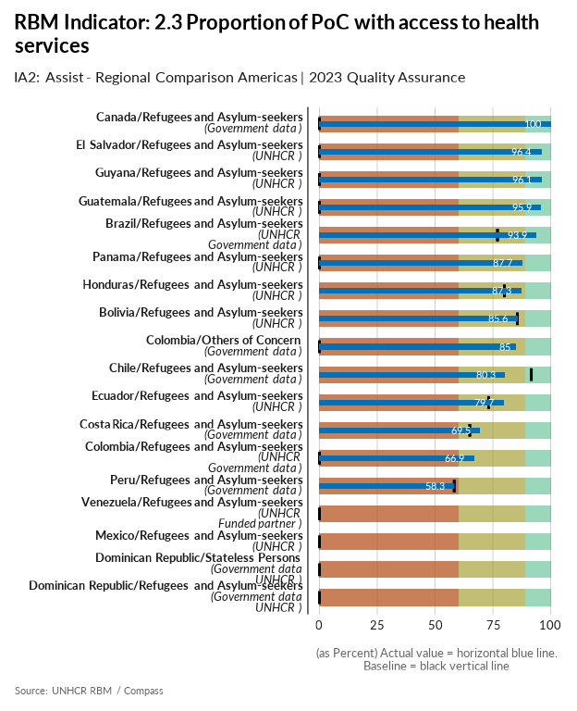

| group | baseline | actual | QA_logical | data_limitation |
| --- | --- | --- | --- | --- |
| Bolivia/Refugees and Asylum-seekers | 85.6 | 85.6 |  | Non-probabilistic sample. 209 people interviewed by phone in December 2023. |
| Brazil/Refugees and Asylum-seekers | 77 | 93.9 |  | Considering the legislation remained the same as the assessed in 2022, what can point to a chage in result refers to 1) sampling; 2) the longer the people live in Brazil, the more equipped to access/claim their rights they become; 3) considering the pandemic of Covid-19 has ended, refugees have been able to finally seek health services for issues that have been postponed and ignored in the previous years, also because health services were overloaded during the pandemic, preventing full access to services by both refugees and host communities. |
| Canada/Refugees and Asylum-seekers | 0 | 100 | Numerator for baseline is missing - Denominator for baseline is missing - More than 20% difference between Actual and Baseline | Both actual numerator and denominator are from the 2023 MYSR. Both numerator and denominator are the total number of refugees, refugee-like and asylum seekers combined. |
| Chile/Refugees and Asylum-seekers | 91.6 | 80.3 |  | Was calculated with data from CASEN 2022 |
| Colombia/Others of Concern | 0 | 85 | Numerator for baseline is missing - Denominator for baseline is missing - More than 20% difference between Actual and Baseline | En la Encuesta de Calidad de Vida incluye variables sobre ciudadanía, lugar de nacimiento y lugar de residencia cinco años antes y se realizan las estimaciones de retornados basándose en los ciudadanos colombianos, incluidos los de doble nacionalidad. Numerador: Personas que se le diagnosticaron alguna enfermedad crónica y que recibieron tratamiento/ Denominador: Total de Personas reportadas en esta variable. |
| Colombia/Refugees and Asylum-seekers | 0 | 66.9 | Numerator for baseline is missing - Denominator for baseline is missing - More than 20% difference between Actual and Baseline | En la encuesta calidad de vida se lugar de nacimiento y se identifica las personas con nacidas en Venezuela. Numerador: Venezolanos que se le diagnosticaron algunas enfermedad crónica y que recibieron tratamiento/ Denominador: Total Venezolanos que reportaron en esta variable. La información de la línea base 2023 fue tomada de HFS, mientras que el Actual 2023 es de la Encuesta de Calidad de Vida, por lo tanto no son comparables. |
| Costa Rica/Refugees and Asylum-seekers | 65 | 69.5 |  | ENAHO2023 - 2,148 nicaraguans surveyed.Weighted result. Ver https://github.com/UNHCR-CostaRica/ENAHOrbm |
| Dominican Republic/Refugees and Asylum-seekers | 0 | 0 | Numerator for Actual is missing - Denominator for Actual is missing - Numerator for baseline is missing - Denominator for baseline is missing | It is estimated that the results report of ENI III-Third National Survey of Immigrants will be published by the ONE in 2026. |
| Dominican Republic/Stateless Persons | 0 | 0 | Numerator for Actual is missing - Denominator for Actual is missing - Numerator for baseline is missing - Denominator for baseline is missing | It is estimated that the results report of ENI III-Third National Survey of Immigrants will be published by the ONE in 2026. |
| Ecuador/Refugees and Asylum-seekers | 73.1 | 79.7 |  | Our KOBO xls form version had a different option 3 (as this option was different in the V3 xls form and we used the form we had available when the data collection begun). This option was more about the service being unavailable, so we slightly change our methodology from that suggested by HQ |
| El Salvador/Refugees and Asylum-seekers | 0 | 96.4 | Numerator for baseline is missing - Denominator for baseline is missing - More than 20% difference between Actual and Baseline | Due an increase in the sample size, the indicator value shown a decrease from the previous year. While for baseline 36 survey were applied, in 2023 the quantity of surveys applied were 57. |
| Guatemala/Refugees and Asylum-seekers | 0 | 95.9 | Numerator for baseline is missing - Denominator for baseline is missing - More than 20% difference between Actual and Baseline | - |
| Guyana/Refugees and Asylum-seekers | 0 | 96.1 | Numerator for baseline is missing - Denominator for baseline is missing - More than 20% difference between Actual and Baseline | There are some considerations in regard to the reported value that the operation would like to note: 1. data was collected in accesible communities in Guyana where there was humanitarian presence of UNHCR and partners. Therefore, it is not representative of all rural and urban communities in Guyana, including those where the access to health services might be more limited. 2. The reported value was calculated based on the suggested questions on if you needed health assistance and if you received it. In many of the indigenous assessed communities, there was a perception of not needing traditional health assistance due the availability of chamans and other community members with knowledge of traditional medicine. 3. After consulting with field colleagues, they confirmed the wide-spread presence of very basic health facilities. In some of the assessed communities, however, it was identified other type of essential services lacking such as safe water, education and others. |
| Honduras/Refugees and Asylum-seekers | 80 | 87.3 |  | Small sample of refugees and asylum-seekers surveyed through the RMS in collaboration with the National Migration Institute. Data is extrapolated to RAS population. |
| Mexico/Refugees and Asylum-seekers | 0 | 0 | Numerator for Actual is missing - Denominator for Actual is missing - Numerator for baseline is missing - Denominator for baseline is missing | This indicator is left blank as suggested by RBA. Preliminary results from RMS regarding this indicator are based on a sample too small that does not allow for a generalization. |
| Panama/Refugees and Asylum-seekers | 0 | 87.7 | Numerator for baseline is missing - Denominator for baseline is missing - More than 20% difference between Actual and Baseline | - |
| Peru/Refugees and Asylum-seekers | 58.3 | 58.3 |  | Data from ENPOVE (2022) |
| Venezuela/Refugees and Asylum-seekers | 0 | 0 | Numerator for Actual is missing - Denominator for Actual is missing - Numerator for baseline is missing - Denominator for baseline is missing | There is no data for refugees and asylum seekers. ENCOVI is a national household survey that is representative to the entire host population. There could be different profiles and needs of the displaced population within Venezuela, which the survey is not capturing. |

[Link to indicator metadata](https://intranet.unhcr.org/content/dam/unhcr/intranet/protection-operations/compass/en/guidance/3/coreindicatorsmetadata/2.0%20Core%20Indicator%20Metadata%2004%2010%202021.pdf#page=26)

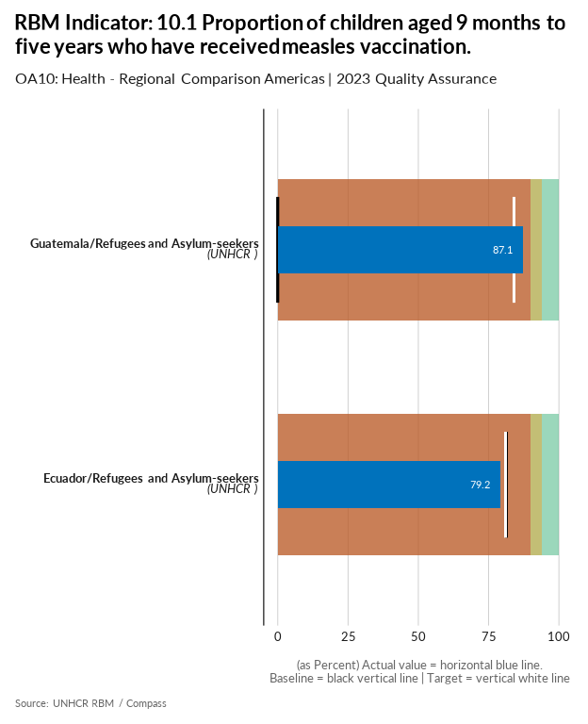

| group | baseline | actual | target | QA_logical | data_limitation |
| --- | --- | --- | --- | --- | --- |
| Ecuador/Refugees and Asylum-seekers | 81.3 | 79.2 | 81 | Target value is below the baseline - Target value is below acceptable standard | Numerator: # of children aged 9 months to 5 years who have received a measles containing vaccine (in the household survey*) Denominator: Total # of children aged 9 months to 5 years of age (in the household survey*) |
| Guatemala/Refugees and Asylum-seekers | 0 | 87.1 | 84 | Numerator for baseline is missing - Denominator for baseline is missing - Target value is below acceptable standard - More than 40% difference between Target and Baseline - More than 20% difference between Actual and Baseline | In this indicator we present the whole number of people surveyed in the RMS who reported having children of that age. We used the real number and not a generalization to portray the reality of children as it was reported. |

[Link to indicator metadata](https://intranet.unhcr.org/content/dam/unhcr/intranet/protection-operations/compass/en/guidance/3/coreindicatorsmetadata/2.0%20Core%20Indicator%20Metadata%2004%2010%202021.pdf#page=120)

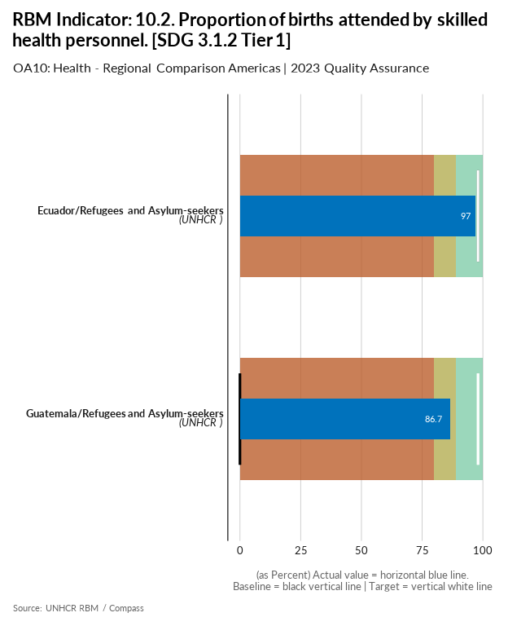

| group | baseline | actual | target | QA_logical | data_limitation |
| --- | --- | --- | --- | --- | --- |
| Ecuador/Refugees and Asylum-seekers | 98 | 97 | 98 | Target value is below the baseline - Target value is below acceptable standard | There were changes in the answer options of the 2023 survey, option three should have nurse/obstetrician and midwife should be next to traditional midwife. Numerator: # of women aged 15-49 with a live birth attended by a skilled health personnel (e.g. doctors, nurses or midwives) Denominator: # of women aged 15-49 with a live birth in the same period |
| Guatemala/Refugees and Asylum-seekers | 0 | 86.7 | 98 | Numerator for baseline is missing - Denominator for baseline is missing - Target value is below acceptable standard - More than 40% difference between Target and Baseline - More than 20% difference between Actual and Baseline | Some of the women who answered the survey reported having the baby in their house. |

[Link to indicator metadata](https://intranet.unhcr.org/content/dam/unhcr/intranet/protection-operations/compass/en/guidance/3/coreindicatorsmetadata/2.0%20Core%20Indicator%20Metadata%2004%2010%202021.pdf#page=122)

## Shelter

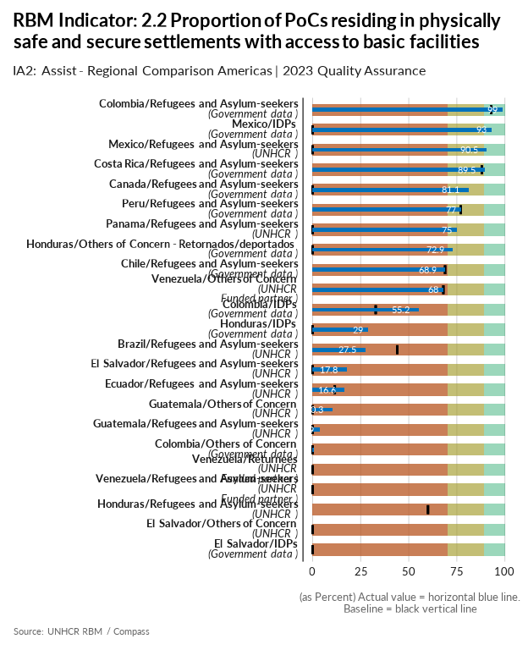

| group | baseline | actual | QA_logical | data_limitation |
| --- | --- | --- | --- | --- |
| Brazil/Refugees and Asylum-seekers | 44 | 27.5 |  | The decrease in the results can be factored in by 1) sampling and 2) actual socioeconomic decrease in some communities, which could have affected this indicator, but considering responses point to a situation that does not reflect the general aspect of the country's context, biased sampling can be playing a stronger role in this result. |
| Canada/Refugees and Asylum-seekers | 0 | 81.1 | Numerator for baseline is missing - Denominator for baseline is missing - More than 20% difference between Actual and Baseline | The UNHCR indicator definition comprises two sub-components: 1) quality of shelter (i.e., the structural integrity of the dwelling and the presence of overcrowding), and 2) access to public services (namely: health, water, and electricity). The indicator was calculated by combining the census variables for core housing need (StatsCan’s measure of quality of shelter) and non-zero spending on shelter costs (which includes electricity, heat, and water, but not health services) as a proxy for access to the relevant services. See here for the definition of Core Housing Need: https://www12.statcan.gc.ca/census-recensement/2021/ref/dict/az/Definition-eng.cfm?ID=households-menage037 and here for shelter cost: https://www12.statcan.gc.ca/census-recensement/2021/ref/dict/az/definition-eng.cfm?ID=households-menage033. Data applies to permanent residents who had been refugees. |
| Chile/Refugees and Asylum-seekers | 68.9 | 68.9 |  | Calculation was made using CASEN 2022 |
| Colombia/Refugees and Asylum-seekers | 92.9 | 99 |  | Numerador: Personas Migrantes con asentamientos seguros/ Total de personas reportadas |
| Colombia/IDPs | 32.8 | 55.2 |  | IGED : Numerador Vivienda con servicios públicos adecuador. Denominador Total del universo de la medición (IGED). |
| Colombia/Others of Concern | 0 | 0.6 | Numerator for baseline is missing - Denominator for baseline is missing | En la Encuesta de Calidad de Vida incluye variables sobre ciudadanía, lugar de nacimiento y lugar d residencia cinco años antes y se realizan las estimaciones de retornados basándose en los ciudadanos colombianos, incluidos los de doble nacionalidad. Numerador: Personas que su vivienda se ha visto afectada / Denominador: Total de personas país reportadas en esta variable. |
| Costa Rica/Refugees and Asylum-seekers | 88 | 89.5 |  | ENAHO2023 - 2,148 nicaraguans surveyed.Weighted result. Ver https://github.com/UNHCR-CostaRica/ENAHOrbm |
| Ecuador/Refugees and Asylum-seekers | 11.5 | 16.6 |  | Methodological change un more than one dimension of this composite indicator. It is advised to reconsider the inclusion of affordable housing as it is relevant for our operation. |
| El Salvador/Refugees and Asylum-seekers | 0 | 17.8 | Numerator for baseline is missing - Denominator for baseline is missing | Due an increase in the sample size, the indicator value shown a decrease from the previous year. While for baseline 36 survey were applied, in 2023 the quantity of surveys applied were 57. |
| El Salvador/IDPs | 0 | 0 | Numerator for Actual is missing - Denominator for Actual is missing - Numerator for baseline is missing - Denominator for baseline is missing | Data will be available when EHPM be officially published in July/August 2024 |
| El Salvador/Others of Concern | 0 | 0 | Numerator for Actual is missing - Denominator for Actual is missing - Numerator for baseline is missing - Denominator for baseline is missing | There are not data available for 2023. Resources are required to implement an RMS exercise in 2024. |
| Guatemala/Others of Concern | 0 | 10.3 | Numerator for baseline is missing - Denominator for baseline is missing | Following the changes in the RMS survey, specifically in the set of questions of shelter, the measure has change in comparison to last year's RMS. |
| Guatemala/Refugees and Asylum-seekers | 0 | 3.9 | Numerator for baseline is missing - Denominator for baseline is missing | The changes in the RMS survey, specifically in the set of questions of Shelter, changed the way this indicator is measured, which explains why the actual value is lower this year |
| Honduras/Others of Concern - Retornados/deportados | 0 | 72.9 | Numerator for baseline is missing - Denominator for baseline is missing - More than 20% difference between Actual and Baseline | The denominator is the same as the one used in the ASR population. And the numerator was calculated through various factors included in SEDESOL's SIRBHO portal such as building material, access to drinkable water, type of fuel used for cooking, etc. crossed with returnees that originally abandoned their homes due to violence. |
| Honduras/IDPs | 0 | 29 | Numerator for baseline is missing - Denominator for baseline is missing | This data is from National Statistics Institute's (INE) EPHPM Q1-Q3 survey data. We are still pending the consolidated data for the whole year (including Q4) but did not receive it yet. |
| Honduras/Refugees and Asylum-seekers | 60 | 0 | Numerator for Actual is missing - Denominator for Actual is missing - More than 20% difference between Actual and Baseline | Small sample of refugees and asylum-seekers surveyed through the RMS in collaboration with the National Migration Institute. However the calculation for this resulted in 0, but as recommended we did not want to report this as 0% is not really representative. |
| Mexico/IDPs | 0 | 93 | Numerator for baseline is missing - Denominator for baseline is missing - More than 20% difference between Actual and Baseline | The IDP total population figure is different from that of the ASR as it is an estimate based on the expanded 2020 Census questionnaire that is applied to a representative sample and not to all persons. To calculate the required indicator an analysis of the 2020 Census extended questionnaire microdata was conducted. In particular, the following questions were considered: Q1-Walls, Q2-Seeling, Q3-Floors, Q10-Electricity, Q12-Water, Q16-Sanitary, Q19-Sewer. The calculation was made considering the estimate of PoC with safe housing and access to basic services (261,460) with respect to the estimate of total PoC (281,200). |
| Mexico/Refugees and Asylum-seekers | 0 | 90.5 | Numerator for baseline is missing - Denominator for baseline is missing - More than 20% difference between Actual and Baseline | Preliminary RMS data relates only to Refugee population (this includes complementary protection beneficiaries) |
| Panama/Refugees and Asylum-seekers | 0 | 75 | Numerator for baseline is missing - Denominator for baseline is missing - More than 20% difference between Actual and Baseline | - |
| Peru/Refugees and Asylum-seekers | 77 | 77 |  | Data from ENPOVE (2022) |
| Venezuela/Others of Concern | 68 | 68 |  | The data for this indicator was measured in 2022 through the ENCOVI, for 2023 the ENCOVI did not have this question. Actuals for 2023 adjusted using actuals of 2022 by suggestion of the bureau. |
| Venezuela/Refugees and Asylum-seekers | 0 | 0 | Numerator for Actual is missing - Denominator for Actual is missing - Numerator for baseline is missing - Denominator for baseline is missing | The operation does not have information on Venezuelan refugees residing in physically safe and secure settlements with access to basic facilities. |
| Venezuela/Returnees | 0 | 0 | Numerator for Actual is missing - Denominator for Actual is missing - Numerator for baseline is missing - Denominator for baseline is missing | The operation does not have information on Venezuelan returnees residing in physically safe and secure settlements with access to basic facilities. |

[Link to indicator metadata](https://intranet.unhcr.org/content/dam/unhcr/intranet/protection-operations/compass/en/guidance/3/coreindicatorsmetadata/2.0%20Core%20Indicator%20Metadata%2004%2010%202021.pdf#page=24)

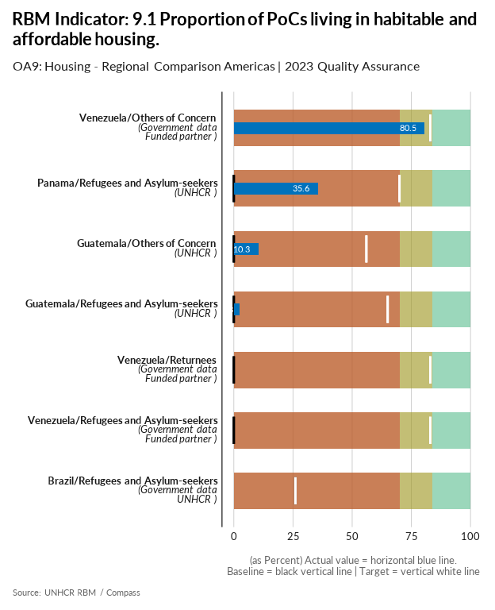

| group | baseline | actual | target | QA_logical | data_limitation |
| --- | --- | --- | --- | --- | --- |
| Brazil/Refugees and Asylum-seekers | 26 | 0 | 26 | Numerator for Actual is missing - Denominator for Actual is missing - Target value is below acceptable standard | The expected data source for this indicator was the National Census. However, the government has not yet shared its results, although the data collection process took place in 2022. Apart from the delay, there is an excessive amount of time since the data collection took place, meaning that the results might no longer represent the state of forcibly displaced and stateless persons in Brazil. This indicator was also not included in the RMS under the assumption that the government was going to soon share their results, which unfortunately it did not. |
| Guatemala/Others of Concern | 0 | 10.3 | 56 | Numerator for baseline is missing - Denominator for baseline is missing - Target value is below acceptable standard - More than 40% difference between Target and Baseline | The changes in the RMS survey, specifically in the set of questions of Shelter, changed the way this indicator is measured, which explains why the actual value is lower this year |
| Guatemala/Refugees and Asylum-seekers | 0 | 2.3 | 65 | Numerator for baseline is missing - Denominator for baseline is missing - Target value is below acceptable standard - More than 40% difference between Target and Baseline | The changes in the RMS survey, specifically in the set of questions of Shelter, changed the way this indicator is measured, which explains why the actual value is lower this year |
| Panama/Refugees and Asylum-seekers | 0 | 35.6 | 70 | Numerator for baseline is missing - Denominator for baseline is missing - Target value is below acceptable standard - More than 40% difference between Target and Baseline | - |
| Venezuela/Others of Concern | 83 | 80.5 | 83 | Target value is below acceptable standard | The calculation is based on the population living in households where there is no overcrowding and the housing offers living conditions out of the total population. The information was provided by the ENCOVI survey of 2023. |
| Venezuela/Refugees and Asylum-seekers | 0 | 0 | 83 | Numerator for Actual is missing - Denominator for Actual is missing - Numerator for baseline is missing - Denominator for baseline is missing - Target value is below acceptable standard - More than 40% difference between Target and Baseline | ENCOVI collects data for the total population of the country and does not differentiate between the population groups specified by the UNHCR. |
| Venezuela/Returnees | 0 | 0 | 83 | Numerator for Actual is missing - Denominator for Actual is missing - Numerator for baseline is missing - Denominator for baseline is missing - Target value is below acceptable standard - More than 40% difference between Target and Baseline | ENCOVI collects data for the total population of the country and does not differentiate between the population groups specified by the UNHCR. |

[Link to indicator metadata](https://intranet.unhcr.org/content/dam/unhcr/intranet/protection-operations/compass/en/guidance/3/coreindicatorsmetadata/2.0%20Core%20Indicator%20Metadata%2004%2010%202021.pdf#page=115)

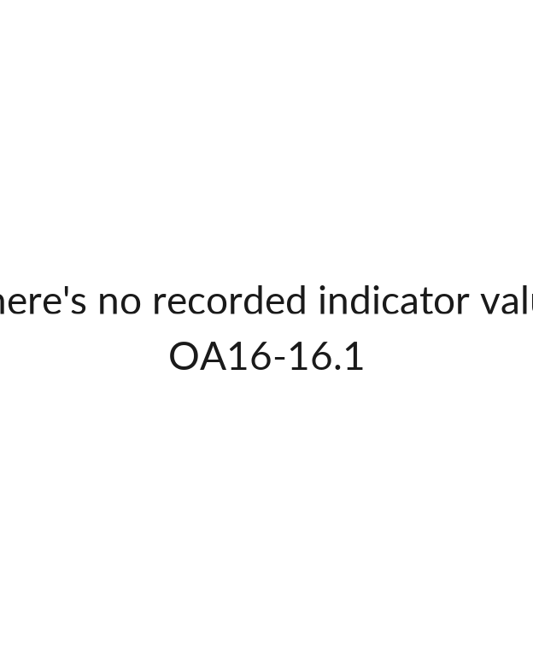

## [1] ""

[Link to indicator metadata](https://intranet.unhcr.org/content/dam/unhcr/intranet/protection-operations/compass/en/guidance/3/coreindicatorsmetadata/2.0%20Core%20Indicator%20Metadata%2004%2010%202021.pdf#page=153)

## Water, Sanitation & Hygiene

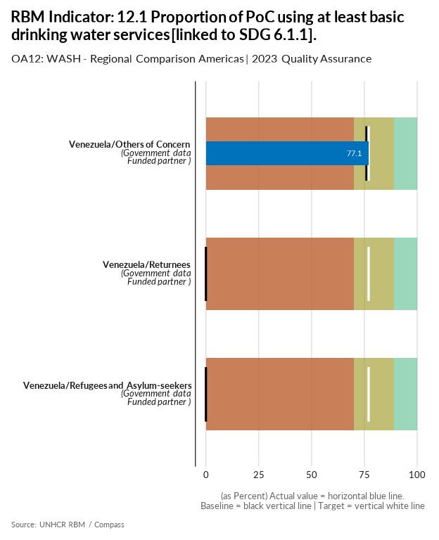

| group | baseline | actual | target | QA_logical | data_limitation |
| --- | --- | --- | --- | --- | --- |
| Venezuela/Others of Concern | 76 | 77.1 | 77 | Target value is below acceptable standard | The calculation is based on the population residing in households where they have access to basic drinking water services out of the total population. The information was provided by the ENCOVI survey of 2023. |
| Venezuela/Refugees and Asylum-seekers | 0 | 0 | 77 | Numerator for Actual is missing - Denominator for Actual is missing - Numerator for baseline is missing - Denominator for baseline is missing - Target value is below acceptable standard - More than 40% difference between Target and Baseline | ENCOVI collects data for the total population of the country and does not differentiate between the population groups specified by the UNHCR. The HAUS instrument was designed in 2023 and is already sampled for application in 2024. |
| Venezuela/Returnees | 0 | 0 | 77 | Numerator for Actual is missing - Denominator for Actual is missing - Numerator for baseline is missing - Denominator for baseline is missing - Target value is below acceptable standard - More than 40% difference between Target and Baseline | ENCOVI collects data for the total population of the country and does not differentiate between the population groups specified by the UNHCR. The HAUS instrument was designed in 2023 and is already sampled for application in 2024. |

[Link to indicator metadata](https://intranet.unhcr.org/content/dam/unhcr/intranet/protection-operations/compass/en/guidance/3/coreindicatorsmetadata/2.0%20Core%20Indicator%20Metadata%2004%2010%202021.pdf#page=128)

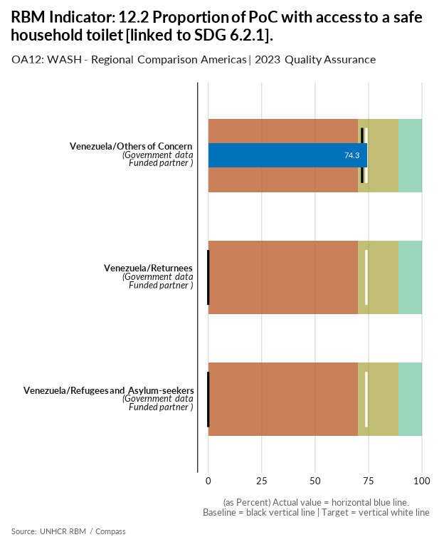

| group | baseline | actual | target | QA_logical | data_limitation |
| --- | --- | --- | --- | --- | --- |
| Venezuela/Others of Concern | 72 | 74.3 | 74 | Target value is below acceptable standard | The calculation is based on the population residing in households where they have access to a safe toilet out of the total population. The information was provided by the ENCOVI survey of 2023. |
| Venezuela/Refugees and Asylum-seekers | 0 | 0 | 74 | Numerator for Actual is missing - Denominator for Actual is missing - Numerator for baseline is missing - Denominator for baseline is missing - Target value is below acceptable standard - More than 40% difference between Target and Baseline | ENCOVI collects data for the total population of the country and does not differentiate between the population groups specified by the UNHCR. The HAUS instrument was designed in 2023 and is already sampled for application in 2024. |
| Venezuela/Returnees | 0 | 0 | 74 | Numerator for Actual is missing - Denominator for Actual is missing - Numerator for baseline is missing - Denominator for baseline is missing - Target value is below acceptable standard - More than 40% difference between Target and Baseline | ENCOVI collects data for the total population of the country and does not differentiate between the population groups specified by the UNHCR. The HAUS instrument was designed in 2023 and is already sampled for application in 2024. |

[Link to indicator metadata](https://intranet.unhcr.org/content/dam/unhcr/intranet/protection-operations/compass/en/guidance/3/coreindicatorsmetadata/2.0%20Core%20Indicator%20Metadata%2004%2010%202021.pdf#page=131)

## Energy

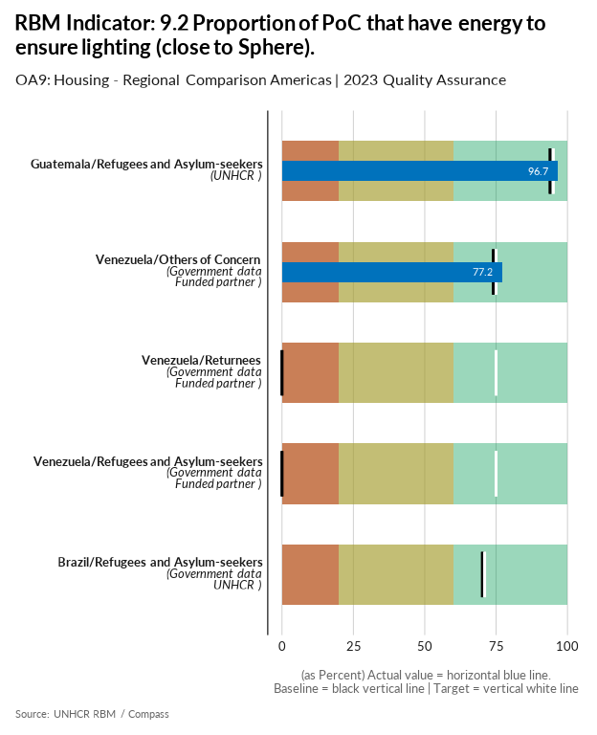

| group | baseline | actual | target | QA_logical | data_limitation |
| --- | --- | --- | --- | --- | --- |
| Brazil/Refugees and Asylum-seekers | 70.2 | 0 | 71 | Numerator for Actual is missing - Denominator for Actual is missing - Target value is below acceptable standard - More than 20% difference between Actual and Baseline | The expected data source for this indicator was the National Census. However, the government has not yet shared its results, although the data collection process took place in 2022. Apart from the delay, there is an excessive amount of time since the data collection took place, meaning that the results might no longer represent the state of forcibly displaced and stateless persons in Brazil. This indicator was also not included in the RMS under the assumption that the government was going to soon share their results, which unfortunately it did not. |
| Guatemala/Refugees and Asylum-seekers | 93.9 | 96.7 | 95 | Target value is below acceptable standard | - |
| Venezuela/Others of Concern | 74 | 77.2 | 75 | Target value is below acceptable standard | The calculation is based on the population residing in households where they have access to electricity service over the total population. The information was provided by the ENCOVI survey of 2023. |
| Venezuela/Refugees and Asylum-seekers | 0 | 0 | 75 | Numerator for Actual is missing - Denominator for Actual is missing - Numerator for baseline is missing - Denominator for baseline is missing - Target value is below acceptable standard - More than 40% difference between Target and Baseline | ENCOVI collects data for the total population of the country and does not differentiate between the population groups specified by the UNHCR. |
| Venezuela/Returnees | 0 | 0 | 75 | Numerator for Actual is missing - Denominator for Actual is missing - Numerator for baseline is missing - Denominator for baseline is missing - Target value is below acceptable standard - More than 40% difference between Target and Baseline | ENCOVI collects data for the total population of the country and does not differentiate between the population groups specified by the UNHCR. |

[Link to indicator metadata](https://intranet.unhcr.org/content/dam/unhcr/intranet/protection-operations/compass/en/guidance/3/coreindicatorsmetadata/2.0%20Core%20Indicator%20Metadata%2004%2010%202021.pdf#page=118)

## Livelihoods & Economic Inclusion

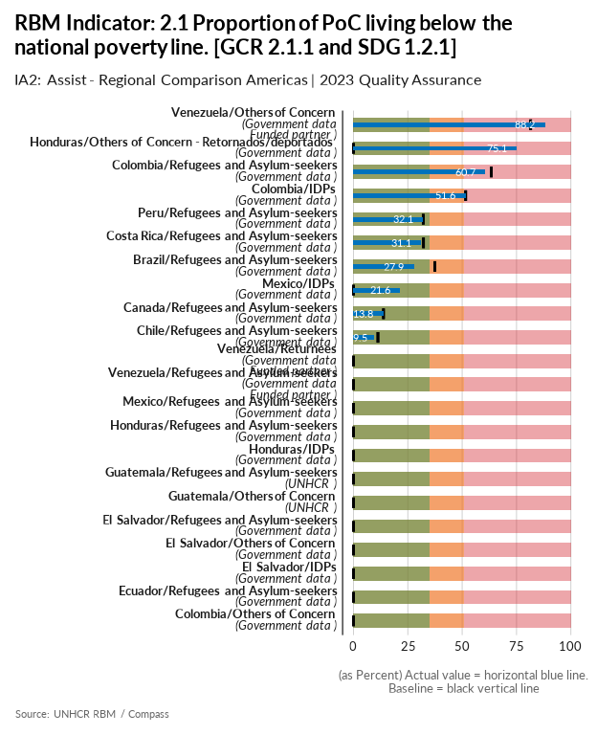

| group | baseline | actual | QA_logical | data_limitation |
| --- | --- | --- | --- | --- |
| Brazil/Refugees and Asylum-seekers | 37.4 | 27.9 |  | - |
| Canada/Refugees and Asylum-seekers | 13.8 | 13.8 |  | Poverty status based on Employment and Social Development Canada's 2018 s Market Basket Measure (MBM) Results for permanent residents who had been refugees. |
| Chile/Refugees and Asylum-seekers | 11.2 | 9.5 |  | Was calculated with data from CASEN 2022 |
| Colombia/Refugees and Asylum-seekers | 63.4 | 60.7 |  | - |
| Colombia/IDPs | 51.6 | 51.6 |  | - |
| Colombia/Others of Concern | 0 | 0 | Numerator for Actual is missing - Denominator for Actual is missing - Numerator for baseline is missing - Denominator for baseline is missing | No se cuenta con información oficialSin información para este indicador para este tipo de población. La fuente de información utilizada para las líneas de pobreza en Colombia es la encuesta Nacional de Presupuestos de los Hogares. Revisando el formulario de esta encuesta no se encuentra una variable de lugar de nacimiento, y/o residencia. Para este caso no se podría utilizar la ECV ya que no es el instrumento estadístico para calcular la línea de pobreza en Colombia. |
| Costa Rica/Refugees and Asylum-seekers | 32.2 | 31.1 |  | ENAHO2023 - 2,148 nicaraguans surveyed.Weighted result. Ver https://github.com/UNHCR-CostaRica/ENAHOrbm |
| Ecuador/Refugees and Asylum-seekers | 0 | 0 | Numerator for Actual is missing - Denominator for Actual is missing - Numerator for baseline is missing - Denominator for baseline is missing | Data is not available, as the ENEMDU questionnaire is not a reliable source of information. |
| El Salvador/IDPs | 0 | 0 | Numerator for Actual is missing - Denominator for Actual is missing - Numerator for baseline is missing - Denominator for baseline is missing | Data will be available when EHPM be officially published in July/August 2024 |
| El Salvador/Others of Concern | 0 | 0 | Numerator for Actual is missing - Denominator for Actual is missing - Numerator for baseline is missing - Denominator for baseline is missing | The poverty indicator for this population type in El Salvador is not be feasible to obtain in the medium or long term due the sample design for National Household Multipurpose survey (EHPM) is updated every 5 years (last update was in 2022). On the other hand, Government declares in the methodological aspects to develop this survey that, if information from other type of subpopulation is required, specific sample designs should be prepared. Currently EHPM doesn´t include Returnees or people at risk of displacement as population type. (For Reference please check https://www.bcr.gob.sv/documental/Inicio/vista/de6f89280f6c55567717efaf39534d6d.pdf) |
| El Salvador/Refugees and Asylum-seekers | 0 | 0 | Numerator for Actual is missing - Denominator for Actual is missing - Numerator for baseline is missing - Denominator for baseline is missing | The poverty indicator for this population type in El Salvador is not be feasible to obtain in the medium or long term due the sample design for National Household Multipurpose survey (EHPM) is updated every 5 years (last update was in 2022). On the other hand, Government declares in the methodological aspects to develop this survey that, if information from other type of subpopulation is required, specific sample designs should be prepared. Currently EHPM doesn´t include Returnees or people at risk of displacement as population type. (For Reference please check https://www.bcr.gob.sv/documental/Inicio/vista/de6f89280f6c55567717efaf39534d6d.pdf) |
| Guatemala/Refugees and Asylum-seekers | 0 | 0 | Numerator for Actual is missing - Denominator for Actual is missing - Numerator for baseline is missing - Denominator for baseline is missing | Following instructions of the RBA, we don't calculate this indicator |
| Guatemala/Others of Concern | 0 | 0 | Numerator for Actual is missing - Denominator for Actual is missing - Numerator for baseline is missing - Denominator for baseline is missing | Following instructions of the RBA, we don't calculate this indicator |
| Honduras/Others of Concern - Retornados/deportados | 0 | 75.1 | Numerator for baseline is missing - Denominator for baseline is missing - More than 20% difference between Actual and Baseline | Calculated through SEDESOL's government portal SIRBHO which provides poverty rates on the vulnerable Honduran population. This was projected and crossed with returnees that originally abandoned their homes due to violence. |
| Honduras/IDPs | 0 | 0 | Numerator for Actual is missing - Denominator for Actual is missing - Numerator for baseline is missing - Denominator for baseline is missing | To extract the data for this indicator we need the National Statistics Institute's (INE) EPHPM Q4 survey data that we did not receive it yet. |
| Honduras/Refugees and Asylum-seekers | 0 | 0 | Numerator for Actual is missing - Denominator for Actual is missing - Numerator for baseline is missing - Denominator for baseline is missing | No existing government data as they do not collect data on poverty specifically for RAS. |
| Mexico/IDPs | 0 | 21.6 | Numerator for baseline is missing - Denominator for baseline is missing | No specific official data on IDPs in Mexico. However, the 2020 Population and Housing Census includes a question regarding people who change their place of residency due to insecurity or violence between 2015 - 2020 that serves as a proxy to estimate this population. In particular, Q25-Place of residency and Q27-Cause of Migration included in the census were used as a proxy. The IDP total population figure is different from that of the Annual Statistical Report as it is an estimate based on the expanded 2020 Census questionnaire that is applied to a representative sample and not to all persons. To calculate the required indicator an analysis of the 2020 Census extended questionnaire microdata was conducted. In particular, Q36 - Labor Income, was considered. It is important to note that the question is a proxy, as no data on consumption is considered within the Census but only economic income. Also, denominator only considers people occupied. The income poverty line figure for 2020 was taken from CONEVAL. |
| Mexico/Refugees and Asylum-seekers | 0 | 0 | Numerator for Actual is missing - Denominator for Actual is missing - Numerator for baseline is missing - Denominator for baseline is missing | This indicator is left blank as instructed by RBA. Since it should come from the same source that the country uses to report their official PL, usually the NSO. This is not possible/available in Mexico at the moment for REF&AS. |
| Peru/Refugees and Asylum-seekers | 32.1 | 32.1 |  | Data from ENPOVE (2022) |
| Venezuela/Others of Concern | 81.5 | 88.2 |  | The calculation is based on the population with declared household income. Excluded from the estimate are 3,136,399 people without information. |
| Venezuela/Refugees and Asylum-seekers | 0 | 0 | Numerator for Actual is missing - Denominator for Actual is missing - Numerator for baseline is missing - Denominator for baseline is missing | The operation doesn't have information to report on the proportion of refugees living below the national poverty line. To respond to this indicator in 2024, the operation is preparing an instrument that will be carried out by the UCAB; This instrument is the HAUS survey, which is being modified to include questions from the RMS, and to respond to the indicators following the methodology proposed in the metadata. |
| Venezuela/Returnees | 0 | 0 | Numerator for Actual is missing - Denominator for Actual is missing - Numerator for baseline is missing - Denominator for baseline is missing | The operation doesn't have information to report on the proportion of returnees living below the national poverty line. To respond to this indicator in 2024, the operation is preparing an instrument that will be carried out by the UCAB; This instrument is the HAUS survey, which is being modified to include questions from the RMS, and to respond to the indicators following the methodology proposed in the metadata. |

[Link to indicator metadata](https://intranet.unhcr.org/content/dam/unhcr/intranet/protection-operations/compass/en/guidance/3/coreindicatorsmetadata/2.0%20Core%20Indicator%20Metadata%2004%2010%202021.pdf#page=21)

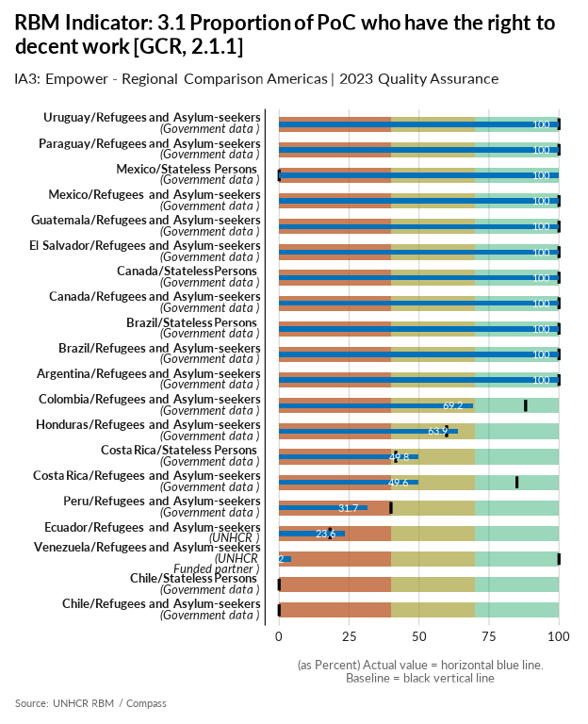

| group | baseline | actual | QA_logical | data_limitation |
| --- | --- | --- | --- | --- |
| Argentina/Refugees and Asylum-seekers | 100 | 100 |  | Based on ASR 2023 figures. Data without information on age is redistributed proportionally to calculate the working age group (+18) |
| Brazil/Refugees and Asylum-seekers | 100 | 100 |  | - |
| Brazil/Stateless Persons | 100 | 100 |  | - |
| Canada/Refugees and Asylum-seekers | 100 | 100 |  | Both actual numerator and denominator are from the 2023 MYSR. Both numerator and denominator are the total number of refugees and asylum seekers combined. |
| Canada/Stateless Persons | 100 | 100 |  | Both actual numerator and denominator are from the 2023 MYSR. Both numerator and denominator are the total number of stateless persons. Note that Canada does not have a Stateless determination system and as such numbers are unreliable. |
| Chile/Stateless Persons | 0 | 0 | Numerator for Actual is missing - Denominator for Actual is missing - Numerator for baseline is missing - Denominator for baseline is missing | There is no age disaggregated information available for this type of population. |
| Chile/Refugees and Asylum-seekers | 0 | 0 | Numerator for Actual is missing - Denominator for Actual is missing - Numerator for baseline is missing - Denominator for baseline is missing | It was decided to report the indicator blank due to the impossibility of showing the existing gap in access to decent work. Those who do not have access to decent work in Chile are people in an irregular situation and these are not counted in the ASR 2023 OIP figure. |
| Colombia/Refugees and Asylum-seekers | 88.1 | 69.2 |  | Se estima que la población Venezolana con edad de trabajar es del 84,9% partiendo de los resultados de la Encuesta Pulso sobre población venezolana (edad). Se realiza la estimación con este porcentaje al reporte de población total venezolana en Colombia de Migración. |
| Costa Rica/Stateless Persons | 41.7 | 49.8 |  | Calculation methodology changed in 2023. Core Impact 3.1 tool. |
| Costa Rica/Refugees and Asylum-seekers | 85 | 49.6 |  | Calculation methodology changed in 2023. Core Impact 3.1 tool. |
| Ecuador/Refugees and Asylum-seekers | 18.2 | 23.6 |  | Numerator includes REF+ASY (all nationalities) + Venezuelans with a VIRTE visa. Denominator includes all Venezuelan people and REF+ASY not-Venezuelan. We do not have exact information on people with a VIRTE visa over 15 years old, so we make a proxy calculation based on the data of people registered by the Ministry of Foreign Affairs until November 2023, which indicates that 20% of the people in the process of Registration and Migratory Regularization (VIRTE) are children and adolescents. |
| El Salvador/Refugees and Asylum-seekers | 100 | 100 |  | - |
| Guatemala/Refugees and Asylum-seekers | 100 | 100 |  | - |
| Honduras/Refugees and Asylum-seekers | 59.9 | 63.9 |  | Based on the legal analysis on access to the labour market: the Labour Law and Migration and Foreigners Law do not prohibit access to decent work, with reference to article 17 of the 1951 Convention. However, in order to obtain a work permit in Honduras, persons have to be recognised as refugees and issued a refugee ID card. Asylum-seekers therefore do not have the right to work. Refugees can choose to apply to formal jobs by law, on the other hand, in practice they are not able to work beacuse the state does not create mechanisms that facilitate access to these (legal loopholes). |
| Mexico/Refugees and Asylum-seekers | 100 | 100 |  | 100% of access applies in line with the guidelines |
| Mexico/Stateless Persons | 0 | 100 | Numerator for baseline is missing - Denominator for baseline is missing - More than 20% difference between Actual and Baseline | 100% of access applies in line with the guidelines. There is a filled out template that complement this analysis (xls). |
| Paraguay/Refugees and Asylum-seekers | 100 | 100 |  | Based on ASR 2023 figures. Data without information on age is redistributed proportionally to calculate the working age group (+18) |
| Peru/Refugees and Asylum-seekers | 40 | 31.7 |  | - |
| Uruguay/Refugees and Asylum-seekers | 100 | 100 |  | Based on ASR 2023 figures. Data without information on age is redistributed proportionally to calculate the working age group (+18) |
| Venezuela/Refugees and Asylum-seekers | 100 | 4.2 | More than 20% difference between Actual and Baseline | - |

[Link to indicator metadata](https://intranet.unhcr.org/content/dam/unhcr/intranet/protection-operations/compass/en/guidance/3/coreindicatorsmetadata/2.0%20Core%20Indicator%20Metadata%2004%2010%202021.pdf#page=28)

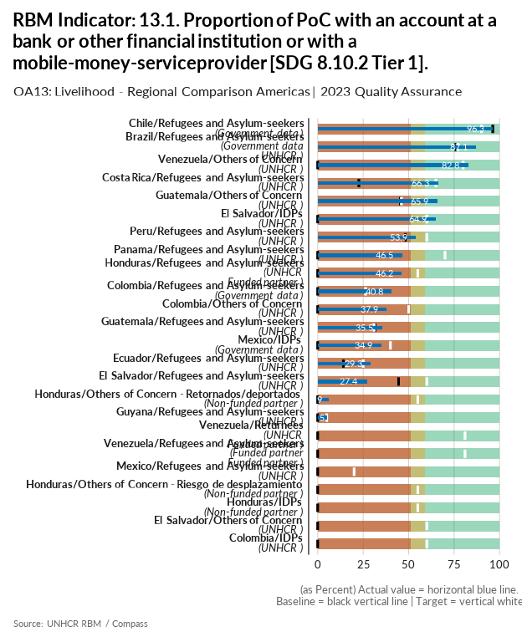

| group | baseline | actual | target | QA_logical | data_limitation |
| --- | --- | --- | --- | --- | --- |
| Brazil/Refugees and Asylum-seekers | 76 | 87.1 | 77 | Target value is below acceptable standard | Data limitation as it is a biased and not representative sample. |
| Chile/Refugees and Asylum-seekers | 96.3 | 96.3 | 90 | Target value is below the baseline - Target value is below acceptable standard | The National Migration Survey only includes people in a regular situation so the proportion of people for this indicator may be overestimated. As a reference, the percentage of the Venezuelan population in an irregular situation according to Sermig and INE estimates as of 31 December 2022 is 13%. |
| Colombia/Refugees and Asylum-seekers | 0 | 40.8 | 26.3 | Numerator for baseline is missing - Denominator for baseline is missing - Target value is below acceptable standard - More than 20% difference between Actual and Baseline | Numerador: Personas Migrantes con con cuenta de ahorros - corriente - / Total de personas reportadas |
| Colombia/Others of Concern | 0 | 37.9 | 50 | Numerator for baseline is missing - Denominator for baseline is missing - Target value is below acceptable standard - More than 40% difference between Target and Baseline | En la Encuesta de Calidad de Vida incluye variables sobre ciudadanía, lugar de nacimiento y lugar d residencia cinco años antes y se realizan las estimaciones de retornados basándose en los ciudadanos colombianos, incluidos los de doble nacionalidad. Numerador: Númeto de personas que usan banco, cajero automático o corresponsal bancario /Total de personas. |
| Colombia/IDPs | 0 | 0 | 60 | Numerator for Actual is missing - Denominator for Actual is missing - Numerator for baseline is missing - Denominator for baseline is missing - Target value is below acceptable standard - More than 40% difference between Target and Baseline | No hay información disponible para este indicador. Posiblemente se incluirá este indicador en la HFS. |
| Costa Rica/Refugees and Asylum-seekers | 22.6 | 66.3 | 65 | Target value is below acceptable standard - More than 40% difference between Target and Baseline - More than 20% difference between Actual and Baseline | Calculation methodology changed in 2023 using RMS module questions incorporated to CBI socio economic evaluation (targetting tool). 2211 households have been interviewed between september 22st and december 31st. |
| Ecuador/Refugees and Asylum-seekers | 14.1 | 29.3 | 25 | Target value is below acceptable standard | The increase reflects reality indeed. In 2023, UNCHR intensified partnership with financial service providers (FSPs) raising the number of 5 to 14 banks and cooperatives actively providing access to deposit accounts, payments, and credit for forcibly displaced population. Together with FSPs, UNHCR implemented 49 brigades in 15 localities to access financial services, 626 refugees were assisted for opening saving accounts. |
| El Salvador/IDPs | 0 | 64.9 | 60 | Numerator for baseline is missing - Denominator for baseline is missing - Target value is below acceptable standard - More than 40% difference between Target and Baseline - More than 20% difference between Actual and Baseline | - |
| El Salvador/Refugees and Asylum-seekers | 44.4 | 27.4 | 60 | Target value is below acceptable standard | Due an increase in the sample size, the indicator value shown a decrease from the previous year. While for baseline 36 survey were applied, in 2023 the quantity of surveys applied were 57. |
| El Salvador/Others of Concern | 0 | 0 | 60 | Numerator for Actual is missing - Denominator for Actual is missing - Numerator for baseline is missing - Denominator for baseline is missing - Target value is below acceptable standard - More than 40% difference between Target and Baseline | There are not data available for 2023. Resources are required to implement an RMS exercise in 2024. |
| Guatemala/Others of Concern | 45.4 | 65.9 | 46 | Target value is below acceptable standard | Although this change from 2022 to 2023 may not reflect reality we think that the value reported this year is accurate as most of OoC do not have the same administrative trouble that RAS face for this specific indicator. |
| Guatemala/Refugees and Asylum-seekers | 31.5 | 35.5 | 31 | Target value is below the baseline - Target value is below acceptable standard | Legal barriers to access of REF/AS to bank accounts and other financial services. |
| Guyana/Refugees and Asylum-seekers | 0 | 5 | 5 | Numerator for baseline is missing - Denominator for baseline is missing - Target value is below acceptable standard | - |
| Honduras/Refugees and Asylum-seekers | 0 | 46.2 | 55 | Numerator for baseline is missing - Denominator for baseline is missing - Target value is below acceptable standard - More than 40% difference between Target and Baseline - More than 20% difference between Actual and Baseline | Small sample of refugees and asylum-seekers surveyed through the RMS in collaboration with the National Migration Institute. Data is extrapolated to RAS population. |
| Honduras/Others of Concern - Retornados/deportados | 0 | 5.9 | 55 | Numerator for baseline is missing - Denominator for baseline is missing - Target value is below acceptable standard - More than 40% difference between Target and Baseline | Calculated through SEDESOL's government portal SIRBHO which provides bank account ownership rates on the vulnerable Honduran population aged 15+. The available data is from 15-19, then 20-24, and so on. This was projected and crossed with returnees that originally abandoned their homes due to violence. |
| Honduras/IDPs | 0 | 0 | 55 | Numerator for Actual is missing - Denominator for Actual is missing - Numerator for baseline is missing - Denominator for baseline is missing - Target value is below acceptable standard - More than 40% difference between Target and Baseline | Small sample of IDPs surveyed through the LIS baseline (before receiving the programme) conducted end of 2023 as its first step but was not representative enough to be reported. This exercise should continue during 2024 and more data will be collected to get a larger sample. |
| Honduras/Others of Concern - Riesgo de desplazamiento | 0 | 0 | 55 | Numerator for Actual is missing - Denominator for Actual is missing - Numerator for baseline is missing - Denominator for baseline is missing - Target value is below acceptable standard - More than 40% difference between Target and Baseline | A LIS exercise was initiated in collaboration with partners but we are still establishing the criteria to interview this population and implement it in 2024. |
| Mexico/IDPs | 0 | 34.9 | 40 | Numerator for baseline is missing - Denominator for baseline is missing - Target value is below acceptable standard | The IDP total population figure is different from that of the Annual Statistical Report as it is an estimate based on the expanded 2020 Census questionnaire that is applied to a representative sample and not to all persons. To calculate the required indicator an analysis of the 2020 Census extended questionnaire microdata was conducted. In particular, Q35-Labor Benefits, was considered. It is worth mentioning that the question serves as a proxy, no questions about the specific variables of the indicator were available. Only population occupied is considered. The calculation was made considering the estimate of PoC occupied with an account at a bank or other financial institution (48,148) with respect to the estimate of total PoC occupied (137,880). |
| Mexico/Refugees and Asylum-seekers | 0 | 0 | 20 | Numerator for Actual is missing - Denominator for Actual is missing - Numerator for baseline is missing - Denominator for baseline is missing - Target value is below acceptable standard | This indicator is left blank as requested by Result Manager. There is an available preliminary RMS result that relates only to Refugee population (this includes complementary protection beneficiaries). |
| Panama/Refugees and Asylum-seekers | 0 | 46.5 | 70 | Numerator for baseline is missing - Denominator for baseline is missing - Target value is below acceptable standard - More than 40% difference between Target and Baseline - More than 20% difference between Actual and Baseline | - |
| Peru/Refugees and Asylum-seekers | 48.2 | 53.9 | 60 | Target value is below acceptable standard | - |
| Venezuela/Others of Concern | 0 | 82.8 | 80 | Numerator for baseline is missing - Denominator for baseline is missing - Target value is below acceptable standard - More than 40% difference between Target and Baseline - More than 20% difference between Actual and Baseline | The calculation is based on the population that handles a banking instrument out of the total population aged 14 and over. |
| Venezuela/Refugees and Asylum-seekers | 0 | 0 | 81 | Numerator for Actual is missing - Denominator for Actual is missing - Numerator for baseline is missing - Denominator for baseline is missing - Target value is below acceptable standard - More than 40% difference between Target and Baseline | Data limitation. There is no data to indicate the proportion of Refugees with access to financial services. Venezuela operation does not collect information about socio-economic condition of refugees. |
| Venezuela/Returnees | 0 | 0 | 81 | Numerator for Actual is missing - Denominator for Actual is missing - Numerator for baseline is missing - Denominator for baseline is missing - Target value is below acceptable standard - More than 40% difference between Target and Baseline | Data limitation. There is no data to indicate the proportion of Refugees with access to financial services. Venezuela operation does not collect information about socio-economic condition of returnees. |

[Link to indicator metadata](https://intranet.unhcr.org/content/dam/unhcr/intranet/protection-operations/compass/en/guidance/3/coreindicatorsmetadata/2.0%20Core%20Indicator%20Metadata%2004%2010%202021.pdf#page=134)

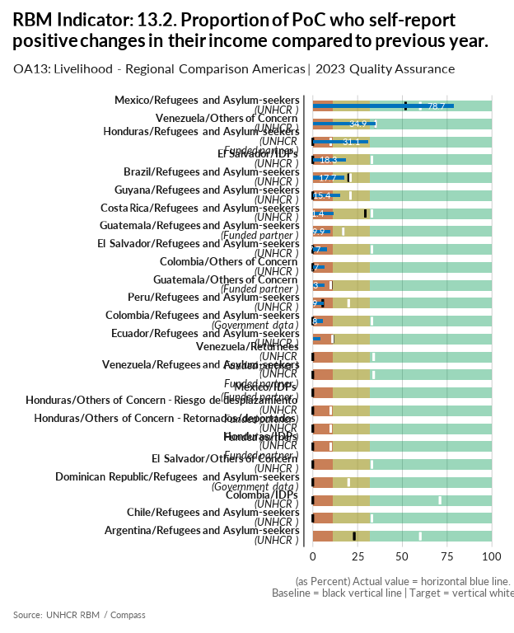

| group | baseline | actual | target | QA_logical | data_limitation |
| --- | --- | --- | --- | --- | --- |
| Argentina/Refugees and Asylum-seekers | 23.1 | 0 | 60 | Numerator for Actual is missing - Denominator for Actual is missing - Target value is below acceptable standard | The results of the Livelihood Iinformation System Surveys, due to their implementation cycle, will be available from March 2024, but it is possible to project some numbers based on the final reports of our partner agencies. |
| Brazil/Refugees and Asylum-seekers | 20 | 17.7 | 21 | Target value is below acceptable standard | - |
| Chile/Refugees and Asylum-seekers | 0 | 0 | 33 | Numerator for Actual is missing - Denominator for Actual is missing - Numerator for baseline is missing - Denominator for baseline is missing - Target value is below acceptable standard | No data available. |
| Colombia/Others of Concern | 0 | 6.7 | - | Missing Target - Numerator for baseline is missing - Denominator for baseline is missing | En la Encuesta de Calidad de Vida incluye variables sobre ciudadanía, lugar de nacimiento y lugar d residencia cinco años antes y se realizan las estimaciones de retornados basándose en los ciudadanos colombianos, incluidos los de doble nacionalidad. Numerador: Número de personass que consideran que mejoró la situación económica del hogar / Denominador: Total de personas reportadas en esta variable. |
| Colombia/Refugees and Asylum-seekers | 0 | 5.8 | 33 | Numerator for baseline is missing - Denominator for baseline is missing - Target value is below acceptable standard | En la Encuesta de Calidad de Vida se incluye variables sobre lugar de nacimiento y país de origen. Se realizan las estimaciones de venezolanos reportados en la encuesta con estas variables. Numerador: Número de venezolanos que considera que mejoro la situación económica del hogar / Denominador: Total de venezolanos reportados en esta variable. |
| Colombia/IDPs | 0 | 0 | 71 | Numerator for Actual is missing - Denominator for Actual is missing - Numerator for baseline is missing - Denominator for baseline is missing - Target value is below acceptable standard - More than 40% difference between Target and Baseline | No hay información disponible para este indicador. Posiblemente se incluirá este indicador en la HFS. |
| Costa Rica/Refugees and Asylum-seekers | 29.3 | 11.4 | 33 | Target value is below acceptable standard | Calculation methodology changed in 2023 using RMS module questions incorporated to CBI socio economic evaluation (targetting tool). 2211 households have been interviewed between september 22st and december 31st. |
| Dominican Republic/Refugees and Asylum-seekers | 0 | 0 | 20 | Numerator for Actual is missing - Denominator for Actual is missing - Numerator for baseline is missing - Denominator for baseline is missing - Target value is below acceptable standard | No data |
| Ecuador/Refugees and Asylum-seekers | 11.2 | 4.4 | 11 | Target value is below the baseline - Target value is below acceptable standard | RMS 2023 does include variables INC01 and INC02 this year and we followed the script exactly as it was supposed to. We just meant that this indicator measures if PoC can afford more goods/services, even if income decreases or stays the same, not only if income increases. |
| El Salvador/IDPs | 0 | 18.3 | 33 | Numerator for baseline is missing - Denominator for baseline is missing - Target value is below acceptable standard | - |
| El Salvador/Refugees and Asylum-seekers | 0 | 7.7 | 33 | Numerator for baseline is missing - Denominator for baseline is missing - Target value is below acceptable standard | Due 2022 RMS an smaller sample size was taken, the value for baseline is not comparable to actual 2023, however the data we had available at the time was 14% |
| El Salvador/Others of Concern | 0 | 0 | 33 | Numerator for Actual is missing - Denominator for Actual is missing - Numerator for baseline is missing - Denominator for baseline is missing - Target value is below acceptable standard | There are not data available for 2023. Resources are required to implement an RMS exercise in 2024. |
| Guatemala/Refugees and Asylum-seekers | 16.9 | 9.9 | 17 | Target value is below acceptable standard | - |
| Guatemala/Others of Concern | 10.1 | 6.3 | 10 | Target value is below the baseline - Target value is below acceptable standard | The cost of the basic food basket in Guatemala in 2023 (Q.3,735.73) increased by 8.12% compared to 2022 (Q.3,454.98), while minimum wages increased by only 3.68% (2022: Q.3,209.24; 2023: 3,327.56), representing for the population for 2023 an increase in the prices of products compared to 2022, taking into account that salaries in 2023 are 12.27% below the cost of the basic basket (7.6% below in 2022). |
| Guyana/Refugees and Asylum-seekers | 0 | 15.4 | 21 | Numerator for baseline is missing - Denominator for baseline is missing - Target value is below acceptable standard | - |
| Honduras/Refugees and Asylum-seekers | 0 | 31.1 | 10 | Numerator for baseline is missing - Denominator for baseline is missing - Target value is below acceptable standard | Small sample of refugees and asylum-seekers surveyed through the RMS in collaboration with the National Migration Institute. Data is extrapolated to RAS population. |
| Honduras/IDPs | 0 | 0 | 10 | Numerator for Actual is missing - Denominator for Actual is missing - Numerator for baseline is missing - Denominator for baseline is missing - Target value is below acceptable standard | Small sample of IDPs surveyed through the LIS baseline (before receiving the programme) conducted end of 2023 as its first step but was not representative enough to be reported. This exercise should continue during 2024 and more data will be collected to get a larger sample. Otherwise, we would collect poverty rates between the two EPHPM rounds and calculate the difference. |
| Honduras/Others of Concern - Retornados/deportados | 0 | 0 | 10 | Numerator for Actual is missing - Denominator for Actual is missing - Numerator for baseline is missing - Denominator for baseline is missing - Target value is below acceptable standard | Data from the EPHPM could not be extrapolated to this population yet. |
| Honduras/Others of Concern - Riesgo de desplazamiento | 0 | 0 | 10 | Numerator for Actual is missing - Denominator for Actual is missing - Numerator for baseline is missing - Denominator for baseline is missing - Target value is below acceptable standard | Data from the EPHPM could not be extrapolated to this population yet. |
| Mexico/Refugees and Asylum-seekers | 51.8 | 78.7 | 60 | Target value is below acceptable standard | Data comes from UNHCR Relocation programme monitoring: considers status one month before relocation, and months 1 and 6 following relocation Same calculation and indicator as for user-defined indicator: % of relocated cases who managed to increase their income thanks to integration support |
| Mexico/IDPs | 0 | 0 | - | Missing Target - Numerator for Actual is missing - Denominator for Actual is missing - Numerator for baseline is missing - Denominator for baseline is missing | No data available for the moment because the main source for this population (Census 2020) does not include a question related to this indicator. Targets cannot be calculated because there is no baseline available. Data is expected to be collected next year through Funded Partner reports. |
| Peru/Refugees and Asylum-seekers | 5.5 | 5.9 | 20 | Target value is below acceptable standard | - |
| Venezuela/Others of Concern | 34.9 | 34.9 | 35 | Target value is below acceptable standard | The calculation is based on the population residing in which households reported an increase in income between January 2020 and January 2021 |
| Venezuela/Refugees and Asylum-seekers | 0 | 0 | 34 | Numerator for Actual is missing - Denominator for Actual is missing - Numerator for baseline is missing - Denominator for baseline is missing - Target value is below acceptable standard | Data limitation. There is no data to indicate changes in refugees' income. Venezuela operation does not collect information about socio-economic condition of refugees. |
| Venezuela/Returnees | 0 | 0 | 34 | Numerator for Actual is missing - Denominator for Actual is missing - Numerator for baseline is missing - Denominator for baseline is missing - Target value is below acceptable standard | Data limitation. There is no data to indicate changes in returnees' income. Venezuela operation does not collect information about socio-economic condition of returnees. |

[Link to indicator metadata](https://intranet.unhcr.org/content/dam/unhcr/intranet/protection-operations/compass/en/guidance/3/coreindicatorsmetadata/2.0%20Core%20Indicator%20Metadata%2004%2010%202021.pdf#page=136)

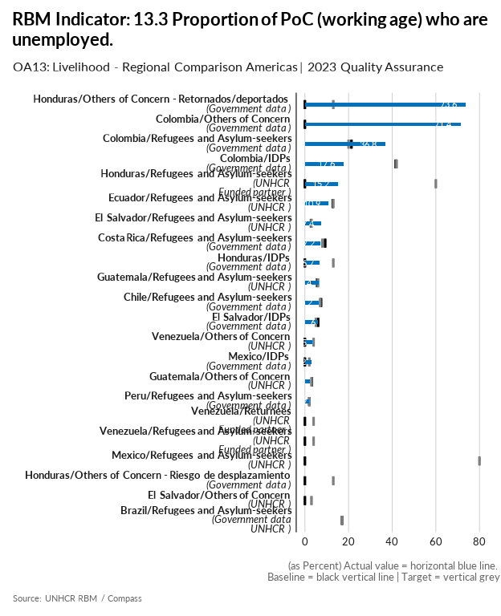

| group | baseline | actual | target | QA_logical | data_limitation |
| --- | --- | --- | --- | --- | --- |
| Brazil/Refugees and Asylum-seekers | 17 | 0 | 17 | Numerator for Actual is missing - Denominator for Actual is missing | The expected data source for this indicator was the National Census. However, the government has not yet shared its results, although the data collection process took place in 2022. Apart from the delay, there is an excessive amount of time since the data collection took place, meaning that the results might no longer represent the state of forcibly displaced and stateless persons in Brazil. This indicator was also not included in the RMS under the assumption that the government was going to soon share their results, which unfortunately it did not. |
| Chile/Refugees and Asylum-seekers | 7.4 | 6.2 | 7 |  | Calculation was made using CASEN 2022 expanded sample following the unemployment criteria of the survey. Employed persons are defined as those who worked at least one hour in the week prior to the survey. Decent employment criteria are not considered for the definition of employed and no distinction is made between formal and informal employment. |
| Colombia/Others of Concern | 0 | 71.4 | - | Missing Target - Numerator for baseline is missing - Denominator for baseline is missing - More than 20% difference between Actual and Baseline | En la Encuesta de Calidad de Vida incluye variables sobre ciudadanía, lugar de nacimiento y lugar d residencia cinco años antes y se realizan las estimaciones de retornados basándose en los ciudadanos colombianos, incluidos los de doble nacionalidad. Numerador: Personas que perdieron su trabajo/Denominador: Total de personas en edad de trabajar |
| Colombia/Refugees and Asylum-seekers | 21.3 | 36.8 | 20 |  | Tasa de desocupados venezolanos |
| Colombia/IDPs | 41.6 | 17.6 | 42 |  | Tasa de desocupados Desplazados Internos |
| Costa Rica/Refugees and Asylum-seekers | 9.3 | 7.2 | 8 |  | ENAHO2023 - 2,148 nicaraguans surveyed.Weighted result.Ver https://github.com/UNHCR-CostaRica/ENAHOrbm Numerator= working age ASR population 2023 * % enrrollment & Denominator=working age ASR population 2023 |
| Ecuador/Refugees and Asylum-seekers | 12.7 | 10.9 | 13 |  | Numerator: # of ppl who replied Yes to the reference question in the household survey//Denominator: Total people in the household survey |
| El Salvador/Refugees and Asylum-seekers | 2.8 | 7.4 | 3 |  | - |
| El Salvador/IDPs | 6 | 6 | 5 |  | Available data from the last IDP profiling exercise from 2016; Data will be updated when EHPM be officially published in July/August 2024 |
| El Salvador/Others of Concern | 0 | 0 | 3 | Numerator for Actual is missing - Denominator for Actual is missing - Numerator for baseline is missing - Denominator for baseline is missing | There are not data available for 2023. Resources are required to implement an RMS exercise in 2024. |
| Guatemala/Refugees and Asylum-seekers | 5.6 | 6.4 | 6 |  | - |
| Guatemala/Others of Concern | 3.2 | 2.4 | 3 |  | This indicator measures unemployment, so we surpassed the target. |
| Honduras/Others of Concern - Retornados/deportados | 0 | 73.6 | 13 | Numerator for baseline is missing - Denominator for baseline is missing - More than 20% difference between Actual and Baseline | Calculated through SEDESOL's government portal SIRBHO which provides unemployment rates on the vulnerable Honduran population at working age (15-69). This is because legal employment in Honduras starts from 15 years. This was projected and crossed with returnees that originally abandoned their homes due to violence. |
| Honduras/Refugees and Asylum-seekers | 0 | 15.2 | 60 | Numerator for baseline is missing - Denominator for baseline is missing - More than 40% difference between Target and Baseline | Small sample of refugees and asylum-seekers surveyed through the RMS in collaboration with the National Migration Institute. Data is extrapolated to RAS population. |
| Honduras/IDPs | 0 | 6.7 | 13 | Numerator for baseline is missing - Denominator for baseline is missing | This data is from National Statistics Institute's (INE) EPHPM Q1-Q3 survey data. We are still pending the consolidated data for the whole year (including Q4) but did not receive it yet. |
| Honduras/Others of Concern - Riesgo de desplazamiento | 0 | 0 | 13 | Numerator for Actual is missing - Denominator for Actual is missing - Numerator for baseline is missing - Denominator for baseline is missing | Challenges were faced in collecting this data. In 2024 criteria will be reviewed with bureau to identify how to collect this information. |
| Mexico/IDPs | 0 | 3.2 | 2 | Numerator for baseline is missing - Denominator for baseline is missing | The IDP total population figure is different from that of the ASR as it is an estimate based on the expanded 2020 Census questionnaire that is applied to a representative sample and not to all persons. To calculate the required indicator an analysis of the 2020 Census extended questionnaire microdata was conducted. In particular, the following questions were considered: Q30-Activity Condition (this means if a person was employed) and Q31-Activity Contidition Check (as a proxy to calculate unemployment). Only people 15 years and older were considered (working age). The calculation was made considering the estimate of PoC aged 15 and over who are unemployed (4,935) with respect to the estimate of PoC employed and unemployed (155,790). |
| Mexico/Refugees and Asylum-seekers | 0 | 0 | 80 | Numerator for Actual is missing - Denominator for Actual is missing - Numerator for baseline is missing - Denominator for baseline is missing - More than 40% difference between Target and Baseline | This indicator is left blank as requested by Result Manager. There is an available preliminary RMS result that relates only to Refugee population (this includes complementary protection beneficiaries). |
| Peru/Refugees and Asylum-seekers | 2 | 2 | 2 |  | Data for baseline and actual values comes from ENPOVE 2022. This refers only to unemployment, not subemployment (which at a national level stands around 47% of the economically active population). |
| Venezuela/Others of Concern | 0 | 3.5 | 4 | Numerator for baseline is missing - Denominator for baseline is missing | The calculation is based on the economically active population aged 10 and over that is unemployed out of the total active population in that age range. |
| Venezuela/Refugees and Asylum-seekers | 0 | 0 | 4 | Numerator for Actual is missing - Denominator for Actual is missing - Numerator for baseline is missing - Denominator for baseline is missing | Data limitation. There is no data to indicate the proportion of Refugees unemployment. Venezuela operation does not collect information about socio-economic condition of refugees. |
| Venezuela/Returnees | 0 | 0 | 4 | Numerator for Actual is missing - Denominator for Actual is missing - Numerator for baseline is missing - Denominator for baseline is missing | Data limitation. There is no data to indicate the proportion of returnee's unemployment. Venezuela operation does not collect information about socio-economic condition of returnees. |

[Link to indicator metadata](https://intranet.unhcr.org/content/dam/unhcr/intranet/protection-operations/compass/en/guidance/3/coreindicatorsmetadata/2.0%20Core%20Indicator%20Metadata%2004%2010%202021.pdf#page=139)

## Social Protection

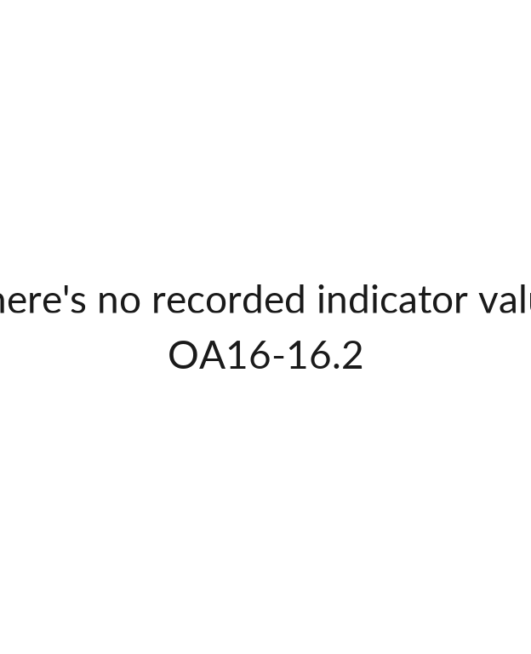

## [1] ""

[Link to indicator metadata](https://intranet.unhcr.org/content/dam/unhcr/intranet/protection-operations/compass/en/guidance/3/coreindicatorsmetadata/2.0%20Core%20Indicator%20Metadata%2004%2010%202021.pdf#page=156)