Community assets and capacity mapping

Elena Seydel

18 April 2017

Table of Contents

1) Data load 3

2) Introductory questions (to be filled by surveyor) 3

2.1) Status of surveyor 3

2.2) Country where mapping takes place 3

2.3) Governorate/District where mapping takes place 4

2.4) City where mapping takes place 4

2.5) Type of collaborating community in this mapping 5

2.6) List of collaborating entities (for internal use only) 5

3) Community demographics & structure 6

3.1) Community type (formal/informal/individual) 6

3.2) Demographics of communities (informal & formal) 6

3.2.1) Way of establishment 6

3.2.2) Community structure 7

3.2.3) Membership requirements 7

3.2.4) Members 8

3.2.5) Community size 8

3.2.6) Proportion of female, elderly, children within the community 9

3.2.7) Ethical standards in the community 9

3.3) Demographics of engaged individuals 10

3.3.1) Sex 10

3.3.2) Age* 10

3.3.3) Nationality 10

4) Community work & services 11

4.1) Working area 11

Prioritized working area 11

4.2) Community services 12

Prioritized community services 12

4.3) Recognition of engaged individual (entity = individual) within the community 12

4.4) Skills of enganged individual (entity = individual) 13

4.5) Talents of enganged individual (entity = individual) 14

5) Referrals* 14

6) Targeted groups 14

6.1) Percent of targeted groups 14

6.2) Specific groups of concern 15

7) Active community members 15

7.1) Type of active community members 15

7.2) Duration of community work 16

8) Communication channels 16

8.1) Type of used communication shannels 16

8.2) List of manual entries of specific communication channels 17

9) Meeting space 17

9.1) Type of meeting space 17

9.2) Type of access to meeting space 18

9.3) Conduciveness of meeting space 18

10) Community challenges 19

11) Community collaboration 19

11.1) Reward to motivate community work 19

11.2) Collaboration with UNHCR 20

12) Contact details (for internal use only) 20

# 1) Data load

# 2) Introductory questions (to be filled by surveyor)

## 2.1) Status of surveyor

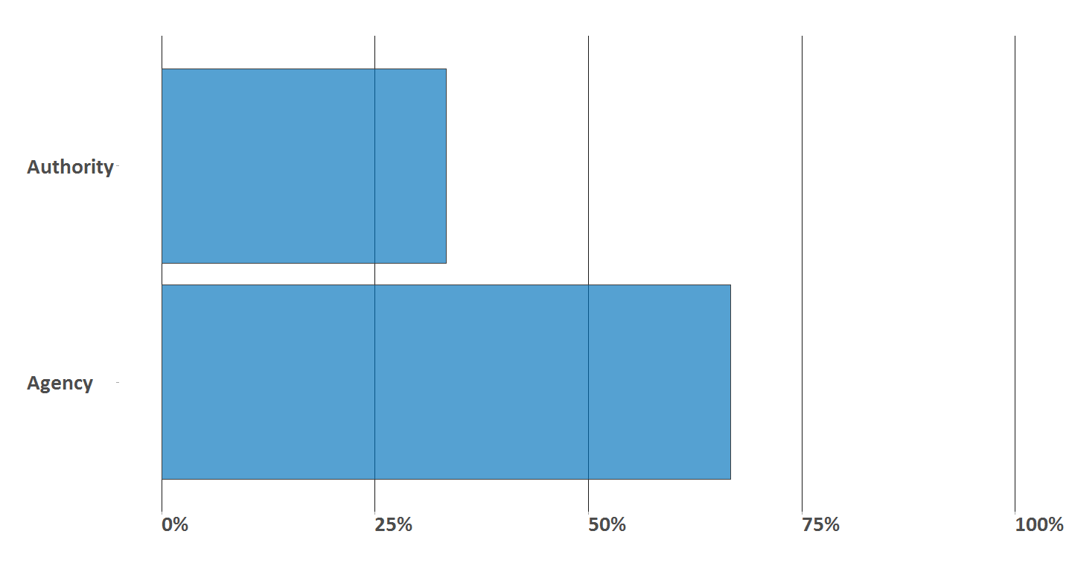

## 2.2) Country where mapping takes place

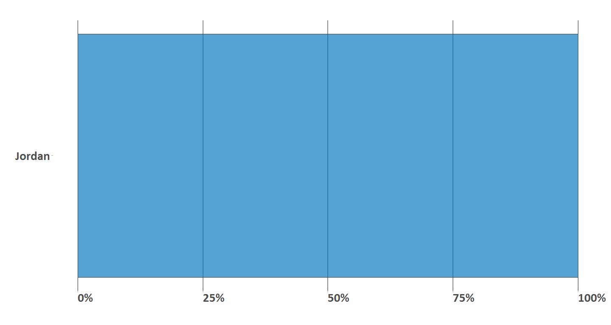

## 2.3) Governorate/District where mapping takes place

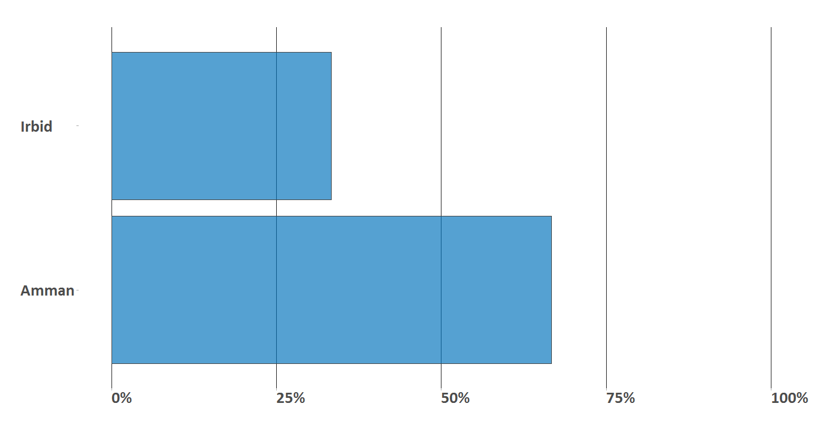

## 2.4) City where mapping takes place

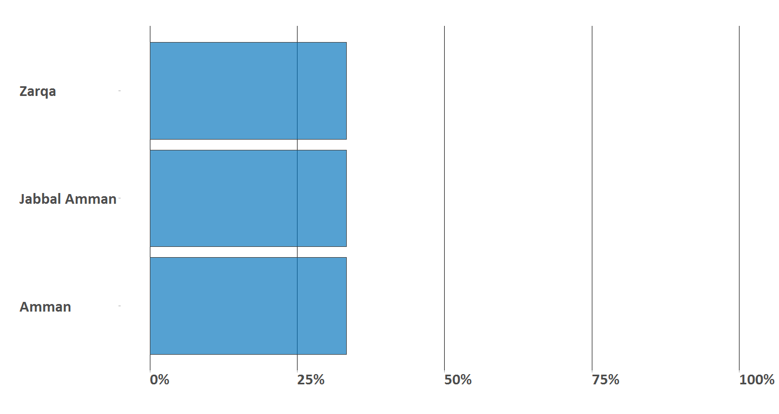

## 2.5) Type of collaborating community in this mapping

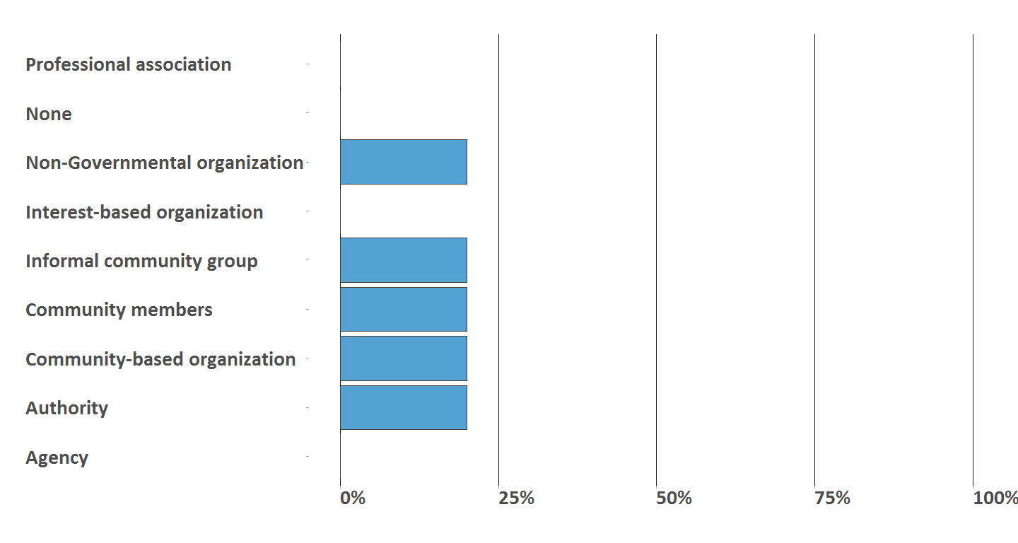

## 2.6) List of collaborating entities (for internal use only)

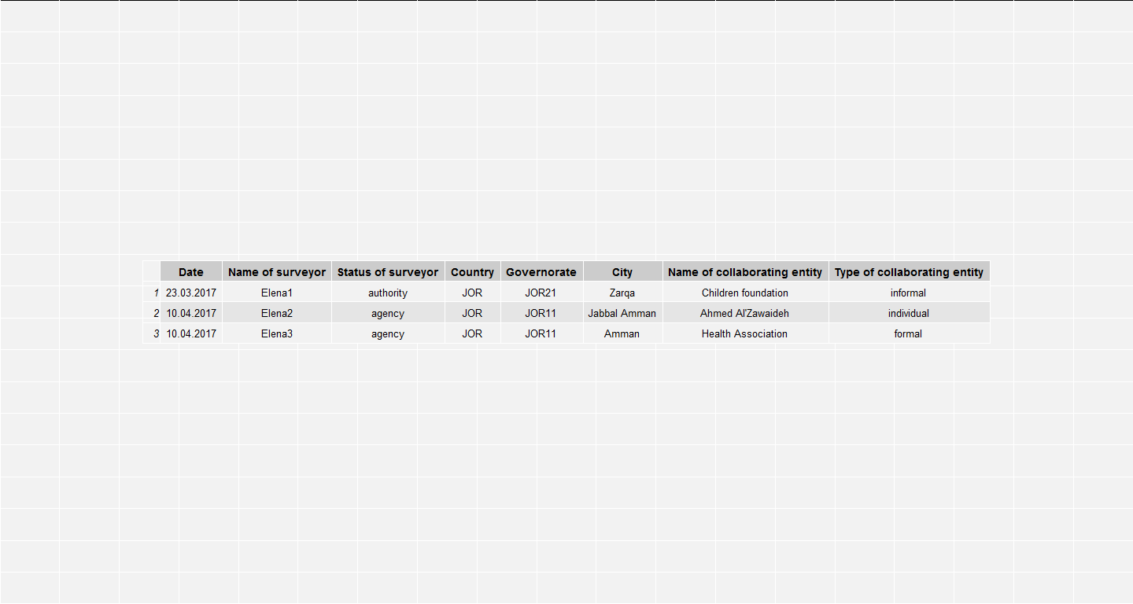

# 3) Community demographics & structure

## 3.1) Community type (formal/informal/individual)

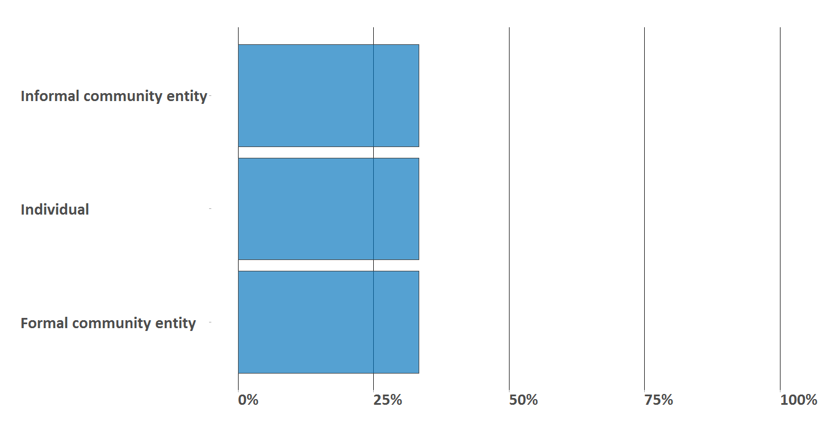

## 3.2) Demographics of communities (informal & formal)

## 3.2.1) Way of establishment

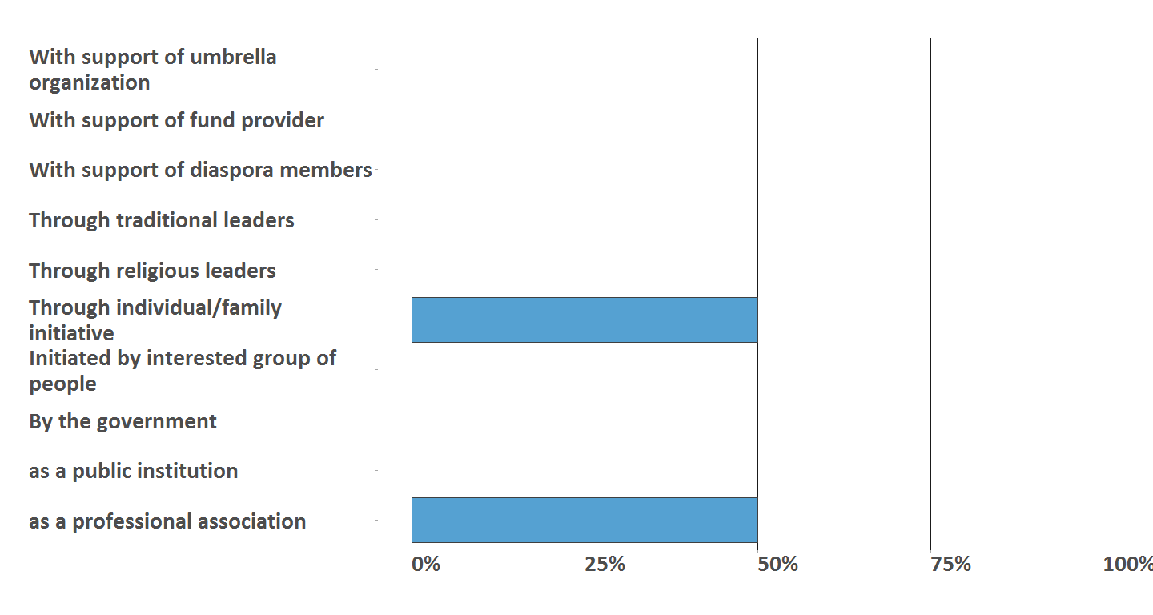

## 3.2.2) Community structure

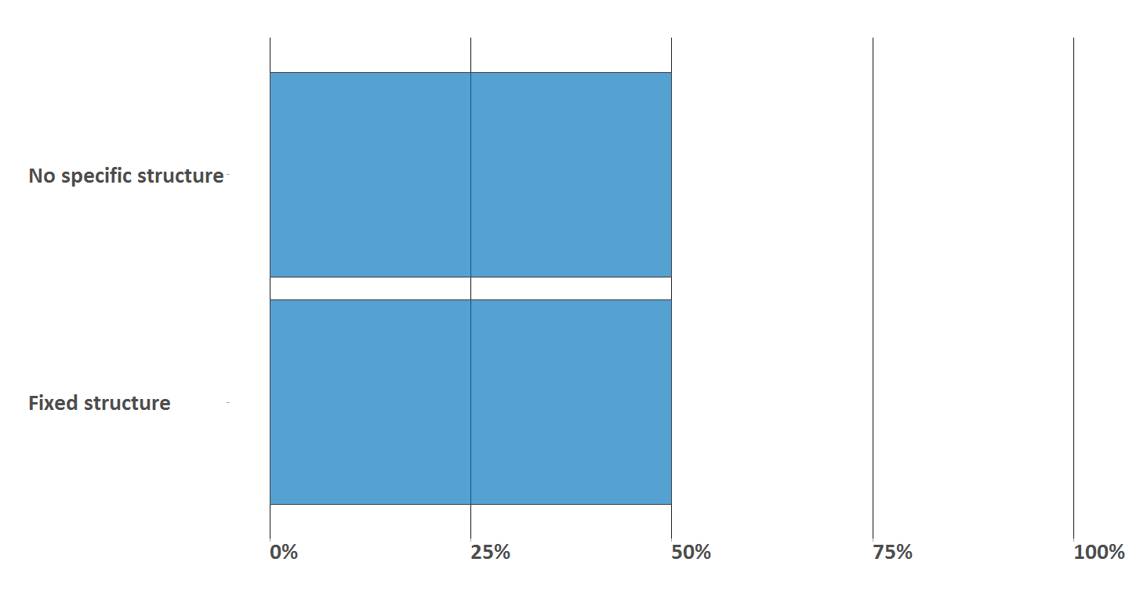

## 3.2.3) Membership requirements

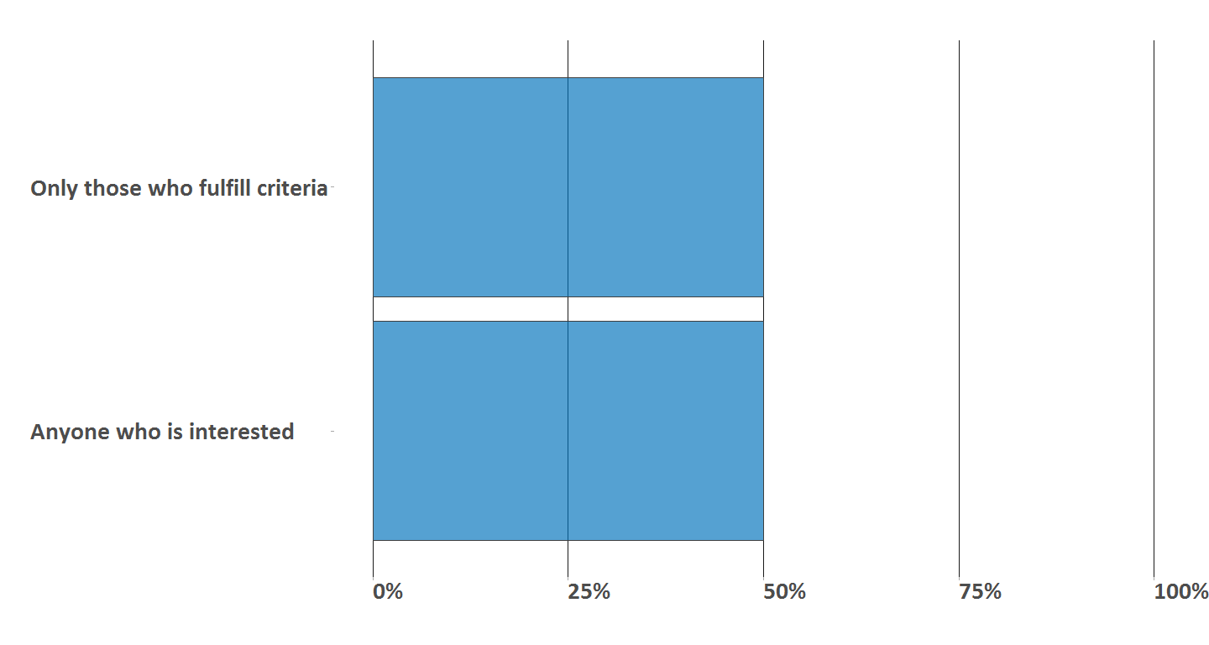

## 3.2.4) Members

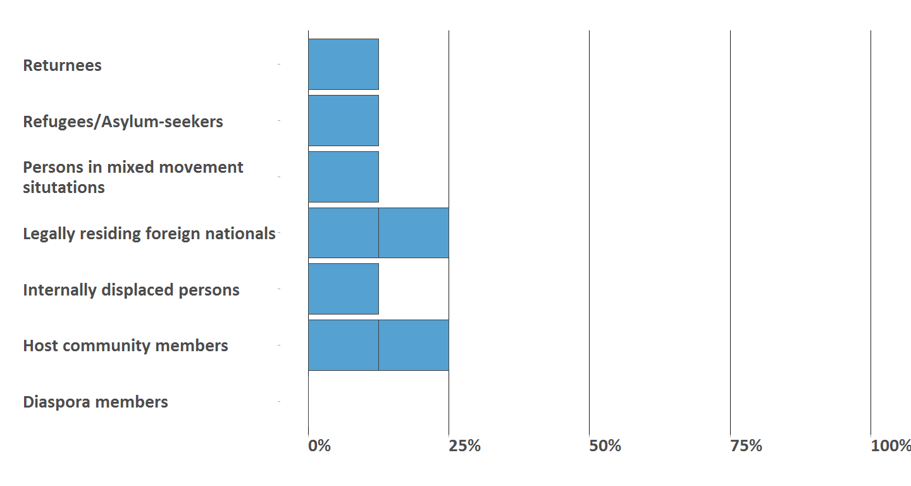

## 3.2.5) Community size

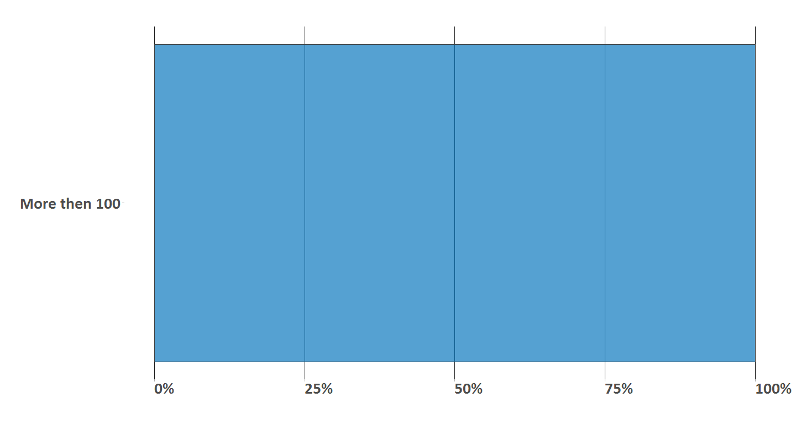

## 3.2.6) Proportion of female, elderly, children within the community

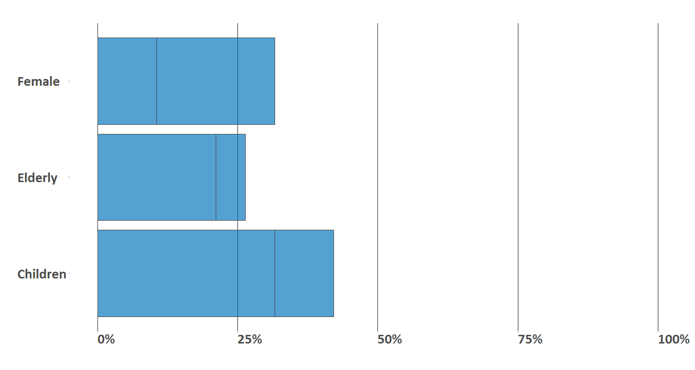

## 3.2.7) Ethical standards in the community

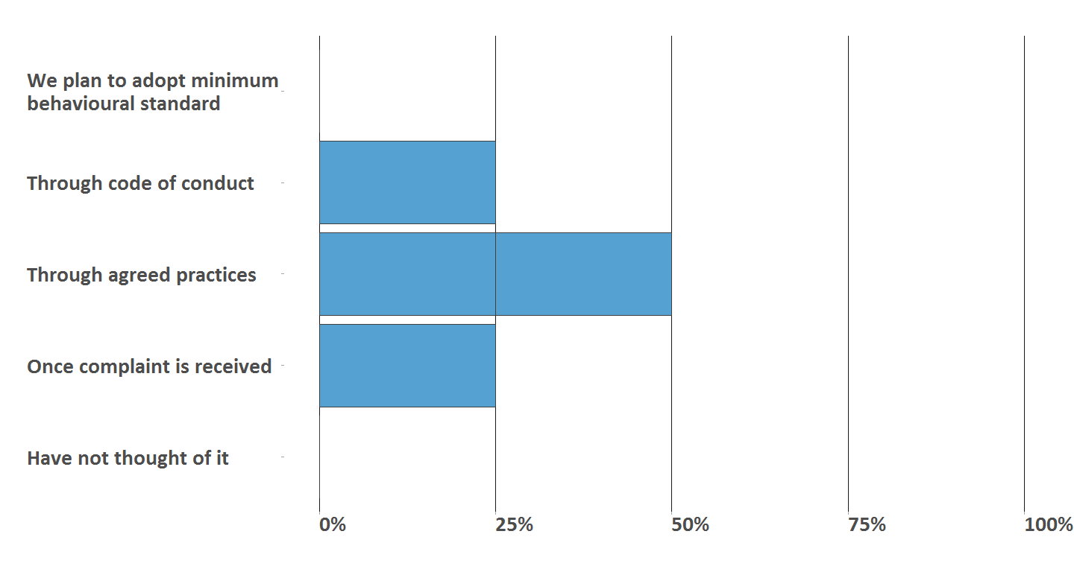

## 3.3) Demographics of engaged individuals

## 3.3.1) Sex

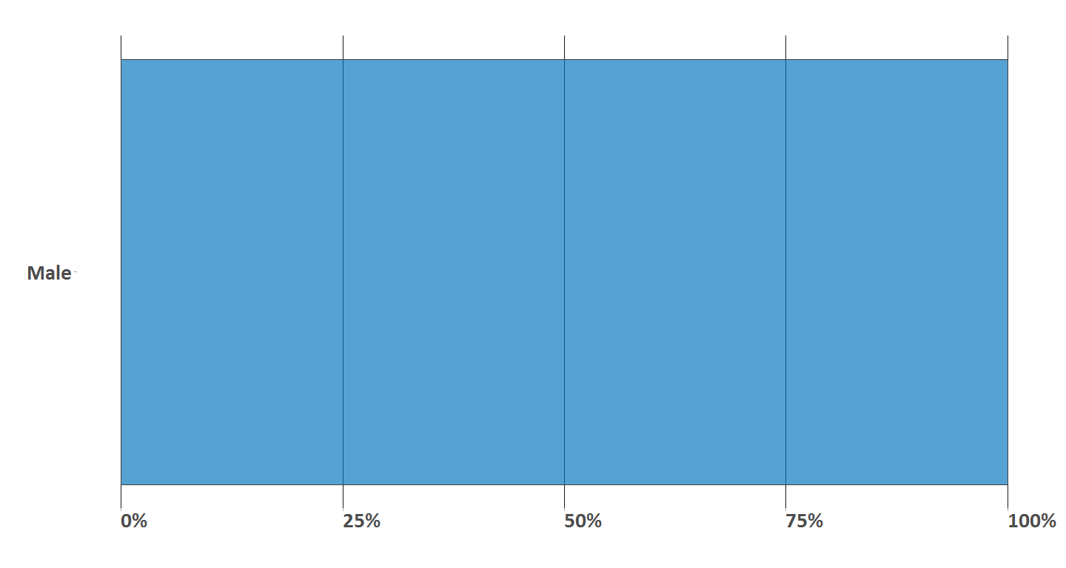

## 3.3.2) Age*

## 3.3.3) Nationality

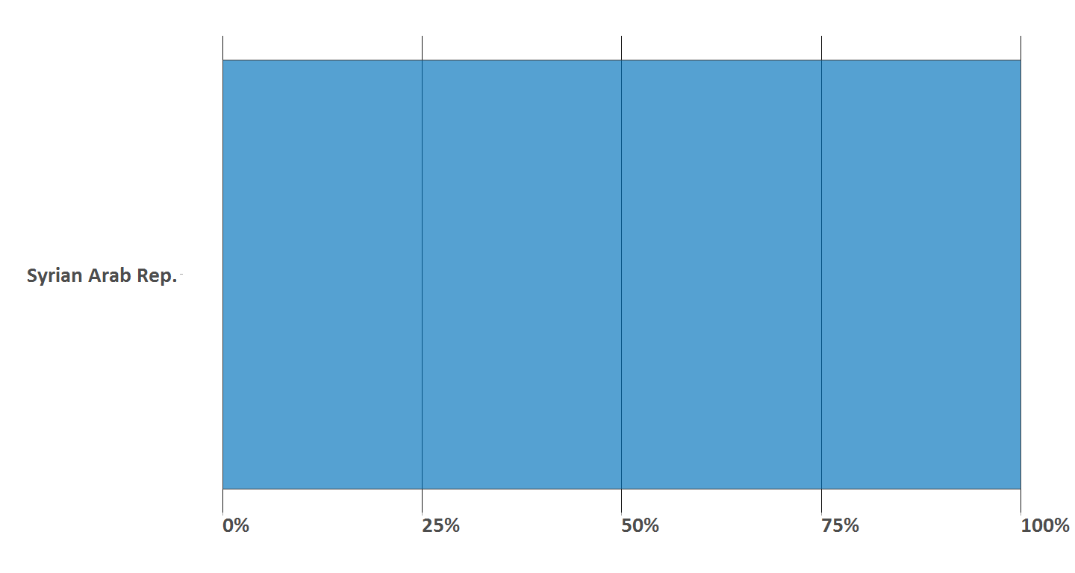

# 4) Community work & services

## 4.1) Working area

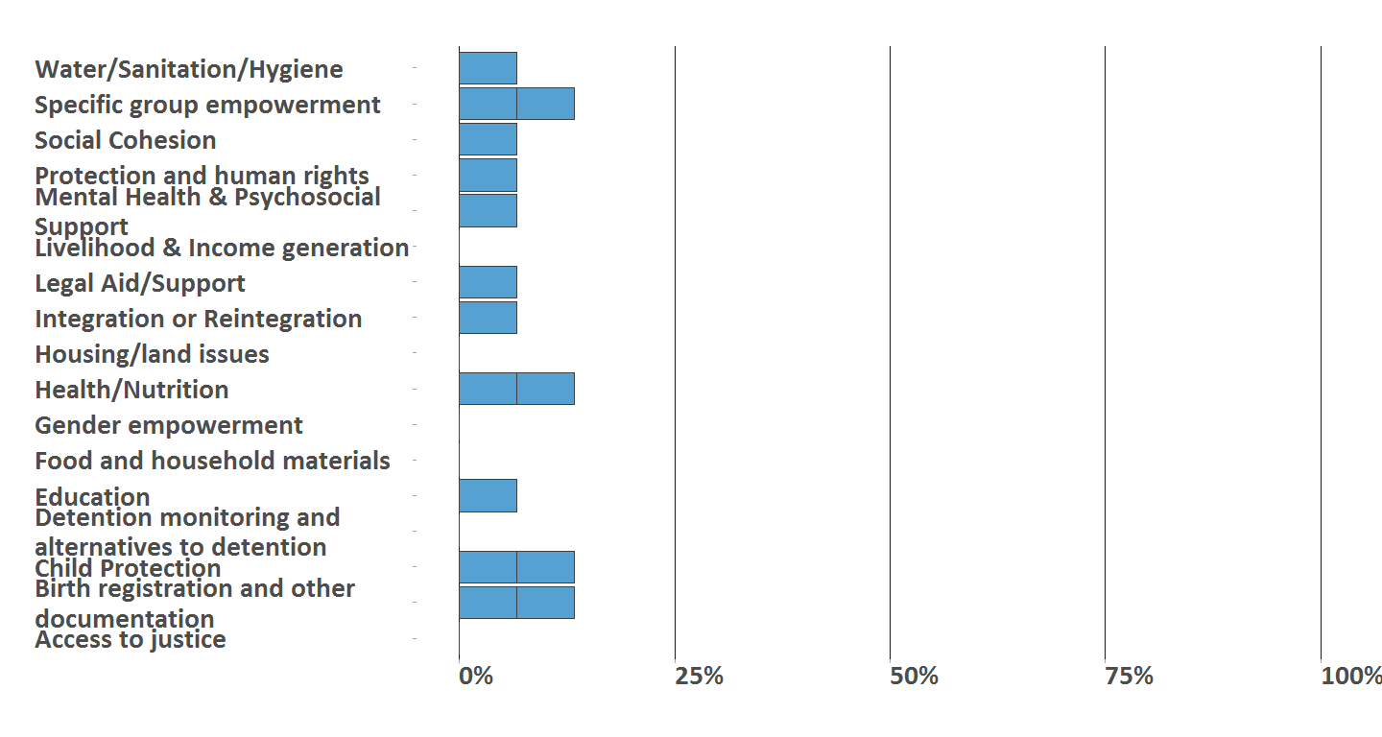

## Prioritized working area

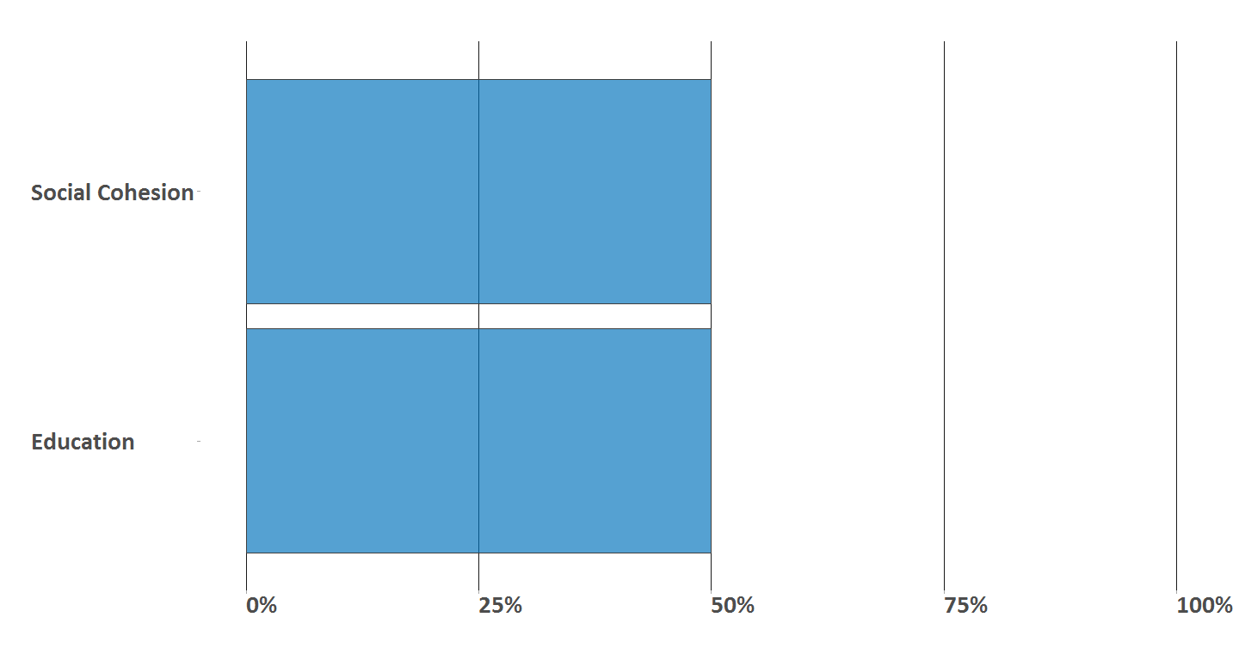

## 4.2) Community services

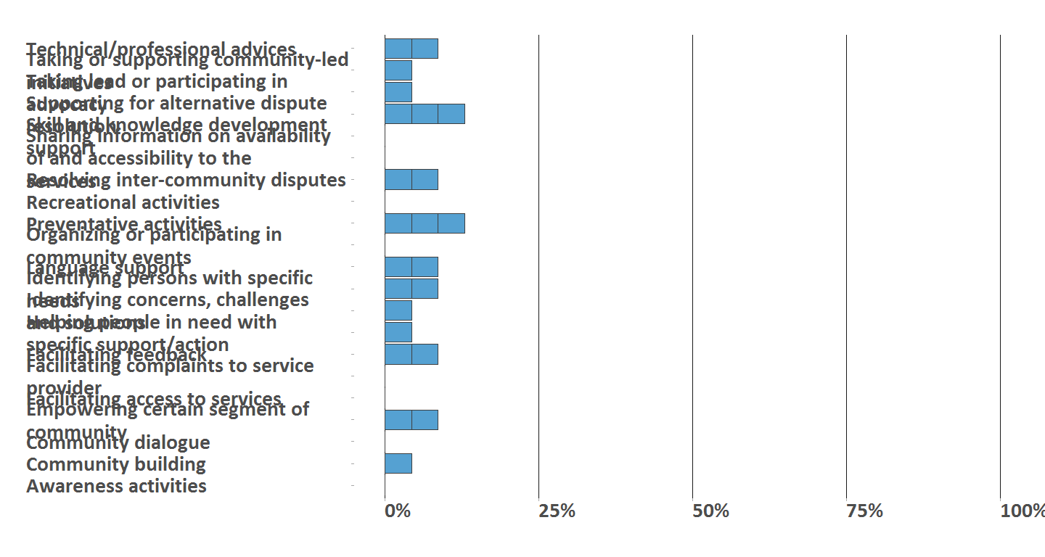

## Prioritized community services

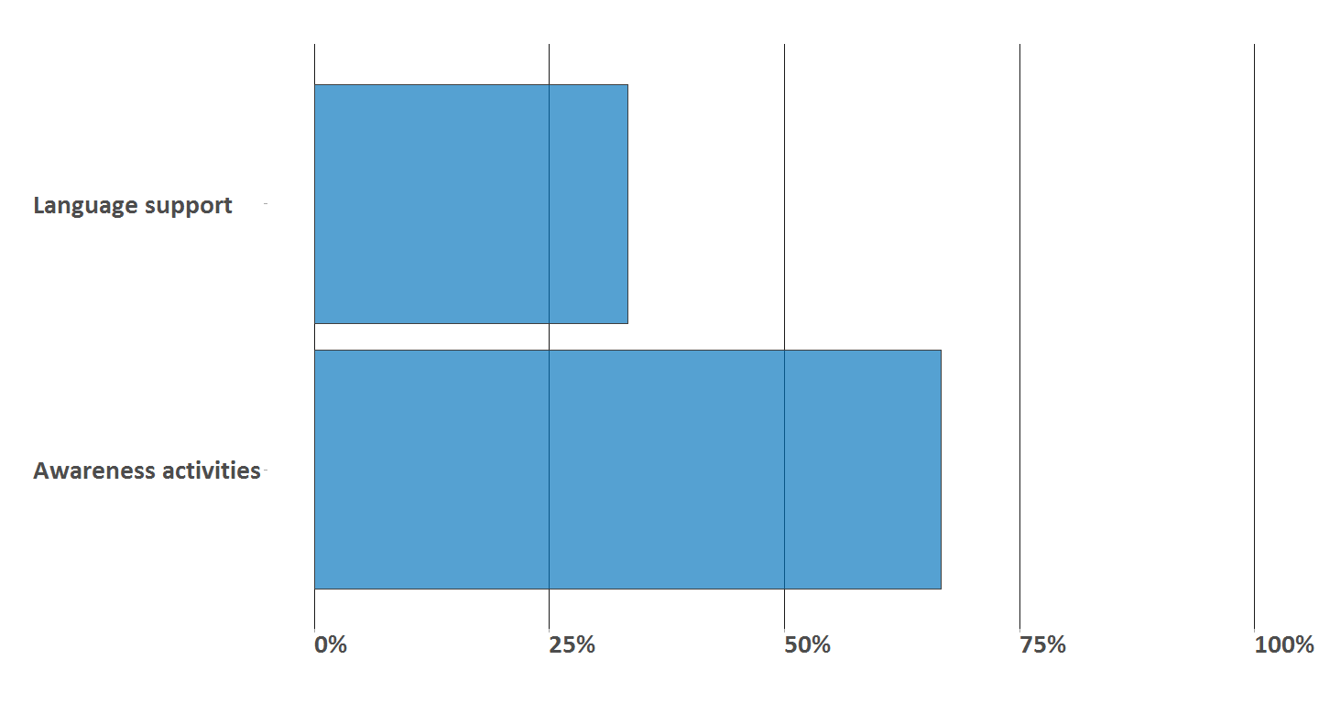

## 4.3) Recognition of engaged individual (entity = individual) within the community

## Warning: Removed 48 rows containing missing values (position_stack).

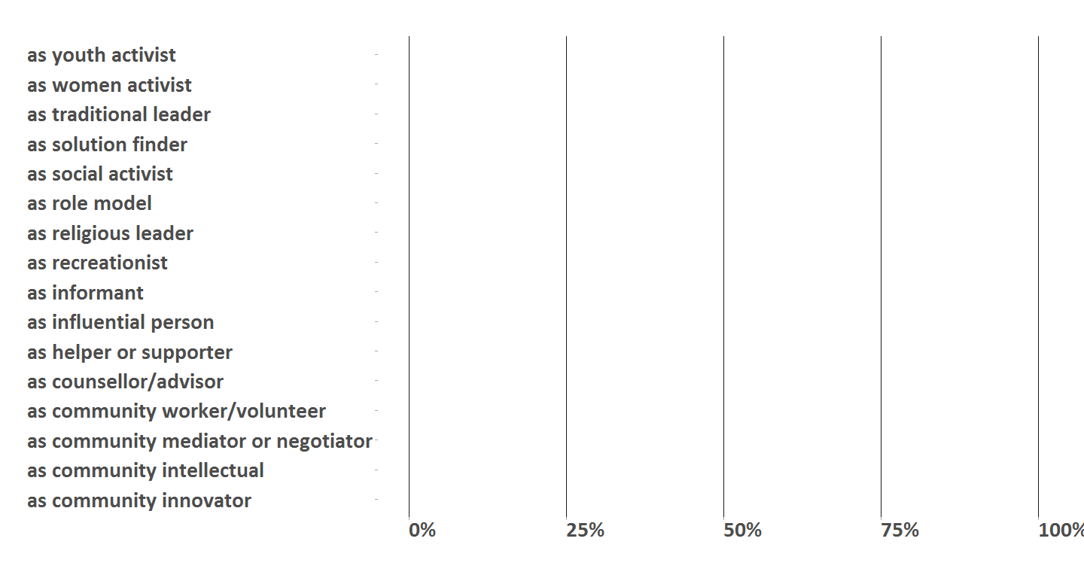

## 4.4) Skills of enganged individual (entity = individual)

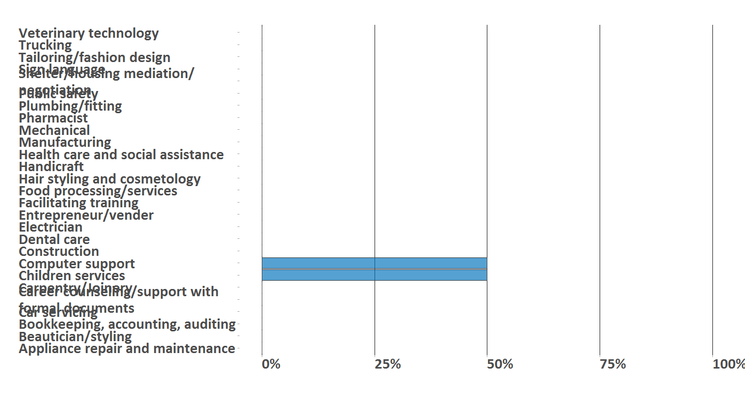

## 4.5) Talents of enganged individual (entity = individual)

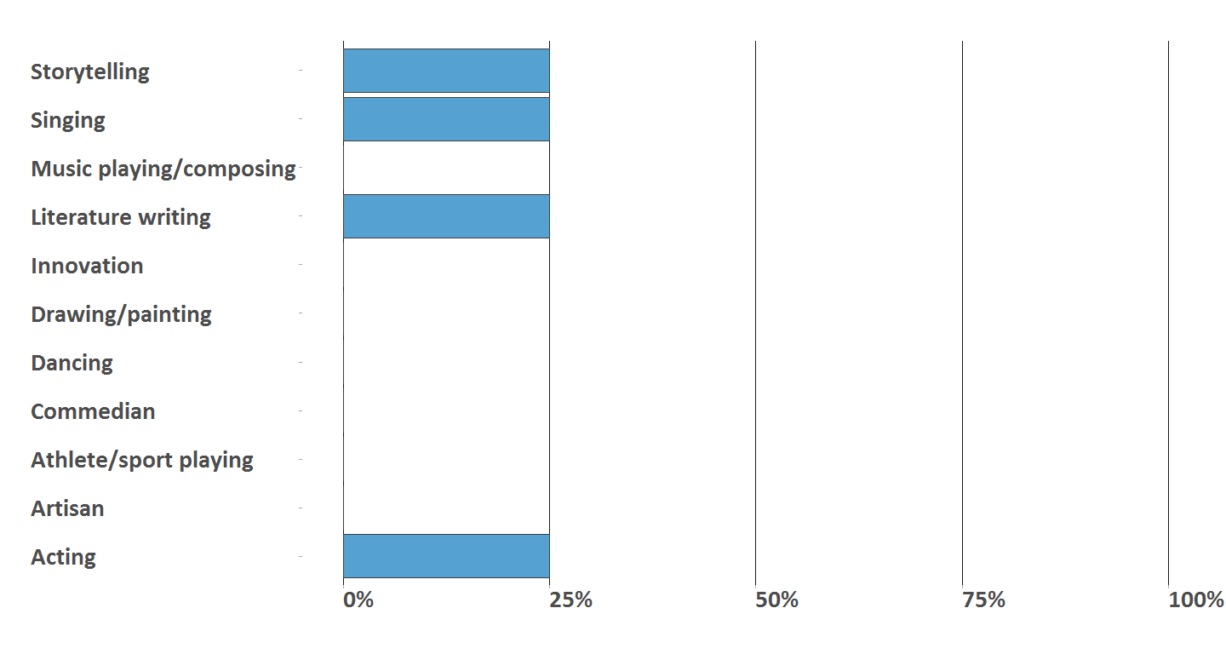

# 5) Referrals*

# 6) Targeted groups

## 6.1) Percent of targeted groups

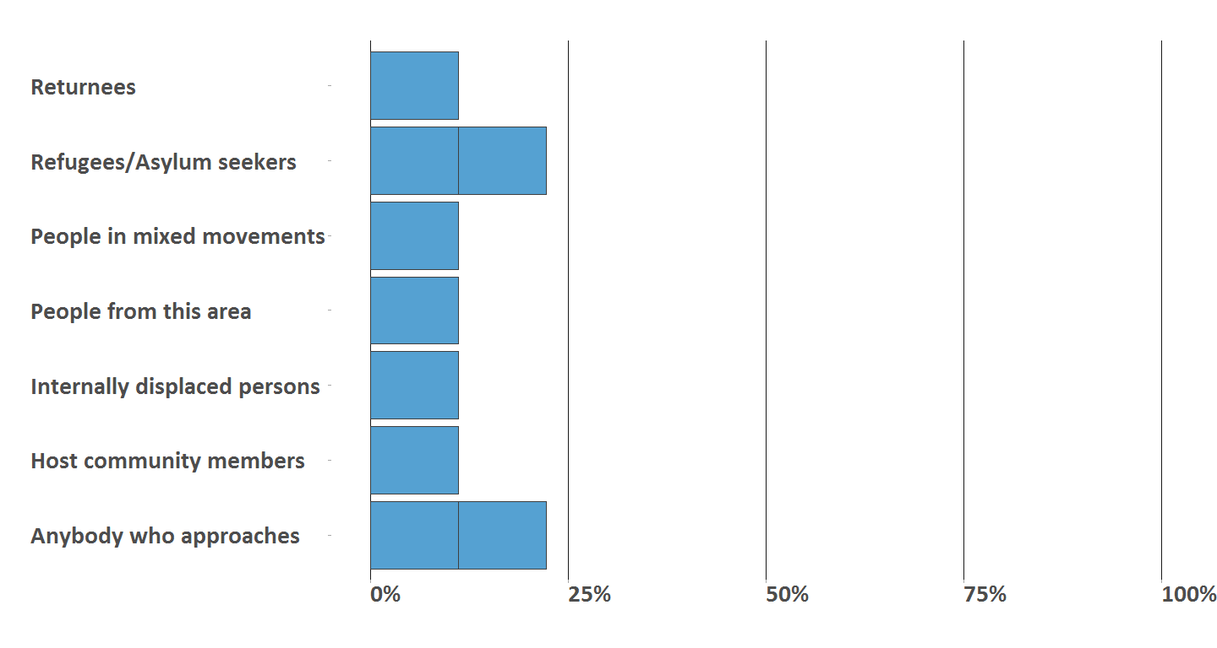

## 6.2) Specific groups of concern

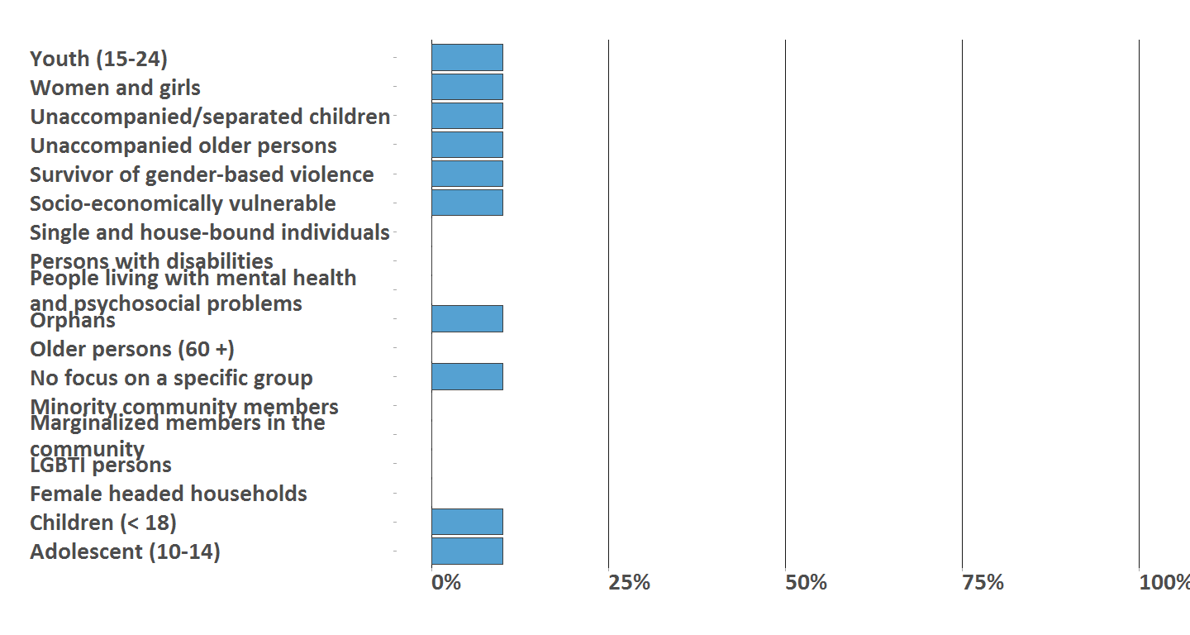

# 7) Active community members

## 7.1) Type of active community members

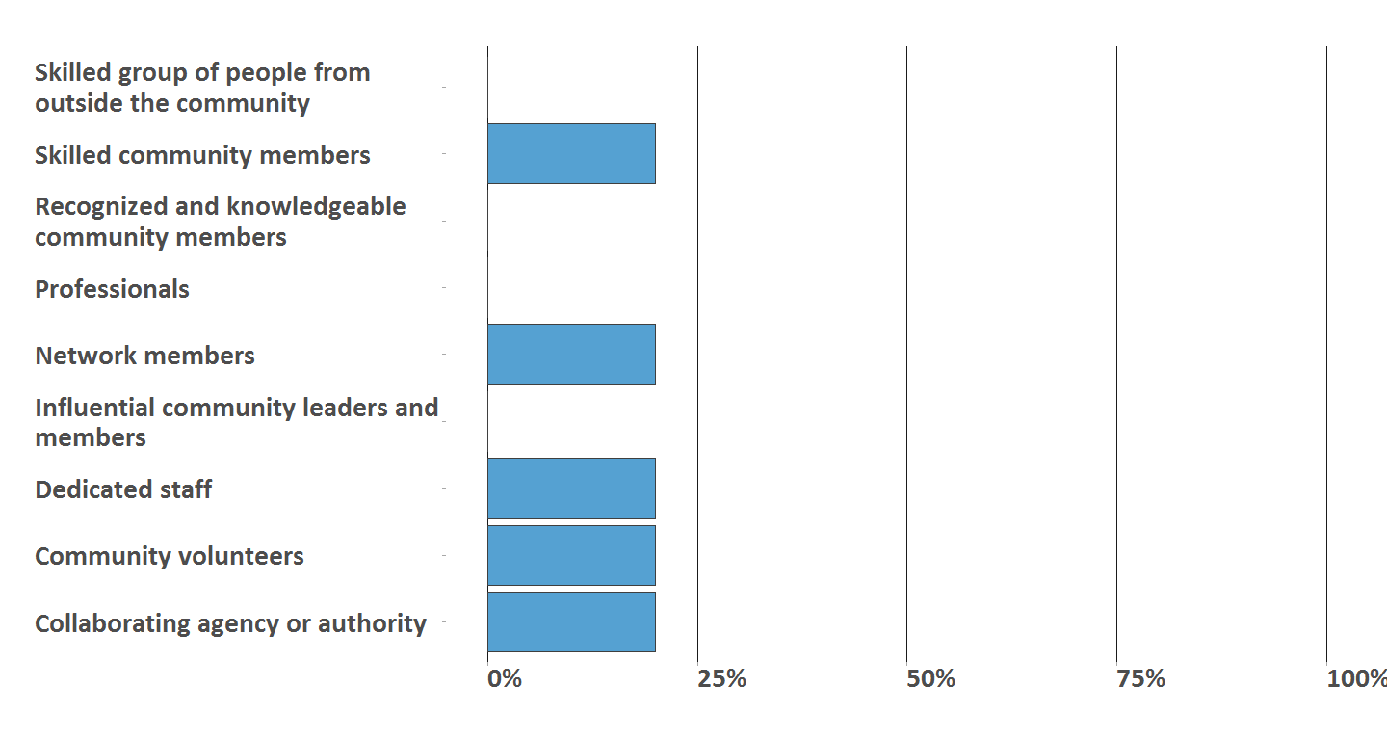

## 7.2) Duration of community work

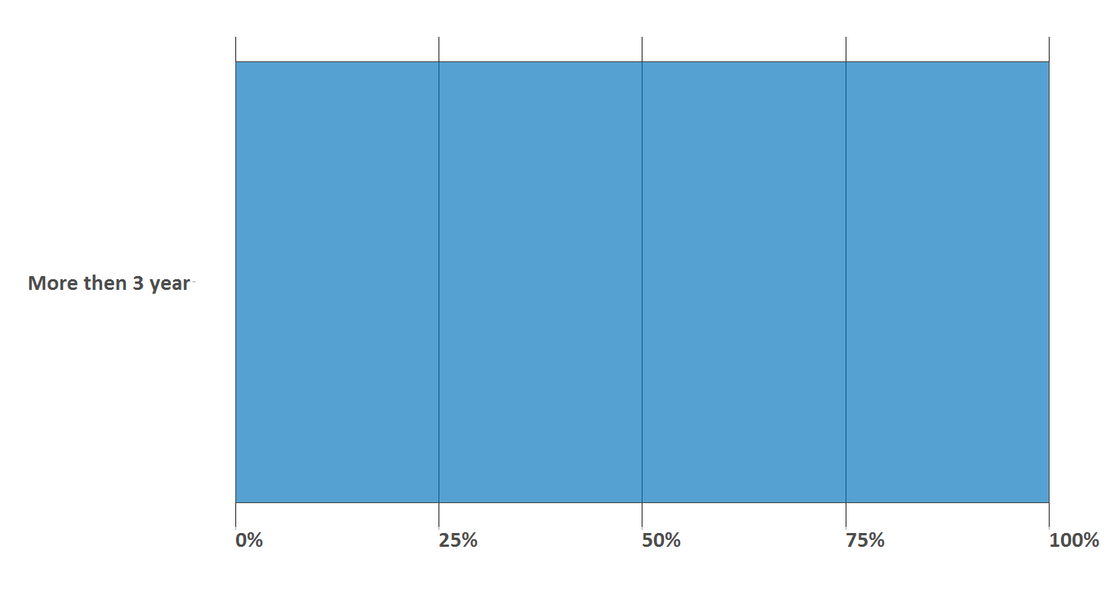

# 8) Communication channels

## 8.1) Type of used communication shannels

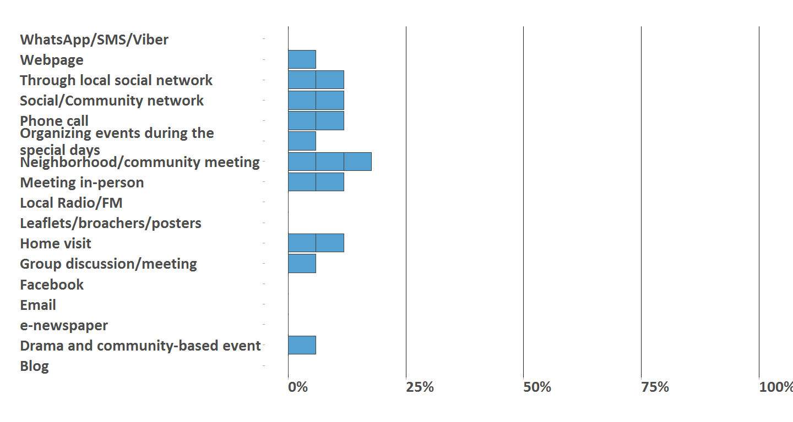

## 8.2) List of manual entries of specific communication channels

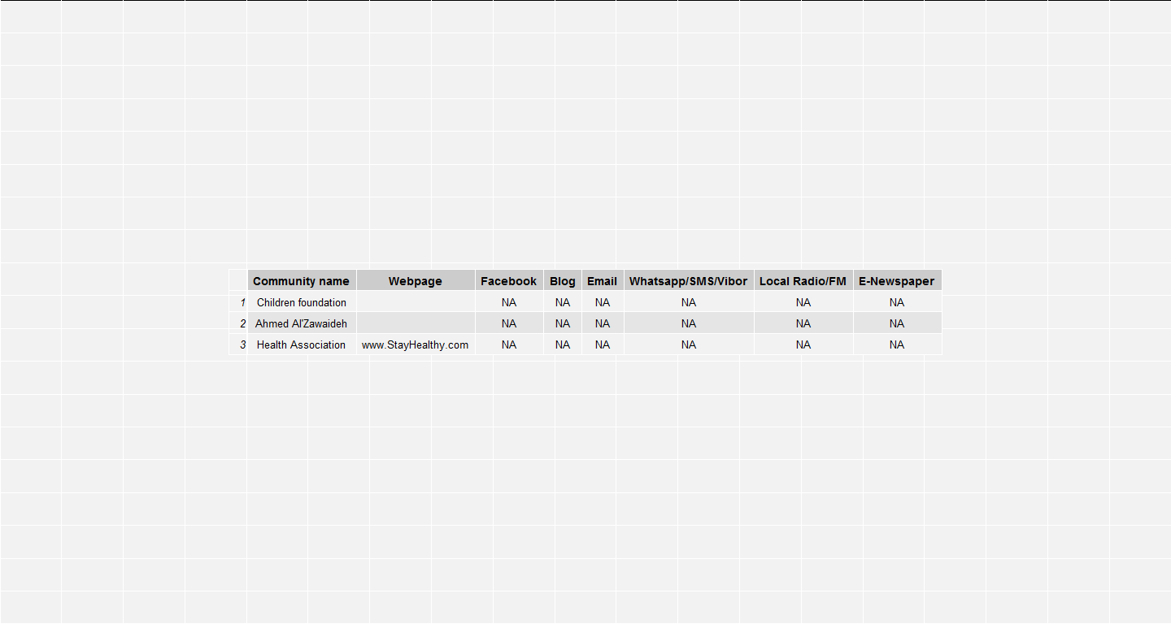

# 9) Meeting space

## 9.1) Type of meeting space

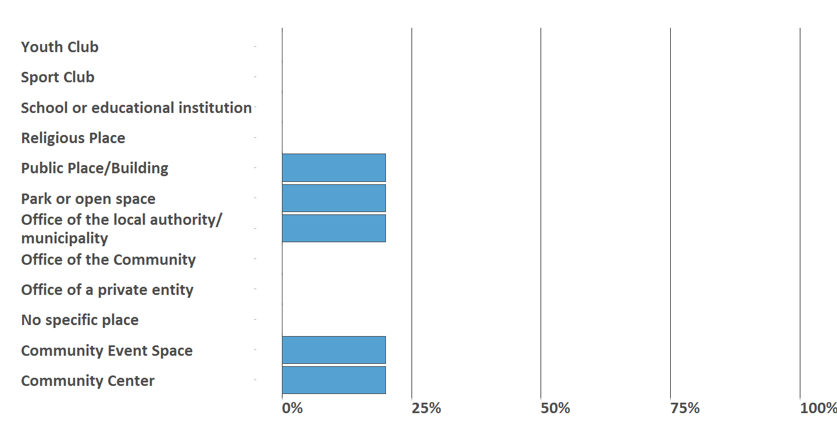

## 9.2) Type of access to meeting space

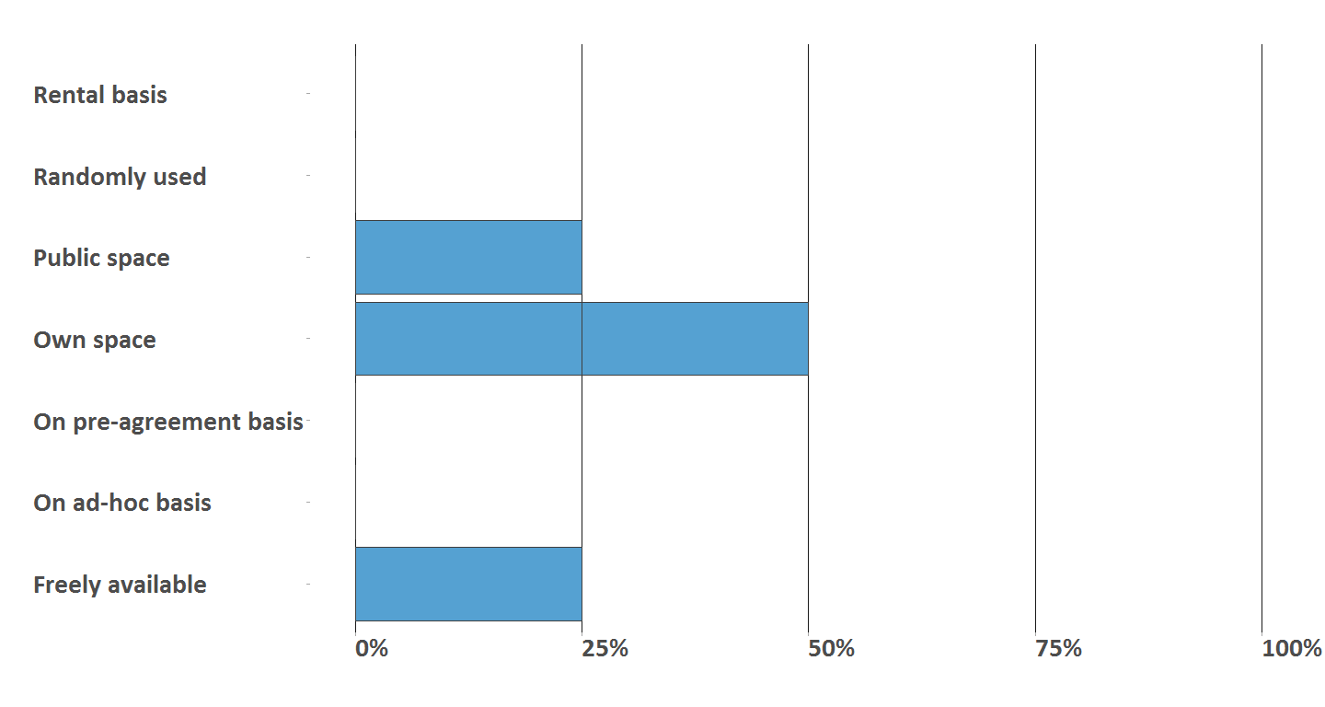

## 9.3) Conduciveness of meeting space

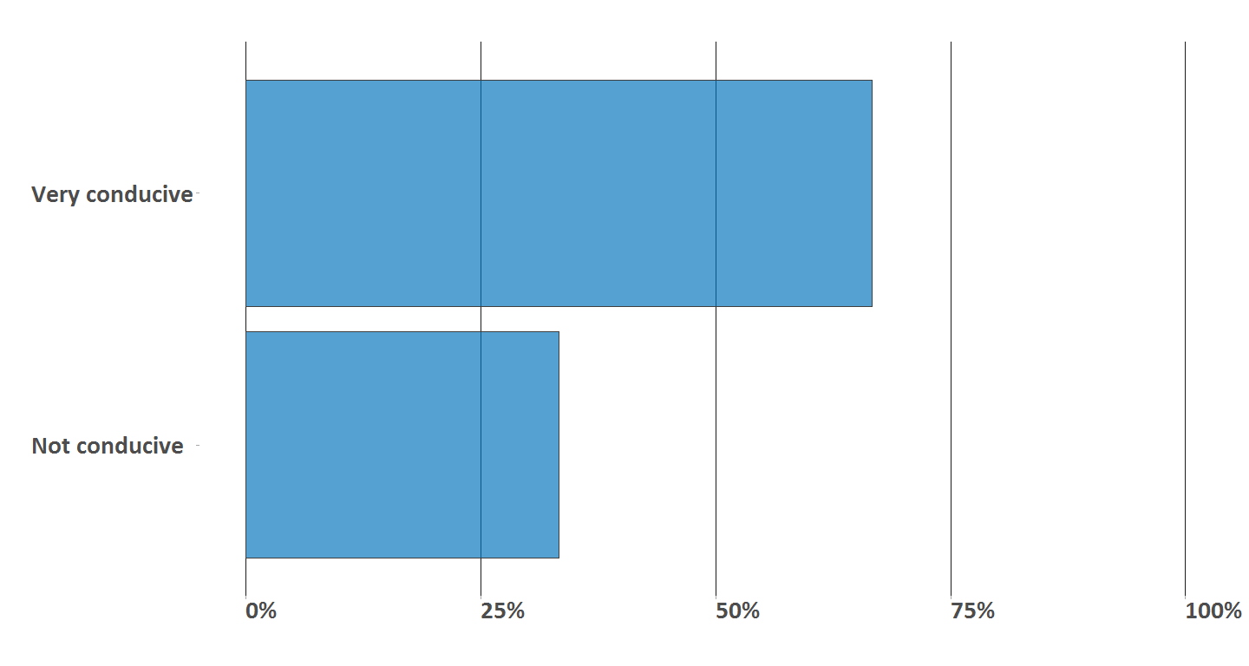

# 10) Community challenges

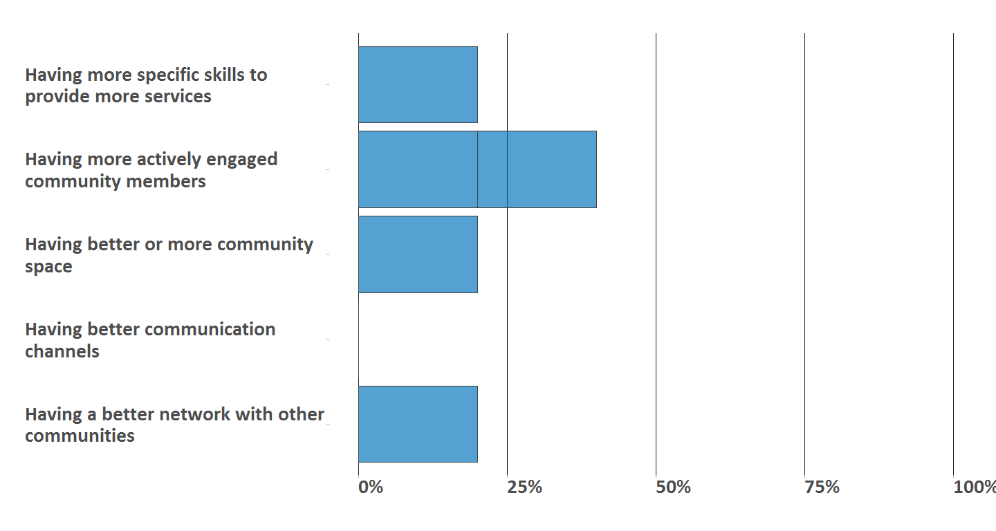

# 11) Community collaboration

## 11.1) Reward to motivate community work

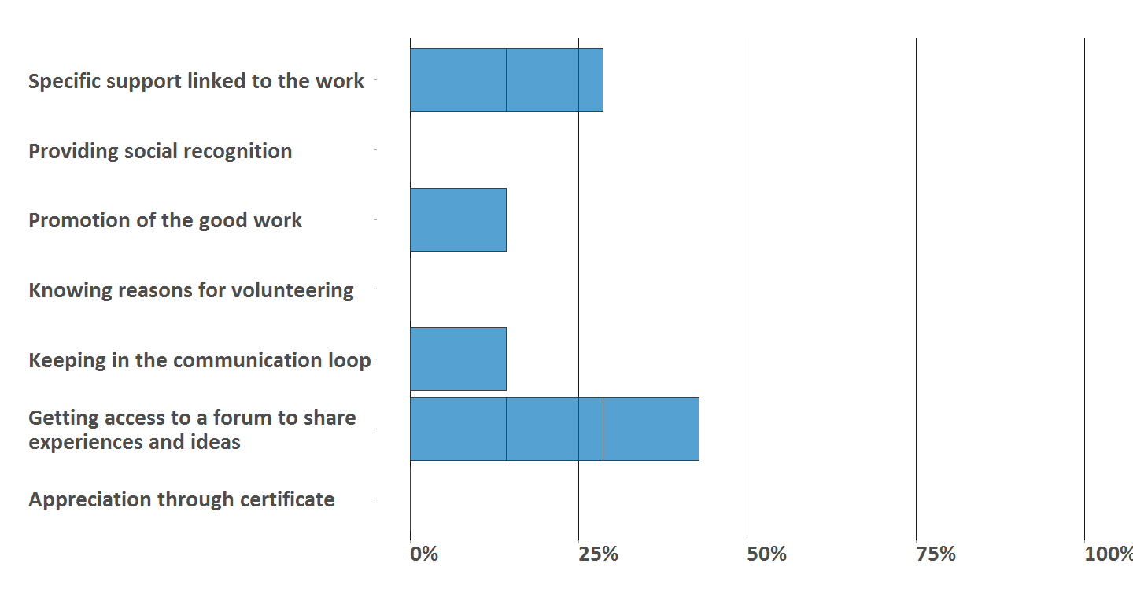

## 11.2) Collaboration with UNHCR

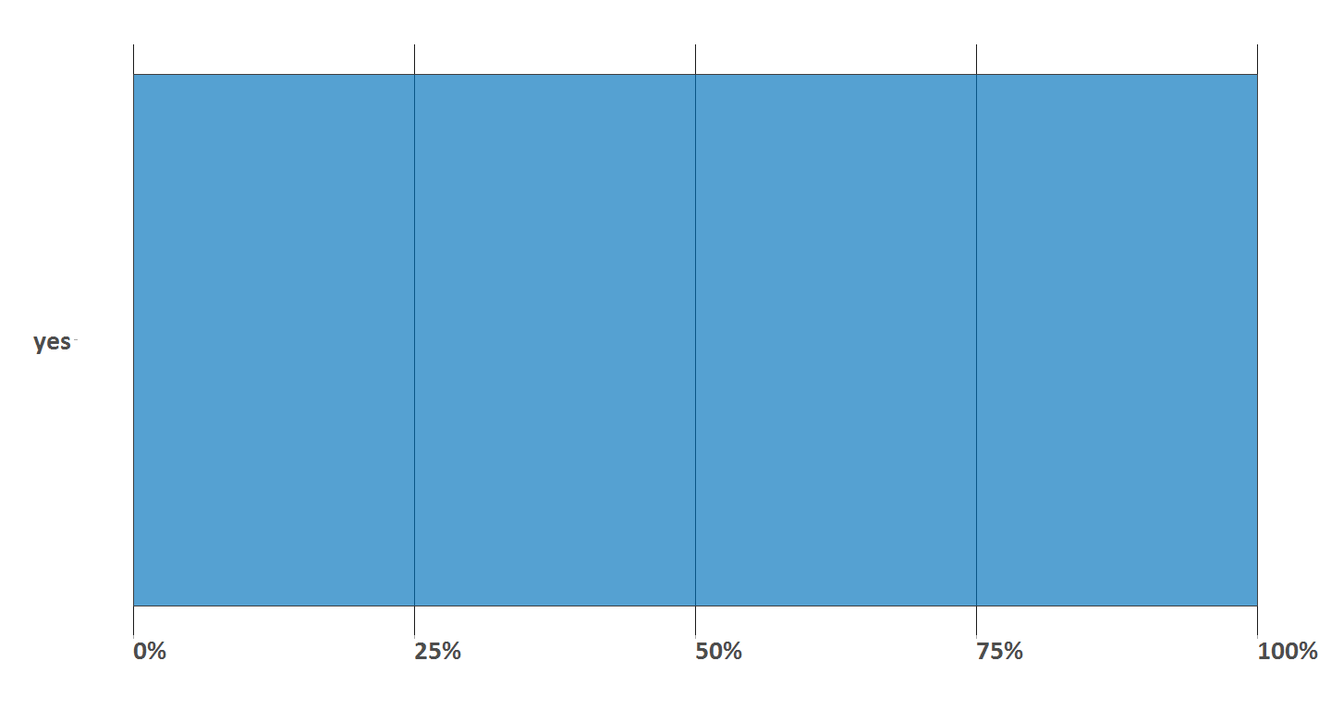

# 12) Contact details (for internal use only)

