**Information about the study**

In this study, you will be wearing a virtual reality headset, in a similar setup of this room with table and chair as shown in the image.

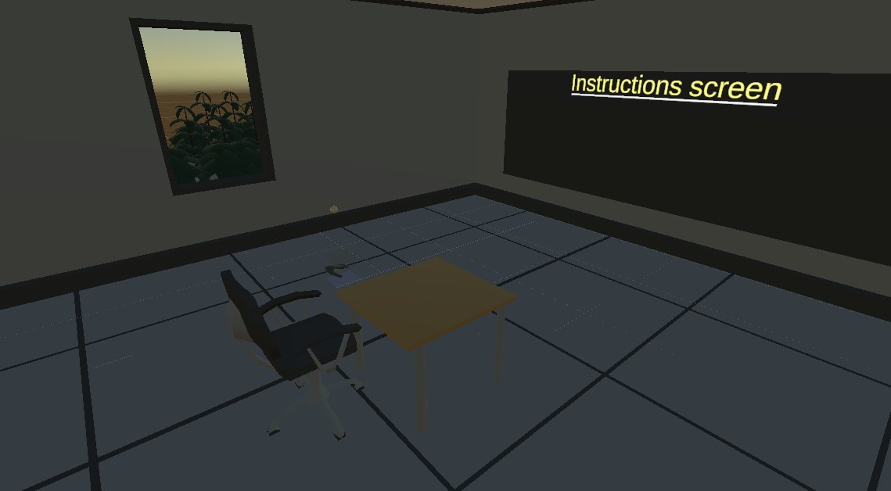

***Figure 1. Setup of the VR scene.***

You will place your left arm on the arm rest with open palm, your hand should be aligned to the blue hologram plane in the scene. In your right hand you will hold a controller and the only button you will use in the experiment is the trigger button. For trigger button reference, see the image below.

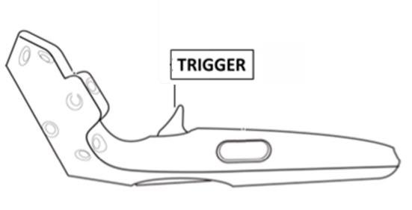

***Figure 2. Trigger button on vive controller.***

The user study is divided in 3 parts. In first part 2 balls will fall on your left hand in the virtual reality, and you will feel the haptic sensation on your hand, by sensing the haptic sensation you will have to answer which ball you felt was heavier.

In the second part, you will play a game. While playing this game, a magic ball will fall on your hand and this ball has maximum weight and a minimum weight, you will feel the weight of the ball with mid-air haptic. You will toss the ball so that it touches the red magic cube. As soon as the ball touches the red magic cube, the weight of the ball increases. To win the game, you have to reach the maximum weight of the ball. But there is a catch, another evil cube with blue colour is constantly moving between your ball and the red cube, it will try to reduce the weight of the ball. If the ball reaches the minimum weight you lose, If the ball reaches its maximum weight you win,.

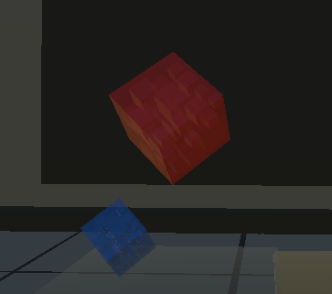

***Figure 3. The Magic cubes in the game.***

Between each of the sessions you will have to take a break to rest you hand. After each session and at the end of the experiment we will also kindly ask you to answer some questions to better understand your experience. If you do not have inconvenience, we will audio record a short interview that will carry out at the end of the study to better understand your opinion.

**IMPORTANT**

1. Your hand in the virtual reality should always touch the blue light plane, the haptic sensation works best at that distance.

2.  There is a black light plane in the virtual reality scene, please make sure you don't touch it accidentally while moving your hands, specially in the game.

3. When you are tossing the ball, please do not raise your arm and only move your hand from the wrist and above. Please ask the researcher to give you a proper demo of this.

4. There is a black mark on the chair and the table. Please align them while sitting to have the best seating position for the experiment.

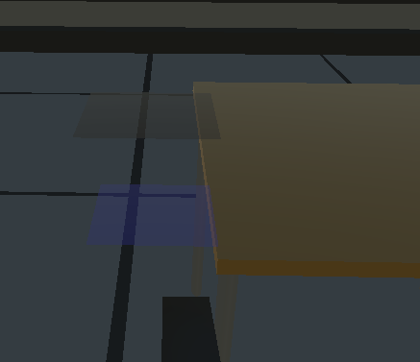

***Figure 3. The Magic cubes in the game.***

**PROCEDURES THAT EACH PARTICIPANT HAS TO UNDERSTAND AND ACCEPT**

* You are asked to read, understand and sign the informed consent. If you sign this form, we will count with your participation for the experiment. Remember that you can leave the experiment at any time without giving a reason.
* We are going to ask you to please turn off your mobile phone.
* We can ask you to answer some question in real time so we can understand your responses during the study.
* Thanks for your participation! Please don`t talk about the experiment with anyone during 3 months while the experiment continues.
* If you have any question you can ask the researcher.