Kutab LMS
Deployment Architecture & Scaling Plan
Docker Swarm — Silo-per-Tenant SaaS
Recommended starting topology: a single shared database node,
scaling node-by-node into a robust cluster as tenants are added.
Prepared by Platform Engineering • Version 1.0 • June 2026

Contents

1. Executive Summary
Kutab is a multi-tenant SaaS learning-management platform deployed on Docker Swarm using a strict silo-per-tenant model: every tenant receives its own isolated stack of containers — a dedicated MySQL database, a dedicated Valkey (Redis) cache, the Laravel API (php-fpm), an Nginx proxy, a Nuxt SSR frontend, queue workers, a scheduler, and a Reverb websocket server. Tenants share only the ingress (Traefik), the overlay network, and the observability stack.
Recommendation. Start on a single node that carries everything, then — as the second paying tenant is onboarded — split out one dedicated, shared database node that hosts every tenant’s MySQL and Valkey containers while the application tier runs on separate app nodes. This keeps the data tier on fast, isolated storage, keeps cost low (one DB node rather than one per tenant), and requires no application code changes — the existing database-per-tenant container model is preserved exactly. From there the cluster grows one node at a time toward a quorum of managers, an app pool, and (only when the single DB node is genuinely saturated) database sharding across a DB pool.
This document records the tenancy model, the recommended topology and why it is preferred over the alternatives, the per-service resource limits now enforced on every tenant stack, the 1-node → cluster growth path, the monitoring and logging pre-configuration (including new backend-exception tracking), and the backup and security posture.

1.1 Key decisions at a glance
Decision | Choice
Tenancy model | Silo per tenant — isolated container stack + private DB and cache volume per tenant. No shared schema, no per-request DB selection.
Starting topology | Single node (Phase 0), then a single shared DB node + app node(s) (Phase 1, recommended near-term target).
Database placement | All tenant MySQL + Valkey containers pinned to nodes labelled kutab.db / kutab.cache — one shared DB node to begin with.
Scaling unit | Add nodes and raise replicas; scheduler bin-packs using per-service CPU/memory reservations.
App code impact | None. The growth path is purely an infrastructure/placement concern.

2. Tenancy Model
Each tenant is provisioned as an independent Docker Swarm stack named kutab-<slug>. The stack template (tenant-stack.yml) defines the following services, all sharing one tenant-private overlay network (tenant-internal) plus the shared ingress network (kutab-shared):
Service | Role | Notes
mysql | Tenant database (MySQL 8.4) | Private volume mysql-data; pinned to a DB node.
valkey | Cache / queue / sessions (Valkey 7.2) | appendonly persistence; pinned to a cache node.
backend | Laravel API (php-fpm) | Internal alias app; replicas scale with load.
nginx | API web proxy | Public api host via Traefik; exposes /metrics.
frontend | Nuxt SSR app | Public frontend host via Traefik.
worker / worker-notifications | Queue workers | queue:work --max-time=3600 (recycle on clean exit).
scheduler | Laravel scheduler | Single replica.
reverb | Websocket server | Public ws host via Traefik.

Why this matters for scaling. Because each tenant already owns a separate database container and volume, the platform never needs runtime database selection or a tenant-routing layer in application code. “Where does this tenant’s data live?” is answered entirely by Swarm placement labels — which is what makes the whole node-by-node growth path a configuration exercise rather than a code migration.

3. Recommended Topology: One Shared Database Node
Three placement strategies were considered for the data tier. The recommended option is the single shared DB node.

3.1 Options compared
Option | Description | Verdict
A. Everything co-located | All services (app + DB + cache) share each node; no data/app separation. | Phase 0 only — fine for the first tenant.
B. Single shared DB node | One dedicated node hosts every tenant’s MySQL + Valkey container; app tier runs on separate node(s). | RECOMMENDED — best cost/isolation balance.
C. DB node per tenant | Each tenant gets its own dedicated database node. | Premature — high cost, low utilisation early.
D. Managed external DB | Move MySQL to a managed service (RDS/Cloud SQL) per tenant. | Future option at large scale; not now.

3.2 Why the single shared DB node wins early
- Cost-efficient: one well-provisioned, IOPS-optimised node carries many tenants’ databases instead of paying for a node (or managed instance) per tenant.
- Still fully isolated: each tenant keeps its own MySQL container, credentials, and data volume — a shared node is not a shared database.
- Predictable performance: separating the data tier from app CPU means a busy frontend can never starve database I/O, and vice-versa.
- Clean upgrade path: when the single DB node saturates, tenants are spread across a db_pool (Phase 3) with no app changes — only new labels.
- Operationally simple: backups, tuning, and monitoring target one data node, not a sprawl of them.

4. Resource Limits & Capacity Planning
Every tenant service now declares both a CPU/memory limit (noisy-neighbour protection — one container can never starve its node) and a reservation (so the Swarm scheduler can bin-pack safely across nodes). All values are overridable per plan/tenant via environment variables, so a premium tenant can be given more headroom without editing the template.

4.1 Default per-service profile
Service class | CPU limit | Mem limit | CPU resv | Env override (limit)
App (php-fpm, frontend) | 1.0 | 768M | 0.10 | KUTAB_APP_CPU_LIMIT / _MEM_LIMIT
Proxy (nginx) | 0.50 | 128M | 0.05 | KUTAB_PROXY_CPU_LIMIT / _MEM_LIMIT
Worker (queue/sched/reverb) | 0.75 | 512M | 0.05 | KUTAB_WORKER_CPU_LIMIT / _MEM_LIMIT
Database (mysql) | 1.0 | 1024M | 0.25 | KUTAB_DB_CPU_LIMIT / _MEM_LIMIT
Cache (valkey) | 0.50 | 256M | 0.05 | KUTAB_CACHE_CPU_LIMIT / _MEM_LIMIT

Reservations enable bin-packing. The reservation is the amount Swarm guarantees before scheduling a task on a node. Summing reservations against a node’s capacity tells you exactly how many tenants fit per node and prevents over-commitment. Limits cap the upside; reservations protect the floor.

4.2 Rough capacity rule of thumb
Using the default reservations, the data tier reserves ~0.30 vCPU and ~576 MB per tenant (MySQL + Valkey), and the app tier reserves ~0.30 vCPU and ~640 MB per tenant at one replica each. A modest 4 vCPU / 8 GB DB node therefore comfortably reserves space for roughly 8–12 tenants’ databases before vertical or horizontal scaling is required — the precise number depends on real query load, which the monitoring stack will reveal.

5. Growth Path: One Node to a Robust Cluster
The cluster grows in four phases. Each phase is reached by adding nodes and re-labelling — never by changing application code.
Phase | Trigger | Topology | Key actions
0 — Single node | MVP / 1st tenant | One manager node carries infra + tenant stacks; all labels on it. | Init Swarm; label node app+db+cache+monitoring; deploy infra + first tenant.
1 — Split DB node | 2nd tenant onboarding (RECOMMENDED target) | Add a node; one node = shared DB+cache, the other = app tier. | Label nodes kutab.db/cache vs kutab.app; redeploy; data tier reschedules onto the DB node.
2 — App pool | App CPU is the bottleneck | Multiple app nodes (app_pool); DB node scales vertically. | Add app nodes; raise BACKEND/FRONTEND/WORKER replicas; DB stays put.
3 — Robust cluster | Resilience / DB saturation | 3+ managers (quorum), dedicated monitoring node, DB pool sharding tenants. | Add managers; spread tenants across db_pool; off-node backups; optional managed DB.

Placement labels are the lever. The tenant template already pins each service with constraints such as node.labels.kutab.db == true and node.labels.kutab.db_pool == ${DB_POOL}. Moving the data tier from Phase 0 to Phase 1 is literally: label the new node, remove the db/cache labels from the original node, and redeploy. Swarm reschedules the MySQL and Valkey containers onto the DB node; volumes follow their placement.

6. Monitoring & Observability
A shared observability stack runs on nodes labelled kutab.monitoring and is reachable through Traefik behind basic-auth. It was reviewed and the missing alert-delivery path was added during this work.

6.1 Components
Component | Purpose
Prometheus | Scrapes Traefik, node-exporter, cAdvisor, and each tenant’s /metrics endpoint (via Docker Swarm service discovery). 30-day retention.
Grafana | Dashboards over Prometheus + Loki; admin credentials via Swarm secrets.
Loki + Promtail | Central log aggregation; Promtail runs globally and ships every container’s stdout/stderr into Loki.
Alertmanager (added) | Now wired to Prometheus. Routes alerts, groups by tenant, and is ready for a Slack/webhook/email receiver. Critical alerts inhibit the matching warning.
node-exporter / cAdvisor | Host and per-container resource metrics (global services).
Portainer | Stack/service management UI.

6.2 Business & health metrics
Each tenant’s Nginx exposes a token-aware /metrics endpoint (Prometheus text format) produced by the backend MetricsController. It publishes users, lectures, subscriptions, invoices, support tickets, queue depth, failed jobs, active sessions — and, new in this revision, reported exceptions (see §7.2).

6.3 Alert rules
Prometheus evaluates the kutab-platform rule group. Existing rules cover target-down, failed-job spikes, queue backlog, high container CPU, low node disk, traffic spikes, and sustained HTTP 5xx. Two backend-exception rules were added:
- KutabBackendExceptions (warning): more than 10 exceptions for a tenant in 15 minutes.
- KutabBackendExceptionSpike (critical): more than 50 exceptions for a tenant in 5 minutes — indicative of an outage or a bad release.
Action required to receive pages: Alertmanager ships with a no-op default receiver so the stack starts cleanly. Fill in a Slack webhook, generic webhook, or SMTP block in configs/alertmanager/alertmanager.yml and redeploy the infra stack to actually be notified.

7. Logging & Exception Tracking

7.1 Log pipeline (pre-configuration fixed)
Previously, tenant application logs were written only to a file (laravel.log) inside the container, which Promtail — a stdout reader — never collected, so application logs were not reaching Loki. The tenant provisioning script now sets the backend’s LOG_CHANNEL=stderr (and LOG_LEVEL=info), so all application logs flow to container stdout → Promtail → Loki and become searchable in Grafana.
Flow: Laravel → stderr → Docker json-log → Promtail → Loki → Grafana

7.2 Backend exception capture
To answer “did any exceptions happen, and can I monitor them?” a report() hook was added to the backend (bootstrap/app.php). Every reported exception — from HTTP requests, queue jobs, and console commands alike — is now:
- Counted in the tenant’s Redis (kutab:metrics:exceptions_total, plus a per-class breakdown), exposed as the Prometheus counters kutab_exceptions_total and kutab_exceptions_by_type_total.
- Written to a dedicated, rotating exceptions log channel (storage/logs/exceptions.log) so an operator can tail exceptions in isolation on the node.
- Still logged through the default channel to stderr → Loki, so the full stack trace is searchable centrally.
The counter bookkeeping is wrapped in try/catch so it can never interfere with normal error handling, and the metrics endpoint degrades gracefully if Redis is briefly unavailable.
Where to look | What you get
Grafana / Prometheus | Exception rate per tenant and per exception class; the two alert rules above.
Grafana / Loki | Full exception messages and stack traces (filter by tenant container / ERROR).
Node: exceptions.log | A focused, rotating on-node file of just the exceptions.

8. Backups & Disaster Recovery
Each tenant’s durable state lives in two named volumes: mysql-data (the database) and valkey-data (append-only cache/queue state). Recommended posture as the cluster grows:
- Nightly logical backup: mysqldump per tenant database, streamed to off-node object storage (e.g. S3-compatible), retained 7–30 days.
- Volume-level snapshots of the DB node’s storage for fast whole-node recovery, in addition to logical dumps.
- Restore drills: periodically restore a tenant dump into a scratch stack to validate the backup is usable, not just present.
- Gap to close: automated per-tenant backups are not yet wired into the provisioning scripts. This should be the next infrastructure task once the first DB node is live (a scheduled mysqldump sidecar or host cron per DB node).

9. Security Notes
- Secrets: MySQL passwords are delivered via Swarm secrets (mysql_password, mysql_root_password), not environment variables in plain text.
- TLS everywhere: Traefik terminates TLS with Let’s Encrypt for every tenant’s api, frontend, and ws hosts.
- Monitoring UIs (Prometheus, Alertmanager) sit behind Traefik basic-auth; Grafana uses secret-backed admin credentials.
- Review item — metrics exposure: the tenant /metrics endpoint is reachable through the public api host. Prometheus scrapes it internally without a token, so it is currently unauthenticated. Before going live, restrict /metrics to the internal scrape path (deny it at Nginx/Traefik for public callers) or set METRICS_TOKEN and configure the scrape to send it, so business metrics are not publicly readable.

10. Cluster Bring-Up Checklist
When the servers are ready, the live bring-up follows this order. A companion runbook accompanies this document for the exact commands.
- Provision nodes; install Docker Engine; open Swarm + ingress ports between them.
- docker swarm init on the first manager; join additional nodes as managers/workers.
- Apply node labels for the target phase (kutab.app / kutab.db / kutab.cache / kutab.monitoring and the *_pool labels).
- Create the external kutab-shared overlay network and the required Swarm secrets.
- Deploy the infra stack (Traefik, Prometheus, Alertmanager, Grafana, Loki, Promtail, exporters, Portainer); confirm targets are UP.
- Fill in the Alertmanager receiver and verify a test alert is delivered.
- Provision the first tenant (deploy-tenant.sh); confirm migrations ran, the site serves over TLS, and /metrics is scraped.
- Verify logs appear in Loki and the exception counters increment on a forced test error; then remove the test.

Support offer: Platform Engineering can drive this bring-up interactively — running each script against the live nodes, validating labels and placement, confirming the monitoring/logging pipeline end-to-end, and onboarding the first tenant — as soon as the servers are available.

Appendix A — Node Labels & Scaling Knobs

Placement labels
Label | Meaning
kutab.app == true | Node may run the application tier (php-fpm, nginx, frontend, workers, scheduler, reverb).
kutab.app_pool == <id> | Sub-pool for spreading app load across multiple app nodes.
kutab.db == true | Node hosts tenant MySQL containers (the shared DB node).
kutab.cache == true | Node hosts tenant Valkey containers.
kutab.db_pool / kutab.cache_pool | Sub-pools for sharding the data tier across nodes (Phase 3).
kutab.monitoring == true | Node runs the shared observability stack.

Replica & resource environment knobs
Variable | Effect
BACKEND_REPLICAS / FRONTEND_REPLICAS | Horizontal scale of the app + SSR tier.
WORKER_REPLICAS / NOTIFICATION_WORKER_REPLICAS | Queue-worker concurrency per tenant.
REVERB_REPLICAS / NGINX_REPLICAS | Websocket and proxy replica counts.
KUTAB_APP_* / _DB_* / _CACHE_* / _PROXY_* / _WORKER_* | Per-class CPU/memory limits and reservations (see §4).
APP_POOL / DB_POOL / CACHE_POOL | Select which pool a tenant’s services land on.

Appendix B — Architecture Diagrams
These diagrams summarise the three hosting options, the database and storage model, and the tenant provisioning flow described above. They are shown in landscape for legibility; all tenants are treated identically (shared app and DB pools).

Figure 1 — Hosting options
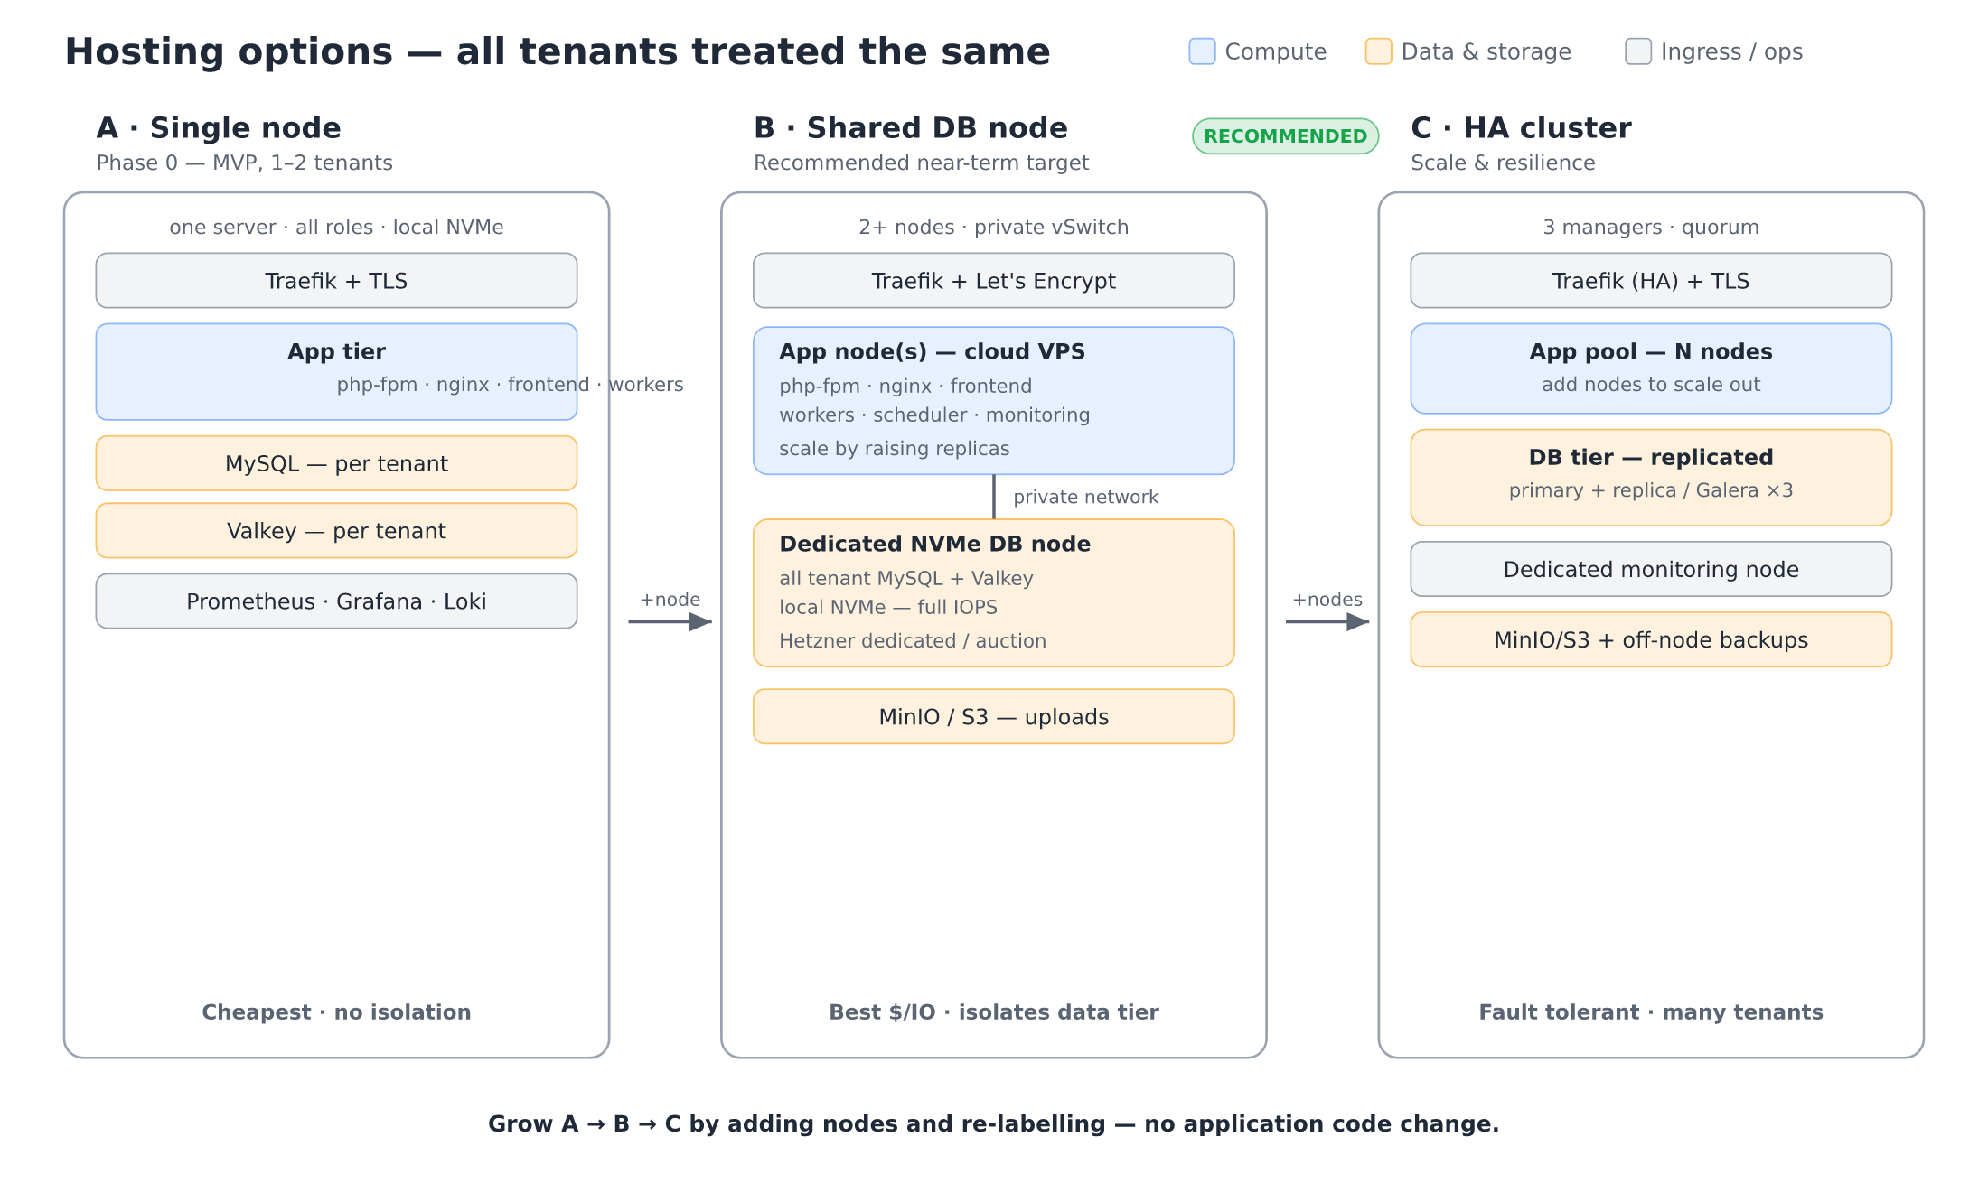
Figure 1. Hosting options — single node, shared DB node (recommended), and HA cluster. Grow A → B → C by adding nodes and re-labelling, with no application code change.

Figure 2 — Database & storage model
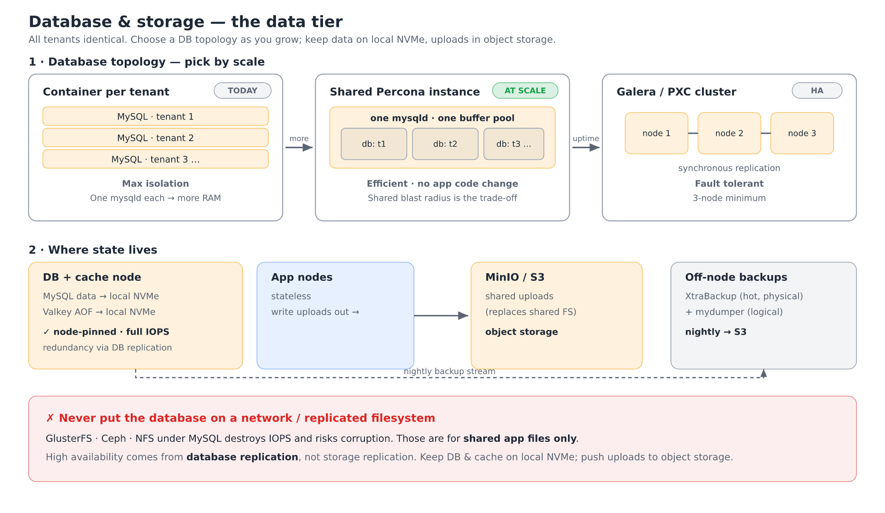
Figure 2. Database topology choices and where state lives — DB and cache on local NVMe, uploads in object storage, backups off-node.

Figure 3 — Tenant provisioning flow
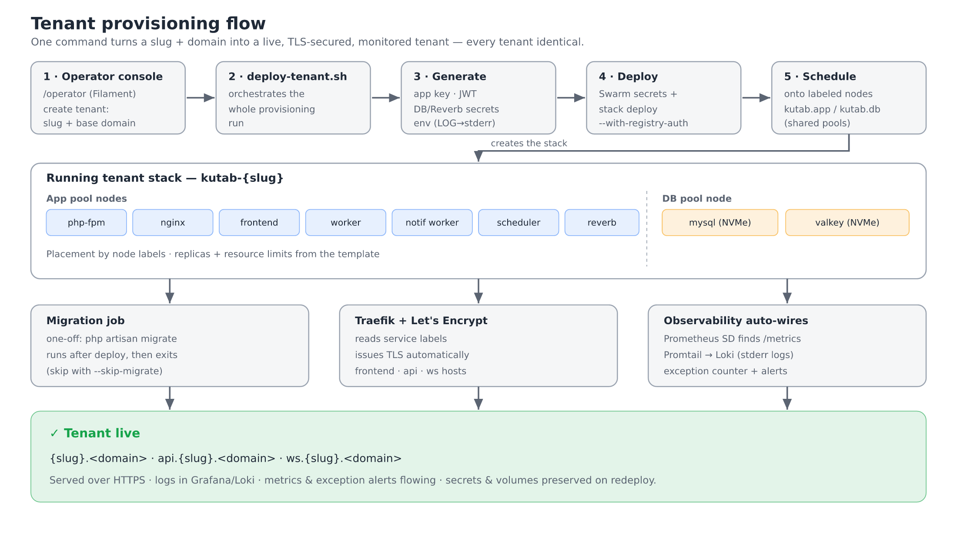
Figure 3. From the operator console to a live, TLS-secured, monitored tenant.

