Final Project Report

20181283 황교훈 ( HWANG GYOHUN )

Introduction to AI Programming 2

At first, What we do is build a machine learning model that classifies artworks by the genre.

And the Problem Settings are like below.

Input : Artwork Images(64x64x3)

Output : Genre

Goal : Classify the given artwork into the correct genre category

We can make some parts(which model is used, how to use, etc.) or can change some parts like epoch and batch size of code. So What I do is below.

1. Abstract
2. Which model is used for final project ( e.g. ResNet )
3. If more detailed, What is used( e.g. ResNet34 or ResNet50 )
4. Implementation details
5. What is my epoch
6. What is my batch size
7. The difference in result value according to epoch
8. The difference in result value according to batch size
9. conclusion
10. Abstract

Artificial neural networks are one of machine learning models inspired by the networks of biological neurons.

ANN is one field of Deep learning. Using Deep learning there are some concepts like threshold. So using threshold and various layers, computers can get proper output.

We learned about CNN and RNN which is part of ANN.

Lastly, we learned about keras to implement and how to use it. Thus I implement some code with keras and test it to solve the final project problem.

1. Which model is used?

We learned about lots of models. I use one of them which is CNN for using specified size data and output value of a specified size.

1. More specifically, which model is used?

More specifically, There are many kinds of ResNet like ResNet 34 and ResNet 50, etc. I can get more scores with more layers using ResNet 50, etc. But we have little data set. Thus I use ResNet 34 for the final project.

1. Implementation details

As I mentioned earlier, I can change the epoch and batch size and make a model. Using one epoch and many batch sizes, I get proper batch size which is in my case 100. And using one batch size and many epochs, I get a proper epoch which is in my case 80.

I put my epoch to 80 and batch size to 100.

In the case of optimizers, we learned lots of optimizers including NAG, Momentum, SGD, etc. Optimizer Adam which is the most commonly used optimizer has merit both RMSProp and Momentum. That is the reason I chose it.

And the rest of the model, I refer to what we do in lab sessions.

1. What is my epoch

I tested some epochs using the same batch size and model.

Below are my test cases.

* Using epoch = 10, then I get a grade 15.02 score.
* Using epoch = 50, I get a grade 28.69 score.
* Using epoch = 80, I get a grade 33.21 score.
* Using epoch = 90, I get a grade 29.05 score.
* Using epoch = 100, I get a grade 31.13 score.

Thus I get the proper batch size which is 80. And If I put the epoch more than 100, there can exist an epoch that gives a high score. But I didn’t put epochs more than 101 to avoid overfitting.

1. What is my batch size

I tested some batch sizes using the same epoch and model.

* using batch size = 10, I get grade 7.69
* using batch size = 80, I get grade 27.6
* using batch size = 100, I get grade 33.21
* using batch size = 120, I get grade 24.8

Thus I get the proper batch size which is 100. And like epochs, there can exist a batch size that gives a higher score. But I didn’t do that because of overfitting.

1. result value according to epoch

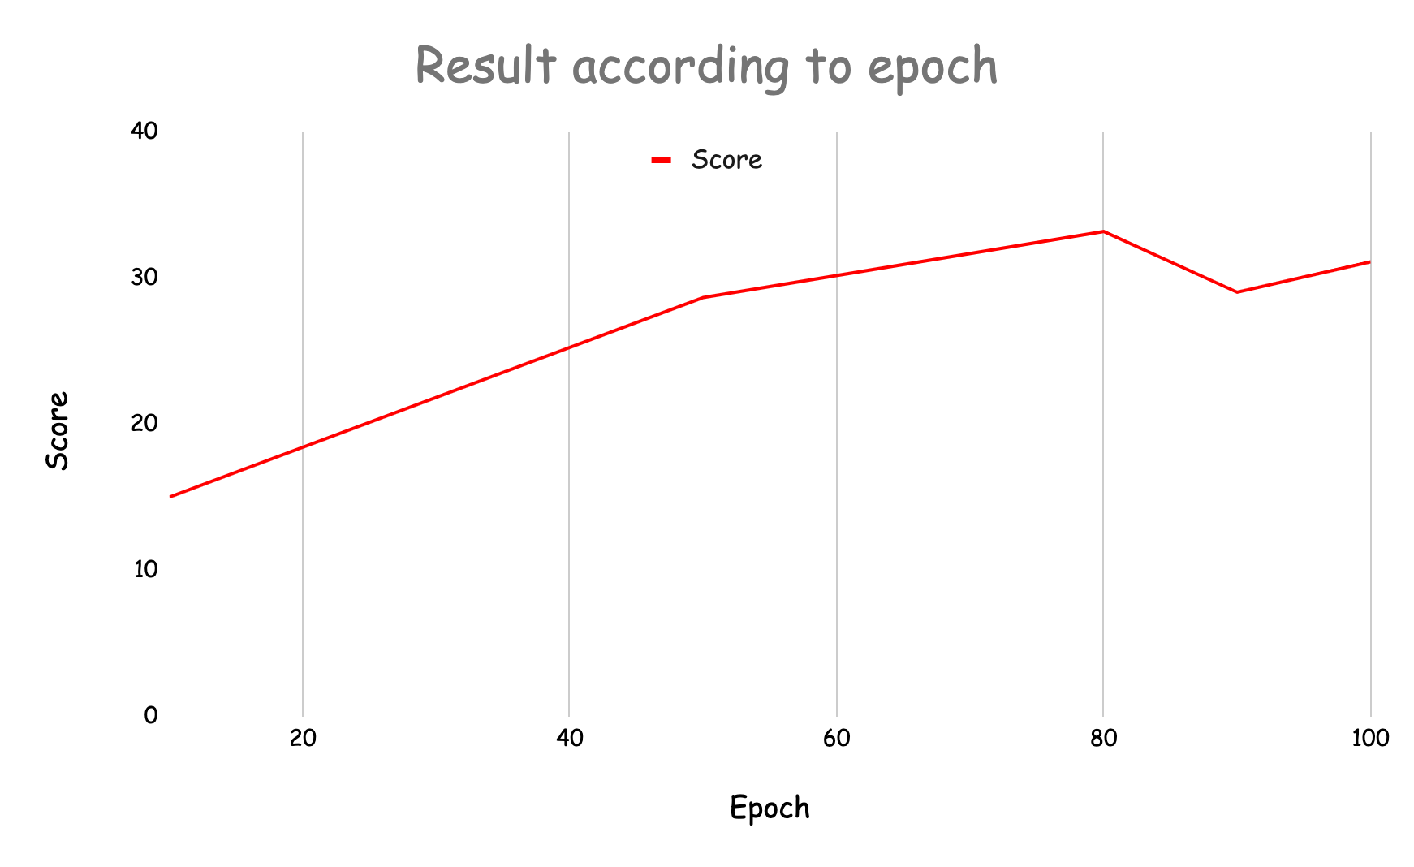

1. result value according to batch size

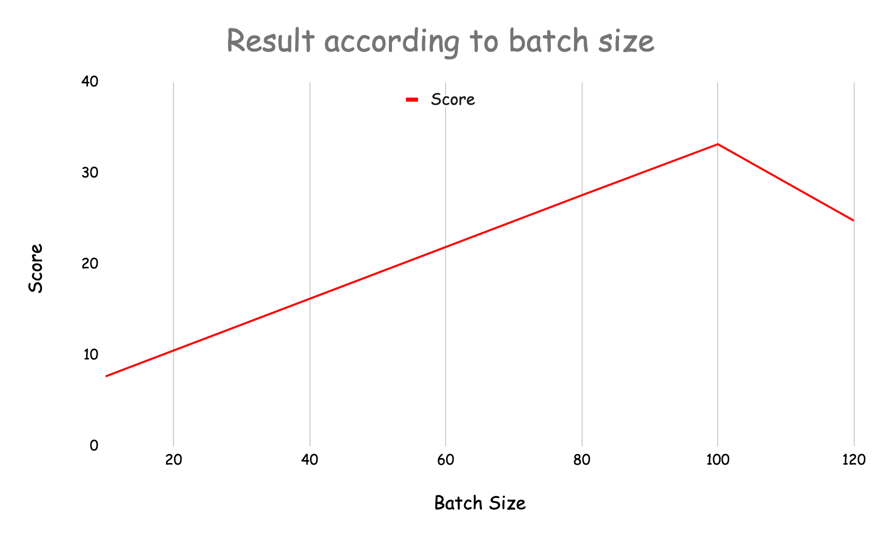

1. conclusion

As a result, I get the proper model, batch size and epoch. And Get the 33.21 score. And let the last of the csv files(result_epo_1_bs_2_) in result_zip.zip file. Each of them means epoch 1 and batch size 2.

for example result_epo10bs100 means I make a csv file with epoch 10 and batch size 100.