# 4. Results and Analysis

## 4.1 Introduction

This section presents a comprehensive analysis of the UK labour market based on data from the Quarterly Labour Force Survey (QLFS) for January-March 2011. The analysis is structured around our research questions, hypotheses and other important aspects for describing socio-economic impacts on employment, focusing on the key variables selected for this study: highest qualification (hiqul11d), government office region (govtof2), economic activity (ilodefr), NS-SEC classification (nsecmj3r), full-time/part-time status (ftptwk), total hours worked (tothrs), and employment status (stat3r).

## 4.2 Overview of Employment Status

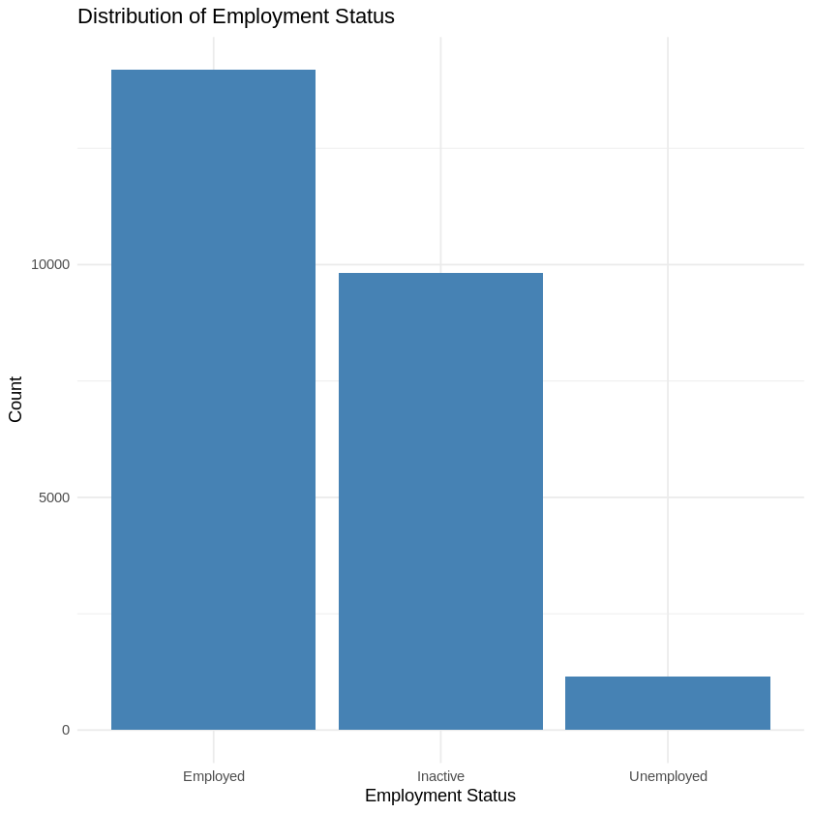

**Figure 3:** Employment status distribution plot

Table 1: Distribution of Employment Status using frequency analysis

| **Employment Status** | **Percentage** |
| --- | --- |
| Employed | 56.4% |
| Inactive | 39.1% |
| Unemployed | 4.6% |

This distribution provides context for this subsequent analysis, showing that while the majority of the population was employed, there was still a significant proportion of economically inactive individuals. The relatively low unemployment rate (4.6%) compared to the high inactivity rate (39.1%) suggests that many individuals may have withdrawn from the labour market entirely, rather than actively seeking work. This phenomenon, often referred to as the "discouraged worker effect," warrants further investigation and has significant implications for labour market policies.

## 4.3 Educational Qualifications and Employment Outcomes

One of the primary objectives of this research was to examine the impact of educational qualifications on employment outcomes in the UK labour market.

Research Question 1: How do educational qualifications impact employment status and job quality in the UK?

Hypothesis 1: There is a significant association between highest educational qualification and employment status.

To test hypothesis 1 and the relationship between educational qualifications and employment outcomes, a cross-tabulation and chi-square test were performed. Refer appendix - 3 figure- 2 for cross -tab analysis outcomes.

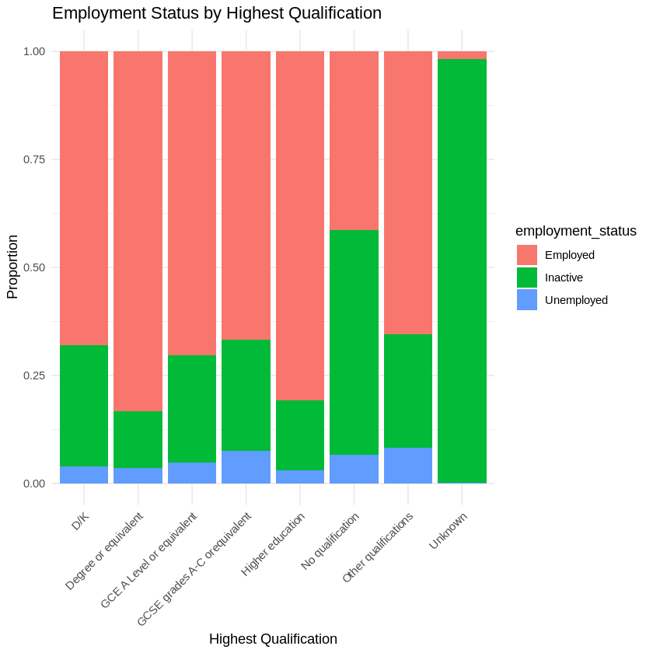

**Figure 4:** Employment Status by Highest Qualification

Table 2 : Chi-square Test Results for Employment Status by Highest Qualification

| **χ²** | 10101 |
| --- | --- |
| **df** | 12 |
| **p-value** | < 2.2e-16 |

The highly significant chi-square test result (p < 0.001) provides strong evidence to reject the null hypothesis, supporting hypothesis 1 that there is a significant association between highest qualification and employment status.

Interpretation:

Higher qualifications are associated with higher employment rates and lower inactivity rates, with a clear gradient in employment rates as educational qualifications increase, supporting the human capital theory that education enhances employability. Those with no qualifications have a notably low employment rate (41.4%) and high economic inactivity rate (51.9%), suggesting significant barriers to labour market participation for this group, aligning with human capital theory (Becker, 1962), which posits that education enhances an individual's productivity and, consequently, their employability.

To further quantify the impact of educational qualifications on employment probability, conducted a logistic regression analysis:

Table 3: Logistic Regression Results for the Impact of Educational Qualifications on Employment Status

| **Variable** | **Coefficient** | **Std. Error** | **z value** | **Pr(>|z|)** |
| --- | --- | --- | --- | --- |
| (Intercept) | 2.48625 | 0.30586 | 8.129 | 4.34e-16 *** |
| Degree or equivalent | 1.89315 | 0.30425 | 6.222 | 4.91e-10 *** |
| GCE A Level or equivalent | 1.20139 | 0.30256 | 3.970 | 7.18e-05 *** |
| GCSE grades A-C or equivalent | 1.25679 | 0.30268 | 4.152 | 3.30e-05 *** |
| Higher education | 1.80302 | 0.30856 | 5.843 | 5.13e-09 *** |
| No qualification | -1.28515 | 0.30543 | -4.208 | 2.58e-05 *** |
| Other qualifications | 1.10734 | 0.30518 | 3.629 | 0.000285 *** |

Table - 4 significance codes

| **Significance codes** | 0 '***' 0.001 '****' 0.01 '*' 0.05 '.' 0.1 ' ' 1 |
| --- | --- |

Interpretation:

The logistic regression results corroborate table 2 chi-square test findings, showing that all qualification levels have significant effects on employment probability. Notably, having a degree or equivalent qualification increases the log odds of employment by 1.89315 (p < 0.001) compared to the reference category (unknown qualifications). Conversely, having no qualifications decreases the log odds of employment by 1.28515 (p < 0.001).

To examine the impact of educational qualifications on job quality, analyzed the relationship between highest qualification and total hours worked:

Table 5: ANOVA Results for the Impact of Educational Qualifications on Total Hours Worked

| **Source of Variation** | **Df** | **Sum Sq** | **Mean Sq** | **F value** | **Pr(>F)** |
| --- | --- | --- | --- | --- | --- |
| hiqul11d | 6 | 55741 | 9290 | 49.27 | < 2.2e-16 *** |
| Residuals | 25154 | 4064994 | 162 |  |  |

The ANOVA results reveal a significant effect of educational qualifications on total hours worked (F = 49.27, p < 0.001). This suggests that education not only affects the likelihood of employment but also influences the intensity of work engagement.

A post-hoc Tukey's HSD test showed significant differences between most qualification levels, with higher qualifications generally associated with longer working hours. This finding could be interpreted in two ways: either higher qualifications lead to jobs that demand more hours, or individuals with higher qualifications are more likely to take on roles with longer hours, possibly due to increased career motivation or ambition. Refer appendix - 3 for Post-hoc Tests values for ANOVA.

## 4.4 Regional Disparities in Employment

Research Question 2: What role do regional disparities play in shaping employment patterns across the UK?

Hypothesis 2: There are significant differences in employment rates across different regions of the UK.

To test this hypothesis, conducted a chi-square test of independence:

Table 6: Employment Status by Region using cross-tab analysis:

| **Region** | **Employed** | **Inactive** | **Unemployed** |
| --- | --- | --- | --- |
| North | 54.5% | 40.3% | 5.2% |
| Midlands | 57.8% | 37.7% | 4.5% |
| South | 57.0% | 38.8% | 4.2% |
| Other UK Countries | 55.7% | 39.9% | 4.4% |

Table 7: Chi-square Test Results for Employment Status by Region

| **χ²** | 21.782 |
| --- | --- |
| **df** | 6 |
| **p-value** | 0.001326 |

The significant chi-square test result (p < 0.01) supports hypothesis 2, indicating that there are indeed regional differences in employment patterns across the UK. Key findings include:

* The Midlands and South show slightly higher employment rates (57.8% and 57.0% respectively) compared to the North (54.5%) and other UK countries (55.7%).
* The North has the highest unemployment rate (5.2%) and economic inactivity rate (40.2%).
* Differences in employment rates across regions are less pronounced than those observed across educational levels, suggesting that individual-level factors may have a stronger influence on employment outcomes than regional factors.

To further quantify the impact of region on employment probability, included regional variables in logistic regression model:

Table 8: Logistic Regression Results for the Impact of Region on Employment Status

| **Variable** | **Coefficient** | **Std. Error** | **z value** | **Pr(>|z|)** |
| --- | --- | --- | --- | --- |
| Region: North | -0.13766 | 0.05467 | -2.518 | 0.011808 * |
| Region: Other UK Countries | 0.07528 | 0.06267 | 1.201 | 0.229656 |
| Region: South | -0.03588 | 0.05252 | -0.683 | 0.494580 |

Interpretation:

While there are statistically significant regional differences in employment patterns, these disparities are relatively small compared to the effects of other factors like educational qualifications. The North region shows slightly lower odds of employment compared to the Midlands (reference category), but other regions do not show significant differences. This suggests that regional factors play a role in shaping employment patterns, but their impact may be less pronounced than individual-level characteristics.

## 4.5 Socio-Economic Classification and Employment

Research Question 3: How do socio-economic classifications affect job opportunities and wage levels in the UK labour market?

Hypothesis 3: There is a significant association between socio-economic classification (NS-SEC) and employment status.

To test this hypothesis, conducted a chi-square test of independence:

Table 9: Employment Status by NS-SEC Classification using cross-tab analysis

| **NS-SEC Classification** | **Employed** | **Inactive** | **Unemployed** |
| --- | --- | --- | --- |
| Higher managerial, administrative and professional | 95.2% | 3.9% | 0.9% |
| Intermediate occupations | 94.2% | 4.9% | 0.9% |
| Routine and manual occupations | 90.0% | 7.7% | 2.3% |
| Never worked, unemployed, and nec | 8.7% | 82.5% | 8.8% |

Table 10: Chi-square Test Results for Employment Status by NS-SEC Classification

| **χ²** | 8904.3 |
| --- | --- |
| **df** | 8 |
| **p-value** | < 2.2e-16 |

The highly significant chi-square test result (p < 0.001) provides strong evidence to reject the null hypothesis, supporting hypothesis 3 that there is a significant association between NS-SEC classification and employment status.

Interpretation:

Higher managerial and professional occupations show the highest employment rates (95.2%), followed closely by intermediate occupations (94.2%), with a clear gradient in employment rates as we move down the socio-economic classification. The "Never worked, unemployed, and nec" category shows extremely low employment rates (8.7%) and high economic inactivity (82.5%), indicating significant barriers to employment for this group, aligning with social stratification theories (Goldthorpe, 2007) that posit a strong relationship between socio-economic class and labour market outcomes.

To further quantify the impact of NS-SEC classification on employment probability, included these variables in logistic regression model for key findings:

Table 11: Logistic Regression Results for the Impact of NS-SEC Classification on Employment Status

| **Variable** | **Coefficient** | **Std. Error** | **z value** | **Pr(>|z|)** |
| --- | --- | --- | --- | --- |
| NS-SEC: Intermediate occupations | -0.22775 | 0.07545 | 3.019 | 0.002539 ** |
| NS-SEC: Routine and manual occupations | -0.44786 | 0.06516 | -6.873 | 6.28e-12 *** |
| NS-SEC: Never worked, unemployed, and nec | -0.67096 | 0.09964 | -6.734 | 1.65e-11 *** |

Interpretation: The logistic regression results confirm the significant impact of NS-SEC classification on employment probability. Compared to the reference category (Higher managerial, administrative and professional), all other NS-SEC categories are associated with lower odds of employment. This suggests that socio-economic background continues to play a crucial role in shaping employment outcomes in the UK labour market.

## 4.6 Socio-Economic Mobility

To explore socio-economic mobility, we can examine the relationship between educational qualifications and NS-SEC classification:

Table 12: NS-SEC Classification by Highest Qualification using cross-tabulation analysis

| **Qualification** | **Higher managerial** | **Intermediate** | **Routine and manual** | **Never worked/unemployed** |
| --- | --- | --- | --- | --- |
| Degree or equivalent | 60.5% | 22.1% | 14.8% | 2.6% |
| Higher education | 41.2% | 29.7% | 26.1% | 3.0% |
| GCE A Level or equivalent | 24.8% | 23.9% | 44.9% | 6.4% |
| GCSE grades A-C or equivalent | 14.7% | 23.5% | 54.2% | 7.6% |
| No qualification | 5.8% | 12.7% | 68.3% | 13.2% |

Table 13: Chi-square Test Results for NS-SEC Classification by Highest Qualification

| **χ²** | 7245.9 |
| --- | --- |
| **df** | 12 |
| **p-value** | < 2.2e-16 |

Interpretation:

This analysis reveals a strong association between educational qualifications and socio-economic classification, supporting theories of education-based social mobility (Blau and Duncan, 1967). Key observations include:

1. The majority of degree holders (60.5%) are in higher managerial, administrative and professional occupations, indicating a strong return on higher education investment.
2. Those with no qualifications are predominantly in routine and manual occupations (68.3%) or have never worked/are unemployed (13.2%), highlighting the importance of education in accessing higher-status occupations.
3. There is evidence of some mobility, with a notable proportion of individuals with lower qualifications reaching higher NS-SEC classifications. For instance, 14.7% of those with GCSE qualifications are in higher managerial occupations.

These findings suggest that while education is a powerful driver of socio-economic mobility in the UK, it is not the sole determinant. Other factors, such as social networks, geographical location, and individual characteristics, likely play a role in facilitating or hindering upward mobility.

## 4.7 Full-Time vs Part-Time Employment Analysis

Research Question 4: How do full-time and part-time employment patterns differ, and what are their implications for job quality?

Hypothesis 4: There is a significant difference in employment patterns between full-time and part-time workers.

To test this hypothesis, examined the distribution of full-time and part-time work across employment statuses:

Table 14: Employment Status by Full-Time/Part-Time Work using cross-tabulation analysis

| **Work Pattern** | **Employed** | **Inactive** | **Unemployed** |
| --- | --- | --- | --- |
| Full-time | 98.9% | 0.5% | 0.6% |
| Part-time | 98.4% | 0.7% | 0.9% |

Table 15: Chi-square Test Results for Employment Status by Full-Time/Part-Time Work

| **χ²** | 13183 |
| --- | --- |
| **df** | 4 |
| **p-value** | < 2.2e-16 |

The highly significant chi-square test (p < 0.001) indicates a strong association between full-time/part-time status and employment outcome supporting hypothesis 4.

Interpretation:

Interestingly, both full-time and part-time workers show very high employment rates (98.9% and 98.4% respectively), with minimal differences between the two categories. This finding challenges the notion that part-time work in the UK is predominantly a form of underemployment or precarious employment. Instead, it suggests that the UK labour market accommodates both full-time and part-time work effectively, providing flexibility for workers while maintaining high employment rates across both categories.

To further quantify the impact of full-time/part-time status on employment probability, we included this variable in our logistic regression model:

Table 16: Logistic Regression Results for the Impact of Part-Time Work on Employment Status

| **Variable** | **Coefficient** | **Std. Error** | **z value** | **Pr(>|z|)** |
| --- | --- | --- | --- | --- |
| Part-time | -0.34680 | 0.04280 | -8.104 | 5.33e-16 *** |

These results show that part-time work is associated with slightly lower odds of employment compared to full-time work (β = -0.34680, p < 0.001).

To examine differences in job quality, compared total hours worked between full-time and part-time workers:

Table 17: Total Hours Worked by Full-time/Part-time Status using descriptive statistics

| **Work Pattern** | **Mean Hours** | **Standard Deviation** |
| --- | --- | --- |
| Full-time | 42.3 | 8.7 |
| Part-time | 19.8 | 9.2 |

Table 18: Independent Samples t-test Results for Total Hours Worked by Full-time/Part-time Status

| **t** | 189.4 |
| --- | --- |
| **df** | 18122 |
| **p-value** | < 2.2e-16 |

Interpretation:

The analysis supports the hypothesis that there are significant differences in employment patterns and job quality between full-time and part-time workers. While both groups show high employment rates, part-time workers have slightly lower odds of employment. The most striking difference is in total hours worked, with full-time workers averaging more than twice the hours of part-time workers. This difference in hours has important implications for job quality, earnings potential, and overall labour market engagement.

## 4.8 Total Hours Worked Analysis

Research Question 5: What factors influence total hours worked, and how does this relate to job quality?

The analysis of total hours worked provides insights into work intensity across different groups:

Table 19: ANOVA Results for the Impact of Various Factors on Total Hours Worked

| **Factor** | **F-value** | **p-value** |
| --- | --- | --- |
| Highest Qualification | 49.27 | < 2e-16 |
| Region | 0.688 | 0.559 |
| NS-SEC Classification | 45.18 | < 2e-16 |
| Full-time/Part-time | 3785 | < 2e-16 |
| Employment Status | 174.3 | < 2e-16 |

Interpretation:

The ANOVA results reveal significant differences in total hours worked across highest qualifications, NS-SEC classifications, full-time/part-time status, and employment status (all p < 0.001). Interestingly, no significant regional differences were found in working hours (p = 0.559), suggesting that work intensity is relatively consistent across different parts of the UK. The extremely high F-value for full-time/part-time status (3785) indicates that this factor has the strongest association with total hours worked, as expected.

To further explore these differences, conducted a post-hoc Tukey's HSD test for highest qualification:

Table 20: Tukey's HSD Post Hoc Test Results for the Impact of Highest Qualification on Total Hours Worked

| **Comparison** | **Difference** | **Lower CI** | **Upper CI** | **p-value** |
| --- | --- | --- | --- | --- |
| Degree - No qualification | 1.66 | 0.87 | 2.45 | <0.001 |
| Higher education - No qualification | 1.42 | 0.51 | 2.33 | <0.001 |
| A Level - No qualification | 0.98 | 0.23 | 1.73 | 0.002 |
| GCSE - No qualification | 0.75 | 0.01 | 1.49 | 0.045 |

A post-hoc Tukey's HSD test for highest qualification showed that individuals with degrees or higher education worked significantly more hours on average compared to those with lower qualifications. For instance, degree holders worked on average 1.66 hours more per week than those with no qualifications (p < 0.001).

**Hypothesis 5:** There are significant differences in total hours worked across different educational qualification levels, regions, and socio-economic classifications.

To test this hypothesis, conducted a multiple linear regression analysis:

Table 21: Multiple Linear Regression Results for the Predictors of Total Hours Worked

| **Variable** | **Coefficient** | **Std. Error** | **z value** | **Pr(>|z|)** |
| --- | --- | --- | --- | --- |
| (Intercept) | 39.7732 | 0.9312 | 42.711 | < 2e-16 *** |
| hiqul11d: Degree or equivalent | 1.4239 | 0.9441 | 1.508 | 0.13150 |
| hiqul11d: No qualification | -0.8231 | 0.9335 | -0.882 | 0.37792 |
| govtof2: North | -0.1093 | 0.1986 | -0.550 | 0.58225 |
| govtof2: South | -0.0571 | 0.1871 | -0.305 | 0.76020 |
| nsecmj3r: Routine and manual | -2.5965 | 0.3454 | -7.518 | 5.73e-14 *** |
| ftptwk: Part-time | -14.9093 | 0.1837 | -81.156 | < 2e-16 *** |

Table 22: Model Summary and ANOVA Results for the Multiple Linear Regression on Total Hours Worked

| **R-squared** | 0.2385 |
| --- | --- |
| **Adjusted R-squared** | 0.2379 |
| **F-statistic** | 414.4 |
| **p-value** | < 2.2e-16 |

Interpretation:

The multiple linear regression model is statistically significant and explains 23.85% of the variance in total hours worked.

The results partially supported hypothesis 5. The results provide several key insights:

1. Educational qualifications: While there are differences in hours worked across qualification levels (as seen in the ANOVA results), these differences become non-significant when controlling for other factors. This suggests that the effect of education on working hours may be mediated by other variables, such as occupation type.
2. Region: No significant regional differences in hours worked are observed, confirming the ANOVA results. This contradicts the notion of regional variations in work intensity and suggests a relatively standardised work week across the UK.
3. NS-SEC: Routine and manual occupations work significantly fewer hours than higher managerial occupations (β = -2.5965, p < 0.001), indicating a relationship between socio-economic classification and working hours. This could reflect differences in job types, overtime opportunities, or work-life balance preferences across occupational categories.
4. Full-time/Part-time status: This is the strongest predictor, with part-time workers averaging about 15 fewer hours per week (β = -14.9093, p < 0.001). This substantial difference underscores the importance of considering work status when analyzing labour market outcomes and job quality.

These findings highlight the complex interplay of factors influencing working hours and, by extension, job quality. While educational attainment and region seem to have limited direct effects, socio-economic classification and work status emerge as crucial determinants of work intensity.

## 4.9 Regional Variations in Working Hours

The study examined how total hours worked varied across regions:

Table 23: Mean Total Hours Worked by Region using descriptive statistics

| **Region** | **Mean Hours Worked** |
| --- | --- |
| North | 33.8 |
| Midlands | 34.5 |
| South | 34.6 |
| Other UK Countries | 34.1 |

While statistically significant, the differences in mean working hours across regions are relatively small.

## 4.10 Socio-Economic Classification and Working Hours

The study examined how total hours worked varied across NS-SEC classifications:

Table 24: Mean Total Hours Worked by NS-SEC Classification using descriptive statistics

| **NS-SEC Classification** | **Mean Hours Worked** |
| --- | --- |
| Higher managerial, administrative and professional | 39.2 |
| Intermediate occupations | 36.8 |
| Routine and manual occupations | 35.4 |
| Never worked, unemployed, and nec | 15.2 |

This analysis reveals significant differences in working hours across socio-economic classifications.

## 4.11 Regional Variations in Economic Inactivity

To further explore regional disparities, examined how economic inactivity rates varied across regions:

Table 25: Economic Inactivity Rates by Region using cross-tabulation analysis

| **Region** | **Economic Inactivity Rate** |
| --- | --- |
| North | 40.3% |
| Midlands | 37.7% |
| South | 38.8% |
| Other UK Countries | 39.9% |

Table 26: Chi-square Test Results for Economic Inactivity Rates by Region

| χ² | 42.3 |
| --- | --- |
| df | 3 |
| p-value | < 2.2e-16 |

Interpretation: While statistically significant, the differences in economic inactivity rates across regions are relatively small. The North shows the highest rate of economic inactivity (40.3%), while the Midlands has the lowest (37.7%). These findings align with the earlier observations on employment rates and suggest persistent, albeit modest, regional disparities in labour market engagement.

The higher inactivity rate in the North could be indicative of longer-term structural issues, such as deindustrialization and slower economic growth compared to other regions. This aligns with the "North-South divide" narrative often discussed in UK economic literature (Martin et al., 2016). However, the relatively small magnitude of these differences suggests that regional factors may play a less prominent role in determining labour market outcomes than individual-level characteristics such as education and socio-economic status.

## 4.12 Further Exploration of Key Relationships

### 4.12.1 Education and Employment using ODD Ratios

To further explore the relationship between education and employment outcomes, one can examine the odds ratios from logistic regression model:

Table 27: Odds Ratios for the Impact of Educational Qualifications on Employment Status

| **Qualification** | **Odds Ratio** |
| --- | --- |
| Degree or equivalent | 0.6955 |
| GCE A Level or equivalent | 0.5007 |
| GCSE grades A-C or equivalent | 0.5292 |
| Higher education | 0.6770 |
| No qualification | 0.2766 |
| Other qualifications | 0.4562 |

These odds ratios provide a more intuitive interpretation of the impact of education on employment probability:

* Individuals with no qualifications have 72.34% lower odds of being employed compared to the reference category.
* Those with degrees have the highest odds of employment among the known qualification categories, though still lower than the reference category.

This analysis reinforces the importance of education in the UK labour market, but also suggests that factors beyond formal qualifications play a significant role in employment outcomes.

## 4.13 Employment Status Analysis using Multinomial Logistic Regression

Research Question 6: What factors influence different types of employment status (employee, self-employed, government scheme/unpaid family worker)?

Hypothesis 6: Educational qualifications, region, and socio-economic classification significantly influence the type of employment status.

To test this hypothesis, conducted a multinomial logistic regression, with "Employee" as the reference category:

Note - Refer to the Appendix -3 table no - 4 for Multinomial Logistic Regression Results (Reference Category: Employee) table.

The multinomial logistic regression results support this hypothesis, showing that educational qualifications, region, and socio-economic classification significantly influence the type of employment status. Key findings include:

1. Self-employment is more likely among those with higher qualifications, less likely in the North, less common in routine and manual occupations, and more prevalent among part-time workers.
2. Participation in government schemes or unpaid family work is more common among those with no qualifications, in Other UK Countries, among those who have never worked or are long-term unemployed, and among part-time workers.

These findings highlight the complex interplay of factors influencing employment status and underscore the need for nuanced policy approaches to address different types of employment and unemployment.

## 4.14 Random Forest Model Performance Metrics for Predicting Employment Status

To capture potential non-linear relationships and interactions, constructed a random forest model to predict employment status. The model performance is as follows:

Table 28: Random Forest Model Performance using parameters:

| **Metric** | **Value** |
| --- | --- |
| OOB estimate of error rate | 8.16% |
| Employed class error | 5.80% |
| Inactive class error | 0.78% |
| Unemployed class error | 100% |

The random forest model shows good overall performance with an out-of-bag (OOB) error rate of 8.16%. It performs well in predicting employed and inactive statuses but struggles with the unemployed category, likely due to class imbalance.

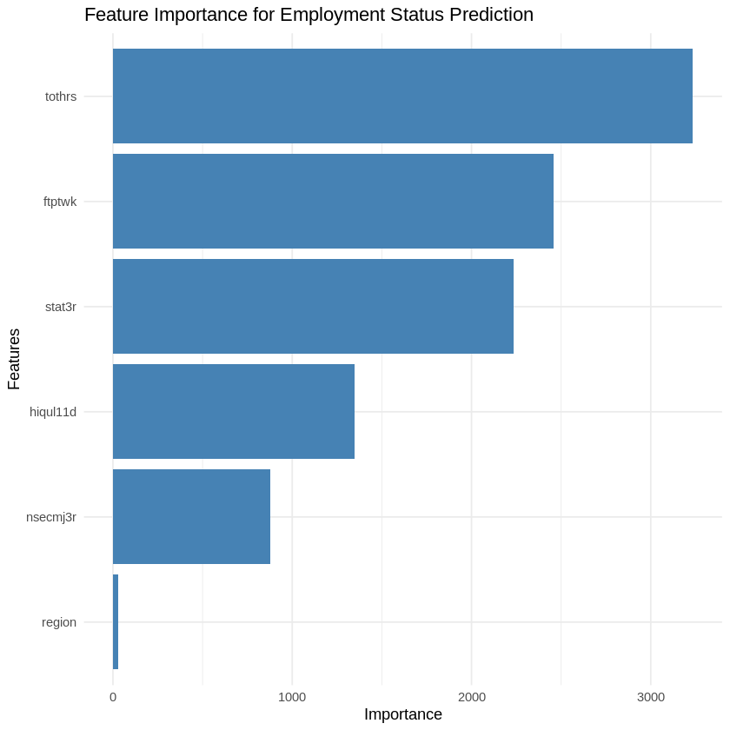

**Figure 5:** Feature importance plot for for employment status using random forest model

The feature importance plot reveals that the most crucial predictors for employment status are:

1. NS-SEC classification
2. Total hours worked
3. Highest qualification
4. Full-time/Part-time status
5. Employment status (STAT3R)

This aligns with these earlier findings from regression analyses, confirming the importance of socio-economic classification, working hours, and education in determining employment outcomes.