**Project Requirements**

**Project Name:**

**Team: ESE Team 8**

**Customer:**

Revision History

| **Version** | **Date** | **Revision Description** |
| --- | --- | --- |
| 1.01 | 05.10.2015 | Regrouping of the first Project Requirements |

Date: October 6, 20155

# Diagram

***Use Case Diagram (V1.1)***

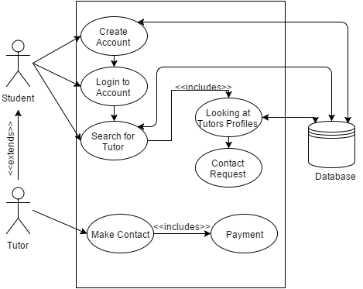

# Use cases

1. **Create Account**
   1. **Actors**

Student

Tutor

Database (secondary)

* 1. **Description**

A User wants to create a new Account

* 1. **Trigger**

A User clicks on the Create New Account Button

* 1. **Pre-conditions**

User shouldn’t be registered yet

* 1. **Post-conditions**
     1. **For Student**
        1. Username and email must stay unique
        2. Password shouldn’t be null
        3. New User should be saved in Database
     2. **For Tutor**
        1. Must at least teach one Subject
  2. **Main Scenario**
     1. User clicks on the Create New Account Button
     2. The Subscribe Page opens
     3. Enters First Name, Username and Email
     4. Check checkbox “Tutor” if needed
     5. Clicks on the Button Finish
     6. Data is Saved on Database
     7. Opens new Page with: “Sign Up Complete”
  3. **Alternative Scenarios**

User Closes the Window or reloads it, all entered data are deleted

4a. Username or Email already exist in Database

1. Stay on the Subscribe Page
2. Notifies User that Username/Email are already used

4b. Username’s Email is invalid

1. Notifies User that email is invalid

* 1. **Special Requirements**

-

* 1. **Notes**

-

1. **Fill in account for Tutor**
   1. **Actors**

Tutor

Database (secondary)

* 1. **Description**

As a tutor I want to create a rich profile that highlights my skills and maximizes my visibility.

* 1. **Trigger**

A User clicks on the Create New Account Button

* 1. **Pre-conditions**

User must be logged in as a tutor

* 1. **Post-conditions**

Must at least teach one Subject

* 1. **Main Scenario**
     1. User clicks on the “Fill in my account”
     2. Enters Subjects, Grades and Time Slots
     3. Clicks on the Button Finish
     4. Data is Saved on Database
     5. Opens new Page with: “Your account is updated”
  2. **Alternative Scenarios**

User Closes the Window or reloads it, all entered data are deleted

* 1. **Special Requirements**

-

* 1. **Notes**

-

1. **Login to Account**
   1. **Actors**

Student

Tutor

Database (secondary)

* 1. **Description**

A User wants to login

* 1. **Trigger**

User enters the URL address of the Website and access the login Page

* 1. **Pre-conditions**

-

* 1. **Post-conditions**

1. User enters his/her account if username matches password.
   1. **Main Scenario**
2. User enters the URL address of the Website and access the login Page
3. User enters Username and Password
4. System verifies match with data in Database
5. Data matches, and a new Page Opens with the actual User logged in
   1. **Alternative Scenarios**

3a. Username doesn’t exist in Database

1. Goes back to step 2 with notification to User

3b. Password doesn’t match Username in Database

1. Goes back to step 2 with notification to User
   1. **Special Requirements**

-

* 1. **Notes**

-

1. **Search for Tutor**
   1. **Actors**

Student

Database (secondary)

* 1. **Description**

As a student I want to find a tutor that studied the subject I'm preparing for.

As a student I want to make sure that a tutor can provide his services according to my needs.

As a student I want to make sure that a tutor has good knowledge of the subject.

* 1. **Trigger**

Student clicks on “Search Tutor” Button

* 1. **Pre-conditions**
     1. Student is logged in
  2. **Post-conditions**

**-**

* 1. **Main Scenario**

1. Student clicks on “Search Tutor” Button
2. Student applies filter
3. Student looks at a Tutor Profile
   1. **Alternative Scenarios**

2a. No Tutor matches the filter

1. System prompts an excuse message
   1. **Special Requirements**

-

* 1. **Notes**

-

1. **Contact Request**
   1. **Actors**

Student

Database (secondary)

* 1. **Description**

As a student I want to contact a tutor and discuss the details of the engagement.

* 1. **Trigger**

Student has clicked on the “Make Contact” Button on a Tutor Profile Page

* 1. **Pre-conditions**
     1. Student is logged in
  2. **Post-conditions**

1. Contact request sent to Tutor
   1. **Main Scenario**
2. Student has clicked on the “Make Contact” Button on a Tutor Profile Page
3. System sends a Notification Email to the Tutor
   1. **Alternative Scenarios**

-

* 1. **Special Requirements**

-

* 1. **Notes**

-

1. **Make Contact**
   1. **Actors**

Tutor

* 1. **Description**

As a tutor I want to effortlessly interact with potential customers

As a service provider I want to earn a commission on each engagement

* 1. **Trigger**

Tutor receives notification Email

* 1. **Pre-conditions**

Tutor is logged in

* 1. **Post-conditions**

-

* 1. **Main Scenario**

1. Tutor receives notification Email
2. Tutor clicks on the link in the Email
3. Tutor accepts the offer
4. Tutor pays the commission
5. Tutor receives Student contacts
   1. **Alternative Scenarios**

3a. Tutor does not accept the offer

1. Student receives Notification Email that the request was declined
   1. **Special Requirements**

-

* 1. **Notes**

-