**Software Requirements Specification**

**Project name:**

**Team:** Nr. 9

**Customer:**

|  |  |  |
| --- | --- | --- |
| **Version** | **Date** | **Revision description** |
| 0.1 | 02.10.15 | Initial SRS |
|  |  |  |

1. Introduction

The purpose of this project is to create a website that acts as an agency between students.

More precisely, it acts as an agency between students who are looking for a tutor, and students who want to tutor another student. The persons of interest are therefore mostly students and the service provider.

For now, we assume that the students will be from the university of bern (i.e. the available courses for tutors to subscribe to will be the same as here).

In the following, we will refer to the students looking for a tutor as students and for those who want to tutor as tutors.

A goal is to create a website that allows tutors to create a profile to present themselves. Among other things, this profile will display the courses for which they offer tutoring, and the grade they had in those courses. A function to verify, if the tutor really has passed the course and with which grade is not part of this project.

Another goal is to provide an interface for the students, where they can search from and browse between the available tutors. If they are interested, they can send requests to the tutor.

Since the service provider wants to earn a commission, the tutor profile will not display to specific information (i.e. no e-mail address and not the full name). The tutor will receive the informations to contact the student once he paid. If this will be a commission for each answered request or a one-time fee is still open.

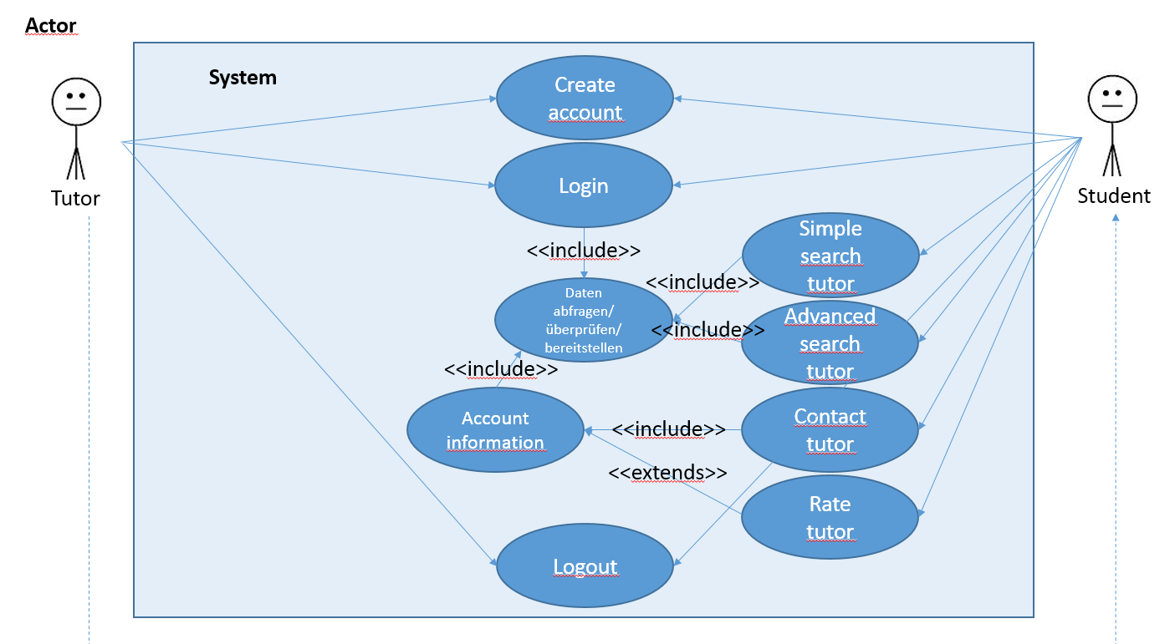

1. **Overall description**

* **Use Cases:**

1. Create a Tutor Account
   1. Actors

Tutor

* 1. Description

As a tutor I want to create a tutor account to display information about my tutoring abilities in order to attract potential clients (students) and interact with them.

* 1. Trigger

Sign up page requested to create a tutor account.

* 1. Pre-Conditions

1. Tutor doesn’t have an account yet
   1. Post-Conditions
2. System contains user account for a tutor
3. If the account couldn’t be created the system provides enough information for the tutor to sign up correctly
   1. Main Scenario
4. Tutor requests sign up page
5. Tutor enters account information
6. Tutor clicks sign up button
7. System validates the input
8. System creates a tutor account
9. Page displays that the account was created successfully
   1. Alternative Scenarios

4a. Not all necessary fields are filled out

1. Display help information that all fields have to be filled out
2. Tutor fills out the rest and clicks sign up button
3. Use Case resumes on step 4

4b. Input doesn’t have the right format (e.g. email is not valid)

1. System displays help information that the input is not formatted correctly
2. Tutor changes badly formatted input
3. Use Case resumes on step 4

4c. Already an account registered under the given email/username

1. Display information that there’s already an account registered for the given email/username
2. Use Case resumes on step 4
   1. Special Requirements
   2. Notes
3. Create A Student Account
   1. Actors

Student

* 1. Description

As a student, I want to create an account in order to find potential tutors and interact with them over the system.

* 1. Trigger

Sign up page requested to create a student account.

* 1. Pre-Conditions

1. Student doesn’t have an account yet
   1. Post-Conditions
2. System contains user account for a student
3. If the account couldn’t be created the system provides enough information for the student to sign up correctly
   1. Main Scenario
4. Student requests sign up page
5. Student enters account information
6. Student clicks sign up button
7. System validates the input
8. System creates student account
9. Page displays that the account was created successfully
   1. Alternative Scenarios

4a. Not all necessary fields are filled out

1. Display help information that all fields have to be filled out
2. Student fills out the rest and clicks signup button
3. Use Case resumes on step 4

4b. Input doesn’t have the right format (e.g. email is not valid)

1. System displays help information that the input is not formatted correctly
2. Student changes badly formatted input
3. Use Case resumes on step 4

4c. Already an account registered under the given email/username

1. Display information that there’s already an account registered for the given email/username
2. Use Case resumes on step 4
   1. Special Requirements
   2. Notes
3. Login
   1. Actors

Student/Tutor

* 1. Description

As a student or tutor I would like to log into my account in order to interact with the system and view any information based on my identity (tutor, student).

* 1. Trigger

Student/Tutor wants to login

* 1. Pre-Conditions

1. User isn’t logged in yet
2. User already has an account
   1. Post-Conditions
3. User is logged into his account
4. If the login didn’t work, enough information is displayed so that the user knows what went wrong
   1. Main Scenario
5. User requests login
6. User fills out username and password
7. User sends request
8. System checks if the request is valid and there is already an account
9. User can now interact with the system in the designated way
   1. Alternative Scenarios

4a. No account registered under the given username

1. Display message that there is no account registered with the specified username
2. Give the user the possibility to create a new account
3. User can register a new account

4b. Username was wrong

1. Display message that there is no account registered with the specified username
2. User fills out form again
3. User sends request
4. Resume use case on step 4
   1. Special Requirements
   2. Notes
5. Logout
   1. Actors

Student/Tutor

* 1. Description

As a user I want to end my session in order that no one else can use my account and my authorization.

* 1. Trigger

User requests logout

* 1. Pre-Conditions

1. User has been logged in before
   1. Post-Conditions
2. User is logged out meaning that no authorized interaction can happen without logging in again.
   1. Main Scenario
3. User requests logout
4. System ends session with the designated user and prevents further use with this user
5. A message is displayed if the logout was successful or not
   1. Alternative Scenarios
   2. Special Requirements
   3. Notes
6. Search for tutors with simple search
   1. Actors

Student

* 1. Description

As a student I want to search for tutors based on subject in order to choose and contact a tutor. The search should be simple, meaning that I can simply enter the text in a search bar and all matching tutors are displayed in a list.

* 1. Trigger

Student requests a simple search on the webpage.

* 1. Pre-Conditions

1. Student has an account ?
   1. Post-Conditions
2. All matching tutors are displayed
   1. Main Scenario
3. Student enters text in the search bar
4. Student clicks search button
5. System checks the database for all matching tutors
6. Tutors are displayed in a list
   1. Alternative Scenarios
   2. Special Requirements
   3. Notes
7. Search for tutors with advanced search
   1. Actors

Student

* 1. Description

As a student I want to search for a tutor based on subject, fee range, gender, rating and university in order to contact the tutor and arrange tutoring hours.

* 1. Trigger

Student requests an advanced search.

* 1. Pre-Conditions

1. Student has an account?
   1. Post-Conditions
2. All matching tutors are displayed
   1. Main Scenario
3. Student can choose different filters to search for
4. Student clicks to start the search
5. All tutors are displayed according to the chosen filters in a list
   1. Alternative Scenarios
   2. Special Requirements
   3. Notes
6. Contact a tutor
   1. Actors

Student

Tutor

* 1. Description

As a student I want to contact a tutor in order to begin the tutoring hours.

* 1. Trigger

Student chooses a tutor from a displayed list

* 1. Pre-Conditions

1. Student has searched for tutors
   1. Post-Conditions
2. The contacted tutor will be notified
3. The student receives a message that the request was sent
   1. Main Scenario
4. Student searches for a tutor with simple or advanced search
5. Student
   1. Alternative Scenarios
   2. Special Requirements
   3. Notes
6. Rate a tutor
   1. Actors

Student

Tutor

* 1. Description

As a student I want to give feedback in order for other students to find appropriate tutors.

* 1. Trigger
  2. Pre-Conditions

1. The tutor has been hired by the rating student
2. Student and tutor have finished their tutoring lesson
   1. Post-Conditions
3. The feedback is stored persistently by the system
4. The change is represented by the view
   1. Main Scenario
5. Student chooses tutor to rate
6. Student chooses a rating based on stars
7. System is notified of the rating and saves it persistently
   1. Alternative Scenarios
   2. Special Requirements
   3. Notes
      1. The rating system is implemented by a five star system

* Actor characteristics

1. **Specific Requirements**
2. **Functional requirements**

* FR1 Tutor
  + A user can create a tutor profile. The tutor-profile consists of the following information: full name, email, course of studies, subject and grade (multiple subjects are possible), semester, university, gender, fee range and rating.
* FR2 Student
  + A user can create a student profile. The student profile consists of the full name and email of the user.
* FR3 Search
  + Search for tutors by subject, fee range, gender, rating and university.
* FR4 Rating
  + A student can rate his tutor.
* FR5 Initial contact
  + Initial contact happens within the application. The application contacts the tutor when he was requested by a student.

1. **Non-functional requirements**

* NFR1 Privacy
  + Privacy of the tutor and the student: Full name and contact information should only be revealed after successfully establishing contacts.
* NFR2 Commission
  + The tutor needs to pay a commission to be able to answer requests.