- Explain the terms concurrency and parallelism, with an example.
Ans:
Concurrency involve multitasking within a particular period through switching from one task to another but do not require all tasks to be done simultaneously.
For example, if you engage in studying, responding to text messages, and snacking at the same time, that is concurrent activity.
Parallelism refer to multitasking involving simultaneous performance of several tasks.
For example, in a group assignment, one member may be typing, another one searching for information, and yet another creating a presentation at the same time.
In computer systems, concurrency take place when a single CPU core performs multiple tasks through switching among them, whereas parallelism involve multiple CPU cores doing various tasks concurrently.

- Explain the terms threads and multithreading, with an example.
Ans:
Thread is the smallest unit of execution in a process. Thread is a component of a software program that runs independently but uses the same memory space and shares resources with other threads from the same process.
Example: In a web browser, a thread may be used to download a website while another thread can play a video clip.

Multithreading involves using several threads in a program simultaneously to enhance efficiency and speed up performance.
Example: In a music program, one thread is used to listen to music while another thread downloads music files.

Simply put, a thread is an individual task executed in a software program, while multithreading involves executing numerous tasks at once in one software application.

- Explain what the following functions do? (explain input parameters, and return type of each)
  - pthread_create(thread, attr, routine, arg);
Ans:
This function is used to create a new thread.
- thread: Pointer to pthread_t where the thread ID will be stored
- attr: Thread attributes (usually NULL for default settings)
- routine: Function that the thread will execute
- arg: Argument passed to the thread function
Return Type: int
- Returns 0 if successful
- Returns non-zero if there is an error

  - pthread_join(thread1, NULL);
Ans:
This function is used to wait for a thread to finish its execution.
- thread1: The thread ID of the thread to wait for
- NULL: Used when no return value from the thread is needed
Return Type: int
- Returns 0 if successful
- Returns non-zero if there is an error

  - pthread_exit(NULL);
Ans:
This function is used to terminate the calling thread.
- NULL: Indicates no return value is being sent back
Return Type: void
- It does not return any value

  - pthread_self();
Ans:
This function is used to get the ID of the currently running thread.
- No input parameters
Return Type: pthread_t
- Returns the thread ID of the calling thread

- Write a multithreaded program using pthreads where a single thread is created from the main function. The thread should print a simple message such as “Hello from the child thread”. Ensure that the main function waits for the thread to complete before terminating the program.
Ans:
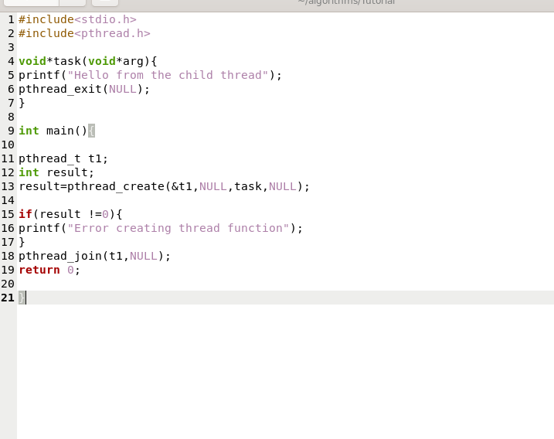

Output:
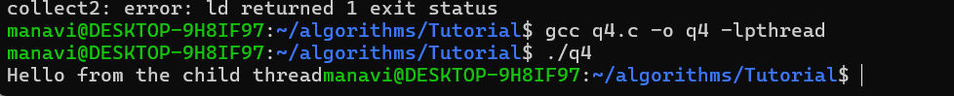
- Write a multithreaded program in which the main function passes an integer value (N) to a thread. The thread should compute the sum of all numbers from 1 to N and display the result within the thread function.
Ans:
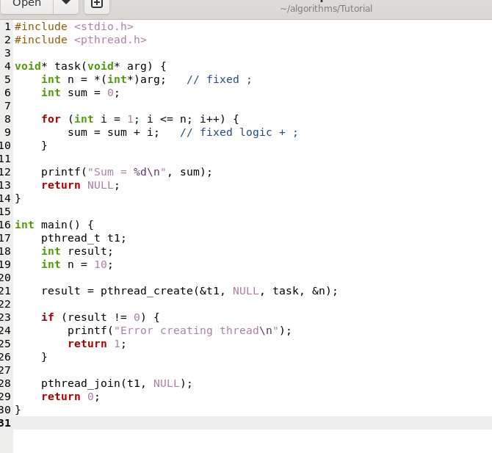

Output:
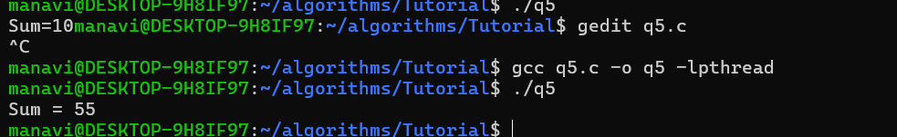

- Write a multithreaded program that defines a structure containing two integer variables: start and end. Pass this structure to a thread, and the thread should compute the sum of all integers between start and end (inclusive). Display the result from the thread function.
Ans:
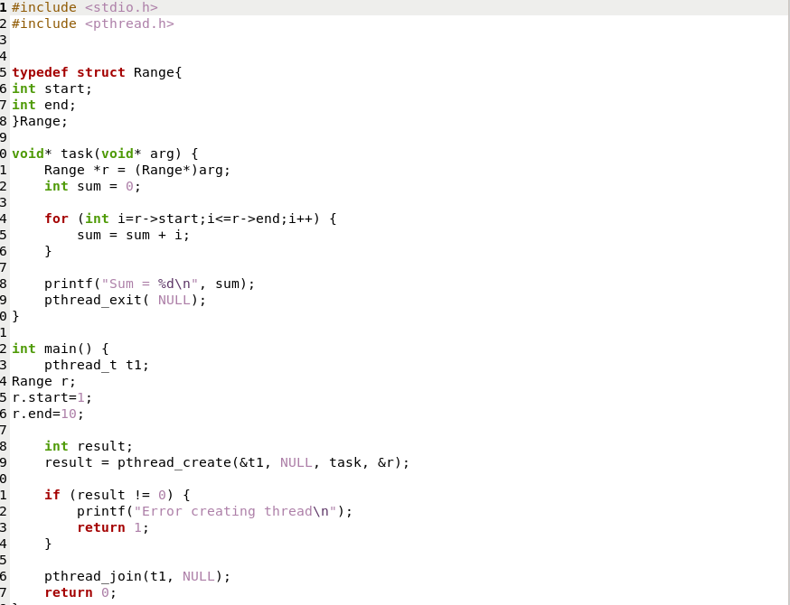
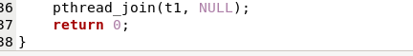

Output:
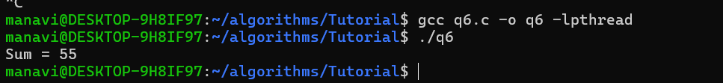
The End

