Admin panel :

1. Add event
2. Add photo
3. Management of reservation
4. Management of menu
5. Maps location
6. Management off Facebook page/ twitter/ tripadvisor

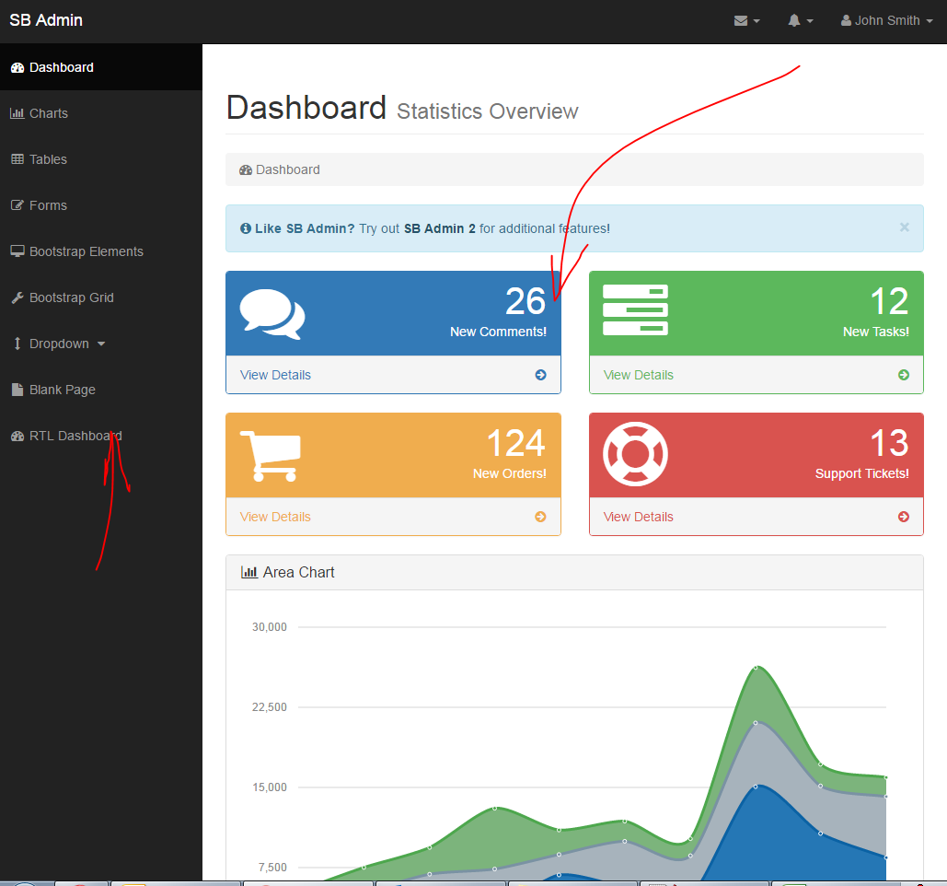

Web site

1. photo
2. event
3. reservation
4. example  restaurant and reservation:
   1. <http://bella.designershare.net/index-bella-firenze.html>
   2. http://www.latabledulancaster.fr/en/