**APPLICATION DESIGN**

* **Software Architect:**

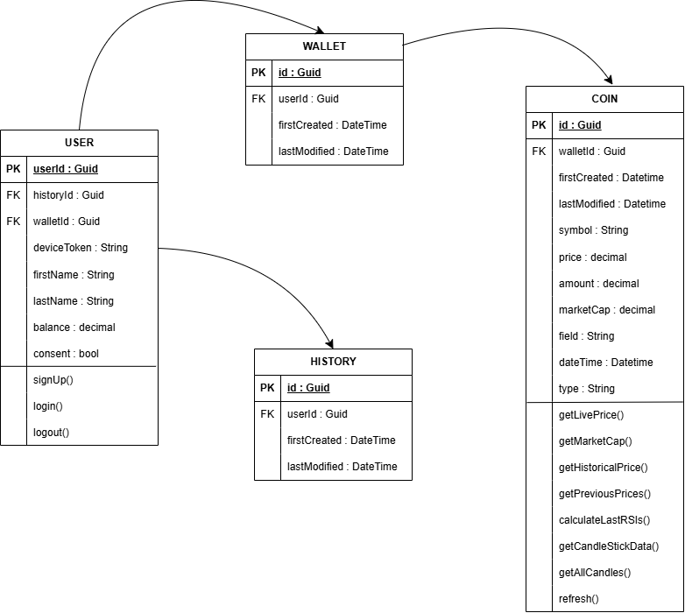

* **Product Owner:**

