KALIRAJ SAMUTHIRAM
Phone : +91- 97876 30475
E-mail:rajmuthuinfo@yahoo.com
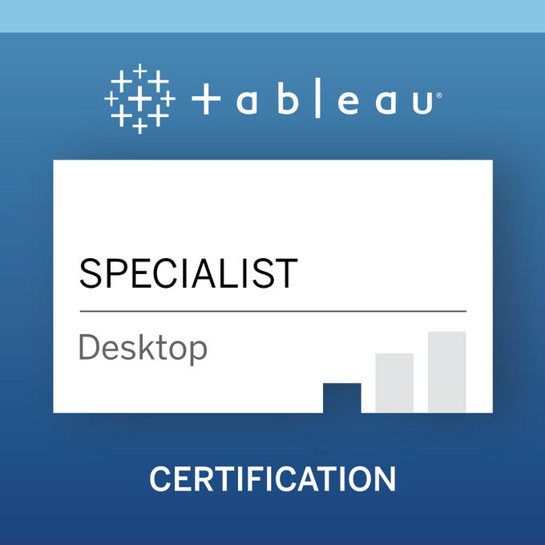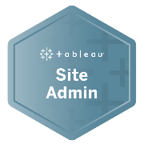

CAREER SUMMARY:
- Extensive experience in System Designing, Analysis, Application Development, Maintenance, Implementation and Project Management using BI tools.
- Experienced in analyzing BI needs, interpreting business user requirements, and translating them into reports.
- Strong Analytical and Problem-Solving Skills with ability to work independently and in team environments, simultaneously on multiple projects with competing priorities.
EXPERIENCE:
Total Experience: 12 Years.
Relevant Analytics Experience: 8 Years.

- July 2023 – till date, Genesys Telecom Lab, Chennai.
- Oct 2021 – July 2023, Standard Chartered Global Business Service, Chennai.
- Mar 2020 – Sep 2021, Genesys Telecom Lab, Chennai.
- Feb 2018 – Feb 2020, HCL Technologies, Chennai.
- Jun 2016 – Nov 2017, Société Generale Global Solution Center, Italy/Chennai.
- Jan 2015 – Jun 2016, BNY Mellon International Operations India Pvt Limited, Chennai.
- May 2010 – Dec 2014, Tata consultancy services Limited, Chennai.

TECHNICAL SKILLS
- Databases: Oracle, SQL Server, Snowflake.
- Data warehousing: Informatica, Talend, Matillion
- Operating System: Windows, Red Hat Linux 5.0
- Data Analysis Tool: Tableau Desktop/Server/Tableau Prep, Power BI, Tibco Spotfire, Alteryx, Dataiku.
Tableau Public profile: https://public.tableau.com/profile/kaliraj.s#!/

PROJECT SUMMARY

Geneys Telecom Lab

CRM : Salesforce
BI Tool : Tableau Desktop, Tableau Prep, Tableau Server,
Tableau CRM, TABCMD, Alteryx.
Database : Snowflake,
Data warehouse : Talend
Project Tool : Jira, Confluence, SharePoint.

Responsibilities:

- Migrating the tableau datasource between different applications.

- Migrating alteryx workflow to Tableau prep for cost saving and application inline with tableau environment.

- Developing the reports for Audit\HR\Finance Account Receivable teams.

- Maintaining data catalog for the above reports in Alation data governance and maintain data lineage when changes are happening.

- Managing tableau sites for finance projects and keep the permissions at data source and report level.

Standard Chartered Global Business Service

Project : Liquidity
BI Tool : Tableau Desktop, Tableau Prep, Tableau Server, Power BI,
Tableau CRM, TABCMD, Dataiku, Microstrategy
Database : Hive
Project Tool : Jira, Confluence, SharePoint.
Reports Development: LCR, NSFR, OLAR, CFMR

Responsibilities:

- Being the advocate of BI and Analytics for data driven decision making across the enterprise through strategic leadership and guidance
- Defining scope, project plans and schedules for projects across the Business Intelligence portfolio
- Maintaining and updating the Business Intelligence project portfolio in response to changes in priority, scope and progress
- Driving innovation on development of tools, reporting improvements, automation, and creating new insightful reports
- Evaluate company needs, analyze options, recommend actions to provide business intelligence across the business
- Responsible for leading the strategic design and maintenance of business intelligence applications. Identifies, researches, and resolves complex technical problems
- Design, build, deploy, and support BI and ETL processes, applications and products
- Working with team of developers designed, developed, and implement a BI solution for Data quality management squad.
- Managing Tableau sites and Dev/Test server.
- Involved in troubleshooting and performance tuning of reports and resolving issues within Tableau Server and Reports.
- Participated in weekly meetings, reviews, and user group meeting as well as communicating with stakeholders and business groups.
Geneys Telecom Lab

Project : Global 360 Analytics
CRM : Salesforce
BI Tool : Tableau Desktop, Tableau Prep, Tableau Server,
Tableau CRM, TABCMD
Database : Snowflake,
Data warehouse : Talend
Project Tool : Jira, Confluence, SharePoint.

Responsibilities:

- Working with team of developers designed, developed, and implement a BI solution for Sales, Product and Customer KPIs.
- Developed a 360-business dashboard with multiple panels and parameters that became a favorite sales tool for most of the sales force at CE.
- Implemented Tableau mobile dashboards via Tableau mobile application.
- Strong Dashboard design experience and passionate practitioner of effective data visualization. Familiarity with best practices around visualization and design.
- Utilized Tableau server to publish and share the reports with the business users.
- Also involved in administration tasks such as Setting permissions, managing ownerships, and providing access to the users and adding them to the specific group.
- Distributed Tableau reports using techniques like Packaged Workbooks, PDF to different user community.
- Produced attractive visuals/dashboards to convey the story inside the data.
- Built dashboards using techniques for guided analytics, interactive dashboard design, and visual best practices.
- Involved in trouble shooting of performance issues which were associated with Tableau reports.
- Also involved in administration tasks such as publishing workbooks, setting permissions, managing ownerships, providing access to the users, and adding them to the specific group and scheduled instances for reports in Tableau Server.
- Worked in all phases of BW/BI full life cycles including analysis, design, development, testing, deployment, post-production support/maintenance, documentation, and end-user training.
HCL Technologies

Project : Credit Card Spending Analytics and Insurance Analytics
Client : Commonwealth Bank of Australia
BI Tool : Tableau Desktop, Tableau Prep, Tableau Server, TABCMD
Database : Oracle SQL
Project Tool : Jira, Confluence, Documentum.

Responsibilities:

- Created the BI reporting requirements document template to capture business & functional requirements that include system analyst and security requirements.
- Understanding the KPIs and Requirements Documents.
- Working with Data Warehouse teams and understanding Claims Data Mart and Policy Data Mart.
- Designing, Developing, and testing reports using Tableau.
- Supporting User Acceptance Testing and validating the generated reports in collaboration with Business Users.
- Setup sites, projects & local user groups as per functional teams of the organization and implemented Tableau standard operational process for granting user access and for publishing workbooks, data sources.
- Experience with Create/Manage Groups, Users, Workbooks and Projects, Database Views, Data Sources and Data Connections.

Société Générale Global Solution Centre

Project : Custody Security Trade Settlement
BI Tool : Tableau Desktop, Tableau Prep, Tableau Server
Database : Oracle, SQL Server.
Project Tool : Jira, Confluence.

Roles & Responsibilities:

- Prepared Technical Specifications Document for the project development based on the functional Specs.
- Utilizing capabilities of Tableau such as Data extracts, Data blending, Forecasting, Dashboard actions and Table calculations.
- Building, publishing customized interactive reports and dashboards, report scheduling using Tableau server.
- Created action filters, parameters, and calculated sets for preparing dashboards and worksheets in Tableau.
- Restricted data for users using Row level security and User filters.
- Developed Tableau visualizations and dashboards using Tableau Desktop.
- Developed Tableau workbooks from multiple data sources using Data Blending.
- Provided 24/7-production support for Tableau users.
- Create/Manage Groups, Workbooks and Projects, Database Views, Data Sources and Data Connections
- Add/Edit Sites and corresponding administration rights (System vs. Content)
- Create/Modify/Manage server task schedules
- Monitor server activity/usage statistics to identify possible performance issues/enhancements.

BNY Mellon International Operations India Pvt Limited

Project : Client Accounting and Reporting Services
Client : Blackrock, Invesco
BI Tool : Tableau Desktop, Tableau Server
Database : Oracle, SQL Server.
Internal DB : Workbench Data, TradeOne

Roles & Responsibilities:
- Involved in reviewing requirements and data sources form MS Excel and MS Access for design, development, testing, and production rollover of reporting and analysis projects within Tableau Desktop.
- Used Tableau Desktop for blending databases and creating different interactive views and dashboards.
- Created extract files for improving the performance. Used different Mark types and Mark properties in views to provide better insights into large data sets. Created various types of charts to provide better visualization.
- Using Tableau Desktop created Interactive reporting dashboards by combining multiple views.
- Involved in troubleshooting and performance tuning of reports and resolving issues within Tableau Server and Reports.
- Participated in weekly meetings, reviews, and user group meeting as well as communicating with stakeholders and business groups.
Tata Consultancy Services

Project : Wealth Management, P&C Insurance Claims
Client : Morgan Stanley, Marsh & McLennan Agency
BI Tool : Tableau Desktop, QlikView
Database : Oracle SQL

Roles & Responsibilities:

- Translated clients’ needs into useable mapping and coding instructions and created functional requirements document and mockups for reporting.
- Prepared Business Requirement Documents (BRD's) after the collection of Functional Requirements from System Users that provided appropriate scope of work for technical team to develop prototype and overall system.
- Designed and implemented basic SQL queries for testing and report/data validation. Developed and maintained reporting using in MS Excel queries and SQL. Produce performance reports and implement changes for improved credit reporting along with performing conditional formatting for data analysis.
- Created Test Cases and Activity Diagrams, systems Flow Charts.
- Reviewed request to determine basic characteristics, such as origin and report flow, mapping, format, frequency, distribution, and purpose or function of report.
- Worked closely with the Information management groups to develop, test, and validate systems and reports, attended meetings with users and IT, documented business, technical, and systems requirements.
- Cleaning and Blending multiple data sources to allow for different views on application data in a single dashboard.
- Created numerous dashboards in Tableau Desktop based on the data collected and blending data from MS Excel and CSV files along with SQL Server Databases.
- Complied interactive dashboards in Tableau Desktop and published them to Tableau Server which allowed story telling with Quick Filters for on demand needed information with just a click of a button.
- Conducted presentations to other lines of business as a meta role to show value of Tableau as a BI tool

ACADEMIC PROFILE
- 2015 - MBA (Operations Management) from ITM University collaborated with Southern New Hampshire University, USA, secured 3.54 out of 4 CGPA.
- 2008 - B. Tech (IT) from P.S.R. Engineering College, Sivakasi, secured 77%.
ACHIEVEMENTS
- Star Performer of Analytics Catalyst Program (HCL, 2019)
- Received Best Innovator award from business head. (Société Generale, Q3/Q4 2016)
- Received the Employee of the Quarter award (BNY Mellon, Q1, 2015)
- For APAC region, led the Education/Training/Development channel as a strategic channel leader.
- Led Best Practice Group for sharing the best practices across Chennai/Pune locations.
- Received the star performer award - November 2010 (TCS).
- Six Sigma Green Belt Certified in TCS.

