CURRICULLUM VITAE

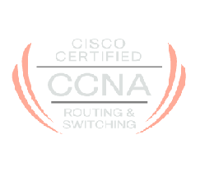
Suraj K More 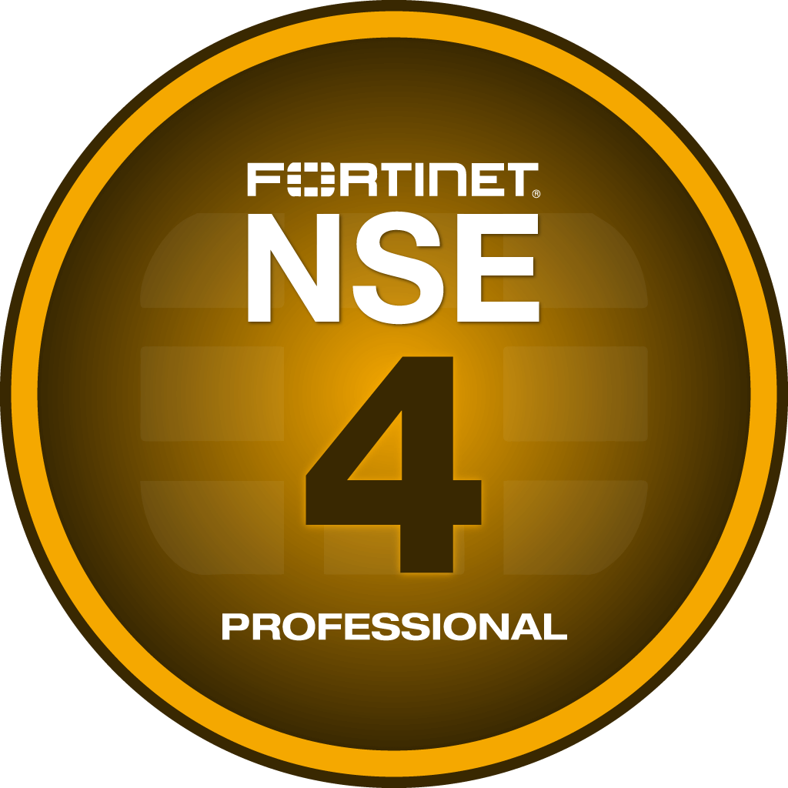
Network & Security Professional
B.E – Electronics Engineering
Cisco ID No. : CSCO13228914
NSE 4 ID No. : lc2oGduxgT
Surajmore126@gmail.com
9028424809

Profile Summary

Hard-working Network and security Engineer skilled at overseeing complex company networks with a focus on efficiency and performance optimization. Detail-oriented and proactive with strong troubleshooting, communication and analytical abilities.

Networking & security Platforms

Routers - Cisco ASR 1000, Cisco 8200, Cisco 1900,2900, Brocade NetIron CER 2024C, Cisco 841

Switches - Cisco Nexus 9K, Cisco Catalyst 9200, Cisco Catalyst 9300, Cisco Catalyst 1000, Cisco 2960,3560,
Brocade ICX 6450,7250 VDX 6740, HP 2510G, HP 1920S, HP1910, HP 5500

Firewalls - PaloAlto3250, SonicWALL NSA5600,3600,2600, FortiGate 1100E, 500D, 200F, 100F, Fortinet SDWAN 40F

Load Balancer - F5, Baracoda, Radware

Wireless - FortiAP, Forticontroller, Aruba 315,215, Arista C75, C215

NMS - Manage Engine OP Manager, Netflow, PRTG, Motadata, Zabbix

Security Monitor - SonicWALL Analyzer, Forticloud, Brocade Network Advisor, GMS server

WAF - Imperva, Baracoda, Zscaler, Cyberoam CR 500ing

Endpoint Security - Forcepoint proxy, Bitdefender, Symantec

Networking & Security Skills

Routing - Static, RIP, OSPF, EIGRP, BGP Basics, NAT, Policy Based Routing

Switching - Stacking, VLAN, Inter VLAN, VTP, STP, RSTP, PVLAN, ETHERCHANNEL, HSRP, VRRP, GLBP

Security - VPN (IPSEC, SSL), ACL, Web Filtering, Firewall Policy, Geo-IP filtering, Port security

Professional Experience

Organization - Suryoday Small Finance Bank Ltd
Profile - Deputy Manager, Network and Security
Duration - Feb 2019 – Till Date

Key Responsibilities:

- Managing DC Routers, Switches, Firewall, Load Balancer, WAF, Regulatory and Backbone Links.
- Managing PAN India Suryoday Branches links and Routers/SD WAN.
- Configuration and troubleshooting firewall policy implementation of Palo Alto, Cisco ASA and Fortinet Firewall.
- Managing S2S VPN creation with multiple vendors and SSL VPN access with 2FA for users
- DC/DR network revamping/migration and conducting DR drill.
- Documenting network changes and updating diagrams accordingly.
- Monthly, Quarterly, Yearly review of Network and Security Audit as per the RBI regulation.
- Participating in RBI CSITE, Cyber Security, ISO 27000, KPMG and various Internal Audits.
- IOS upgradation of Firewalls, Routers, Switches, Access points.
- Co-ordination for Network link Shifting of IT Office, Branches and New Branches link delivery.
- AP configuration for multiple locations for WiFi access.
- Troubleshooting for site unreachable, WAN link down issues, hardware failure issues, etc.
- Trouble Shooting on Firewall for Network Access Issue.
- Load Balancer Configuration for new application on boarding.
- Data Centre Migration and Build new Data Centre Network Architecture.
- Rollout of 801.1X in LAN and Wireless Network and Trouble shooting.
- Working with Bank Partners like NPCI, IDRBT, VSOFT etc for Network Access and Network Management.
- Managing UPI, Payment Partner, CTS, CBS Network and co-ordination with Vendor.

Organization - Artech Infosystem Pvt.Ltd
Profile - Network Engineer
Duration - Sept 2017 – Feb 2019

Key Responsibilities:

- Managing Sonicwall & Fortigate Firewall, HP switches .
- Configuring & Managing Network monitoring tool (MOTADATA)
- Handling Project of office shifting.
- Setting up new Internet and Intranet link.
- Handling with network connections & trouble shooting issues.
- Wi-Fi (Aruba & Eginius) Network Assessment, Implementation, Management & Report Generation
- Co-ordinating with ISP team for installation and configuring Link
- Managing and maintaining MIS report maintaining Data
- Making and managing Network Budget

Organization - XcellHost Cloud Services Pvt.Ltd
Profile - Network & Security Executive
Duration - Jan 2017 – Sept 2017

Key Responsibilities:

- Handling Cloud Network Security issues and activities of critical Datacenter located in India, Singapore, Dubai.
- Taking care of In-house Enterprise Networks & Security consists of Firewalls, Switches, Proxy Servers, Wireless, ILL.
- Configuring, Managing and Troubleshooting Network Devices Switches & Routers, Firewalls
- Resolving customer queries and issues related to network & Security like Port access issue, Content Filtering, Latency Issue, Bandwidth and VPN issues.
- Actively participating in major activities carried out in DC such as Firmware upgradation, HA testing, Stacking, new installation of Routers, Switches, Firewall and Wireless.
- Working on Cases/Tickets with Vendors (SonicWALL, FortiGate, Brocade, Zscaler, Bitdefender) for any Hardware, products, License and Network related issues
- Actively participating in new Network & Security projects (ONAPP, Sophos, IPV6 implementation)
- Acting upon Network & Security Threats/Alerts receiving from Monitoring team.

Projects Handled:

- Switches Migrated from Brocade ICX-6450 to ICX-7250
- Deployed Bitdefender as anti-malware solution for clients located globally.
- Deployed Cacti as a monitoring tool for bandwidth utilization.
- Deployed SonicWALL Analyzer and monitoring the vulnerabilities
- Deployed Brocade Network Advisor for monitor the switch conditions (cpu, memory and interface utilization)
- IPV6 address implementing on the infrastructure.
- Upgraded hardware/firmware/links/license core and distribution level Brocade switches.

Organization - IT Source Technologies Ltd
Profile - Network Engineer
Duration - Feb 2016 – Jan 2017

Key Responsibilities:

- Configuration of Router & Switch.
- Configuration of Dell Firewall.
    - Dell SonicWALL Series  NSA 4600.
- Configuration of Cyberoam Firewall.
    - Sophos Cyberoam Series  CR500ing.
- Monitoring and Maintaining Network, Network Link, Network devices & Link Utilization.
- Generating reports of Devices on Weekly basis.

Organization - MTNL
Profile - Trainee Engineer
Duration - Jan 2015 – Dec 2015

INTERNSHIP :

- Working as a TRAINEE ENGINEER in MTNL ( JAN 2015  DEC 2015 )
- Introduction to different types of Network.
- Trained on the networks like TEJAS and FIBCOM.
- Maintaining the connectivity of fibers.
- Testing the links of 2mb.
- Monitor the different networks.
- Handled an OPTICAL TIME DOMAIN REFLECTOMETER.
- Taking care of Fault management.
- Understood and Learned CRIMPING and FIBRE SPLICING.
- Worked in GSM Switching.
- Monitor the BSC and MSC related issues.
- Monitor and Handled different types of problem in BTS Maintenance.
- Worked on MOTOROLA and ALCATEL systems in OMC-R.
- Worked in BROADBAND section.

Academics:

- Bachelors of Engg. (Electronics )
Completed in May 2014 with 62.39 % from PVPPCOE college Sion College.
- HSC ( Science )
Completed in March 2010 with 57.83 % from Maharashtra State Board.
- SSC
Completed in March 2008 with 84.92 % from Maharashtra State Board.

Personal Details:

Gender : Male.
Date of Birth : 26th Oct 1992
Address : R-007, B- Wing, Vaishnavi Apartment, Chinchpada Kalyan East - 421306
Marital Status: Married
Nationality : Indian.
Valid Passport: Yes.

Date:

Place: Mumbai (Suraj More)

