  Assistant Manager at Deloitte USI  Oct/2021 – Present  Role: Enterprise Network Engineer  Summary  I am 2016 Graduate (B.tech), having 7 Years of diverse experience in Enterprise Networking. I am passionate about learning new skills and working on new technologies. Interested in Networking, Automation and Cloud Computing. | - NITISH  - MISHRA  Yemalur, Marathahalli  Bengaluru-560037, KA  Ph : +91 8013536890  Email:neomishra007@gmail.com  Academic Qualification:  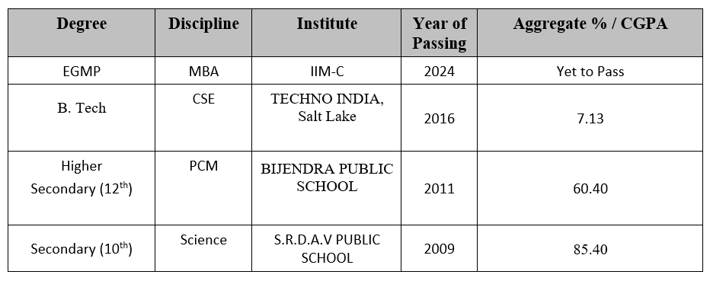
Key Skills  OSI/TCP-IP, Subnetting, LAN, VLAN, WAN, WLAN/WLC,DNAC, Firewall (CheckPoint & PaloAlto), DHCP, DNS, VLAN, HSRP, ACL, STP, VPN, VRF, DM-VPN, IPSEC, Security, MPLS, VPLS, BGP, OSPF, Network Security, AWS, VPC, Transit Gateway, ALB, SG, Route 53.  Programming Languages: C, Python  CERTIFICATIONS  Cisco CCNA (R&S), CCNA Collaboration, 5x Microsoft Azure Certified (incl. Az-305), 2x AWS SAA-02, MS Teams Voice Engineer Expert (Exam Passed), CCNP (75 Hrs of training completed from CBTNuggets)  AChievements  Received multiple Awards for Excellence in Work, Star Performer Award, Trophies, Cash Rewards, Certificates from Business Leaders. | Experience  Company: Deloitte USI (Oct-2021 till Present)  Role: Network Engineer  Responsibilities:  Configuring, Designing and Troubleshooting Enterprise Network, Cisco Routers, Switches, ISE, WLC (8500 & 5500), Checkpoint, Cyclades, VPN, Network Automation Using HPNA, DNAC, NQRA, Thousand Eyes, ODC New office Builds, Network Infrastructure for Clients. Deloitte USI IP telephony Infrastructure using Cisco CUCM, Voice Gateways, AudioCodes SBC, MS Teams Admin Center, Polycom Clarity Manager.  AWS Networking, VPC/Peering, Transit Gateway/Peering, Route-Table, ALB, Route 53, SG, S2S VPN, VPN Gateway, NAT Gateway, IGW.  Company: TCS (Dec 2016 – Dec 2021)  Role: Network Administrator  Responsibilities: Monitoring and Managing LAN/WAN/TELECOM infrastructure of Client having Global Presence in all regions. Using Cisco Routers, Switches, ISE, Palo Alto FW, Implementing DM-VPN with IPSEC S2S Tunnels, GRE Tunnels, F5, Citrix NetScaler Load balancer, SolarWinds/PVSR, Ultra DNS Portal, Verisign, CUCM, CUC, VOIP.  Designing & Configuring Enterprise IP Telephony with CUCM & Unity, H.323 Voice Gateway and Cisco Analogue Gateways (VG224, VG350), T1/E1 Lines, call-block, Digit-Manipulation, POTS FXS/FXO lines, 3rd Party Sip Devices, Call Routing, Enterprise Parameters, Bulk Administration, User Management, OS Administration & Disaster Recovery.
Key Projects:  USI Office Network Deployment  Duration: 6 Months  USI Network Configuration Validation  Duration: 3 Months  USI ODC Infra  Duration: December 2021-Present.  USI Polycom Migration  Duration: 3 Months  USI CUCM Build  Duration 3 Months  DNA Spaces Migration  Duration 3 Months  Certificate of Excellence from  Chief Information Officer. | 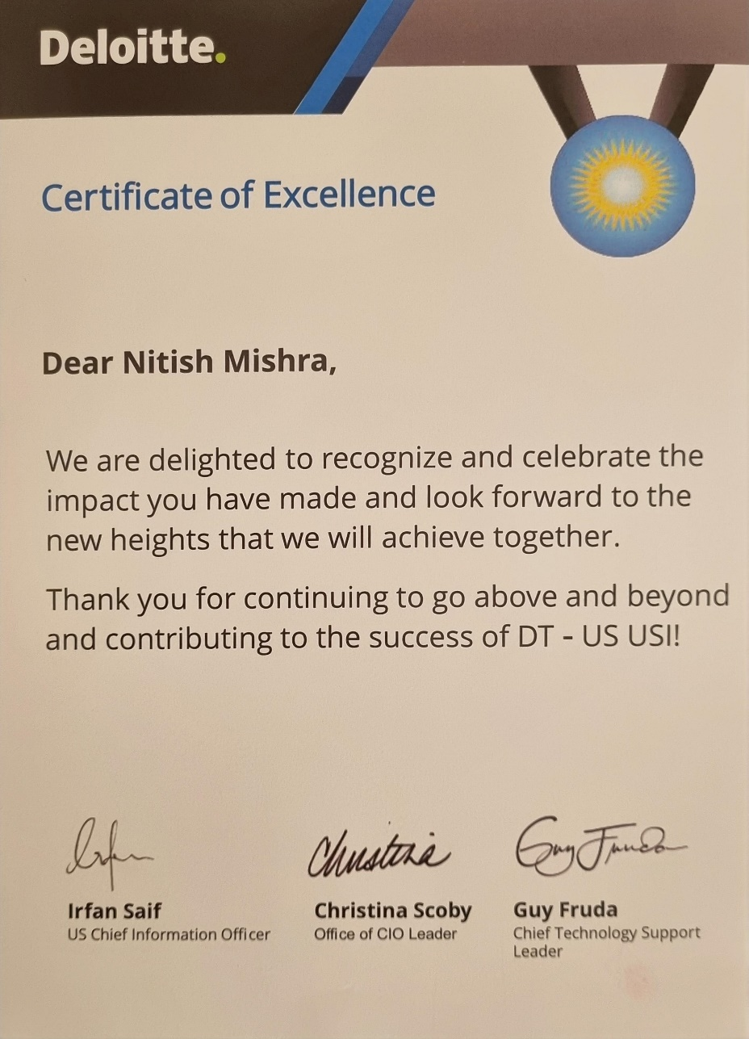
  Summary | Key Skills Used
  Lift and shift Core Infra during Floods in Bengaluru (2022). | IP Subnetting, Layer 2 and Layer 3 switching and Routing, Network Designing and planning, DNAC Implementation, STP, AAA, HSRP, VPLS, OSPF, BGP, Route-Summarization, Redistribution, Distribute-list, Prefix-list, PBR.
  Summary | Key Skills Used
  Validating the network configuration as per best practices and preparing for failover. | Validating, BGP route Manipulation and best Path Algorithms, BGP Dampening, BFD, Communities, Redistribution, Track, IP SLA, NetFlow, PIM-Multicast, Network Automation Using HPNA.
  Summary | Key Skills Used
  Onboarding new ODCs to Deloitte Infrastructure on-prem and cloud and providing solution as per Client compliance & Security requirements. | IP Subnetting, VLANs, DHCP, DNS, Static Routes, FW policies & Rules using CheckPoint FW, NAT, Port Security, Polycom IP Phone setup, Designing Network Diagrams on MS Visio, UAT, AWS Cloud, VPC,Route 53, SG, S2S VPN, VPN Gateway, NAT Gateway, IGW
  Summary | Key Skills Used
  Migrating Polycom IP Phones from On-Prem Skype Server to Microsoft Teams Server hosted on Cloud. | Researched and Prepared POA for the migration via multiple ways including manual and Bulk migration. Migrated more than 1500 Polycom phones without Downtime. Updated DHCP Option 161 for auto upgrade.
  Summary | Key Skills Used
  Building CUCM Server Infrastructure with 4 Call processing Node and one Publisher. Reducing the cluster from 8 Nodes to 4. | Designing & Implementing CUCM IP telephony Solution for VOIP with Regional Failover, OS installation on VM , Dial-Plan, MGCP Gateway, SIP-Trunk, Translation Rules, Speed Dial, Media Resources, CSS, Partitions.
  Summary | Key Skills Used
  Migrating Floor Maps from Cisco Prime 3.10 to Cisco DNA Spaces. | DNA Spaces, Cisco Prime 3.10 , REST Maps & AutoCad LT 2023, measuring the physical length of Floors for Access Point Positioning, for Office Space utilization Analysis.

