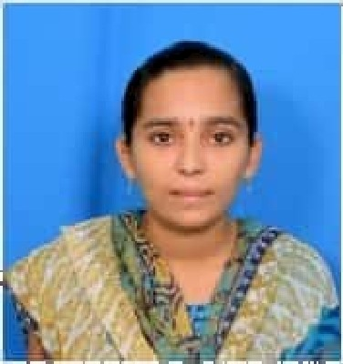 **RAJINI NARRA**

**Email:** narrarajini431@gmail.com

**Mobile:** 8639604769

|  |
| --- |
| CAREER OBJECTIVE: |

##### 

##### A dedicated individual seeking a job to build up a career in a reputed organization like by facing challenging assignments and adding to success of organization.

|  |
| --- |
| EDUCATIONAL QUALIFICATION: |

|  |  |  |  |  |  |
| --- | --- | --- | --- | --- | --- |
| S.No | Qualification | Institution | Board/University | Year | CGPA |
| 1. | B.Tech | LBRCE, Mylavaram. | JNTUK | 2017-2021 | 8.03 |
| 2. | Intermediate | Sri Chaitanya junior College, Vijayawada. | BIEAP | 2015-2017 | 9.29 |
| 3. | SSC | Vision high School, Tiruvuru. | BSEAP | 2015 | 7.8 |

|  |
| --- |
| TECHNICAL SKILLS: |

**Programming Languages:** SQL, Python.

**Packages:** Ms Office

**Certifications:** NPTEL Certifications on

* Problem solving through programming in C.
* Joy of Computing using Python.

**Projects:** Completed projects on

* TV Remote Jammer using IC555.
* I’ve done a mini project in Measuring Dissolved Oxygen Concentration in Aqua Culture.

**Internship:**

* I did my industrial training for a period of 15 days in “**NTTPS**”, IBM, and this training gave me good knowledge on the usage and working with various equipments.

**Industrial Visit:**

* Visited “**COCO-COLA**” Company Beverages Indian, Pvt.Ltd.

|  |
| --- |
| ACHIEVEMENTS: |

**Academic:**

* I’ve won a cash prize for attending all classes without fail.
* Selected as a **School People Leader** at school level.

**Co-curricular:**

* Member of **”ISOI”,** and also participated in the event of “Circuit Design” in ISOI.
* Participated in many “**Quiz**” conducted by **ISRO i**n LBRCE College.
* Participated in MEDHA-quiz in LAKSHYA-2k19 Fest in our college.

**Extra-Curricular:**

* Won many prizes in “**Kho-Kho**” Competitions.
* Participated in many “**Indoor Games**” like Carroms, Shuttle in LBRCE College.
* Served as **NSS** volunteer.
* Acquired Yoga certificate.
* Participated in essay writing competition organised by Spurthi Literature Club.

|  |
| --- |
| STRENGTHS: |

* Hardworking
* Good at communication skills
* Teamwork
* Social Service

|  |
| --- |
| HOBBIES: |

* Craft work
* Drawing Pictures
* Playing games

|  |
| --- |
| PERSONAL DETAILS: |

* DOB: 05-08-1999
* SEX: Female
* Father’s Name: N. Hanumantha Rao
* Address: D:no 3-59/A, Anjaneya swami temple street, kambhampadu, Krishna Dt.

|  |
| --- |
| DECLARATION: |

I hereby declare that the details furnished above are true and correct to the best of my knowledge.

Place: Kambhampadu N.Rajini

Date:27-03-2023