UNICASE Client Quick User Guide
Visit this group's homepage:
http://groups.google.com/group/unicase-users?hl=en
Email this group:
unicase-users@googlegroups.com
Product website:
http://teambruegge.informatik.tu-muenchen.de/groups/unicase/

- Introduction:
The UNICASE is a CASE-Tool integrating models from the different development activities, such as requirements, use cases, UML models, schedules, bug report and feature models into a unified model. The UNICASE client allows viewing and modifying these models in a textual, tabular and diagram visualization. The models are stored and versioned on a server called EmfStore comparable to SVN, but customized for models. UNICASE is based on the Eclipse platform including EMF and GMF. The project is open-source and released under the Eclipse Public License v 1.0 (EPL). To get started with the UNICASE Client you need to install it first, instructions can be found at: http://teambruegge.informatik.tu-muenchen.de/groups/unicase/wiki/50f86/Downloads.html

- UNICASE Client’s Views:
The UNICASE Client consists of several views supporting users to access and navigate their project. This document will briefly explain two of the main views: “EmfStore Browser” and “Unicase Navigator”.

2.1. EmfStore Browser:
The EmfStore Browser view allows the user to access different project models from the “EmfStore” server that is quite similar to SVN, but customized for models. Through the EMF Browser view the user can Login to the Server and check out projects stored on the server, thus transferring the project from the server to the user’s workspace.

2.1.1. Login:
A user must first be authorized to access the Repository before the user checks out a project form the server. In order for the user to login the user must follow these few steps:

  - Open the EMFstore Browser view by selecting “Window” from the main menu of Eclipse, then select Show View->Other->unicase->EmfStore Browser.
  - Then, right click on the desired repository and select “Login”.
  - A window will appear requesting user login information, if the login is successful the projects belonging to that specific user will appear on the EmfStore Browser view.

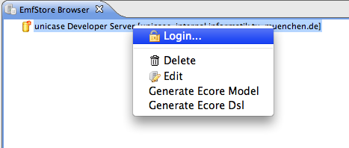
After a successful login
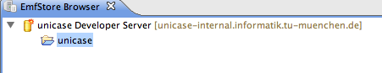

Note: The user must acquire an account from the UNICASE administrators or a public guest account can be used. The guest account has the following information:

- Username: guest.
- Password: guest.
Through out the guest account you can checkout the "SupermarketExampeProject" on the UNICASE Server this project is a trial sample that you may commit any changes you want to it, as we will reset the supermarket project from time to time.

2.1.2. Checkout:
Through the checkout the user will be able to transfer the project’s content from the server to his local workspace. The following steps explain how the checkout is done:

- Open the EmfStore Browser view.
- Login to the desired repository.
- Select the desired project from the repository and then right click and select checkout. Then, the project folder will appear in the Unicase navigator view automatically, in which it’s saved on your local file systems, i.e. workspace.

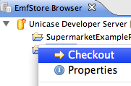

2.1.3. Add a New Repository:
Through the EmfStore Browser view you can add new repository to the repositories list available on your workspace. This can be done following the steps:

- Open the EmfStore Browser view.
- Right click away from the repository list and select new repository or you can simply press the button on the far right of the window of the EmfStore Browser view .
- A new Window will appear requesting the server details that you are using to upload your projects on it.

Note: If your project is uploaded on UNICASE server, please set your repository server are as follows:
Name: UNICASE Server
URL: unicase.in.tum.de
Port: 1099
Certificate: unicase.org 2009#1
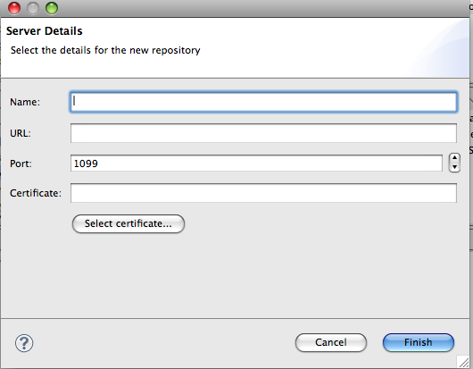

2.2. Unicase Navigator View:
The Unicase Navigator view allows the user to add, edit, view, update, share and commit his project. This allows performing many tasks such as: adding and editing documents, sections and model elements. The MEeditor is associated with the use of Unicase Navigator, which allows the user to view and edit model element attributes and links, in addition to the ability to link model elements together.

The following section will give a quick overview on how a user can commit, update and edit a project using Unicase Navigator. To open the Unicase Navigator view you simply need to open the UNICASE perspective. (Window-> Open perspective -> Other...).

2.2.1. Add a New Project:
To add a new project into a specific repository you need to do the following:

- Log into the UNICASE Server (EmfStore Browser)
- Right click on the “Unicase Navigator” perspective and choose “Create new project“. A wizard will appear, where you should fill in the project details such as: name and description after clicking “OK” a new empty project will appear in your workspace.
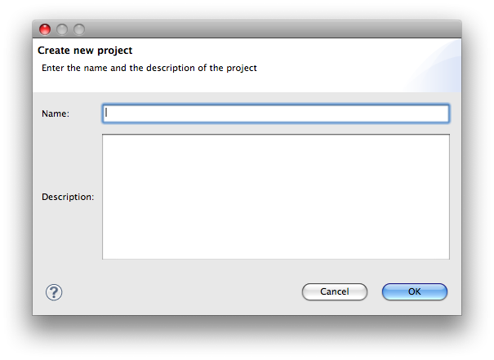
2.2.2. Commit a Project:
To commit a project is to apply the changes that you performed on your workspace to the version of the project uploaded on the server, i.e. sharing it with other users. Once you perform any changes in your project a star sign will appear on your project folder and document. This star is used to indicate that a change has been made, thus urging the user to commit his project.

The following steps clarify how to commit a project:

- After you logged into your repository and checked out your project you have to open the Unicase Navigator view by selecting “Window” from the main menu, then select Show View->Other->unicase->Unicase Navigator.
- After editing your project, you then need to select the project’s folder you just edited and then press right click select Commit Project.

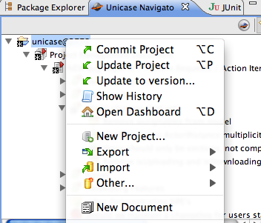

- A new window will appear requesting a log message that is used to indicate the type of changes done by the user. Through this window you can also send a notification to certain user concerning the changes you made, which will eventually appear as a sort of a message on his/her dashboard. This is can be done by pressing on notify users button, another window will appear in which you will press the button and add a new notification.
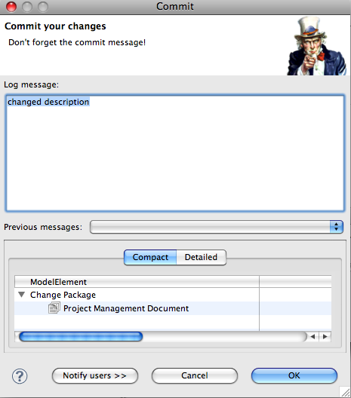
Used to send notification for users about project changes

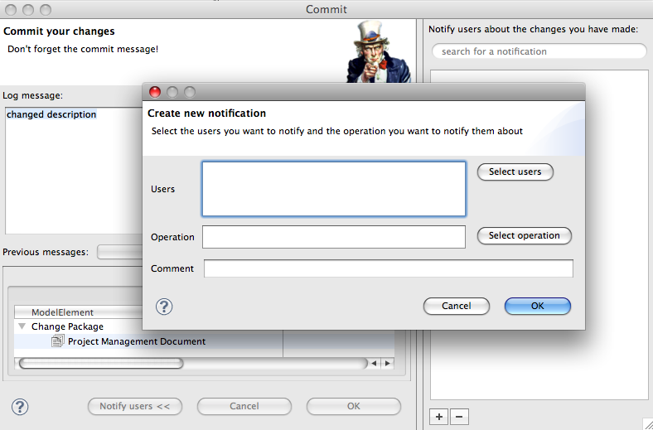

Used to add/remove users from the notification recipient list

2.2.3. Update an Existing Project:
To update a project is to apply the changes that were performed by other users to your workspace. It’s recommended that you update your project every time you open your workspace.
The following steps clarifies how to update a project:

- Open the “Unicase Navigator”.
- Select the project’s folder you want to update and then press right click select “Update Project”.

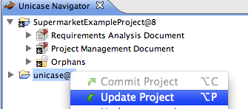

2.2.4. Add a New Model Element:
To add a new model element to your project such as a new functional requirement, diagram, usecase and scenario you need to follow these few steps:
- Open the Unicase Navigator.
- Any project is organized in a hierarchical structure where a project is divided into a group of documents and each document contains a group of composite sections and leaf sections. However, a composite section may contain other composite sections or leaf sections. Furthermore, a new model element is added only to a leaf section. To add the model element select the leaf section you would like to add the element to, press right click and then select New model element.
- Next a window will appear requesting the type of model element you like to add such as: bug, change and document.

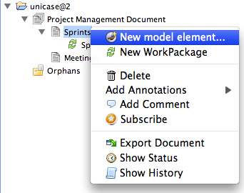
Document
Leaf Section
Model element

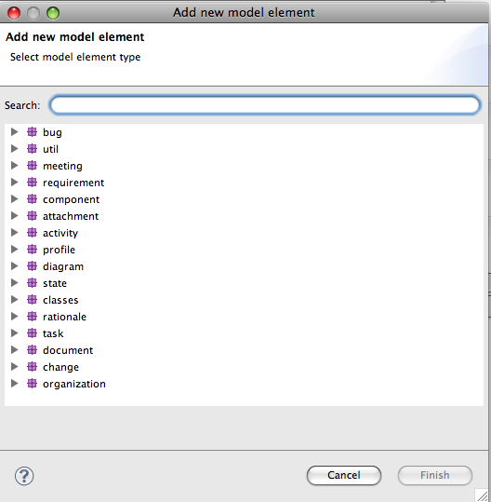

2.2.5. Add a New Section:
Sections are used to structure your project in a hierarchical way like having folders in a file system. To add a new section to your project you need to follow these few steps:

- Open the “Unicase Navigator”.
- To add a new composite or a leaf section for the first time, select the project’s folder you want to add the section to and then press right click select “New Document”.
- Select the document you just added and press right click and select “New composite section” or “leaf section”.
- Otherwise, just select the document you want to add the section to and perform step 3.

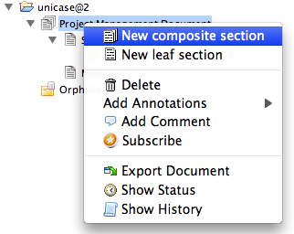
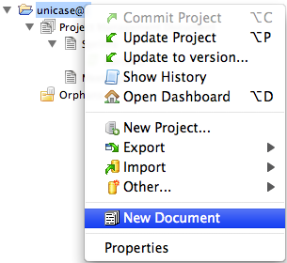

2.3. MEeditor:
The MEeditor allows the user to view and edit model element’s attributes and links, thus giving the user the ability to link model elements together. In the following section we will give a brief outline on how to use the MEeditor.

2.3.1. View Model Element’s Attributes:

- Select the model element you would like to view its attributes and double click on it.
- The MEeditor window then will appear containing all the model element’s attributes.

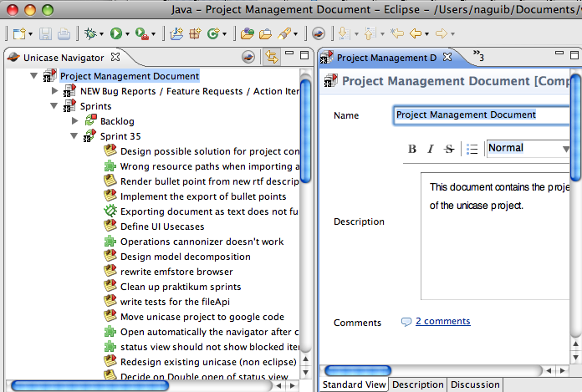
MEeditor

2.3.2. Edit Model Element’s Attributes:

- Select the model element you would like to edit its attributes and double click on it.
- Then, the MEeditor window will appear containing all the attributes of the model element, where the user can immediately modify the attributes.

Note:
A star sign will appear on your project folderas sign that a change has been made on your workspace. This star acts a reminder for the user to to commit his work after editing so can be uploaded on repository server.
s
2.3.3. Link Model Element to another:

- Select the model element you want to add a link to it and double click on it.
- Then, the MEeditor window will appear containing all the attributes of the model element.
- On the right side of the editor you will find different types of links that you can connect the model element with, for example an action item can be linked with specific participate. To add the link you will use the linking button .
- A window will appear indicating a list of elements that can be linked to the selected model element.

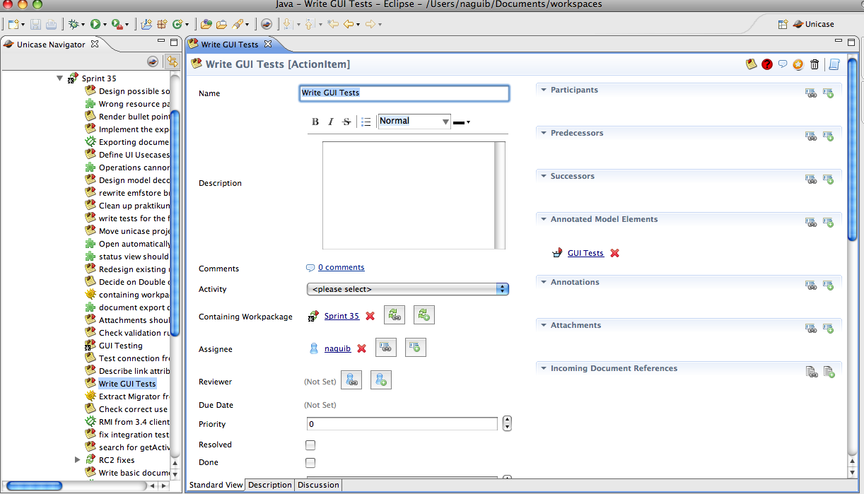
MEeditor Linking options
For example: An action item can be linked to a specific participant.

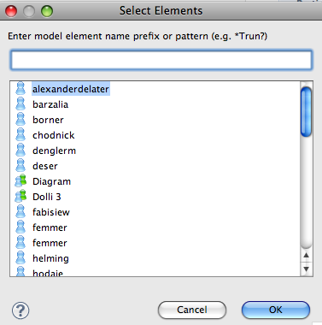

Important Notes:

- All the changes made through the MEeditor are immediately saved, but in order for other users to view the modifications made by you, the project should be committed to update the version on the server.

- There are two ways to link and model element with another:
- The first one is through the link button where you can link the model element with existing model elements that have been added previously.
- The second one is through the create and link button where you can link an existing model element with a new model element that you need to create it first from scratch.

