Semi-automatic Assignment of Work Items

1st Author
1st author's affiliation
1st line of address
2nd line of address
Telephone number, incl. country code
1st author's email address

2nd Author
2nd author's affiliation
1st line of address
2nd line of address
Telephone number, incl. country code
2nd E-mail

3rd Author
3rd author's affiliation
1st line of address
2nd line of address
Telephone number, incl. country code
3rd E-mail

ABSTRACT
Many software development projects maintain a repository to manage work items such as bug reports, change requests or tasks. Especially in an open-source context, these repositories are often open for end-users or clients, allowing them to enter new work items. These artifacts have to be further triaged. The most important step especially in self-organizing environments is the initial assignment of a work item to a person with expertise with the related parts of the system. As a consequence, a number of semi-automatic approaches exist to facilitate the assignment of bug reports, e.g. using methods from machine learning. In this paper we propose an approach to assign new work items to developers using content as well as structural information. Our approach provides the following novelties: (1) Our approach can be applied to all types of work items, including bug reports, issues and tasks. (2) As our approach is based on a unified model, we also consider relations from work items to the system specification for the task assignment. (3) We evaluate our approaches over the history of projects to determine in which states of a project they work best.
Categories and Subject Descriptors
D.3.3 [Programming Languages]: Language Contructs and Features – abstract data types, polymorphism, control structures. This is just an example, please use the correct category and subject descriptors for your submission. The ACM Computing Classification Scheme: http://www.acm.org/class/1998/
General Terms
Algorithms, Management, Experimentation, Documentation,
Keywords
Task assignment, Machine learning, SVM, UNICASE, unified model, Management.

INTRODUCTION
Many software development projects make use of repositories, managing different type of work items. This includes bug tracker system like Bugzilla [12], task repositories like Jira [15] or integrated solutions like Jazz [13] or the Team Foundation Server [14]. A communality of all these repositories is the possibility to assign a certain work item to a responsible person or team ([11]).
It is a trend in current software development to open these repositories to other groups beside the project management allowing them to enter new work items. These groups could be end-users of the system, clients or the developers themselves. This possibility of feedback helps to identity relevant features and improves the quality by allowing more bugs to be identified [1]. But this advantage comes with significant cost ([2]), because every new work item has to be triaged. That means it has to be decided whether the work item is important or maybe a duplicate and further, whom it should be assigned to. As a part of the triage process it would be beneficial to support the assignment of work items to developers with experience in the area of this work item. This automatically assigned developer is probably a good candidate to work on the work item. On the other hand if the developer will not complete the work item himself, he probably has the experience to further triage the work item and reassign it. There are several approaches, which semi-automatically assign work items (mostly bug reports) to developers. We will give an overview over existing approach in section 2.1 In this paper we propose a new approach to semi-automatically assign work items. Our approach has the following novelties:
- Unified model
Our approach is based on a unified model, implemented in a tool called UNICASE. The unified model is a repository for all different type of work items. Existing approaches usually focus on one type of work item, for example bug reports. The use of a unified model enables us to apply and evaluate our approach with different type of work items, including bug reports, feature requests, issues and tasks. We will describe UNICASE more in detail in section 3.
- Model-based recommendation
UNICASE does not only contain different types of work items, but also artifacts from the system specification, i.e. the system model ([3]). Work items can be linked to these artifacts from the system specification. For example a task or a bug report can be linked to a related functional requirement. These links, , provide additional information about the context of a work item which are useful for a semi-automatic assignment, as we will show in section.
Existing approaches are usually evaluated in a certain project state. This approach has two shortcomings: (1) The approach usually gets less information then it would have had at the time a certain work item was triaged. (2) No Conclusion can be made, how different approaches work in different states of a project, for example depending on the number of existing work items. Über diesen Absatz müssen wir noch einmal genauer reden.
We evaluate our approach in three different projects, which use UNICASE as a repository for their work items and system model. XXErgebnisse
The paper is organized as follows:

Combination with automated Iteration Planning.
False positives are not bad because…

RELATED WORK
In this section we give an overview over relevant existing approaches. In section 2.1 we describe approaches, which semi-automatically assign different types of work items. In section 2.2 we describe approaches which classify software engineering artifacts using machine learning and are therefore also relevant for our approach.

Task assignment

Classifying software engineering artifacts
Oder allgemein klassifizierung. Als vorlage ware sicher das Task classification paper gut, das sollte auch zitiert werden. Ansonsten wollte hier rauskommen, warum wir welche asnätze auswählen. Diese, die wir tatsächlich verenden werden dann in kapitel 4 genauer beschrieben.
Machine learning provides a number of classification methods, which can be applied to categorize different items and can also be applied to software artifacts. Each item is characterized through a number of attributes, such as name, description or due date, which have to be converted into numerical values to be useable for machine learning algorithms. These algorithms require a set of labeled training data, i.e. items for which the desired class is known (in our case the developer to whom an item has been assigned). The labeled examples are used to train a classifier, which is why this method is called “supervised learning”. After the training phase, new items can be classified automatically, which can serve as a recommendation for task assignment. A similar task has been done by Cubranic et. al. [?] who used a naive Bayes classifier to assign bug reports to developers. In contrast to their work, our approach is not limited to bug reports, but can rather handle different types of work items. Moreover, we evaluate and compare different classifier. Also Bruegge et. al. [?] have taken a unified approach and used a modular recurrent neural network to classify status and activity of work items.
For our task of assigning work items to developers, we have selected five common machine learning methods for classification and evaluate their performance on three example projects. In particular, we compare logistic regression, decision trees, support vector machine, neural networks and naïve Bayes.

PREREQUESITES
We implemented and evaluated our approach for semi-automated task assignment in a unified model provided by the tool UNICASE. In this section we will describe the artifact types we apply our approach on as well as features of UNICASE rely on in our evaluation. UNICASE is a repository for arbitrary types of software engineering artifacts. These artefacts can either be part of the system model, i.e. the requirements model and the system specification, or the project model, i.e. artifacts from project management like work items or developers ([XXX]).
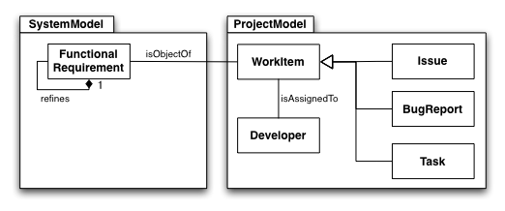
Figure 1: Excerpt from the unified model of UNICASE (UML class diagram)

Figure 1 shows the relevant artifacts for our approach. The most important part is the reference between Work Item and Developer. This reference expresses, that a Work Item is assigned to a certain developer and is therefore the reference we semi-automatically want to set. Work Items in UNICASE can be Issues, Tasks or Bug Reports. As we apply our approach to the generalization Work Item it is not limited to one of the subtypes as in existing approaches. As we proposed in our previous work ([XXX]), Work Items in UNICASE can be linked to relevant Functional Requirements modeled by the reference isObjectOf That expresses that the represented work of the Work Item is necessary to fulfill the requirement. This reference, if already existent adds additional context information to a Work Item. Modeled by the Refines reference, Functional Requirements are structured in a hierarchy. We navigate this hierarchy in our model-based approach to find the most experienced developer, described in section XXX. As a first step in this approach, we have to find out the related Functional Requirement of the currently inspected Work Item, we want to semi-automatically assign. As a consequence this approach only works for Work Items, which are linked to Functional Requirements.
As the model-based approach of semi-automated task assignment only relies on references in UNICASE, the five machine learning approaches mainly rely on the content of the artifacts. All content is stored in attributes. The following table gives an overview over the relevant features we used to evaluate the different approaches:

Feature | Meaning
Name | A short and unique name for the represented work item.
Description | A detailed description of the work item.
AnnotatedModelElements | The object of the work item, usually a Functional Requirement.

We will show in the evaluation section, which features had an significant impact on the accuracy of the approach.
UNICASE provides an operation-based versioning for all artifacts. That means all past project-states can be restored. Further we can retrieve any event, when a Work Item was assigned by a project manager to a certain developer. We will use this versioning system in the second part of our evaluation. The goal is to evaluate whether our approach would have chosen the same developer for an assignment then the project manager did. This evaluation method provides a more realistic result then evaluating the approaches only on the last project state, because all approaches, the machine learning and the model-based approaches can only process the information which was existing at the time of the assignment.

MACHINE LEARNING APPROACHES
Hier die approaches, die wir ausgewählt haben beschreiben.
We have used the Universal Java Matrix Library (UJMP) [?] to convert data from UNICASE into a format suitable for machine learning algorithms. This matrix library can process numerical as well as textual data and can be integrated very easily into other projects. All work items are aggregated into a two-dimensional matrix, where each row represents a single work item and the columns contain the attributes (name, description, annotated items). Punctuation and stop words are removed and all strings are converted to lowercase characters. [Stemming???] After that, the data is converted into a document-term matrix, where each row still represents a work item, while the columns contain information about the occurrence of terms in this work item. There are as many columns as different words in the whole text corpus of all work items. For every term, the number of occurences in this work item is counted. This matrix is normalized using tf-idf (term frequency / inverse document frequency):
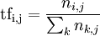
where n_{i,j} is the number of occurrences of the considered term (t_{i}) in document d_{j}, and the denominator is the sum of number of occurrences of all terms in document d_{j}.
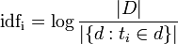
The inverse document frequency is a measure of the general importance of the term: total number of documents in the corpus divided by number of documents where the term t_{i} appears.

This matrix is used as input to machine learning algorithms. We have used the Java Data Mining Package (JDMP) [?] for this purpuse as it provides an intuitive interfaces to numerous machine learning algorithms from various libraries and facilitates the comparison of different methods. We have selected some common classification algorithms:

Logistic Regression
This method uses the logistic function 1/(1+exp(-x)) to express the probability that an item belongs to a particular class. We use the implementation from JDMP or Weka.

Decision Trees
Decision trees break down the classification problem into a set of simple if-then decisions based on the data which lead to the final prediction. We use the implementation for boosted decision trees from Weka

Support Vector Machine
The support vector machine calculates a separating hyperplane between data points from different classes and tries to maximize the margin between them. We use the implementation from LIBLINEAR [?].

Neural Networks
Neural networks can learn non-linear mappings between input and output data, which can be used to classify items into different classes. We use the implementation from Weka

Naïve Bayes
This classifier is based on Bayes' theorem. It assumes that all features are independent which is certainly not the case for the ducment-term matrix. However, it scales very well to large data sets and yields ususally good results even when the independence assumption is violated. We use the implementation from JDMP or Weka.
We trained these classifiers using a cross validation scheme: The data has been split randomly into ten subsets. Nine of these sets were selected to train the classifier and one to assess its performance. After that, another set was selected for prediction, and the training has been performed using the remaining nine sets. This procedure has been performed ten times for all sets and has been repeated ten times (10 times 10-fold cross validation).

MODEL-BASED APPROACH
For model based triage of work items we use the structural information available through unicase project and system models. unicase provides a unified repository to manage system design artifacts, such as requirements, along with project management artifacts such as tasks and organizational units.
In this section we first provide a description of unicase model elements relevant to our approach.
5.1. unicase model
Figure 1 shows excerpt of unicase model relevant to model based triage of work items.
The main source of information for model based approach are Requirements, WorkItems and Developers and the relationship between these objects. Every Requirement can have a set of related work items. These are work units that are to be accomplished in order to fulfill this requirement. This set can be changed and refined during the time. Each Requirement can also have a set of refining requirements, and also one refined requirement. In this way the requirements are modeled in a hierarchical way in unicase.
On the other hand every WorkItem can also be related to a set of Requirements, which we call related requirements. One advantage of unicase model over other issue tracking systems is the generalization of unit of work. A WorkItem can be a BugReport, an Issue, or an ActionItem. Each WorkItem can be assigned to a Developer which is called its assignee. A work item has also the attribute effort estimate.
There are further refinements to this model in present unicase model. For example die Developers are organized in Groups and a WorkItem can have group as its assignee. Further a WorkItem can have some other organizational units (Devlopers, Groups) as its participants. We do not use these further information for our approach, because our experiments showed that they do not provide a significant improvement int results of model based triage.
The main idea of our model based approach is to find the set of relevant work items for a given work item and based on this set suggest an appropriate developer to assign the new work item to. The following section describes this idea in detail and the important information that must be already available in unicase repository so that this approach works.
5.2. Expertise
The most important information our model based approach relies on is the link between work items and requirements. This information must be available in order to model based approach can provide good results.
In unicase normally every time a new work item is created it is also linked to one or more relating requirements. Through this link and using the hierarchical relationship between requirements we determine the set of work items relevant to the given work item W (RelevantWorkItems(W)) and use this set to determine expertise of each developer regarding the given work item.
To acquire these relevant work items we need to first find the relevant requirement for the work item W using requirements relating to it (RelatingRequirements(W)). The relevant work items will then be all those work items relating to relevant requirements.
As the hierarchical relationship between requirements implys, every requirement R in RelatingRequirements(W) can have many refining requirements and one refined requirement. For each requirement R in RelatingRequirements(W) we get its refined requirement (if available) and add all the hierarchical refining requirements of this to the set of relevant requirements. If there is no refining requirement for R then we just add all requirements hierarchical refining R to relevant requirements.
One parameter we can control in this process is the depth of traversing requirements hierarchy, both upward and downward. We chose to traverse the requirements hierarchy only one level upward and unlimited downward. ????????????????? ????? why ?? Table xxx shows results of choosing different value for upward and downward traversal.???????????????
Using the set RelevantWorkItems(W) we determine expertise of each developer D regarding W (Expertise_{w}(D)) . We defined Expertise_{w}(D) as the number of relevant work items this developer has already accomplished. We can also weight this expertise using effort estimate of accomplished work items.
???????????? But we did not do it. Why??????????????????
After determining Expertise_{w}(D) for all developers, the one with highest expertise value is suggested as the appropriate assignee of the work item W.

EVALUATION
In this section we evaluate and compare the different approaches of semi-automated task assignment. We evaluated the approaches using three different projects. All projects have used UNICASE to manage their work items as well as their system documentation. In section 6.1 we introduce the three projects and their specific characteristics. In section 6.2 we evaluate the approaches „state-based“. That means we took the last available project state and tried to classify all asignments post-mortem. This evaluation techniques was also used in approaches like [XXX]. Based on the results of the state-based evaluation we selected the best-working configurations and approaches and evaluated them history-based. That means we browsed through the history of the evaluation projects until an assignment was done. Then we tried to predict this specific assignment post-mortem and compared the result with the assignment, which was actually done by the user. We claim this evaluation to be more realistic then the state-based as it simulates the accuracy of the approach if it has been used in practise during the project. Furthermore it shows how the approaches perform in different states of the project depending on the different size of existing data. As a general measure we used the accuracy. XXX Beschreiben

EVALUATION PROJECTS
We have used three different projects as datasets for our evaluation. As a first dataset we used the repository of the UNICASE project itself, which has been hosted on UNICASE for nearly one year. The second project, DOLLI 2, was a large student project with 26 participants over 6 month. The third application is an industrial application of UNICASE in the company Beople, where UNICASE has been used for over 6 month now. The following table shows the number of participants and relevant work items per project.
Table 1: Developer and work items per project
 | UNICASE | DOLLI | Beople
Developer | XXX | XXX | XXX
Assigned  work items | 1191 | 411 | 256
Annotated  work items | 290 | 203 | 97

State-Based Evaluation
For the state-based evaluation we used the last existing project state like it was done in [2]. Based on this state we try to classify all existing work items and compare the result with the actually assigned person. We haven chosen different combinations of features as input of the application and applied the machine learning approaches describe in section 4 as well as the model-based approach describe in section 5. Our goal was to determine the approaches, configurations and feature-sets, which lead to the best results and re-revaluate these in the history-based evaluation (see section 6.3). We started to compare different feature sets. As we expected the name of a work item to contain the most relevant information, we started the evaluation with the name feature only. I a second and third run, we added the features description and annotatedModelelements.
Table XXX shows the results of different feature sets and .
Table 2: Different sets of features as input data
Name
 | UNICASE | DOLLI | Beople
LibLinear | 36.5%  (±0.7%) | 26.5% (±0.7) | 38.9 (±1.4)
Logistic  Regression | (± 0.0%)
Name and description
 | UNICASE | DOLLI | Beople
LibLinear | 37.1% (±1.0) | 26.9% (±1.0) | 40.7% (±0.9
Name, description and annotatedModelelements
 | UNICASE | DOLLI | Beople
LibLinear | 38.0% (±0.5) | 28.9% (±0.7) | 43.4% (±1.7)
In the next step we applied all described machine learning approaches using the best working feature set as input (Name, description and annotatedModelelements). The results confirm the results, which were presented in [XXX], that SVM leads to the best results.
Table 3: Different machine learning approaches state-based
LibLinear
For a comparison we applied the model-based approach on the same data, with surprisingly high results (see Table 4). The first rows the accuracy of recommendations, when the model-based approach could be applied. The approach is only applicable on work items, which were linked to functional requirements. The number of work items the approach could be applied on are listed in Table 1. For a fair comparison with the machine learning approaches, which are able to classify every work items we calculate the accuracy for all work items, including those, which were not predicted.
It is worth mentioning that once we also considered the second guess of the model-based approach and only linked work items, we achieved accuracies of 96,2% for the UNICASE, 78,7% for DOLLI and 94,7% for the Beople project.
 | UNICASE | DOLLI | Beople
Linked work items | 82,6% | 58,1% | 78,4%
All  work items | 19,9% | 20,7% | 29,3%

History-Based Evaluation
In the second part of our evaluation we wanted to simulate the actual use case of assignment. The problem with the state-based evaluation is, that the system has actually more information at hand, as it would have had at the time, a work item was assigned. Consequently we simulated the actual assignment situation. Therefore we used the operation-based versioning of UNICASE in combination with a analyzer framework provided by UNICASE. This enables us to iterate the project state trough time and exactly recreate the state before a single assignment was done. Then we apply our approaches on exactly that state. For the machine learning approaches we trained the specific approach based on that state. We compared the result of the recommendation with the assignment, which was actually chosen by the user.

Unicase liblinear
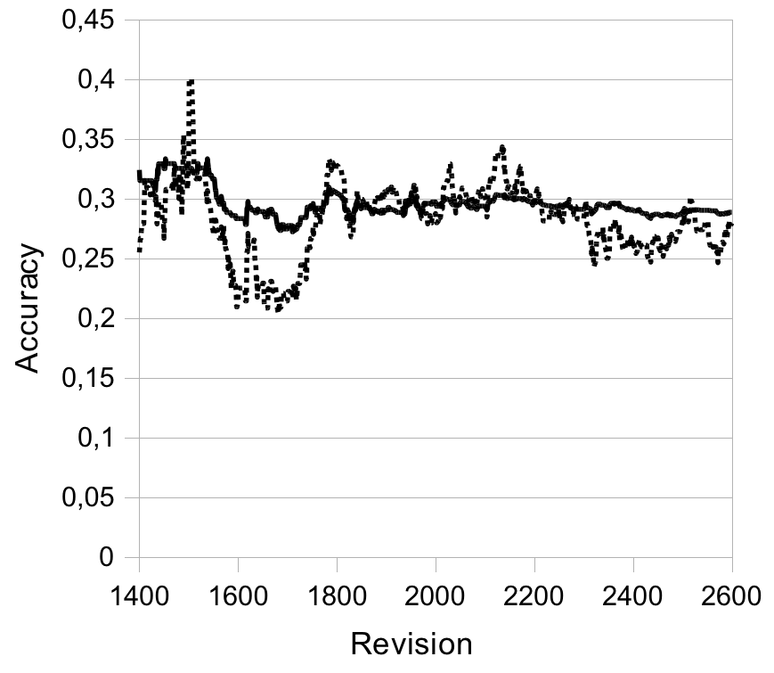

Dolli LibLinear

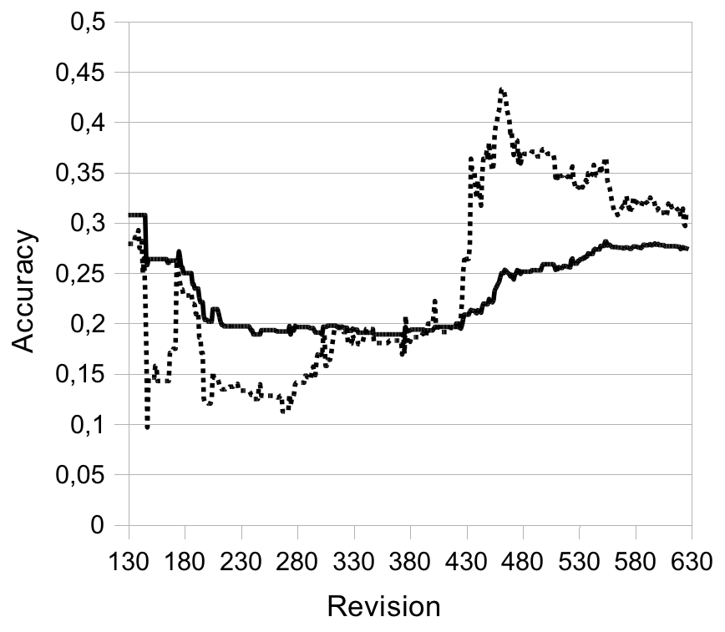
Unicase model-based

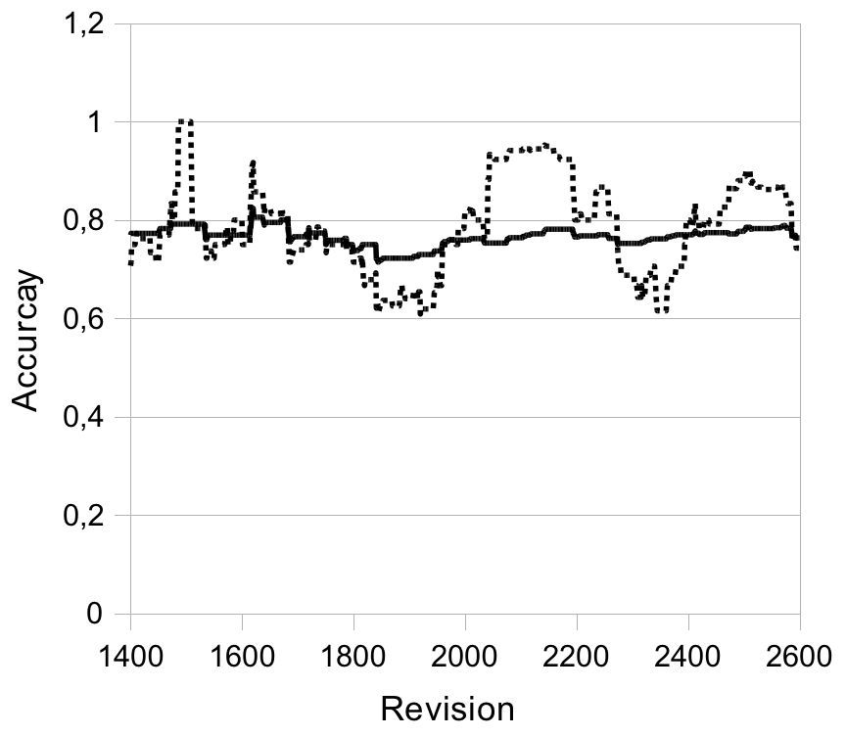
DOLLI model-based

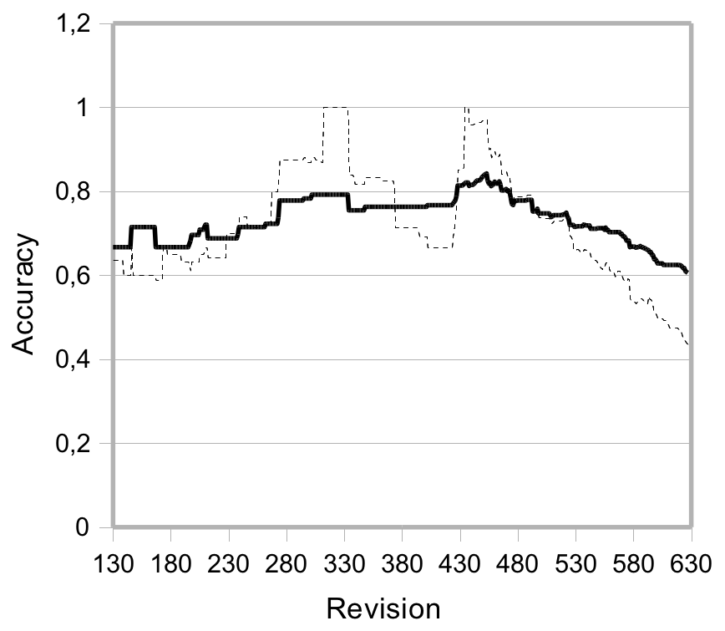

CONCLUSION
Integration with automatic Planning of Iterations
Model-Based approach transferable to Bug Reports which are linked to Components.
Model based sehr gut, aber nur bedingt applybar
Liblinear am besten
History based evaluation
Machine learning robuster gegen Änderungen

REFERENCES

- E. S. Raymond. The cathedral and the bazaar. First Monday, 3(3), 1998.
- J. Anvik, L. Hiew, und G.C. Murphy, “Who should fix this bug?,” Proceedings of the 28th international conference on Software engineering, Shanghai, China: ACM, 2006, S. 361-370.
- J. Helming, J. David, M. Koegel, H. Naughton, "Integrating System Modeling with Project Management - a Case Study", In Proceedings of the 33rd International Computer Software and Applications Conference, COMPSAC 2009
- B. Bruegge, J. David, J. Helming, M. Koegel, “Classification of Tasks Using Machine Learning”, Proceedings of the 5th International Conference on Predictor Models in Software Engineering
- R.-E. Fan, K.-W. Chang, C.-J. Hsieh, X.-R. Wang, C.-J. Lin, „LIBLINEAR: A Library for Large Linear Classification“, Journal of Machine Learning Research, Vol. 9, 2008
- H. Arndt, M. Bundschus, A. Naegele, “Towards a Next-Generation Matrix Library for Java“, In Proceedings of the 33rd International Computer Software and Applications Conference, COMPSAC 2009
- H. Arndt, “The Java Data Mining Package – A Data Processing Library for Java“, In Proceedings of the 33rd International Computer Software and Applications Conference, COMPSAC 2009
- Ian H. Witten and Eibe Frank (2005) "Data Mining: Practical machine learning tools and techniques", 2nd Edition, Morgan Kaufmann, San Francisco, 2005.
- D. Cubranic, G.-C. Murphy, “Automatic bug triage using text categorization”, Proceedings of the 16th International Conference on Software Engineering & Knowledge Engineering, 2004
- F. Sebastiani, “Machine Learning in Automated Text Categorizetion”, ACM Computing Surveys, 2002
- J. Anvik, “Automating bug report assignment,”Proceeding of the 28th international conference on Software engineering - ICSE '06, Shanghai, China: 2006, S. 937.
- http://www.bugzilla.org/, verified 03/09/2009
- www.jazz.net, verified 03/09/2009
- http://msdn.microsoft.com/de-de/library/ms242904(VS.80).aspx, verified 03/09/2009
- www.atlassian.com/software/jira/, verified 03/09/2009

Columns on Last Page Should Be Made As Close As Possible to Equal Length

