GLOBAL NUTRITION MONITORING BRIEF - UNICEF Office of Strategy and Evidence, Data & Analytics Section
Child Stunting: Where Levels Remain Highest and Where Progress Has Been Strongest
UNICEF Combined Nutrition Database, 2026 | Indicator: Stunting (modeled height-for-age < -2 SD), children under 5
Key Messages
• An estimated 150.2 million children under 5 were stunted in 2024. The burden is highly concentrated: the top 20 countries account for over three quarters of the global total.
• The highest-prevalence countries are concentrated in Sub-Saharan Africa, while the largest absolute burdens are concentrated in high-population countries in Southern Asia and Sub-Saharan Africa.
• The global number of stunted children fell by 51.7 million over the past two decades, and the five countries with the largest reductions accounted for 91% of the global reduction.
• Global under-five population fell by 5.3% between 2012 and 2024 and in many countries population decline accelerated the reduction in the number of stunted children.
• In contrast to global trends, child population grew by 20.3% in Sub-Saharan Africa from 2012 to 2024, and for some countries the number of stunted children rose or remained flat even when prevalence declined.

Current Scale: Prevalence & Burden
Burundi had the highest modeled stunting prevalence in 2024 at 55.3%, followed by Niger, Eritrea, Angola, and Papua New Guinea. The highest-prevalence countries remain concentrated in Sub-Saharan Africa, with one Pacific country in the top five. (Figure 1a)
India had the largest estimated number of stunted children in 2024 at 37.4 million - one in every four stunted children globally. At the regional level, Southern Asia remained the single largest concentration of affected children at 56.4 million, while Sub-Saharan Africa had 59.6 million in total.
The burden is highly concentrated. (Figure 1b) The top 5 countries accounted for 50% of the global total, the top 10 for 62%, and the top 20 for 77%.
The prevalence and burden rankings overlap but are not identical. Eleven countries appear in both the top-20 highest-prevalence and top-20 highest-burden lists: Afghanistan, Angola, the Democratic Republic of the Congo, Ethiopia, Madagascar, Mozambique, Niger, Nigeria, Pakistan, Sudan, and Yemen. Targeting countries with both high prevalence and high burden can enable an equityf-focused approach that also achieves impact at scale.
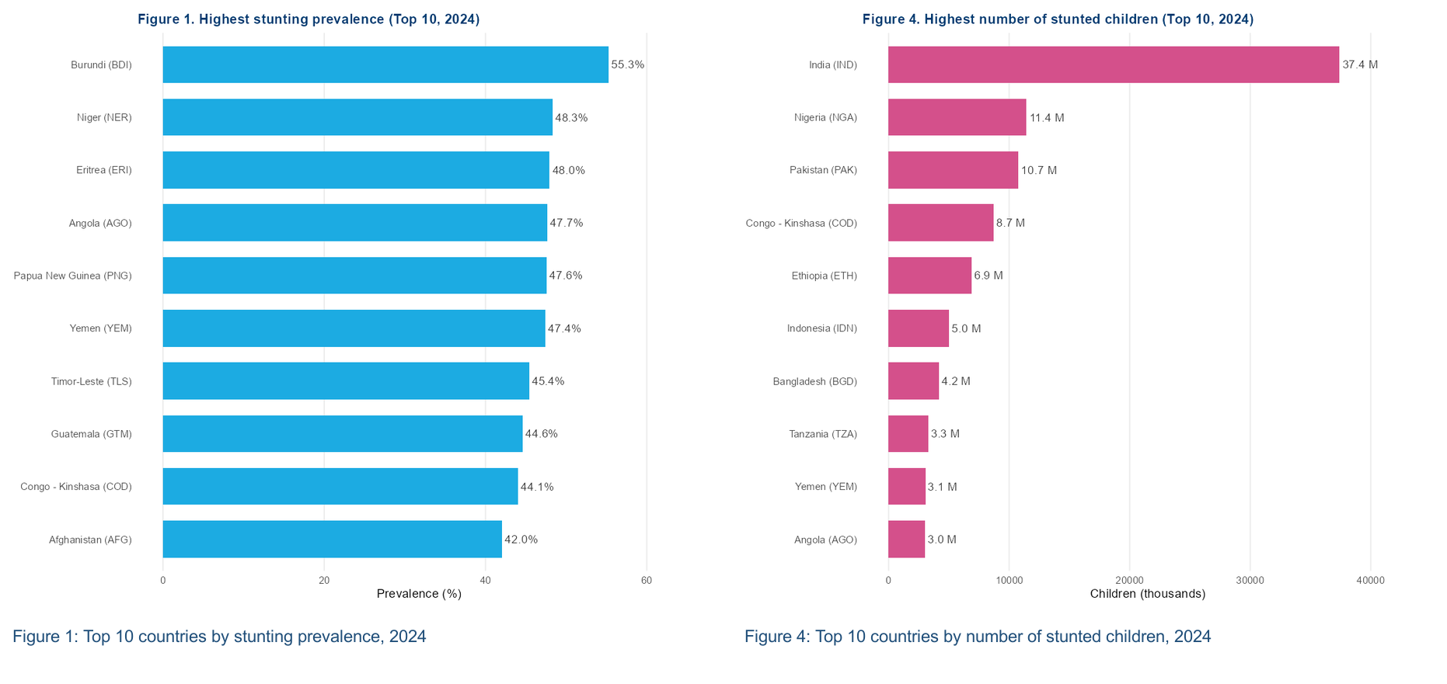
Countries ranked 11-20 for highest prevalence, 2024: Central African Republic (38.9%); Madagascar (38.4%); Mozambique (37.0%); Ethiopia (35.5%); Sudan (35.4%); Lesotho (35.0%); Nigeria (33.8%); Pakistan (33.6%); Benin (33.2%); Malawi (33.2%)
Countries ranked 11-20 for highest number of stunted children, 2024: Afghanistan (2.8m); Sudan (2.7m); Philippines (2.5m); China (2.4m); Niger (2.3m); Mozambique (2.1m); Uganda (1.9m); Madagascar (1.8m); Egypt (1.5m); South Africa (1.4m)
Data source: UNICEF, WHO, World Bank Group Joint Child Malnutrition Estimates, 2025 edition.

GLOBAL NUTRITION MONITORING BRIEF - UNICEF Office of Strategy and Evidence, Data & Analytics Section
Progress: Reduction in Prevalence and Number of Affected Children Over 20 Years
North Korea showed the largest 20-year reduction in stunting prevalence, with a decline of 27.6 percentage points between 2004 and 2024. The average reduction in prevalence for the top five ountries was 1.3 percentage points per year.
The global number of stunted children fell from 201.9 million in 2004 to 150.2 million in 2024 - a reduction of 51.7 million. India alone accounted for 27.5 million of that reduction, or 53.3% of the global total, yet it remains the single largest-burden country.
This concentration is striking: the top 5 burden reducers accounted for 91.3% of the global reduction, and the top 10 for 100.9%. That the top-10 share exceeds 100% is not an error - it reflects the fact that burden increased in some countries over this period, particularly in African countries that had high population growth and little or no improvement in prevalence. The top 20 reducers accounted for 111.3%, reinforcing that progress has been driven by a small number of populous countries while burden grew elsewhere.
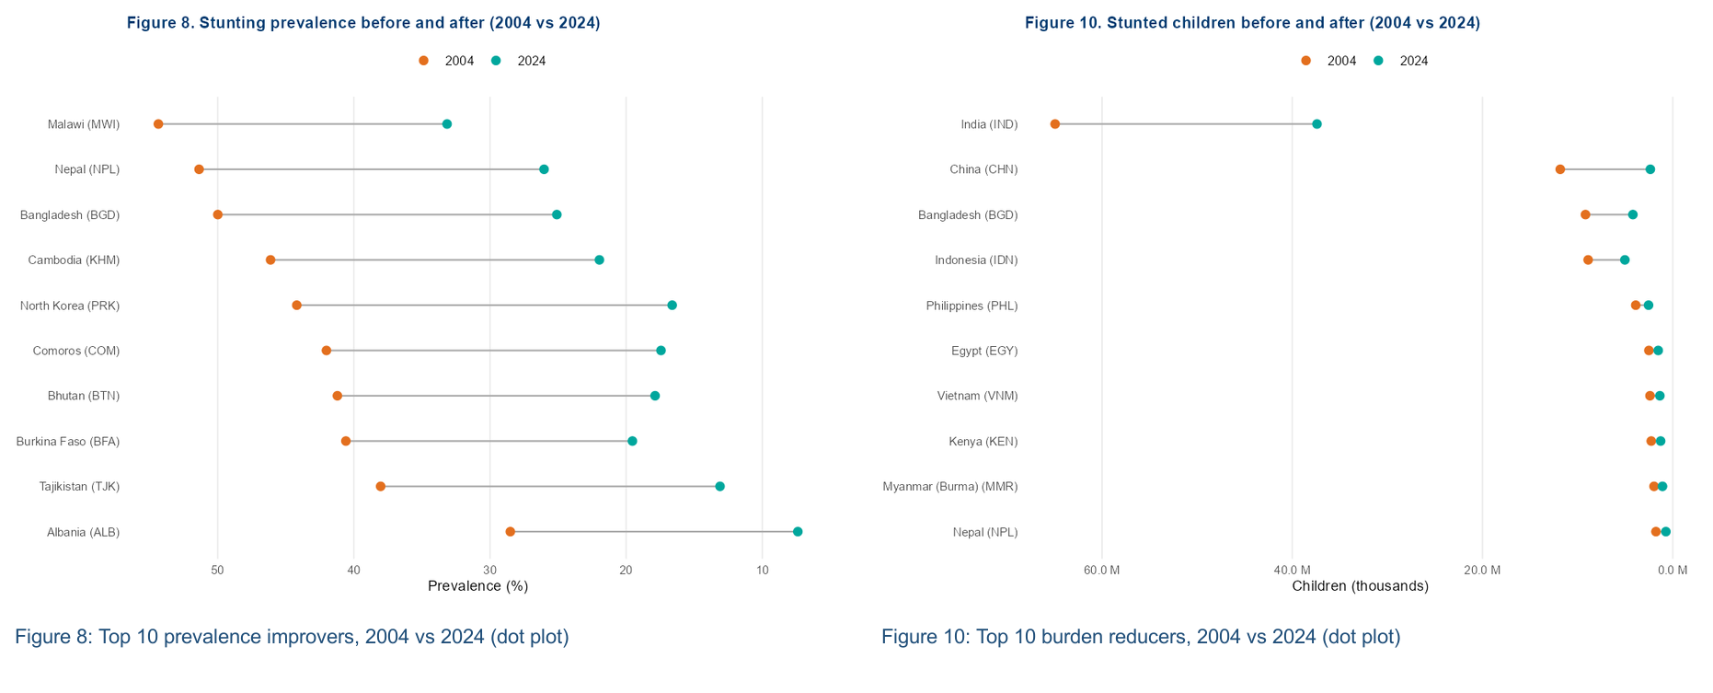
Countries ranked 11-20 for largest reduction in prevalence, 2004-2024: Kenya (19.9 pp); Bolivia (19.6 pp); Peru (19.1 pp); Rwanda (18.7 pp); Azerbaijan (18.6 pp); Uganda (18.4 pp); Zambia (18.2 pp); Laos (18.0 pp); Iraq (17.8 pp); Sao Tome & Principe (17.5 pp)
Countries ranked 11-20 for largest reduction in number of stunted children, 2004-2024: Turkey (0.74m); Mexico (0.7m); Iraq (0.7m); Peru (0.6m); Ethiopia (0.6m); North Korea (0.5m); Pakistan (0.5m); Thailand (0.4m); Ghana (0.4m); Uganda (0.4m)
Data source: UNICEF, WHO, World Bank Group Joint Child Malnutrition Estimates, 2025 edition.
Interpreting the Results
Population change is central to interpretation. The global under-five population fell from 683.5 million in 2012 to 647.3 million in 2024, but it rose from 154.0 million to 185.4 million in Sub-Saharan Africa. In Middle Africa alone, the under-five population grew by 38.5%, helping push the number of stunted children from 10.0 million to 14.8 million over the same period.
Regional population trends help explain why prevalence gains translate unevenly into burden reduction. In Western Africa, prevalence fell from 33.7% to 29.7% from 2012 to 2024 while the number of stunted children remained almost unchanged at about 19.9 million.
By contrast, Southern Asia combined a 6.1% decline in the under-five population with a fall in stunting prevalence from 40.3% to 31.4%, reducing the number of stunted children from 77.0 million to 56.4 million between 2012 and 2024.
Data limitations must also be considered for interpretation.These rankings use JME modeled stunting estimates, which are appropriate for trend comparison but produce smoothed trajectories rather than direct annual observations. Acute shocks - including conflict, economic crisis, and food emergencies - may not be captured in real time by the modeled series. Estimates and rankings should not be over-interpreted.

