1. Need Upazila & union Mapping (no need to create Union) ()

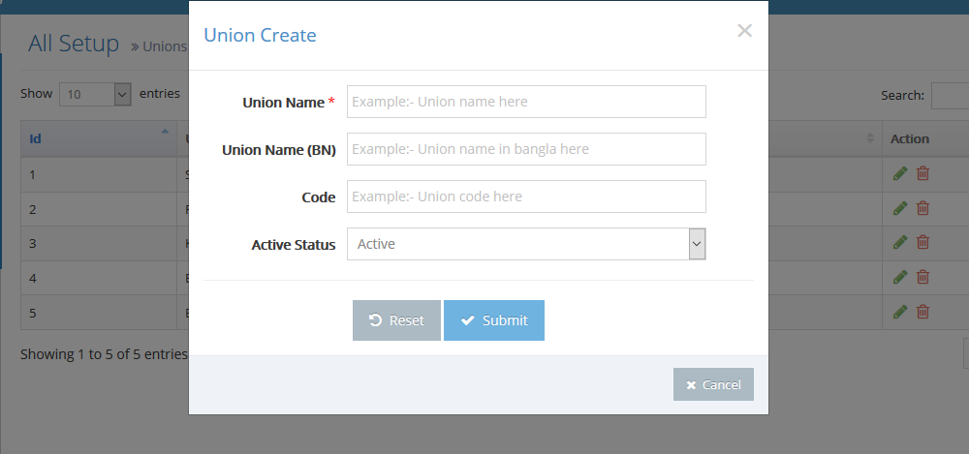

2. Session out message need (exe: your session is out please login again)

3. Farmers age auto calculated when date of birth select

4. Date picker not working in Mozilla browser

5. IF farmers type CIG the CIG related field show otherwise this field hide

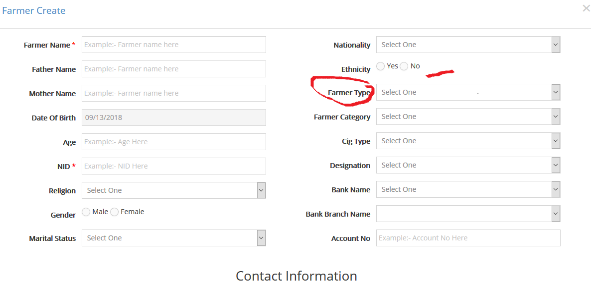

6. Why CIG Name field under Contact information ?

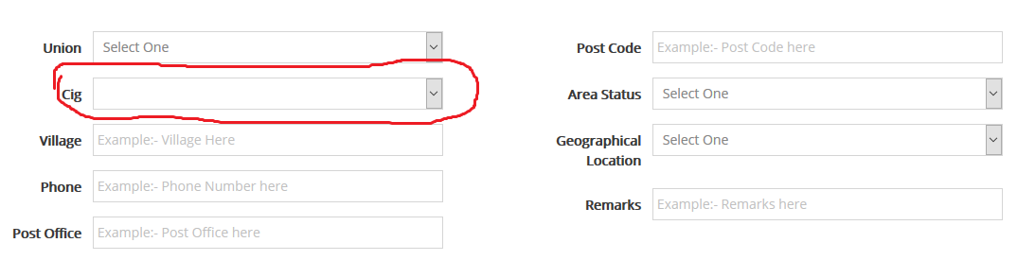

7 Bank & branch setup related entry should be need upazila tag (coz we need upazila wise branch name)

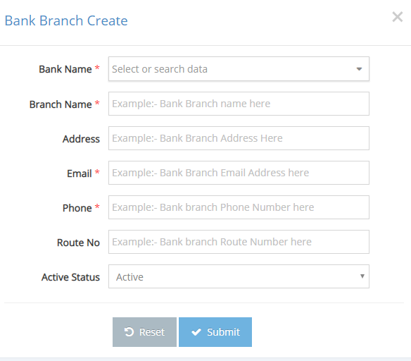

8. Manu Order first Union second CIG Group Then Farmers

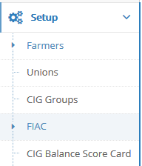

9.Union List page not auto refresh when create new union page so user don’t understand union create or note (need ajax action)

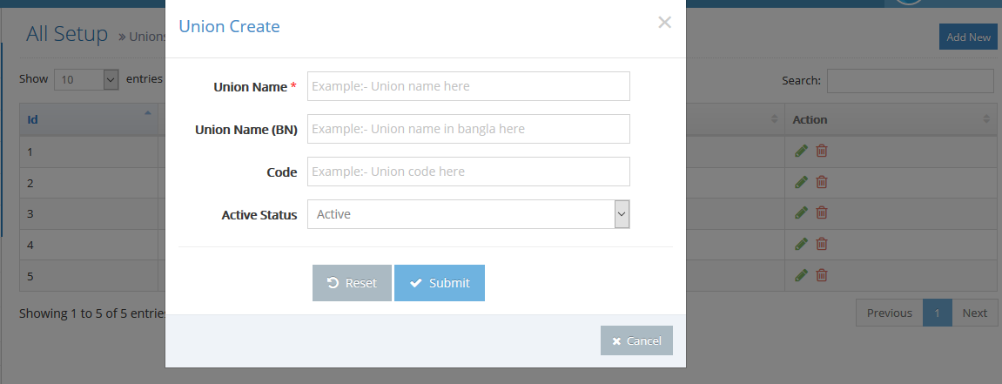

10.Upazila name need to top position no need shows several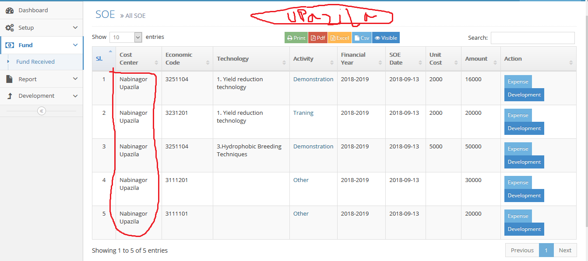

11.Activity should be first and when select other activity then technology season unite cost batch etc should be disable

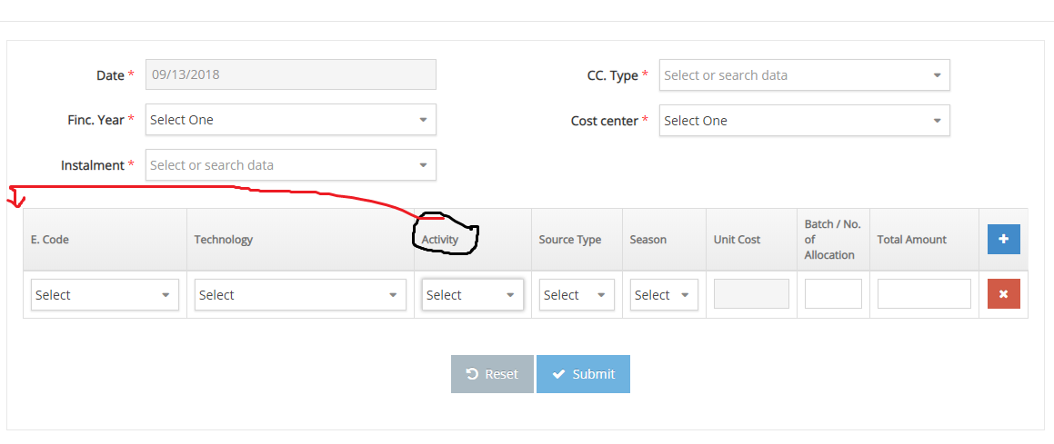

12. Unite cost setup here must be need activity tag for setup unit cost (Activity must be Required)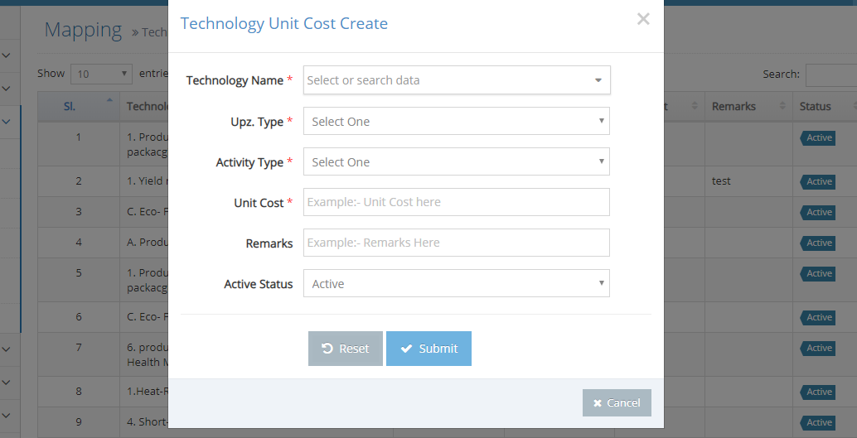

13. training subject should be upazila panel they add training subject

14 crops verities should be added from upazila panel

15 crops problem should be added from upazila panel