Academic Curricula Design and Management System
ACADEM

User Guide

Universidad Icesi
Faculty of Engineering
Software Engineering Group
Santiago de Cali, 2013

Procedure

- Login

The login component determines the user profile wich indicates the screen that is going to be displayed to the logged user. There are three different profiles: Administrator, Owner and Evaluator. Figure 1 presents the current login of the tool.

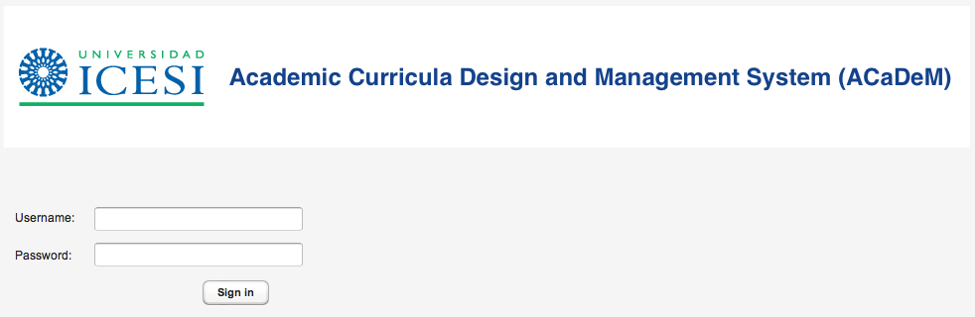
Figure 1. User Login

- Administrator Profile: Management

The administrator is in charge of creating the surveys to be carried out, indicating the program and the owner of each. To create a survey the user presses the Create Survey button, this will popup a form containing information needed to accomplish this task. Figure 2 presents this form.

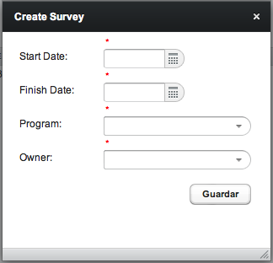
Figure 2. New survey form

3. Owner Profile: Management

The owner is in charge of selecting the stakeholders who will assess the surveys associated to him. He also determines the associated roles or groups to each survey, with its respective percentage. The owner can consolidate as well the resulting proficiency level of the owned surveys.

3.1. Selecting the Stakeholders

When the owner logs in, a list containing his owned surveys will be displayed at the left side of the screen. The user has to select the survey that is going to be modified and then select the Stakeholder tab (Red box) as shown in the following figure.

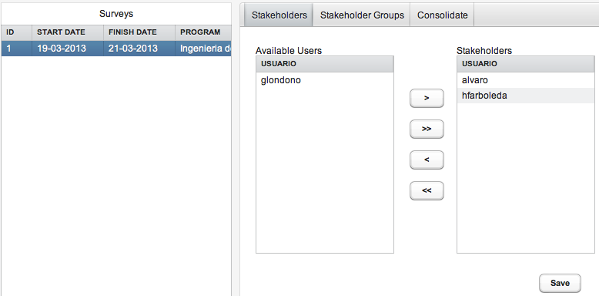
Figure 3. Selecting the stakeholders
There are two lists: Available Users and Stakeholders. The first one contains all the registered users in the system. The second one contains the selected stakeholders for the selected survey. Once the stakeholders are selected the user has to press the Save button to preserve the changes made.
3.2. Selecting the Stakeholder Groups (Roles)
The Stakeholder Groups tab shown in figure 3 allows to create and edit the stakeholder groups for the selected survey. This functionality is currently under construction.
3.3. Consolidate the Resulting Proficiency Level
The Consolidate tab shown in figure 3 allows to consolidate the resulting proficiency level of the owned surveys, based on the selected stakeholders assessments. This consolidate is grouped by the roles described in the previous section. This functionality is currently under construction.

4. Evaluator Profile: Management
The evaluator is in charge of assess the surveys created by the administrators in order to contribute to the Resulting Proficiency Level, allowing the decisionmaking about the topics that should be part of a academic curricula. When the evaluator logs in, a list containing the surveys to be assessed will be displayed at the left side of the screen. The user has to select the survey that is going to be assessed and then start the assessment for each topic displayed on the screen. Figure 4 presents this procedure.

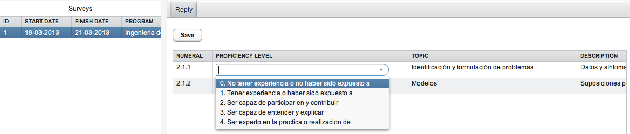
Figure 4. Performing an assessment
There is a proficiency level between 0 and 4 for each topic as shown in figure 4. Once the assessment is complete the user has to press the Save button.

