Simple FSI Training Track for OpenFOAM

Brief of the course
Module begins with short introduction to fluid-structure interaction (FSI) problems, overview and classification of cases which arises in real world. One of the most simple and common case of FSI is selected for demonstrations of OpenFOAM's capability to create complex numerical models - weakly coupled motion of solid body with limited number of degrees of freedom in flow. For the demonstration purposes particular real world example is considered - flow-induced vibration of cylinder, connected to spring which is fixed on another of its side. Mathematical model is formulated for this case.
With respect to this example case different approaches for solution of this problem are discussed. Difference between custom solver, functionObject and fvOption classes is shown in discussion. For the current case selection of standard OpenFOAM solver pimpleDyMFoam and usage of functionObject is argued. Procedure of creating user functionObject is discussed, including: setup of custom dynamic library, creation of class which inherits standard OpenFOAM library "forces", working with objectRegistry class, mesh motion issues and etc.
During the track we will compile our FSI class and will run simulation with new library. Results of FSI simulation will be analyzed, compared to experimental observations and to results of simulation from in-house code, implementing vortex method. The attendees will require good knowledge of setting up cases, running/modifying tutorial cases as well as a basic understanding of programming/compiling source code.

Directory structure
Location of the course - https://github.com/unicfdlab/TrainingTracks /
Folder simpleFsi-OF3.0.0 for OpenFOAM 3.0.0 version of the course
The folder contains next sub-directories:
No. | Name | Description
1. | cases | Cases that will be used to demonstrate functionObject's, created during the track.
1.1 | validation-helloWorld | Simple case for demonstration of helloWorldFunctionObject, printing vector of forces acting from fluid to cylinder. Laminar flow of incompressible fluid over cylinder is considered.
1.2 | validation-laminar | Case for validation of FSI implemented in basicFsiFunctionObject . Case was constructed according to [2].
1.3 | validation-laminar-cont | Case for validation of restart (loading from file) capabilities in FSI implemented in weaklyCoupledFsiFunctionObject. Case is indentical to previous (1.2), with the only difference, that it can be started from end time specified in 1.2.
1.4 | main-les-short | Case for the demonstration of developed functionObject weaklyCoupledFsiFunctionObject to reproduce 2D turbulent cases. Length of domain corresponds to approximately 5 wavelength of dynamic system.
1.5 | main-les-long | Case for the demonstration of developed functionObject weaklyCoupledFsiFunctionObject to reproduce 2D turbulent cases. Similar to 1.5, but length of domain corresponds to approximately 10 wavelength of dynamic system.
1.6 | main-les-long-SBRS | This case is intended to demonstrate how to select different mesh motion algorithms in FSI problems. Similar to case 1.5.
2. | geometry | Contains geometry and mesh files, created using SALOME platform, version 7.3.0.
3. | papers | Papers, that were used in this course. If paper is open-access, then the PDF is placed, if not – only the reference.
4. | src | Source code functionObject classes, considered in this track.
4.1 | helloWorldFunctionObject | Test functionObject, used to demonstrate process of creating custom functionObject from standard OpenFOAM class.
4.2 | basicFsiFunctionObject | Implementation of FSI using custom functionObject and standard OpenFOAM library libforces.
4.3 | weaklyCoupledFsiFunctionObject | Implementation of FSI functionObject with restart capabilities.
5. | materials | Materials that were used in the presentation and this documents

Case definitions
Diagram describing cases from this track is shown below.

Main case (turbulent)
This case was selected from experiment series [1]. Dimensionless, geometry and physical parameters has next values:
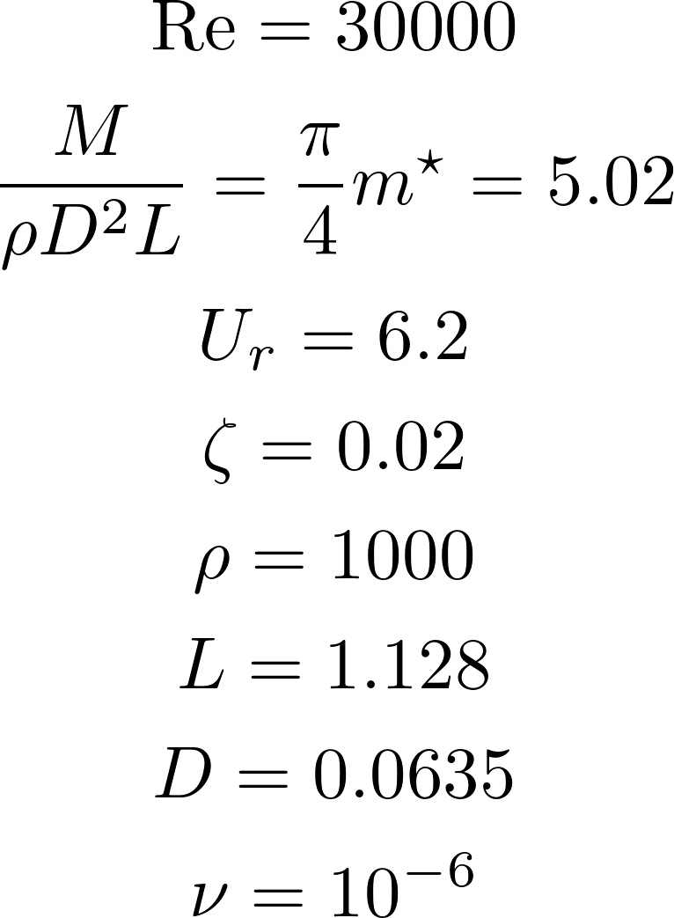

From this parameters mechanical system coefficients are calculated:
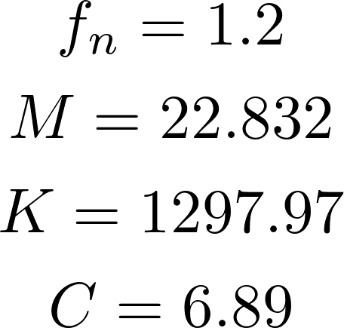
This regime corresponds to regime No.15 from table 1 of [1]. According to Fig. 2 of [1], it is assumed that amplitude of vertical motion of cylinder in this case will be larger then 1 diameter.

Validation case (laminar)
This case was selected from experiment series [2]. Dimensionless parameters were taken from [2], physical and geometry parameters were set according to turbulent case (see section 3.1). This case is used to validate implemented FSI model. It is assumed for this case, that in quasi steady-state regime, amplitude of cylinder motion in y-direction will be around 0.55 of it's diameter.
Dimensionless parameters are next:
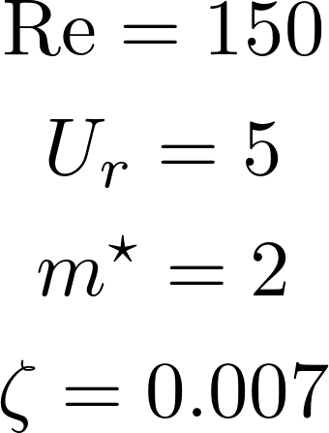

Next geometrical and physical parameters were used from turbulent case section 3.1):
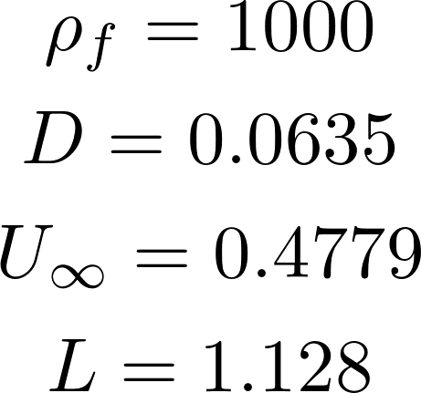

From this parameters other values can be evaluated:
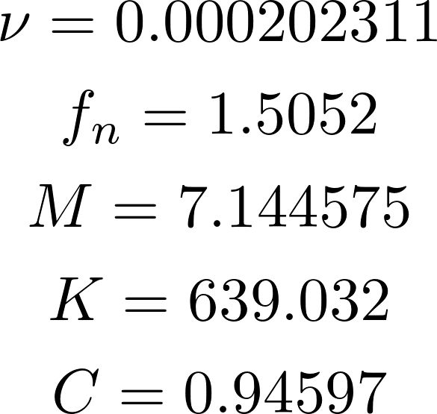

References

[1] Robert D. Blevins, Charles S. Coughran, 2009 «Experimental Investigation of Vortex-Induced Vibration in One and Two Dimensions With Variable Mass, Damping, and Reynolds Number». J. Fluids Eng 131(10), 101202 (Sep 30, 2009) (7 pages), doi:10.1115/1.3222904

[2] B.S. Carmo, S.J. Sherwin, P.W. Bearman, R.H.J. Willden «Flow-induced vibration of a circular cylinder subjected to wake interference at low Reynolds number»

