1)Sap Authorisation form New user kindly share 5 sample in total (scan image) - Bhavesh
2) User Exit form – (all plant 2 sample) (scan image) - Bhavesh
3) Change in SAP (T code) access form share 5 sample (scan image) - Bhavesh
4) 3 login attempts screen shot for application like SAP, O365, Windows. Parameter Settings.
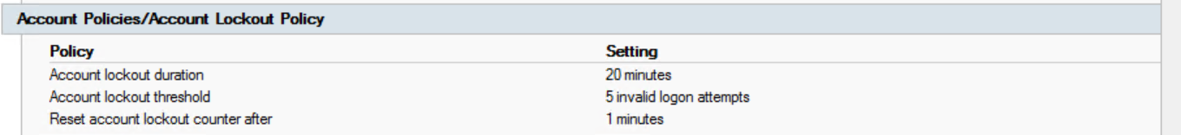

5) For SAP email to unlock, O365 self service portal evidence
6) User Review (SAP) monthly email 2 month.
7)Development Quality user list 5.1 – Jitu sir
8)CCP 2 sample .in SAP – Jitu sir
8.3) Quality Server Refreshed screen shot – Jitu sir
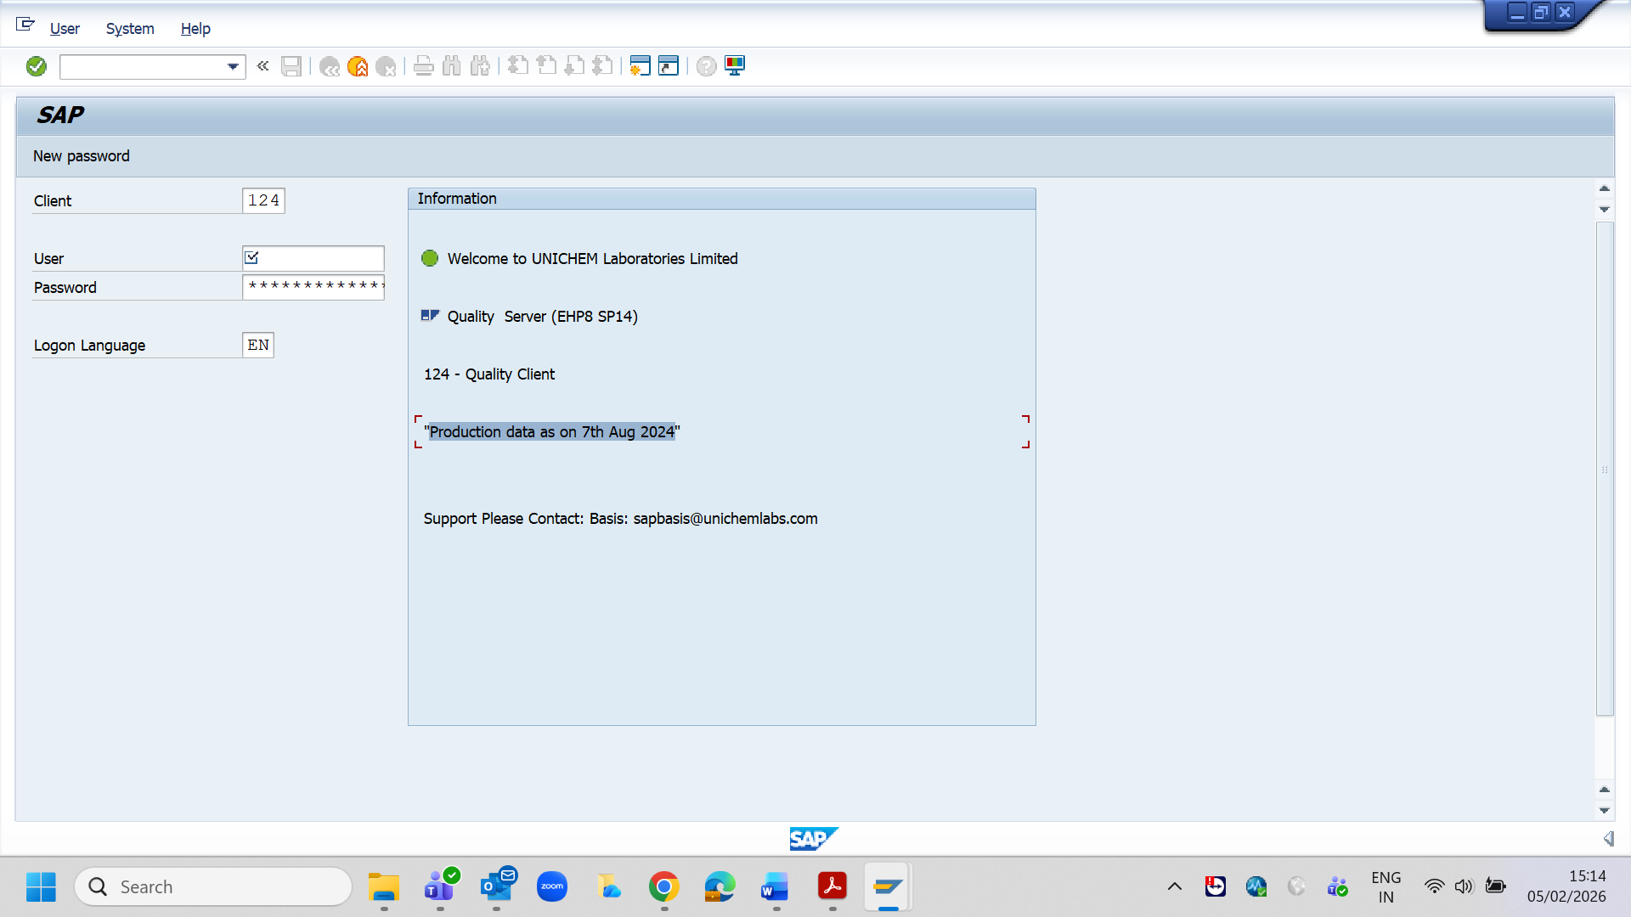
9)Window setting screen shot
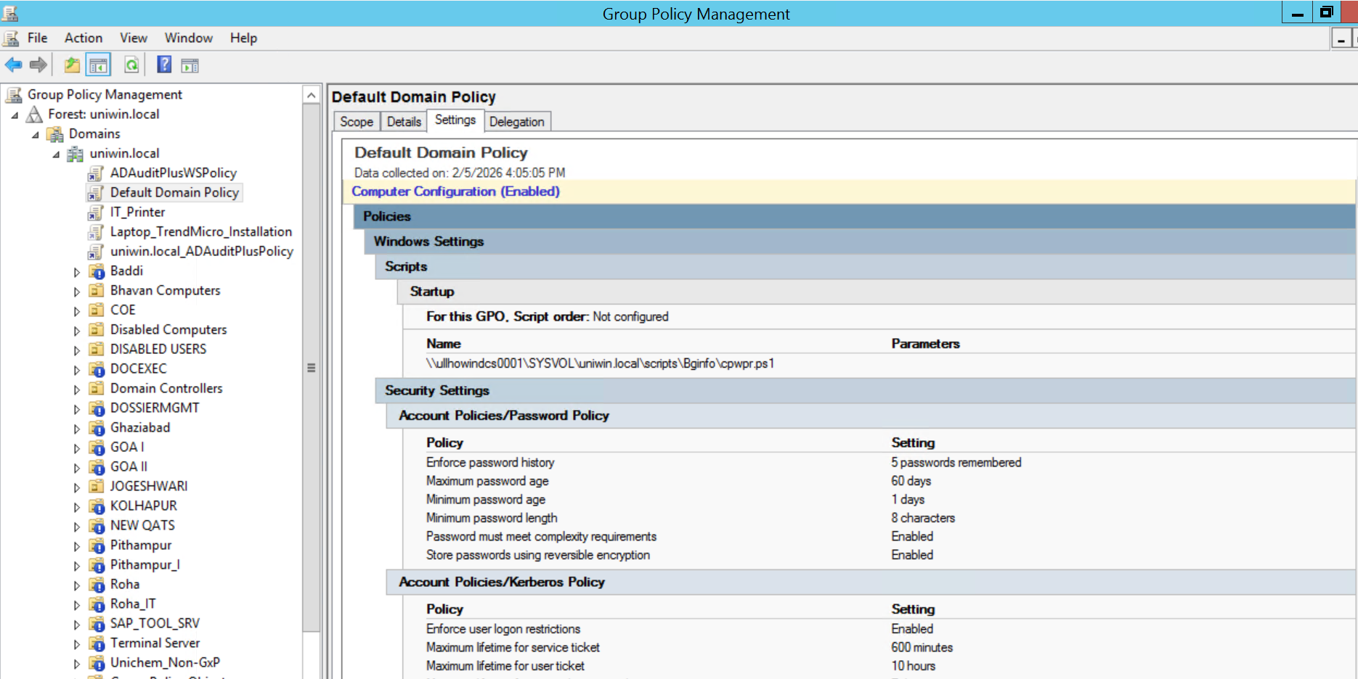
10) Trend micron dash board screen shot - Siddesh
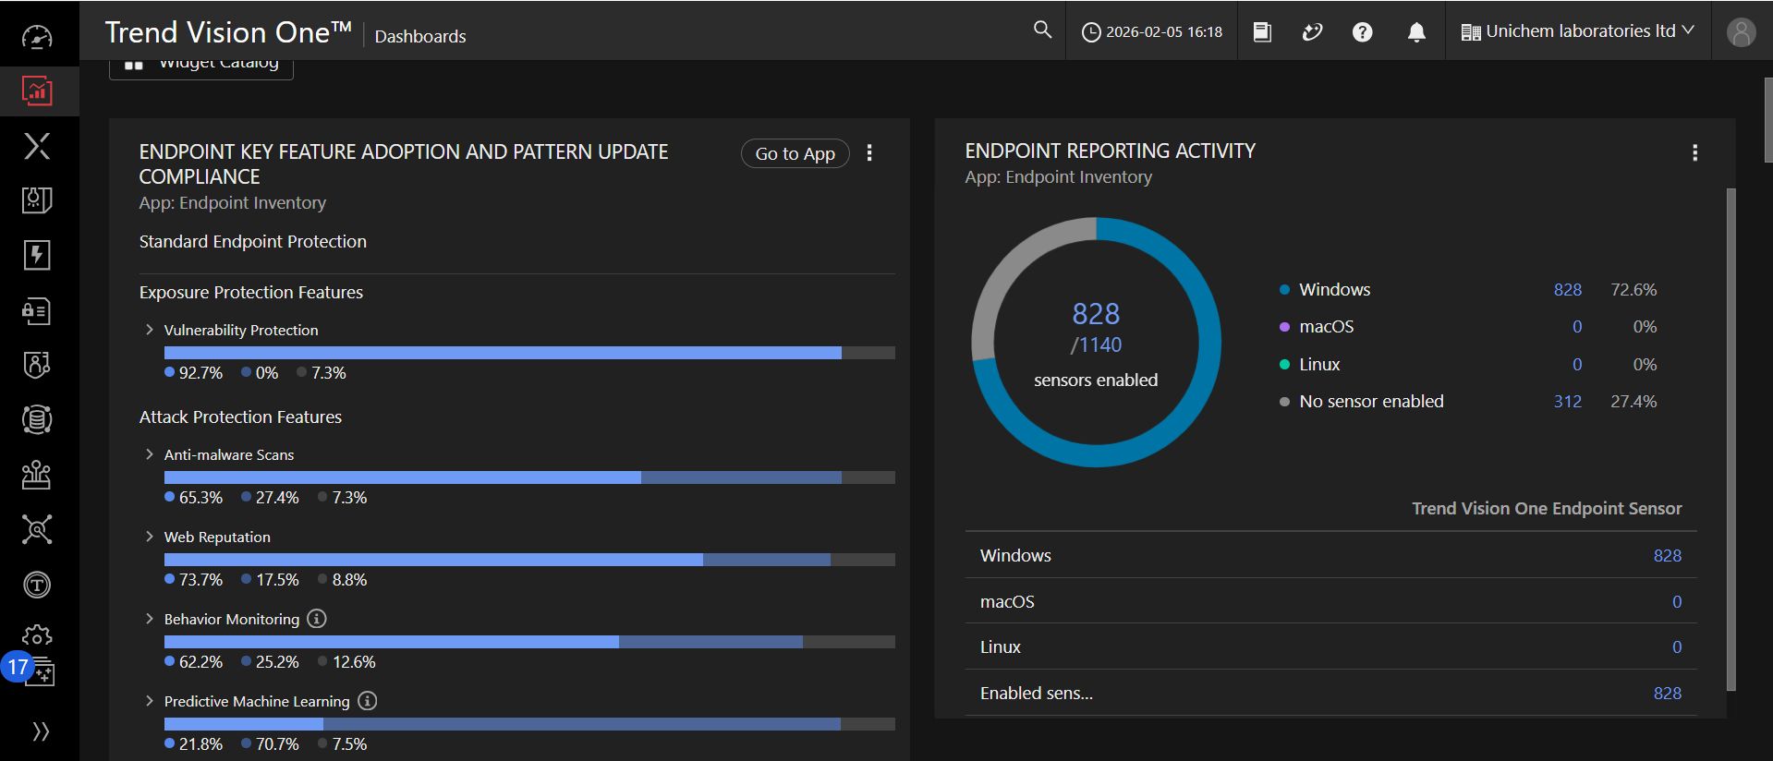
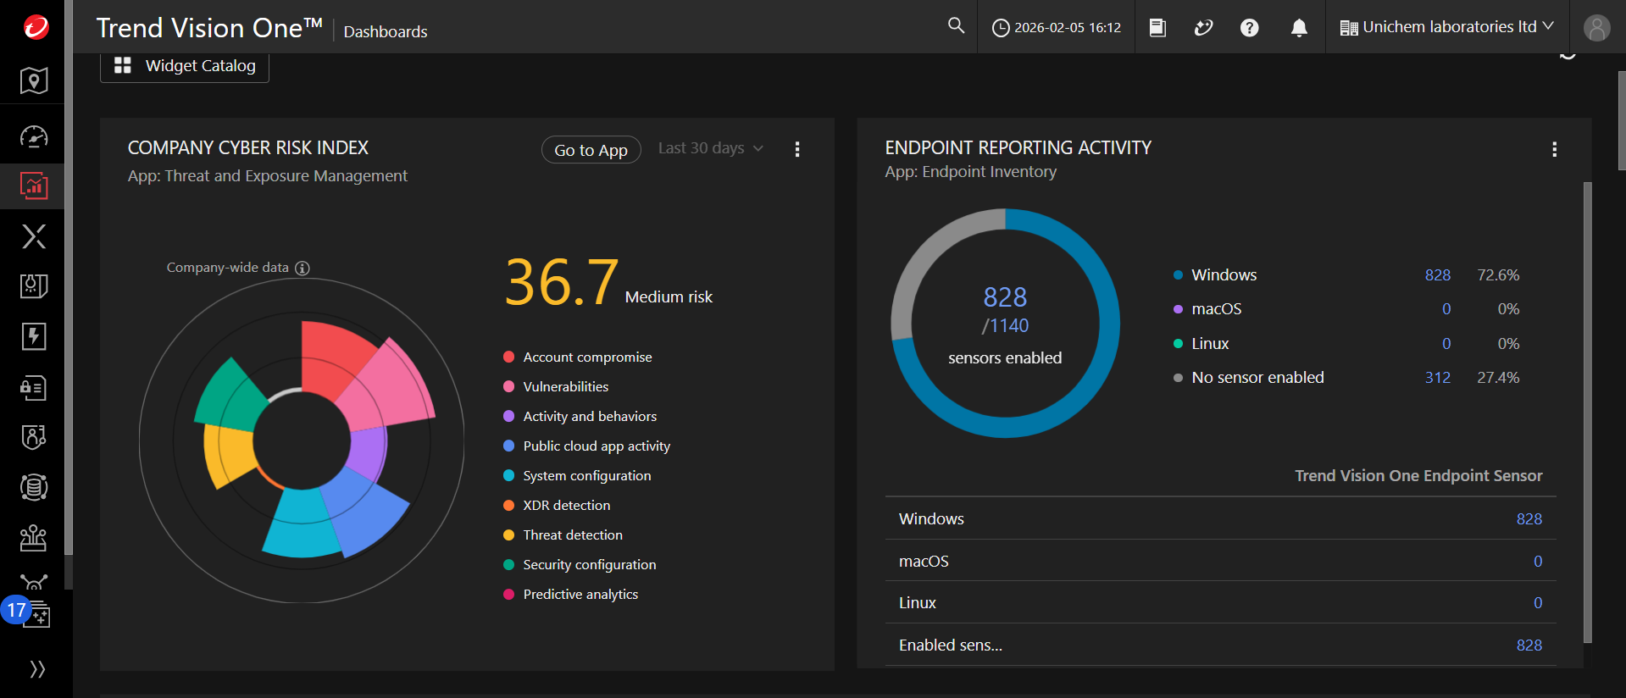
11) Asset Authorization form – Arun Verma (SOP: IT/051)
12) Back up report - Siddesh

