**Practical : 4**

**TOPIC :**

Fuzzy Inference System(FIS)

**Introduction**

Fuzzy inference is the process of formulating the mapping from a given input to an output using fuzzy logic. The mapping then provides a basis from which decisions can be made, or patterns discerned. The process of fuzzy inference involves Membership Functions, Logical Operations, and If-Then Rules. You can implement two types of fuzzy inference systems in the toolbox: Mamdani-type and Sugeno-type. These two types of inference systems vary somewhat in the way outputs are determined.

**Theory**

Fuzzy inference is the process of formulating the mapping from a given input to an output using fuzzy logic. The mapping then provides a basis from which decisions can be made, or patterns discerned. The process of fuzzy inference involves : Membership Functions, Logical Operations, and If-Then Rules. You can implement two types of fuzzy inference systems in the toolbox: Mamdani-type and Sugeno-type. These two types of inference systems vary somewhat in the way outputs are determined.

Fuzzy inference systems have been successfully applied in fields such as automatic control, data classification, decision analysis, expert systems, and computer vision. Because of its multidisciplinary nature, fuzzy inference systems are associated with a number of names, such as fuzzy-rule-based systems, fuzzy expert systems, fuzzy modeling, fuzzy associative memory, fuzzy logic controllers, and simply (and ambiguously) fuzzy systems.

**Procedure :**

1. Click on any function of the Dirtiness section to select the level of Dirtiness.

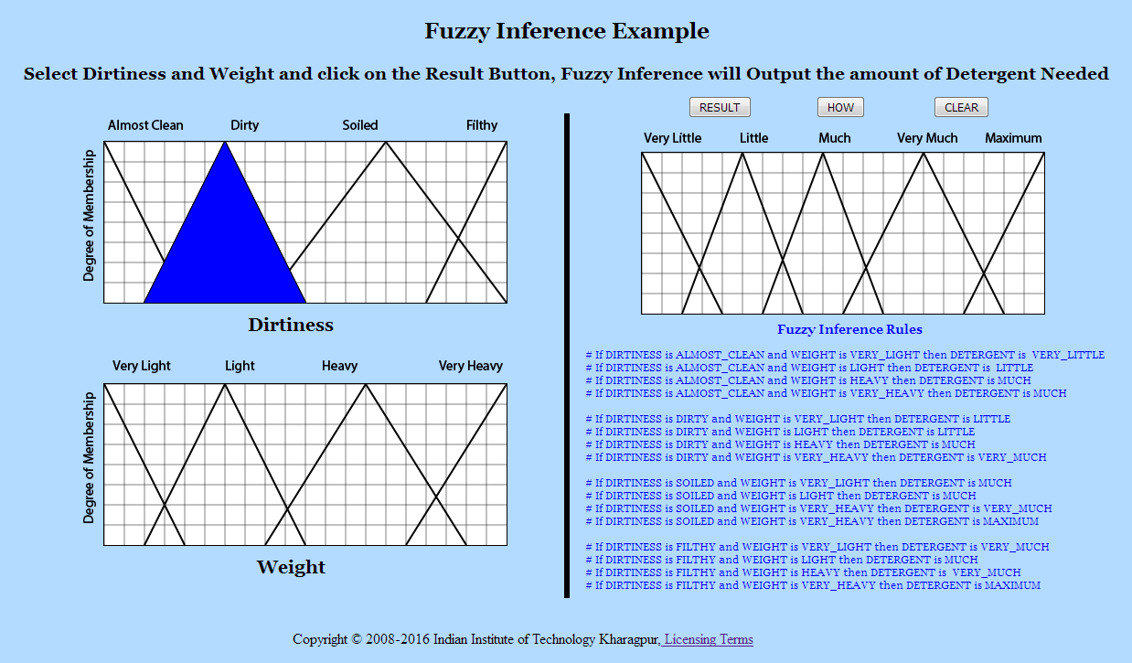

1. Click on any function of the Weight section to select the Weight.

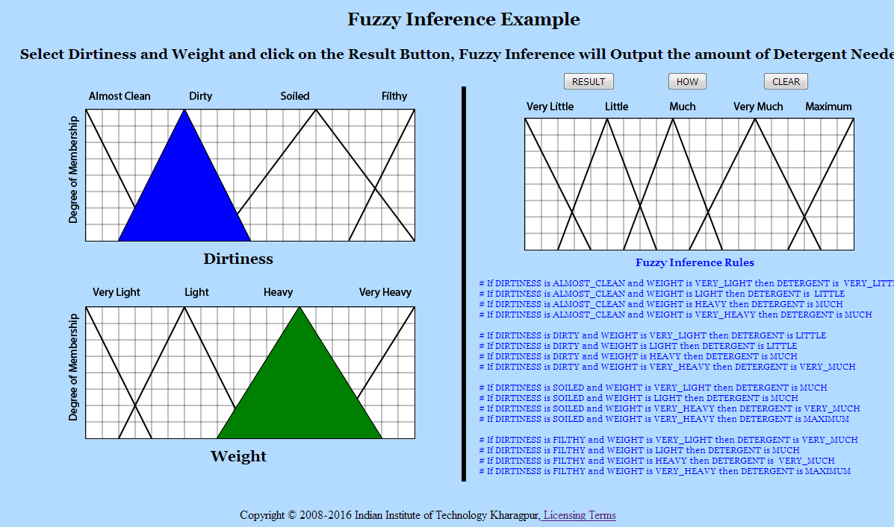

1. After selecting Dirtiness and Weight click on the Result button to get the amount of Detergent needed.

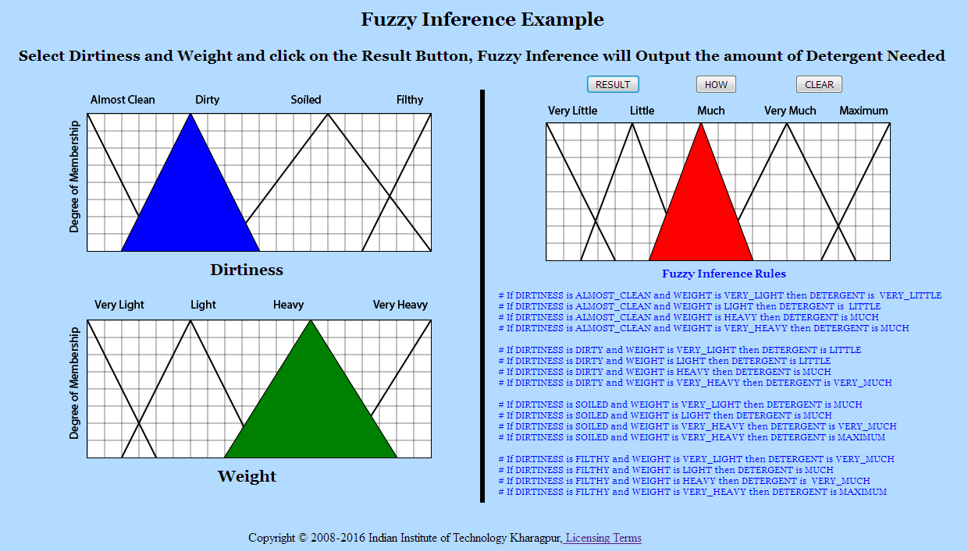

1. Click on How? Button to know which inference rule was used to arrive at the Conclusion.

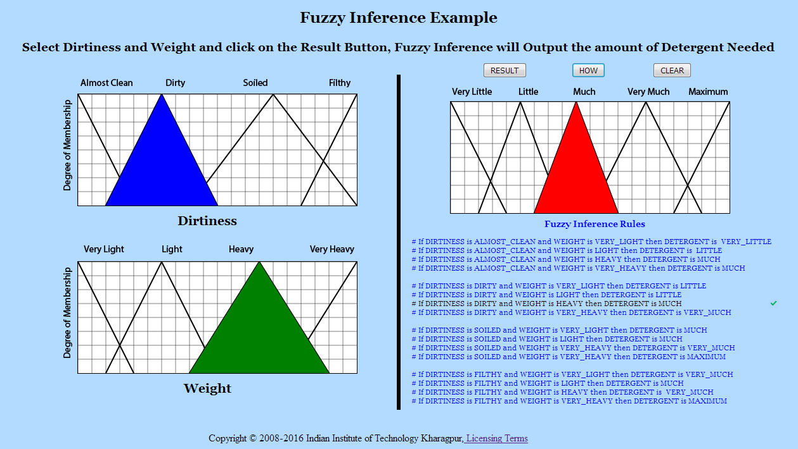

1. Click on Clear Button and Perform the experiment again.

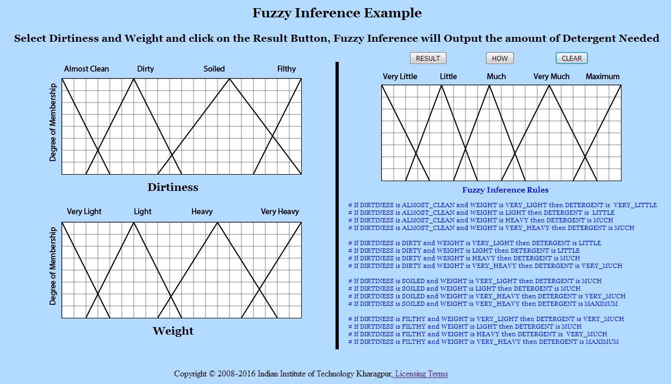

**Output :**

|  |
| --- |
|  |
|  |
|  |
|  |
|  |
|  |