Unicode® and IBM WebSphere®

On the Development and Deployment of

Unicode Based Multilingual Web Applications

in IBM WebSphere Application Server

Kentaro Noji  Globalization Center of Competency  Yamato Software Laboratory  IBM Japan, Ltd. | Debasish Banerjee  WebSphere Development  IBM Rochester  IBM Corporation

Abstract. With the advent and popularity of the Internet-based e-commerce products, the need to develop multilingual Unicode-based applications is becoming increasingly important. The IBM WebSphere® application server is very well suited for the development and deployment of multilingual Unicode-based applications, both traditional and Web-based. The globalization mechanism embedded in the Web container of the WebSphere application server allows one to develop internationalized Servlets and JSPs to serve documents in any language and code set of choice, including Unicode-based multilingual documents. The Web container provides unique features for code set customization and fine-tuning. A system administrator can map language names to code sets of choice, including Unicode, and the IANA code set names of Asian ideographic languages can be fine-tuned to correspond to the Java™ Development Kit (JDK) converters of choice. The present paper describes some important technical considerations behind the development and deployment of multilingual Unicode-based Java™ 2 Enterprise Edition (J2EE) compliant Web applications. WebSphere's unique globalization mechanism including the code set customization is also explained with accompanying examples of a Servlet and a JSP for serving multilingual Unicode-based documents. The ongoing and future internationalization work in WebSphere application server is also highlighted.

Introduction
The IBM WebSphere® Application Server, Version 4.0, provides a Java™ 2 Enterprise Edition (J2EE) 1.2 [7] compliant environment for the development and deployment of enterprise applications covering a wide-variety of back-ends and front-ends. Ideally, all the business and presentation logic should use Unicode [11] for uniform and unrestricted processing and representation of characters from any language in the world. Indeed, all the Java™ based server-side business components deployed in WebSphere internally use Unicode, and Unicode is the process code set of Java. Unfortunately not all the back-ends (databases, transaction processing monitors, etc.) and front–ends (application clients GUIs, browsers, etc.) use Unicode, so they may not have the Unicode handling or presentation capabilities. To interface with legacy applications, WebSphere application components may also have to use native code sets.

Internet-based eCommerce applications are becoming increasingly popular, and IBM WebSphere, Version 4.0, offers a powerful environment for hosting such applications. The users of an eCommerce application can be located in any country and can potentially use any code set, including Unicode, for communicating with the server-side business logic.
Clearly, a globalized server-side Web application should provide support for multiple code sets, and it should be able to receive and send data in any selected code set including Unicode. IBM WebSphere’s Web container provides a unique customizable and fine-tunable code set selection mechanism for hosting Servlets and JSPs, the two J2EE server-side Web components. The present paper describes the motivation and actual implementation behind this code set selection mechanism, along with appropriate examples.

Section 2 illustrates a general globalized eCommerce environment. Section 3 describes the code set selection mechanism embedded inside IBM WebSphere’s Web container. Section 4 contains examples illustrating the code set selection mechanism. Section 5 mentions the future globalization intentions of IBM WebSphere, and finally Section 6 presents our conclusions. A few configuration files and configuration procedures appear in the Appendices.

A Globalized eCommerce Environment
Figure 1 illustrates a typical large eCommerce deployment scenario, which may have clients and servers situated in various geographically distinct locations. A Web browser can access any Web server application program, and a server-side Web application should be able to communicate with any browser client located anywhere in the world. IBM WebSphere Application Server can naturally assume the role of servers like A, B, C or D.

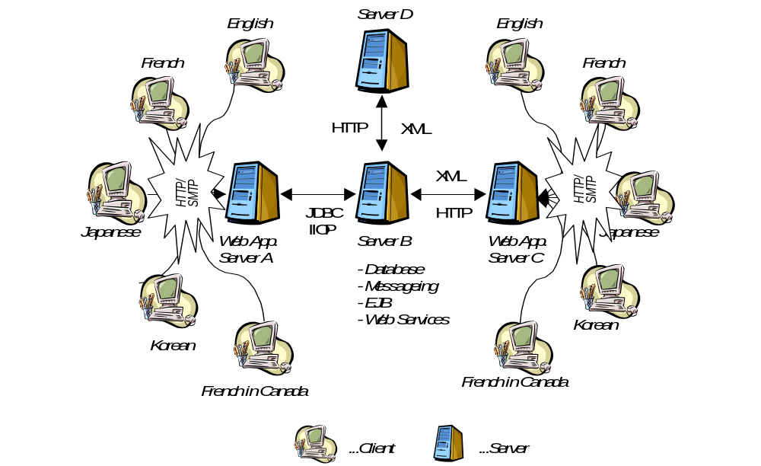Figure 1. A large eCommerce deployment scenario
Servers A and C serve multilingual Web content to the requesting Web clients, while servers B and D only participate in intra-server communications, and can process and serve multilingual content to other servers. To communicate effectively and reliably in a multilingual environment a receiver should know the code set of the incoming request. If all the server-side components are written in Java, the intra-server communication will take place in Unicode, and no special consideration is needed for code set determination. But for a server like A or C that communicates with clients, it is strictly necessary to determine the input and output code sets associated with requests and responses.

Ascertaining Code Sets in IBM WebSphere
Servlets and JSPs usually communicate with the clients using the HTTP protocol [2]. This section describes the way by which the IBM Web container (Version 4.0) attempts to determine the input and output code sets associated with HTTP-based communications between browser clients and Servlets or JSPs.

3.1 Code set of an HTTP Request
HTTP input data can be encoded in any valid IANA[3] code set. Inside a Servlet or a JSP, the HTTP input data is usually obtained by invoking the getParameter() family of methods available in the javax.servlet.ServletRequest interface. The entire request body can also be obtained using the java.io.BufferedReader object returned by the javax.servlet.ServletRequest.getReader() method. All the above methods return data encoded in UCS-2 (Java’s internal process code set) variant of Unicode, and the Web container has to convert the input HTTP data to UCS-2. To perform a proper conversion the Web container has to know the encoding of the input HTTP request so that it can invoke an appropriate JDK converter for conversion to UCS-2.

Theoretically speaking, an HTTP request may have a ‘Content-Type’ header optionally containing a ‘charset’ attribute. For example, an HTTP client can transmit the header Content-type text/html; charset=ISO-8859-2 along with a GET request. The Web container can then easily convert the ISO-8859-2 encoded data to UCS-2.

Unfortunately like all the other HTTP headers, this ‘Content-Type’ header is also optional, and the presence of the ‘charset’ component in a ‘Content-Type’ header is optional too. In fact, neither Netscape nor Microsoft® Internet Explorer, the two most popular browsers, transmit ‘Content-Type’ HTTP headers containing any ‘charset’ attribute. The question naturally arises: In the absence of any explicit code set information in the HTTP request, how can a Web container perform an appropriate UCS-2 conversion?

Web containers available in the market have followed various ad-hoc strategies to arrive at a value of the input code set, though some of them are arguably wrong. Some of the strategies that we have seen or have heard of are:

- If available, use the value of the ‘Accept-Charset’ HTTP header as the value of the input encoding. This approach is incorrect—‘Accept-Charset’ is not intended to specify the encoding of the input request.

- Use the default JDK converter for conversion to UCS-2. The approach assumes the input code set to be identical to that of the ‘file.encoding’ system property of the Web container’s Java™ Virtual Machine (JVM), and it may not work in multilingual environments. It may also create trouble in EBCDIC environments (System/390®).
- Always use the ISO-8859-1 → UCS-2 converter. Obviously, this approach may not work for non-Latin1 clients.

3.2 Deciding on the Input Code Set
If the input request does not explicitly specify the code set value using the “Content-Type” HTTP header, there is no simple but definitive way to arrive at a value of the input encoding. A Web container can only apply heuristic strategies to arrive at a reasonable value of the input code set using indirect avenues. The following sketches the heuristic strategy followed by the IBM Web container. The strategy is divided into four sequential steps. If the Web container decides on the input code step at a particular step, the succeeding steps are skipped.

Step 3.2.1 If the ‘Content-Type’ HTTP header is present and contains the ‘charset’
attribute, the value of the ‘charset’ attribute is the input code set.
Step 3.2.2 Try to determine the input code set from the locale associated with the HTTP request. The locale of the javax.servlet.http.HttpServletRequest object may be determined from the ‘Accept-Language’ HTTP header [2, 6, 7].

The input locale is mapped to a code set using “encoding.properties”, an IBM WebSphere- provided properties file for mapping locales to IANA char sets.

Figure 2 illustrates a sample mapping. Appendix A shows a typical ‘encoding.properties’ file.

Locale Name | IANA Charset Name
en | ISO-8859-1
cs | ISO-8859-2
ja | Shift_JIS
ko | EUC-KR
zh | GB2312
zh_TW | Big5

Figure 2. Sample mapping rules in encoding.properties

Step 3.2.3 Look for “default.client.encoding”, a Web container-specific JVM system property. If present, use that value as the input code set.
Step 3.2.4 As the final recourse, just use ISO-8859-1 as the input code set.

3.3 Deciding on the Output Code Set
Quite similar to the input request, on the output side, a Servlet has to convert UCS-2 encoded data before sending it to the browsers. If a Servlet or a JSP developer explicitly specifies a ‘charset’ attribute by invoking the javax.servlet.ServletResponse.setContentType() method, the output code set is known. In the absence of a ServletResponse.setContentType() invocation, again there is no clear way to arrive at a value for the output code set. To decide the value of the output encoding, the IBM Web container follows the following heuristic strategy. If the Web container decides on the output code step at a particular step, the succeeding steps are skipped.

Step 3.3.1 If the Servlet or JSP developer has explicitly specified a ‘charset’ attribute, use the value of the attribute as the output code set.
Step 3.3.2 If the Servlet or JSP developer has explicitly invoked javax.servlet.ServletResponse.setLocale() API, use “encoding.properties” to map the specified locale to a code set.
Step 3.3.3 Use ISO-8859-1 as the value of the output code set.

3.4 Fine-Tuning Code Set Converters
The code set names used in Internet protocols must be registered in the IANA charset database. For certain language environments, the official IANA charset names may have more than one JDK converter associated with them. For example, the most popular code set in Japanese PC environments is “Shift-JIS”, and there exist a large number of “Shift-JIS” converters. In fact, JDK presently supports Cp943, Cp943C, Cp942, Cp942C, SJIS, and MS932 converters. All of these converters are for “UCS-2 Shift-JIS” conversions. These converters are very similar but not identical. Figure 3 depicts four variants of
“UCS-2 → Shift_JIS” conversions for the “\u2015\uff5e\u2225\uff0d\uffe4\u2014\u301c\u2016\u2212\u00a6” string using the native2ascii command of JDK V1.3.

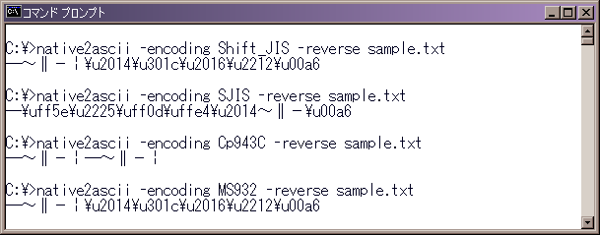

Figure 3. Sample Conversions

JDK equates “Shift-JIS” to ‘MS932’, but some Web container installations may want to use Cp943C or SJIS for conversion to or from UCS-2. For fine-tuning the selection of input and output code set converters, IBM WebSphere provides “converter.properties”, a properties files for mapping IANA charset names to JDK converters. Figure 4 depicts a sample mapping, and a typical “converter.properties” file appears in Appendix A.

IANA Charset Name | JDK Converter
Shift_JIS | Cp943C
EUC-JP | Cp33722C

Figure 4. Sample mapping rules in converter.properties

To take “converter.properties” into consideration, the following fine-tuning step is added in our input and output code set determination strategies.

Fine-Tuning Step
Search ‘converter.properties’ for a match with the IANA code set name. If there is a match, use the corresponding JDK converter for conversions to and from UCS-2; otherwise use the original IANA name as the JDK converter.

3.5 Customization
The IBM Web container determines the input and output code sets based on the various internationalization configuration parameters as detailed in Sections 3.2, 3.3, and 3.4. All of these internationalization configuration parameters are customizable by system administrators.

Both ‘encoding.properties’, the mapping from locale to IANA charset, and ‘converter.properties’, the mapping from IANA charset to JDK converters, are exposed as properties files, and both can be altered to suit specific Web container installations.

For example, in a Japanese PC-based environment, the “ja → Shift_JIS” mapping should suffice, whereas in a Linux client environment, the mapping should be changed to
“ja → EUC-JP”. If all the Japanese Web content is encoded in UTF-8, the mapping rule must be changed to “ja → UTF-8” for that particular installation.

In a pure Unicode-based environment, all Web input is encoded in UTF-8. The IBM Web container can easily set the input code set to be UTF-8 for specific languages. The system administrator simply has to use the UTF-8 in the ‘encoding.properties’ file for the appropriate languages. Entries for new locales can also be added easily. The “default.client.encoding” Web container property should be used as a “catch-all”, and it is recommended that it be set as UTF-8. The input code set for any unusual locale (for example, various Indic locales) will then automatically default to UTF-8.

Certain environments may need customization of the “converter.properties” file. As mentioned in Section 3.4, in Japanese environments, the Shift_JIS code set corresponds to more than one JVM converter. In fact, Shift-JIS can really be considered to be a vendor unique code set, where the actual character sets and the “Shift_JIS  UCS-2” mappings depend on the vendor-specific implementations.

If one needs to follow the JIS (Japanese Industry Standard) or the UTC (Unicode Technical Committee) standard Shift_JIS code set conversion rules, it may suffice to map the Shift_JIS entry of ‘converter.properties’ to the SJIS converter. As a side effect, some vender specific characters defined in Microsoft® Windows or for the Macintosh may simply disappear. Figure 5 shows some NEC-defined characters, which will be filtered out by JDK’s SJIS converter.

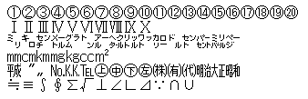
Figure 5. Some NEC special characters filtered out by Java SJIS converter

If a particular installation needs to use an IBM-defined code conversion rule, especially for using IBM back-end data storage (DB2®, IMS, etc), Shift_JIS should be mapped to Cp943C, or some important characters may be corrupted in the Web application.

Examples
This section briefly describes illustrative examples using a Servlet and a JSP serving data in Unicode. The Unicode data is represented as escaped Unicode sequences. The variable unicode_data in Examples 1 and 2 represents arbitrary data from a Shift_JIS database. The unicode_data string is displayed as a Shift_JIS encoding using the IANA charset parameter explicitly specified in the setContentType() call. Figures 6 and 7 show the results as displayed in MS Internet Explorer without and with fine-tuning.

Example 1. Servlet
public class Sample extends HttpServlet{
String unicode_data = "\u96fb\u8a71(Phone)\uff17\uff12\uff13\u2212\uff13\uff12\uff15\uff16";

// ‘unicode_data’ is an example of a telephone number in Unicode. Normally, a Unicode string is
// is transmitted via JDBC, HTTP communication and so on. Here we present a simulation using an
// escaped sequence.

public void doGet(HttpServletRequest request, HttpServletResponse response)
throws ServletException, IOException{
response.setContentType("text/html; charset=Shift_JIS"); // Unicode_data is converted to
PrintWriter pw = response.getWriter(); // Shift_JIS using JDK converter pw.println("<HTML>");
pw.println("<TITLE>");
pw.println("Sample");
pw.println("</TITLE>");
pw.println(unicode_data);
pw.println("</HTML>");
}
}
Example 2. JSP
<%@ page contentType="text/html;charset=Shift_JIS" %>
<HTML>
<TITLE>Sample</TITLE>
<%
String unicode_data =
“\u96fb\u8a71(Phone)\uff17\uff12\uff13\u2212\uff13\uff12\uff15\uff16";
out.println(unicode_data);
%>
</HTML>

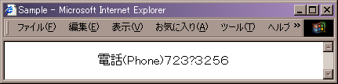

Figure 6. Result of Examples 1 and 2

Without the proper use of “converter.properties” file, the minus sign of the telephone number gets displayed as a question mark in Figure 6, because JDK’s Shift_JIS converter maps the Unicode minus sign to an unassigned Shift_JIS code point. But using the “Shift_JIS → Cp943C” fine-tuning, the telephone number gets displayed properly as shown in Figure 7.

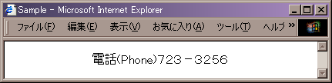

Figure 7. Result of Examples 1 and 2 with fine-tuning

Figure 8 illustrates an example of the mapping rule to and from Unicode and Shift_JIS families of encodings in Java. The “MINUS SIGN (0x817C): character name of JIS X0208” is frequently used in a database or text data, here as the telephone number separator character. The JIS X0208: 1997 standard specifies that the code point of the minus sign is 0x817C in the Shift_JIS encoding. However, the mapping rule differs within the Shift_JIS family of converters in JDK, and sometimes, the minus sign is not preserved in round trips, and is displayed incorrectly (see Figure 8). Using the ‘converter.properties’ file, IBM WebSphere provides a solution to the Shift_JIS code set conversion problem. It should be mentioned however that, the use of UTF-8 code set for HTTP communication perhaps provides a more elegant solution to the problems associated with UCS-2 conversions in certain Asian ideographic language environments.
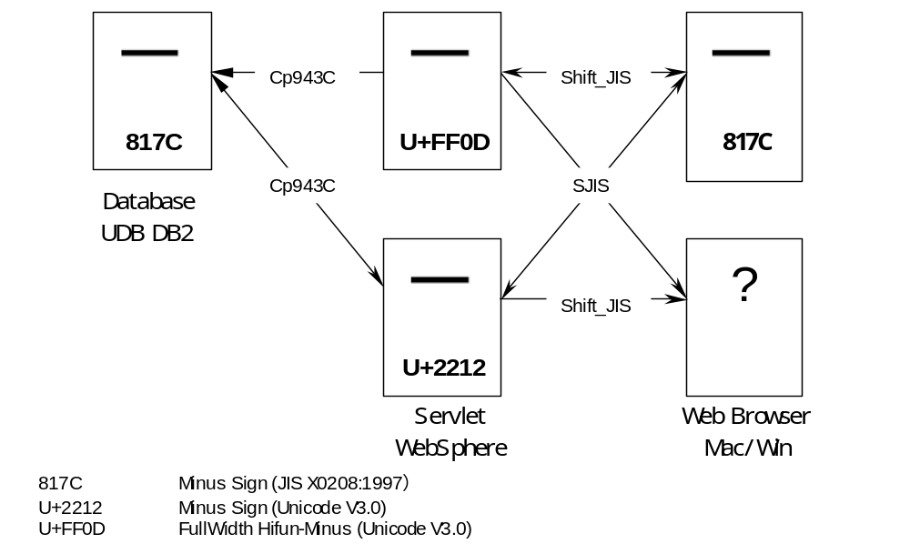Figure 8. Round trip of the “-” sign.

5. Input Code Set in Servlet 2.3
The issue of ‘input code determination’ of an HTTP request has created some confusion among Web container developers. As mentioned in Section 3.1, some Web containers are (or were) following highly questionable strategies for arriving at a value for the input code set. Probably as a result of this, and also for maintaining portability across different Web containers, the emerging Servlet 2.3 specifications [8] has attempted to address the issue of ‘Request data encoding’ by
- mandating that in the absence of any ‘charset’ information in the HTTP header, ISO-8859-1 will be the default encoding of the HTTP request, and
- introducing the new javax.servlet.ServletRequest.setCharacterEncoding() method.

Some may think that [8] has simply shifted the complex burden of ‘input code set determination’ from the Web container developer to the Servlet or JSP programmers. The central question still remains: How can an application programmer developing Servlets or JSPs figure out the input encodings in non-Latin1 multilingual environments in order to know the parameter when calling the newly introduced method?

In a future release of WebSphere, IBM plans to implement the Servlet 2.3 (and JSP 1.2) specifications. To aid the Servlet (and JSP) programmers, so that they do not have to worry about input encoding in most situations, IBM intends to provide a special deployment descriptor for Servlets and JSPs as a simple extension to the J2EE 1.3 specifications [6]. This deployment descriptor can be described informally as:

<!—
The servlet element contains the declarative data for a servlet or a JSP.
-->

<!ELEMENT servlet(icon?, servlet-name, display-name?, description?, (servlet-class|jsp-file), init-param*, load-on-startup?, run-as?, security-role-ref*, request-encoding?)>

<!—
The request-encoding element must be one of the following:
<request-encoding>J2EE</request-encoding>
<request-encoding>IBMWAS</request-encoding>
with J2EE as the default.

If J2EE is specified, in the absence of any explicit ServletRequest.setCharacterEncoding() API invocation, ISO-8859-1 encoding for the request data will be assumed by the IBM Web container, if the charset' information is also missing in the "Content-Type" HTTP header.

If IBMWAS is specified, in the absence of any explicit ServletRequest.setCharacterEncoding() API invocation, the IBM Web container will use steps 3.2.1 to 3.2.4 (see Section 3.2) to decide on the input encoding of the request data.
-->

<!ELEMENT request-encoding (#PCDATA)>

When available, an application programmer can deploy Servlets and JSPs using
<request-encoding>IBMWAS</request-encoding> in IBM WebSphere. The programmer then in most cases will not have to worry about the ‘input code set’, and can concentrate on the business logic of the application. The IBM Web container will ascertain the input encoding based on its internationalization configuration.

6. Conclusions
The present paper described the heuristic strategies used by IBM WebSphere to determine the input and output code sets associated with HTTP requests and responses. The strategies use customizable ‘locale → code set’ and ‘code set → converter’ mapping tables. The ‘locale → code set’ mapping is also mentioned in [4], and is used in Tomcat’s [5] Servlet 2.2 implementation for determining the code sets of the HTTP responses.

In contrast to Tomcat, the IBM Web container’s use of mapping functions is completely flexible. For example, the ‘ja → Shift_JIS’ mapping is hard-wired in Tomcat [5]. In a Japanese Linux or some other environment, if a ‘ja → EUC-JP’ mapping is desired for some reason, nothing much can be done in Tomcat without explicit programmer intervention, because the mapping table is compiled into the Web container’s implementation. In IBM WebSphere, the system administrator can simply make a minor adjustment in the “encoding.properties” file, thereby providing EUC-JP encoded responses. The concept of customizable fine-tuning while selecting the JDK UCS-2 converters, which is especially applicable for the Asian ideographic language environments, is also unique in IBM WebSphere.

As mentioned earlier, in the absence of the explicit code set information in an HTTP request, there is no simple but definitive way to ascertain the value of the input encoding. To our knowledge, Tang [10] first suggested the use of a hidden form variable for communicating the code set information from a browser to the server. Tang’s technique is used in a somewhat indirect way in [4] to illustrate the use of the ‘session tracking’ mechanism for converting request data to UCS-2 inside a servlet. The approach of [4] is somewhat complex, indirect, dependent on browsers, and based on the assumption that the Web containers will always use ISO-8859-1 as the request code set.

IBM plans to release a future version of WebSphere compliant with the J2EE 1.3 specifications [6], and IBM also intends to introduce request-encoding, a deployment descriptor element for deploying Servlets and JSPs. When introduced, Servlet (JSP) developers can easily use this deployment descriptor, and the IBM Web container will automatically set the input code sets, and this may satisfy the needs of many business installations. Of course, a Servlet developer can always override the code set determined by the IBM Web container by using the new setCharacterEncoding(enc) method. The proper value for ‘enc’ can be obtained directly from the user, by using session tracking, or from other indirect mechanisms.

For successful globalization, in addition to the input code set, the server-side application components should also be aware of the client’s locale. Though a Servlet can determine a client’s locale, in a traditional J2EE environment the business logic implemented as EJBs remains unaware of the input locale. IBM WebSphere, Version 4.0, provides “Internationalization Service” [1]—a unique mechanism for transparently propagating the callers’ (standalone clients, Servlets, JSPs) locale and time zone information to the server-side application components (Servlets, JSPs, EJBs). Using Internationalization Service, the business logic of any server-side application component can easily localize relevant computations for the caller’s locale and time zone. The existence of the code set determination heuristics along with the Internationalization Service probably makes IBM WebSphere one of the best available environments for the development and deployment of internationalized J2EE applications.

Acknowledgements
Rob High of IBM, Austin, USA suggested the idea of an extended deployment descriptor for request encoding. Shannon Jacobs of IBM-Japan, HRS provided numerous suggestions for improving the technical accuracy and the quality of the presentation.

References
- Banerjee D., et al. Internationalization Service – A Solution for Internationalization in Distributed Heterogeneous Multilingual Client-Server Environments. In preparation.
- Fielding R., et al. HyperText Transfer Protocol – HTTP/1.1. Network Working Group, RFC 2068, Jan. 1997.
- http://www.iana.org/assignments/character-sets.
- Hunter J., Crawford, W. Java Servlet Programming, 2nd Edition, O’Reilly, Sebastopol, CA, 2001.
- http://java.sun.com/products/jsp/tomcat.
- Sun Microsystems. Java 2 Platform Enterprise Edition Specifications, v1.3, Proposed Final Draft 4, Palo Alto, CA, July 2001.
- Sun Microsystems. Java 2 Platform Enterprise Edition Specifications, Version 1.2, Palo Alto, CA, Dec. 1999.
- Sun Microsystems. Java Servlet Specifications, Version 2.3, Proposed Final Draft 2, Palo Alto, CA, April 2001.
- Sun Microsystems. Java Servlet Specification, v2.2, Palo Alto, CA, Dec. 1999.
- Tang F, Y. International Challenges for Netscape Communicator. Tenth International Unicode Conference, Mainz, Germany, March 1997.
- The Unicode Consortium. The Unicode Standard, Version 3.0, Addison-Wesley, Reading, Mass., 2000.

Appendix A

encoding.properties

en=ISO-8859-1  fr=ISO-8859-1  de=ISO-8859-1  es=ISO-8859-1  pt=ISO-8859-1  da=ISO-8859-1  ca=ISO-8859-1  fi=ISO-8859-1  it=ISO-8859-1  nl=ISO-8859-1  no=ISO-8859-1  sv=ISO-8859-1  is=ISO-8859-1  eu=ISO-8859-1  cs=ISO-8859-2  hr=ISO-8859-2  hu=ISO-8859-2  lt=ISO-8859-2  lv=ISO-8859-2  pl=ISO-8859-2  sh=ISO-8859-2  sk=ISO-8859-2  sl=ISO-8859-2  sq=ISO-8859-2  fo=ISO-8859-2  ro=ISO-8859-2  mt=ISO-8859-3  et=ISO-8859-4 | be=ISO-8859-5  bg=ISO-8859-5  mk=ISO-8859-5  ru=ISO-8859-5  sr=ISO-8859-5  uk=ISO-8859-5  ar=ISO-8859-6  fa=ISO-8859-6  ms=ISO-8859-6  el=ISO-8859-7  iw=ISO-8859-8  he=ISO-8859-8  ji=ISO-8859-8  yi=ISO-8859-8  tr=ISO-8859-9  th=windows-874  vi=windows-1258  ja=Shift_JIS  ko=EUC-KR  zh=GB2312  zh_TW=Big5  hy=UTF-8  ka=UTF-8  hi=UTF-8  mr=UTF-8  sa=UTF-8  ta=UTF-8  bn=UTF-8

converter.properties

Shift_JIS=Cp943C
EUC-JP=Cp33722C
EUC-KR=Cp970
EUC-TW=Cp964
Big5=Cp950
GB2312=Cp1386
ISO-2022-KR=ISO2022KR

Appendix B
Unicode Setting for WebSphere Application Server V4.0 and Universal Database DB2® V7.2

- Specify UTF-8 for content-type’s charset attribute on Servlet and JSP
- Specify default.client.encoding=UTF-8
- Mask the locale name from converter.properties.
References in this document to IBM products or services do not imply that IBM intends to make them available in every country.

The following terms are trademarks or registered trademarks of International Business Machines Corporation in the United States, other countries, or both:
WebSphere System/390 DB2 IMS IBM

Java and all Java-based trademarks and logos are trademarks or registered trademarks of Sun Microsystems, Inc. in the United States, other countries, or both.

Microsoft, Windows, Windows NT, and the Windows logo are trademarks of Microsoft Corporation in the United States, other countries, or both.

Information is provided "AS IS" without warranty of any kind.

All customer examples described are presented as illustrations of how those customers have used IBM products and the results they may have achieved. Actual environmental costs and performance characteristics may vary by customer.

Information in this presentation concerning non-IBM products was obtained from a supplier of these products, published announcement material, or other publicly available sources and does not constitute an endorsement of such products by IBM. Sources for non-IBM list prices and performance numbers are taken from publicly available information, including vendor announcements and vendor worldwide homepages. IBM has not tested these products and cannot confirm the accuracy of performance, capability, or any other claims related to non-IBM products. Questions on the capability of non-IBM products should be addressed to the supplier of those products.

All statements regarding IBM future direction and intent are subject to change or withdrawal without notice, and represent goals and objectives only. Contact your local IBM office or IBM authorized reseller for the full text of the specific Statement of Direction.

Some information in this presentation addresses anticipated future capabilities. Such information is not intended as a definitive statement of a commitment to specific levels of performance, function or delivery schedules with respect to any future products. Such commitments are only made in IBM product announcements. The information is presented here to communicate IBM's current investment and development activities as a good faith effort to help with our customers' future planning.

Performance is based on measurements and projections using standard IBM benchmarks in a controlled environment. The actual throughput or performance that any user will experience will vary depending upon considerations such as the amount of multiprogramming in the user's job stream, the I/O configuration, the storage configuration, and the workload processed. Therefore, no assurance can be given that an individual user will achieve throughput or performance improvements equivalent to the ratios stated here.

Photographs shown are of engineering prototypes. Changes may be incorporated in production models.

