Unicon 3D Graphics
User's Guide and Reference Manual

Naomi Martinez, Clinton Jeffery, and Jafar Al Gharaibeh
Unicon Technical Report #9b
November 8, 2010

Abstract

Version 11 of the Unicon language includes 3D graphics facilities. This document describes the design of the Unicon 3D graphics facilities, and provides several examples detailing their use.

University of Idaho
Moscow, ID 83844

This work was sponsored by the National Library of Medicine, the Alliance for Minority Participation, and by NSF grants EIA-0220590 and EIA-9810732.

1. Introduction

Most application programming interfaces for writing 3D computer graphics applications are complicated and difficult to master. Toolkits such as OpenGL [OpenGL00] and Open Inventor are powerful, but several weeks or even months are needed to gain proficiency. Even after gaining proficiency, many lines of code are required to implement most features. There is much that can be simplified.
Unicon [Jeffery03] is a superset of the Icon programming language [Griswold96] that offers many features that minimize the time and effort spent programming. Programs written in Unicon require from two to ten times fewer lines of code than programs written in languages such as C, C++, or Java. This report describes a set of simple, easy to use 3D graphics facilities for Unicon.
Icon and Unicon already provide facilities that simplify the process of programming 2D graphics applications [Griswold98]. Unicon’s 3D graphics facilities are based upon and integrated with the 2D facilities. Unicon’s 3D facilities are built on top of one of the leading 3D graphics libraries, OpenGL. OpenGL is more widely portable and available than most similar toolkits.
This paper discusses the design and demonstrates the use of Unicon’s 3D graphics facilities. Section two contains the design of the Unicon 3D graphics facilities. Examples and sample code can be found in section three. References for functions and attributes are found in section four. The implementation of the Unicon 3D graphics facilities is discussed in [JeffMart03].

2. Design

The Unicon 3D graphics facilities aim to provide the basic elements of 3D computer graphics in a simplified fashion. The basic functionality includes primitives, transformations, lighting, and texturing. With these features, the Unicon 3D graphics facilities should provide a good basis to construct an OpenGL scene using Unicon.
The features of the Unicon 3D graphics facilities differ from the features of OpenGL in several ways. The Unicon 3D graphics facilities introduce several not available in OpenGL. These features include the direct use of image files as textures and the use of the foreground attribute to manipulate material properties. Also there are several features of OpenGL that are not available in the Unicon 3D graphics facilities. These feature include blending, fog, antialiasing, display lists, selection, and feedback. If there is need to, future work might include implementing these features.

2.1 Application Programming Interface (API) Reduction

OpenGL contains over 250 functions that can be called to render 3D graphics applications. Also needed are many window system calls that are not provided by OpenGL, to open and close windows and handle input from the user. The Unicon 3D graphic facilities reduce the number of functions that a Unicon user must typically learn to use. The Unicon 3D graphics facilities contain sixteen new functions and six functions that have been extended from the 2D graphics facilities.
Some of the API reduction was obtained by trivial application of Unicon language features. The ability to store different data types in the same variable and the fact that Unicon handles functions with a variable number of arguments and varying types reduced the number of functions needed in the API. For example there are six different functions one can call to clear a window in OpenGL. Unicon users only need one. Other methods of reduction include providing OpenGL features with default parameters and eliminating unnecessary function calls.

2.2 Opening Windows for 3D Graphics

The first step in 3D graphics programming is opening windows to render 3D graphics, as in the line:

W := open(“win”, “gl”)

To open a 3D graphics window, call the built in function open(), passing in the title of the window to be opened and mode “gl”. In the above example, “win” is the title of the window to be opened. The parameter “gl” indicates that a window for rendering 3D graphics should be opened. As in the 2D facilities, if a window is assigned to the keyword variable &window, it is a default window for subsequent 3D function calls. The newly opened window can be queried for the specifications of the 3D graphics library. The following example demonstrates the use of such attributes:
procedure main(av)
&window := open("gl attributes", "gl", “canvas=hidden”)
write("glversion : ", WAttrib("glversion"))
write("glvendor : ", WAttrib("glvendor"))
write("glrenderer : ", WAttrib("glrenderer"))
end
and here is a sample output of the program after running it on some specific hardware:
glversion : 2.1.2 NVIDIA 195.36.15
glvendor : NVIDIA Corporation
glrenderer : Quadro FX Go1400/PCI/SSE2

2.3 The Coordinate System

Features such as lighting, perspective, texturing, and shading, give a scene the illusion of being three-dimensional. In order to control such features, a Unicon programmer makes use of context attributes. By assigning new values to various attributes the programmer can effectively change many aspects of the scene. Attributes to control the coordinate system, field of view, lighting and textures are included in the Unicon 3D graphics facilities.
Some of the most basic context attributes concern the coordinate system. In 3D graphics one can think of drawing the scene in a three-dimensional coordinate system. A set of three numbers, an x-coordinate, a y-coordinate, and a z-coordinate, determine where to place an object. The objects that are visible on the screen depend on several things, the eye position, the eye direction, and the orientation of the scene. If these things are not taken into account, the scene drawn and the scene desired by the user might be two very different things.
To help think about these attributes, imagine a person walking around a 3D coordinate system. What this person sees becomes the scene viewed on the screen. The eye position specifies where this person is standing. For instance if this person is standing at the origin, (0, 0, 0), then things close to the origin appear larger and seem closer than objects further from the origin. The eye direction supplies the direction in which the person is looking. Suppose the person is looking toward the negative z-axis. Then only the objects situated on the negative z-axis are viewed in the scene. Anything on the positive z-axis is behind the viewer. Finally, the up direction can be described by what direction is up for the person.
In the Unicon 3D graphics facilities, the eye position is given by the attribute eyepos. By default this is set to be at the origin or (0, 0, 0). The eye direction is given by the attribute eyedir. By default this is set to be looking at the negative z-axis. The up direction can be specified by the attribute eyeup and by default is (0, 1, 0). The attribute eye allows the user to specify eyepos, eyedir, and eyeup with a single value; for convenience a function Eye() sets these attributes directly from numeric parameters. After changing any of these attributes, the scene will redraw itself with the new eye specifications.

2.4 Drawing Primitives

In the Unicon 2D graphics facilities, a user can draw 2D points, lines, polygons, and circles. Primitives analogous to these and more are available in Unicon’s 3D graphics facilities. The Unicon 3D primitives are a cube, a point, a line, a line segment, a sphere, a torus, a cylinder, a disk, a partial disk, a filled polygon, and an outline of a polygon. These are described in Table 1 below. All functions specified, can take as their first parameter the window to be drawn on. When a window is not specified the primitives will be drawn on the default window, &window.
In the Unicon 3D graphics facilities, one can draw 2D, 3D or 4D objects within the same scene. With the use of the context attribute, dim, the user can switch between the different dimensions of an object. A user can draw 2D, 3D, or 4D, objects by assigning dim the values of 2, 3, or 4. It is worth noting that a 2D object drawn in a 3D scene does not use Unicon’s 2D graphics facilities for its implementation. Instead, the dim attribute defines how many components a vertex of a primitive will have. The value of dim affects the primitives drawn in several ways. For functions such as DrawPolygon() which take the coordinates of each vertex as parameters, the value of dim specifies the number of parameters each vertex will have. For primitives that take x, y, and z coordinates, specifying only x and y coordinate is not sufficient. For this reason, “dim = 2” disallows the use of these primitives. These functions are DrawSphere(), DrawTorus(), DrawCube(), and DrawCylinder(). By default the value of dim is three. An example of drawing primitive can be found in section 3.2.

Table 1 – types of primitives

Primitive | Function | Parameters | Picture
Cube | DrawCube() | the x, y, and z coordinates of the lower left front corner, and the length of the sides. | 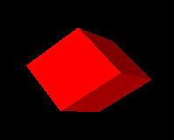
Cylinder | DrawCylinder() | the x, y, and z coordinates of the center, the height, the radius of the top, the radius of the bottom. If one radius is smaller than the other a cone is formed. | 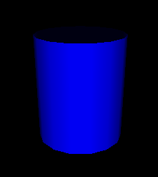  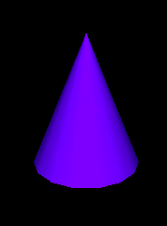
Disk | DrawDisk() | the x, y, and z coordinates of center, the radius of the inner circle, and the radius of the outer circle. By specifying an additional two angle values a partial disk is obtained. | 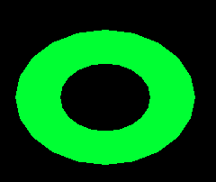  
Filled Polygon | FillPolygon() | the x, y, and z coordinates of each vertex of the polygon. | 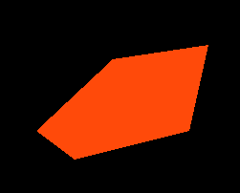
Line | DrawLine() | the x, y, and z coordinates of each vertex of the line. | 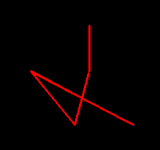
Polygon | DrawPolygon() | the x, y, and z coordinates of each vertex of the polygon. | 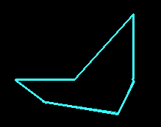
Point | DrawPoint() | the x, y, and z coordinates of each individual point. | 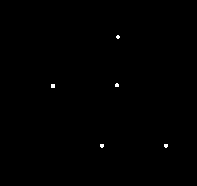
Segment | DrawSegment() | the x, y, and z coordinates of each vertex of the line segments. | 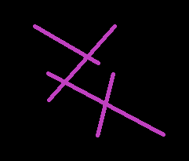
Sphere | DrawSphere() | the x, y, and z coordinates of center and the radius of the sphere. | 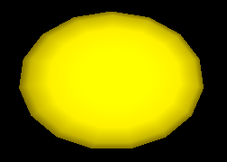
Torus | DrawTorus() | the x, y, and z coordinates of the center, an inner radius and an outer radius. | 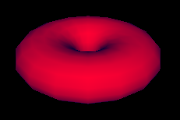
Several functions from the 2D graphics facilities have been extended for the 3D graphics facilities. By doing this, learning to use the Unicon 3D graphics facilities may be easier for users of the Unicon 2D graphics facilities. These functions are DrawPoint(), DrawLine(), DrawSegment(), DrawPolygon(), and FillPolygon(), which draw a point, a line, a line segment, an outline polygon or a filled polygon, respectively. Through the use of the already present 2D functions, the number of functions added for the 3D graphics facilities are kept to a minimum.

2.5 Transformations

Matrix multiplications are used to calculate transformations, such as rotations, translations, and scaling, on objects and the field of view. In order for the user to keep track of matrices and matrix multiplications, functions to perform several operations are included in Unicon’s 3D graphics facilities.
In many 3D graphics applications, several transformations are performed on one object and several other transformations are performed on another object. For this reason, it is desirable to use different matrices to perform these calculations. OpenGL keeps track of the current matrix with a stack of matrices, where the top of the stack is the current matrix. The Unicon 3D graphics facilities make use of OpenGL’s implementation of the matrix stack to implement transformations.
Several functions are provided to the Unicon user to manipulate the matrix stack. The function PushMatrix() pushes a copy of the current matrix onto the stack. By doing this the user can compose several different transformations. The function IdentityMatrix() changes the current matrix to the identity matrix. Finally, to discard the top matrix and to return to the previous matrix, the function PopMatrix()will pop the top matrix off the matrix stack.
As in OpenGL, there are two different matrix stacks, projection and modelview, in the Unicon 3D graphics facilities. The projection matrix stack contains matrices that perform calculations on the field of view. These calculations are based on the current eye attributes. If these eye attributes are changed, then previous manipulations of the projection matrix stack are no longer valid. The maximum depth of the projection matrix stack is two. Trying to push more than two matrices onto the projection matrix stack will generate a runtime error. The modelview matrix stack contains matrices to perform calculations on objects within the scene. Transformations formed using the matrix stack only effect the objects that a programmer desires. The maximum depth of this stack is thirty-two. So, pushing more than thirty two matrixes onto the modelview matrix stack will generate an error. Furthermore, only one matrix stack can be manipulated at any given time. The function MatrixMode() switches between the two matrix stacks.

2.6 Lighting and Materials

The use of lighting is an important step in making a 3D graphics scene appear to be 3D. Adding lighting to a scene can be fairly complicated. A light source can emit different types of light: ambient light, diffuse light, and specular light. Ambient light is light that has been scattered so much that is difficult to determine the source. Backlighting in a room is an example of ambient light. Diffuse light comes from one direction. This type of light mostly defines what color the object appears to be. Finally, specular light not only comes from one direction, but also tends to bounce off the objects in the scene.
Lighting has been implemented in the Unicon graphics facilities through the use of context attributes. The use of context attributes reduces the number of functions added to the Unicon 3D graphics facilities. For a 3D scene implemented in Unicon, there are eight lights available. Using the attributes light0 through light7 one can control the eight lights. Each light is on or off and has the properties diffuse, ambient, specular, and position.
A scene not only has several lighting properties, but the objects in scene may have several material properties. The material properties are ambient, diffuse, and specular, which are similar to the light properties, emission, and shininess. If an object has an emission property, it emits light of a specific color. Using combinations of these material properties one can give an object the illusion of being made of plastic or metal.
In the Unicon 2D graphics facilities, users use a rich naming scheme to specify the current foreground color using the attribute fg. Colors can be specified using a string name, a hexadecimal number, or red, green, and blue components each between 0 and 65535. The 3D graphics facilities have extended this idea to the lighting and material properties. For a material property, the programmer can specify the material property by stating the type of the material property and then the color that the property should have. Similarly the values for each of the lights follow the same pattern. Also, not only can a programmer specify a color in the same ways as the 2D graphics facilities, but also a color can be given by providing the red, green, and blue intensities between 0.0 and 1.0. Examples of lighting and material properties can be found in section 3.3.
By extending the features of the 2D graphics facilities, adding and changing properties of lights and material has been simplified. Furthermore, the use of the foreground attribute greatly reduces the number of lines of code needed for a scene. This design along with several defaults, a user of the Unicon 3D graphics facilities can have lighting in a 3D graphics application without much effort.

2.7 Textures

Another important area of three-dimension computer graphics is textures. Adding textures to a scene can give a scene a realistic feel. In order to implement textures in the Unicon 3D graphics facilities, several aspects of texturing have to be taken into account. A texture image can be viewed as a rectangular image that is “glued” onto objects in a scene. The appearances of the textured objects in the scene depend on several key pieces of information supplied by the programmer. These include the texture image and what parts of the texture image is mapped to what parts of an object.
Since not all scenes require the use of textures, the attribute texmode is included in the Unicon 3D graphics facilities. By default, textures are turned off. In order to turn on texturing in a scene use the following line of code
WAttrib(W, “texmode=on”)
Once textures are turned on and a texture image is given, the texture image will be applied to subsequent objects in the scene. By using the following line of code, textures will be disabled for all successive objects.
WAttrib(W, “texmode=off”)
Texture images in OpenGL programs are images that have been encoded into an array. So if a programmer wants to use a .gif image file, the file must be converted into a format accepted by OpenGL. Often times this is a cumbersome process to obtain the desired result. For this reason, the Unicon 3D graphics facilities provide several different formats to specify a texture image. A texture image can be another Unicon window, an image file, or a string. If the texture image is a string it must be encoded in one of two language standard formats. Either it is in the format
“width,pallet,data” or “ width,#,data”
where pallet is one of the pallets described in the 2D graphics facilities and data is a hexadecimal representation of an image. In the first case the pallet will determine what colors appear in the texture image. In the second case, the foreground color and background color will be used. The ability to use another Unicon window as a texture provides the programmer with greater flexibility for texture images. For OpenGL, a texture image must be known before the start of the program. The use of a window as a texture allows the programmer to create a texture image dynamically.
Textures must have a height of 2^{n} pixels and width of 2^{m} pixels where n and m are integers. If not, the texture dimensions are automatically scaled down to the closest power of 2. Rescaling affects application performance and may cause visual artifacts, so it may be wise to create textures with appropriate sizes in the first place. Section 3.4 contains examples on how to use textures specified in the different forms.
A programmer can give the texture in one of two ways, one can use WAttrib(“texture=…”) or the function Texture(t). These methods do differ in one important way, a window cannot be used as a texture with WAttrib(). So a function call must be made to Texture() if a window is to be used as a texture.
For textures, a programmer must specify how a texture is applied to particular object. This is done by specifying texture coordinates and vertices. Since a texture image can be viewed as a rectangular image, texture coordinates are x and y coordinates of the texture image. So the texture coordinate (0.0, 0.0) corresponds to the lower left hand corner of the texture image. The texture coordinates are mapped to the vertices specified by the programmer. These vertices are usually the vertices of an object in the scene. Together, the texture coordinates and the vertices determine what the scene looks like after textures have been applied.
The design of textures in the Unicon 3D graphics facilities aims to simplify the process of mapping a texture onto an object by setting defaults for texture coordinates. There are several ways to specify texture coordinates. To use the defaults given by the Unicon 3D graphics facilities, one can either use WAttrib(“texcoord=auto”) or Texcoord(“auto”). The defaults are dependent on the type of primitive and are outlined in the table 2.
If the programmer wishes to use texture coordinates other than the defaults, these can be specified in several ways. One can use WAttrib(“texcoord=s”) where s is a comma separated string of real number values between 0.0 and 1.0. Each pair of values is to be taken as one texture coordinate; there must be an even number of decimal values or the assignment of texture coordinates will fail. Also one can assign texture coordinates by Texcoord(x1, y1, …) where each x and y are real number values between 0.0 and 1.0. Finally one can use Texcoord(L) where L is a list of real number texture coordinates. The texture coordinates specified by the programmer are used differently depending on the type of primitive to be drawn. If the primitive is a point, line, line segment, polygon, or filled polygon, then a texture coordinate given is assigned to each vertex. If there are more texture coordinates than vertices, the unused texture coordinates are ignored. If there are more vertices than texture coordinates the application of a texture will fail. In order to use non default texture coordinates with cubes, tori, spheres, disks, and cylinders a programmer should approximate the desired mapping with filled polygons. These specifications are given in the following table.

Table 2 – texture coordinates and primitives

Primitive | Default Texture Coordinates  (from [OpenGL00] chapter 6) | Effect of Non-default Texture Coordinates | Picture
Cube | The texture image is applied to each face of the cube. | None | 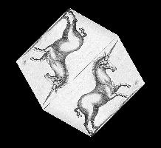
Sphere  Cylinder | The y texture coordinate ranges linearly from 0.0 to 1.0. On spheres this is from  z= -radius to z=radius; on cylinders, from  z = 0 to z = height. The x texture coordinate ranges from 0.0 at the positive y-axis to 0.25 at the positive x-axis, to 0.5 at the negative  y-axis to 0.75 at the negative x-axis back to 1.0 at the positive y-axis. | None | 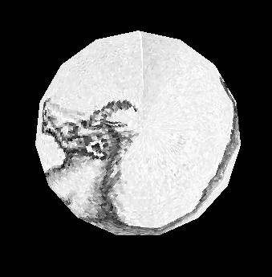  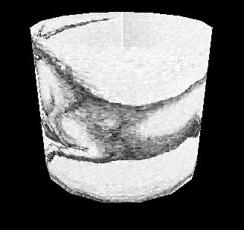
Filled Polygon  Line  Polygon  Segment | The x and y texture coordinates are given by p₁x₀+p₂y₀+p₃z₀+p₄w₀ | A texture coordinate is assigned to a vertex. | 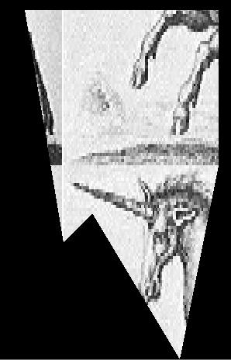  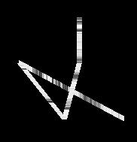  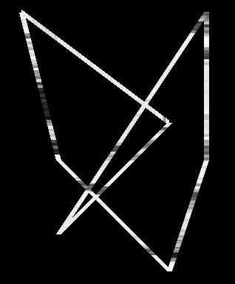  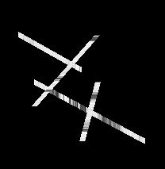
Torus | The x and y texture coordinates are given by p₁x₀+p₂y₀+p₃z₀+p₄w₀ | None | 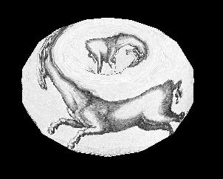

3. Examples

The following section provides examples and a further description of the Unicon 3D graphics facilities.

3.1 Changing Context Attributes

As mentioned in the above design section, new context attributes have been added to the Unicon 3D graphics facilities. The user can change these attributes throughout a program. To change from an attribute, make a call to WAttrib() with the window to be drawn on, the attributes to be changed, and their new values. Multiple attributes can be changed with one call to WAttrib(). This is illustrated in the following line of code, where the user changes the eye position to (0.0, 0.0, 5.0) and the eye direction to look at the positive z-axis on the window w. Since an assignment to eyepos, eyedir, eyeup or eye redraws the screen, it is important to note that the following will redraw the scene once.

WAttrib(w, “eyepos=0.0,0.0,5.0”,“eyedir=0.0,0.0,1.0”)

The values of the attributes can also be read by using the function WAttrib(). By passing WAttrib() the window and the name of the attribute to be read, the user will obtain the value of the specified attributes. For example, to obtain the value of the current eye position, call

WAttrib(w, “eyepos”)

Multiple attributes can be read with one call to WAttrib(). This is shown in the following line of code where the user reads the current value of the eye direction and up direction.

every put(attrList, WAttrib(w, “eyedir”, ”eyeup”)

3.2 Drawing Primitives

The following is an example on how to use some of the functions to draw primitives.

Fg(w, "ambient yellow")
DrawDisk(w, 0.4, -0.5, -4.0, 0.0, 1.0, 0.0, 0.0, 1.0, 0.5, -5.0, 0.5, 1.0)
Fg(w, "diffuse white")
DrawDisk(w, 0.4, -0.5, -4.0, 0.0, 1.0, 0.0, 225.0,1.0, 0.5, -5.0, 0.5,1.0,0.0,125.0)
Fg(w, "ambient pink")
DrawCylinder(w, 0.0, 1.0, -5.0, 1.0, 0.5, 0.3)
Fg(w, "specular navy")
DrawDisk(w, -0.5, -0.5, -2.0, 0.5, 0.3)
Fg(w, "emission green")
DrawSphere(w, 0.5, 1.0, -3.0, 0.5)
WAttrib(w, "light0=on, diffuse white")
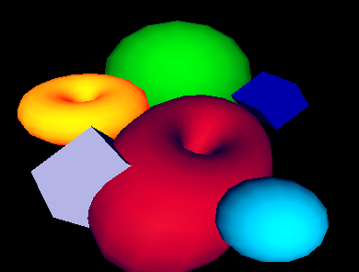
The function Fg(), specifies the material properties of an object. These material properties affect the color and appearance of the primitives. After a call to Fg(), all objects will be drawn with the material properties until the material property is changed with another call to Fg(). In this example, a cube with a diffuse green material is drawn with sides of length 0.7. Then a sphere with a diffuse purple and ambient blue material is drawn with radius 0.5 and center (0.4, -0.5, -4.0). Next a diffuse yellow and ambient grey torus with center (-1.0, 0.4, -4.0), an inner radius of 0.4, and an outer radius of 0.5 is drawn. Finally a filled polygon with a diffuse red material property and three vertices, (0.25, -0.25, -1.0), (1.0, 0.25, -4.0) and (1.3, -0.4, -3.0) is drawn.

3.3 Slices and Rings
In many cases, it is useful to be able to control the level of detail when drawing graphics primitives, for example depending on how far away and/or how large the primitive is. Slices and rings attributes serve this purpose. Both attributes take integer vales greater than 0 and denote how closely to approximate the abstract graphics shape when rendering with simpler graphics primitives such as triangles or quads. WAttrib(“slices=10”, “rings=10”) for example sets them both to 10. Greater values achieve smoother and more fine detailed shapes but are more expensive to render, so these values should be picked with care. These attributes can also be used to achieve some useful effects, such as drawing a diamond using the the DrawSphere() function or drawing a pyramid using the DrawCylinder() function. Slices and rings affect DrawSphere(), DrawCylinder(), DrawTorus() and DrawDisk() functions. The example and figure below illustrates the use of slices and rings.
procedure main()
&window := open("slices & rings", "gl", "size=800,600") | stop("can't open window!")

Fg("blue")
WAttrib( "slices=25", "rings=25" )
DrawSphere(-2.0, 2.0, 0, 0.5)

WAttrib( "slices=4")
DrawSphere(-1.0, 2.0, 0, 0.5)

Rotate(45.0, 0, 1, 0)
DrawSphere( 0.0, 2.0, 0, 0.5)
Rotate(-45.0, 0, 1, 0)

WAttrib( "slices=25", "rings=4")
Fg("red")
DrawSphere(-2.0, 0.5, 0, 0.5)

WAttrib( "slices=4", "rings=4")
DrawSphere(-1.0, 0.5, 0, 0.5)

Rotate(45.0, 0, 1, 0)
DrawSphere(0.0, 0.5, 0, 0.5)
Rotate(-45.0, 0, 1, 0)

WAttrib( "slices=25", "rings=25")
Fg("green")
DrawCylinder(-2.0, -1, 0, .6, 0.5, 0.01)

WAttrib( "slices=4", "rings=16")
DrawCylinder(-1, -1, 0, .6, 0.5, 0.01)

Rotate(25.0, 0, 1, 0)
DrawCylinder(0, -1, 0, .6, 0.5, 0.01)
Rotate(-25.0, 0, 1, 0)
Eye( 0 , 0.5, 5.2, -1,0.66,0, 0,1,0 )
Refresh()
Event()
end

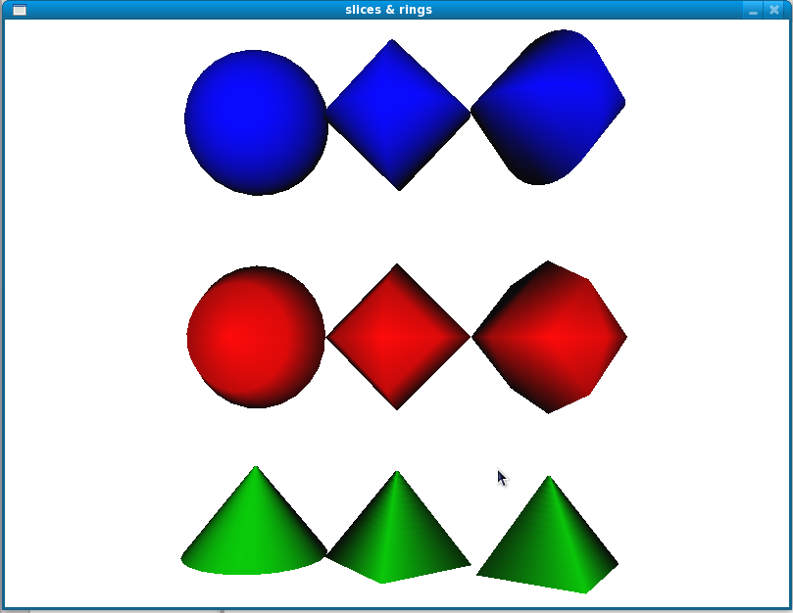

3.4 Lighting and Materials

There are a maximum of eight lights that can be used in each scene of the Unicon 3D graphics facilities. The lights are control by the context attributes light0 through light7. Each light has five properties that can be changed throughout the program, ambient, diffuse, specular, position, and on/off. The properties of a light can be changed by using WAttrib() and one of light0 through light7. To turn on or off a light, one can assign “on” or “off” to the light, followed by a comma and a lighting value. A lighting value is a string which contains one or more semi-colon separated lighting properties. A lighting property is of the form
[
]
diffuse
ambient color name
specular

If one does not want to turn on or off a light, a lighting value is specified. The following is a line of code which turns light1 on and gives it diffuse yellow and ambient gold lighting properties.

WAttrib(w, “light1=on, diffuse yellow; ambient gold”)

The following line of codes sets light0 to the default values for the lighting properties.

WAttrib(w, “light0=diffuse white; ambient black;
specular white; position 0.0, 1.0, 0.0”)

The follow example shows the difference between the different types of lighting that can be used in a scene. Each window is the same scene rendered using different lighting. The upper right scene has an ambient blue-green light. The upper left scene was drawn using a diffuse blue-green light. The lower right scene uses only a specular blue-green light. The scene in the lower left uses all three types of lighting.

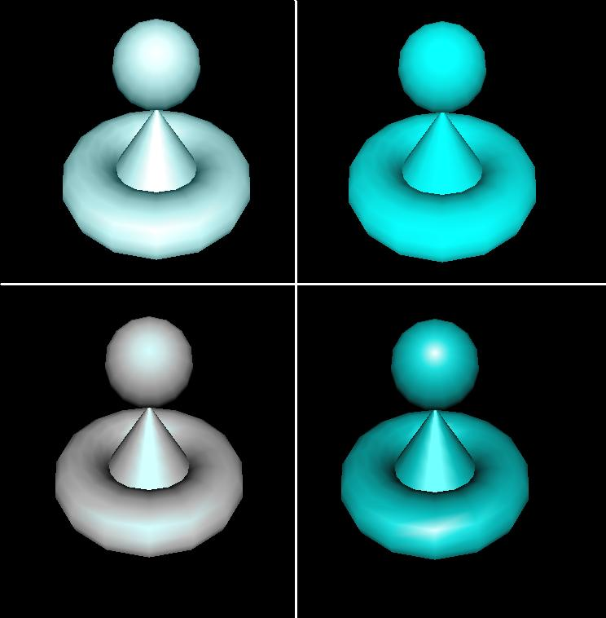

w := open("ambient.icn","gl", "bg=black", "size=400,400")
WAttrib(w, "light0=on, ambient blue-green", "fg=specular white")
DrawCylinder(w, 0.0, -0.2, -3.5, 0.75, 0.5, 0.0)
DrawTorus(w,0.0, -0.2, -3.5, 0.3, 0.7)
DrawSphere(w,0.0, 0.59, -2.2, 0.3)

x := open("diffuse.icn","gl", "bg=black", "size=400,400")
WAttrib(x, "light0=on, diffuse blue-green", "fg=specular white")
DrawCylinder(x, 0.0, -0.2, -3.5, 0.75, 0.5, 0.0)
DrawTorus(x,0.0, -0.2, -3.5, 0.3, 0.7)
DrawSphere(x, 0.0, 0.59, -2.2, 0.3)

y := open("specular.icn","gl", "bg=black", "size=400,400")
WAttrib(y, "light0=on, specular blue-green", "fg=specular white")
DrawCylinder(y, 0.0, -0.2, -3.5, 0.75, 0.5, 0.0)
DrawTorus(y, 0.0, -0.2, -3.5, 0.3, 0.7)
DrawSphere(y, 0.0, 0.59, -2.2, 0.3)

z := open("all.icn","gl", "bg=black", "size=400,400")
WAttrib(z, "light0=on, diffuse blue-green; specular blue-green; _
ambient blue-green", "fg=specular white")
DrawCylinder(z, 0.0, -0.2, -3.5, 0.75, 0.5, 0.0)
DrawTorus(z, 0.0, -0.2, -3.5, 0.3, 0.7)
DrawSphere(z, 0.0, 0.59, -2.2, 0.3)
[
]
Materials can be changed using Fg() or WAttrib() with the context attribute fg. A material value is a string containing one or more semi-colon separated material properties. Material properties are of the form

diffuse
ambient color name or “shininess n”, where n is between 0 and 128.
specular
emission

The default material property type is diffuse, so the call Fg("red") is equivalent to Fg("diffuse red"). For shininess, a value of 0 spreads specular light broadly across an object and a value of 128 focuses specular light at a single point. The following line of code changes the current material property to diffuse green and ambient orange.

WAttrib(w, “fg=diffuse green; ambient orange”)

The default values of the material properties are given in the following example.

Fg(w, “diffuse light grey; ambient grey; _
specular black; emission black; shininess 50”)

The following is an example of several different material properties used within one scene.
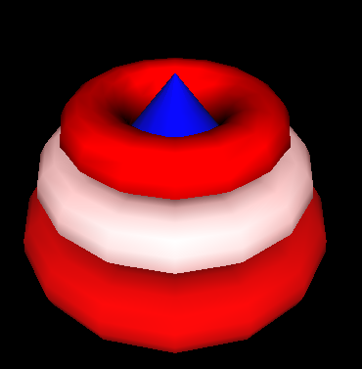

Fg(w, "diffuse blue")
DrawCylinder(w, 0.0, -0.2, -3.5, 1.2, 1.0, 0.0)
Fg(w, "diffuse red")
DrawTorus(w, 0.0, -0.2, -3.5, 0.3, 1.0)
Fg(w, "diffuse white; ambient red")
DrawTorus(w, 0.0, 0.2, -3.5, 0.3, 0.9)
Fg(w, "shininess 10; diffuse red; specular red; ambient black")
DrawTorus(w, 0.0, 0.55, -3.5, 0.3, 0.72)

First a cylinder with a diffuse blue material is drawn. Then the bottom torus is drawn, which has a diffuse red material. Next the middle torus is draw with a diffuse white and ambient red property. Finally the top torus is drawn with a diffuse red, specular red and ambient property, and shininess of 10. Notice, that in order an object not to be drawn with a previous material property, that property must be reset to its default.
The following example shows the effects of emission color on an object.

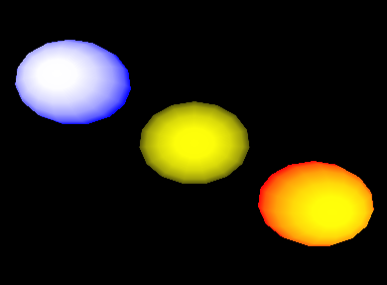

Fg(w, "emission blue; diffuse yellow")
DrawSphere(w, -1.5, 1.0, -5.0, 0.7)
Fg(w, "emission black")
DrawSphere(w, 0.0, 0.0, -5.0, 0.7)
Fg(w, "emission red")
DrawSphere(w, 1.5, -1.0, -5.0, 0.7)

In the above example, there are three diffuse yellow spheres drawn. If an emission color of blue is applied to the sphere, the sphere appears white with a blue ring. If the emission color is red, the sphere remains yellow, but now has an orange-red ring. The middle sphere shows the effect of having no emission color. Note that in order to obtain the diffuse yellow sphere in the center, the emission color had to be change to black. It was not needed to change the diffuse material property.

3.5 Textures

This section contains several examples of the use of textures in a scene. There are several ways to specify the texture image in the Unicon 3D graphics facilities: a file, an image string, or another Unicon window. The following example shows how to use a file as a texture. A .gif image of a map of the word is used to texture a torus. The texture coordinates are the default coordinates as describe in 2.7.

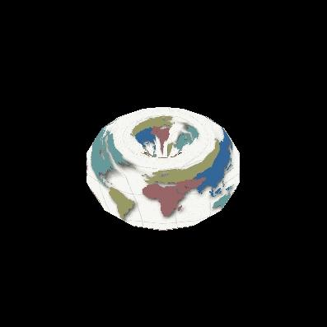

WAttrib(w, "texmode=on", "texture=map.gif")
DrawTorus(w, 0.0, 0.0, -3.0, 0.3, 0.4)

Instead of using WAttrib(w, "texture=map.gif") to specify the .gif file, a call to Texture(w, "map.gif") could be used to obtain the same result.

The next example illustrates the use of an image string to specify a texture image. The format of the string is described in section 2.7. The string used for this example is taken from Graphics Programming in Icon [Griswold98] page 156. This string is used as a texture on a cube using the default texture coordinates.

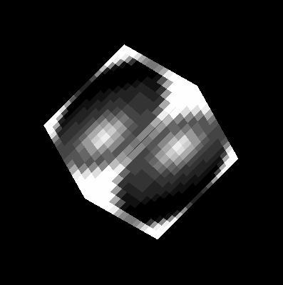

WAttrib(w, "texmode=on")
sphere:= "16,g16, FFFFB98788AEFFFF" ||
"FFD865554446AFFF FD856886544339FF E8579BA9643323AF"||
"A569DECA7433215E 7569CDB86433211A 5579AA9643222108"||
"4456776533221007 4444443332210007 4333333222100008"||
"533322221100000A 822222111000003D D41111100000019F"||
"FA200000000018EF FFA4000000028EFF FFFD9532248BFFFF"
Texture(w, sphere)
DrawCube(w, 0.0, 0.0, -3.0, 1.2)

The next example shows the use of another Unicon window as a texture. A simple scene of a lamp is drawn on the first window, which is opened in “gl” mode. This window is then captured and used as a texture on a cylinder. If a Unicon window opened in “g” mode as a texture the same method can be used. Note that in the following code the first window is opened with size 256 x 256. Texture images must have height and width that are powers of 2, or the system must rescale them. The default coordinates for cylinders are used.

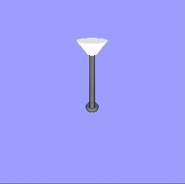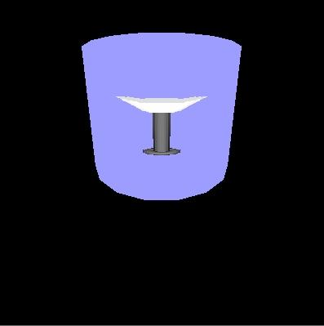

w := open("win1","gl","bg=light blue","size=256,256")
Fg(w, "emission pale grey")
PushMatrix(w)
Rotate(w, -5.0, 1.0, 0.0, 0.0)
DrawCylinder(w, 0.0, 0.575, -2.0, 0.15, 0.05, 0.17)
PopMatrix(w)
Fg(w, "diffuse grey; emission black")
PushMatrix(w)
Rotate(w, -5.0, 1.0, 0.0, 0.0)
DrawCylinder(w, 0.0, 0.0, -2.5, 0.7, 0.035, 0.035)
PopMatrix(w)
DrawTorus(w, 0.0, -0.22, -2.5, 0.03, 0.06)
DrawTorus(w, 0.0, 0.6, -2.5, 0.05, 0.03)

w2 := open("win2.icn","gl","bg=black","size=400,400")
WAttrib(w2, "texmode=on")
Texture(w2, w)
Fg(w2, "diffuse purple; ambient blue")
DrawCylinder(w2, 0.0, 0.0, -3.5, 1.2, 0.7, 0.7)

The next two examples illustrate the use of the default texture coordinates versus texture coordinates specified by the programmer. In both examples, a bi-level image is used as the texture image. The format for such a string is described in section 2.7. This image is taken from Graphics Programming in Icon [Griswold98] page 159. The first example uses the default texture coordinates for a filled polygon, which in this case is just a square with sides of length one. In this case the default texture coordinates are as follows. The coordinate (0.0, 0.0) of the texture image is mapped to the vertex (0.0, 0.0, -2.0) of the square, (0.0, 1.0) is mapped to (0.0, 1.0, -2.0), (1.0, 1.0) is mapped to (1.0, 1.0, -2.0), and (1.0, 0.0) is mapped to (1.0, 0.0, -2.0).

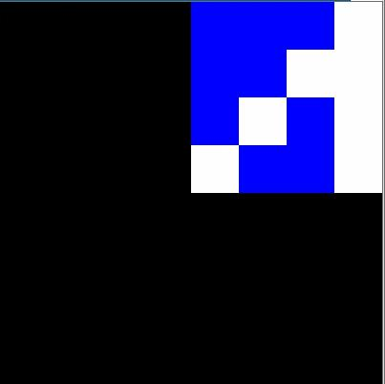

WAttrib(w, "fg=white", "bg=blue", "texmode=on", "texture=4,#8CA9")
Fg(w, "diffuse purple; ambient blue")
FillPolygon(w, 0.0, 0.0, -2.0, 0.0, 1.0, -2.0, 1.0, 1.0, -2.0, 1.0, 0.0, -2.0)

This example uses the same texture image and the same object to be textured, but instead uses the texture coordinates (0.0, 1.0), (1.0, 1.0), (1.0, 1.0), and (1.0, 0.0). So the coordinate (0.0, 1.0) of the texture image is mapped to the vertex (0.0, 0.0, -2.0) of the square, (1.0, 1.0) is mapped to (0.0, 1.0, -2.0),(1.0, 1.0) is mapped to (1.0, 1.0, -2.0), and (1.0, 0.0) is mapped to (1.0, 0.0, -2.0).

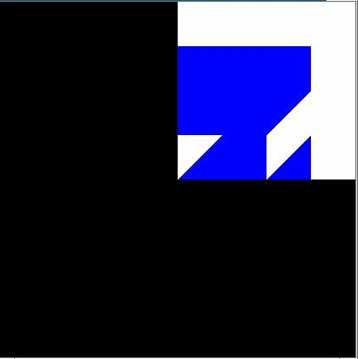

WAttrib(w, "fg=white", "bg=blue", "texmode=on",
"texcoord=0.0, 1.0, 1.0, 1.0, 1.0, 1.0, 1.0, 0.0", "texture=4,#8CA9")
FillPolygon(w, 0.0, 0.0, -2.0, 0.0, 1.0, -2.0, 1.0, 1.0, -2.0, 1.0, 0.0, -2.0)

Also instead of using WAttrib() with the attribute texcoord, the function Texcoord() could be used. So the line

WAttrib(w,"texcoord=0.0, 1.0, 1.0, 1.0, 1.0, 1.0,1.0, 0.0")

could be replaced by

Texcoord(w, 0.0, 1.0, 1.0, 1.0, 1.0, 1.0,1.0, 0.0)
3.6 A Larger Textures Example

The following is a more complicated example that uses many features of the Unicon 3D graphics facilities described in the previous sections. This example also illustrates the effect that adding texture to a scene can have. The scene on the left is a scene drawn without any texturing. The scene on the right contains texturing. The scene on the right is a much more realistic scene than the one on the left.
All textures used in the textured scene, except for the unicorn, where captured using a digital camera. These images were then converted into .gif files and scaled to width and height of 2^{n}. Directly using an image file is one feature of the Unicon 3D graphics facilities that makes adding textures simpler than using OpenGL.

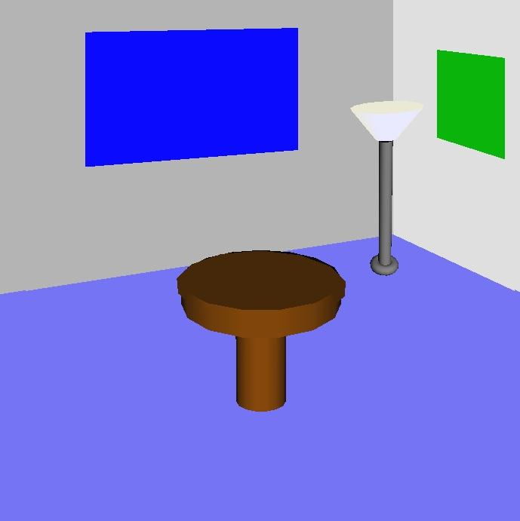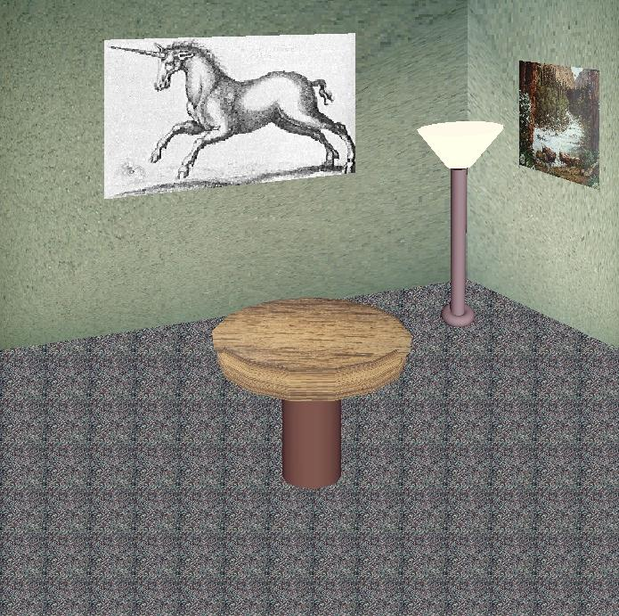
A untextured scene A textured scene

procedure main()
&window :=open("textured.icn","gl","bg=black","size=700,700")

# Draw the floor of the room
WAttrib("texmode=on", "texture=carpet.gif")
FillPolygon(-7.0, -0.9, -14.0, -7.0, -7.0, -14.0,
7.0, -7.0, -14.0, 7.0, -0.9, -14.0, 3.5, 0.8, -14.0)

# Draw the right wall
WAttrib("texture=wall1.gif", "texcoord=0.0, 1.0, 0.0, 0.0, 1.0, 0.0, 1.0, 1.0")
FillPolygon(2.0, 4.0, -8.0, 8.3, 8.0, -16.0, 8.3, -1.2, -16.0, 2.0, 0.4, -8.0)

# Draw the left wall
WAttrib("texture=wall2.gif")
FillPolygon(2.0, 4.0 ,-8.0, -9.0, 8.0, -16.0, -9.0,-1.2,-16.0, 2.0, 0.4, -8.0)

# Draw a picture
WAttrib("texture=poster.gif", "texcoord=0.0, 1.0, 0.0, 0.0, 1.0, 0.0, 1.0, 1.0")
FillPolygon(1.0, 1.2, -3.0, 1.0, 0.7, -3.0, 1.2, 0.5, -2.6, 1.2, 1.0, -2.6)

# Draw another picture
WAttrib("texture=unicorn.gif", "texcoord=1.0, 0.0, 0.0, 0.0, 0.0, 1.0, 1.0, 1.0")
FillPolygon(0.8, 2.0, -9.0, -3.0, 1.6, -9.0, 3.0, 3.9,-9.0, 0.8, 4.0, -9.0)

# Draw the lamp
WAttrib("texmode=off")
PushMatrix()
Translate(0.7, 0.20, -0.5)
Fg("emission pale weak yellow")
PushMatrix()
Rotate(-5.0, 1.0, 0.0, 0.0)
Rotate( 5.0, 0.0, 0.0, 1.0)
DrawCylinder(-0.05, 0.570, -2.0, 0.15, 0.05, 0.17)
PopMatrix()
Fg("diffuse grey; emission black")
PushMatrix()
Rotate(-5.0, 1.0, 0.0, 0.0)
Rotate( 6.0, 0.0, 0.0, 1.0)
DrawCylinder(0.0, 0.0, -2.5, 0.7, 0.035, 0.035)
PopMatrix()
PushMatrix()
Rotate(6.0, 0.0, 0.0, 1.0)
DrawTorus(-0.02, -0.22, -2.5, 0.03, 0.05)
PopMatrix()
PopMatrix()

# Draw the table
WAttrib("texcoord=auto", "texmode=on", "texture=table.gif")

PushMatrix()
Rotate(-10.0, 1.0, 0.0,0.0)
DrawCylinder(0.0, 0.2, -2.0, 0.1, 0.3, 0.3)
PopMatrix()

PushMatrix()
Translate(0.0, -0.09, -1.8)
Rotate(65.0, 1.0, 0.0, 0.0)
DrawDisk(0.0, 0.0, 0.0, 0.0, 0.29)
PopMatrix()

WAttrib("texmode=off", "fg=diffuse weak brown")
PushMatrix()
Rotate(-20.0, 1.0, 0.0,0.0)
DrawCylinder(0.0, 0.2, -2.2, 0.3, 0.1, 0.1)
PopMatrix()
while (e := Event()) ~== "q" do {
write(image(e), ": ", &x, ",", &y)
}
end

In order to apply textures to the scene, texturing must first be turned on. Next, the texture to be applied is specified. Then the floor of the scene is drawn, which is done by using a filled polygon. The default texture coordinates are used to apply the carpet texture to the floor of the room. The tiled appearance on the floor of the room is caused by the use of the default texture coordinates. This can be avoided by using user defined texture coordinates. This is what is done for the textures that are applied to the two walls of the room and the pictures.
The lamp does not have any texturing applied to it, so it is necessary to turn off texturing before drawing the lamp. Also for the lamp to be centered properly in the room, transformations are used. Notice the use of matrices to isolate the transformations of the lamp. Finally to draw the table with a textured top and an untextured base, two cylinders and a disk are used. Texturing is applied to a cylinder and the disk. Notice the call
WAttrib(w, "texcoord=auto")
This resets the texture coordinates to the defaults. Finally, texturing is turned off to draw the base of the table.

3.7 Animation

Graphics animation is performance sensitive, and Unicon is substantially slower than lower level systems programming languages such as C and C++. Nevertheless, it is possible to prototype simple 3D animations using Unicon; applications with few moving objects can achieve smooth animation with acceptable frame rates.
In OpenGL, animations are normally written to redraw the entire scene each time any object has moved, or the user has changed point of view. An application can repeatedly call EraseArea() followed by the appropriate graphics primitives to achieve this effect, but the results often appear to flicker. It is better to let OpenGL's built-in double buffering, and Unicon's runtime system, do the redrawing. Unicon maintains a display list of graphics operations to execute whenever the screen must be redrawn; these operations are effectively everything since the last EraseArea(). The display list for a window can be obtained by calling WindowContents(). The elements of the list are Unicon records and lists containing the string names and parameters of graphics primitives. For example, a call to DrawSphere(w,x,y,z,r) returns (and adds to the display list) a record gl_sphere(“DrawSphere”, x, y, z, r). Instead of redrawing the entire scene in order to move an object, you can modify its display list record and call Refresh(). The following code fragment illustrates animation by causing a ball to slide up and down. In order to “bounce” the program would need to incorporate physics.

sphere := DrawSphere(w, x, y, z, r)
increment := 0.2
every i := 1 to 100 do {
every j := 1 to 100 do {
sphere.y +:= increment
Refresh(w)
}
}
This technique gives animation rates of 100-200 frames per second in simple tests on current midrange PC hardware, indicating that the system will support smooth animation, at least for small numbers of objects.

3.8 Object Selection

Many 3D applications allow the user to interact with, select, or identify 3D objects in a scene by clicking on objects with the mouse. In Unicon, a window attribute (pick) enables or disables 3D selection. When pick=on, keyword &pick can be used to access the 3D selection results. The function (WSection()) is used to name objects in the scene. The steps required to use 3D selection in Unicon are summarized by the following:

- Enable the selection
- Give selectable 3D objects unique string names
- Collect selection results through the keyword &pick

Although this section uses the word “selection” freely to refer to 3D object selection, the Unicon language consistently uses “pick” instead of “select” for 3D objects. The reason for this is that “selection” is used in other ways in computing systems and user interfaces. In Unicon and in certain window systems, it refers to the mechanism used when data is copied and pasted between applications.

3.8.1 Controlling the selection state
Attribute “pick” turns on or off selection within portions of a rendered scene. To turn on 3D selection at any point in the program, the following statement should be inserted at that point:

WAttrib("pick=on")

To turn off the 3D selection, simply make another call to WAttrib():

WAttrib("pick=off")

To check the current 3D selection state (on or off), the function WAttrib can be called with the string parameter "pick" (i.e WAttrib(“pick”) ) and it will return a string value of "on" or "off" depending on the current 3D selection state. By default 3D selection is turned off. The program can turn on and off the 3D selection depending on the program requirements. For a better performance, selection should be turned off for all non-selectable objects in the scene.

3.8.2 Naming 3D objects
3D Objects are defined by their corresponding rendered primitives. The function WSection() marks the beginning and the ending of a section that holds a 3D object. A call to WSection() with a parameter string marks the beginning of a 3D object with the string as its name. Another call to WSection with no string parameter marks the end of the 3D objects. All of the rendered graphics between a beginning WSection() and its corresponding ending WSection are parts of the same object. To make it selectable, a 3D object must have at least one graphical primitive. A line or a sphere are examples of such primitives. The string name should be unique to distinguish different objects from each other. Different objects could have the same name if the same action would be taken no matter which of these objects is picked. The following code fragment is an example of named 3D objects. It simply draws a red rectangle and gives it the name "redrect".

WSection("redrect") # beginning of a new object named redrect
Fg("red")
FillPolygon(0,0,0, 0,1,0, 1,1,0, 1,0,0)
WSection() # end of the object redrect

In the example above WSection("redrect") marks the beginning of a new object with the name redrect. Fg("red") doesn’t affect selection because it doesn’t produce a rendered object. FillPolygon(0,0,0, 0,1,0, 1,1,0, 1,0,0) on the other hand does affect selection because it produces a rendered object, and it actually represents the object named redrect. WSection() marks the end of the object named redrect.

3.8.3 Retrieving picked objects

The keyword &pick generates the names of objects that were clicked on at the last returned event, if they were associated with a name using WSection(name). A given mouse click might correspond to multiple objects that are rendered along the ray from the camera through the point clicked. In addition, WSection() calls may be nested, in which case the name reported by &pick will be a concatenation (separated by hyphens) of the WSection() names enclosing the object clicked. The following code fragment writes all of the objects names that were picked by the mouse click:

every picked_object := &pick do
write(" picked object :", picked_object)

If there were no selectable objects under the cursor at the time of the event, &pick just fails and produces no results. &pick gets its results from both left-clicks and right-clicks.

These ideas are illustrated in the following example, which draws a crude humanoid figure. The rendering function turns “pick=on” and then uses WSection() calls to identify different parts of the figure.
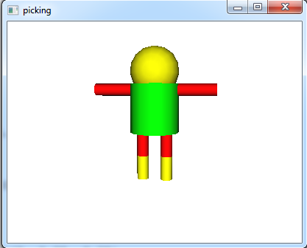

procedure drawman()
h := 2.0
WAttrib("pick=on")
WSection("man")
WSection("body")
Fg("green")
DrawCylinder(0, 0, 0, h, 1.0, 1.0)
WSection()
WSection("head")
Fg("yellow")
DrawSphere(0.0,h+0.5,0.0, 1.0)
WSection()
WSection("rightleg")
WSection("upperrightleg")
Fg("red")
DrawCylinder(-0.5, -h/2, 0, h/2, 0.25, 0.25)
WSection()
WSection("lowerrightleg")
Fg("yellow")
DrawCylinder(-0.5, -h, 0, h/2, 0.25, 0.25)
WSection()
WSection()
WSection("leftleg")
WSection("upperleftleg")
Fg("red")
DrawCylinder(0.5, -h/2, 0, h/2, 0.25, 0.25)
WSection()
WSection("lowerleftleg")
Fg("yellow")
DrawCylinder(0.5, -h, 0, h/2, 0.25, 0.25)
WSection()
WSection()
PushMatrix()
Translate(0.5, h-0.25, 0.0)
Rotate(-90, 0, 0, 1)
WSection("leftarm")
Fg("red")
DrawCylinder(0, 0, 0, h, 0.25, 0.25)
WSection()
PopMatrix()
PushMatrix()
Translate(-0.5, h-0.25, 0.0)
Rotate(90, 0, 0, 1)
WSection("rightarm")
Fg("red")
DrawCylinder(0, 0, 0, h, 0.25, 0.25)
WSection()
PopMatrix()
WSection()
end

The event-handling code for &lpress looks in &pick to see what (if anything) the user was selecting.

procedure main()
&window := w := open("picking" , "gl", "size=400,300") |
stop(" failed to open 3d window! ")
drawman()
Eye(-2,1.8,-12, 0,0,0, 0,1,0 )
Refresh(w)
repeat {
case e := Event(w) of{
"q"|"\e" : { return }
&lpress : {
write(" mouse click" )
every item := &pick do{
write( "on part:", item)
}
}
}
}
end

3.8.4 Higher level Interface for 3D Object Selection

Using 3D selection directly through WSection() function and &pick keyword is easy. The programmer should give unique names for objects using WSection(), and then collect selected objects names by scanning string names generated using &pick, and then take the appropriate action based on the selected object. For small programs with very few selectable objects this is a trivial task and maybe the easy and clean way to do it, But once the program and the number of the selectable objects gets larger, managing the selectable objects and the actions to be taken based on object selection especially if the objects are hierarchical could be challenging and cumbersome. When using selection, from a high level and abstracted view the programmer defines a selectable object and assigns an action to it to be taken when this object is selected. It can be thought of as GUI objects, when you create a button for example, you do not worry about the button name (except to make it readable and meaningful), and you do not worry about how or when this button was clicked. All of what you want is to take an action if this button is clicked. This section discusses the introduction of a new class to the Unicon language for this purpose. Managing 3D selection and adding a high level abstracted layer for using 3D selection.

For better code organization a new class was introduced with the name Selection3D. The class holds information about what objects are selectable, what events should these objects respond to and what is the action to be taken when an object is selected (received an event that it should respond to). Any selectable object can respond to one or more mouse events. A separate table for each one of these mouse events (except for CLICK and DRAG, they simply reuses other events tables) keeps all of the objects that can respond to that particular event. For example there is a table of all objects that can respond to a LEFT_CLICK event if any of these objects were selected. This table is called Tleft_click. The mouse events that are recognized by this class and to what table each of these events maps to are listed in Figure 2.

CLICK ➔ Tleft_click and Tright_click
LEFT_CLICK ➔ Tleft_click
RIGHT_CLICK ➔ Tright_click
DOUBLE_CLICK ➔ Tdouble_click
DRAG ➔ Tleft_drag and Tright_drag
LEFT_DRAG ➔ Tleft_drag
RIGHT_DRAG ➔ Tright_drag

Figure 2. Events that are recognized by the selection3D class and the mapping between these events and their corresponding objects tables

The Selection3D class uses another helper class to store information about each selectable object, its name (given by the user), the action associated with it, the class objects that holds the action if the action is a method, and the event type (specified by the user). Figure 3 shows the two classes and their relationship

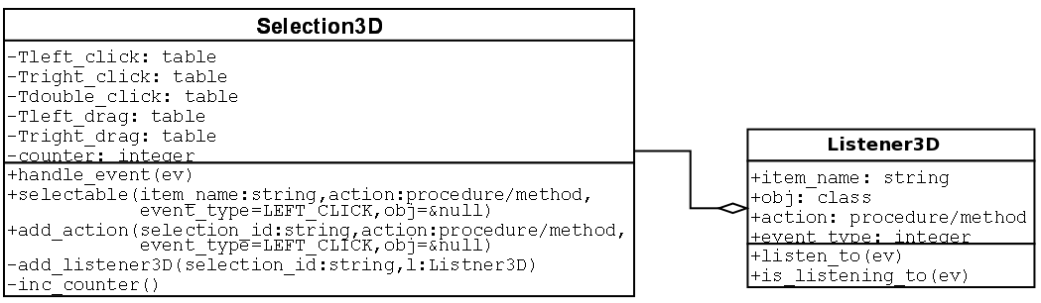
Figure 3. UML diagram for the classes used to manage/control 3D object selection

To make Selection3D class available to a program, the following statement should be added at beginning of the source code.

link Selection3D

An instance of this class can be created simply by an assignment statement. The following example line creates this instance and store it in a variable called select3D:

select3D := Selection3D()

The Selection3D class has three methods that can be called to manage the 3D selection in the program. The first method is selectable(), which is used to register new 3D objects to make them selectable. This method takes up to four parameters in the following order

- A string name of the 3D object. The name does not affect the selection behavior in any way.
- A procedure/method name to be called when this 3D object is selected
- An optional event type which could be any of the event types shown in Figure 2. The default event type is LEFT_CLICK
- The class object that has the method name (second parameter). This is only valid (and mandatory) if the second parameter is a method which is part of a class object.

The method selectable() returns a string value which is referred to as selection_id. selection_id is a unique value that can then be passed to WSection() to mark a new 3D object name. The following is an example of such use

select_id := select3D.selectable("red ball", on_red_ball)
WSection(select_id)

In this example a 3D object named “red ball” was registered to be selectable. The procedure on_red_ball will be called if this 3D object is selected. No event type was passed in the call so this 3D object will respond to mouse left click. on_red_ball must be a procedure name (not a method) so nothing should be passed as a fourth parameter also. The example also shows how is the returned value select_id was passed to WSection().

The second method in Selection3D class is add_action(). This method takes four parameters exactly like selectable() except for the first parameter. Instead of taking a random string name, it takes a string name that was returned and registered by selectable() to add another action or response to another kind of event. In the example above the following line of code can be added right after the first line to make the red ball respond to mouse right click by calling the procedure on_right_click():

select3D.add_action(select_id, on_right_click, select3D.RIGHT_CLICK)
The third and the last method in the Selection3D class is handle_event(). Normally this method should be part of the event handling loop in the program. At least all types of mouse events in Unicon should be passed to this method. This lets the Selection3D class to collect events information and picked objects through &pick and take the appropriate action. Failure to pass any kind of mouse events to the Selection3D class might cause it not to produce the interned behavior. i.e. 3D object selection would not work as you expect. A correct way to use the method handle_event() is shown toward the end of the following complete example

link selection3D
global select3D
procedure on_red_ball()
write(" You picked the red ball!")
end
procedure on_blue_ball()
write("You picked the blue ball")
end
procedure main()
&window := open("3D selection in Unicon", "gl","size=500,500") |
stop("can't open 3D window")
select3D := Selection3D()
# begin a new selectable section/object with the name "red ball"
WAttrib("pick=on") #turn on 3D selection
select_id := select3D.selectable("red ball", on_red_ball)
WSection(select_id)
Fg("red")
DrawSphere(1, 0.5, 0, 0.5)
WSection() # end of the red ball
# Draw a nonselectable green ball
Wattrib("pick=off") #turn off 3D selection
Fg("green")
DrawSphere(-1, 0.5, 0, 0.5)
# begin a new selectable section/object with the name "blue ball"
WAttrib("pick=on") #turn on 3D selection
select_id := select3D.selectable("blue ball", on_blue_ball)
WSection(select_id)
Fg("blue")
DrawSphere(0, -0.5, 0, 0.5)
WSection() # end of the blue ball
#setup the eye just to make sure where are looking exactly at the spheres
Eye(0,0,4, 0,0,0, 0,1,0)
Refresh()
repeat{ # enter an event loop to handle user events
if (ev := \Event()) then{
select3D.handle_event(ev)
if ev ===("\e"|"q") then exit(0)
}
}
end

4. Open Issues and Conclusions

The Unicon 3D graphics facilities provide many of the features of 3D graphics programming. Several areas in which improvements and extensions can be made have been discussed where appropriate in previous sections. Besides those topics already mentioned throughout the paper, there are several areas where work could still be done. These areas include animation, composition, and simplification of the design of the matrix stack.
The Unicon 3D graphics facilities do not contain special features to simplify the process of animation. Future work may include the examination of different ways to directly support animation in Unicon.
Composition is viewing several different pieces as one piece. For example, say the user wants to implement a moving car. To do this, the user would need to break the car into several pieces, possibly, four tires, a car body, windows, and lights. To make the process of simulating the moving car easier, one would like these individual pieces to be one piece. Currently, a Unicon programmer can develop such applications using the 3D graphics facilities. The question remains whether composition should be added as a feature of the Unicon 3D graphics facilities.
The design of matrices and transformation in the Unicon 3D graphics facilities is similar to the design of OpenGL. For this reason, there is no advantage gained over OpenGL in the area of transformations. It might be necessary in the future to consider ways to simplify matrices and transformation in Unicon. One improvement to consider is a reduction in the number of parameters needed for function like Translate(), Rotate() and Scale(). The elimination of the need for two different matrix stacks might be another simplification.
The current Unicon 3D graphics facilities have made an improvement over OpenGL in terms of the number of lines of coded needed to implement a 3D graphics application. Programmers that want to develop 3D graphics applications but do not have the time to learn one of the standard toolkits might find this project valuable. Although the Unicon 3D graphics facilities provide the important feature of 3D graphics, there are some limitations. One limitation might be the lack of some feature in Unicon that are available in OpenGL. Another limitation might be the use of default parameters that are used in some feature of the Unicon 3D graphics facilities. These defaults reduce the flexibility of the programmer and will be seen as a restriction by some. Future work on the Unicon 3D graphics facilities might include the addition of attributes or other mechanisms to remove those of these limits which prove to be problems. The current Unicon 3D graphics facilities provide a basis in which 3D graphics can be implemented in Unicon.

5. Functions and Attributes

The built-in functions attributes in the Unicon 3D graphics facilities are described in this section. For all functions with a window argument W, the parameter can be omitted. Also the use of “…” indicates that more arguments can be given. By doing this, the result is similar to that of multiple function calls. The window argument should not be specified again for this case.

5.1 New Functions

The functions in this section have been added specifically for the Unicon 3D graphics facilities.

DrawCube(file, real, real, real, real,…): record draws a cube

DrawCube(W, x, y, z, l…) draws a cube with sides of length l at the position (x, y, z) on the window W. The display list element is returned. This procedure fails if the context attribute, dim, is set to 2.

DrawCylinder(file, real, real, real, real, real, real,…): record draws a cylinder

DrawCylinder(W, x, y, z, h, r1, r2, …) draws a cylinder with a top of radius r1, a bottom with radius r2, and a height h. The disk is centered at the point (x, y, z). The display list element is returned. This procedure fails if the context attribute dim is set to 2.

DrawDisk(file, real, real, real, real, real, real, real,…): record draws a partial disk

DrawDisk(W, x, y, z, r1, r2, a1, a2, …) draws a disk on the window W centered at (x, y, z). The inner circle has radius r1 and the outer circle has radius r2. The parameters a1 and a2 are optional. If they are specified, a partial disk is drawn with a starting angle a1 and sweeping angle a2. The display list element is returned.

DrawSphere(file, real, real, real, real,…): record draws a sphere

DrawSphere(W, x, y, z, r,…) draws a sphere with radius r centered at (x, y, z) on the window W. The display list element is returned. This procedure fails if the context attribute dim is set to 2.

DrawTorus(file, real, real, real, real, real,…): record draws a torus

DrawTorus(W, x, y, z, r1, r2,…) draws a torus with inner radius r1, outsider radius r2, and centered at (x, y, z) on the window W. The display list element is returned. This procedure fails if the context attribute dim is set to 2.

Eye(file, real, real, real, real, real,…): record place camera

Eye(W, x, y, z, x2, y2, z2, x3,y3,z3) places the camera at position (x1,y1,z1) looking at the point (x2,y2,z2). The direction (x3,y3,z3) will be “up” in the rendered scene.

IdentityMatrix(file): record loads the identity matrix

IdentityMatrix(W) changes the current matrix to the identity matrix. The display list element is returned.

MatrixMode(file, string): record changes the matrix mode

MatrixMode(W, s) changes the matrix mode to s. The string s must be either “projection” or “modelview”. Otherwise this procedure fails. The display list element is returned.

MulMatrix(file, x): list multiply transformation matrix

MulMatrix(W, L) multiply transformation matrix by the list L where *L is 16.
MulMatrix(W, x₁, …, x₁₆) multiply transformation matrix by the numbers x₁ ... x_{16.}
In both cases above, the values represent a matrix of size 4x4 stored in column format The values should be Exactly 16 otherwise the function will fail.

Normals(file, x): list set normals

Normals(W, L) sets the normals to use for subsequent rendered objects to those given in list L.
Normals(W, x₁, y₁,z₁, ..., x_{n}, y_{n}, z_{n}) sets the normals to use for subsequent rendered objects to x, y and z values. Each x, y, z triple forms one normal coordinate that corresponds to one vertex.
In all cases the display list element is returned.

PopMatrix(file): record pops a matrix from the matrix stack

PopMatrix(W) pops the top matrix from the matrix stack. The matrix stack is determined by the current matrix mode, either “projection” or “modelview”. This procedure fails if there is only one matrix on the matrix stack. The display list element is returned.

PushMatrix(file): record pushes a matrix onto the matrix stack

PushMatrix(W) pushes a copy of the current matrix onto the matrix stack. The current matrix mode determines what stack the new matrix is pushed upon. This procedure fails if the matrix mode is “projection” and there are already two matrices on the stack. If the matrix mode is “modelview” and there are already thirty two matrices on the stack, then this procedure will fail. The display list element is returned.

Refresh(file):file redraws the window

Refresh(W) redraws the contents of the window. The window W is returned.

Rotate(file, real, real, real, real,…): record rotates objects

Rotate(W, a, x, y, z,…) rotates objects affected by this transformation by the angle a, in around the axis represented by the vector formed of the (x, y, z) values. The display list element is returned.

Scale(file, real, real, real,…): record scales objects

Scale(W, x, y, z,…) scales object according to the given x, y and z coordinates. The display list element is returned.

Texcoord(file, X):list defines texture coordinates

Texcoord(W, x₁, y₁, …, x_{n}, y_{n}) sets the texture coordinates to x₁, y₁, …, x_{n}, y_{n.} Each x, y, pair forms one texture coordinate. Every x must match to a y otherwise the assignment of texture coordinates will fail.
Texcoord(W, L) sets the texture coordinates to those specified in the list L.
Texcoord(W, s) sets the texture coordinates to those specified by s. The string s must be “auto” otherwise the procedure will fail. In all cases the display list element is returned.

Texture(file, X): record applies a texture

Texture(W, s) creates a texture image that is applied to subsequent objects on the window W. The string s specifies the texture image as a filename, a string of the form width,pallet,data or width,#,data, where pallet is a pallet from the Unicon 2D graphics facilities and data is the hexadecimal representation of an image. The display list element is returned.
Texture(W1, W2) creates a texture image that is applied to subsequent objects on the window W1. The file W2 is another Unicon window. The contents of W2 are used to create the texture image. The display list element on W1 is returned.
Texture(W1, R) creates a texture image that is applied to subsequent objects on the window W1. The Record R is another texture record that will be used to create the new texture reusing R texture data. This is useful to reapply the same texture on different places in the program.

Translate(file, real, real, real,…): record translates objects

Translate(W, x, y, z,…) moves objects affected by this transformation in the direction (x, y, z). The display list element is returned.

WindowContents(file):list produce contents of window

WindowContents(W) returns a Unicon list of display elements, which are records or lists. Each element has a function name followed by the parameters of the function, or an attribute followed by its value. The display list is further described in section 3.6.

5.2 Extensions from the 2D Graphics Facilities

Several functions from the Unicon 2D graphics facilities have been modified for use in the 3D facilities. This section describes the parameters and use of these functions.

DrawLine(file, real, real, real, …): list draw a line

DrawLine(W, x1, y1, z1, …,xn, yn, zn) draws a line connecting the n vertices specified by (x, y, z). If only one set of vertices is given, then no line is drawn. If the attribute dim is set to 2, then DrawLine(W, x1, y1,…,xn, yn) draws a line connecting the n vertices of the form (x, y). If the attribute dim is set to 4, then
DrawLine(W, x1, y1,z1, w1…,xn, yn,zn, wn) draws a line connecting the n vertices of the form (x, y, z, w). The display list element is returned.

DrawLine(W, L) draws lines whose coordinates are passed as a list of real values.

DrawPoint(file, real, real, real, …): list draw points

DrawPoint(W, x1, y1, z1, …) for each set of vertices (x, y, z) a point is drawn. If the attribute dim is set to 2, then DrawPoint(W, x1, y1,…) draws points of the form (x, y). If the attribute dim is set to 4, then DrawPoint(W, x1,y1,z1,w1…) draws points of the form (x, y, z, w). The display list element is returned.

DrawPoint(W, L) draws points whose coordinates are passed as a list of real values.

DrawPolygon(file, real, real, real, …): list draw a polygon

DrawPolygon(W, x1, y1, z1, …, xn, yn, zn) draws an outline of a polygon formed by connecting the n vertices of the form (x, y, z). If the value of the context attribute dim is 2 then DrawPolygon(W, x1, y1, …, xn, yn) draws an outline of a polygon using the n vertices of the form (x, y). If dim is set to 4, then DrawPolygon(W, x1, y1, z1, w1 …, xn, yn, zn, wn) draws an outline of a polygon formed by connecting the n vertices of the form (x, y, z, w). The display list element is returned.
DrawPolygon(W, L) draws polygons/shapes whose coordinates are passed as a list of real values.

This function can be used to draw shapes other than polygons, this feature can be controlled by the attribute meshmode which is discussed in the New Attributes section.

DrawSegment(file, real, real, real, …): list draws segments

DrawSegment(W, x1, y1, z1, x2, y2, z2,…) draws a line segment between a pair of vertices of the form (x, y, z). If the context attribute dim has value 2 then DrawSegment(W, x1, y1, x2, y2,…) draws a line segment between a pair of vertices of the form (x, y). If the context attribute dim has value 4 then DrawSegment(W, x1, y1, z1, w1, x2, y2, z2, w2,…) draws a line segment between a pair of vertices of the form (x, y, z, w). If an odd number of vertices if given, then the last vertex is ignored. The display list element is returned.

DrawSegment(W, L) draws line segments whose coordinates are passed as a list of real values.

EraseArea():file clears the contents of the window

EraseArea(W) clears the contents of the window. Although the 2D facilities allow for specifying a specific area, EraseArea() erases the entire contents of a 3D window.

Fg(file, string):string writes/reads the current foreground color

Fg(W, s) changes the material properties of subsequently drawn objects to the material properties specified by s. The string s must be one or more semi-colon separated material properties. A material property is of the form
[
]
diffuse
ambient color name or “shininess n”, where n is between 0 and 128.
specular
emission

If string s is omitted, the current values of the material properties will be returned.

FillPolygon(file, real, real, real, …): list draws a filled polygon

FillPolygon(W, x1, y1, z1, …, xn, yn, zn) draws a filled polygon formed from the n vertices of the form (x, y, z) and the current foreground color. If the context attribute dim is set to 2, then FillPolygon(W, x1, y1, …, xn, yn) draws a filled polygon formed from the n vertices of the form (x, y) and the current foreground color. If dim is set to 4, then FillPolygon(W, x1, y1, z1, w1 …, xn, yn, zn, wn) draws a filled polygon formed from the n vertices of the form (x, y, z, w) and the current foreground color. The display list element is returned.
FillPolygon(W, L) draws filled polygons/shapes whose coordinates are passed as a list of real values.

This function can be used to draw shapes other than polygons, this feature can be controlled by the attribute meshmode which is discussed in the New Attributes section.

5.3 New Attributes

This section describes the new context attributes that have been added specifically for the 3D graphics facilities.

dim dimensionality of graphic objects

The functions DrawLine(), DrawPolygon(), DrawSegment(), DrawPoint(), and FillPolygon(), use the value of dim to determine how many coordinates each vertex has. If “dim = 2” then DrawTorus(), DrawSphere(), DrawCube(), and DrawCylinder() cannot be used.

Values: “2”, “3”, or “4”
Default value: “3”

eye point of view

This attribute assigns the eyepos, eyedir, and eyeup attributes. See also the Eye() function.

Default value: “(0.0, 0.0, 0.0, 0.0, 0.0, 0.0, 0.0, 1.0, 0.0)”

eyedir eye direction

The eye direction is the direction in which the eye is looking.

Default value: “(0.0, 0.0, 0.0)”

eyepos eye position

The eye position is the where the eye is currently located.

Default value: “(0.0, 0.0, 0.0)”

eyeup up direction

The eyeup attribute specifies what direction is up in the scene.

Default value: “(0.0, 1.0, 0.0)”

glrenderer 3D renderer

Read only attribute that gives the specific hardware configuration (video card name) that is used to render 3D graphics.

glvendor 3D vendor

Read only attribute that gives the vendor of the 3D graphics library implementation.

glversion 3D version

Read only attribute that gives the 3D graphics library version number.

light0 ... light7 light source properties

There are eight lights in the Unicon 3D graphics facilities. Each light can be assigned values to each of its properties on/off, diffuse, ambient, specular, and position. The values of diffuse, ambient, specular are a color specification. The position is given by a (x, y, z) coordinate. The default values are as follows for the lights.

Light | On/Off | Diffuse | Ambient | Specular | Position
light0 | On | white | black | white | (0.0, 0.0, 1.0)
light1- light7 | Off | black | black | black | (0.0,0.0,1.0)

texcoord texture coordinates

The attribute texcoord can be assigned the value “auto”, or a string of texture coordinates. If texcoord has the value “auto”, texture coordinates are determined by the Unicon 3D graphics facilities. Otherwise texture coordinates, which are pairs (x, y) with x and y are between 0.0 and 1.0, are obtained from attribute texture.

Default: “auto”.

meshmode mesh mode type

The meshmode attribute changes how the coordinates passed to DrawPolygon() and FillPolygon() will be interpreted. This attribute can take the following values: “points”, “lines”, “linestrip”, “lineloop”, “triangles”, “trianglefan”, “trianglestrip”, “quads”, “quadstrip” and “polygon”.

Default: “polygon”.

normode enable/disable normals

If normode has the value “auto”, then normals are automatically generated for each drawn polygon so that the normal is perpendicular on the polygon and pointing away from it. If normode has the value of “on” then the user can supply custom normals using the Normals() function. Otherwise normode has the value “off”, which indicates objects are drawn using a default preset normal. By default normode has the value “auto”.

rings sets the number of rings

rings should be an integer value greater than 0. It controls the level of details for drawing spheres, cylinders and toruses by setting the number of rings used to draw those objects. By default slices has the value 15.

slices sets the number of slices

slices should be an integer value greater than 0. It controls the level of details for drawing spheres, cylinders, toruses and disks by setting the number of slices used to draw those objects. By default slices has the value 15.

texmode enable/disable texturing

If texmode has the value “on”, then textures are mapped onto drawn objects. Otherwise texmode has the value “off”, which indicates objects are drawn using the background color. By default texmode has the value “off”.

texture texture image

The attribute texture is assigned a filename or a string of the following format.
width,pallet,data or width,#,data
where pallet is a pallet defined in the Unicon 2D graphics facilities and data is the hexadecimal representation of an image. The value assigned to texture is used to create a texture image which is applied to subsequent objects on the window.

5.4 Extensions from the 2D Graphics Attributes

Several attributes have been extended to be used in the 3D graphics facilities. The new meanings of these attributes are described in this section.

fg foreground color and material properties

The string assigned to fg must be one or more semi-colon material properties. A material property is of the form
[
]
diffuse
ambient color name or “shininess n”, where n is between 0 and 128.
specular
emission

linewidth width of lines

The line width in 3D windows is a real number in world coordinates.

Default value: 1.0

References

[Foley82] Foley, J.D; and A.Van Dam. Fundamentals of Interactive Computer Graphics. Reading, MA: Addison-Wesley Publishing Company, 1982.

[Griswold96] Griswold, Ralph E and Griswold, Madge T. The Icon Programming Language, Third Edition. San Jose, CA: Peer-To-Peer Communications, 1996.

[Griswold98] Griswold, Ralph E.; Jeffery, Clinton L.; and Townsend, Gregg M. Graphics Programming in Icon. San Jose, CA: Peer-To-Peer Communications, 1998.

[Jeffery03] Jeffery, Clinton; Mohamed, Shamim; Pereda, Ray; and Parlett, Robert. Programming with Unicon. Draft manuscript from http://unicon.sourceforge.net

[JeffMart03] Jeffery, Clinton and Martinez, Naomi. The Implementation of Graphics in Unicon Version 11. Unicon Technical Report #5a, http://unicon.sf.net, 2003.

[OpenGL99] OpenGL Architecture Review Board; Woo, Mason; Neider, Jackie; Davis;
Tom; Shreiner, Dave. OpenGL Programming Guide: the Official Guide to
Learning OpenGL, Third Edition. Reading, MA: Addison-Wesley
Publishing Company, 1999.

[OpenGL00] OpenGL Architecture Review Board; Shreiner, Dave.
OpenGL Programming Guide: the Official Reference Document to
OpenGL, Third Edition. Upper Saddle Reading, MA: Addison-Wesley
Publishing Company, 2000.

[Walker94] Walker, Kenneth; The Run-Time Implementation Language for Icon. Technical Report from http://www.cs.arizona.edu/icon/

