Q&A Section

1. Explains the concept of WordPress Hooks and their practical usage. Additionally, how
would you create custom hooks, and how would you remove a registered hook.
Bonus:
What priority/order means in WordPress Hooks ?

WordPress hooks allow users to manipulate WordPress without modifying its core.
Hooks are essentially placeholders in the code where developers can attach their own custom functions.
Hooks are divided into two categories:
Action – allows users to add data or change how their websites work. An action hook will run at a specific time when the WordPress core, plugins, and themes are executing.
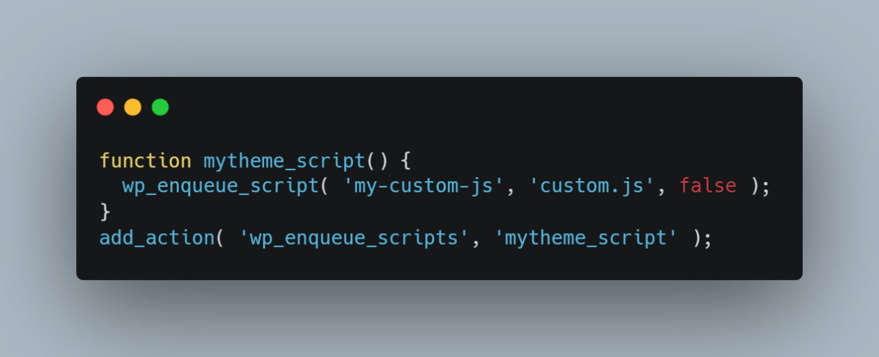
Filter – can change data during WordPress core, plugins, and theme execution.
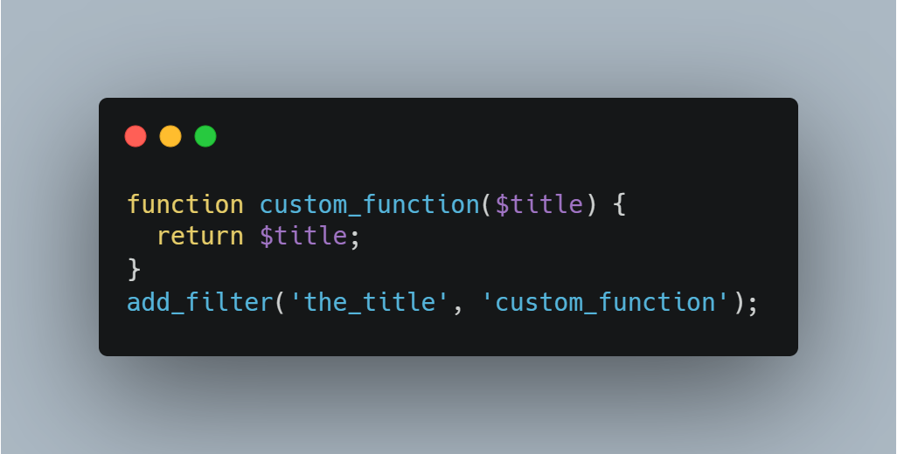

I can create custom hooks with add_action() / do_action() and add_filter() / apply_filters().
Also I can remove hooks with remove_action() and remove_filter().

we can determine the order in which hook callback is run using priority.
Hooks run in numerical order of priority, starting at 1.

- Which tools, functions, or features in WordPress would you employ to enhance the security and safety of your plugins or themes? Please elaborate on the specific scenarios in which you would utilize each of these measures.

- Validation and Sanitization
We can use some functions to prevent SQL injection, XSS
sanitize_text_field(), sanitize_email(), sanitize_url(), wp_kses(), check_admin_referer(), check_ajax_referer()

- Nonces
To prevent CSRF attacks, we can use this function.
wp_create_nonce(), wp_verify_nonce(), check_admin_referer(), check_ajax_referer()

- Capability Checks
We can control access to certain features or functionalities based on user roles and capabilities.
current_user_can(), add_cap(), remove_cap()

- Escaping Output
We use escaping output to prevent XSS attacks.
esc_html(), esc_attr(), esc_js(), esc_url(), esc_html_e(), esc_attr_e(), esc_js_e(), esc_url_e()

- Secure Database Queries
We can prevent SQL injection.
$wpdb->prepare(), wpdb::insert(), wpdb::update(), wpdb::delete()

- SSL and HTTPS
We encrypt data in transit and ensure secure communication.
is_ssl(), force_ssl_admin()

3. Your friendly neighbor said: “Your plugin slowing down my WordPress site!”. No context whatsoever, it could be your backend codes or frontend codes, or maybe not even your codes, but something else in their website! You have access to everything: your codes that you can debug locally in your machine, the site admin credentials, the server credentials, the database server credentials, and you are allowed to do anything you want. Elaborate steps that you would do to identify the issue What tools you would use, and what are the reasons behind using these tools.

Clone the Site Locally:
Set up a local development environment using the same WordPress version.
Clone the site's content and database to your local machine for testing.

Use Query Monitor:
Install the Query Monitor plugin on the local site.
Identify slow database queries, PHP execution times, and external requests.
Check for any errors or warnings.

Debug Bar:
Enable the Debug Bar plugin to get insights into memory usage, queries, and hooks.
Analyze resource consumption during page loads.

Browser Developer Tools:
Use browser developer tools to analyze frontend performance.
Look for slow-loading resources, excessive HTTP requests and JavaScript errors.

Optimize Database Tables:
Use plugins like WP-Optimize to clean and optimize database tables.
Remove unnecessary data, such as revisions and transients.

Review Code Quality:
Inspect your plugin/theme code for performance bottlenecks.
Look for inefficient loops, excessive database queries, or resource-intensive operations.

Use Debugging Tools:
Utilize PHP debugging tools like Xdebug to step through the code.
Identify any infinite loops, excessive function calls, or memory leaks.

Use Tools Like New Relic:
Install performance monitoring tools like New Relic for in-depth analysis.
Identify trends, bottlenecks, and areas of improvement.

Optimize Code:
Apply optimizations based on the identified issues.
Fix inefficient code, optimize queries, and implement best practices.

Performance Plugins:
Install performance optimization plugins such as W3 Total Cache or WP Super Cache.
Configure caching settings for improved page load times.

Update Software:
Ensure that WordPress, themes, and plugins are updated to the latest versions.

- Share your thoughts on the concept of Modern PHP. And in your view, what distinguishes a codebase as reflecting Modern PHP principles, and how would you integrate these principles into the WordPress environment?

- Modern PHP
Object-Oriented Programming (OOP): Emphasizes the use of classes, inheritance, encapsulation, and polymorphism for creating modular, maintainable, and scalable code.
Composer: A crucial dependency manager that facilitates efficient integration of third-party libraries and manages project dependencies.
PSR Standards: PHP-FIG's PSRs establish coding standards, promoting interoperability across different frameworks and libraries.
Testing (PHPUnit): Prioritizing testing practices ensures code reliability, early bug detection, and overall system stability.
Security Best Practices: Highlights security measures, including input validation and protection against common web vulnerabilities, to safeguard applications.

- Distinguishes
Object-Oriented Structure: Embraces modular, organized code through object-oriented programming (OOP) principles, promoting reusability and maintainability.
Composer Integration: Efficiently manages dependencies using Composer, fostering a modular and extensible architecture.
PSR Compliance: Adheres to PHP-FIG's PSR standards, ensuring consistent coding style, autoloading conventions, and interoperability across frameworks.
Testing Practices: Implements robust testing with tools like PHPUnit, including unit, integration, and possibly end-to-end tests for code reliability.
Security Measures: Prioritizes security with best practices, including input validation and protection against common web vulnerabilities.

- Integrate into the WordPress environment
Object-Oriented Programming (OOP):
Custom Classes and Plugins: Organize code into custom classes within plugins or themes, promoting modularity.
Hooks Utilization: Leverage WordPress action and filter hooks to encapsulate functionality, enhancing maintainability.

Composer Integration:
Dependency Management: Use Composer to manage third-party dependencies and streamline autoloading.
Autoloading Efficiency: Implement Composer's autoloading for improved code organization.

PSR Compliance:
Coding Standards: Adhere to PSR coding standards for consistent codebase formatting.
Autoloading Standards: Follow PSR-4 autoloading standards using Composer for streamlined class loading.

Testing Practices:
PHPUnit Implementation: Implement PHPUnit tests for critical components like plugins, ensuring code reliability.
WordPress PHPUnit Test Library: Utilize the WordPress PHPUnit Test Library for testing WordPress-specific functionalities.

Security Measures:
Data Validation: Employ WordPress functions for input sanitization, such as sanitize_text_field().
Escaping Usage: Use appropriate escaping functions like esc_html() and esc_url() to prevent XSS vulnerabilities.
Capability Handling: Follow WordPress best practices for user capability and permission management.

5. jQuery or no jQuery ?. Anyway, provide insights into how you would seamlessly integrate ReactJS into your WordPress plugin, what is the benefits and challenges of using ReactJS in WordPress environment?.

- Integrate React JS into WordPress plugin.
Create React App: Develop your React application using tools like Create React App.
Configure Build Process: Set up the build process to generate static files for inclusion in the WordPress plugin.
Use WordPress Enqueue System: Include React scripts using WordPress's enqueue system, ensuring proper loading and avoiding conflicts.
Utilize WordPress REST API: Fetch and send data between React and WordPress using the REST API. Ensure authentication and authorization.
Test Across Environments: Ensure compatibility with various WordPress themes, plugins, and environments to prevent conflicts.
Verify Backward Compatibility: Confirm compatibility with older WordPress versions or themes that may not fully support React.

-Benefits and Challenges
Benefits
Dynamic UI: React enables the creation of dynamic and interactive user interfaces, improving the overall user experience.
Component-Based Architecture: React's component-based architecture promotes modularity and reusability, facilitating easier maintenance and updates.
Redux or Context API: React allows for efficient state management using tools like Redux or React's Context API, ensuring a consistent data flow.
Sophisticated Front-End Features: React empowers developers to build sophisticated front-end features and interactive elements, providing a more modern and engaging experience.
Large Developer Community: React has a large and active developer community, providing access to a wealth of libraries, tools, and resources.

Challenges
Page Load Times: Overloading the front end with complex React components may impact page load times, requiring careful optimization strategies such as code splitting.
Theme and Plugin Conflicts: Ensuring compatibility with various WordPress themes and plugins is crucial, as conflicts may arise with different front-end libraries.
Client-Side Rendering: React applications are typically rendered on the client side, potentially impacting SEO if not handled properly. Server-side rendering or proper SEO practices are necessary.
Compatibility Issues: Ensuring backward compatibility with older versions of WordPress or themes that don't support React is essential for wider adoption.
Workflow Complexity: Managing the build and deployment workflow for both the WordPress plugin and the React app requires careful consideration to avoid integration issues.
Styling Challenges: Integrating React components may lead to styling conflicts with existing WordPress themes, requiring careful management of CSS to maintain a cohesive design.

6. Automated Testing and WordPress Coding Standards:
- Outline the importance of Automated Testing.
Automated testing detects bugs early in the development process, preventing issues from propagating through the codebase.
Ensures stability by preventing new changes from breaking existing functionalities.
Provides rapid feedback, speeding up the development process and reducing manual testing time.
By providing rapid feedback, automated testing accelerates the development process, reducing manual testing efforts and streamlining the workflow.
Automated tests are crucial for seamless continuous integration and deployment, ensuring that only thoroughly validated code is deployed to production environments.
Automated testing contributes to cost savings by detecting and addressing bugs early in the development process, minimizing the need for extensive manual testing and debugging in live environments.

- With the best of your knowledge and experience, what tools or framework or libraries that you will use to achieve Automated Testing within your WordPress project?
PHPUnit for Unit Testing: PHPUnit is essential for unit testing individual components in a WordPress project, ensuring the reliability of core functionalities.
Codeception for Versatile Testing: Codeception offers a versatile framework supporting unit, integration, and acceptance testing, making it invaluable for comprehensive testing of WordPress plugins, themes, and core features.
Behat for Acceptance Testing: Behat, a Behavior-Driven Development (BDD) framework, is crucial for acceptance testing, validating that the WordPress application behaves as intended from the user's perspective.
Selenium for Browser Automation: Selenium is a powerful tool for browser automation, enabling end-to-end testing of WordPress websites and ensuring proper functionality in various web environments.
CI Tools (Travis CI, GitHub Actions, Jenkins): Continuous Integration (CI) tools like Travis CI, GitHub Actions, or Jenkins automate testing processes. They integrate seamlessly with PHPUnit and other frameworks, providing consistent and automated testing with each code update.

- How familiar are you with WordPress Coding Standards, and how do you ensure your codebase consistently aligns with them?
We utilize tools like PHP_CodeSniffer, specifically configured for WordPress standards. Code Sniffer scans the codebase for deviations from coding standards and provides feedback on necessary corrections.
Also we can Integrate Development Environments (IDEs) or text editors can be configured to highlight deviations from coding standards in real-time, assisting developers in making corrections during the coding process.
We are Integrating automated tests and checks for coding standards into the continuous integration (CI) process ensures that any proposed changes are tested against coding standards automatically.
Recently most developer using ChatGPT and Git Copilot to ensure codebase.

- How would you integrate both Testing and Coding Standards into CI/CD ?
Ensure my project is using a version control system (e.g., Git) to manage changes. CI/CD processes typically start with version control triggers.
Configure CI/CD to run automated tests on each code push. This can include pre-commit hooks, pre-push hooks, or CI jobs triggered on push events.
Configure your CI/CD pipeline to run coding standards checks as part of the build process. This can be done using pre-defined coding standards configurations (PHP_codeSniffer, ESLint, …).

Bonus: How would you maintain the quality of the Automated Testing?
Periodically refactor automated tests to keep them concise, maintainable, and aligned with evolving code.
Leverage parallel test execution in CI/CD to obtain faster feedback and streamline the testing process.
Automate routine maintenance tasks, such as updating locators or modifying test data, to reduce manual effort.
Consider implementing self-healing mechanisms in UI tests to adapt to changes in the application's UI automatically.

7. We want to know you better:
Which main Code Editor/IDE you are using, and what makes it your preferred choice?
Additionally, could you share the plugins/extensions you use with it, explaining their significance in enhancing your coding experience?
I prefer Visual Studio Code.
I started JavaScript development such as React, Vue and Angular with this IDE and it’s very comfortable than others.
So now I am using this for other language development.
There are some extensions that I am using.
ESLint, Prettier, GitLens, Bracket Pair Colorizer, Auto Rename Tag, Docker, Remote-SSH

- AI this, AI that. Do you utilize any AI tools to enhance your daily workflow, and if so,
which ones?
Yes. I am using AI tools.
I prefer ChatGPT tool.

Coding Section

<?php
/*
* Plugin Name: table-manager
* Plugin URI:
* Description: This is a plugin to manage table data.
* Version: 1.0
* Requires at least:
* Requires PHP:
* Author: Julian Kevin
* Author URI:
* License:
* License URI:
* Update URI:
* Text Domain:
* Domain Path:
*/

// Ensure the plugin is loaded only in the admin area
add_action('init', 'my_init');

function my_init() {
maybe_create_my_table();
add_shortcode('my_form', 'my_shortcode_form');
add_shortcode('my_list', 'my_shortcode_list');
add_action('rest_api_init', 'register_custom_endpoints');
}

function maybe_create_my_table() {
global $wpdb;
$table_name = $wpdb->prefix . 'things';

if ($wpdb->get_var("SHOW TABLES LIKE '$table_name'") != $table_name) {
$sql = "CREATE TABLE $table_name (
id INT NOT NULL AUTO_INCREMENT,
name VARCHAR(255) NOT NULL,
PRIMARY KEY (id)
)";
require_once(ABSPATH . 'wp-admin/includes/upgrade.php');
dbDelta($sql);
}
}

function my_shortcode_form() {
if ($_SERVER['REQUEST_METHOD'] === 'POST') {
insert_data_to_my_table();
}
echo <<<FORM
<form method="POST">
<label for="thing_name">Thing's Name:</label>
<input type="text" name="thing_name" id="thing_name">
<input type="submit" value="Add Thing">
</form>
FORM;
}

function my_shortcode_list() {
$data = get_my_table_data();
echo '<table>';
echo '<tr><th>ID</th><th>Name</th></tr>';
foreach ($data as $row) {
echo '<tr>';
echo '<td>' . esc_html($row['id']) . '</td>';
echo '<td>' . esc_html($row['name']) . '</td>';
echo '</tr>';
}
echo '</table>';
}

function get_my_table_data() {
global $wpdb;
$table_name = $wpdb->prefix . 'things';
$results = $wpdb->get_results("SELECT * FROM $table_name", ARRAY_A);
return $results;
}

function insert_data_to_my_table() {
if (isset($_POST['thing_name']) && !empty($_POST['thing_name'])) {
global $wpdb;
$table_name = $wpdb->prefix . 'things';
$data = array('name' => sanitize_text_field($_POST['thing_name']));
$wpdb->insert($table_name, $data);
}
}

// REST API Custom Endpoints
function register_custom_endpoints() {
register_rest_route('table-manager', '/insert', array(
'methods' => 'POST',
'callback' => 'rest_insert_data_to_my_table',
));

register_rest_route('table-manager', '/select', array(
'methods' => 'GET',
'callback' => 'rest_get_my_table_data',
));
}

function rest_insert_data_to_my_table($data) {
if (isset($data['name']) && !empty($data['name'])) {
global $wpdb;
$table_name = $wpdb->prefix . 'things';
$inserted = $wpdb->insert($table_name, array('name' => sanitize_text_field($data['name'])));

if ($inserted) {
return array('status' => 'success', 'message' => 'Data inserted successfully.');
} else {
return array('status' => 'error', 'message' => 'Error inserting data.');
}
} else {
return array('status' => 'error', 'message' => 'Name is required.');
}
}

function rest_get_my_table_data($data) {
$page = isset($data['page']) ? absint($data['page']) : 1;
$per_page = isset($data['per_page']) ? absint($data['per_page']) : 10;
$orderby = isset($data['orderby']) ? sanitize_text_field($data['orderby']) : 'id';
$order = isset($data['order']) ? sanitize_text_field($data['order']) : 'ASC';
$search = isset($data['search']) ? sanitize_text_field($data['search']) : '';

return get_my_table_data_rest($page, $per_page, $orderby, $order, $search);
}

function get_my_table_data_rest($page, $per_page, $orderby, $order, $search) {
global $wpdb;
$table_name = $wpdb->prefix . 'things';

$offset = ($page - 1) * $per_page;
$where = '';

if (!empty($search)) {
$where = $wpdb->prepare("WHERE name LIKE '%%%s%%'", $search);
}

$sql = $wpdb->prepare("SELECT * FROM $table_name $where ORDER BY $orderby $order LIMIT %d OFFSET %d", $per_page, $offset);

$results = $wpdb->get_results($sql, ARRAY_A);

return $results;
}

