Sant Dnyaneshwar Shikshan Sanstha’s
ANNASAHEB DANGE COLLEGE OF ENGINEERING &
TECHNOLOGY, ASHTA (SANGLI).



DEPARTMENT OF COMPUTER SCIENCE AND ENGINEERING
A
MINI PROJECT REPORT
ON
“Ceiling Function”
Submitted By
1. Mr. Patil Omkar A. (Group Leader)
2. Mr. Patil Sangram M.
3. Mr. More Aditya A.
4. Mr. Patil Rushikesh B.

Under The Guidance Of
Mrs. V. A. Kamble
Academic Year: 2017-18
Second Year (Even Semester)
Sant Dnyaneshwar Shikshan Sanstha’s
Annasaheb Dange College Of Engineering &Technology, Ashta.

Sant Dnyaneshwar Shikshan Sanstha’s
ANNASAHEB DANGE COLLEGE OF ENGINEERING &
TECHNOLOGY, ASHTA (SANGLI).

This is to certify that,
Names Roll no
- Mr. Patil Omkar A. 229
- Mr. Patil Sangram M. 232
3. Mr. More Aditya A. 219
4. Mr. Patil Rushikesh B. 230

Of Second Year Computer Science and Engineering have satisfactorily completed miniproject work entitled “Ceiling Function” towards the partial fulfilment of Degree in Computer Science & Engineering for the academic year 2017-18 by Shivaji University, Kolhapur

Mr. V. A. Kamble. Dr. S. K. Shinde
Guide HOD

Principal External Examiner

ACKNOWLEDGEMENT

It gives us the great pleasure to remain deeply indebted to our estimated Guide Mr .V .A. Kamble and our Head of Department Dr.S.K.Shinde under whom we had the privilege to work with the faith and confidence shown by here in us boosted our moral and motivated you to perform better in preparing this miniproject .We are highly indebted to them for their help in solving our difficulties, which came across also during whole project.
We are also thankful to all staff of our department for giving us guidance for making this project successful.

1. Mr. Patil Omkar A.
2. Mr. Patil Sangram M.
3. Mr. More Aditya A.
4. Mr. Patil Rushikesh B.

S.E. (C.S.E.) 2017-18

CHAPTER 1

- Introduction:

1.1 Introduction

In this project we are going to provide software. For that we use binary search tree concept. By using BST concept we are determining that How many different binary search tree shapes are induced.

Here user gives a no of inputs for that BST, according to that inputs we construct the binary search tree. So that ACM can analyze ceiling prototype with different tree shapes as well as group of ceiling prototypes that have trees of the same shape.

Our task is to determine how many different shapes are induced.

ACM has a set of ceiling prototype it wants to analyze by trying to collapse them. It wants to take each group of ceiling prototypes that have trees of same shape and analyze them together.
  - Necessity

It is used to calculate the number of different shapes of given sample.
  - Objective

The main purpose of project is to give number of different shapes of binary search tree for given input samples of collapse resistance value in short time. So that after testing it can be used to execute construction on the field.
  - Theme
The main theme of our project is, it is one kind of computer application. The application provides an authentication to administrator and perform various operations like logging in, taking input values from user and display final count of different shapes.

  - Report Organization

The project report is organized as follows
    - Chapter 1 : Introduction

This chapter contains basic concept regarding ceiling function. It also describes the need of the project work and objectives of the project work.

    - Chapter 2 : Literature Survey

This chapter describes the various websites we had studied for understanding various concepts and development of project work.
    - Chapter 3 : System design

This chapter describes the design of the basic architecture of the project work dataflow, diagram, flowchart and sequence diagram.
    - Chapter 4 : Experimental setup and Results

This chapter describes the experimental setup along with the detail of the installation of software required for development of the project and the result achieved from the project work.
    - Chapter 5 : Conclusion

This chapter describes the final conclusion obtained from the proposed system and also describes the future work that can be done in the prosed system. It also describes the various application of the project.
    - Chapter 6 : References

This chapter describes the various websites which studied for the understanding the development of the project work.
    - Chapter 7 : Appendices

This chapter contains some complex part of code which was used in the development of the project and few commands related to the project work.

CHAPTER 2

Literature Survey

- Literature Survey
- Website for Problem Statement

In this website we studied the problem statement.

https://www.google.co.in/search?q=acm+icpc&oq=acmic&aqs=chrome.1.69i57j0l5.7667j0j8&sourceid=chrome&ie=UTF-8
- From this website we cleared the concept of ceiling function

https://en.wikipedia.org/wiki/Floor_and_ceiling_functions

CHAPTER 3

System Design
- System Design
  - System Architecture
User
BST
Input
Values

Compare shapes
Count no. of different Shapes
Output

Description:
- User : - User can access the system . ID and password are provided to enter the system. The user who have correct ID password can access the system.

- Log in :- When user enters login ID and password system will take you to next step. If entered ID or password is incorrect then access will be not granted to user until user enters correct ID and password .If it is incorrect then page of password and ID will redisplay.

- Formation of table :- In this section user will enter the number of sample of ceiling and number of layers in each sample. Then user will enter the values of samples.

- Representation :- In representation section user will get the structure of entered collapse resistance value.

- User:- At this stage user will get the required unique count of the collapse resistance value .The count of different shape will be calculated and count will be displayed. If the shape of two trees are same then the count of that shapes will be considered 1. In this way user will get the result.

  - Data Flow Diagram

User

Wrong
ID password Password

No. of collapse
Log in
Sample of resistance
Ceiling and values
No. of layer
In each sample

Access

Formation of table

Collapse resistance
Value
Representati-on

Count of different shapes

User

3.3 Sequence Diagrams

User System Database
Login Request Login ID
Login ID Ok
Password Request
Password
Valid ID &
Password

Exception Invalid ID/Password

No. of Sample of Ceilings and Store the Input Values
No. of layer in each Sample
Request for collapse
Resistance value
Collapse resistance value Collapse resistance value

Graphical representation
Collapse resistance value

Complete count

3.4 Flow Chart
First value=root node

START

Enter the no of prototypes (k)

Enter the values for layers (v)

Enter the data for BST
Node<root node

Node=rchild
Node=lchild

STOP

3.5 Module 1: Login Module

The given module ask user for userid and password . the common user id and passward are digital and lib respectively. By string comparision we compare user id and passward and let user login.

3.6 Module 2 : Enter the Input for ceiling function:

The given module consist of the input regarding to ceiling function. The first line of the input contain two integers n (1<=n<=50),which is the number of ceiling prototypes to analyze, and k(1<=k<=20),which is the number of layers in each of the prototype.

The next n lines describe the ceiling prototypes.

3.4 Module 3 : Compare shapes of Binary Search Tree:

In this module we compare the Shapes formed by Binary Search Tree, and display the count of different shapes.

CHAPTER 4

Experimental Setup and Results

4.1 Requirements :

4.1 Hardware Requirements :

1. Processor = intel i3

2. Ram = 4gb

3. Hard disk = 500GB

4.2 Software Requirements :

1. Programming Language = Dev C++

2. Operating System = Windows 7,8,8.1,10

4.3 Other Requirements :

1. Internet Facility

2. MS-Office

4.2 Result

4.2.1 Student Login

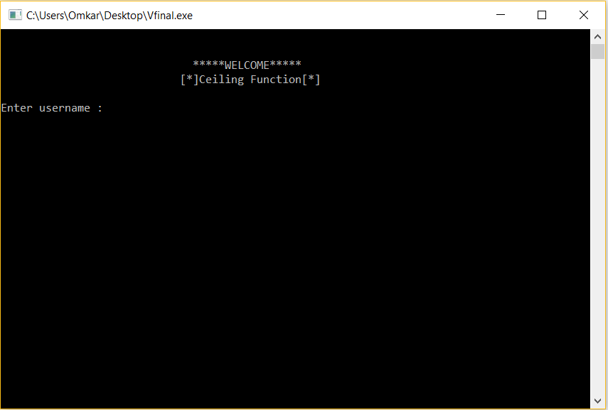

4.2.2 Window for sample input

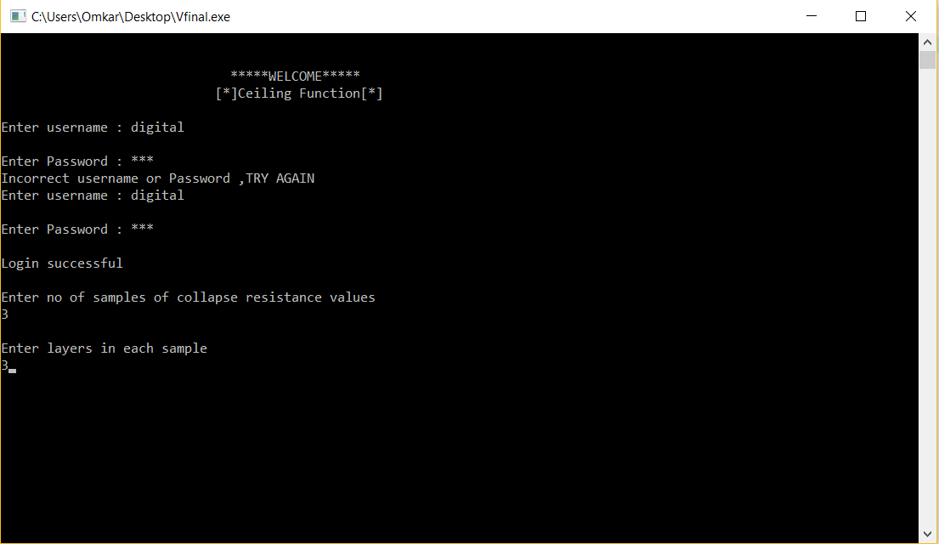

4.2.3 Window after sample input

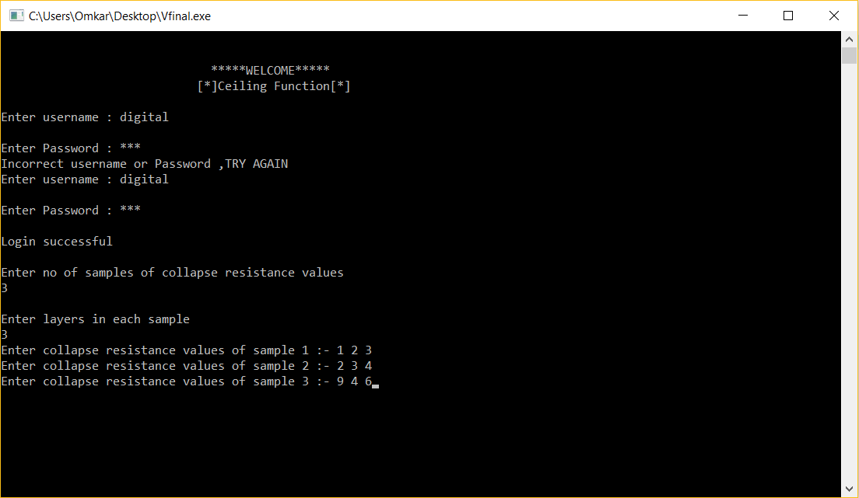

4.2.4 Output window

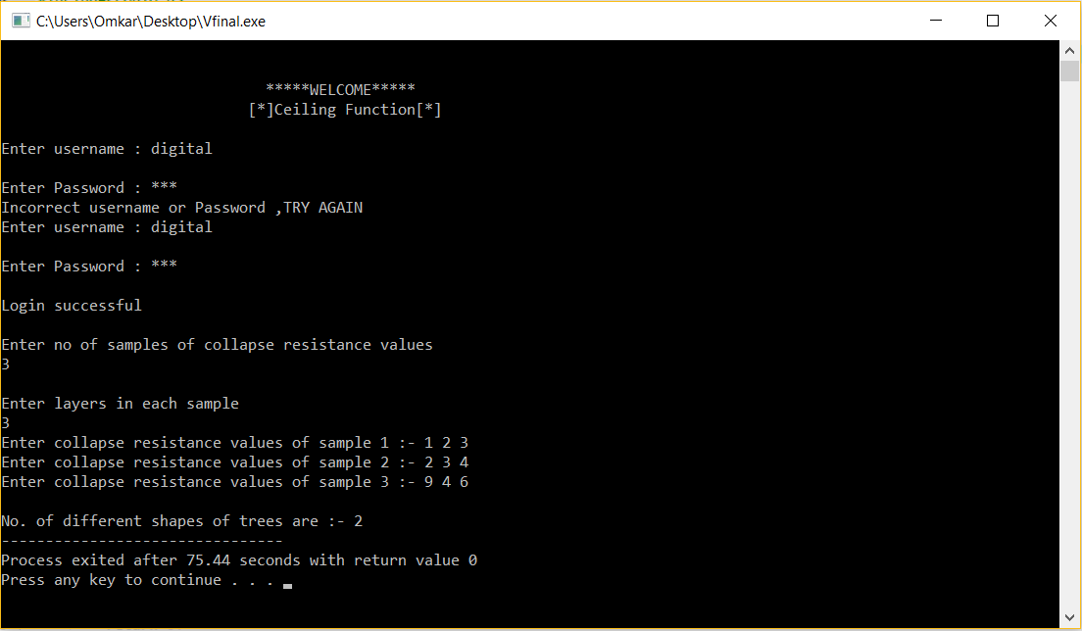

CHAPTER 5

Conclusions

5 Conclusion

5.1 Conclusions

This development will enable Advance Ceiling Manufacturers (ACM) to effectively analyze the set of ceiling prototype.

5.2 Future Work

5.3 Applications

References

6 References

6.1 Books

1. Lets us C++ by Yashwant Kanetkar.

2. Complete reference by Herbert Schildt.

6.2 Internet Resources

1. ACM – icpc world finals 2016 problem.
2. www.google.co.in

3. www.youtube.com

4. htttps://en.m.wikipedia.org/wiki/ceiling

