# Behavioral Motion Control System

Zhihao Yan unicornyzh@gwu.edu

Here is the basic structure of my project:

It’s contain three parts:

Support Functions part:

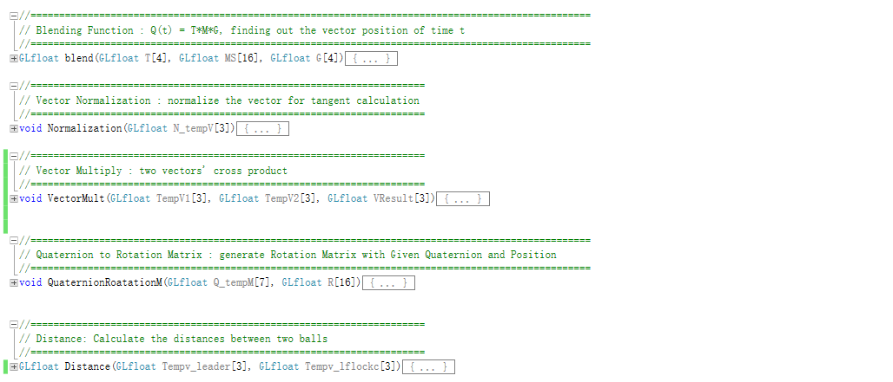

Constrain part:

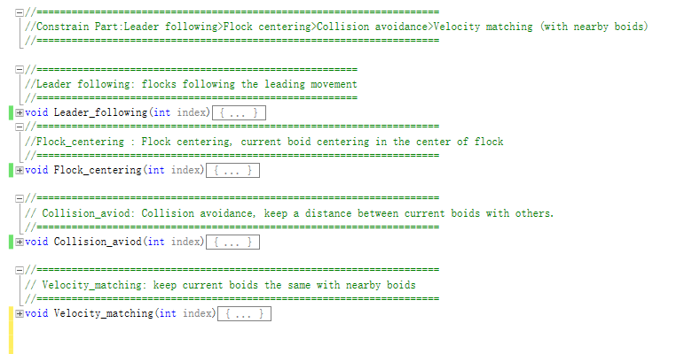

Main part:

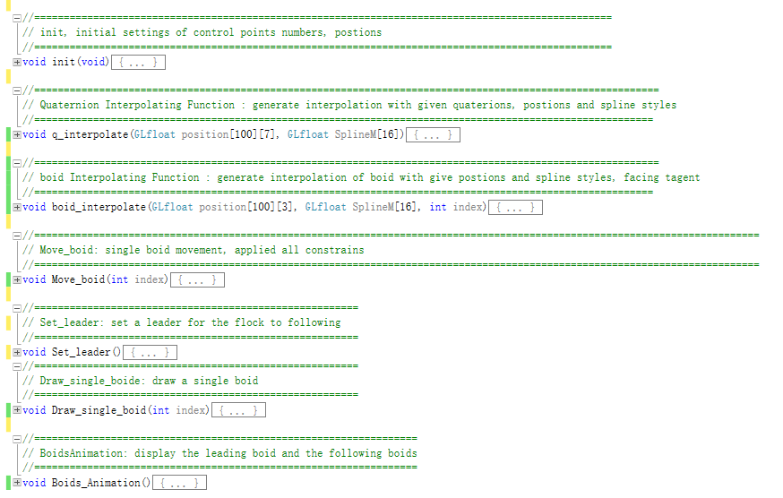

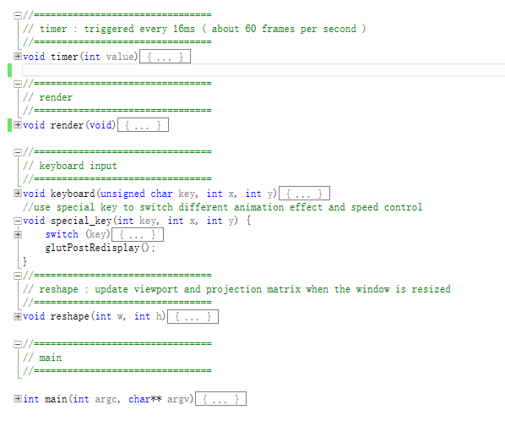

For this lab, I implemented the animation of flocks using four constrains, Leader following>Flock centering>Collision avoidance>Velocity matching (with nearby boids). In the begin, the init() function wthen initialize the initial position and colors of each boid. In the render function, it would call the Boids_Animation() function to animate all the boids under those four constrains. And Move_boid () would deal with each single boid’s movement using matrix of each boid by calling four constrains functions to calculate its next position and velocity. And I also implement the boid moving facing their tangent direction by boid_interpolate() function.

## Control description:

Press R to reset dt to the default value (0.005)

Use up and down to increase or decrease dt (spacing).