* **Step 1**

Compile Stable Coin token smart contract (SC.sol) using Remix IDE with solidity 0.4.18 compiler.

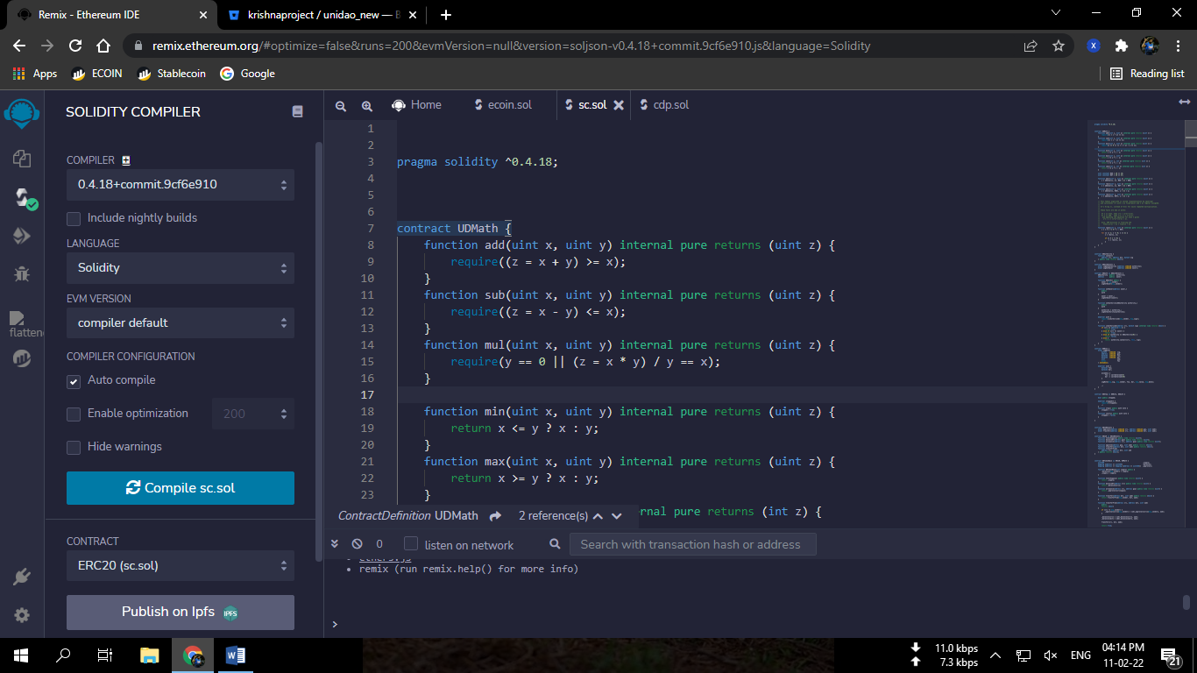

*Image 1 : Compiling of SC.sol file.*

* **Step 2**

After succesfull compiling the contract (SC.sol), now deploy the contract named as UDToken1 with constructor parameter token name (“XUSD”).

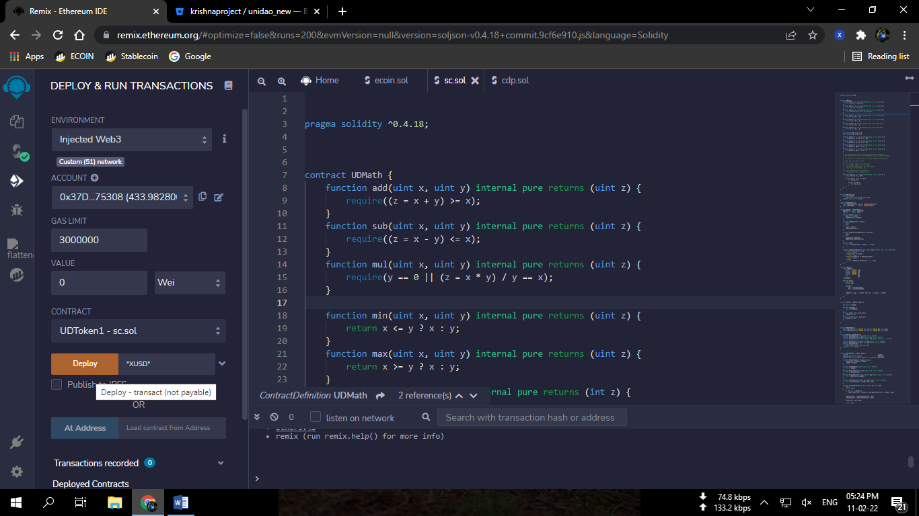

*Image 2: Deployment of Stable coin token contract*

* **Step 3**

Now compile ECOIN.sol with solidity 0.4.24 compiler and deploy XCOIN (dummy ecoin) contract.

This will mint 10 Billion supply of xcoin (dummy ecoin) to your wallet.

We’ll use this as collateral token.

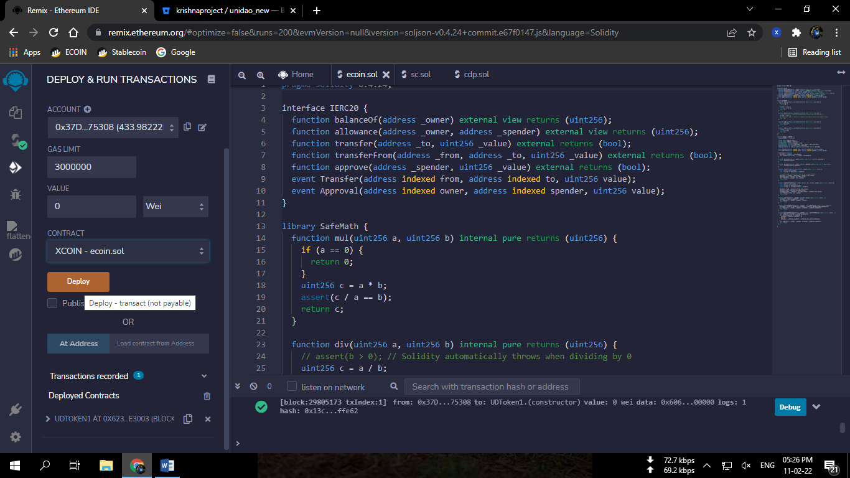

*Image 3: Compiling and deploying Ecoin.sol*

* **Step 4**

Now compile cdp.sol with solidity 0.4.18 compiler and deploy the contract UDTub.

While deploying it will ask for 3 contract addresses

1. CC_ = Collateral coin address (The one we deployed in step 3)
2. SC_ = Stablecoin Address(The one we deployed in step 2)
3. PF_ = Pricefeed Address (0xccd47446B3698Ee0f9E7E331f5653a206696B179)

(For more info of pricefeed visit <https://bitbucket.org/krishnaproject/pricefeed/src/master>)

Enter the following addresses carefully and deploy it.

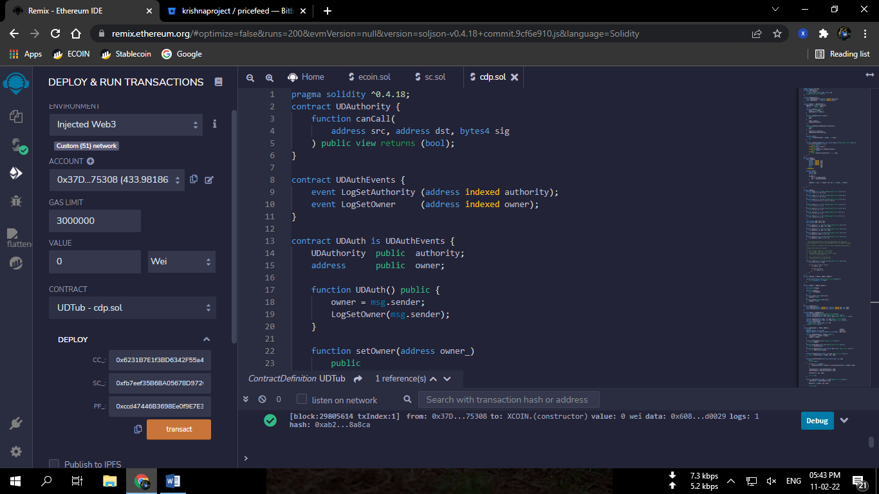

*Image4: Deployment of CDP contract with the constructor parameters : CC_, SC_, and PF_.*

* **Step 5**

Now copy the deployed contract address of CDP and go to UDToken1 (Stablecoin token) contract that you deployed in step 2 and set the copied address as authority using setAuthority Function.

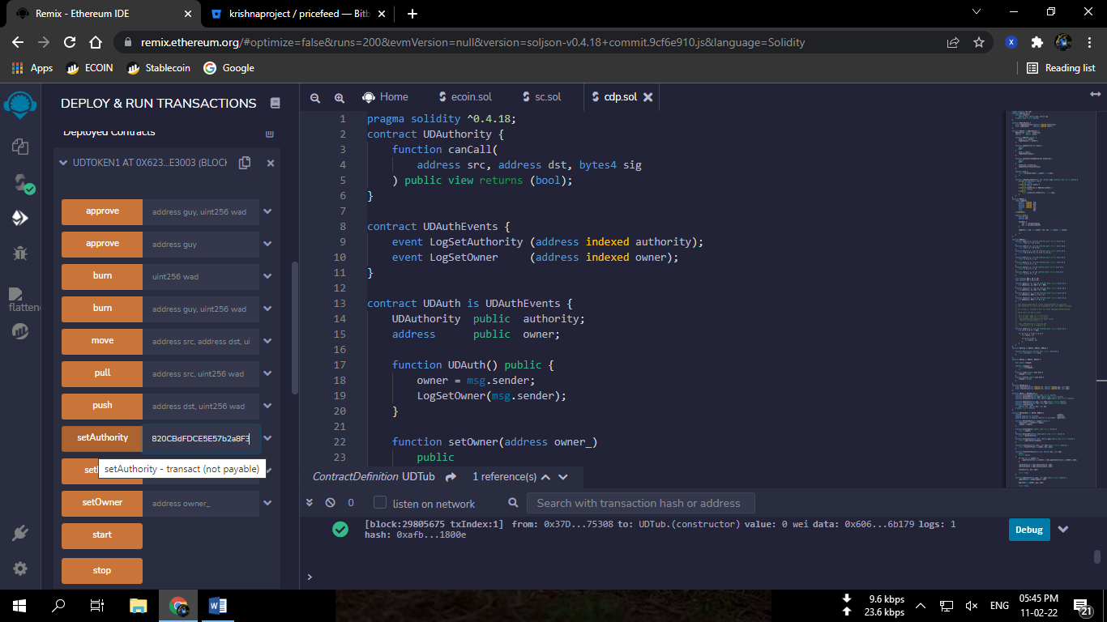

* **Step 6**

Now go to the deployed XCOIN contract and approve some amount of Xcoin to the cdp address so that we can deposit Xcoin in the cdp.

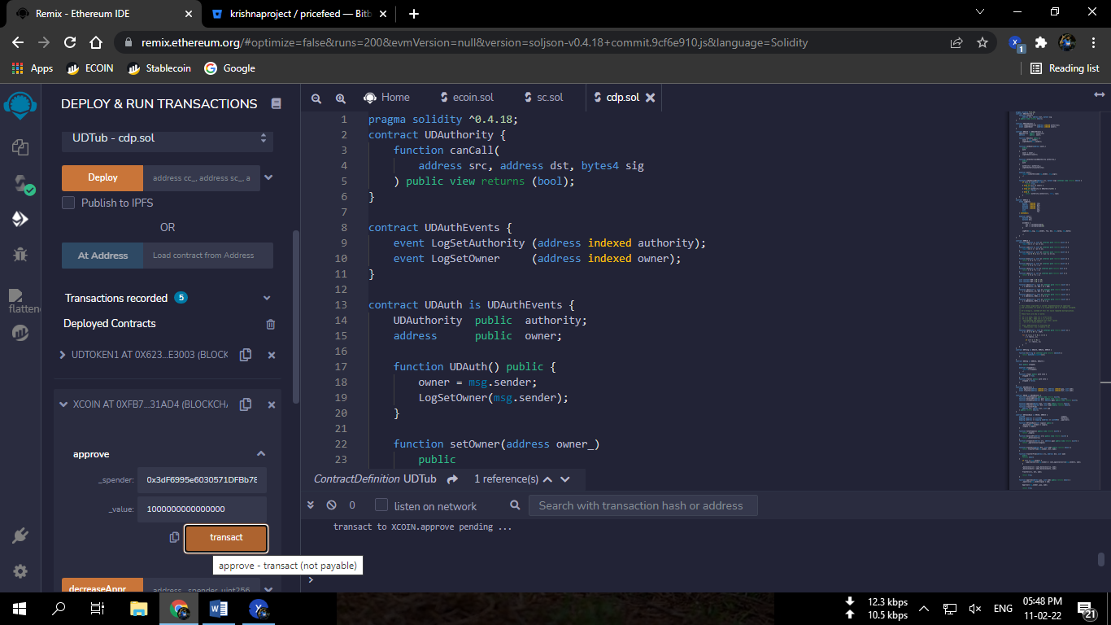

*Image6: Approval of XCOINS to the cdp contract.*

*(Note: Please enter 10 Zeros after the value you want to approve for decimals)*

* **Step 7**

Now go to the cdp contract.

Open a vault using Open() function.

Vault will be opened after you sign the transaction. You will get a vault number that you can check with the cupNo() function.

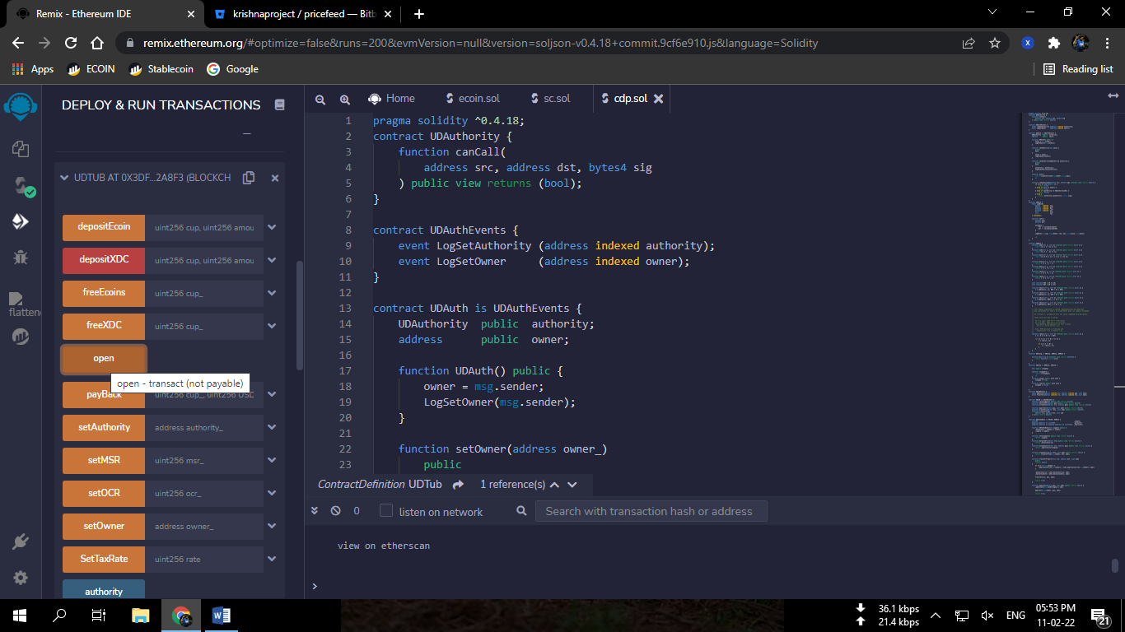

*Image7:Opening of Vault.*

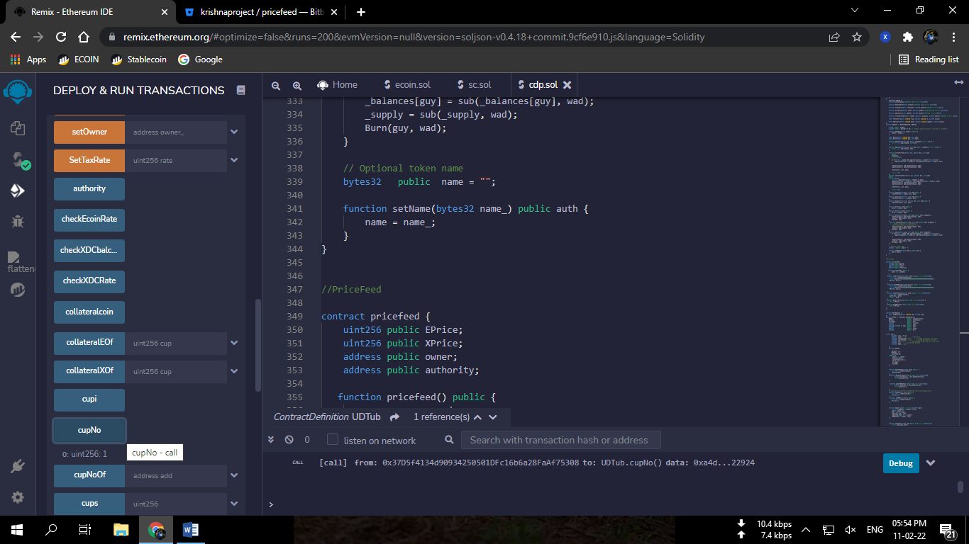

*Image8: Check Cup (vault) number.*

* **Step 8**

Now we’ll deposit ecoins (xcoin) and mint stablecoin using the depositEcoin function.

Go to the deposit Ecoin function and enter your cup no.(from step7) and the amount of ecoins you want to deposit. (amount should be with zero decimals.)

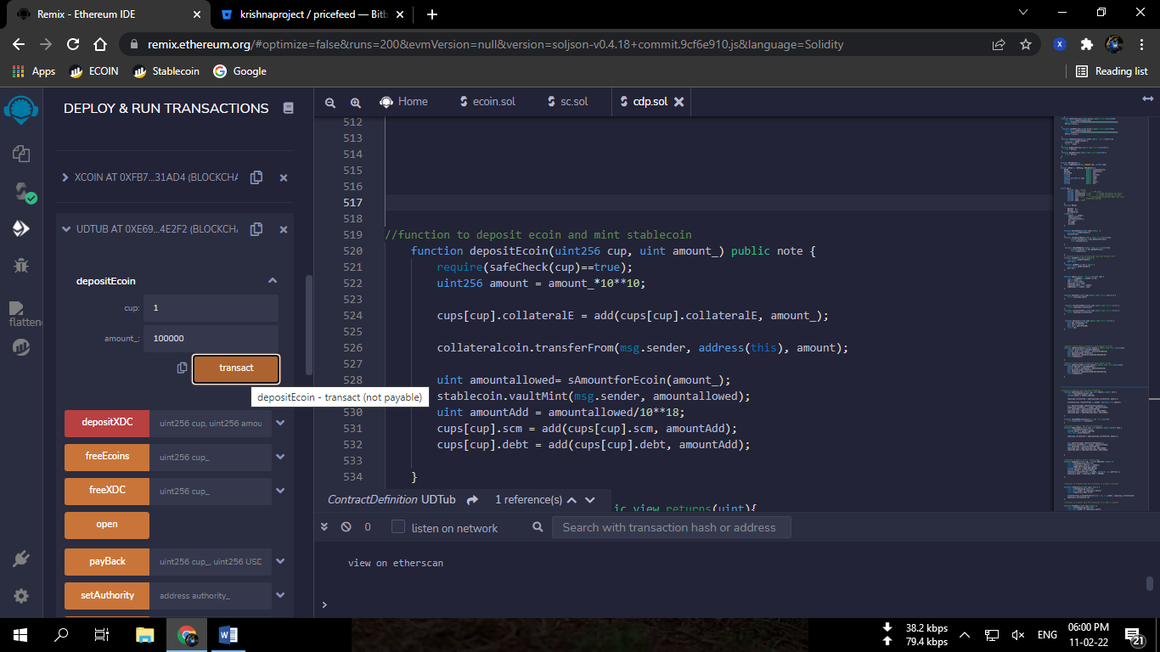

*Image9: Depositing 100000 (1 Lac) Ecoins in the vault 1.*

Wait for the transaction to get completed.

Stable coins will be minted with over collaterization ratio of 500% and latest price of ecoin.

* **Step 9**

Add stablecoin token(decimal 18) in your xdc wallet with the UDToken1 contract address (step 2) and check your balance.

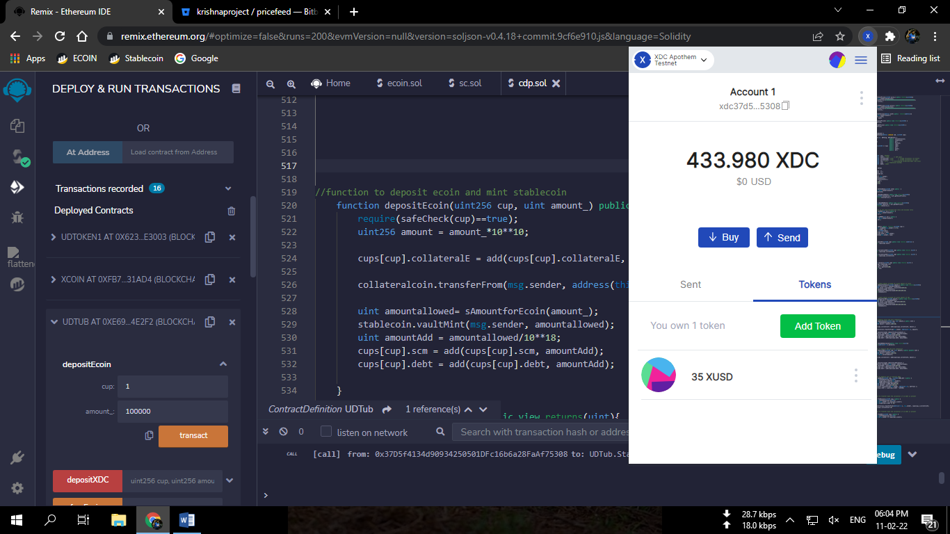

*Image10: XUSD Stablecoin balance in XDC wallet*

* **Step 10**

Now you can check the details of your vault using the cups function.

Enter the number of your cup in the cups function and call.

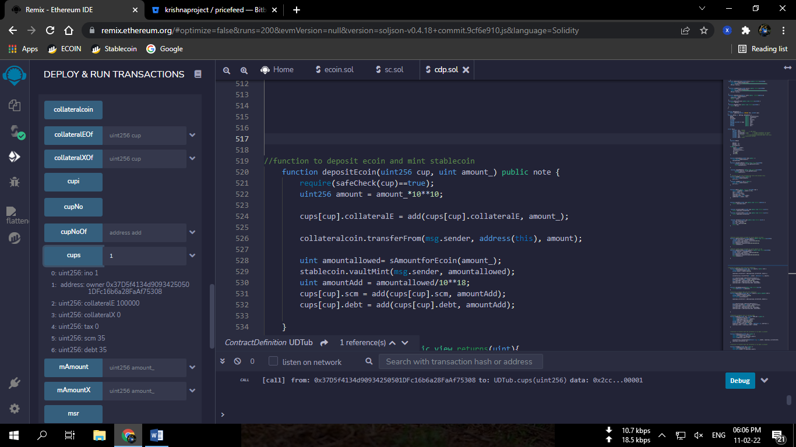

*Image11: Vault Details check.*

*Ino is index number*

*collateralE is Ecoin Collateral amount*

*collateralX is XDC collateral amount*

*tax is tax*

*scm is total stablecoin minted*

*debt is current debt*