Contents

1 Introduction and Objectives 2

2 Problem Statement 3

2.1 Steps Followed 3

2.2 Validation 5

3 Conclusion 8

# Introduction and Objectives

The objective of this document is to show how to enable a triggering mechanism in UNIX environment on directory/file events.

# POC

Create the trigger to run the script if the file is created in the directory.

## Steps Followed

Step 1: First configure the triggering mechanism in UNIX environment.

* Login with **root user**
* Enable EPEL repository ( *UNIX Syntax* *to list out the repository name* - **# yum repolist** )
* For RHEL/CentOS 7 64-Bit
* **# wget** [**http://dl.fedoraproject.org/pub/epel/7/x86_64/e/epel-release-7-10.noarch.rpm**](http://dl.fedoraproject.org/pub/epel/7/x86_64/e/epel-release-7-10.noarch.rpm)
* **# rpm -ivh epel-release-7-10.noarch.rpm**
* For RHEL/CentOS 6 64-Bit
* **# wget** [**http://download.fedoraproject.org/pub/epel/6/x86_64/epel-release-6-8.noarch.rpm**](http://download.fedoraproject.org/pub/epel/6/x86_64/epel-release-6-8.noarch.rpm)
* **# rpm -ivh epel-release-6-8.noarch.rpm**
* Install inotify-tools
* **# yum install inotify-tools**

Or

**# yum --enablerepo=epel -y install inotify-tools**

Step 2: Make sure the permission to access this configuration by the relevant users, example – oracle

Step 3: Log In with user, where you want to enable triggering mechanism for directory.

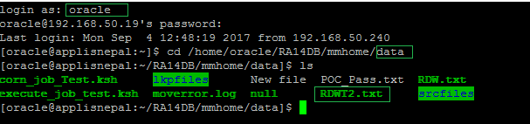

Step 4: Create a script as “**inotify_wait.ksh**”, which is able to trigger if the file is created under the specified directory

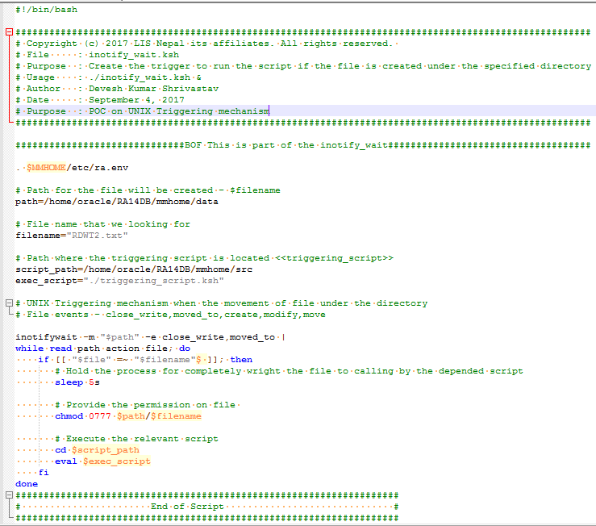

Step 4: Make Sure the dependent script is placed on the desired location as “**triggering_script.ksh**”

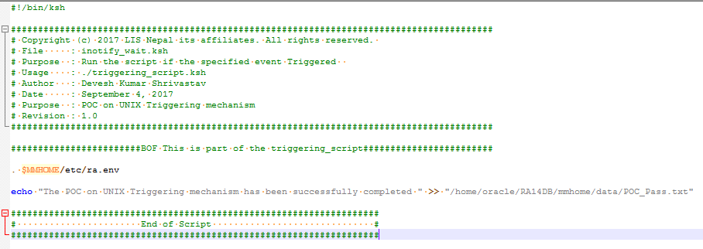

Step 5: To enable the trigger, execute the following command at once

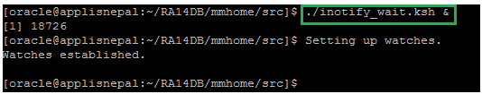

Step 5.1: To check the trigger status (enabled)

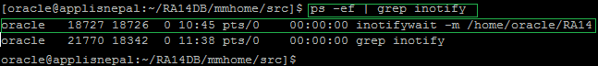

Step 5.2: To disable the trigger (Note: If required)

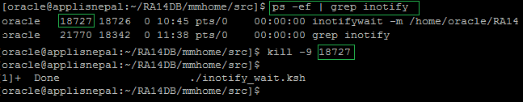

Step 5.3: To check the trigger status (disabled)



## Validation

Enable the trigger

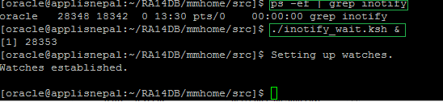

To check the trigger status

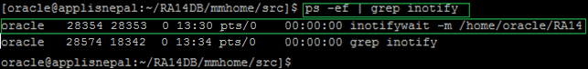

Before snapshot of directory – (RDWT2.txt) – *For new file*

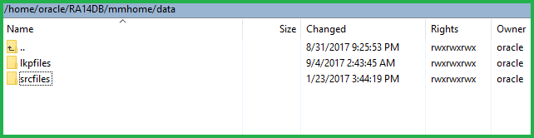

After snapshot of directory – (RDWT2.txt) – *For new file*

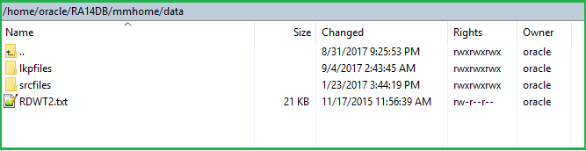

After the required file exists (RDWT2.txt), another shell script triggered on 5 second waiting to generate the file (POC_Pass.txt). Note: The wait time to fully preparation time of the existing file - RDWT2.txt – *For new file*

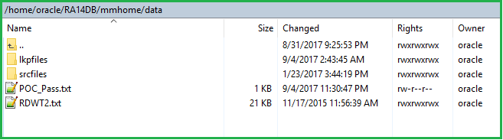

Before snapshot of directory – (RDWT2.txt) – *For existing file*



After snapshot of directory – (RDWT2.txt) – *For existing file*



After replace the existing required file (RDWT2.txt), another shell script triggered on 5 second waiting to generate the file (POC_Pass.txt). Note: The wait time to fully preparation time of the existing file - RDWT2.txt – *For existing file*



# Conclusion

The UNIX Triggering mechanism has been successfully configured to monitors the activity/events of specific file under a directory.

# Appendix



