Explain my work.

* Created the “Package” folder and created the sub folder “com.william.leaderboardsdk”.
* Also, continue to create the sub folder “Runtime” folder.

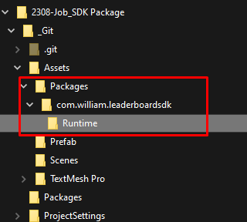

* Created LeaderBoardSDK.cs file that performs functions of SDK library.

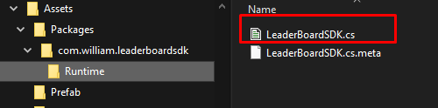

* This folder is converted into a tgz file.

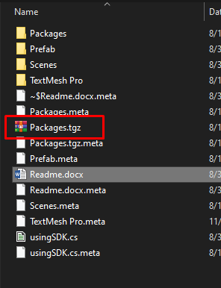

* This tgz format library is imported in the following way as the picture.

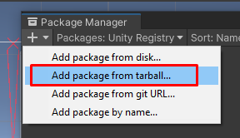

* The contents of the basic class of the SDK library are as shown in the picture.

GetLeaderBoardAPIData function get leaderboard using Unity WebRequest class and API endpoint .

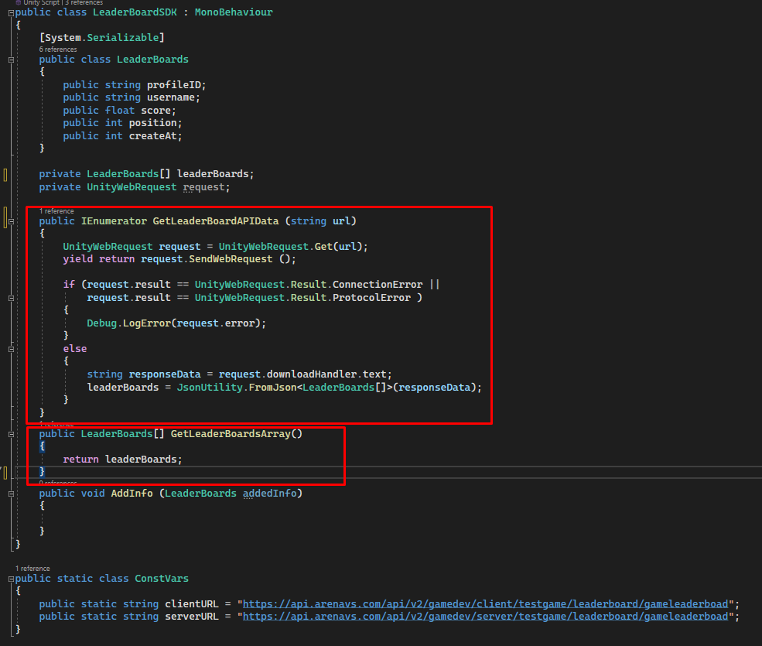

* The part that use the API of SDK is shown in the following picture.

When the UI button is pressed, the SDK’s GetLeaderBoardAPIData function and GetLeaderBoardsArray function are used to display the game’s leaderboard information on the ScrollView.

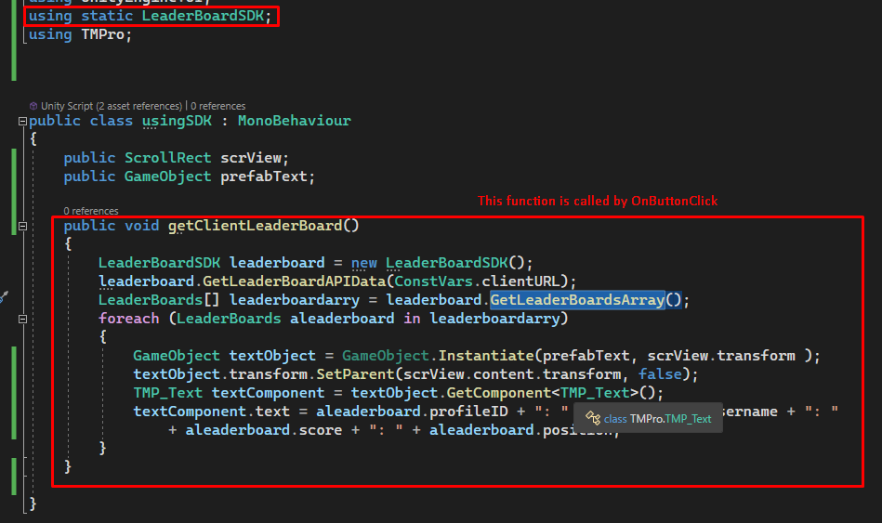

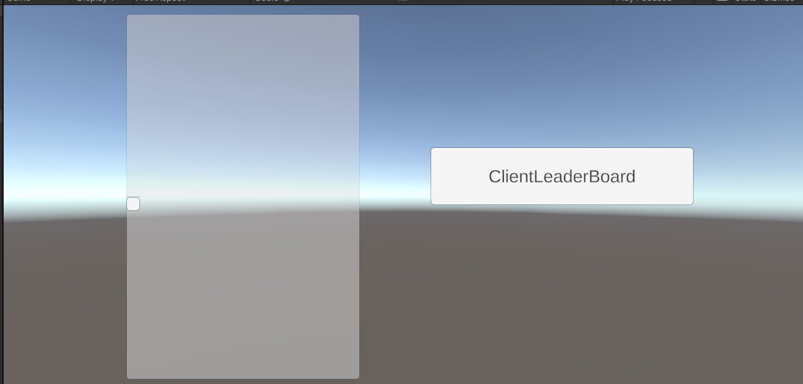

Currently, There is no leader data, Therefore, even though the API is called by pressing the button, a null value is received. If

Thank you!