1/ look at the picture then complete the following sentences/questions with some or any  1/ there are …………….apples.  2/ there aren’t …………….dates.  3/ Are there ………………grapes?  4/there are …………………bananas.  5/ there aren’t ………………… vegetables.  6/ there are ……………pears.  7/ there are …………………..stawberries.  8/ Are there ………………….oranges?  9/ Are there ………………..lemons?  10/ there aren’t …………………….figs.  2/ turn the following sentences into the negative form:  1/ there are some pens in my schoolbag.  ………………………………………………………………..  2/ there are some ducks in the farm.  ……………………………………………………………….  3/ there are some people at the bus stop.  ……………………………………………………………….  4/ there are 10 actors on the stage.  ………………………………………………………………  5/ there are many trees in our garden.  ……………………………………………………………….  4/ look at Mrs. Mc Lean’s fridge and try to complete the following sentences with there is/are/ isn’t / aren’t don’t forget to use any and some in the correct place:  1/ ……………………………………………….bananas.  2/ ……………………………………………..onions.  3/ ………………………………………………milk.  4/ ……………………………………………….eggs.  5/ ……………………………………………..cabbage.  6/ ……………………………………………..chicken.  7/ …………………………………………….tomatoes.  8/ ……………………………………………oranges.  9/ ……………………………………pomegranates.  10/ …………………………………………juice.  5/ Now look at the picture carefully and try to memorize as many items as you can. Work with a partner. One of you should hide his picture and the other asks him/her questions:  e.g: is there any butter in the fridge?  The other should answer:  -Yes there is some.  exchange roles. The winner is the one who gives more correct answers. | 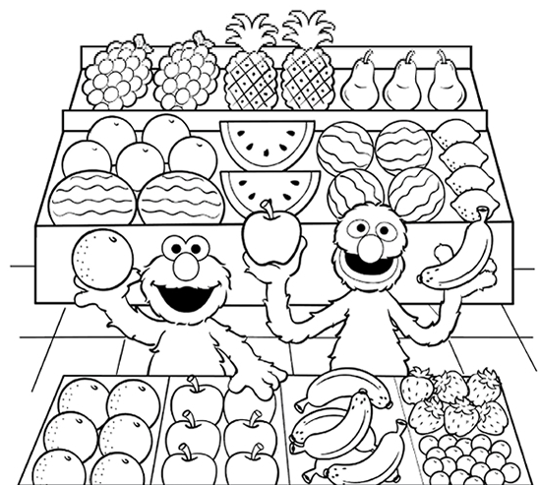  3/ make questions about the underlined words:  1/ there are some cows in the cowsheds.  …………………………………………………………………….  2/ there are many children in the garden.  ………………………………………………………………………  3/there isn’t any cheese in the fridge.  ………………………………………………………………………  4/There aren’t any pupils in the classroom at lunch time.  ………………………………………………………………………  5/ there are some oranges in the basket.  …………………………………………………………………..  